
Information Engineering
DATA FLOW DIAGRAM

January 12, 2018
Student ID: 1704831
STUDENT NAME: PRIYANKKUMAR J PATEL

Data Flow Diagram: Level 0
Kitchen
Invoice
Billing Department
Order
Invoice
Customer

The Pizza For U

Data Flow Diagram: Level 1
Kitchen
Customer

1.0
Receive and Transform
Customer Food Order
Food Order
Order

Receipt

2.0
Update Foods
Sold File
3.0
Update Inventory File

Inventory Data
Goods Sold

Foods sold file
D2
Inventory File
D1

Daily Foods
Sold amount
4.0
Daily Goods
Sold Amount
Daily Depletion
Amount

Data Flow Diagram: Level N
4.1
1.0
Access Foods Sold and Inventory Data

Foods Sold Data

Inventory Data

4.2
1.0
Aggregate Foods Sold
And Inventory Data

Aggregated Data

4.3

1.0
Prepare Management Reports

Formatted Data

4.4
1.0
Print Management Reports
Owner
Management Reports

An Entity Relationship Diagram:

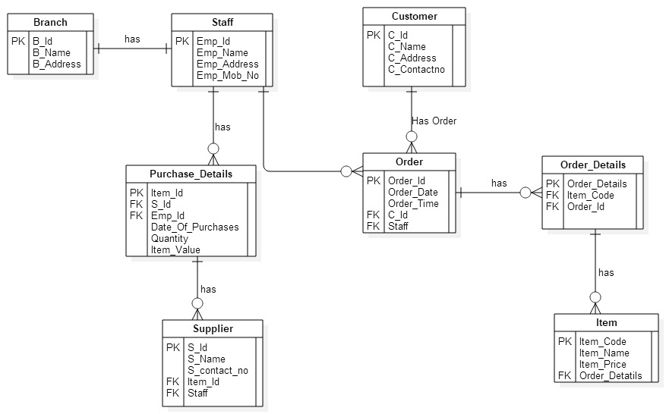

- Branch (B_id, B_Name, B_Address)
- Staff (Emp_id, Emp_Name, Emp_Address, Emp_mob_No)
- Purchase_Details (Item_id, S_id, Emp_Id, Date_of_Purchase, Quantity, Item_Value)
- Supplier (S_Id, S_Name, S_Contact_no, Item_Id, Staff)
- Customer (C_Id, C_Name, C_Address, C_Contactno)
- Order (Order_id, Order_Date, Order_Time, C_Id, Staff)
- Order_Details (Order_Details, Item_Code, Order_Id)
- Item (Item_Code, Item_Name, Item_Price, Order_Details)

