

Programme: Master of Business Administration
Module: Marketing Management
Module code: LCMB7024
Title: Marketing Environmental Analysis for Pioneers and Followers

Lecturer: Dian Mayasari
Student Name: Naveenkumar Jayakannu
Student ID: 2438827
Submission Date- 24th October 2025
Selected Macro Environment Factors: Social & Technological
Pioneer- KFC
Follower- Popeyes

Index
- Introduction…………………………………………………………………….3
- PESTEL approach…………………………………………………………….4
- Task 1 Threats and Opportunities of Social and
Technological Factors of Pioneer and Follower……………………….4
3.1. Social Factors of KFC…………………………………………………...4
3.2. Technological Factor of KFC…………………………………………...5
3.3. Social Factors of Popeyes………………………………………………6
3.4. Technological Factor of Popeyes………………………………………8
- Task 2- Strategical Respond………………………………………………9
4.1. Strategical Respond to Social Factor …………………………………9
4.2. Strategical Respond to Technological Factor………………………...11
4.3. Positioning of KFC and Popeyes……………………………………....12
- Conclusion……………………………………………………………………..14
- Bibliography……………………………………………………………………15

- Introduction
In the context of the highly competitive global Quick Service Restaurant (QSR) industry, the rivalry between KFC (Kentucky Fried Chicken) and Popeyes Louisiana Kitchen offers a compelling analysis of the Pioneer and follower concept. KFC stands as the quintessential pioneer in the mainstream fried chicken segment, having established its global footprint and signature product (Original Recipe) decades before many of its current competitors. Conversely, Popeyes, though established in the early 1970s, has historically operated as a fast-growth, often more regionally focused, follower brand, particularly in the core U.S. market
This analysis will examine how the differing market entry orders of KFC and Popeyes have shaped their strategic responses to the dynamic marketing environment, encompassing macro environmental trends.

Fig 1.1: Factors for Macro Environment (Self Source)

- PESTEL APPROACH
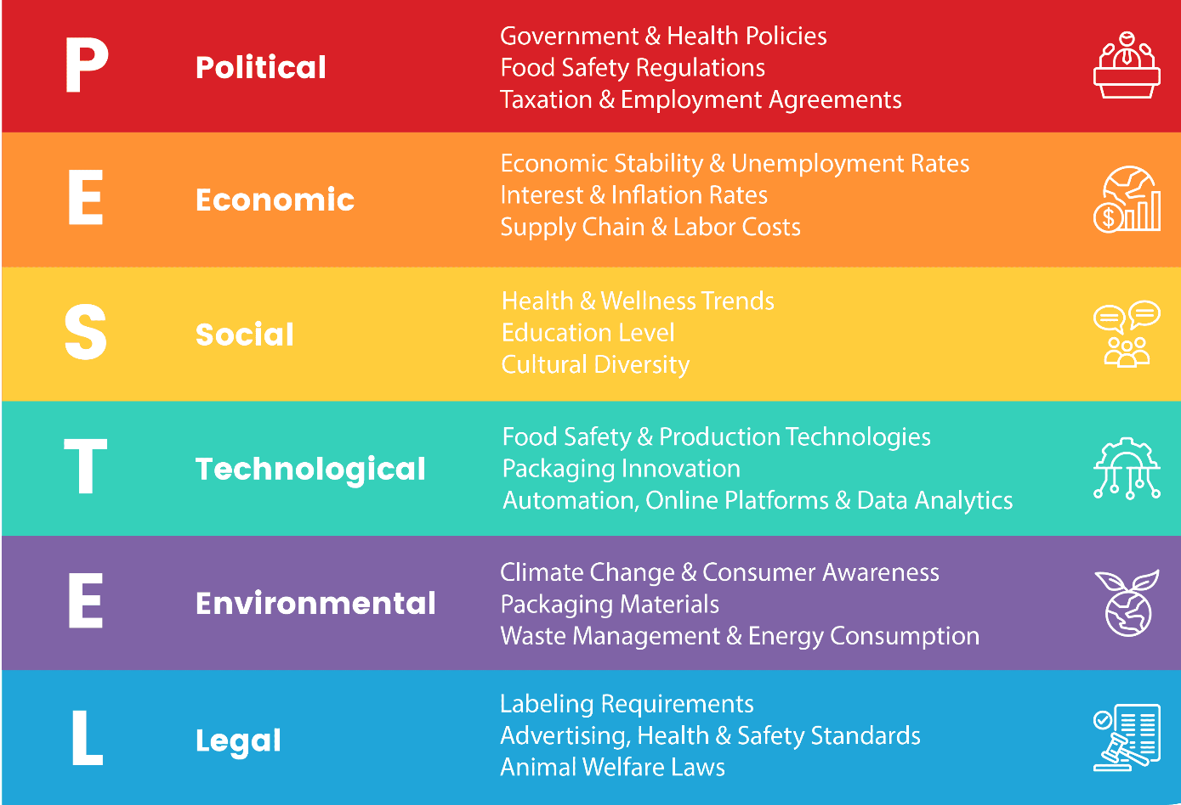
Macro-environmental factors and forces could present both opportunities and threats, and organizations use information from macro-environmental analysis to develop strategies that would minimize the effects of threats and capitalize on opportunities. Mentioned table is an example of relevant macro-environmental influences specific to a Food Industry in the commercial airline industry identified under the six PESTEL analysis categories of factors.
Fig1.2- PESTEL Analysis (Pestelanalysis.com)

- TASK- 1 Threats and Opportunities of Social and Technological Factors of Pioneer and Follower.
3.1 Social factors KFC (Pioneer)
The key social factors affecting KFC in the UK revolve around three main consumer shifts: heightened Health Consciousness, the demand for strong Corporate Social Responsibility (CSR) and Ethics, and the changing Modern Lifestyle which identifies these trends as crucial. Specifically, the national focus on health pushes KFC to diversify its menu with lower-calorie options and plant-based items, directly challenging its traditional "fried chicken" image. Concurrently, public demand for ethical business practices compels the company to invest heavily in youth employment programs (like Hatch) and transparent animal welfare standards, serving as an expectation for major global brands operating in a socially aware market like the UK. (MBA Skool, 2019-2024)
The main opportunities KFC in social factor is

- Increasing demand for healthier food (Sally Ho, 2021)
- Cultural localization (Marshub, 2022)
- Customer Social Responsibility (KFC U.K & IRELAND, 2022)
- Digital Engagement (QSR Magazine, 2024)
- Social Media Engagement (Enrich Labs, 2024)
Mean While Threats are
- Perception of Unhealthy Food (The Digital Gems, 2025)
- Shift to Plant-Based/Flexitarian Diets (PETA UK, 2019)
- Ethical/Animal Welfare Concerns (Marketing91, 2025)
- Cost-of-Living Crisis (The Food Foundation, 2023)
- Changing Mindset of Consumers.

3.2 Technological factors KFC
KFC has received many emerging advances and changes to stay aware of the changing trends and taste of the consumers. Most outlets today have a click and carry choice, where you can arrange your food before arriving at the chain restaurant in this manner causing you to save time in waiting and falling lines. KFC has received numerous new advances and changes to stay aware of the changing trends and taste of the consumers.
KFC's technological factor is primarily centered on a comprehensive Digital Transformation that leverages Artificial Intelligence (AI) and an Omnichannel Experience to boost both operational efficiency and customer satisfaction. The overall strategy is to shift from being "a chicken company that has technology" to being "the leading quick-service restaurant across uk in digital experience, with finger lickin' chicken," with a global ambition to reach 100% digital sales. (Judopay, 2023; QSR Magazine, 2024)
Opportunities (The strategy Story, 2023)
- Technological and Digital initiations
- Boost the customer experience
- Online ordering
- Online delivery services
- AI Based Customer analytics

Threats (The strategy Story, 2023)
- Data security and privacy
- AI powered attacks
- Poor security controls
- Vulnerable legacy System

3.3 Social Factor Popeyes (Follower)
Social trends are arguably the most influential external drivers for the Popeyes brand, focusing on culture, health, and viral buzz. Viral Marketing and Hype: The brand's success is deeply connected to its ability to generate viral social media engagement, stemming from the original "Chicken Sandwich Wars." This organic and high-energy marketing is key to attracting younger, digitally-native consumers (Awario, 2020). Menu Localization is to achieve sustainable global growth, Popeye successfully localize its authentic Louisiana menu to fit local tastes, a lesson learned from initial struggles in markets like China where cultural misalignment was a challenge (Chandler Collings, 2024).
Opportunities
- Positive Internal Culture: By emphasizing that its employees are "Joy Creators" and focusing on excellent internal culture, which has led to a 20% above-average staff retention rate in the QSR sector, Popeyes builds a strong employer brand. (Matt Hudson, 2025).
- Community and Social Responsibility: Partnerships, such as those that hire people from disadvantaged backgrounds, help the brand "Do Mighty Good" (Barclays Corporate Banking, 2025).
- Marketing Authentic Culinary Credentials: The brand has the opportunity to further push its messaging—as seen in its "We Don't Make Sense, We Make Chicken" campaign—to highlight the high-quality, time-honored traditions like the 12-hour marination process (Popeyes News, 2025).
- Sustaining the "Chicken Wars" Momentum: The 2019 launch of its Chicken Sandwich, spurred by a witty tweet, created a cultural phenomenon that led to an estimated $23.25 million in equivalent ad value (Media Frenzy Global).
Threats
- Menu Limitations: Popeyes' menu has a high density of fried dishes and is often perceived as having high fat and calorie content (MBA Skool). This makes it a turn-off for the rapidly growing segment of health-conscious consumers who are actively seeking less processed, organic, or vegetarian alternatives (MDPI, 2022)
- Viral Negative Feedback: Unlike positive hype, negative comments—especially those concerning food safety tend to induce negative consumer responses regardless of the source's credibility, making them particularly damaging (ResearchGate)
- Supply Chain Allegations: Allegations regarding food safety in the supply chain, even if officially denied, can cause immediate and significant reputational damage and loss of consumer confidence. For instance, a viral TikTok video warning consumers about a lawsuit alleging the sale of "unsafe and unlawful raw chicken" led to users urging support for local, rival brands (Aird & Berlis LLP, 2025)
- Targeting Health Disparities: The fast-food industry has historically targeted low-income communities and communities of color through race-based marketing, contributing to a disproportionate incidence of food-related diseases in these groups (ScholarSpace). Popeyes, which has successfully engaged Black social media for viral success, risks being implicated in the broader critique of promoting unhealthy foods to vulnerable populations (AURN, 2019)
3.4 Technological Factors Popeyes
The technological factor of Popeyes Louisiana Kitchen is defined by a deep focus on digital integration and back-of-house operational efficiency, driven by its parent company's (Restaurant Brands International) broader modernization strategy. Popeyes UK is implementing Voice AI in its drive-thrus (dubbed "Al," after founder Al Copeland). This conversational AI is designed to handle orders, reduce human error, and improve order accuracy (reported at 97% in a pilot). The system adapts to various UK accents and provides visual confirmation of the order. (David carey, 2024).
As part of the "Easy to Run" initiative, Popeyes is standardizing and implementing new back-of-house technology across US stores. This includes: cloud-based point-of-sale (POS) systems, digital drop charts (replacing old-school intuition), order-ready boards, and new kitchen equipment like auto batter-makers and improved hot holding units. (Joshua kobza, 2025)
In the UK, Popeyes has implemented Sona's AI-powered workforce management solution for functions like forecasting, auto-scheduling, and productivity optimization across its estate. This is aimed at improving both operational efficiency and the employee experience. (Retail technological innovation Hub, 2025)
Advancements in technology have revolutionized the restaurant industry, presenting
both challenges and opportunities for Popeyes. Automation, digitalization, and online
ordering platforms have become integral parts of the fast-food experience. Popeyes
Advancements in technology have revolutionized the restaurant industry, presenting
both challenges and opportunities for Popeyes. Automation, digitalization, and online
ordering platforms have become integral parts of the fast-food experience. Popeyes
Advancements in technology have revolutionized the restaurant industry, presenting
both challenges and opportunities for Popeyes. Automation, digitalization, and online
ordering platforms have become integral parts of the fast-food experience. Popeyes
Advancements in technology have revolutionized the restaurant industry, presenting
both challenges and opportunities for Popeyes. Automation, digitalization, and online
ordering platforms have become integral parts of the fast-food experience. Popeye
Advancements in technology have revolutionized the restaurant industry, presenting
both challenges and opportunities for Popeyes. Automation, digitalization, and online
ordering platforms have become integral parts of the fast-food experience. Popeyes
Threats
- Franchise IT Inconsistency: A largely franchised model means that maintaining a uniform, high standard of IT security across thousands of individually owned and operated point-of-sale (POS) systems is difficult. A security flaw at a single franchise can lead to a systemic data compromise (Sintel Systems)
- Integration Complexity and Cost: Popeyes is actively implementing new tech, like AI voice ordering and integrated digital kiosks, to improve efficiency and order accuracy (QSR Media UK, 2025)
- Competitive Replication of AI: Competitors with larger R&D budgets could rapidly replicate or improve upon Popeyes' AI systems, erasing the first-mover advantage and forcing Popeyes into a costly technological arms race. (Self Source)
- Data Security and Privacy Risks: The reliance on digital platforms for customer transactions and loyalty programs exposes the brand to the constant threat of a data breach. A major cybersecurity incident would severely damage customer trust and lead to regulatory fines. (Malwarebytes, 2025)
Opportunities
- Raise in Order Accuracy and Efficiency: Popeyes is rolling out AI-powered voice drive-thrus, such as the "Al" assistant, which have been successfully piloted with 97% order accuracy and an ability to understand diverse customer accents. (QSR Media UK, 2025; Retail Times, 2024)
- Data-related Operations: The AI system can provide real-time data on order times and customer sentiment, which can then be used for order forecasting and improving overall kitchen flow, addressing historical operational challenges (Retail Times, 2024; QSR Magazine, 2024).
- Increase First-Party Digital Sales: Shifting orders to the first-party app from third-party services means Popeyes retains a higher margin on those transactions (McKinsey, 2023)
- Targeted Digital Marketing: Leveraging data analytics and AI-powered programmatic advertising allows Popeyes to run highly targeted digital campaigns. This approach, which has been recognized with industry awards, delivers ads to the right audiences at the right time, boosting awareness, conversions, and in-store traffic more efficiently than traditional marketing (Stack Adapt, 2025)

- Task-2 Strategical Respond
4.1 Strategical Respond to Social Factor
Narration | Pioneer: KFC's Strategy | Follower: Popeyes' Strategy
Health Consciousness | Defensive Diversification: Introduced non-fried alternatives (e.g., grilled chicken, rice bowls, 'Beyond Fried Chicken' plant-based items) and subtly rebranded from "Kentucky Fried Chicken" to "KFC" to remove the negative association of the word "fried" (MBA Skool, n.d.; EdrawMax Online, n.d.). | Focus on Indulgence & Quality: Maintained focus on its core, flavour-forward, high-calorie fried chicken. Responded primarily by emphasizing authenticity and quality (marination process) over health (Entri Blog, n.d.).
Localization & Tastes | Deep Menu Adaptation (Glocalisation): Aggressively adapts its menu to local tastes in over 145 countries (e.g., Halal options, congee/porridge in China, rice-based dishes in Asia). Strategy is crucial for maintaining global market share leadership (KFC Marketing Strategy, 2025). | Gradual, Flavour-Led Adaptation: Relies heavily on the global appeal of its distinct Louisiana Cajun flavour profile as its core differentiator. Localization, when it occurs, often focuses on regional flavour twists that still lean into its spicy, bold identity (Entri Blog, n.d.).
Pricing Strategy | Hot chicken wings & pieces of chicken on the bone with 3 wings costing 2.10 £, & 5 wing meal with drink at 7.49 £ | 3 wings costs 1.96£, & 5 wing with drinks at 5.90£

Table 2.1 Strategical Respond to Social Factor
Critical Evaluation:-
- KFC's broad response is a necessary defense for a market leader, aiming to mitigate threats across diverse segments, but risks brand dilution. Popeyes' narrow, contrarian focus is a smart follower strategy, building strong competitive differentiation in a niche (flavour-led indulgence) which, despite health trends, remains a powerful consumer driver, especially in QSR (Bartleby.com, n.d.).
- KFC is more strategically effective globally due to its established franchise model that enables fast localization (aabri, n.d.). Popeyes leverages its unique heritage as its differentiation basis, using a lower-risk strategy of limited, authentic adaptation, which is cost-effective for a follower but potentially slower to penetrate diverse new markets (Atlantis Press, 2020).
- Here KFC uses the premium pricing strategy due to its brand perception and will fluctuate as per future demand whereas popeye uses the dynamic pricing which keeps changing as per needs
4.2 Strategical Respond to Technological Factor
Narration | Pioneer: KFC's Strategy (Operational Integration) | Follower: Popeyes' Strategy (Disruptive Engagement)
Digital Ordering | Omni-channel Investment: Consistent investment in self-order kiosks, mobile apps, proprietary delivery, and data analytics to optimize operations and service speed. The focus is on efficiency, convenience, and service consistency (The Strategy Story, n.d.; PUJIA UNISMUH MAKASSAR, 2024). | Targeted Digital Adoption: Adopted digital ordering and loyalty programs (Popeyes Rewards) to increase customer retention and collect valuable first-party data. Used digital tools to support and track viral promotions (Entri Blog, n.d.).
Social Media & Virality | Controlled Brand Campaigns: Utilizes social media (Facebook, Twitter, Instagram) for general promotions, customer service, and brand storytelling (e.g., featuring the Colonel) (Simplilearn.com, 2025). The approach is structured and controlled. | Disruptive Viral Marketing: Executed the highly effective 2019 Chicken Sandwich Campaign, leveraging real-time social media "wars" with competitors (e.g., Chick-fil-A) to generate massive, organic, earned media (Osum Blog, 2024). The strategy was characterized by a bold, witty, and personalized brand voice (Entri Blog, n.d.).

Table 2.2 Strategical Respond to Technological Factor

Critical Evaluation:-
- KFC’s strategy maintains competitive parity in operational technology—essential for a high-volume pioneer. Popeyes' emphasis on the Rewards app is a clever follower move, leveraging technology as a CRM tool to build loyalty and increase customer lifetime value (CLV), effectively combating the pioneer's advantage of size.

- Popeyes was decisively more successful in using technology (social media) as a primary competitive marketing strategy. By capitalizing on user-generated content and cultural trends, it achieved a level of brand awareness and market disruption that far outweighed its advertising spend, rapidly gaining market share and challenging KFC's dominance (Unacast, 2021). KFC's controlled approach, while safe, missed the opportunity for high-impact market disruption.

  - Positioning of KFC and Popeyes
KFC provides families and individuals with their globally recognized chicken that is better than any other quick service restaurant. KFC does this by making quality chicken unparalleled in flavor and tradition whereas popeye position for truth as defining- born of the unique culinary heritage of Louisiana, blending ingredients and ideas from seven different culture.
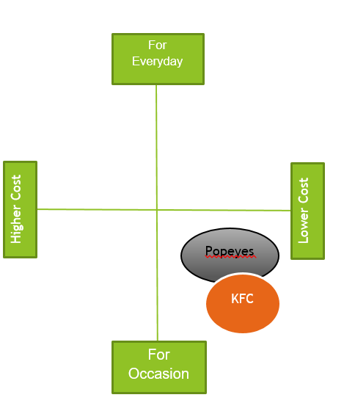

Fig 2.3.1 Positioning of KFC and Popeye (Cost and Use) (Self Source)

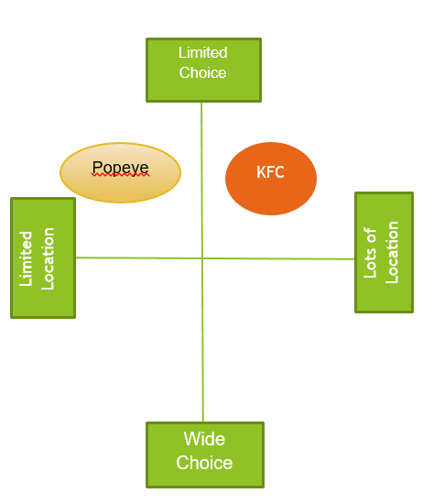

Fig 4.3.2 Positioning of KFC and Popeye (Choice and Location) (Self Source)

- Conclusion
In summary marketing analysis of KFC (Pioneer) and Popeyes (Follower) highlights a dynamic interplay between pioneer innovation and follower adaption within the fast food chicken industry. KFC as pioneer established a strong global brand presence through early market entry, consistent product, innovation and extensive franchise giving it a significant first mover advantage. Its deep understanding of diverse social & Technological environments has allowed it to adapt successfully to local market worldwide.
Whereas Popeyes (Follower) leveraged the groundwork laid by pioneer like KFC identify market gaps and refine its competitive positioning. By emphasizing bold Louisiana inspired flavor, target marketing campaigns and digital engagement Popeyes differentiated itself and gained substantial market share in recent years.

- Bibliography
- Analysing the macro-environment. (n.d.). Available at: https://thinus.weebly.com/uploads/3/0/6/3/30633117/strategic_management_3e_chapter_5.pdf.
- Chappelow, J. (2023). Macro Environment. [online] Investopedia. Available at: https://www.investopedia.com/terms/m/macro-environment.asp.
- ‌ Educatly. (2025). Micro vs Macro Business Environment: Analysis for Strategic Planning | Educatly. [online] Available at: https://www.educatly.com/blog/773/micro-vs-macro-business-environment-strategic-analysis.
‌
- Makos, J. (2024). PESTLE Analysis of the Food Industry. [online] PESTLE Analysis. Available at: https://pestleanalysis.com/pestle-analysis-of-the-food-industry/.
- ‌ Anon, (2024). Analysing the marketing environment - Let’sTalk Strategy. [online] Available at: https://letstalkstrategy.co.uk/analysing-the-marketing-environment/.
‌
- EdrawMax. (2020). Detailed PESTEL Analysis of KFC | EdrawMax Online. [online] Available at: https://edrawmax.wondershare.com/pestel/kfc-pestel-analysis.html [Accessed 8 Oct. 2025].
- ‌ Parkin, G. (2023). Marketing Environment: An Explanation of Components and Importance. [online] GoPromotional Branded Merchandise Blog. Available at: https://www.gopromotional.co.uk/blog/marketing-environment-an-explanation-of-components-and-importance/.
‌
- Rowie Anne Rancap (2024). Micro and Macro Environment of KFC. [online] Scribd. Available at: https://www.scribd.com/document/561181609/Micro-and-Macro-Environment-of-KFC.
- Aithor (2024). KFC Micro- and Macro-Environment Report. [online] aithor.com. Available at: https://aithor.com/essay-examples/kfc-micro-and-macro-environment-report#33-social-factors
- Bhasin, H. (2024). SWOT analysis of KFC - KFC swot analysis & Internal analysis. [online] Marketing91. Available at: https://www.marketing91.com/swot-analysis-of-kfc/.
- Bhasin, H. (2017). Marketing strategy of KFC - KFC Marketing strategy. [online] Marketing91. Available at: https://www.marketing91.com/marketing-strategy-of-kfc/.
- The Strategy Story (2023). KFC SWOT Analysis - The Strategy Story. [online] The Strategy Story. Available at: https://thestrategystory.com/blog/kfc-swot-analysis/.
- Pochin, C. (2021). ‘I compared Popeyes and KFC to see which fried chicken chain is better’. [online] mirror. Available at: https://www.mirror.co.uk/money/i-compared-popeyes-kfc-see-25498800.
- Team, M.S. (n.d.). KFC PESTLE Analysis. [online] MBA Skool. Available at: https://www.mbaskool.com/pestle-analysis/companies/18067-kfc.html#google_vignette.
- Miranda, A., Maddie, Dan and Jillian, F. (n.d.). Available at: https://miranda-scott.com/wp-content/uploads/2018/03/KFC-Final-Presentation-copy.pdf

‌

