REFLECTIVE REPORTS OF NIKE INC.

Stefan Gheorghe-2024473
Ventsislava Kostadinova -2023558
Vianka Canola-2024472
Zheko Valchanov-2024650

Introducing the Modern Workplace LCBB4003
Dr. Gregory Cowan
University of Wales Trinity Saint David
06.05.2021

Table of Contents
Introduction - Ventsislava Kostadinova 3
Global Corporate Leadership - Ventsislava Kostadinova. 3
Semi-Autonomous Geographic Divisions - Ventsislava Kostadinova 4
Global Divisions for Converse and Brand Licensing - Ventsislava Kostadinova 4
Introduction - Stefan Gheorghe 6
Leadership and Management - Stefan Gheorghe 6
Leadership and Management within Nike Inc - Stefan Gheorghe. 9
Conclusion - Stefan Gheorghe 10
Introduction - Zheko Valchanov 10
Description - Zheko Valchanov 10
Conclusion - Zheko Valchanov 12
Motivation and Perception - Stefan Gheorghe 13
References 15
Appendix 16

An organisational Structure and its relationship with organisational culture

NIKE

Introduction
Nike Inc. organizational structure reflects the abilities and limits of the business in its operations. A company’s organizational or corporate structure is the composition and system design applied on the interconnections among employees, groups, and divisions of the business. In Nike’s case, the corporate structure highlights the need to address differences among regional markets. These differences are linked to region-specific demands of target customers, such as variations in the preferences for apparel based on sports popularity and climate. As such, Nike Inc. has developed its organizational structure to enable adjustments in dealing with market differences. As one of the leading players in the athletic footwear, apparel and equipment industry, the company and its corporate structure serve as an example of how regional variations must be included in business strategies. Structural and strategic alignment that considers these variations reinforces Nike’s competitive advantages, especially in penetrating regional markets.

Global Corporate Leadership.
Nike’s organizational structure has global corporate leadership, which involves corporate managers. The managers have offices in the company’s headquarters in Oregon, USA. They decide for the global corporate structure of Nike. For example, the Global Sports Marketing group releases new athletic shoe marketing campaigns for worldwide marketing. Through this feature of Nike’s organizational structure, decisions are easily implemented throughout the company. The following are the main global leadership groups headed by a President, Executive Vice President, or Chief Officer:
- Office of the President & CEO, Nike, Inc.
- Nike Brand
- Finance
- Global Human Resources
- Product & Merchandising
- Administration & Legal
- Global Sports Marketing
- Operations

Semi-Autonomous Geographic Divisions
Geographic divisions are a major organizational structure characteristic of Nike, Inc. The company’s operations are divided into segments based on regional markets. Each regional division’s managers optimize operations in the regional sports shoes, apparel and equipment market. Nike’s organizational structure has the following regional divisions:
- North America
- Western Europe
- Central & Eastern Europe
- Greater China
- Japan
- Emerging Markets
Global Divisions for Converse and Brand Licensing
Nike’s organizational structure also has two global divisions: one for the Converse brand and another for brand licensing. One global division is responsible for managing the worldwide operations of Converse, which is another footwear brand and subsidiary of Nike Inc. Another global division is responsible for licensing the Nike brand. This characteristic of the corporate structure offers control for brand licensing and the operations of Converse.
Nike Inc.’s organizational structure’s characteristics support growth and stability. Global corporate leadership has the advantage of facilitating control on the entire organization. The advantage of the semi-autonomous regional (geographic) divisions is flexibility in satisfying regional market-specific consumer preferences for Nike’s athletic shoes, apparel and equipment. However, a disadvantage of Nike’s organizational structure is the limited approach to managing the operations of Converse.
Deal and Kennedy’s “Strong culture”
Deal and Kennedy argue that a business can succeed by creating a “strong culture”. Then they describe four key components of a strong culture:
- Value and Beliefs
- Heroes
- Rites and Rituals
- Cultural Network
Values and Belief refers to what a company stands for and what values or qualities they are looking for in their employees.
Nike believes in equality and diversity in the workplace. They also value innovation and creativity as they encourage their employees to think outside of the box. Heroes are the individuals who exemplify the organization’s values and personify what the company stands for. Nike’s heroes include: Bill Bowerman and Phil Knight, Michael Jordan.
The cultural network refers to communication system through which cultural values are instituted and reinforced.
Nike often uses content marketing videos to communicate with its employees to relay news or various other topics.
They are also able to communicate with their stakeholders through their website to inform them on the current standing of the organization.
LEADERSHIP AND MANAGEMENT NIKE Inc.

Introduction
I have always been a curious individual that has tried to improve on my accumulated knowledge and improve my personal skills. From this desire came the willingness to make an improvement in my life so I started to think about my future and applied to study at a university to further my career and reach my personal goals. Even though this is my first year in the academic life I feel that my experience and knowledge have improved since I started. Studying this module has given me a better understanding of how organisations work internally and how they interact externally. Through research and study, I understand the need for companies to focus on the terms of leadership and management as concepts necessary for their success. I studied and read what these concepts are, their importance in organisations and their role in achieving organisational goals. There are many approaches on these topics, and I will cover some of them in this report, which are relevant to my case study of Nike Inc...

Leadership and Management
What I learned from my studies is that organisations are created with the purpose of achieving certain goals through their employees, so it becomes important on how they can control and influence them. This is where the importance of leadership and management becomes vital in motivating and engaging the workforce in achieving organisational goals.
Leadership is a vast topic and has been defined in different ways. Buchanan and Huczynski (2017, p.598) define if as “the process of influencing the activities of an organised group in its efforts toward goal setting and goal achievement”.
From my personal experience and from my studies on the subject, the role of leadership is to influence the behaviour of people and to help in fulfilling their needs. Due to the rapid changes in the business environment a leader should help to introduce new changes, he should inspire trust, create a vision for the team to follow and coach members of the team to achieve their potential. What is the difference between a leader and a manager? In my previous workplace I had the opportunity to encounter both types, in the person of the owner of the business and the direct manager that I had worked for. From my time spend there I observed that a leader creates vision while the manager creates goals, leaders take risks while managers control risks, leaders coach while managers direct. There are many examples of differences between these two roles, but sometimes in real life many of them overlap. Another difference that I read about in a book studied is given as that,
Management is the process of making effective use of all available resources to achieve goals while leadership focuses on the key resource that enables goals to be achieved, it is people (Armstrong, 2016).
During classes, the lecturer presented various approaches on leadership and on my individual study I read about them. One of this is the contingency approach, specifically the situational leadership, developed by Hersey and Blanchard (1974). This is “an approach to determine the most effective style of influencing, considering the direction and support a leader gives, and the readiness of followers to perform a particular task” (Buchanan and Huczynski, 2019, p.629). According to this approach the leaders differ on four styles based on two dimensions, directive behaviour and supporting behaviour, and depends on the situation in case and readiness of the followers. This is illustrated in the figure 1 below.
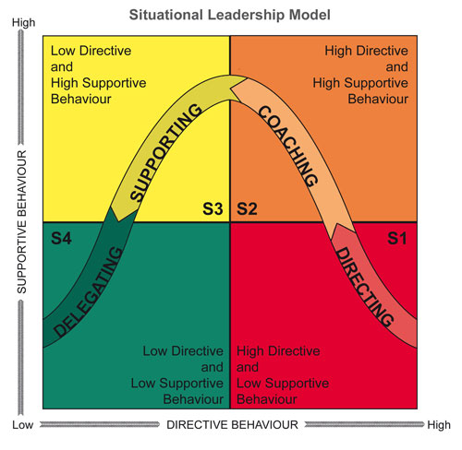
Fig.1 Source: https://www.selfawareness.org.uk/news/situational-leadership-and-developing-great-teams
Another approach on leadership that I studied is the transformational or creative leadership. This “emphasis on generating a vision for the organisation and the leader’s ability to appeal to higher ideals and values of followers, and creating a feeling of justice, loyalty and trust” (Mullins and McLean, 2019, p.350). This leadership approach is focused on long-term changes within an organisation and encourages professional development of the employees.
During my professional life and brief academic studies, I encountered and was introduced to several historical and contemporary approaches to management. Starting with Frederick Taylor scientific approach and Henry Fayol division of labour approach, that were more concerned with productivity and performance, we can see a shift in management approaches with Elton Mayo’s Hawthorne experiment, that looked more into the employee satisfaction and working conditions to improve performance. My personal experiences have taught me that managers usually must find a balance between achieving organisational objectives and dealing with individual factors that affect employees at work.

Leadership and Management within Nike Inc.
During my research on the subject, I found that at Nike Inc., Mark Parker has served as CEO for 14 years (2006-2020) and is currently occupying the executive chairman position (Nike Inc., 2021). During his time as CEO, Parker adopted a transformational leadership style that focused on engagement of the employee and on enhancement of their creativity and innovation skills. Parker used this concept to empower and develop the skills of young workers, to gain a long-term strategic advantage over rivals, by having capable and professional personnel. He also restructured the company by organising it on specific departments that were more customer-focused, and he encouraged the innovation process (Lussier & Achua, 2016).
John Donahoe is President and CEO of Nike Inc. since January 2020 and served on the Board of Directors since 2014 (Nike Inc., 2021). He has a background in technology rather than retail and sportswear and his appointment indicates that the company wishes to expand its digital approach to ecommerce especially with the effects of the pandemic that has affected many businesses. In an interview with SGB Media, he describes his leadership style as servant and states that “to me, servant leadership is all around how you serve your purpose, serve your customers, serve your teammates, and serve the communities in which you operate” (SGB Media, 2020). I consider that he will bring further changes within the company, so his leadership style can be described as transformational.
Regarding the management, Nike Inc. resides on values like lead, coach, inspire and manage their employees and teams. Their managers invest in having the right people employed on the right role and encourages strong human resource policies to build an engaged workforce (Nike Inc., 2021).

Conclusion
As a conclusion, I can say that studying this module and other modules at the university have and will improve my knowledge and skills and I feel that this will better prepare me for a future career and open further opportunities in my life. I can say that although dividing my time between work and study has been a challenge, I was able to efficiently organize my life to fit both requirements and will continue to show great interest in my studies while continue my professional work.

Factors influence team and group behaviour of Nike

Introduction
A team is a group of individuals working together to complete a single mission or complete a frequent task. The efficiency, with which a team or entity works in a company, has a significant impact on the company's performance. The role of a team is especially important in the product sector, where consumers are in constant contact with the product. Customers are satisfied when the team and group behave perfectly because when team and group behave perfectly, quality products will be produced as well, as innovative products will be produced that demand the customers (Hackman and Katz, 2016). At the same time, mediocre team and group behaviour result in the disappointment of the customers. Nike is a world-renowned footwear company. The company has achieved success because of its effective team and group behaviour that the organization always gives great importance on. In this reflective report, I will discuss factors that influence the effective team and group behaviour under the perspective of Nike.

Description
Before creating a collaborative team and group, an organization must weigh several factors. If these considerations are taken into account, the organization will be effective in forming a team. I learned from this assignment that Nike is a well-known company that has focused on some aspects of team creation. These considerations help Nike to become progress. These factors seem quite interesting and fascinating to me.
Team role: Team role has a significant effect on team and company activity because if workers who are specialized in a certain area are not given work that suits their standards, they will be dissatisfied and therefore will not function to their full potential. Their inspiration greatly influences the employee's actions. For example: By following Belbin's team role, this organization offers marketing activities to employees who have strong knowledge of marketing. Then it will be a task as usual for them. However, if management rewards individual employee success and team commitment, all workers' output will influence. The organization offers a bonus to each organization's team if they can fulfil their dedicated tasks properly. Norms are a significant factor that affects team and organization behaviour. If staff members do not obey the team's instructions and regulations, they will act in their manner, and there will be no control in the organization, resulting in poor results. To establish the norms in the organization, the authority has kept punishment provisions in the organization. If an employee does not follow the proper order of the organization, then according to the degree, management takes steps against that employee.
Finally, one of the most important factors influencing team performance and competitiveness is team cohesiveness. Effective teams are made up of partners who work well together. Cohesion within the community does not happen overnight, and it takes time to build. If there aren't enough people on the team, the cohesion will suffer, and there will be tensions among the members. For this reason, the employees who are related to manufacturing tasks must have experience of over three years (Courses.lumenlearning.com, 2021).
During this mission, I had difficulty establishing a connection between these factors and how they affect the organization's team and group behaviour because these factors are difficult to analyze in terms of Nike’s team and group conduct, and there are so many issues within them that choosing the most relevant factors is difficult for me. Then, to overcome these problems, I have done extensive research work, which will help me select the right method for the organization.
When I form a team and group for an organization, I will consider these topics because they significantly impact the performance of the company. For example, when I'm deciding on team assignments or which workers will be responsible for which tasks. When I choose a worker for the agency, I would strictly adhere to Belbin's team role model. I'll assign tasks to workers who are experts in the field. Then, while encouraging the workers, I will use Herzberg's two-factor philosophy, in which I will include the requisite items for finishing the mission while still providing incentive elements such as rewards for individual success and performance bonuses for team and group performance. I would inform them of these motivating aspects before beginning the assignment to be still inspired to complete it. Following that, I would emphasize the relevance of the team's rules and instructions. If an employee refuses to obey the team's rules and procedures, he or she will be disciplined according to organization policies, and I will plan a disciple incentive to encourage staff to follow the simple rules. Then I'll choose the best person for the job as a team and community manager. And if I choose the wrong person as a team and community member, such as someone hostile, moody, and impolite, the organization's entire team connection would suffer.

Conclusion
These are the reasons that influence the team's success; however, external factors influence the team's success. Nike has balanced combination of all of these factors successfully. This has helped Nike to achieve success so fast. I have investigated some intractable problems and have tried to find ways to minimize their effect within the organization. I found that although team leaders have a significant impact on the team's performance, if the team leaders are not welcoming, the staff would not feel the ease working with them. Even though all of the factors are met, the teamwork would eventually be in vain without an efficient leader. I'll take care of those matters with utmost care when I become a leader.

Motivation and Perception
From the research made, on my attempt to cover some of this topic, I found that Nike Inc. motivates their employees in different ways through involvement and personalization and found links of this to some approaches and motivational theories. They use the Maslow Hierarchy of needs and to fulfil this theory Nike Inc. has established an inspection Team that measures the overall performance of the company towards employees, by including health and safety needs. They also provide measures and procedures so that the employees feel protected at work. They seek new ideas from every level of management and rewards the employees to make them feel more involved and the more people are involved, the more they identify with the company values. From my personal experience I can say that how companies motivate and engage their employees represents an important part when we look at organisational performance. If companies have good strategies for motivating its people, either by offering them more physical rewards or by encouraging personal and professional development, this will help the companies to achieve better results than competitors. Nike Inc. not only encourages its employees to develop professionally but also offers them, or some of them, incentives like health insurance, paid holidays and vacations, tuition reimbursement and access to fitness sites (Nike Inc., 2021). When I speak of what this company does to motivate its employees, I should also mention those measures are not enough to keep your people motivated. How they perceive these measures taken to motivate them is as well important. If some employees do not perceive the motivation accordingly, they might not be motivated to perform.

References
Apricot Training Management Ltd., 2013. Selfawareness. [Online]
Available at: https://www.selfawareness.org.uk/news/situational-leadership-and-developing-great-teams
[Accessed 10 4 2021].
Armstrong, M., 2016. Armstrong's Handbook of Management and Leadership. 4th ed. London: Kogan Page.
Buchanan, D. A. & Huczynski, A. A., 2017. Organizational Behaviour. 9th ed. Harlow: Pearson.
Buchanan, D. A. & Huczynski, A. A., 2019. HucBuc Organizational Behaviour. 10th ed. Harlow: Pearson.
Courses.lumenlearning.com, 2021. Factors Influencing Team Performance | Boundless Management. [Online] Courses.lumenlearning.com. Available at: <https://courses.lumenlearning.com/boundless-management/chapter/factors-influencing-team-performance/> [Accessed 6 May 2021].
Hackman, J. and Katz, N., 2016. Group Behaviour and Performance. Handbook of Social Psychology.
Lussier, R. N. & Achua, C. F., 2016. Leadership: Theory, Application & Skill Development. 6th ed. Andover: Cengage Learning.
Mullins, L. J. & McLean, J. E., 2019. Organisational Behaviour in the Workplace. 12th ed. Harlow: Pearson.
Nike Inc., 2021. About Nike-Executives. [Online]
Available at: https://about.nike.com/pages/executives
[Accessed 11 04 2021].
Nike Inc., 2021. Benefits Nike. [Online]
Available at: https://jobs.nike.com/benefits
[Accessed 06 05 2021].
Nike Inc., 2021. Nike Purpose. [Online]
Available at: https://purpose.nike.com/human-resources-management
[Accessed 18 04 2021].
Rodisel,J.(2016)http://panmore.com/nike-inc-organizational-structure-characteristics-analysis
Rodisel,J.(2016)https://www.slideshare.net/JeffreyRodisel/nikes-organizational-culture-rodisel
SGB Media, 2020. SGB Executive. [Online]
Available at: https://sgbonline.com/never-stand-still-nikes-ceo-discusses-leadership-with-paypal-ceo-dan-schulman/
[Accessed 16 04 2021].

Appendix

Slide 1
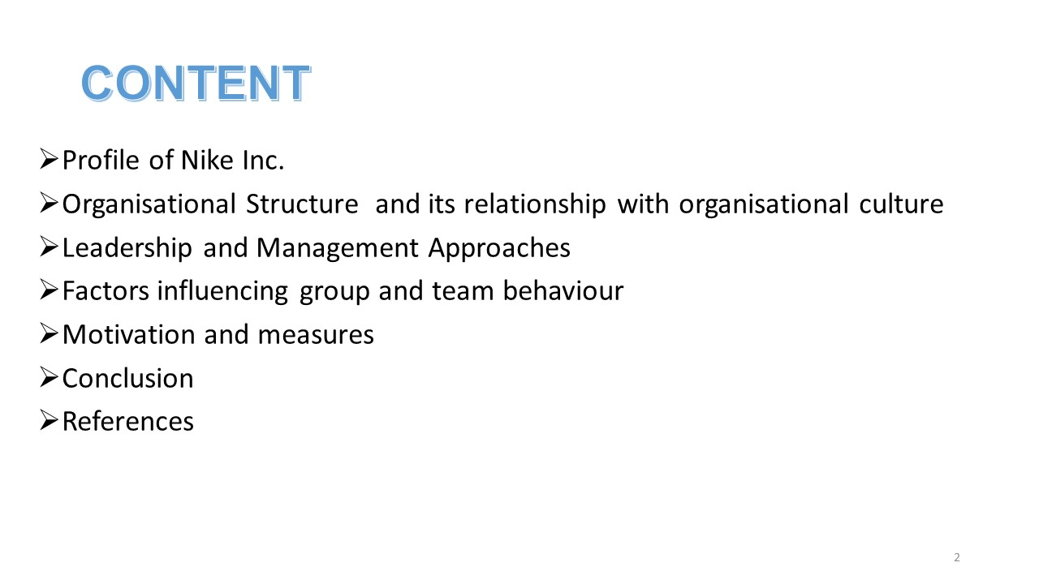
Slide 2
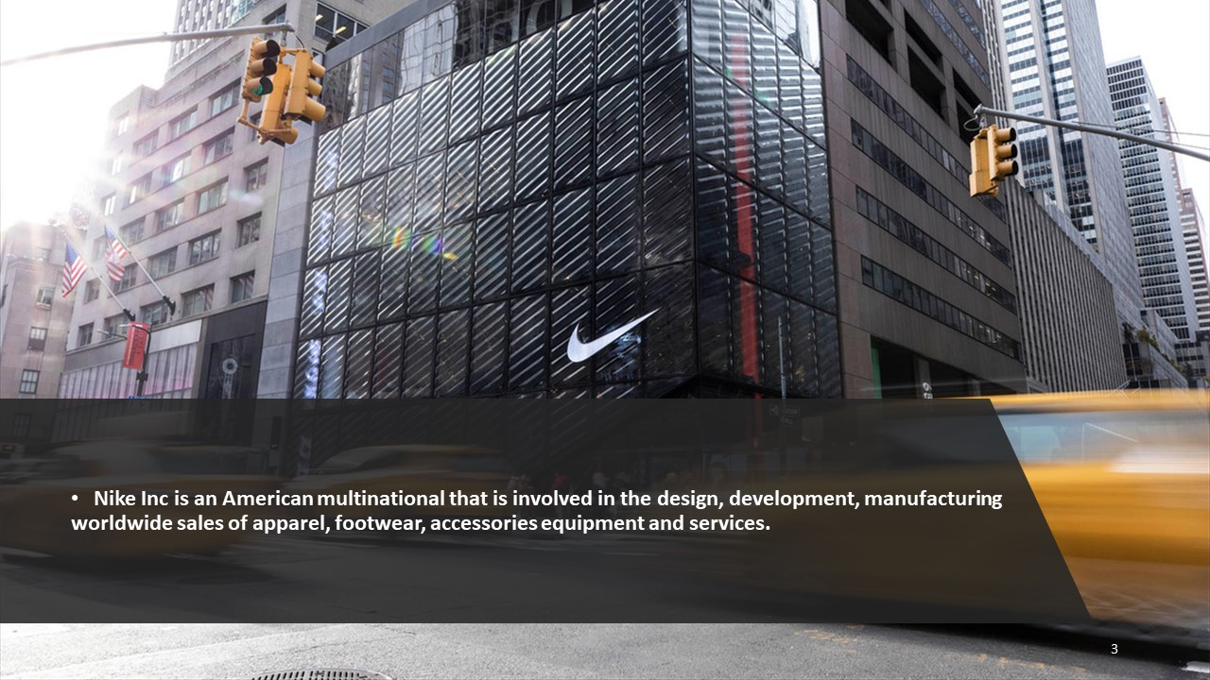
Slide 3
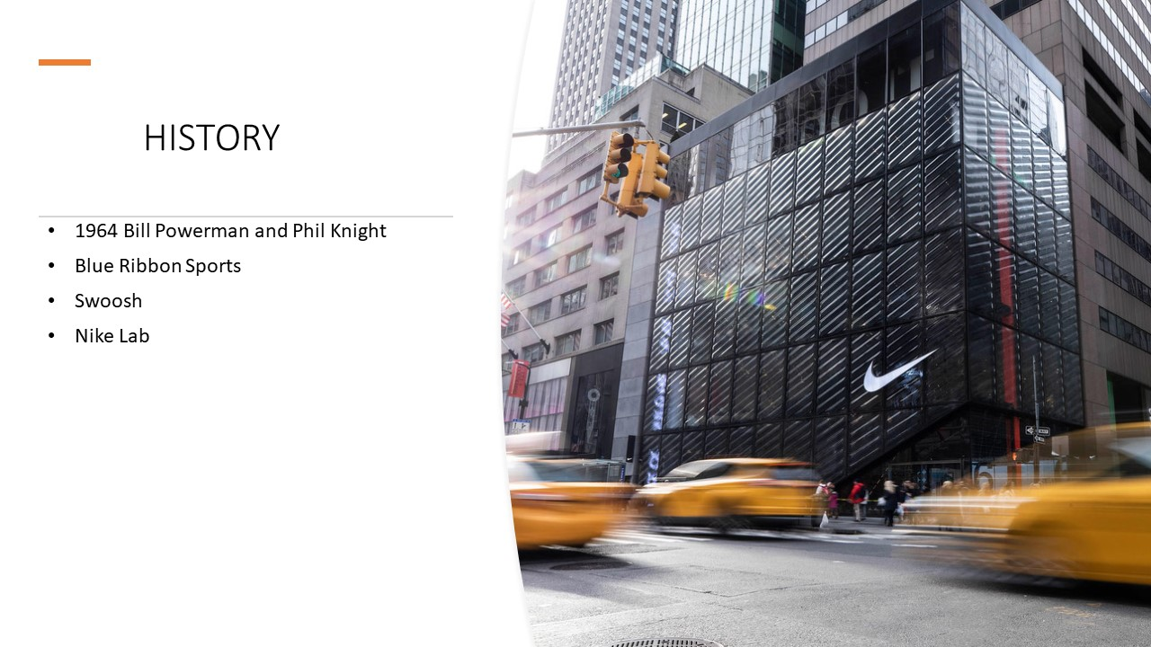
Slide 4
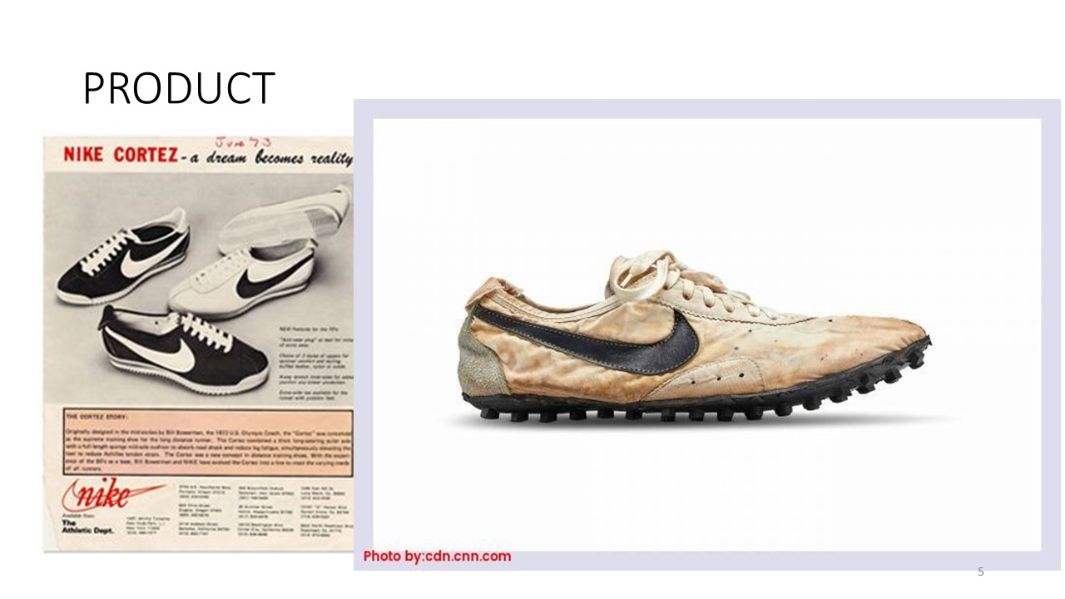
Slide 5
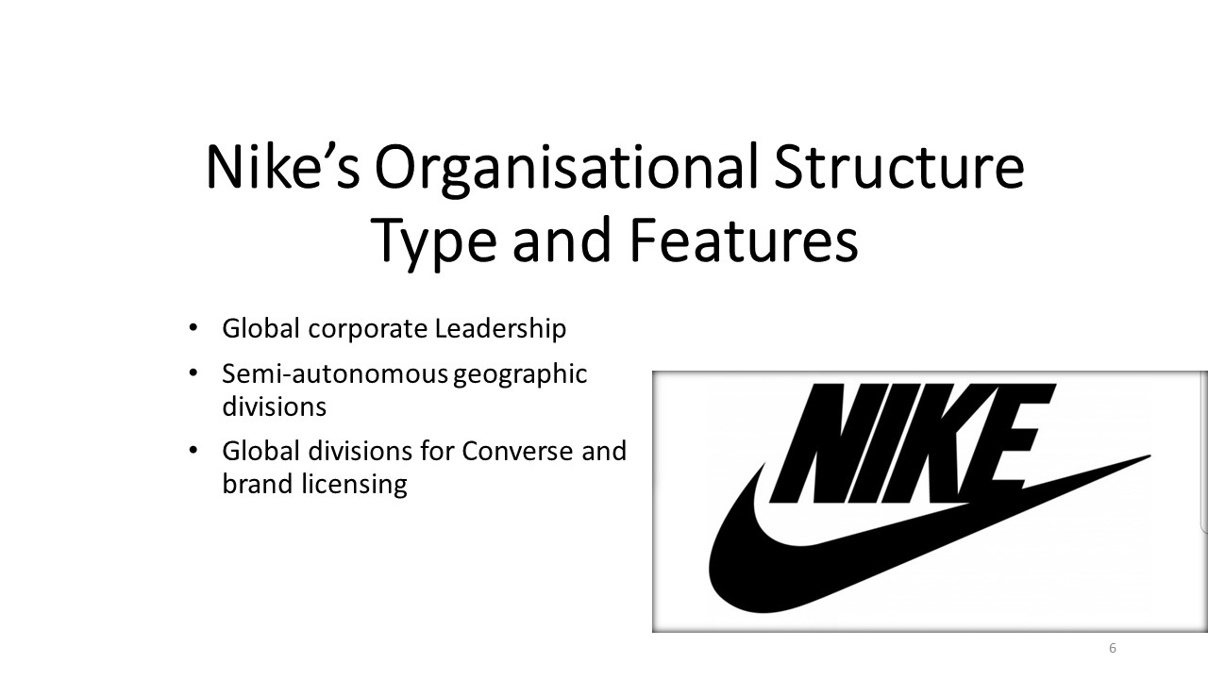
Slide 6
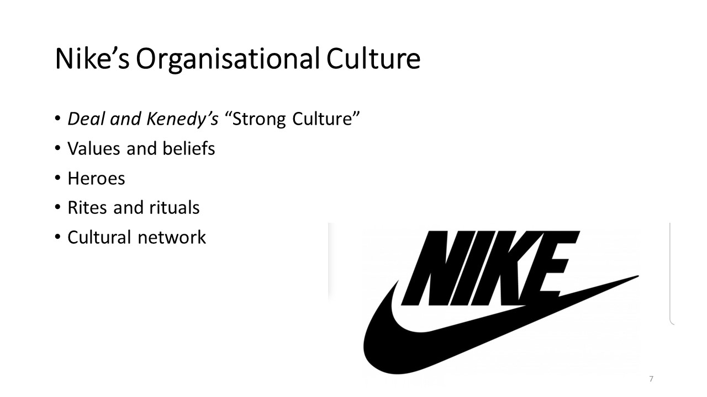
Slide 7
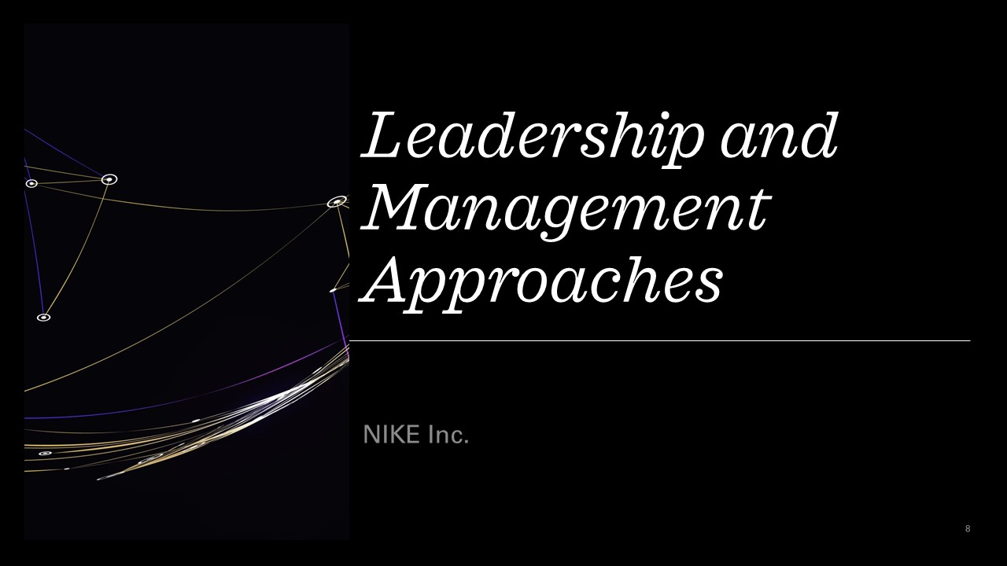
Slide 8
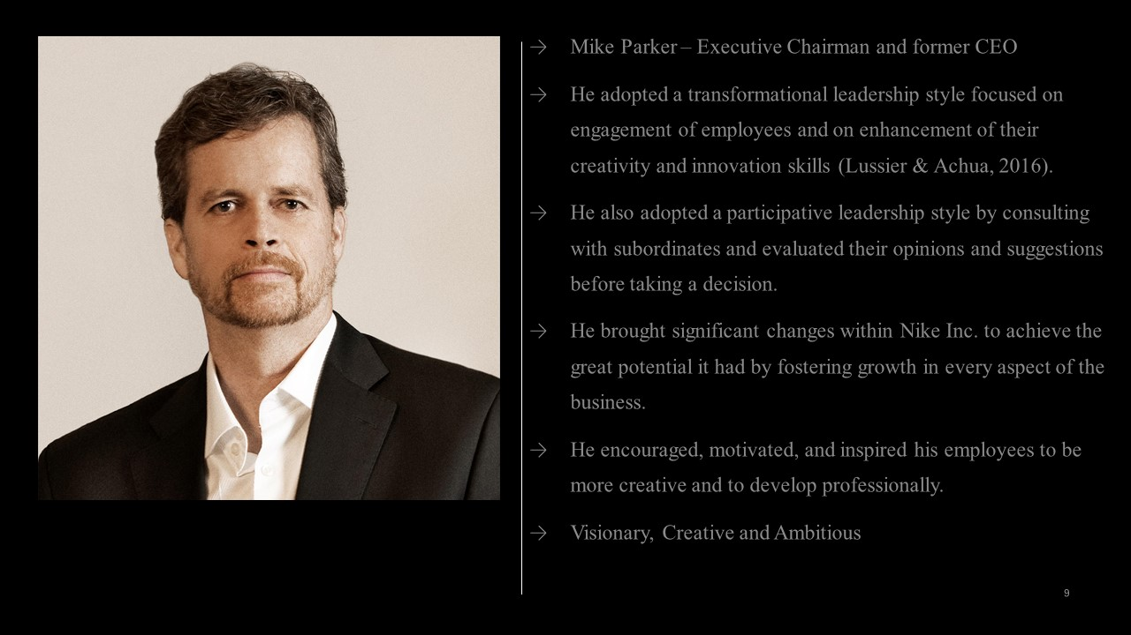
Slide 9
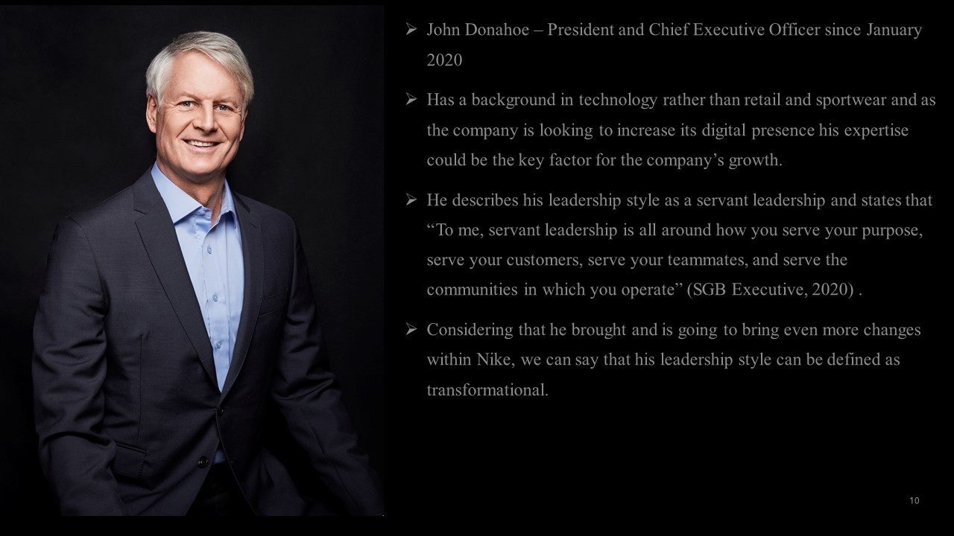
Slide 10
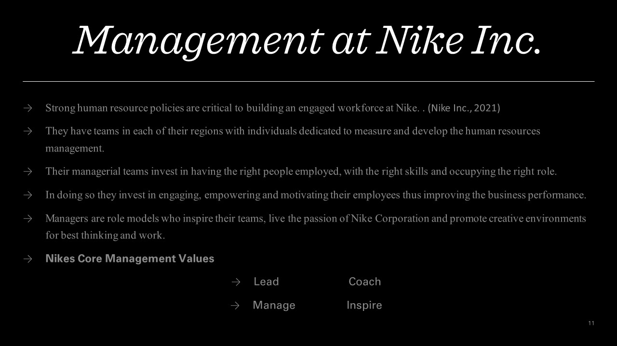
Slide 11

Slide 12
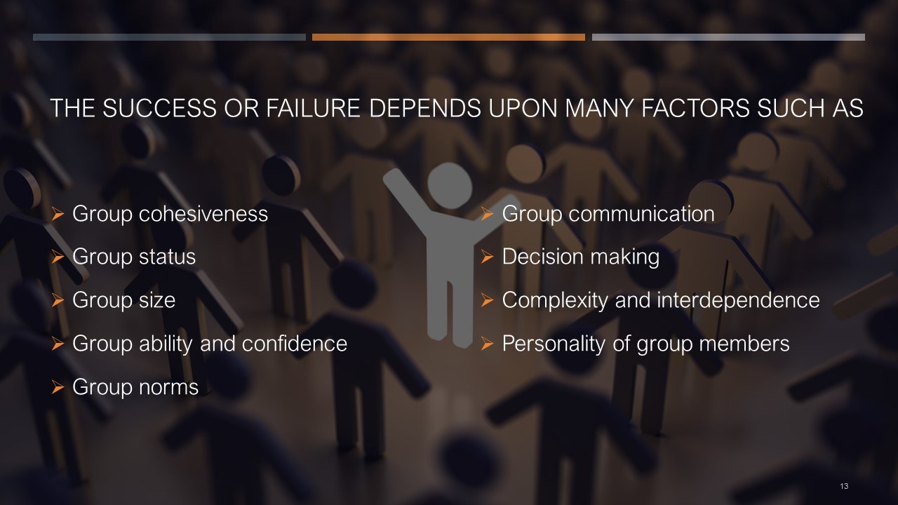
Slide 13
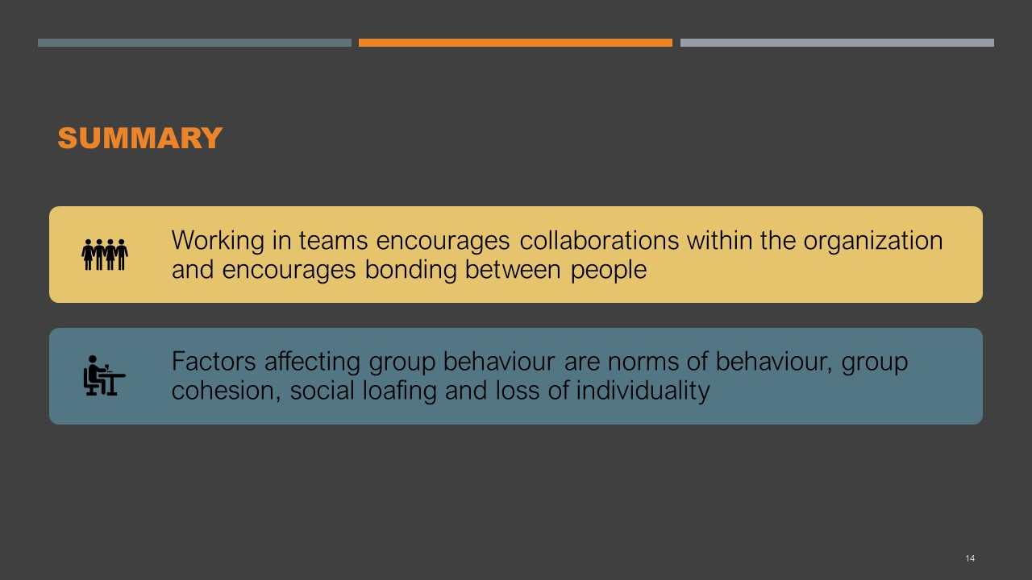
Slide 14
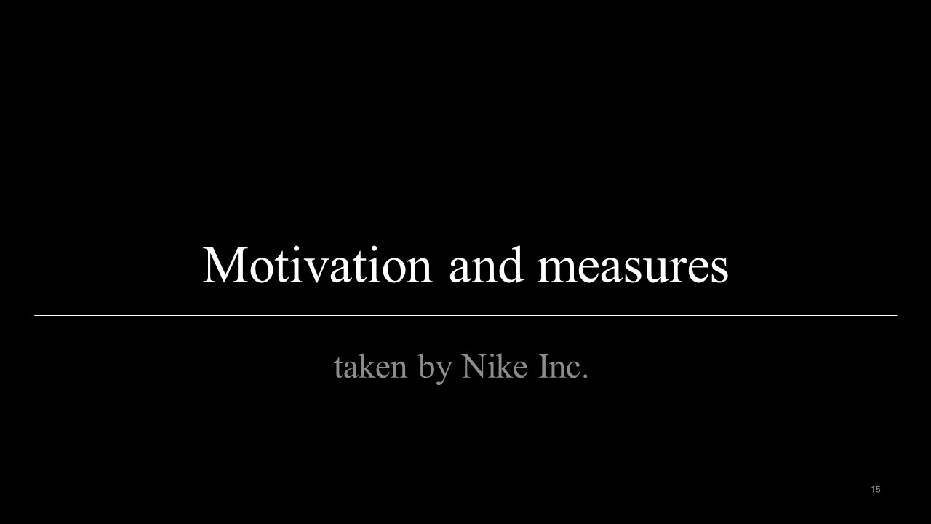
Slide 15
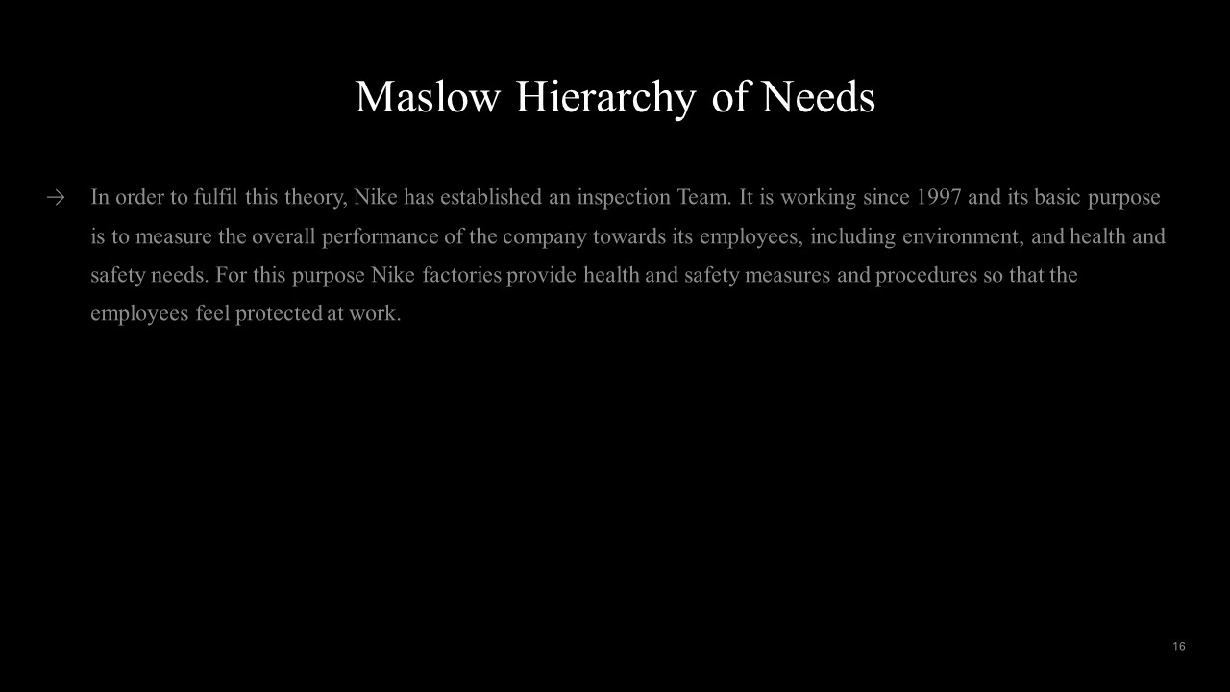
Slide 16
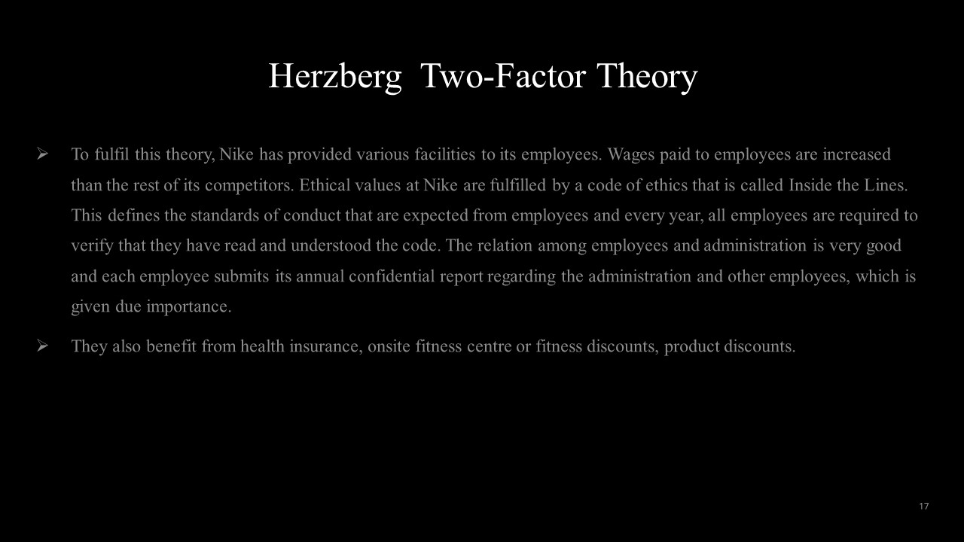
Slide 17
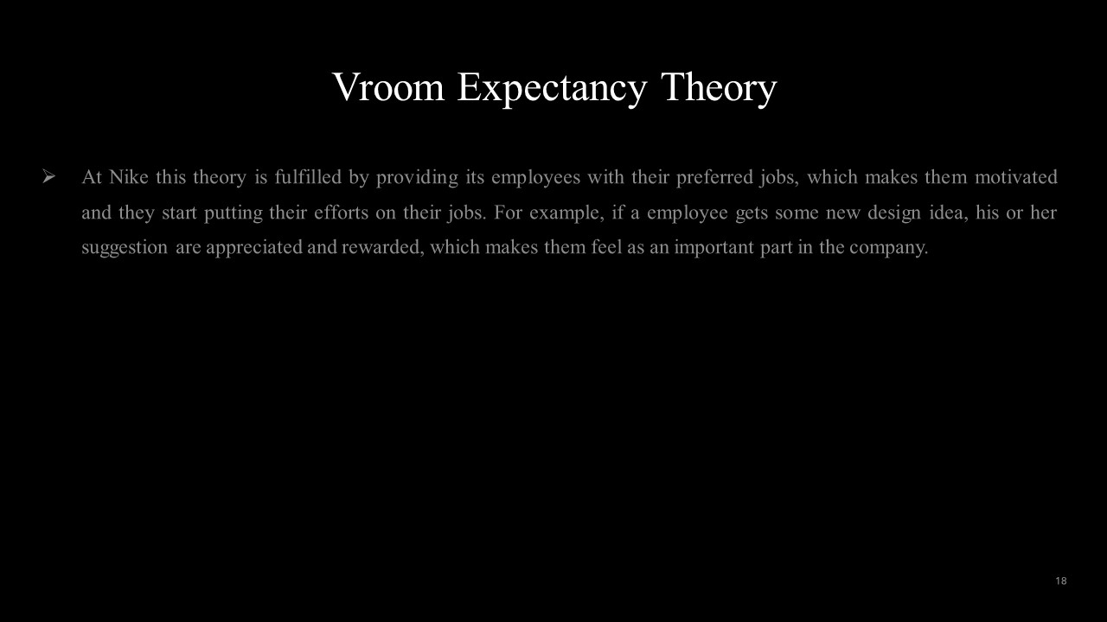
Slide 18
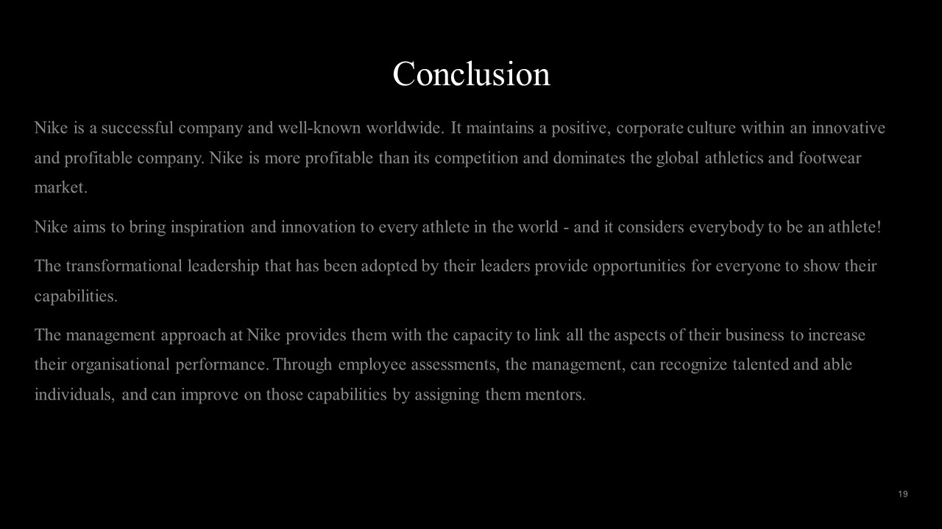
Slide 19
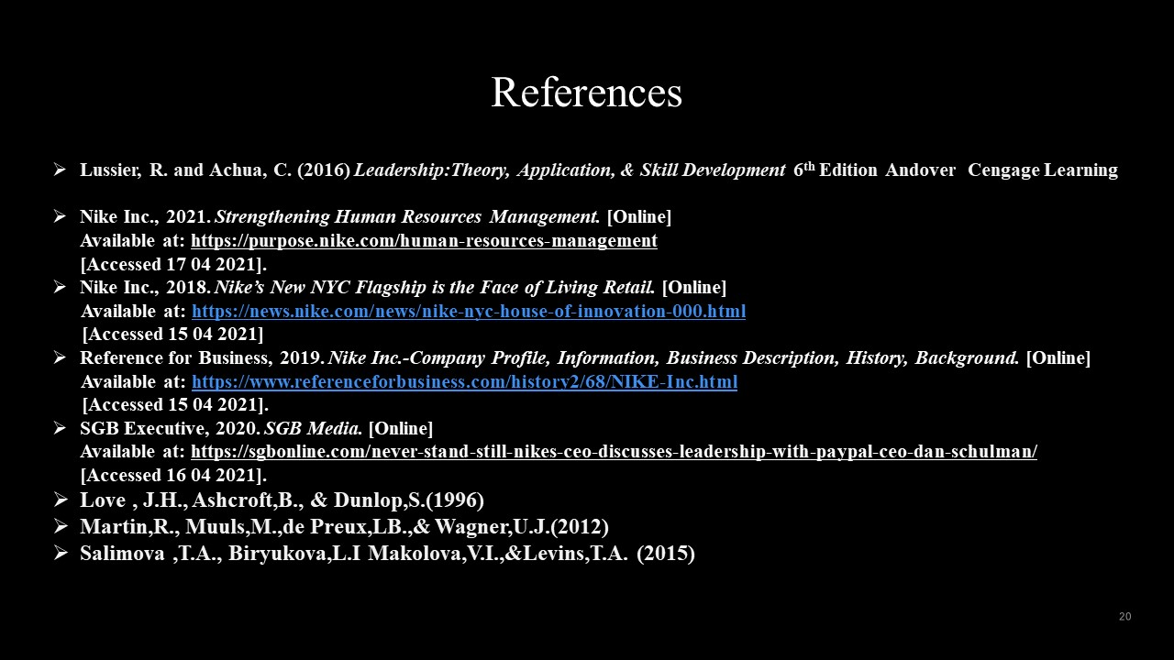
Slide 20

