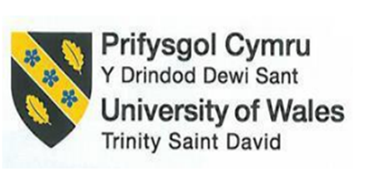

Module Title: Foreign Languages & Cultural Awareness
Programme: BA International Hotel Management
Name: Oana-Andreea Puscuta
ID number: 2232738
Module code: BMIH5003
Lecturer: Giulia Chifari, Antoinette Milne
Assignment Title: Portfolio 4 components

Component 1: Professional Reflection
An experience I gained while working at the Hilton Garden Inn in Doncaster, United Kingdom, explained a situation that demonstrated how uncommon cultural differences between customers and the F&B industry may go unnoticed. More precisely, I will retain the moment in my memory. During the morning, while working as a hostess in a hotel restaurant, a French national visitor confronted me regarding a cultural conflict. A family of two questioned about the executive accommodation at the Hilton Garden Inn. Although they were cordial towards me, our only interaction was a glass of ice-cold water, as I was unable to communicate through the language barrier. At a time when their language was their vernacular, all I could recall was its extraterrestrial existence. Upon my arrival at his table, the gort requested that I "kindly present a black café." I successfully processed the order information despite my uncertainty regarding its benevolence. Always aiming for the exit, it was nearly impossible for me to do so without offering them coffee, which was typically black but to which I was witnessing a variety of reactions regarding my coffee service abilities. This ultimately incited his second, more vociferous request, at which point he bellowed, "Un café noir!" This gave me the impression that the consumer was scheduled to consume plain coffee, not the varieties with milk and sugar. Cultural misunderstandings may result from various communication strategies and assumptions regarding the service, all of which are influenced by language barriers.
In French culture, for instance, the differences between coffee brands are referred to by various names and are not categorised in the same way as they are in other cultures. In contrast, the United Kingdom is an exception to this rule in that the term "coffee" is predominantly applied to cold coffee. Moreover, they might exhibit their unique dining customs and cultural background, which could potentially influence the perception of the British populace and their own way of life. My difficulties appeared as a result of misinterpreting the guest's request, which was exacerbated by my limited proficiency in the French language and the prevailing cultural perspective on coffee. Upon reflection of the experience, I endeavour to recognise certain facets that necessitate further refinement. Addressing these areas for improvement will prevent me from creating an environment that is conducive to further misunderstandings. Despite my best efforts, I must exert even greater effort in order to improve my language proficiency. The undertaking of comprehending the language proficiency of every hotel guest is an unattainable one. It is preferable to select languages that are frequently spoken by the majority of visitors, such as French (Batat, 2021). It will greatly simplify user communication. According to the study (Bavik, 2016), exceptional outcomes are observed when the staff possesses only a limited command of the visitor's language. This undoubtedly contributes to guest satisfaction. Firstly, getting acquainted and being culturally intelligent (CQ) are also critical. Besides the fact that cultural intelligent – having in mind about foreign cultures and their values – can be a support in dealing with customers who are of different cultural backgrounds (Taylor, 2020). There is majority of gaining skills in regard to rules and regulations in place (e. g. dietary considerations and table manners) related to the food and beverage services. For a definite outcome, do not only increase the power of listening.

Component 2: Training Plan
Introduction:
At the core of their business is the Hilton Garden Inn Doncaster's commitment to provide guests from many ethnic backgrounds outstanding hospitality. In spite of this, careful consideration has highlighted areas in which we still need to learn more about other cultures in order to ensure that each visitor is treated with respect and a sense of belonging. Action must be taken, and that action is to create a training programme with the goal of ensuring that each team member is culturally competent.
Objectives:

Figure 1 Importance of Hospitality Sector
- To broaden the knowledge of workers about the diversity of cultures which becomes a core element of the guests' experience.
- To ensure that the staff have the necessary skills to interact with the clients from various cultural backgrounds comfortably (Roque and Ramos, 2019).
- To create an ambiance where the cultural differences are observed and viewed in a positive manner.
- To avoid cultural misconceptions and get enthusiastic customers to satisfy.
Training Components:

Figure 2 Types of Training in Hospitality Sector
Cultural Awareness Workshops:
- We will conduct the workshops run by culture communication specialists that are devoted to raising awareness of cultural diversity as one of the crucial aspects of the hospitality industry.
- Staff will be trained on proper ways of conduct or custom of different cultures, which they will learn along with specific practices related to our diverse clientele.
- The workshops will include participants in interactive activities, case studies and role-playing simulators that aid you in understanding and help you to become an participant of the learning.
Language Training:
- One of the most crucial elements of successful communication amongst visitors with various language backgrounds is language competency.
- It is believed that offering French as well as other languages will help staff members interact with guests effectively and confidently.
- To accommodate varying learning styles, language instruction can be customised through online courses, language exchange programmes, and language immersion experiences (Tracey and Swart, 2020).
Cultural Sensitivity Training:
- The personnel would receive a cultural awareness program the main topic of that program is identifying cultural differences and respecting that.
- Modules will focus on the aspects such as non-verbal communications, gestures and cultural matters to be useful for employees’ interactions with foreign visitors (Sharma et., 2019).
- Role-playing scenes and real-life case studies will be involved to create a work environment by resolving practical problems.
Guest Feedback and Reflection:
- Regular sessions of feedback will be conducted to get information from the employees about how they deal with guests having different cultural backgrounds.
- Team members will be trained to speak of roadblocks, victories and insights they have, resulting in an inclined work environment created by constant development and reflection.
- Feedback will be used to improve training initiatives and design diagnostics for different clients to serve their different needs.
Conclusion:
The thorough training programme offered by Hilton Garden Inn Doncaster will increase staff members' proficiency with cultural issues in an effort to foster an inclusive workplace where each and every guest is valued and respected. Along with continuing to provide reflections, we will be accomplishing the learning objectives of cultural sensitivity, language proficiency, and cultural awareness seminars. All of the knowledge required for our team to carry out the cross-cultural contacts in a meaningful way will be provided.

Component 3: Student Self-Reflection
Gibbs Reflective Model
- Introduction:
Because of the fluctuating changes of hospitality industry it must also address cultural aspects to be seen on the same level as the preferred communication and operational practices. This reflection through Gibbs's reflection showing the path for cultural awareness will be demonstrated in the hospitality sector. Throughout a number of episodes I learnt to associate cultural sensitivity with essential characteristic.
- Description:
In the very first step of my journey, I had some imprecise opinion of cultural awareness mainly related to the hospitality industry. Moreover, intercultural interaction and experiencing the same at term allowed me to have a deeper understanding of the cultural aspect. This is when I spent an exceptional evening at a conference where we came to know that preferences vary from one people to another. Consequently, I had to face hidden indication of norms and values on a daily basis in the course of delivering my provision of services.
- Feelings:
The beginning acted as the arena for the exchange of differing views and cultures which translated to the initial moments of anxiety and saved from the nuances of my own culture. Fear of potentially, if by chance, commit something rude in non-native culture was always going in my mind. However, turning every discussion into a teaching opportunity eventually placed me in contact with other cultures and made me meet my fear of being different for acceptance of people of various backgrounds. Definitely, my freshmen year of college was an intricate learning process for me as I grew.
- Evaluation:
I found out that cultural knowledge in hospitality sector as well as the readiness of the workers operation directly affect I enjoy the job and not only that but it also results to increased satisfaction of the guests and lastly organisational success. Few learnings from orevious experiences enabled process the idea of cultural dimensions, which then led to the understanding that the guests have different expectations as well as whether they consider communication liked away or brush to the point.
- Analysis:
Upon an emotional reflection about the ways I’ve learned, I acknowledge the experiential education, which helps me to develop the awareness regarding diversity in an individual. On the other hand, this resulted in rhythms of immersion in a cultural exchange atmosphere in forms of cultural setting application or cross-cultural training programs which provided me with insight of cultural diversity complex (Ionel, 2016). Alongside having a major boost in my cultural horizons and the extremes of them, I got a taste of how to come up with making my way while encountering the ambiguous environment in nighttime.
- Conclusion:
Therefore, I gathered through the perception of cultural sensitization that will be a catalyst to achieving harmony with my colleagues in the hotel sector. Consequently, the process does not seem to come to an end and I view it as a regular daily educational and self-finding experience which, in its totality, is a problem of cultural awareness development as ethos-building in a global and hospitality context.

- Action Plan:
Continuous Learning and Development: Always try to engage in the educational means that will shape the understanding of what is crucial in the cultural aspects of tourism (Wood, 2015). Tactics that I use like classes or seminars or getting information from appropriate literature can keep me updated in the field.
Cultural Immersion Experiences: It is possible to increase significantly the opportunities of getting acquainted with other cultural milieus even within their country and while being abroad (Kansakar et al., 2019). In contrast for example these may include the endeavors in cultural diploma programs, volunteering to multicultural organizations among others or visiting the cultural heritage sites that have strong history.

Component 4: Presentation
Slide 1: Foreign languages
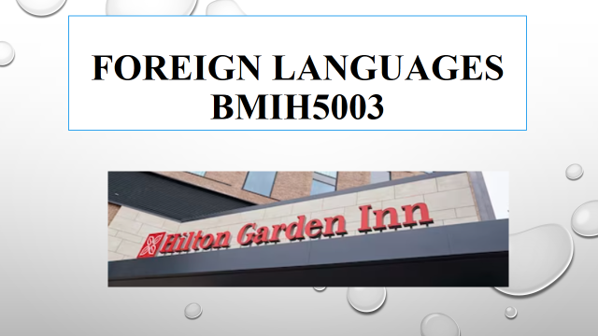
Slide 2: Benefits of multilingualism
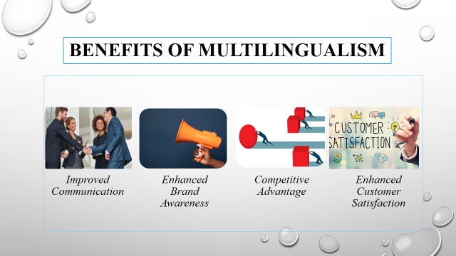
People who work in hotels and speak more than one language are better able to meet the needs of guests from a wide range of cultures (Sann and Lai, 2021). It is easier for guests to understand the hotel's services, requests will be met faster, and the check-in process will be streamlined. If the hotel staff speaks the guests' original language, it can help them with any problems or issues that come up. This led to faster settlement and happy guests. Staff members who speak more than one language make guests from around the world feel welcome. They are a great example of the hotel's commitment to diversity and inclusion. The hotel's name and company image are better when guests have a good time and want to tell others about it (Mantra et al., 2020). Multilingual hotel workers are more likely to cater to each guest's specific tastes and make suggestions that are sensitive to their cultural background. This makes the already excellent service rate even higher.
In today's globally connected economy, hotels are under more and more pressure to meet the needs of a wide range of guests. Having workers who speak more than one language makes it more likely that customers will come back and give good feedback. Guests can get frustrated and mistake things because of language obstacles (Lam et al., 2022). Customers are happier when employees can speak more than one language because they can better meet their needs by talking to them in a clear and straight way. Staff members who speak more than one language can better understand what their clients want, make suggestions that fit each person's tastes, and help them make experiences that last a lifetime.

Slide 3: Importance of language awareness skills for hotel staff

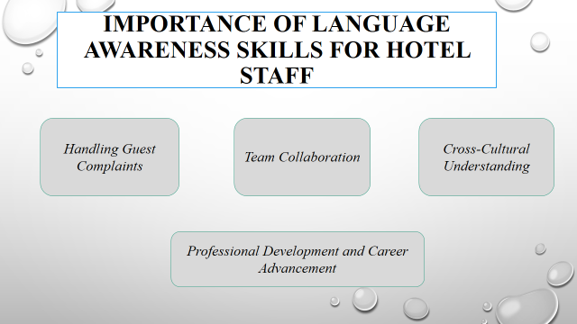
As a hotel worker, it is important to be able to get along with others and understand and solve customer problems. When employees speak more than one language, they can handle sensitive situations with more ease and skill, which makes it less likely that there will be mistakes or disagreements. The ability of hotel staff to talk to each other is very important to the business's growth. Being multilingual makes it easier for teams to talk to each other, which speeds up work and makes it better (Nguyen et al., 2022). Cultural awareness and friendlier interactions happen when staff members speak more than one language and can understand subtle cultural differences and change how they communicate to people to fit those differences. If people who work in hotels want to move up in the company, they should improve their speaking skills. People who speak more than one language might find it easier to get jobs in fields that value speaking skills a lot, like sales, customer service, and management.

Slide 4: Modern European language
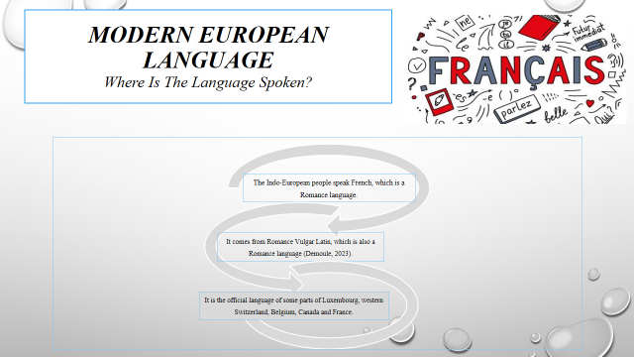
Slide 5:
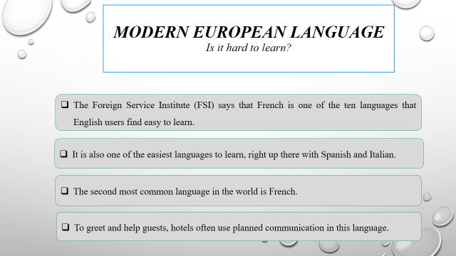
Slide 6:
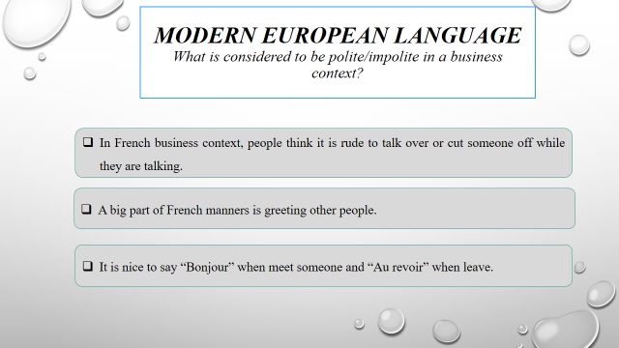
Slide 7: References
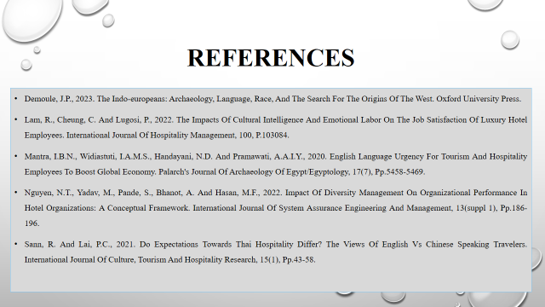

References
Taylor, A., 2020. Domopolitics, Citizenship and Dissent: An Analysis of ‘Crimes of Solidarity’and Hospitality in Contemporary France. International Journal of Politics, Culture, and Society, 33(4), pp.495-512.
Bavik, A., 2016. Developing a new hospitality industry organizational culture scale. International Journal of Hospitality Management, 58, pp.44-55.
Batat, W., 2021. The role of luxury gastronomy in culinary tourism: An ethnographic study of Michelin‐Starred restaurants in France. International Journal of Tourism Research, 23(2), pp.150-163.
Roque, H.C. and Ramos, M., 2019. The importance of cultural training in the hospitality sector. European Journal of Tourism, Hospitality and Recreation, 9(2), pp.58-67.
Tracey, B. and Swart, M.P., 2020. Training and development research in tourism and hospitality: a perspective paper. Tourism review, 75(1), pp.256-259.
Sharma, A., Zsarnoczky, M. and Dunay, A., 2019. The Professional and Economic Development of Individuals with Disabilities in the Hospitality Sector with a Focus on the Importance of Training and Skill Enhancement at all levels: Hungarian Perspective. Littera Scripta, p.127
Wood, R.C. ed., 2015. Hospitality management: a brief introduction. Sage.
Ionel, M., 2016. Hospitality industry. Ovidius University Annals: Economic Sciences Series, 1(1), pp.187-191.
Kansakar, P., Munir, A. and Shabani, N., 2019. Technology in the hospitality industry: Prospects and challenges. IEEE Consumer Electronics Magazine, 8(3), pp.60-65.

Demoule, J.P., 2023. The Indo-Europeans: Archaeology, Language, Race, and the Search for the Origins of the West. Oxford University Press.
Lam, R., Cheung, C. and Lugosi, P., 2022. The impacts of cultural intelligence and emotional labor on the job satisfaction of luxury hotel employees. International Journal of Hospitality Management, 100, p.103084.
Mantra, I.B.N., Widiastuti, I.A.M.S., Handayani, N.D. and Pramawati, A.A.I.Y., 2020. English Language urgency for tourism and hospitality employees to boost global economy. PalArch's Journal of Archaeology of Egypt/Egyptology, 17(7), pp.5458-5469.
Nguyen, N.T., Yadav, M., Pande, S., Bhanot, A. and Hasan, M.F., 2022. Impact of diversity management on organizational performance in hotel organizations: a conceptual framework. International Journal of System Assurance Engineering and Management, 13(Suppl 1), pp.186-196.
Sann, R. and Lai, P.C., 2021. Do expectations towards Thai hospitality differ? The views of English vs Chinese speaking travelers. International Journal of Culture, Tourism and Hospitality Research, 15(1), pp.43-58.

