Student Name: Cristina Tudureanu
Student number: 1917153
Programme: BA Business Management
Module: International Business Communications
Module code: LCBB6001
Lecturer’s name: Zainab Atta
Assignment tittle: Assignment 2/ Individual assignment

INTERNATIONAL BUSINESS COMMUNICATION
Compass Group PLC Report
Assessment 2

Table of contents

- Introduction………………………………………………………………………..…3
- International Business Communication importance…………………………..…3
- Compass company overview………………………………………………..……..4

- India. Country overview………………………………………………………….....5
- International and intercultural communication. Hofstede theory. Analysis…....6
- Cultural sensitivity. Critical evaluation……………………………………………11
- Importance of networking………………………………………………………….11
- Communication barriers experienced by businesses in India…………………12
- Recommendations and conclusion……………………………………………….14
- References…………………………………………………………………………15

- INTRODUCTION

In today's globally interdependent society, effective international business communication has taken on more significance. You need to be able to communicate clearly and fluently with anybody you do business with or work with, no matter where they are located in the world.
This report employs Compass Group PLC as a case study of a globally mobile manufacturing organisation to examine the state of global communication in India. The cultural insights of India will be analysed using the Hofstede theory. We will also talk about the differences and similarities between British and Indian cultures, the value of making connections, and the difficulties that may arise in communicating with Indians. All of these aspects will be evaluated in order to establish communication strategies for the Compass firm and assess whether India is a good place.

- INTERNATIONAL BUSINESS COMMUNICATION IMPORTANCE
Every employee encounter, from the initial handshake to the final report, involves workplace communication. All internal and external (spoken, written, electronic) communication is included (Simon, 2022).
Information exchange is crucial for every business connection, but it's only one facet of corporate communication. Building relationships and trust are key. Improved corporate communication might boost new business, problem-solving, and morale.
Language, cultural, and technology barriers may complicate international communication. With preparation, skilled training, and cross-cultural communication knowledge, you may effectively complete foreign commercial transactions (D. Mcrill, 2019).
Communication is crucial for global trade for two reasons. It increases communication and understanding among individuals of diverse cultures. Recognize and appreciate multinational clients' and workers' cultural differences. Study their views, cultural norms, and preferred ways of communication, then adapt your approach (D. Mcrill, 2019).
In today's integrated global economy, speaking many languages is crucial. If you can't interact with potential clients in their native language, you may be abandoning possibilities for your competitors (Simon, 2022).

- COMPASS COMPANY OVERVIEW

Compass Group PLC is aptly named as the world's largest foodservice company. Vending machines, corporate catering, and the introduction of fast food chains like Burger King, KFC, Taco Bell, Pizza Hut, T.G.I. Friday's, and Harry Ramsden's are just a few examples of the many ways in which Compass Group helps make sure that students, service members, inmates, and patients never go hungry at any of the places where they may be housed. Café Ritazz, Café Select, Upper Crust, Not Just Donuts, Franks, and Sushi Q are just a few of Compass Group's successful restaurant concepts. Compass Group is a Fortune 500 company and FTSE 100 component due to its yearly revenue of more than £4.8 billion ($7.9 billion) (CompassGroup.com, 2022).

- INDIA. COUNTRY OVERVIEW

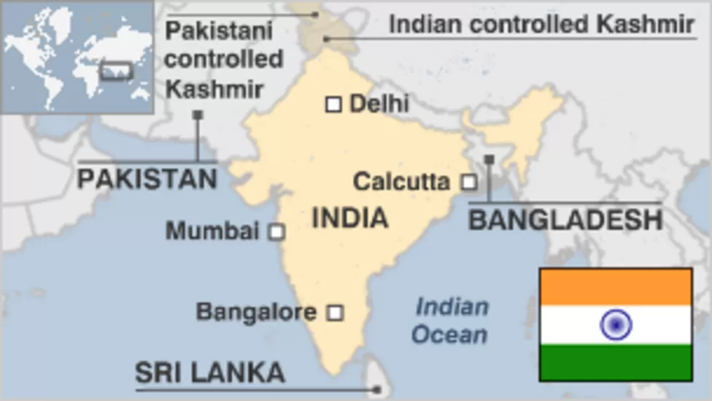
Fig.1: India on Map
Source: BBC, 2019

The people, languages, cultures, and religions of India are as diverse as the nation itself. It's difficult to make broad statements about Indian culture. There are, nevertheless, certain pointers that may help you learn about and adapt to the Indian business culture (BBC, 2019).
India is the most populous democracy in the world, and its population is expected to overtake China's by 2028. Because of its growing economy and nuclear arsenal, India is becoming a major player in the area. It also has massive social, economic, and environmental problems (J.E. Schwartzberg, 2022).
The Indian subcontinent, which stretches from the mountains of Afghanistan to the jungles of Burma and the coral reefs of the Indian Ocean, is home to some of the world's oldest civilizations.
English is one of India's official languages and is used commercially. It's spoken by many Indians and business leaders, although its meaning varies by region or culture. Indians dread being degraded if they say "no." When they mean "no," they may respond "we'll see," "yeah, but it may be difficult," or "I'll try" (BBC, 2019).
Personal ties are important in business. Indians make judgments based on trust, intuition, and data and statistics. Indian companies are hierarchical. At the end of a negotiation, decisions are taken. No meeting decisions are made without the director, owner, or senior management. Only those designated will conduct physical labour, and each individual has a defined role. In Indian culture, supervisors don't execute jobs a lower-level employee could accomplish just as well (J.E. Schwartzberg, 2022).

- INTERNATIONAL AND INTERCULTURAL COMMUNICATION. HOFSTEDE THEORY. ANALYSIS

The cultural elements proposed by Geert Hofstede provide a structure for effective international exchange. It uses a framework derived from component analysis to show how a society's culture affects individual members' values and how those values impact their actions (S. Dewiyanti, 2021).

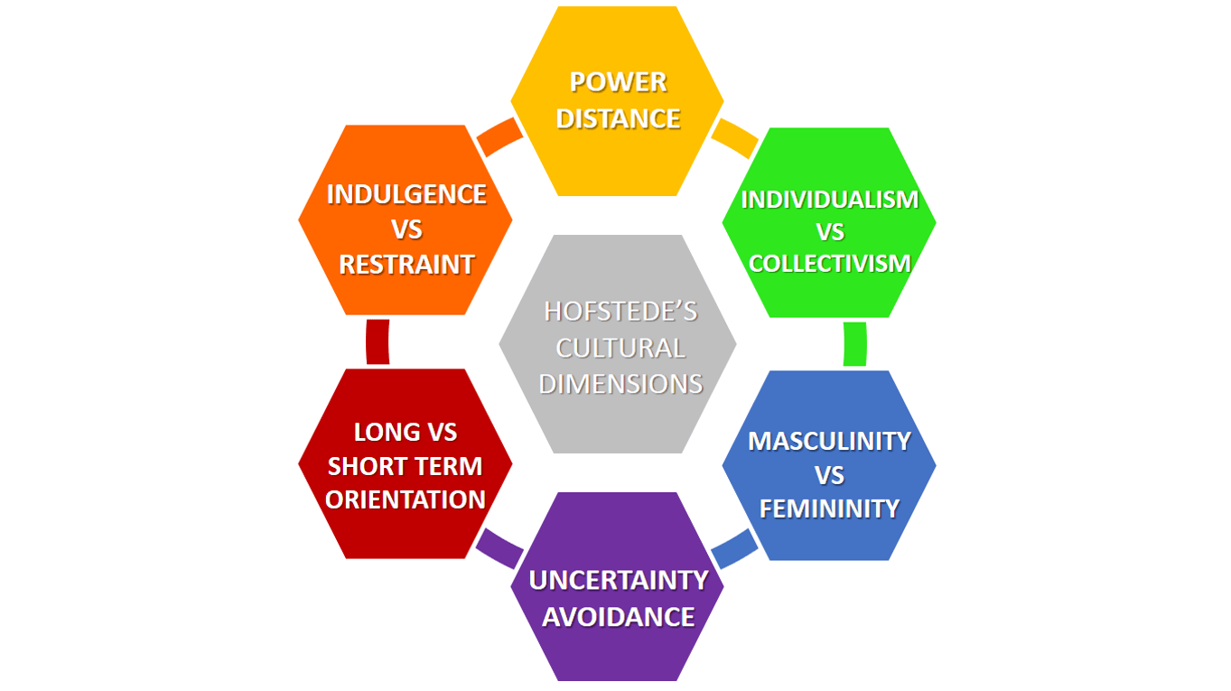
Fig.2: Hofstede’s cultural dimensions
Source: R.M. Steers, 2013

Geert Hofstede found six cultural assessment models in his research that might be used to compare different countries and cultures. The cultural aspect indicates an inclination toward one of the factors that differentiates nations (as opposed to individuals) from one another.
Individualism and collectivism, uncertainty avoidance and power distance (the intensity of social hierarchy), and masculinity and femininity were the four characteristics supplied by the original theory for analysing cultural values (task-orientation versus person-orientation). Hofstede expanded the original Hong Kong-based paradigm by adding a fifth dimension, long-term orientation, to account for value-system features that were overlooked there. Hofstede compared free-spiritedness and restraint along a sixth dimension in 2010 (S. Dewiyanti, 2021).
Researchers and consultants in many fields related to international trade and communication have drawn on Hofstede's work, which established a new line of inquiry in cross-cultural psychology (S. Dewiyanti, 2021).
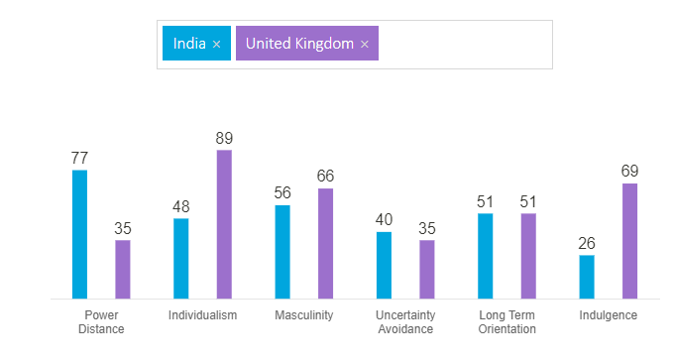
Fig.3: Hofstede model UK and India
Source: Hofstede-insights.com, 2022

POWER DISTANCE
This component reveals a culture's perception on people' different traits. "Power distance" describes how less powerful members of a society's institutions and organisations prepare for and tolerate unequal power distribution (S. Dewiyanti, 2021).
India appreciates authority and a hierarchical working system (77) The following notions describe Indian mentality: In a hierarchical organisation, employees turn to their superiors for advice, recognise that those at the top have more privileges, and can only speak with their immediate supervisors. In a paternalistic organisation, management specifies how employees should do their duties in exchange for loyalty. Despite their lack of authority, managers rely on employee subservience. Management gives employees precise instructions on how to do their jobs. Control is comforting and familiar, and supervisors are formal even if one knows them by first name. Top-down, authoritarian communication is common, and employees seldom criticise superiors (Hofstede.insights, 2022).

INDIVIDUALISM
Here, social connection is key. It's whether people refer to themselves in the first-person singular or plural. Individualists just care about themselves and their family. Collectivist societies assist members in exchange for their loyalty (S. Dewiyanti, 2021).
India has 48 collectivism and individuality. In a collectivist society, people desire to belong to a bigger social framework and perform for the in-wellbeing group's. In these situations, the opinions of one's close and extended family, neighbours, co-workers, and other social networks shape one's behaviour. Rejection from peers or being regarded inferior by in-groups might leave a collectivist feeling lost and hollow. Employer-employee relationships are based on employee loyalty and employer parental protection. In a collectivist culture, connections are key to job and promotion choices (Hofstede.insights, 2022).
Hinduism, India's major religious and philosophical tradition, is credited for fostering the country's individuality. Hindus believe in reincarnation, with each birth decided by the previous one's acts. The activities of this life affect the future incarnation. The mix of traditional collectivism and contemporary individuality gives India a mediocre ranking in this category.

MASCULINITY
If an organisation scores high (Masculine) on this dimension, its members are likely to be driven by competitiveness, accomplishment, and success. Low scores (Feminine) demonstrate care for others and quality of life. Feminine cultures respect individualism less and prioritise personal fulfilment. The main question is whether individuals are driven by competition (usually masculine) or optimism (typically feminine) (Feminine).
India's Masculinity Index is 56. India's strength and prosperity give it a macho appearance. Many people flaunt their success by wearing fancy brands and being ostentatious. India worships several gods. As one of the world's oldest cultures, there should be plenty of opportunities to learn moderation and humility. This is why people don't show more masculinity. In male-dominated society, money symbolises prosperity and achievement. Focusing on work implies prioritising career achievement (Hofstede.insights, 2022).

UNCERTAINTY AVOIDANCE
Uncertainty Avoidance measures how a society handles uncertainty. Should we affect the future or accept it? People from diverse cultures have devised coping techniques to deal with worry. Uncertainty Avoidance measures a culture's fear of the unknown and how it has shaped its worldview and institutions (S. Dewiyanti, 2021).
India has a low-to-moderate preference for clarity, scoring 40 on this criterion. India celebrates sloppiness and doesn't require precision. India is patient and tolerant, welcoming change and originality. Most people are comfortable falling into known habits without challenging them. Ingenious solutions are needed to "escape the system" "Adjust" might mean being patient with rulebreakers or coming up with an innovative solution to a problem. This manner of thinking is the country's issue and its freedom. If you can adapt, nothing is impossible, says an Indian saying.

LONG-TERM APPROACH
This axis indicates how various cultures prioritise keeping previous linkages while facing present and future issues. Low-scoring normative cultures are more conservative and resistive to societal change, prioritising conventions and norms. High-scoring societies promote thrift and contemporary education as means to future-proof themselves.
A score of 51 does not suggest a dominating Indian cultural preference. Karma is an important Hindu concept. Eastern civilizations, who are poor in this area, lay less importance on time because it's not linear. India is known for its religious tolerance. Hinduism is a philosophy with rituals and esoteric beliefs. In Indian tradition, there are several truths, and the seeker must choose the best one. High-pragmatist communities are more tolerant of tardiness, adaptable, and encourage self-discovery over rigid conformity to predefined goals (Hofstede.insights, 2022).

INDULGENCE
Children's socialisation has always been a challenge and still is. Social connection makes us "human." This element reflects how well people regulate their emotions and wants based on their upbringing. Less self-control is called "Indulgence" and more, "Restraint." Thus, civilizations might be "Indulgent" or "Restrictive."
India ranks low (26), indicating a culture of restraint. Low-performing civilizations are cynical and pessimistic. Restrained civilizations limit leisure time and want fulfilment, whereas Indulgent cultures value them. Self-indulgent people believe it limits their moral responsibilities to society (Hofstede.insights, 2022).

- CULTURAL SENSITIVITY. CRITICAL EVALUATION
The ability to recognise and accept cultural differences, which fosters appropriate and effective behaviour in intercultural communication, is what is meant by "international sensitivity" (P.Bhatt, 2020).
According to Triandis (1977), ICS is connected to how one feels about interacting with people from other cultures. Involvement in conversation is the experience of taking part in a conversation with people of different cultures. ICS's respect for cultural variety is the key to understanding and accepting other people's customs and worldviews. The participant's positive or negative outlook on connecting with people of different cultural backgrounds is analysed along the interaction joy dimension. The term "engagement attentiveness" describes the level of effort put forth by a participant in an intercultural contact to fully grasp what is going on in that conversation. The ability to learn about and understand individuals of different cultural backgrounds in order to think and act appropriately is at the heart of ICS (P.Bhatt, 2020).
Since cross-cultural involvement heightens cultural complexity, Indian organisations have challenges while working in culturally varied contexts (Bjorkman & Lervik, 2007; Ting-Toomey et al., 2000). Gundara (2014) proposed encouraging "interculturality" as a means of conflict management and reduction. The resolution of disagreements between managers is profoundly impacted by cultural differences. According to Awang-Rozaimie, Amelia, Aiza, Siti-Huzaiah, and Adib (2013), ICS size facilitates intercultural adjustment to a limited extent. Despite the growing importance of cultural awareness in the business world, few studies have looked at the topic in relation to methods of resolving conflicts (P.Bhatt, 2020).

- IMPORTANCE OF NETWORKING
Companies sell goods on a worldwide scale. As commercial ties are created, partnerships are built with individuals from all cultures. There are communication barriers that arise for firms in every nation and every culture. Good international corporate communication tactics help in the upkeep of these complicated economic agreements. Poor communication tactics might result in economic losses and even international problems. Nonverbal communication and etiquette are intricately linked with verbal communication (D.Mcrill, 2019).
Business networking is a socioeconomic activity that enables groups of commercial experts to explore, create, or pursue business ideas. It enables businesspeople to simultaneously create new business contacts and produce business prospects. Many businesses feel that business networking is a more cost-effective technique of developing new business than advertising or public relations as it is a low-cost activity that involves personal effort rather than corporate finances.
The ability to network, or make new connections and acquaintances, is a vital skill for any CEO of a multinational corporation as well for Compass PLC. Global networking may be particularly tough owing to the fact that the conventions for networking varies throughout cultures. And these cultural impediments could be so daunting that some global leaders strive to forgo networking opportunities despite their value (P.Bhatt, 2019).

- COMMUNICATION BARRIERS EXPERIENCED BY BUSINESSES IN INDIA

The goal of every communication should be to convey the intended meaning to the intended audience through the intended medium at the intended time with the intended feedback.
Disruptions to the free and easy exchange of ideas between a sender and a receiver are the result of barriers to effective communication. The communication process might be hampered by a number of different barriers. Mechanical, physical, psychological, social, noisy, religious, cultural, and linguistic barriers are all possible classifications (I.A.S Buarqoub, 2019).

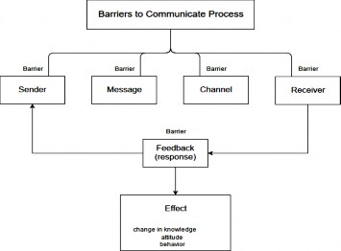
Fig.4: Barriers to communication process
Source: I.A.S Buarqoub, 2019

A person's native language is their primary means of conveying ideas and thoughts to others. Its functions include communication of all kinds (ideas, thoughts, views, and emotions), as well as socialisation, use of sound and recording of factual information, and articulation of individuality. However, there is a widespread barrier that prevents clear expression of ideas. Linguistic or semantic barriers arise when both the sender and the recipient of a message are not fluent in the target language and seek to communicate using terms with multiple meanings. For this reason, it's not always easy to have a meaningful conversation. The message may not reach its target because of problems or obstacles in the communication system. There are often five sources of linguistic difficulty: the sender's actions and the recipient's interpretation of those actions, as well as environmental disruptions (I.A.S Buarqoub, 2019).
In conclusion, linguistic obstacles arise as a result of semantic confusion caused by the encoding and/or decoding of speech into words and ideas. They are among the most major barriers to effective communication. Most misconceptions and misinterpretations occur because of these common communication barriers. They serve to emphasise the challenges inherent in communication between individuals who do not share a common language. They might also mean the complete inability of two people speaking different languages to understand one another.
- RECOMMENDATIONS AND CONCLUSION
Good communication appears to be challenging. Relationships involve verbal and nonverbal communication in today's globalised world. Language may both as a conduit for communication and a barrier to comprehension, making it difficult to communicate clearly and simply. Miscommunication, misinformation, distortion, accidents, result from language barriers in the information era. Language barriers consume time and energy. The study team wants to understand about language obstacles, how they effect communication, and how to remove or work around them (I.A.S Buarqoub, 2019).
Before opening a new business or relocating in India, the company needs to consider its cultural peculiarities. Establishing a dynamic feedback and communication mechanism between British and Indian personnel will enhance cooperation in a vertically organised organisation with clearly assigned functions. British and Indian soldiers can have misunderstandings. Younger Indian workers may not have the same decision-making or criticism rights as their British counterparts.

Indian enterprises are more adaptive than British. Indians commonly perform last-minute jobs. The British team's rigid timetable may be difficult for Indian personnel. To maintain seamless operations, British and Indian personnel should learn about each other's cultures.
Compass must include cultural differences between the UK and India. Both nations have unique cultures, yet they can learn from one other. Compass can benefit from diversity training.

9. REFERENCES
Gill, Karamjit. (2002). Knowledge Networking in Cross-Cultural Settings. AI Soc.. 16. 252-277. 10.1007/s001460200021.
I.A.S Buarqoub, (2019), “Language barriers to effective communication”, Utopía y Praxis Latinoamericana, vol. 24, núm. Esp.6, pp. 64-77.
C.C.Lewis, (2008), “Cross-cultural deception in social networking sites and face-to-face communication”, Volume 24, Issue 6, [pp: 2945-2964].
Schwartzberg, Joseph E. , Wolpert, Stanley A. , Spear, T.G. Percival , Srivastava, A.L. , Calkins, Philip B. , Allchin, Frank Raymond , Thapar, Romila , Subrahmanyam, Sanjay , Dikshit, K.R. , Champakalakshmi, R. and Alam, Muzaffar. "India". Encyclopedia Britannica, 24 Aug. 2022, https://www.britannica.com/place/India. Accessed 31 August 2022.
Hofstede, G. (2001). Culture’s Consequences: Comparing Values, Behaviors, Institutions, and Organizations Across Nations. Second Edition, Thousand Oaks CA: Sage Publications.
BBC, (2019), “India country profile”, Available at: https://www.bbc.co.uk/news/world-south-asia-12557384 , Accessed:18.08.2022.
Durkin,K.(2008). Intercultural education[online].New York.Routledge. Available from: http://pdfserve.informaworld.com/682180_751318492_790663569.pdf , Accessed: 19.08.2022.
Hofstede, G.(2009).”Geert Hofstede Cultural Dimensions”. Available from: http://www.geert-hofstede.com/hofstede_dimensions.php , Accessed:19.08.2022.
UIBC, (2022), “Business culture in India”, Available at: https://www.ukibc.com/india-guide/how-india/business-culture/ , Accessed:18.08.2022.
Steers, R.M. et al. (2013). Management Across Cultures: Developing Global Competencies. Cambridge University Press.
Hofstede-insights.com, (2022),”Hofstede model India vs UK “, Available at: https://www.hofstede-insights.com/country-comparison/india,the-uk/ , Accessed: 18.08.2022.
Simon, (2022), “The Complete Guide To International Business Communication”, Available at: https://www.simonandsimon.co.uk/blog/the-complete-guide-to-international-business-communication , Accessed: 18.08.2022.
Bhatt, Prachi. (2020). “Inter-Cultural Sensitivity, Cultural Intelligence and Conflict-handling Styles in Cross-cultural Interactions: A Study of India-Kuwait Work Interactions”. 10.24193/csq.33.2.
Compass Group PLC, (2022), “Compass Group PLC - Company Profile, Information, Business Description, History, Background Information on Compass Group PLC”, Available at: https://www.referenceforbusiness.com/history2/85/Compass-Group-PLC.html#ixzz7dWxZyK9d , Accessed :19.08.2022.
S.Diwanti, (2021), “Hofstede’s Cultural Dimensions Theory”, Available at: https://accounting.binus.ac.id/2021/11/15/hofstedes-cultural-dimensions-theory/ Accessed: 19.08.2022.
D.Mcrill, (2019), “The Importance of Communication in International Business”, Available at: https://bizfluent.com/12754417/the-importance-of-cultural-sensitivity-in-business-dealings , Accessed: 19.08.2022.
Geert Hofstede Country Comparison Tool: https://www.hofstede-insights.com/product/compare-countries/

