

Student name: Orinthia Wright-Stevens
Student ID: 2418339

Module name: changemakers: Building your Personal Brand for Sustainable Employment
Module code: BMHP5015
Lecturer name: Caroline Salami

Table of contents
Contents | Pages
Table of Contents
1. Introduction…………………………………………………………………………………. | 3
2. Job Description of the Selected Job…………………………………………………………………………………………3-4
3. Analysis of the Skills Required for the Role and Assessment of Personal Skills and Experience…………………………………………………………………….5-6
4. Skills audit comparison of current skills with vacancy requirement………………………………………………………………………………7-8
5. Development of personal skills and resources…………………….…………………………………………………………….9-10
6. Action plan……………………………………………...…………………………...…11-12
Conclusion……………………………………………………………………………14
References…………………………………………………………………………….15
Appendix A. Tailored curriculum vitae for the Workforce Systems Implementation Administrator (Band 5) role…………………………………………………………………………………….17-18

Employability Skills Report: Career Development Towards a Band 5 Administrator Role within the NHS

- Introduction
This report outlines my career development towards the role of Workforce Systems Implementation Administrator (Band 5) at Birmingham Community Healthcare NHS Foundation Trust (BCHC). I have chosen this role to build a long-term career in the NHS and contribute to the effective organisation of healthcare services. I currently work as a Tesco Retail Assistant, processing online customer orders, using digital systems, and working accurately to meet productivity targets. I am also studying Health and Social Care, which has deepened my interest in healthcare administration and workforce management. This report evaluates my skills, identifies development needs, and outlines how I can prepare for NHS administration.

- Job description of the selected job
I have selected the Workforce Systems Implementation Administrator (Band 5) role at Birmingham Community Healthcare NHS Foundation Trust (BCHC). This is a full-time permanent position based in Birmingham, with a salary of £31,049–£37,796.
I chose this role to move from retail into NHS administration and build a career in healthcare management. The role includes maintaining workforce records, supporting e-rostering systems, producing reports, and assisting managers and staff. I consider the most important responsibilities to be maintaining accurate workforce data and supporting e-rostering systems, as both directly affect safe staffing and patient care. Accurate workforce information helps managers plan staffing levels, allocate resources, and avoid payroll or scheduling errors. Effective e-rostering ensures the right staff are available at the right time, improving efficiency, reducing pressure on teams, and supporting the consistent delivery of NHS services.
In my role at Tesco, I use digital systems, work accurately under pressure, and meet deadlines. This has strengthened my organisational, attention-to-detail, and teamwork skills. My Health and Social Care studies have deepened my understanding of confidentiality, communication, and professional practice.

- Analysis of the Skills Required for the Role and Assessment of Personal Skills and Experience
The role requires strong IT, organisational, communication, and prioritisation skills, as well as the ability to work accurately with workforce data. I believe attention to detail and effective prioritisation are most important, as they directly affect workforce planning and the delivery of NHS services. Accurate records and reports enable managers to make informed staffing decisions, allocate resources efficiently, and maintain safe staffing levels. This is particularly important as NHS England emphasises effective workforce planning and digital workforce systems to improve service quality and patient care (NHS England, 2023). In practice, poor record-keeping or inaccurate reports could result in staffing shortages, payroll errors, delayed rota changes, and longer waiting times for patients. Ineffective prioritisation could also delay the delivery of important workforce information, affecting patient pathways and overall service performance.
My experience at Tesco has developed these skills through using digital systems, processing orders accurately, and meeting strict deadlines in a busy environment. I regularly prioritise tasks, solve problems, and communicate with colleagues to ensure work is completed efficiently. My Health and Social Care studies have strengthened my understanding of confidentiality, professionalism, and effective communication, which align with the NHS Constitution’s commitment to delivering high-quality, patient-centred care (Department of Health and Social Care, 2021). Although I do not have NHS experience, I believe my transferable skills closely match the person specification and provide a strong foundation for a career in NHS administration.

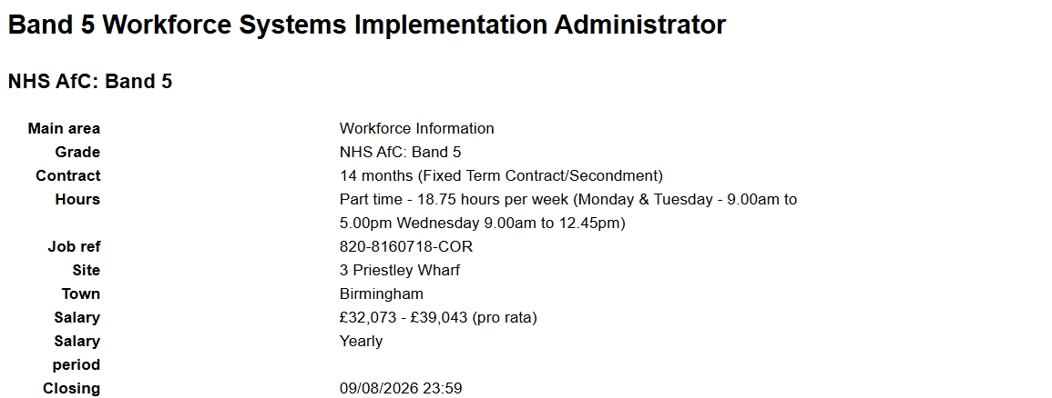
Figure 1. Essential and desirable criteria for the Workforce Systems Implementation Administrator (Band 5) vacancy at Birmingham Community Healthcare NHS Foundation Trust
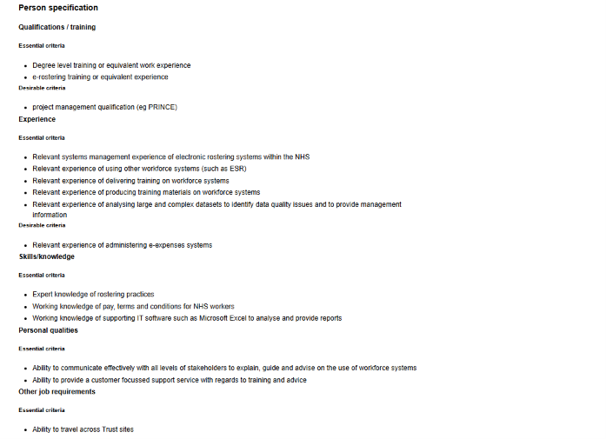
Figure 2. Person specification for the Workforce Systems Implementation Administrator (Band 5) vacancy at Birmingham Community Healthcare NHS Foundation Trust

Skills audit comparison of current skills with vacancy requirements
To evaluate my suitability for the role, I completed a skills audit by comparing my current experience with the person specification for the Workforce Systems Implementation Administrator (Band 5) vacancy. This helped me identify areas where I already meet the requirements and areas that require further development.
Vacancy requirement | My current evidence | Current level | Development gap | Action required
IT and digital systems | Daily use of Tesco online ordering systems | Good | NHS workforce systems and e-rostering | Complete NHS e-learning and e-rostering training
Organisation and prioritisation | Managing high workloads and meeting strict deadlines | Good | Prioritising NHS administrative tasks | Gain NHS administrative experience
Communication | Working with colleagues and customers in a fast-paced environment | Good | Professional communication within NHS teams | Practise written communication and NHS documentation
Teamwork | Daily collaboration with colleagues to achieve operational targets | Good | Multidisciplinary NHS working | Shadow NHS administrative teams
Accuracy and attention to detail | Processing customer orders accurately and maintaining records | Good | Workforce reporting and data analysis | Develop Excel and reporting skills
Workforce administration | Limited direct experience | Basic | NHS workforce planning and reporting | Study NHS workforce processes and person specifications
This skills audit shows that my strongest transferable skills are digital working, organisation, communication, teamwork, and accuracy. The main development gaps relate to NHS workforce systems, data reporting, and administrative processes. Addressing these gaps through targeted training and practical experience will improve my readiness for the Workforce Systems Implementation Administrator role and strengthen my ability to contribute to effective NHS workforce planning and service delivery.

4. Development of personal skills and resources
Continuous professional development (CPD) is important for improving my employability and preparing for a career in NHS administration. Healthcare administration is increasingly reliant on digital systems, workforce planning, and accurate data management, so developing these skills will be essential for the Workforce Systems Implementation Administrator role (NHS England, 2023).
My experience as a Tesco Customer Assistant and Personal Shopper has developed transferable skills in organisation, communication, teamwork, and the accurate use of digital systems. Working in a fast-paced environment has taught me to prioritise tasks, meet tight deadlines, and maintain accuracy under pressure. These skills are relevant to NHS administration, as accurate workforce records, effective communication, and efficient prioritisation support staffing decisions and service performance.
To assess my readiness for the role, I conducted a skills audit comparing my current skills and experience with the person specification for the vacancy. This identified strengths in digital working, customer communication, organisation, and teamwork, but also highlighted development needs in NHS workforce systems, e-rostering, Excel reporting, and administrative processes.
The most significant development need is to deepen my knowledge of NHS workforce systems and data reporting. These skills are important because inaccurate workforce records or reports could affect staffing levels, rota planning, and the efficient delivery of NHS services. Developing my Excel and data analysis skills will improve my ability to produce accurate reports, identify workforce trends, and support evidence-based decision-making.
To address these gaps, I plan to complete NHS e-learning on workforce administration and e-rostering, undertake Microsoft Excel training, and gain practical administrative experience in NHS administrative or healthcare support roles. I will also continue to develop my understanding of NHS policies and workforce planning by studying NHS guidance and Band 5 person specifications. Regular reflection and feedback from supervisors or mentors will help me review my progress and identify further development needs.
Professional resources will also support my development. I will maintain an up-to-date CV (Appendix A), keep a record of CPD activities and training certificates, and seek opportunities to learn from NHS administrative professionals. These resources will demonstrate my commitment to continuous learning and strengthen future NHS applications.
Developing my digital, administrative, and analytical skills will enhance my readiness for the Workforce Systems Implementation Administrator role and support my long-term goal of working in NHS administration.

- Action Plan and Timeline

Developing a career as a Band 5 Workforce Systems Implementation Administrator requires a structured, realistic approach to professional development. My self-assessment was based on a skills audit comparing my current skills and experience with the role’s person specification. This identified strengths in digital working, organisation, communication, and teamwork, while highlighting development needs in NHS workforce systems, Excel reporting, and healthcare administration. I will use the SMART framework (Specific, Measurable, Achievable, Relevant and Time-bound) to set realistic goals, monitor my progress, and review my development every three months (Doran, 1981).
Development need | SMART action | Timeline | Evidence of achievement
NHS workforce systems | Complete NHS e-learning on workforce administration and e-rostering | 1–2 months | NHS e-learning certificate
Excel and data reporting | Complete an intermediate Excel course and practise reporting functions weekly | 2–3 months | Excel certificate and sample workforce reports
NHS administrative knowledge | Study NHS Jobs guidance and analyse three Band 5 administrator person specifications | 1 month | Updated CV and supporting statement tailored to NHS roles
Healthcare administration experience | Apply for NHS administrative, receptionist, or healthcare support roles and seek shadowing opportunities | 3–6 months | Job applications, interviews, or shadowing record
Interview and communication skills | Prepare five STAR examples based on my Tesco and Health and Social Care experience and complete two mock interviews | 2–4 months | Mock interview feedback and improved interview performance
I will review this plan every three months and update my goals in light of feedback and progress. These actions address the key gaps identified in my skills audit and are directly aligned with the vacancy requirements. Developing these skills will enhance my ability to maintain accurate workforce records, support staffing processes, produce reliable reports, and communicate effectively with managers and colleagues, all of which are important for efficient NHS workforce planning and service delivery (NHS England, 2023).

6. Communication of skills to potential employers
To communicate my skills effectively to NHS employers, I will tailor my CV and supporting statement to the person specification for the Workforce Systems Implementation Administrator (Band 5) role. Rather than simply listing organisational or IT skills, I will provide evidence of their practical application. My tailored CV (Appendix A) demonstrates how my retail experience has developed skills directly relevant to NHS administration.
For example, my role at Tesco requires me to use digital systems accurately, prioritise competing tasks, and meet strict deadlines in a fast-paced environment. These skills are relevant to NHS workforce administration, where accurate records, effective communication, and prioritisation underpin staffing decisions and service performance. This aligns with the NHS Constitution’s commitment to professionalism, quality, and patient-centred care (Department of Health and Social Care, 2021).
In interviews, I will use the STAR (Situation, Task, Action, Result) method to provide structured evidence of my skills. For example, during a busy period at Tesco, I was responsible for processing a high volume of online orders within strict time limits. I prioritised urgent orders, communicated with colleagues to resolve delays, and maintained accuracy throughout the shift, resulting in orders being completed on time and to a high standard. This demonstrates my ability to remain organised under pressure and to work effectively as part of a team.
I will also ensure that every NHS application addresses each essential criterion in the person specification, supported by relevant evidence from my work experience and Health and Social Care studies. Providing clear, evidence-based examples will demonstrate to employers that I can contribute to effective workforce planning and service delivery, aligning with NHS England’s focus on developing a skilled and efficient workforce (NHS England, 2023).

7. Conclusion
This analysis has shown that the Workforce Systems Implementation Administrator role is a suitable next step for me, as my retail experience and Health and Social Care studies have provided transferable skills in organisation, communication, accuracy, and digital working.
The main areas I need to develop are my knowledge of NHS workforce systems, e-rostering, and workforce reporting, as these are important for supporting effective workforce planning and service delivery.
My action plan, including NHS e-learning, Excel training, and gaining healthcare administrative experience, will help me develop these skills and support my transition to NHS administration and a long-term career in healthcare management.

References
Birmingham Community Healthcare NHS Foundation Trust (2026) Workforce Systems Implementation Administrator (Band 5) vacancy advertisement (Vacancy reference: 820-8160718-COR). NHS Jobs. Available at: https://www.jobs.nhs.uk/ (Accessed: 1 August 2026).
CIPD (2023) Profession Map. Chartered Institute of Personnel and Development. Available at: https://www.cipd.org/uk/profession-map/ (Accessed: 1 August 2026).
Department of Health and Social Care (2021) The NHS Constitution for England. London: Department of Health and Social Care. Available at: https://www.gov.uk/government/publications/the-nhs-constitution-for-england (Accessed: 1 August 2026).
Doran, G.T. (1981) ‘There’s a S.M.A.R.T. way to write management’s goals and objectives’, Management Review, 70(11), pp. 35–36.
NHS England (2022) Our NHS People Promise. Available at: https://www.england.nhs.uk/ournhspeople/ (Accessed: 1 August 2026).
NHS England (2023) NHS Long Term Workforce Plan. London: NHS England. Available at: https://www.england.nhs.uk/long-read/nhs-long-term-workforce-plan/ (Accessed: 1 August 2026).
NHS Leadership Academy (2023) Healthcare Leadership Model. Available at: https://www.leadershipacademy.nhs.uk/resources/healthcare-leadership-model/ (Accessed: 1 August 2026).
Skills for Health (2022) Core Skills Framework. Available at: https://www.skillsforhealth.org.uk/resources/core-skills-framework/ (Accessed: 1 August 2026).

Appendix A. Tailored curriculum vitae for the Workforce Systems Implementation Administrator (Band 5) role
Orinthia Sedonie Wright-Stevens
Flat 9 Gladys Court, 260 Reigate Road, Bromley BR1 5JN
Email: orinthiabooth@yahoo.com
Telephone: 07460 593862
Professional profile
A motivated and organised professional with extensive experience in customer service, digital systems, and accurate work in fast-paced environments. Skilled in communication, teamwork, prioritisation, and meeting strict deadlines, gained through my role as a Tesco Customer Assistant and Personal Shopper. My Level 5 Health and Social Care qualification has strengthened my understanding of confidentiality, professionalism, equality and diversity, and professional practice. I am seeking to transition into NHS administration and contribute to effective workforce planning, accurate data management, and high-quality service delivery.
Key skills
- Digital systems and accurate data entry
- Organisation and workload prioritisation
- Verbal and written communication
- Teamwork and collaboration
- Problem-solving in fast-paced environments
- Attention to detail and record accuracy
- Customer service and stakeholder communication
- Time management and meeting deadlines
- Confidentiality and professional conduct
Professional experience
Tesco Customer Assistant & Personal Shopper
September 2015 – Present
- Process online customer orders accurately using digital systems.
- Prioritise workloads to meet strict collection and delivery deadlines.
- Maintain accurate records and attention to detail when handling customer information.
- Communicate effectively with colleagues and customers to resolve issues promptly.
- Work collaboratively within a team to achieve daily operational targets.
- Adapt efficiently to changing priorities during busy periods.
Alorica Jamaica Agency Service – Customer Service Advisor
September 2011 – June 2013
- Provided customer service and administrative support in a fast-paced environment.
- Managed customer enquiries professionally and efficiently.
- Used computer-based systems to record information accurately.
- Met performance targets while maintaining high standards of communication.
Education and qualifications

Level 5 Health and Social Care Qualification
University of Wales Trinity Saint David
Caribbean Examination Council (CXC)
- Office Administration
- Office Procedure
- English Language
- Social Studies
Professional development
- NHS workforce administration and e-rostering (planned CPD)
- Microsoft Excel and workforce data reporting
- NHS recruitment processes and workforce planning
References
Available upon request.

