  Component One: Student Journal (learning log) 750 words +/- 10%  Contribution to Overall Module Assessment: 25% | Student No: | 2246573  Ella Daniela Mirea
 | Module Title: | Operating Hotel Facilities
 | Module Code: | BMIH4006
 | Lecturer: | Natalie Brailsford
Introduction

Working within the housekeeping department at the Maldron Hotel Newcastle has provided me with invaluable insights into the meticulous upkeep required to maintain a hotel's cleanliness standards. Utilising the Gibbs Model of Reflection, I will delve into my experiences, emotions, and the professional and personal growth they have fostered.

Prior to commencing each shift, meticulous attention is dedicated to compiling comprehensive visitor records, documenting arrivals and departures. The significance of this routine cannot be overstated, particularly in urgent situations. At the onset of every shift, team members exchange crucial information, covering ongoing tasks, guest preferences, and inventory updates destined for the kitchen, restaurant, or reception.

Within the bustling confines of the housekeeping office, staff adeptly manage guest requests, oversee various operational domains, and exhibit proficiency in computer systems and organisational prowess. Undoubtedly, the housekeeping department serves as the nucleus of a well-operated hotel, where real-time room statuses are meticulously recorded, and any incidents of damage promptly addressed.

Navigating the demands of the housekeeping role at the Maldron Hotel demands clear communication, adept problem-solving skills, and unwavering attention to detail. It underscores the pivotal role played by housekeeping professionals in ensuring a seamless guest experience amid the rigours of hospitality management.

Description
In my role as a housekeeping employee, I undertook various responsibilities, including overseeing the laundry service, meticulously preparing guest rooms, and maintaining the cleanliness of common areas. These duties exceeded standard expectations and significantly shaped the overall guest service experience. The meticulous attention to detail was instrumental in ensuring guests felt warmly welcomed and departed with a lasting impression. Our team's dedication to ensuring guest satisfaction was paramount. The impression visitors formed of their stay hinged largely on the impeccable upkeep and organisation of guest rooms and communal spaces. As every little detail fell into place, the environment became more inviting and comfortable for our guests. I came to realise the pivotal importance of thorough surface cleaning and crisp bed-making in creating a memorable guest experience.
Feelings
The internship experience evoked a range of emotions. The journey at the establishment commenced modestly, and the bustling atmosphere in our hotel paved the way for inspiration. Through collaboration and hard work, we achieved our diverse goals, fostering a tangible sense of unity. Despite facing challenges, such as meeting unscheduled needs and accommodating last-minute changes for our guests, the overall experience proved rewarding (Ambardar and Raheja, 2017).

Evaluation
Reflecting on recent events, I've come to realise the importance of diligence, flexibility, and attention to detail. It's evident that there's room for improvement, particularly in terms of punctuality and effective communication. Given our shared goals and the collaborative nature of cleaning projects, it's clear that coordination is key (Bhatnagar and Nim, 2019). By refining task assignments, we can foster greater teamwork and alleviate individual stress. Additionally, regular brief meetings can help synchronise schedules and address issues proactively (Hamid et al., 2020). Ultimately, maintaining team spirit is crucial as we all strive to provide clients with clean and safe facilities (Alcalde-González et al., 2021).

Main take aways
The key lessons learned from this experience revolve around the importance of being thorough, communicating effectively, and staying adaptable. I realised that every small task plays a role in ensuring visitor satisfaction overall. The cleanliness of the hotel significantly impacts customers' impressions and experiences (Singh, 2015).

Impact on development and perception

This experience has significantly influenced my perception of the hospitality sector. I now regard it as a dynamic field where attention to detail, effective communication, and adaptability are not only desirable but also essential qualities. Professionally, it has broadened my understanding of the wide range of roles within the industry, and personally, it has given me a sense of fulfilment in enhancing visitors' experiences (Andrade et al., 2021).

Action plan for future improvement
I aim to enhance my skills and expertise in the housekeeping division by pursuing additional training in time management and communication. Receiving constructive feedback from peers and supervisors will be crucial for addressing areas needing improvement (Parmar and Dalal, 2017). My ongoing success in the hospitality sector hinges greatly on my continuous learning and development.

In summary, my placement at the Maldron Newcastle Hotel's housekeeping department has been a transformative experience. It has provided me with valuable insights into the importance of adaptation, effective communication, and attention to detail in the hospitality sector. This perspective not only deepened my appreciation for the significance of the housekeeping department but also equipped me for personal and professional growth in the hotel industry.

Component Two: Health and Safety Guide
Contribution to Overall Module Assessment: 25%

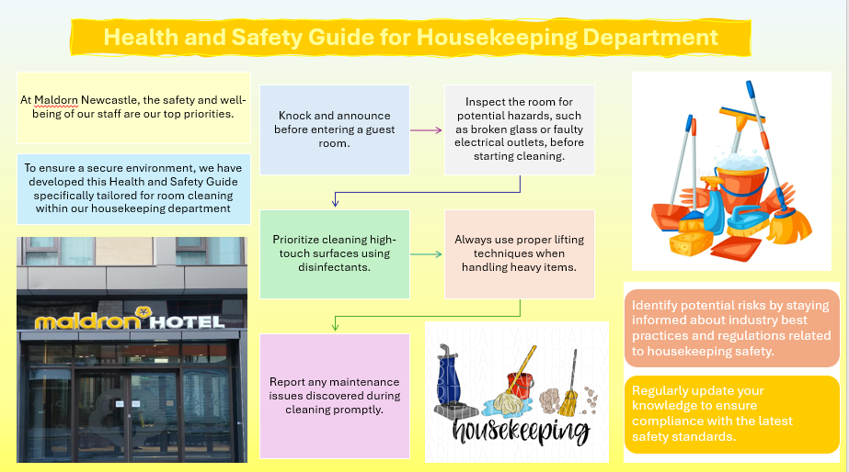
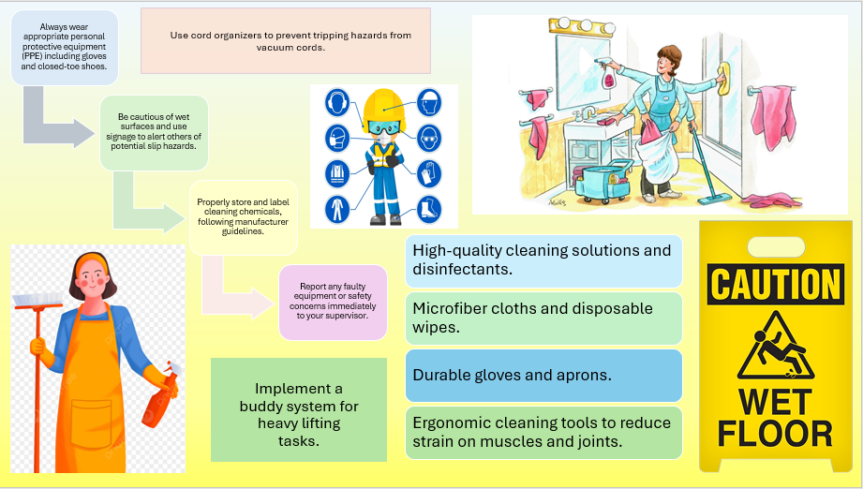

Reference List

Reference List

Alcalde-González, V., Mozo, A.G. and Bustos, A.V., 2021. No clean rooms, no hotel business: Subversion tactics in Las Kellys’ struggle for dignity in hotel housekeeping. Annals of Tourism Research, 91, p.103315.

Ambardar, A. and Raheja, K., 2017. Occupational Safety and Health of Hotel Housekeeping Employees: A Comparative Study. International Journal of Hospitality & Tourism Systems, 10(2).

Andrade, M.S., Miller, D. and Westover, J.H., 2021. Job satisfaction factors for housekeepers in the hotel industry: a global comparative analysis. International Hospitality Review, 35(1), pp.90-108.

Bhatnagar, E. and Nim, D., 2019. Impact of housekeeping services and practices on customer satisfaction and repeat business. Prabandhan: Indian Journal of Management, 12(8), pp.46-57.

Clarke, J., Robinson, O. and Mayo, C., 2018. Trouble in hotel paradise housekeeping department: A case study. Journal of Hospitality & Tourism Cases, 7(1), pp.34-41.

Hamid, R., Ong, M.H.A., Razak, I.R.A., Ismail, T.A.T., Ramli, N. and Nawawi, Z.M.W.N.W., 2020. User acceptance of smart housekeeping: A study of TAM model prototype in hotel industry. Int. J Sup. Chain. Mgt Vol, 9(3), p.308.

Parmar, S. and Dalal, P., 2017. A study of musculoskeletal disorder among housekeeping staff in hotel industry. Int J Home Sci, 3(3), pp.83-5.

Singh, A., 2015. Hotels Housekeeping Innovative Trends and Modern Practices-An overview. Journal for Studies in Management and Planning, 1(3), pp.540-548.

