

EVALUATION AND ANALYSIS OF OPEN SOURCES IDS DEPLOYED AS DOCKER AND VIRTUAL MACHINE

Student Number: P147535
Module Code: ACFA 7004
Module Tutor: Professor Christopher House
Computer Networks and Cybersecurity

MSc Project Proposal

Table of Contents
List of Figures 3
Index Terms: 3
ABSTRACT 4
I. INTRODUCTION 5
II. BACKGROUND RESEARCH 7
III. AIMS AND OBJECTIVES 8
IV. LITERATURE REVIEW 9
1st Paper: A Dynamic Scalable Parallel Network-based Intrusion Detection System using Intelligent Rule Ordering 10
2nd Paper: Open source intrusion detection systems evaluation for small and medium-sized enterprise environments 11
3rd Paper: Evaluation of Intrusion Detection Systems under Denial of Service Attack in virtual Environment 12
V. RESEARCH METHODS 13
1. Research process 13
2. Research Philosophy 14
3. Research Approaches 15
4. Research Strategy 15
5. Choices 16
6. Time Horizon 16
7. Data Collection and Analysis Techniques/Procedures 16
VI. DEVELOPMENT METHODS 17
1. Research deliverables 17
2. Resources and planning 17
2.1 Resources Required 18
2.2 Gantt Chart 19
VII. DESIGN AND IMPLEMENTAION 20
VIII. ETHICAL CONSIDERATIONS 21
IX. CONCLUSION 21
REFERENCES 22

List of Figures
Figure 1: The research onion by Saunders 14
Figure 2: Project Gantt Chart 19
Figure 3: The project experimentation design 20
Figure 4: Inside Docker IDS Server 20

Index Terms:
IDS: Intrusion Detection System
IPS: Intrusion Prevention System
NIDS: Network Intrusion Detection System
HIDS: Host Intrusion Detection System
DoS: Denial of Service (attacks)
NBA: Network Behaviour Analysis
Docker: New emerging trend technology (Set of platforms as a service (PaaS))
VM: Virtual Machine
VMware: Virtualisation Software
Snort: Open source IDS
Suricata: Open source IDS
OSSEC: open source IDS
VRT: Vulnerability Research Team (rules set update)
CPU: Central Processing Unit
RAM: Random Access Memory

ABSTRACT- The purpose of this research is to establish an understanding of how the Intrusion Detection System (IDS) can be deployed as a Docker container and Virtual Machine (VM) to monitor and analyses the network security of small and medium enterprises. This study focuses on the deployment and evaluation of some of the well-established open-source IDS systems using the new emerging trend that is Docker containers technology in comparison to the classic VM approach. Due to the lack of research been done in the field of IDS as Docker, the author is taken this great opportunity to highlight how this new emerging trend can be integrated to network security systems and have an impact on. Also, this would be a modest contribution to knowledge in this key field. This study comparison between Docker-based IDS and VM-based IDS using the top two open sources software Snort and Suricata would provide more clarity on the overall performance of each method and level of detection of this vital security system within every network enterprise when facing Denial of Service (DoS) and reconnaissance attacks.

INTRODUCTION

Intrusion Detection systems (IDS) and Intrusion Prevention Systems (IPS) are widely used by all types of organisations and businesses of all sizes to monitor and analysis of their network security against unwanted traffic and any violation of security policies [1]. In the current hostile internet environment, the increase of the level of threats and the number of cybercrimes using a sophisticated exploit in a way that starts rising alarms and concerns. This is why this topic has seen lots of attention from researchers in recent years, lots of tools, products and services have been developed to strengthen network security such firewalls, antiviruses, IDS, IPS, Network Behaviour analysis (NBA), etc. some of these solutions are commercial and other are open-sources. When it comes to large companies and government organisation the cost of implementing a robust network security using some of the expansive and sophisticated tools and services such as Palo Alto, Sourcefire and SolarWinds is not an issue. However, when it comes to small and medium businesses the feasibility cost analysis would be key in deciding what type of security solution to be implemented [2]. Therefore Open-source solution sometimes is a good option.
Open-source IDS are a variety of security tools developed by communities and free to use and it can be adjusted to suit different business needs, a good IDS is only as good as the way it is been implemented and configured. The author will this experiment using the Network IDS (NIDS) approach simply because Host IDS (HIDS) will not scale well to small and medium networks, with NIDS it would be possible to monitor and analyse the entire traffic after the demilitarised zone from and to all the network hosts. When it comes to the techniques used by IDS to detects threats and malicious traffic, two major techniques can be identified as signature-based and statistical anomaly-based. The signature-based approach compares the incoming packets to the network against pre-stored traffic signatures that matches certain types of known attacks and create an alert to the administrator so actions can be taken, the problem with this technique is that IDS will not be able to detect attacks when no signature has been made yet. As per the statistical anomaly IDS technique, a baseline is set up to determine the type of traffic, the protocols used, the ports and machines generating the traffic and the bandwidth, anything outside this baseline the IDS will generate alerts to notify the administrator [3].
The author will conduct these experiments to evaluate and analyses the performance of Snort and Suricata when it comes to detecting traffic network anomalies and attacks such as network scanning, ports scanning and Denial of Service (DoS) attacks [4], these types of attacks are considered among the notorious Cybersecurity threats that organisations still facing [5].
In terms of major issues that the author must overcome, it will be Docker complexity and heavy Linux coding to configure the snort and Suricata containers to perform a parallel analysis to the network traffics. However, this would have great benefits in developing new skills. Not to ignore developing a suitable experiment design in an isolated network while trying to mimic a good simulation of real network traffic. It is important to highlight that these experiments will have some important boundaries when it comes to other significant types of attacks that the network could face. Also, the simulated traffic can never match the real network traffic.
The key concept of this research is to establish whether containerised IDS would provide better protection to the network security against DoS and reconnaissance attacks comparing to a similar experiment using the VM approach. This is a unique experiment on IDS systems implemented as Docker containers, which has never been conducted the way the author intended to setup. However, there are similar evaluations for those open-source IDS in a different environment like VMware or dedicated servers. The author will conduct a novel performance evaluation of two open-source IDS installed as Docker containers to monitor a simulation of network traffic that mimics a small and medium enterprise when facing DoS and reconnaissance attacks.

BACKGROUND RESEARCH

In the process of selecting some of the top open-source IDS systems deployed today, the author has chosen Snort and Suricata based on prior academic research and IT professionals' reviews.
Snort is single-threaded open-source IDS that was created in 1998 by Martin Roesch and developed by Sourcefire, it becomes a propriety of Cisco after purchasing Sourcefire in 2013, It is rules-based real-time traffic analyser compatible with most of operating systems (e.g. Linux, Unix, Windows, Mac OS, FreeBSD, etc.) [6]. It was chosen simply because it is still considered as the number one open-source IDS when it comes to the community support and rules update regardless of some critics about processing speed and the ability to adapt the rules to some of the challenging complex threats. The main difference between Suricata and Snort is that Suricata was developed in 2009 with multithreading processing ability, capable of handling the demands of modern network infrastructure, it was built to handle an effectively high volume of traffic while processing more rules. Like Snort it is compatible with the most operating system. Both Suricata and Snort can be used as IDS or IPS when connected to the network using the same Syntax rules (not 100%) [7].
The emerging trend Docker has changed significantly today IT industry, this open-source container platform allows developers the flexibility to test, run and deploy their applications in an isolated environment [8]. Thanks to the lightweight, flexibility across different operating systems and management ease, Docker has become one of the fastest-growing trends in the last 5 years [9]. With the help of Docker containers, it would be possible to run multiple Snort/Suricata IDS in parallel in an isolated environment to mitigate the issue of engine become over-loaded and packet been dropped. Also, this could have a major impact on processing time and the usage of processing powers due to the lightweight nature of the Docker system.

AIMS AND OBJECTIVES

This research project aims to evaluate a new deployment approach of the top two IDS open sources Snort and Suricata using the new emerging trend Docker technology. To gain a profound understanding, the author will conduct the required literature review of the different deployment and implementation methods of open-source IDS and the analysis of similar evaluation results of Snort and Suricata. This process will allow the author to establish a clear synopsis and overview of the practical elements of these experiments.
In this project proposal, the author will provide the readers with a clear explanation of each objective and a sound and justified methodology approach followed. Also, a structural guideline will be developed to conduct a successful implementation of this project. The researcher provides a carefully set list of objectives for this project:
- Demonstrate a good understanding of the deployment of open-sources IDS
- Conduct a performance analysis and comparison between Docker and VMware IDS deployment
- Conduct a performance analysis and comparison between Snort and Suricata using Docker and VM methods
- Outline the advantages and limitations for each method (Docker vs VMware)
- Draw a list of recommendations for the best IDS deployment method for small and medium networks.

LITERATURE REVIEW

In general testing and evaluation of open-source intrusion detection systems is not something new. However, the perfect implementation of IDS has always been difficult which makes the testing procedures of IDS an important research subject.
It is important to highlight that most open source IDSs are different when it comes to software design, configuration difficulties, optimisation capabilities, processing speed and the number of rules. All these differences would have a direct impact on the host hardware performance, the quality of detection and quantity of traffic can be handled.
The author is aware of these distinguish variables that would affect the performance and reliability of IDSs. However, the focus of this thesis is to evaluate advantages, disadvantages and performance results using this new Docker deployment approach in comparison to the classic VMware approach.
The author will design different test experiments in an isolated network environment to perform different attacks on these IDSs using different generated traffic speeds, the practical part of this thesis will be designed to fulfil the below conditions:
- System effectiveness.
- Quantity of detection.
- Network traffic capability.
- Host machine performance.
- Test reliability.

The process of conducting this literature review would have great benefits on the author's knowledge and understanding of IDS deployment, design experimentation, set the limits, the scope and set the objectives intelligently for this project. Also, it would enable the author to gather enough information to talk about the topic with authority. Many related quality research papers and thesis have been found, some of these carefully selected studies and papers will be critically analysed and compared in this piece of work.

1st Paper: A Dynamic Scalable Parallel Network-based Intrusion Detection System using Intelligent Rule Ordering
The Network-based intrusion Detection System (NIDS) comprise software and hardware that help in identifying risks to a network. The complexity of NIDS results in some difficulties in processing network traffic. For NIDS to work efficiently, hardware and software must be up to date. The goal of the thesis is to come up with an architecture that reduces the processing time of NIDS in pattern matching. The thesis contains an introduction, background, approach, design, implementation, and experiment. It also contains measurement, analysis, and comparison, discussion and conclusion. The background talks of the technologies relevant to the thesis. The domains for the intrusion detection system are discussed. These domains are Host-based Intrusion Detection System (HIDS) as well as Network-based Intrusion Detection (NIDS). The jobs of these intrusion detection systems include checking critical system files and checking network flow [8]. To realise the purpose of the thesis, multiple steps are followed. The first is designing and implementing a suitable design of the steps to follow. Measurement, analysis, and comparison of results should also be appropriately done. A parallel technique model that outlines why NIDS drops packets and how to reduce the packet drop rate is developed. A technical model is designed showing the features aimed at achieving the objectives of the dissertation. Two algorithms are designed as part of the technical model to test the functionality of the project. Once the technical model is designed, one must lay down technical infrastructure, which includes how the network traffic will be sent to the sensors. Once the set-up is complete, the actual experiment should be run to test the efficiency and usefulness of the layout [8]. Measurement, analysis and data comparison enhances accuracy in the project. The data obtained from the experiment is properly analysed to ensure the set goals are achieved.

2nd Paper: Open source intrusion detection systems evaluation for small and medium-sized enterprise environments
The thesis compares three Intrusion Detection Systems (IDS) ranked by their importance to SMEs. Since the threats in the IT field are continually emerging, the tools required to counter the effects have to develop at a significant rate. Many firms that take security measures seriously normally employ IDS to maintain safety policies. The method used to conduct the research was a collective case study where set goals apply for an assessment of individual cases. Results obtained were applied for comparison of different IDS following factors set by Paytrail Company. This organization deals with payment through the internet and e-commerce services. The thesis mainly focuses on the security performance expected, trustworthy of the open-source project and integration. The study compares IDS solutions and different solutions based on these three factors. The thesis focuses on threats and vulnerabilities related to transactions within the network system. The risks that IDS can identify are grouped into Advanced Persistent Threat (APT) as well as malware [10]. Flow charts and figures are properly used to illustrate various issues in the thesis. In this collective case study, both qualitative and quantitative data are used. The evaluation of criteria in the thesis is conducted according to the factors set by the owner. The environment for the project was set with virtual servers that operate using the oracle virtualisation software. The tests are run at the same time and the results documented from all NIDS. This simultaneous running and reading of results enhance results comparisons and minimises errors [10]. The author studies network attacks vectors and establishes tests for the same. Three open-source solutions that include Snort, Suricata as well as Zeek are analysed in the article to see how they relate as well as effectiveness in ensuring security to network environments run by SMEs.

3rd Paper: Evaluation of Intrusion Detection Systems under Denial of Service Attack in virtual Environment
Intrusion Detection Systems (IDS) identify malicious traffic in many organisations. The authors explore the diverse attacks, which ate detectable by the IDS. The objective of the study was to appraise three commonly applied open-source IDS concerning performance. Other goals include understanding the performance of IDS and obtaining knowledge on cloud computing and cyber-attacks. The experiment is done using TCP, SCAN, ICMP, FTP attack. The assessment of the performance of any of the IDS is calculated using CPU usage, memory usage, and packet loss. This results in the generation of multiple alerts [11]. Various intrusion detection systems were analysed including Host-based and Network-based IDS. According to the authors, the IDS are designed to run in a specific environment, therefore, it is difficult to implement the thesis. The framework and architecture for the Suricata, OSSEC and Snort intrusion detection systems are laid down. The results obtained from the three IDSs are compared. The features compared include multithreading, global variable, windows support, and http accessing [11]. Some of the research questions are answered in the literature review method. Under this approach, it is possible to determine the performance of the IDS as well as the diverse attacks that the system can detect. The other criteria used include Population Intervention Comparison Outcome (PICO). The paper focuses on the comparison of three IDSs, which are Snort, Suricata and Bro.
The merits and demerits of each intrusion detection system are considered in choosing the best. The thesis also analyses the data for mobile networks using the Vulnerability Research Team (VRT) rules set through Snort and bro software. Examples of attacks include bad traffic, scanning attack and denial of service attack. The environmental set up includes a network traffic generator and network switch. The experiment aids in determining accuracy as well as the effectiveness of IDS in performance. The results have been graphical demonstrated using flow charts hence it helps to makes an easy comparison of the different intrusion detection systems.

RESEARCH METHODS

In this section, the author will explain the research methodology principles adopted and followed throughout this project proposal. The research methodology is key when it comes to conducting any successful research project, it is a very important element to all professionals when it comes to gathering specific evidence and data to support researchers unique project. Many ways could be used to collect this information, for instance, interviews, surveys, case studies, questionnaires, experiments, optimisations, etc. this process helps the researcher to gain more control of the suitable literature that would fit the requirement of the project. Different projects require different methods, this could be a qualitative or quantitative research method. The author will conduct an empirical research process in this study to design practical experiments to produce some quantitative data that can be statistically analysed.

Research process
The research process has been adopted in this study would help the author to deliver a systematic model aiming to evaluate the Docker implementation of IDS in comparison to the classic approach of VM, this would benefit to comprehend the validity and reliability of information gathered through the literature. A well-structured research process has been the most appropriate for the proposed study. This process is informed by a layered approach that was developed by Saunders, Lewis, and Thornhill [12], and referred to it as the “Research Onion”. Use of the Research Onion allows researchers to systematically progress from the outmost layer towards the inner layers. The specific layers of the Onion include the following: philosophies, approaches, strategies, choices, time horizons, and techniques and procedures (see figure 1). Each layer has specific options from which the most appropriate for the study at hand are selected. Such a research process provides a clear insight into how a study was or will be conducted or the framework upon which the study was or will be based [13].
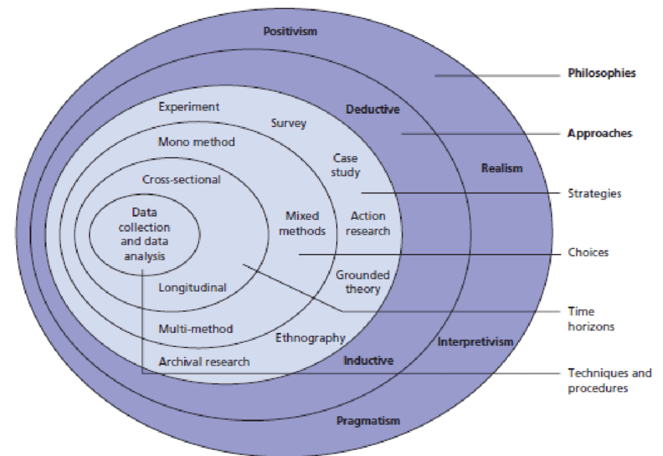
Figure 1: The research onion by Saunders

Research Philosophy
Research philosophy is the idea or belief about knowledge development, including any necessary assumptions about the understanding of the world and the collection, analysis, and interpretation of data. The selected philosophical standpoints reflect the overall perception and reasoning of the researcher concerning a particular study. Interpretivism, realism, positivism, and pragmatism are the most important research philosophies [14].
A combination of realism and positivism are selected as the research philosophies applicable to this study. Realism entails following a scientific path to draw theories and conclusions. This philosophical standpoint does not simply believe in perceptions without satisfactorily supportive scientific logic. Like realism, positivism is based on scientific investigation to observe and interpret reality. However, it specifically emphasises objective experimentation to capture trustworthy and/or factual knowledge. Consistent with this, realism entails the least possible interaction with study participants if there are any [15].
Considering that the current study attempts to experimentally measure the performance results using the Docker-based IDS deployment approach versus the conventional virtual machine or VM-based IDS deployment approach make the realism and positivism philosophical standpoints the most appropriate. No form of survey (such as interviews and questionnaires) would be needed as part of data collection. Rather, Snort and Suricata (open-source IDS variants) will be deployed in Docker and VMware environments to quantitative measure the resultant performance realities [16].

Research Approaches
Saunders et al. focus on deductive and inductive reasoning – the main types of research approaches. Deductive reasoning leverages existing literature to discover theories that are then tested using collected data to draw conclusions. Contrastingly, inductive reasoning entails comprehensive observations (usually a collection of vast qualitative data) as the basis for developing one or more theories [17]. The current study focuses on evaluating whether Docker-based IDS deployment outperforms its VM-based counterpart. Precisely, it is hypothesised that Snort performs better than Suricata on both OS-level virtualized Docker containers and conventional hypervisor-level VM. Therefore, a deductive research approach is the most suitable for the current study.

Research Strategy
When it comes to the research strategy, the question shifts to what aspects the current study attempts to explore and the research design through which the objectives would be accomplished. Therefore, it involves the overall description of a study – is it experimental, action research, case study, survey, grounded theory? For the current study, an experimental research strategy is deemed the most appropriate [17]. The data captured from an experiment involving Snort and Suricata deployed in Docker and VM environments would be analysed and interpreted to draw practical conclusions regarding the performance capabilities of the two IDSs.

Choices
Generally, there are two distinct methodological choices – quantitative (numeric data) and qualitative (non-numeric or descriptive data). When used alone, a study is either quantitative or qualitative – the mono method [13]. When the two approaches are used simultaneously within a single study, the mixed methods approach applies. The multi-method approach applies more than one quantitative or qualitative method [13]. For the current study, a quantitative methodological approach is the most suitable. This is because the experimental investigation is intended to be conducted within a testbed (a small network) to quantitatively measure the performance capabilities of the two IDSs within Docker containers and conventional VMware.

Time Horizon
A cross-sectional or longitudinal time horizon may be adopted. In the case of cross-sectional studies, data is collected and analysed at a particular point in time. Contrastingly, longitudinal studies entail repeatedly collecting and analysing data about the same topic over a prolonged period. Longitudinal studies are particularly necessary when a certain change over time need to be studied [13]. Considering that the current study is not intended to study any changes over time, cross-sectional research is considered as the most suitable option.

Data Collection and Analysis Techniques/Procedures
As highlighted above, empirical data would be collected experimentally. Two test environments will be conducted to measure the performance of Snort and Suricata when running on a Decker container and a conventional VMware environment. Performance parameters include the following:
- Ease of deployment and administration.
- Resource-efficiency – CPU and RAM of the host machine.
- Frequency of alert generation.
- Frequency of false alarms.
- Logging capability.
Similar alert rules will be applied to Snort and Suricata. Then, a series of commands will be run to evaluate how these IDSs will be generating added alerts

DEVELOPMENT METHODS

Research deliverables
The author shall validate the research proposal by providing a profound analysis of the data extracted from the project experiments and the project outcomes. Upon completion of this research, the author is required to deliver the following; the research must answer the thesis key questions and provide evidence for it, help the reader establish a clearer overview on the subject, understand all the pros and cons of each deployment method, self-critic the overall work completed, provides recommendations to readers and conclude whether Docker implementation outweighs VMware when it comes to IDS efficiency for the two open sources Snort and Suricata.

Resources and planning
In this section, the author shall deliver and explain all the essential information related to resources and planning. Every aspect of the resources available and the plan developed shall outline the design and implementation phase and validate the research strategy adopted [14]. A concise analysis of all the resources identified will be explained to the readers to help rationalise the planning and execution procedure and help validate the research proposed method.
Good planning lies at the heart of any successful project, it is inevitable that at some point a few problems and issues will arise throughout this project. However, the key here is to carefully set appropriate milestones and deadlines that should be monitored and updated regularly and design a good contingency plan risk assessment plan to mitigate all possible scenarios.
The author shall conduct a thorough risk analysis to help identify all potential threats that this project might face:
- Budget constraints may become an issue if the author required to build a local cluster in the lab environment where the experiment will be conducted rather than connecting to the university resources available in the comms-room.
- Software licence limitations may impact in dividing the workload between home and University, some of the software is only for academic use.
- Out of hours, access restriction to the lab may delay the progress of this project, the author shall request the necessary access approval.
- Lost or failure to back-up the project data and the experiment results may have a damaging impact on the entire project.
- IT infrastructure failure or planned maintenance may cause delays to this project.

2.1 Resources Required
Every project would require different resources, identifying these resources at an early stage can significantly impact the running of any project and help mitigate any unnecessary delays. Resources vary from hardware, software to individuals. Please see below a detailed list of the necessary resources required for this project:
- Access to the University electronic and physical materials such as journals, books, papers etc.
- The research project supervisor advice and assistance when needed.
- Access privilege to Cisco lab out of hours.
- The latest version of Snort and Suricata VM image.
- The latest version of Snort and Suricata Docker image.
- VMware software.
- Kali Linux OS.
- Ubuntu OS.
- Open vSwitch software.
- Tcpreplay open-source suit.
- Docker Swarm cluster running on a local lab machine.
- Four Dell machines.
- Cisco router 1941 series.
- Cisco Layer two switch 2960 series.
- Windows 10 operating system.

2.2 Gantt Chart
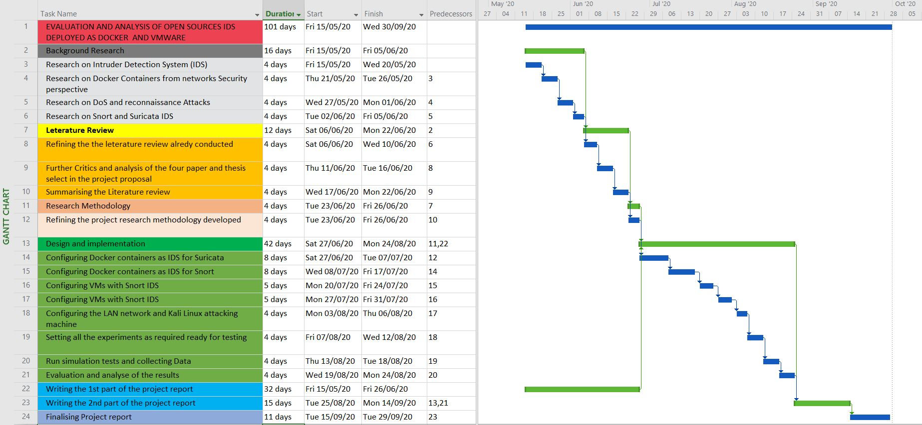
Gantt chart is an important and very valuable tool when it comes to project management, it provides the teams and individuals involved in any project with the visual representation of timescales, resources, activities and the progress of each task. Also, it helps improve communication, collaboration, efficient resource management, time management, promote clarity, boost flexibility and create a sense of accountability, etc. [18]. As a best practice, in this project, the author shall produce a clear Gantt chart (as illustrated in figure 2) to provides the reader with an estimated time scale of each task and some clarity about the execution flow of the entire project. However, this Gantt chart is expected to endure changes and adaptation throughout the execution of this project. Please see below screenshots from the project Gantt chart developed using Microsoft project:
Figure 2: Project Gantt Chart

DESIGN AND IMPLEMENTAION

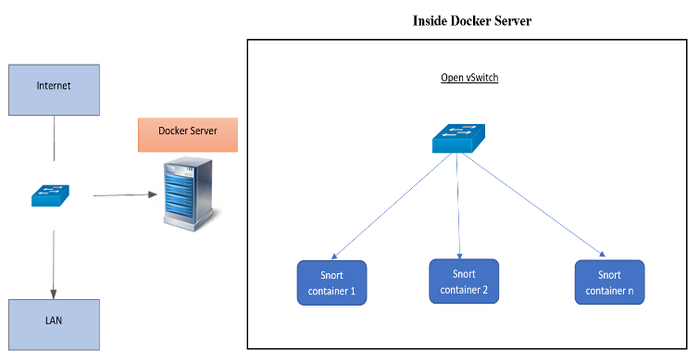
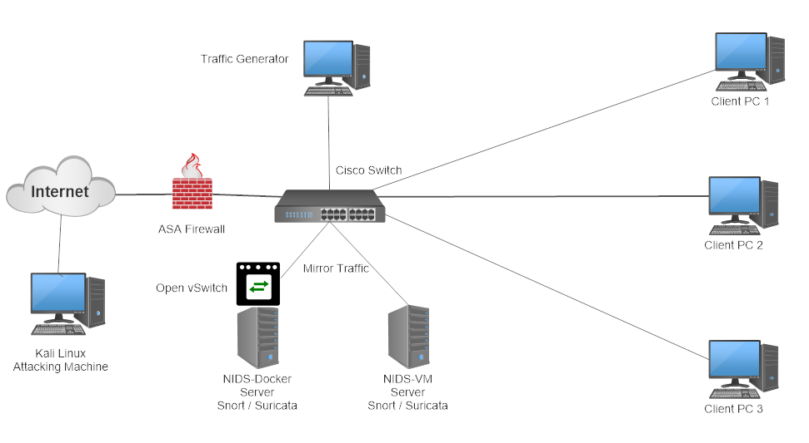
The project experimentation was designed to meet all the objectives in an isolated network to comply with the University rules, the author shall document both deployment approaches; Docker IDS and VMware experiments and compare the results at the end of this project. As illustrated in figures 3, two IDS servers will be set as Docker and VM to monitor the LAN network mimic by a traffic generator and an attacking Kali Linux machine. All the traffic first will be filtered using an ASA firewall with a basic In-Out filter rules configuration. As seen in figure 4 the many containers will be monitoring the network, each container would be running as sub-section of the rules that a normal IDS usually run.
Figure 3: The project experimentation design
Figure 4: Inside Docker IDS Server

ETHICAL CONSIDERATIONS

In every research project, major consideration and a great deal of attention should be considered when it comes to the ethical side of any project. Therefore, the author shall formally request an ethical approval from the University to implement the designed experiment in the isolated lab network environment and run different ethical cyberattacks to evaluate IDSs, the author shall explain to ethics committee all the benefits of pursuing this project and why this research is worthwhile while respecting the University ethical conduct. Besides submitting the “Application of Ethical Approval PG2-E1” form, the researcher is required to read and comprehend some important IT-related laws and regulation documents such as Computer Misuse Act 1990, Data Protection Act 1998, Serious Crime Act 2015, etc. [19].

CONCLUSION

This professional research proposal was carried to try answering a carefully selected hypothesis, this project proposal would give the author the chance to demonstrate whether Docker IDS and parallel network monitoring using different containers would outweigh the classical VM IDS approach performance when using Snort and Suricata software, through this experiment and data analysis of the results the author shall validate or disproved this hypothesis using quantitative data. In this project proposal, the author has outlined clearly the aim and objectives, the scope and set the limits for this project after conducting a good literature review on open-sources IDS deployment methods. The research methodology and the philosophy approach has outlined the necessary steps that the author should consider and follow to complete this research successfully.

REFERENCES

[1] M. Bharati and S. Tamane, “Defending against bruteforc attack using open source - SNORT,” Proc. Int. Conf. Inven. Comput. Informatics, ICICI 2017, no. Icici, pp. 903–907, 2018.
[2] J. T. Rodfos, “UNIVERSITY OF OSLO Department of Mathematics,” Thesis, no. may, 2005.
[3] J. Timofte, “Intrusion Detection using Open Source Tools,” Inform. Econ. J., vol. 12, no. 2, pp. 75–79, 2008.
[4] B. Q. Musawi, “Mitigating DoS / DDoS attacks using iptables,” no. January 2012, 2016.
[5] F. Hock and P. Kortiš, “Commercial and open-source based Intrusion Detection System and Intrusion Prevention System (IDS/IPS) design for an IP networks,” ICETA 2015 - 13th IEEE Int. Conf. Emerg. eLearning Technol. Appl. Proc., pp. 1–4, 2016.
[6] R. F. Erbacher and R. Pino, “Open Source Software Tools for Anomaly Detection Analysis,” no. April, 2014.
[7] O. B. Lawal, A. Ibitola, and O. B. Longe, “Analysis and Evaluation of Network-Based Intrusion Detectionork Using Snort Freeware,” African J. Comput. ICT African J. Comput. ICT Ref. Format O.B. Lawal, vol. 6, no. 2, pp. 169–184, 2013.
[8] H. N. Tran, “A Dynamic Scalable Parallel Network-based Intrusion Detection System using Intelligent Rule Ordering,” 2017.
[9] Y. Al-Dhuraibi, F. Paraiso, N. Djarallah, and P. Merle, “Autonomic Vertical Elasticity of Docker Containers with ELASTICDOCKER,” IEEE Int. Conf. Cloud Comput. CLOUD, vol. 2017–June, pp. 472–479, 2017.
[10] M. Hänninen, “Open source intrusion detection systems evaluation for small and medium-sized enterprise environments,” 2019.
[11] V. Nagadevara, “Evaluation of Intrusion Detection Systems under Denial of Service Attack in virtual Environment,” 2017.
[12] M. Saunders, P. Lewis, and A. Thornbill, Research Methods for Business Studies. 2000.
[13] by R. Burke Johnson and A. Onwuegbuzie, “Mixed methods research: A research paradigm whose time has come,” Educ. Res., vol. 33, no. 7, pp. 14–26, 2004.
[14] H. Berger and A. Jones, “Cyber security & ethical hacking for SMEs,” ACM Int. Conf. Proceeding Ser., vol. Part F130520, 2016.
[15] J. Clonts, “The concept of reliability as it pertains to data from qualitative studies.,” Annu. Meet. South West Educ. Res. Assoc. Houston, TX. , 1992.
[16] T. Linda, “The strengths and weaknesses of quantitative and qualitative research: what method for nursing?,” 1994.
[17] K. Hinkelmann Hans Friedrich Witschel, “How to choose a research metholodology,” pp. 1–49, 2015.
[18] H. Y. Ong, C. Wang, and N. Zainon, “Integrated earned value Gantt chart (EV-Gantt) tool for project portfolio planning and monitoring optimization,” EMJ - Eng. Manag. J., vol. 28, no. 1, pp. 39–53, 2016.
[19] R. A. Lundin, “Ethical considerations in doing and disseminating project management research,” Int. J. Manag. Proj. Bus., vol. 4, no. 1, pp. 150–156, 2011.

