Data Analysis

Submitted by
Student Name: Gabriela Szkutnik
Student Number:2130794
Module Code and Title: LCBB500 Data Handling& Business Intelligence

Submitted to
Lecturer’s Name: Zahra Mohammadnazari

Contents
Part 1: GreenMed Dataset Analysis 3
Introduction 3
a.1. The Mean Processing Time for Hadoop 3
a.2. The Median Processing Time When Using Spark 3
a.3. The Highest Processing Time for R 4
a.4. The Standard Deviation for Processing Time When Using Python 4
a.5. The Lowest Average Processing Time Across the Dataset 4
a.6. Interpretation 5
b. Creating Charts and Graphs Using MS Excel 5
c. SPSS 7
Conclusion 9
Part 2 10
a. The Advantages and Disadvantages of Using SPSS 10
b. The Importance of Data Governance 12
References 14

Part 1: GreenMed Dataset Analysis

Introduction
The “GreenMed_Healthcare_2023” dataset requires an in-depth analysis, to understand the performance metrics of popular data analytics tools like Hadoop, Spark, R, Python, and Tableau for a period of time. Here, the main objective is to uncover new insights about the efficiency and performance of these big data platforms or tools by answering the following questions.

a.1. The Mean Processing Time for Hadoop
Finding the average of the dataset's "Hadoop Processing Time" values is necessary to determine the mean processing time when utilizing Hadoop. The sum of all values divided by the total number of values is the formula for determining the mean.
The mean Hadoop processing time for the given dataset can be found by adding up all of the "Hadoop Processing Time" values and dividing the result by the number of days. The calculation is as follows:
Mean Hadoop Processing Time = ∑ Hadoop Processing Time / Number of Days
Using the “Average” function on MS Excel, the mean processing time when using Hadoop is 2.78 (rounding up).
When this computation is done, the average Hadoop processing time for each day in the dataset will be obtained. It is noteworthy that the aforementioned mean denotes the central tendency of the Hadoop processing times documented in the dataset. This information can be valuable in comprehending the average Hadoop performance within the designated timeframe.

a.2. The Median Processing Time When Using Spark
To find the median processing time when using Spark, we need to identify the middle value of "Spark Processing Time". If there is an even number of values, the median is the average of the two middle values.
Performing these steps and using the “Median” function of MS Excel, the median processing time for Spark is 2.75 (rounding up). It is important to note that the median provides a measure of central tendency that is not affected by extreme values, making it a robust statistic for understanding the typical processing time in this context.

a.3. The Highest Processing Time for R
To identify the date on which R had the highest processing time, we need to look for the maximum value in the "R Processing Time" column and then determine the corresponding date in the "Date" column.
- Find the maximum value in the "R Processing Time" column.
- Identify the corresponding date in the "Date" column.
Performing these steps with the provided dataset and using the “Max” function on MS Excel revealed the specific date when R had the highest processing time. This information is valuable for understanding outliers or instances of particularly high processing times in the context of R usage.
As a result, R had the highest processing time of 4.87 (rounding up) on 2023-01-16.

a.4. The Standard Deviation for Processing Time When Using Python
Using the STDEV.S function of MS Excel, the standard deviation for processing time when using Python is: 1.30 (rounding up). This statistic indicates the amount of variation or dispersion in the Python processing times across the given time period.

a.5. The Lowest Average Processing Time Across the Dataset
To figure out the tool or platform with the lowest average processing time across the dataset, we need to calculate the mean processing time for each tool or platform and then compare the averages. Therefore, we need to follow the steps outlined below -
- Calculate the mean processing time for Hadoop, Spark, R, Python, and Tableau separately.
- Compare the calculated means for each tool or platform.
- Identify the tool or platform with the lowest average processing time.
Performing these calculations with the provided dataset will allow you to determine which tool or platform had the lowest average processing time. This information is essential for assessing the overall efficiency and performance of each tool in the context of the given dataset.
Using the “Average” function on MS Excel for all these five tools or platforms, we can see that Python has the lowest average processing time (2.57).

a.6. Interpretation
The dataset offers processing times over a range of dates for a number of tools and platforms, including Hadoop, Spark, R, Python, and Tableau. Variations in processing durations can be ascribed to the characteristics of every instrument and its particular application. An interpretation of the possible variations is provided below -
Hadoop:
- Exhibits moderate processing times in general.
- Suitable for distributed storage and processing large datasets.
Spark:
- Shows varying processing times, often competitive or faster than Hadoop.
- Designed for in-memory data processing, optimizing iterative algorithms.
R:
- Demonstrates fluctuations in processing times.
- R is a statistical programming language, and variations may be caused by algorithmic complexities.
Python:
- Shows moderate processing times. Also, has the lowest average processing time among all these 5 tools or platforms.
- Python's versatility in data processing and machine learning may contribute to its stability.
Tableau:
- Exhibits varying but generally lower processing times.
- Tableau focuses on data visualization; processing times depend on the complexity of visualizations and data volumes.

b. Creating Charts and Graphs Using MS Excel
The creation of charts and graphs is just one of the many tools available for data analysis and visualization in Microsoft Excel, a potent spreadsheet program. This is a step-by-step guideline on using Microsoft Excel to create charts and graphs:
1. Entering the Data:
Before creating a chart, we need to enter our data into Excel. Each column or row should represent a category, and the cells should contain the corresponding values.
2. Selecting the Data:
Now, we need to highlight the data range we want to include in our chart. We should make sure that we select the entire range, including labels and values.
3. Inserting a Chart:
We have to go to the "Insert" tab in the Excel ribbon and then click on the "Chart" option. A dropdown menu will appear subsequently.
4. Choosing the Chart Type:
Then, we have to select the type of chart that best represents our data. Excel offers various types, including bar charts, line charts, pie charts, etc. For example, if we want to create a bar chart, we should select "Clustered Bar" or "Stacked Bar" under the "Bar Chart" category.
5. Adjusting the Chart:
Once the chart is inserted, we can customize it further. Here, we can use the Chart Tools that appear on the ribbon to modify elements such as titles, axis labels, and data labels. We can right-click on different elements of the chart to access additional formatting options.
6. Switching Rows and Columns:
Depending on how our data is organized, we might need to switch rows and columns in the chart. We can do this by Right-clicking on the chart and choosing "Switch Row/Column."
7. Adding Data Labels:
Data labels provide additional information about the data points. We can add them by selecting the chart, going to the "Chart Elements" button (plus icon), and checking the "Data Labels" option.

8. Formatting the Chart:
Finally, we can customize the appearance of our chart using the formatting options available in the Excel ribbon. We can also change colors, fonts, and other visual elements.
Following the guideline above and given our “GreenMed Healthcare 2023” dataset, we created a Column Graph that will show the average processing time for each of the five tool or platform. A screenshot of the entire process and the column graph is shown below -
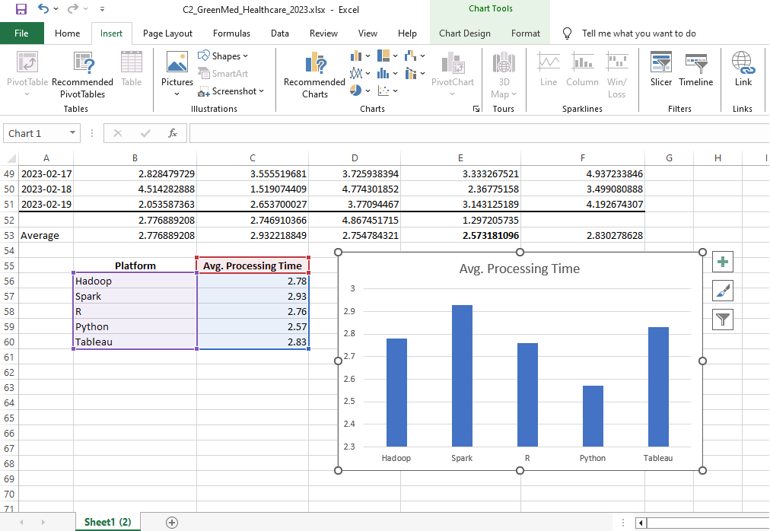

c. SPSS

Correlations
 |  | Hadoop Processing Time | Tableau Processing Time
Hadoop Processing Time | Pearson Correlation | 1 | .178
Hadoop Processing Time | Sig. (2-tailed) |  | .217
Hadoop Processing Time | N | 50 | 50
Tableau Processing Time | Pearson Correlation | .178 | 1
Tableau Processing Time | Sig. (2-tailed) | .217
Tableau Processing Time | N | 50 | 50

As the value of the Pearson correlation lies on.178, this can be demonstrated as a weak correlation. This is because if the value lies between; 0.7 to 1, the relationship is considered to be Strong, and if the value lies in 0.3 to 0.7-5 Moderate, and if the value is Less than 0.3, then the relationship is considered to be weak. The value of the Pearson correlation lies on.178. As a result, this can be demonstrated as a weak correlation.
As a result, it is safe to state that there is not much of a connection between Hadoop Processing Time and Tableau Processing Time.
In addition, the nature of the association is constructive, as demonstrated by the sign of the Pearson correlation coefficient, which is constructive.
If we set the significance level at 0.05 (5%), then we may claim that a relationship is significant if either the P value or the seg value is lower than 0.05. On the other hand, if the relationship is higher than 0.05, then we can say that the relationship is not significant. We are able to claim that the link is not important because the value is.217.
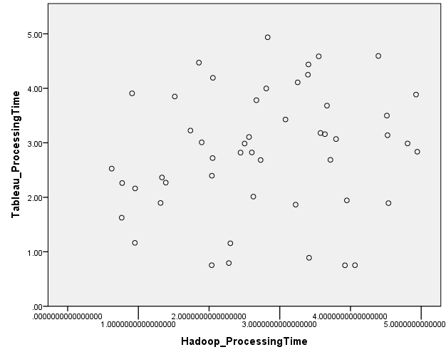
We are able to draw the conclusion that there is no association between Hadoop Processing Time and Tableau Processing Time by examining the graph. This is because the axes are somewhat scattered, and the data do not exhibit either a positive or a negative trend.

Conclusion
A high-level understanding is given by these interpretations. The observed variations in processing times between tools or platforms can be influenced by particular use cases, dataset sizes, and task complexity. Trend analysis over time can provide information about the effectiveness of a tool and help determine which tool is best for a given situation.

Part 2

The Advantages and Disadvantages of Using SPSS

A cornerstone in the data analysis sector, Statistical Package for the Social Sciences (SPSS) gives academics an effective tool for deciphering complicated datasets (Maxwell, 2019). Here, we will explore the benefits and drawbacks of using SPSS, with real-world examples to highlight how it affects statistical analysis.

Advantages:
User-Friendly Interface:
Because of its intuitive design, SPSS may be used by anyone with different degrees of statistical knowledge. Researchers may easily navigate the software with point-and-click capability, which facilitates efficient data analysis (Saunders, 2017). For example, a social science researcher looking into how socioeconomic position and academic achievement are related can input and analyze the data with ease even if they don't know anything about programming.
All-inclusive Statistical Tests:
Numerous statistical tests, ranging from sophisticated analyses to descriptive statistics, are available in SPSS. According to Warner (2018), because of its adaptability, researchers can select the test that best answers their study questions. For instance, a medical researcher looking into a new drug's effectiveness can use SPSS to evaluate the mean differences between treatment groups using an ANOVA or t-test.
Data Visualization:
With the powerful data visualization features that SPSS offers, researchers may produce informative graphs and charts. This is very helpful when presenting research to a variety of audiences (Warner, 2018). For example, a marketing analyst can create visually appealing charts to show consumer preferences and market trends using SPSS.
Data Cleaning and Transformation:
The program makes it easier to clean and transform data, which speeds up the process of becoming ready for analysis. Researchers have little trouble transforming data distributions, recoding variables, and handling missing data (Flynn, 2018). For example, before performing regression analysis, an environmental scientist analyzing climate data can use SPSS to clean and modify raw temperature data.

Disadvantages:
Accessibility and Cost:
Saunders (2017) mentioned that the price of SPSS is a major disadvantage that prevents researchers on a tight budget from using it. Alternatives that are available for free, such as R or Python, provide comparable features without the cost. These options are more affordable, which may appeal to a student doing research for a project.
Limited Flexibility for Advanced Analyses:
Although SPSS has a wide coverage of statistical tests, highly specialized analyses may not be able to fully utilize its flexibility. For their complex data analysis requirements, researchers in fields such as bioinformatics or machine learning may find other tools more appropriate (Flynn, 2018).
Steep Learning Curve for Advanced Features:
While SPSS is easy to use for simple analyses, it can be difficult to learn how to use its more complex features. If researchers want to use sophisticated statistical methods, they might require more training (Maxwell, 2019). For instance, learning and using structural equation modeling in the SPSS environment could take a lot of time for a finance analyst looking to implement the method.
Dependence on GUI:
Because of its heavy reliance on a graphical user interface (GUI), SPSS's analytical automation and reproducibility are limited. Researchers used to platforms that require coding might find it restrictive that there isn't a scripting environment. For greater control and reproducibility, a data scientist working on large-scale projects might favor a coding-centric approach (Warner, 2018).

To sum up, SPSS is a useful tool for statistical analysis because it has an easy-to-use interface, extensive statistical tests, and powerful data visualization. Its costs, limited flexibility for advanced analyses, steep learning curve for advanced features, and reliance on a graphical user interface (GUI) offset some of its benefits, though. Whenever choosing between SPSS and other statistical analysis tools, researchers must carefully consider their unique needs as well as the characteristics of their data.

The Importance of Data Governance
The comprehensive strategy for managing, safeguarding, and guaranteeing the integrity of an organization's data throughout its lifecycle is known as data governance (Englmeier, 2019). It entails creating guidelines for the appropriate use and management of data, such as policies, procedures, and standards. We will now examine the vital importance of data governance and clarify how it promotes compliance, data integrity, and strategic decision-making.
Ensuring the Quality of Data:
An organization's ability to maintain the quality of its information is greatly influenced by data governance. Data that is inaccurate or untrustworthy may result in poor decisions, monetary losses, and harm to one's reputation. Think about a retail business that uses consumer information for targeted advertising. According to Mahanti (2021), errors in the data, such as incomplete contact information or past purchases, could lead to misdirected marketing campaigns, which would waste money and negatively impact the consumer experience.
Regulatory Compliance:
Data governance is crucial for maintaining compliance in an era of ever-tougher data protection laws, like the Health Insurance Portability and Accountability Act (HIPAA) and the General Data Protection Regulation (GDPR). Serious fines and legal repercussions may follow noncompliance. For example, in order to maintain patient confidentiality and comply with HIPAA regulations, a healthcare organization needs to follow stringent data governance practices. If this is not done, the organization may face penalties, fines, and reputational harm (Stevenson, 2021).
Optimizing Decision-Making:
Data governance ensures reliable, high-quality data for strategic planning, preventing dated or untrustworthy investments. It improves decision-making by providing access to accurate and timely information, thereby reducing losses in financial institutions.
Data Privacy and Security:
Protecting the security and privacy of sensitive data is crucial given the rise in data breaches and cyberattacks. To prevent unwanted access and data breaches, data governance sets up procedures for data encryption, access controls, and monitoring (Mahanti, 2021). For instance, a technology company that handles user data needs to put strong data governance procedures in place to guard against cyberattacks, maintain customer confidence, and secure the company's intellectual property.
Establishing Data Accountability:
Data governance defines organizational roles and responsibilities in data management, assigning stewards for data quality, privacy officers for regulatory compliance, and IT administrators for security (Stevenson, 2021). This framework streamlines data-related tasks and ensures prompt resolution of issues.
Facilitating Data Integration:
Many businesses use different databases and operating systems. Integrating these various sources is made easier by data governance, which guarantees coherence and consistency throughout the company. To create standardized data formats and protocols, for example, a manufacturing company with distinct databases for sales, inventory, and production can use data governance to enable seamless integration and a comprehensive view of operations (Englmeier, 2019).
In the end, it can be said that data governance acts as a compass to help organizations navigate the vast ocean of data. Data governance plays a crucial role in the prosperity and long-term viability of contemporary businesses by guaranteeing data quality, encouraging regulatory compliance, improving decision-making, safeguarding confidential information, establishing accountability, and easing data integration. Adopting strong data governance practices becomes essential for organizations navigating the opportunities and challenges of the data-driven landscape, as the volume and complexity of data continue to rise.

References
Englmeier, K. (2019) ‘Role and importance of semantic search in Big Data Governance’, Big-Data Analytics and Cloud Computing, pp. 21–35. doi:10.1007/978-3-319-25313-8_2.
Flynn, J. (2018) ‘Using the SPSS Interactive Graphics Feature’, Next Steps with SPSS, pp. 92–105. doi:10.4135/9781412985284.n6.
Mahanti, R. (2021) ‘Introduction to data, Data Governance, and Data Management’, Data Governance and Data Management, pp. 1–3. doi:10.1007/978-981-16-3583-0_1.
Maxwell, D. (2019) ‘Using the SPSS production facility’, Next Steps with SPSS, pp. 106–117. doi:10.4135/9781412985284.n7.
Saunders, J. (2017) ‘Supplemental SPSS operations’, Introductory Statistics Using SPSS, pp. 243–274. doi:10.4135/9781071878910.n10.
Stevenson, M. (2021) ‘Data and its Governance’, Data Governance and Data Management, pp. 5–82. doi:10.1007/978-981-16-3583-0_2.
Warner, S. (2018) ‘Working in SPSS’, Intermediate Statistics Using SPSS, pp. 20–42. doi:10.4135/9781071802625.n2.

