Ling Scott M | Structural Mechanics/ACDA6009 | November 1, 2021

The deflection of Beams

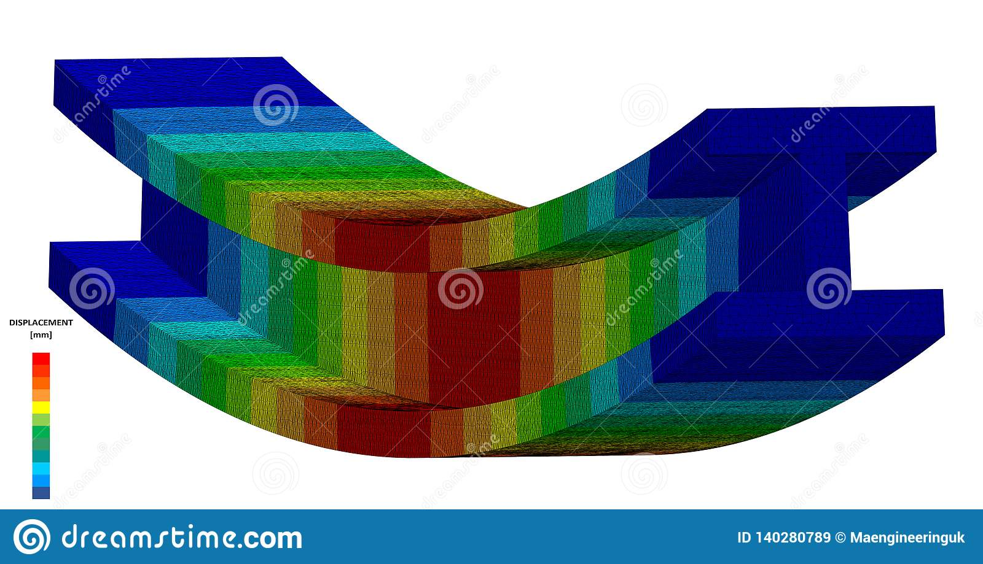
Figure 1 Image of beam deflection (Maengineeringuk, 2009)

Abstract
For the purpose of this report the author will compose a report based on a laboratory experiment on beam deflection experiment on Brass and Mild Steel. A load was applied to the beam at various positions along the beam and measurements were taken and recorded which can be found further in to the report. Once all data was obtained Macaulay’s method was used to calculate the deflections. A comparison of calculated deflections will be carried out with the measured deflections taken during the laboratory experiment.
Contents
Abstract 1
Introduction 2
Background theory 2
What is beam deflection 2
Mild Steel Properties 3
Brass properties 3
Finite Element Analysis 3
The Bernoulli-Euler theory 3
Macaulay’s Method 4
Equipment for Laboratory experiments 5
Experimental Procedure 10
Experiment procedure 1 Beam Load 10
Experiment procedure 2 Beam Material 11
Experiment procedure 3 Beam Dimensions 12
Results 12
Discussions 18
Mitigating factors 19
Conclusions 19
Recommendations 20
Table of Figures 20
References 21

Introduction
For the purposes of this report the author has been requested by a company (Customer) that carries out designs and construction of buildings that are able to withstand blast and ballistic damage. The company has requested an investigation to be carried out into deflection of material beams of brass and Mild Steel.
To be able to achieve this the author will carry out beam deflection calculations using Macaulay’s method and then a laboratory based experiment on beam deflection. The author will record data results from the laboratory based experiment.
The Calculations that were made prior to the laboratory based experiment will be used to validate the results that have been obtained.

Background theory

Beams are structural elements, these are designed to resist and bending and also loading, there is effectively 2 types of beams these are:
- Built in (these can be fixed, clamped or encased)
- Supported (these would have a type of frame or based constructed to the beam)

What is beam deflection
Beam deflection can be explained by referring to it “the change of the beam under load from its unloaded position2. The deflection is measured by its original neutral surface to the neutral surface of the deformed beam.
The configuration taken from the deformed state is known as the elastic curve within the beam. Deflection of a beam can alter due to different circumstances these are as follows:
- Stiffness of the chosen material
- Dimensions of the beam
- Loads applied to the beam
- What support the beam has.
There are four common ways of calculating beam deflections these are:
- Macaulay’s methods (single function0
- Direct integration method
- Superposition method
- Energy method

Mild Steel Properties
Mild steel is a ferrous metal. The strengths and weakness of mild steel is that Mild steel has a high strength value which in turn reflects a lower cost value to produce. It is also more malleable and easily machined, a weakness to mild steel that a coolant is needed to prevent welding for it to be able to be machined.
Mild steel is used in meshes and structural sections and comes in forms of sheets, rods, plates and bars. (BBC GCSE Edaqus, NA)

Brass properties
Brass is an alloy, it is made up of a mixture of zinc and copper, however copper is the dominant component in the mix.
The strengths and weaknesses for copper is that it is known to be corrosion resistant and denser than copper. The properties of brass make it pliable and very ductile. (BBC GCSE Edaqus, NA)

Finite Element Analysis
Finite element analysis (FEA) is a computer software method that can be used for forecasting how a product can react to everyday real world forces. (Autoodesk, n.d.)
By using Finite element analysis this will highlight whether the material in question will break, degrade over time or in fact be suitable for what it is required to do. (Autoodesk, n.d.)
The term analysis is used, however for the development of products, this is used as a prediction to tool to illustrate what will happen when the product is used. (Autoodesk, n.d.)
Finite element analysis performs by breaking the material used into a large number of elements. The software will then use mathematical equations to assist in the prediction of the actions of each element within the material. The software will then calculate the actions of each element to give an overall performance of the material. (Autoodesk, n.d.)

FEA assists the user with the predictions of the products actions that can be impeded by a variety of effects this can include:
- Mechanical stress
- Vibration
- Material fatigue
- Shifting
- Transfer of Heat
- Moisture

The Bernoulli-Euler theory
The Bernoulli-Euler theory is a model from which beams can behave from bending and axial forces.
The theory is based on assumptions, however these assumptions are subsequently used in most design cases.
Following the assumptions that the theory uses it produces an equation as follows:
$\frac{d^{2}∆}{dx^{2}}=\frac{M}{EI}$
Where $\frac{d^{2}∆}{dx^{2}}$a second derivative for deflection within the beam, $∆$ gives the position along the beam. The letter M in the equation denotes the internal moment within the location of$X$.
Young’s modulus is shown in the form of “E” and “I” represents the moment of inertia of the beams cross section.
This differential equation applies to any point for the length of the beam as long as the current assumptions remain valid. (Prof. Jeffrey Erochko, 2020)

Macaulay’s Method
Macaulay’s method is a way of working out the equation for deflection within a beam. This equation shows any deflection that could be useful to the user. Macaulay wrote a paper in 1919, however prior to this there was no way of being able to work out beam deflection.
By using Macaulay’s method it enables the user to use the method to be able to write the equation for bending moment within the full length of the beam.
This is paired with the Euler-Bernoulli theory, by pairing the method with the theory it allows integration to be carried out for the bending moment and enables the calculation for deflection.
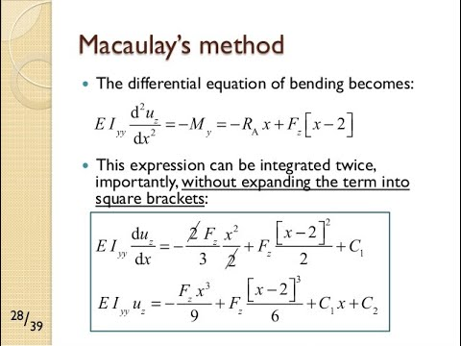
Figure 2 Macaulay’s formula (Engineering, 2020)

Equipment for Laboratory experiments
The equipment that was used in the experiment is as follows:
- Work Panel
- Dial Indicator and wire stirrup
- Brass beam at the measurements of 372mm x 9.5mm x 3mm
- Steel beam at the measurement of 372mm x 9.5mm x 3mm
- Fixing Blocks as supports
- Load hanger
- Weighted disks
- Dial Caliper gauge
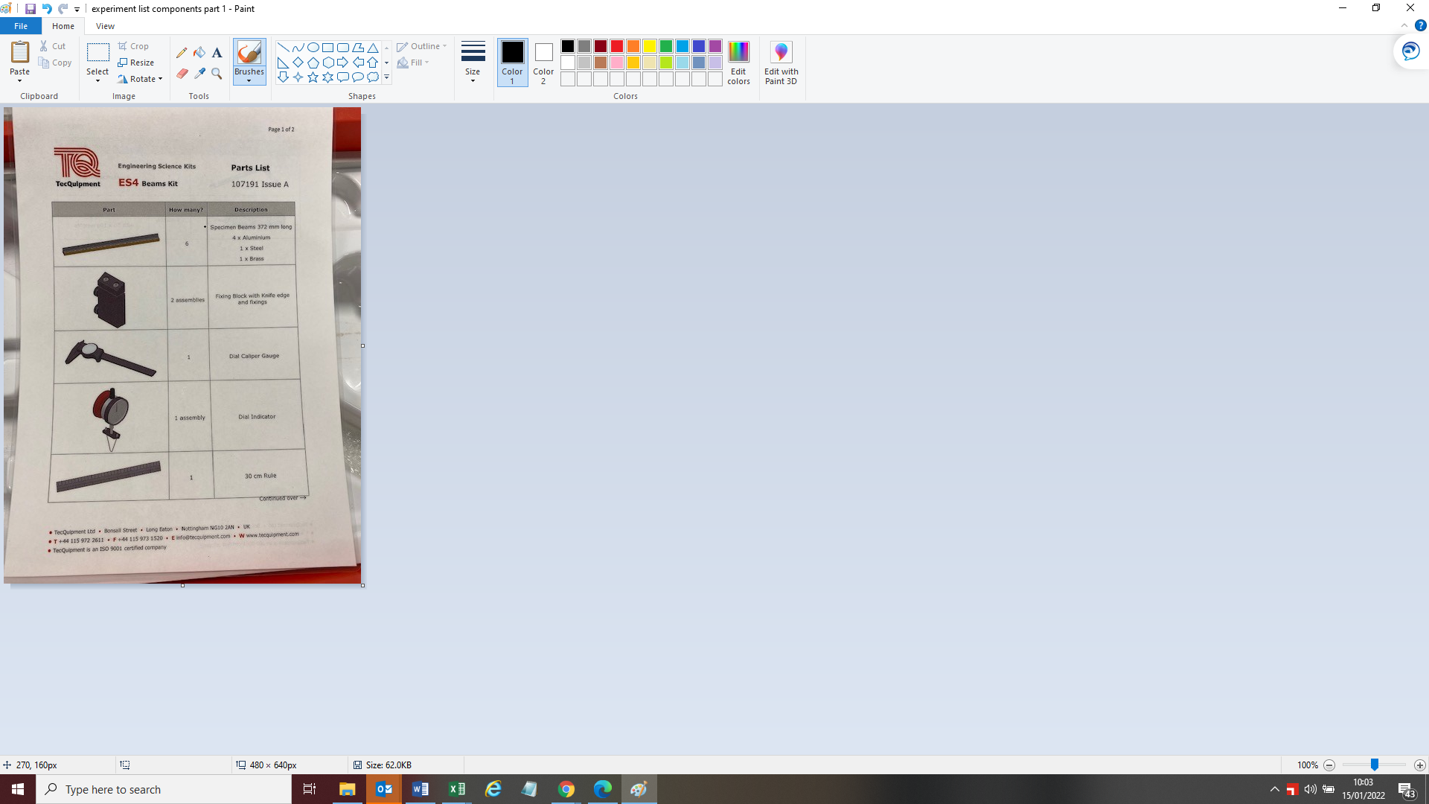
Figure 3 Components list for experiment part 1
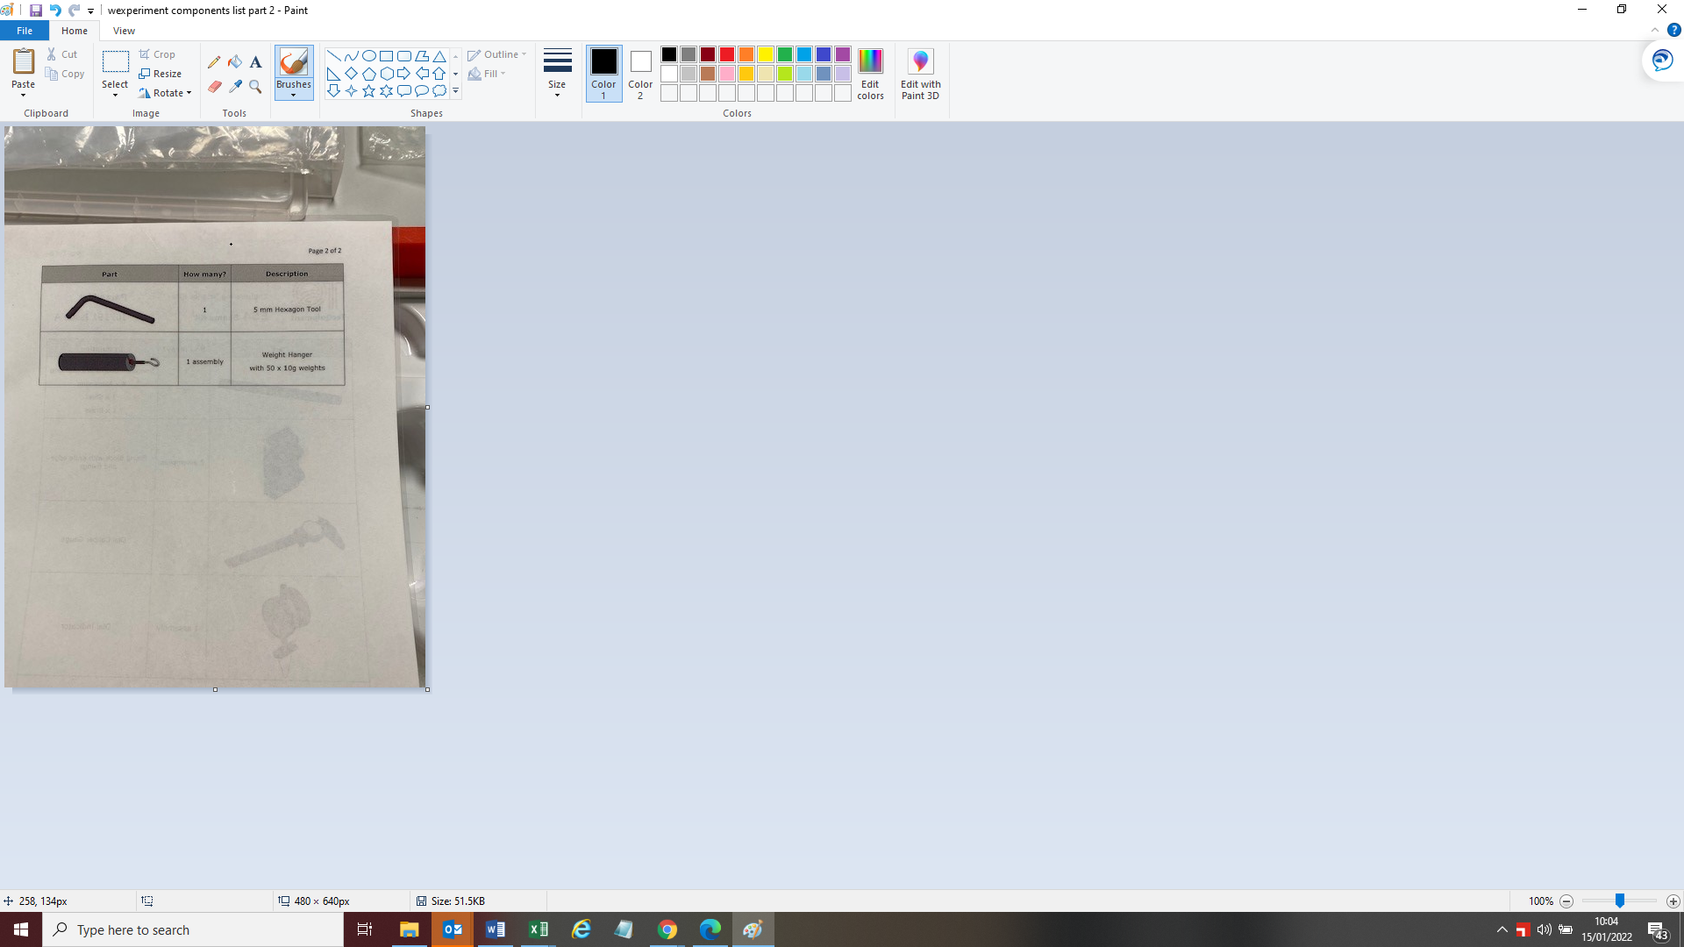
Figure 4 Components list for experiment part 2

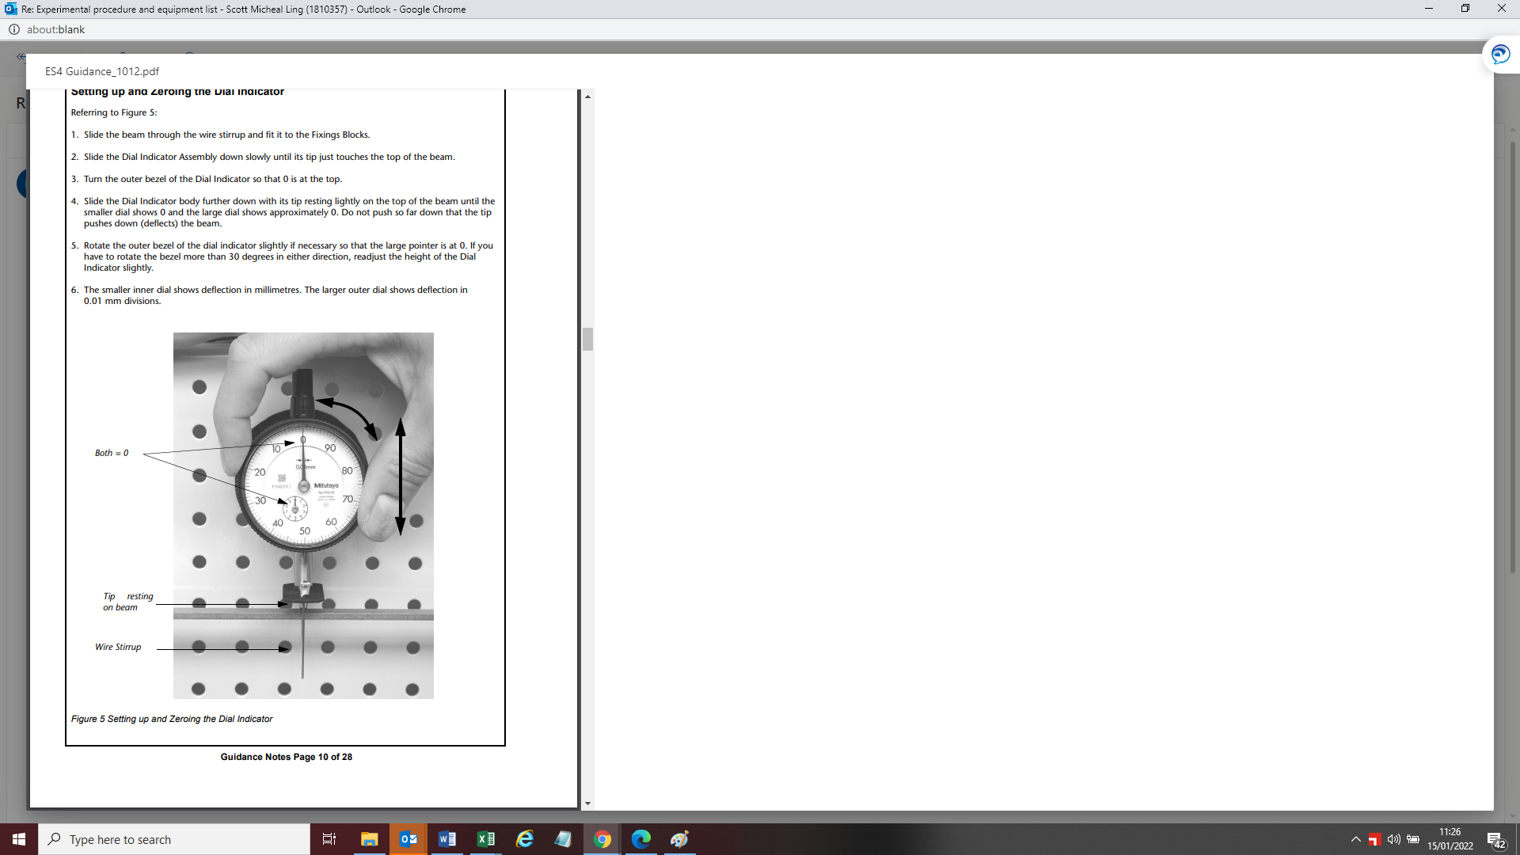
Figure 5 Setting up and zeroing the Dial indicator
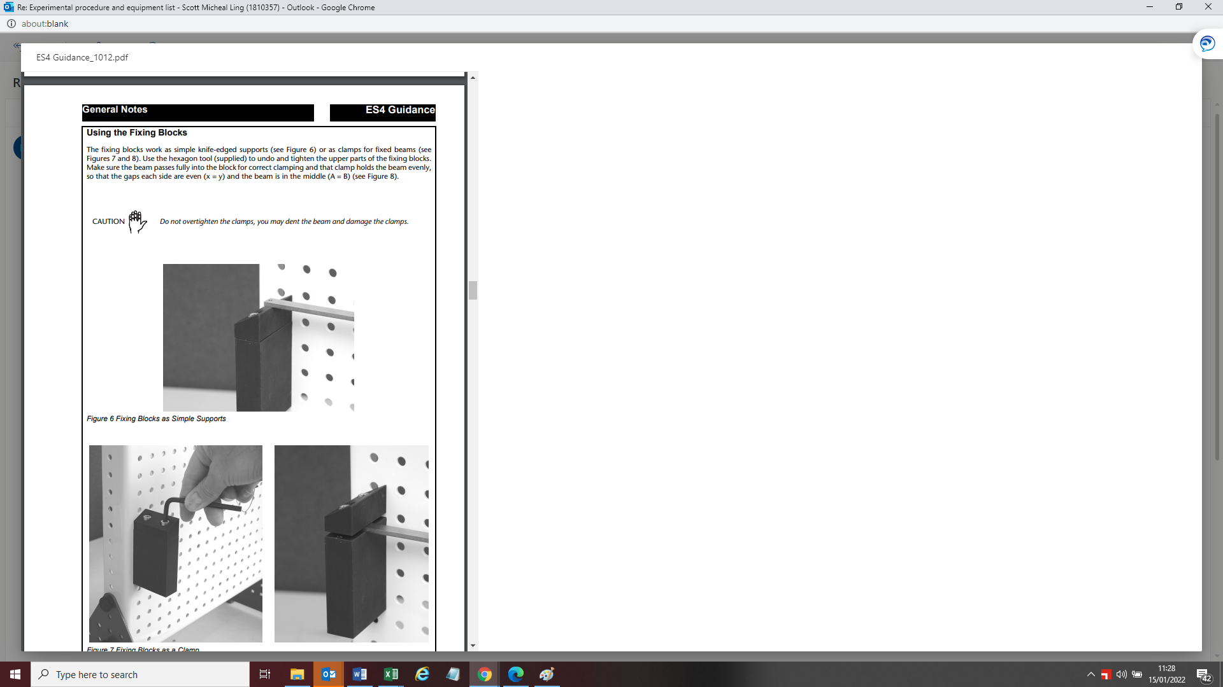
Figure 6 Fixing holding blocks for the beam
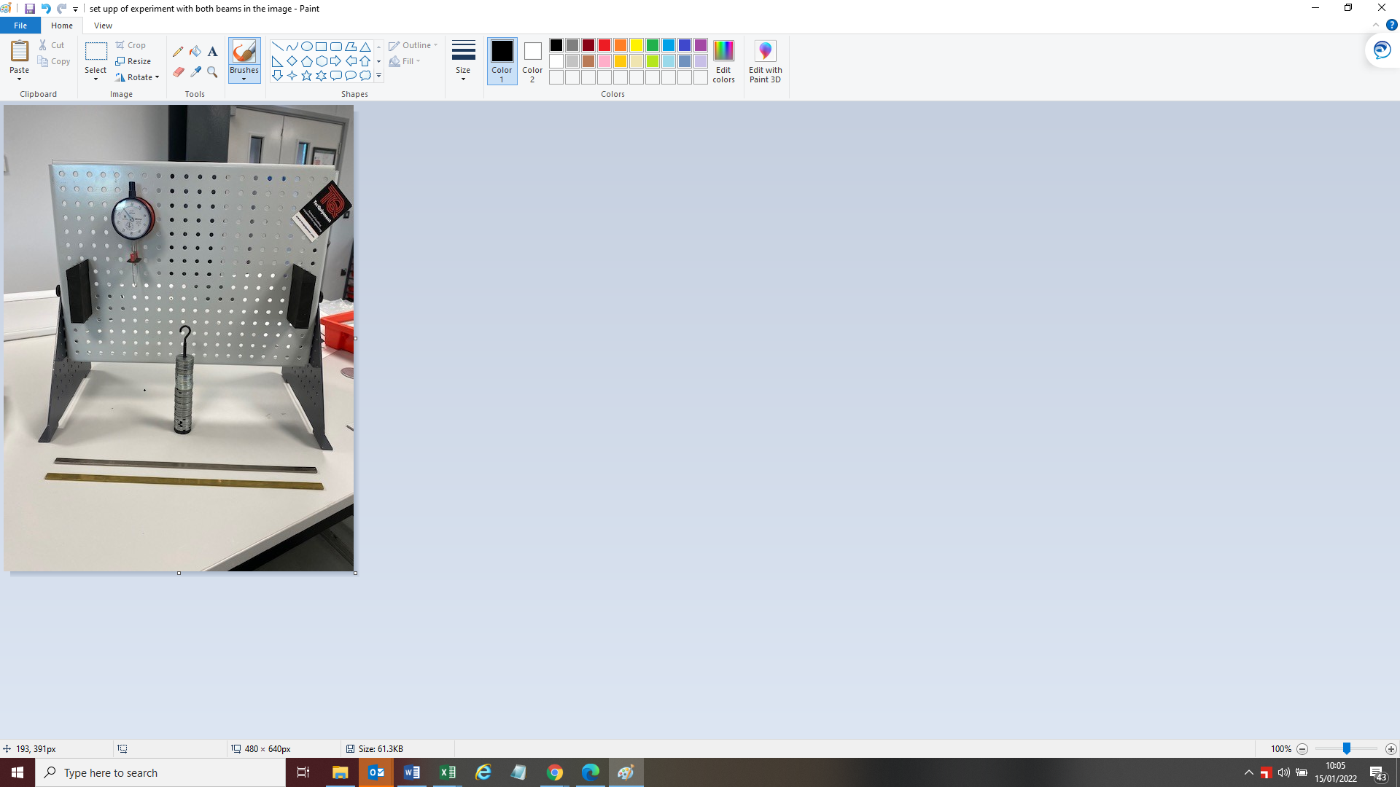
Figure 7 Experiment set up with Brass and Steel beam
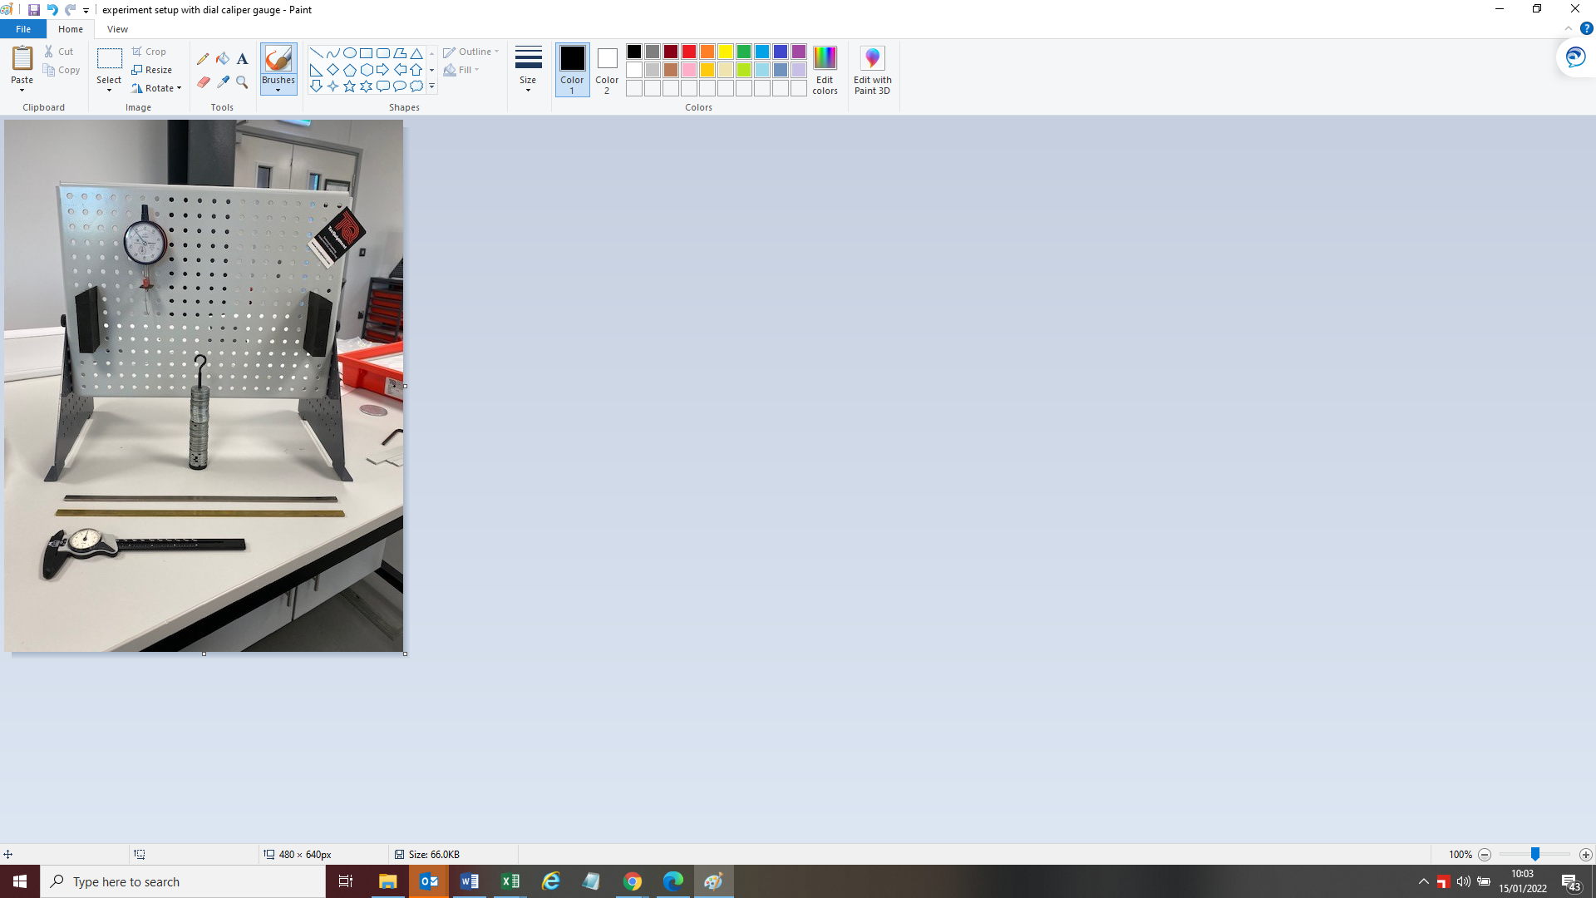
Figure 8 Experiment set up with digital caliper gauge
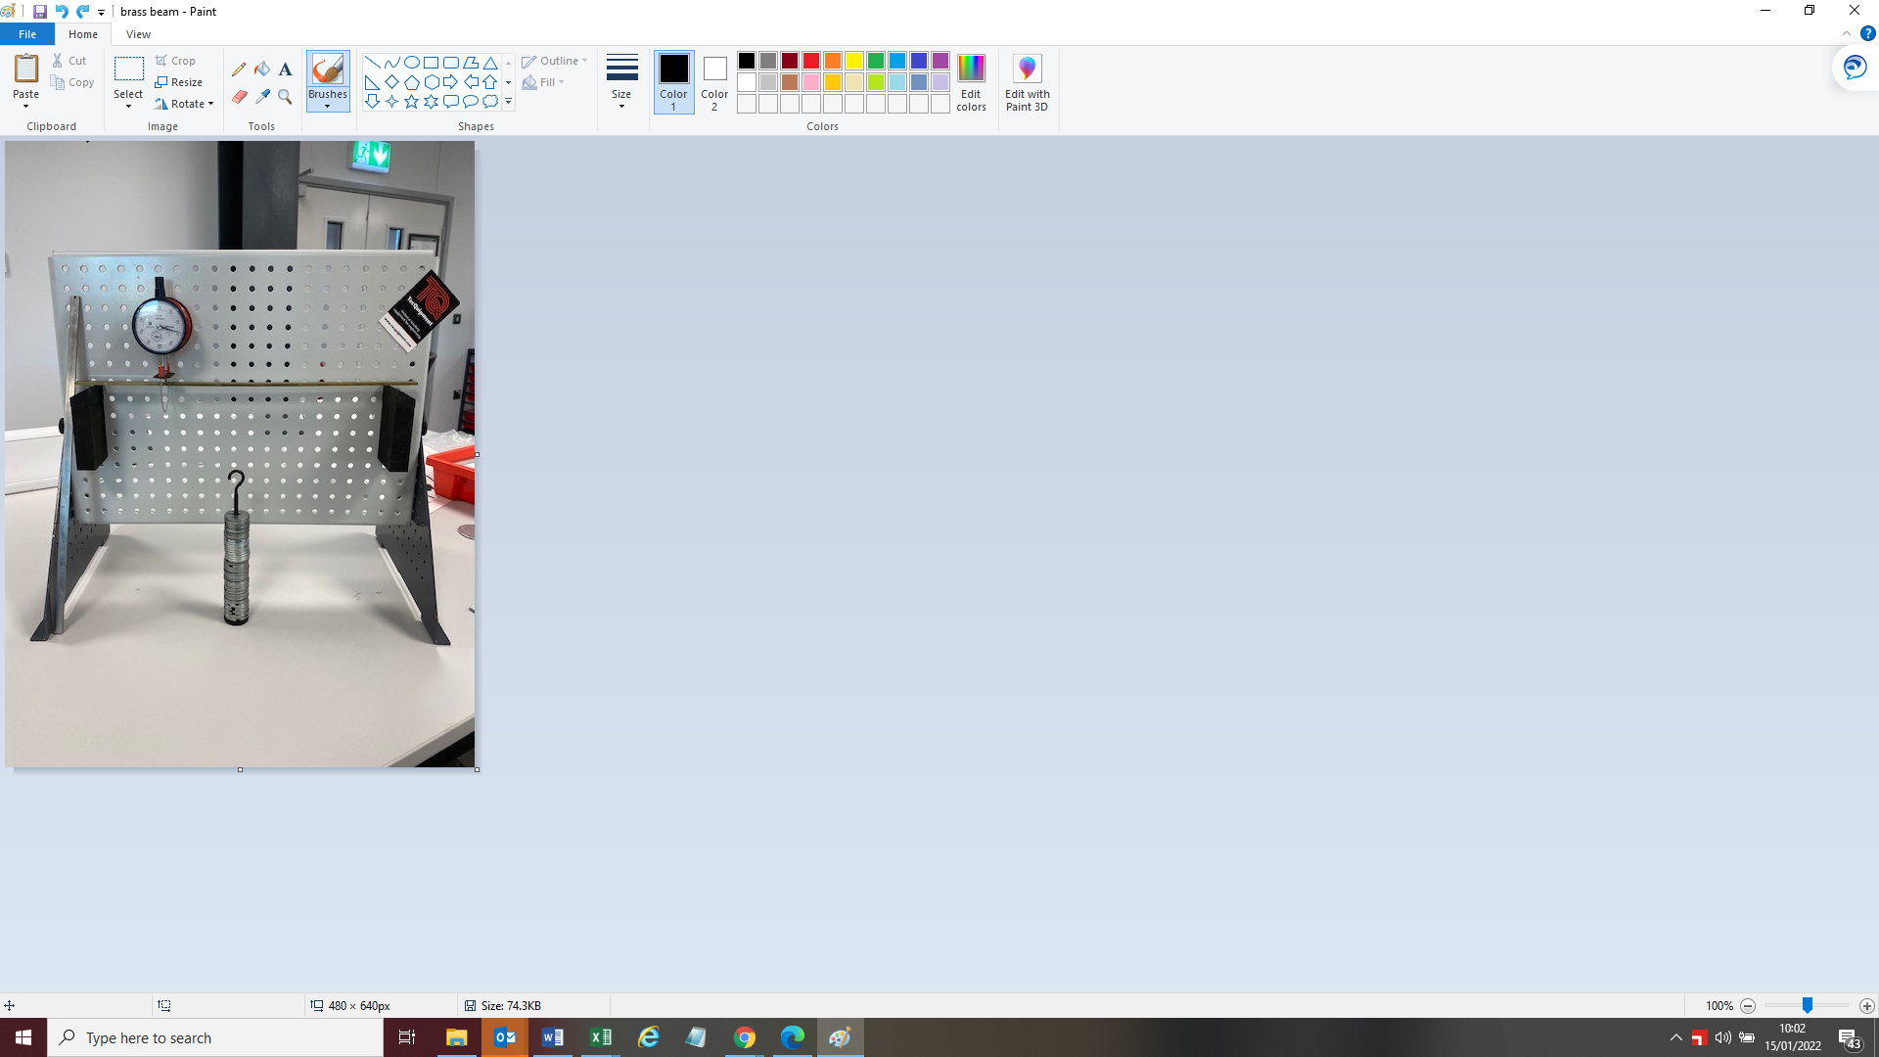
Figure 9 Brass beam placed on supporting blocks

Experimental Procedure

Experiment procedure 1 Beam Load
This experiment is to show the correspondence between load and deflection in a beam.
The experimental procedure for beam loading is as follows:
- Construct the work panel as illustrated in figure 4,
- Fixing blocks should be placed 372mm apart,
- Dial indicator and wire stirrup will be placed in the middle of the work panel at 180mm,
- Set and zero the dial indicator to zero,
- In increments of 100grams, add weights to the beam a maximum of 500 grams.
- Once weights have been added tap the work panel by doing this it will reduce the effects of friction,
- Collect data for the weight set added then repeat until user has reached the previously mentioned limit of 500 grams.
- Calculate the loads into Newton’s.
Data obtained during the experiment will be inputted into a table to allow the user to then input this into an excel document to generate results, the same table will be used for Steel and Brass. An example of the table can be seen in figure 7
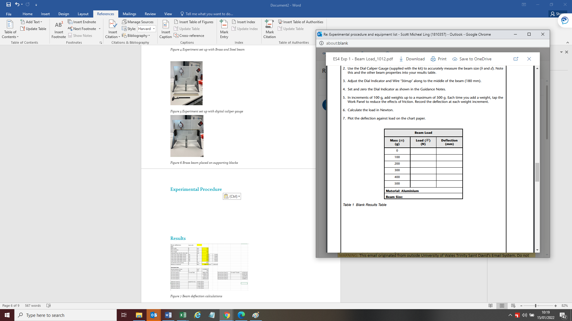
Figure 10 experiment data recording table example

Experiment procedure 2 Beam Material
This experiment is to show that beams of different materials with identical dimensions will deflect by different amounts with the same load. This demonstrates that young’s modulus within the material properties will affect deflection.
The experiment procedure for Beam material is as follows:
- Read guidance Notes
- Find three beams that have similar dimensions
- Use a dial caliper to measure the dimensions
- Rest the Brass beam across the supports and adjust the dial indicator and wire stirrup
- Set and zero the dial indicator
- Add the weight hanger and 49 weights that gives the weight of 500 grams, tap to work stand to reduce friction
- Repeat for the Steel beam

Experiment procedure 3 Beam Dimensions
This experiment is to show that beams dimensions and the correspondence between beam I value and deflection.
The experiment procedure for beam dimension is as follows:
- Use the same equipment set up as previous experiments,
- Use the dial caliper to measure the beam dimensions (b value) and (d value) and calculate the “I value” based on the force applied to its widest face.
- Rest a beam on across the supports and adjust the dial indicator and wire stirrup along the center of the beam,
- Zero the dial indicator as shown in figure 7
- Add the weight hand with 49 weights, by doing this 500 grams is applied to the beam.

Results

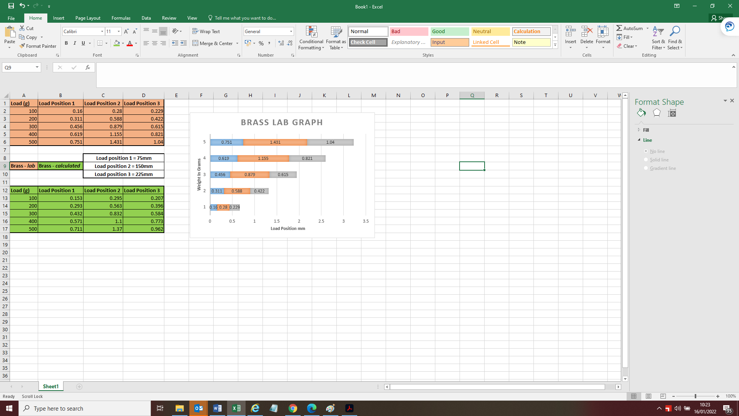
Figure 11 Brass beam experiment and calculations results

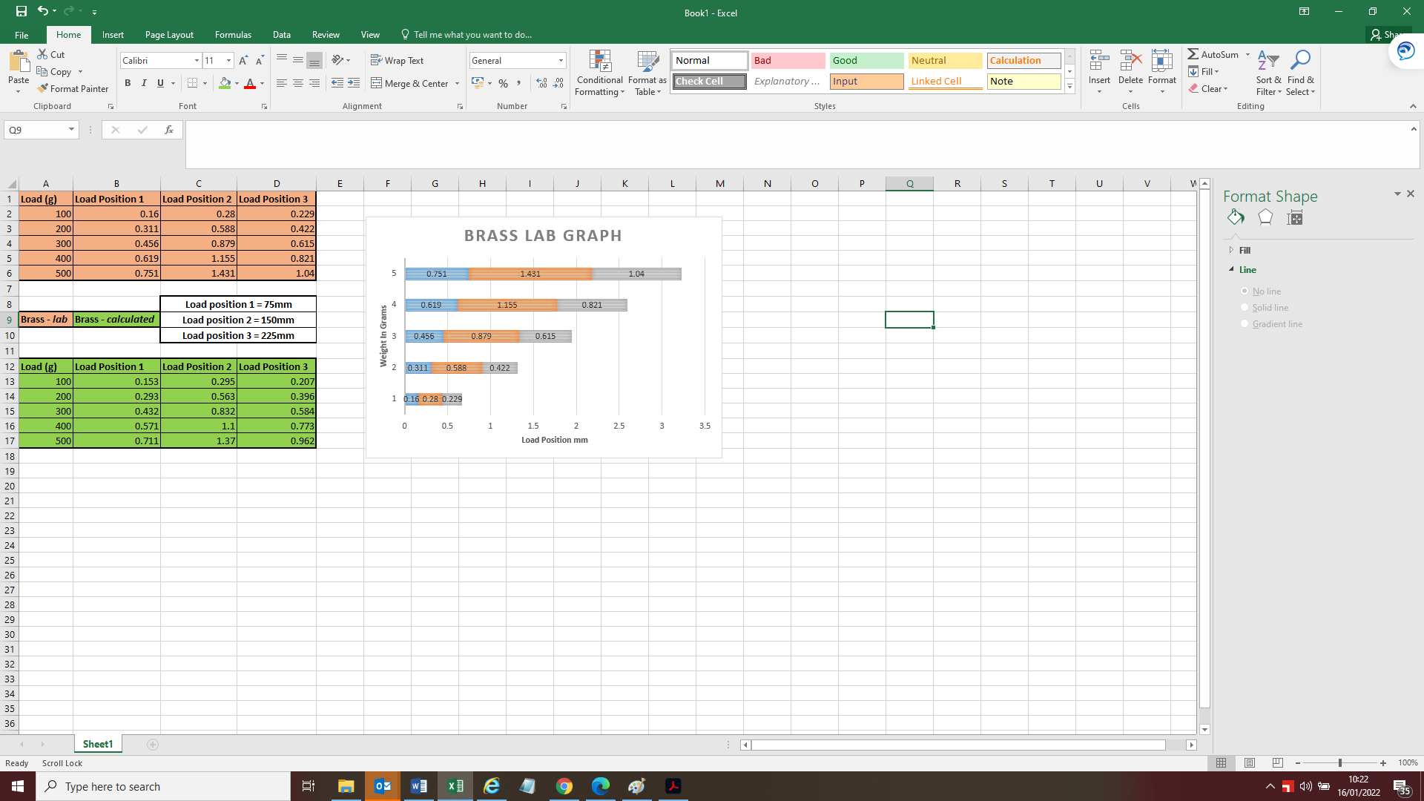
Figure 12 Graph for laboratory experiment results using Brass

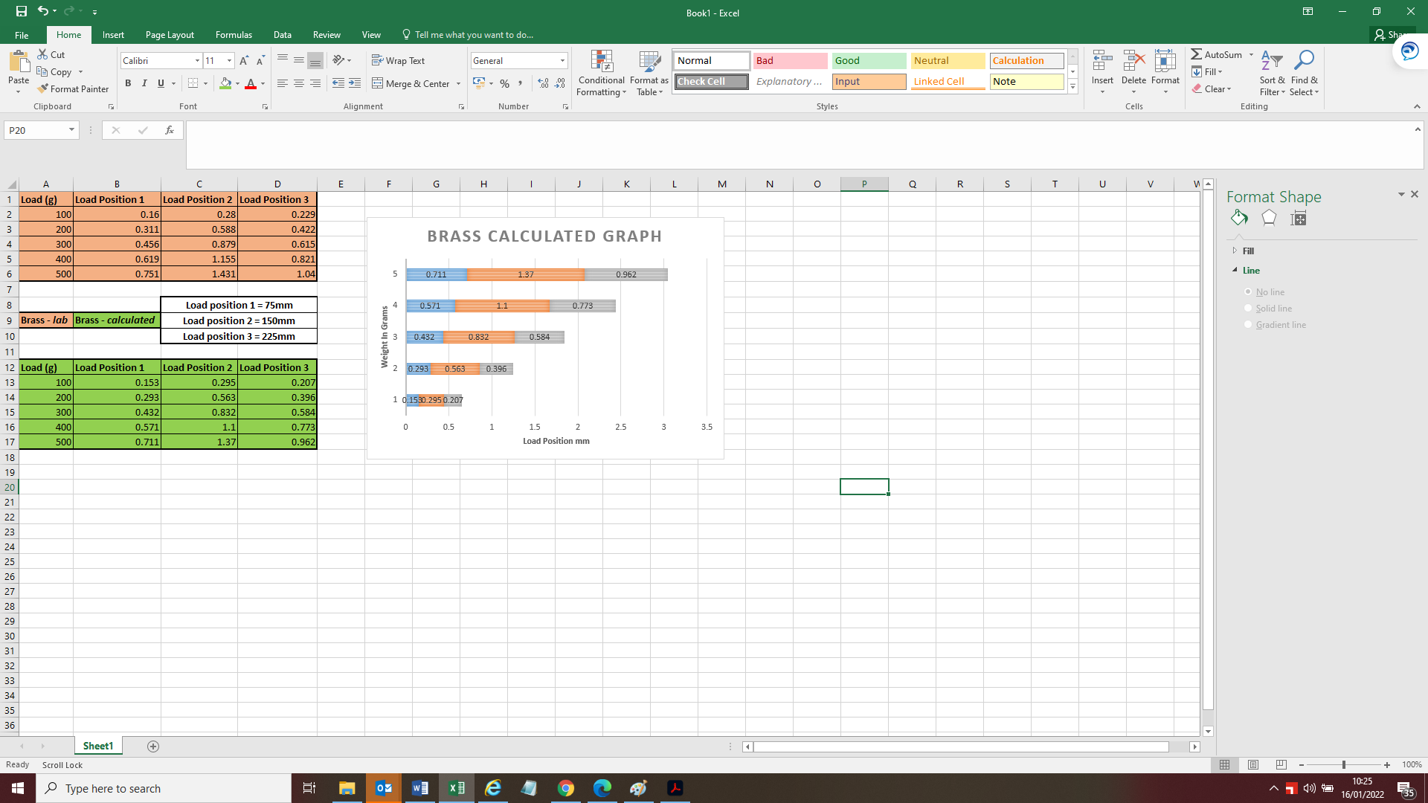
Figure 13 Graph for brass calculated results

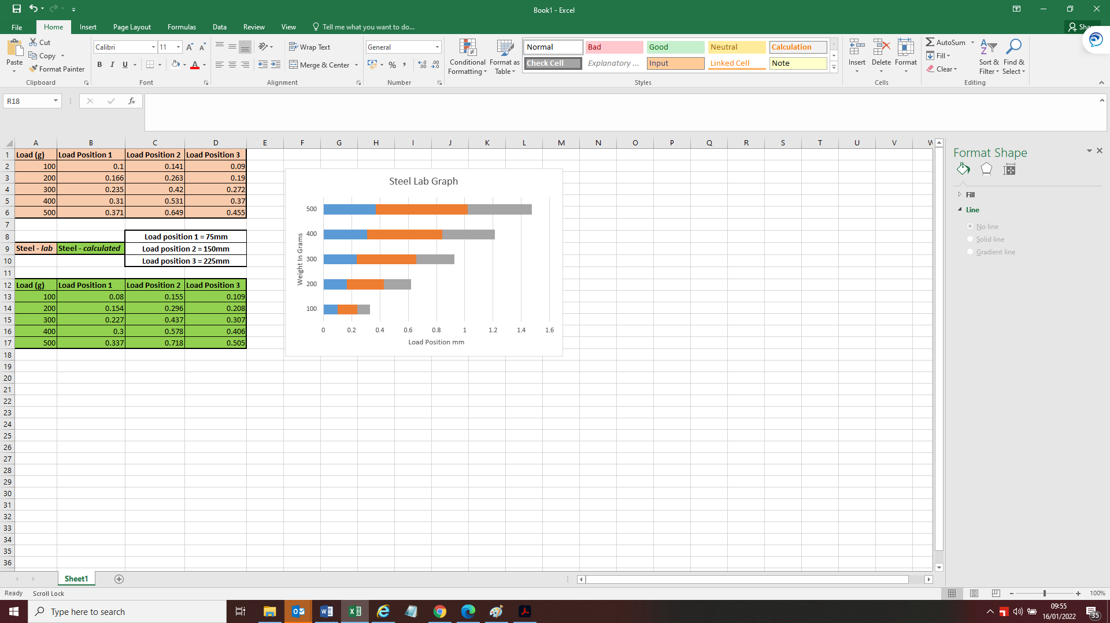
Figure 14 Steel Beam Laboratory experiment results and calculated results

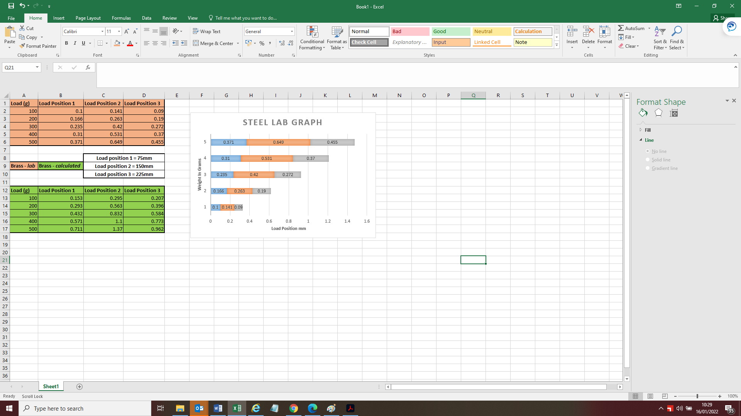
Figure 15 Graph for laboratory results for Steel
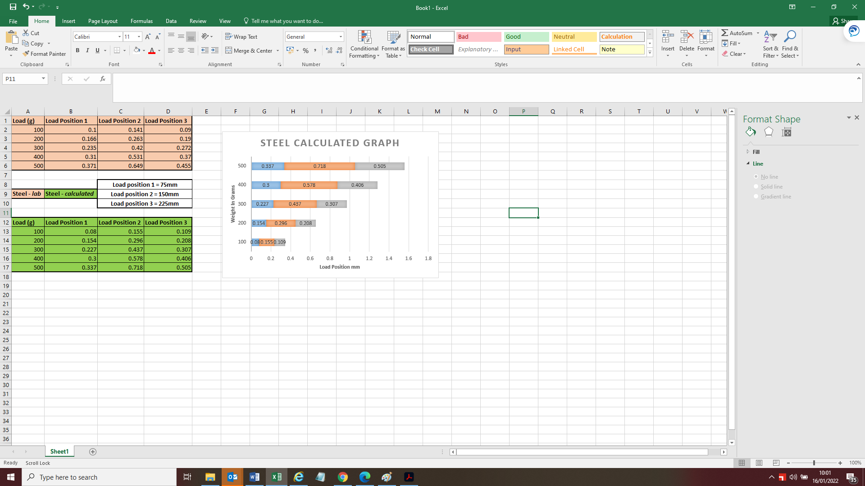
Figure 16 Graph for steel calculations

Discussions
After collecting the data from the using the Macaulay’s method for calculations and carrying out the laboratory based experiment the author can look at comparing the results obtained. The analysis of both data sets can be executed.

A beam that has a higher value with second moment of either inertia or area will show less of a beam deflection and a beam that has a lower value or inertia will show larger deflection. Following this it can be noted second moment of inertia relates to the beam where it will resist the bending or deflection of a beam.
From the results it can be noted that there are differences between the calculated results and the laboratory results.
The laboratory results show a bigger deflection within the materials compared to the calculated results.
From the results it shows that brass has a higher deflection rate that that of steel, this is due to the young’s modulus of the materials with steel having a higher young’s modulus (210) than brass (102-105).

Mitigating factors
The experiments carried out could come with errors, these errors could be from two factors. Factor one could be as a result of the apparatus and the second is down to human error.

Factors to consider from the apparatus error is dial gauge that isn’t accurate, the work surface the test is being carried out on are the beams that are being used have deformation to them prior to the test.

To mitigate against the apparatus errors, the experiment could be repeated again if the figures taken in a repeat experiment are different from the first experiment then the user should look at getting the equipment calibrated.

Human factor errors could be from inaccurate observations, using the methods or not having experience in this could lead to incorrect calculations.

To mitigate against human error the experiment could be carried out with a second person or the original user could seek more experience in this field prior to running the experiment

A further more in depth analysis and exploitation of results could have been carried by the author, however due to restrictions this wasn’t able to be achieved fully at this time.

Conclusions
In conclusion to the data obtained.
Using the calculations and the laboratory experiment to obtain the results is an effective way of obtaining information that can be passed on to the customer.
A beam that has a higher value with second moment of either inertia or area will show less of a beam and a beam that has a lower value or inertia will show larger deflection. Following this it can be noted second moment of inertia relates to the beam where it will resist the bending or deflection of a beam
Additional information could be obtained by carrying out Finite Element Analysis. By carrying out FEA this will give a visual aid on what stress and strains could be applied and highlight the weak points within the desired material.
Computer simulations allows the user to obtain data if it is a new idea or design prior to physically using the material. Carrying out these investigations from a commercial point allows the customer to reduce the overall cost to the project and the company.
However using computer simulation does have it its own draw backs, computer modelling simulation can find it difficult to define material boundaries, as the different materials can mix in the same cell, this happens where the line materials interact.
The mixed cells will require a specific techniques to be able to mitigate this from happening.
Gaining the additional data from computer simulations can be key in the early stages of designing and planning as from the overall project point of this can reduce overall costing to the project if a chosen material is not suitable.
However the computer software will not take into account real life issues that may be presented.

Recommendations
Further recommendations to be made following on from this report would be more investigational work to be carried out using Finite element analysis (FEA). Carrying out an additional FEA investigation will give the customer a more realistic visual review of how the Brass and Mild Steel will be behave under given conditions as this will visually show the stresses a and strains of the materials.

Table of Figures
Figure 1 Image of beam deflection (Maengineeringuk, 2009) 0
Figure 2 Macaulay’s formula (Engineering, 2020) 4
Figure 3 Components list for experiment part 1 5
Figure 4 Components list for experiment part 2 6
Figure 5 Setting up and zeroing the Dial indicator 7
Figure 6 Fixing holding blocks for the beam 7
Figure 7 Experiment set up with Brass and Steel beam 8
Figure 8 Experiment set up with digital caliper gauge 9
Figure 9 Brass beam placed on supporting blocks 10
Figure 10 experiment data recording table example 11
Figure 11 Brass beam experiment and calculations results 13
Figure 12 Graph for laboratory experiment results using Brass 14
Figure 13 Graph for brass calculated results 15
Figure 14 Steel Beam Laboratory experiment results and calculated results 16
Figure 15 Graph for laboratory results for Steel 17
Figure 16 Graph for steel calculations 18

References
Autoodesk, n.d. Finite element analysis software. [Online]
Available at: https://www.autodesk.co.uk/solutions/finite-element-analysis
[Accessed 3 01 2022].
BBC GCSE Edaqus, NA. Metals. [Online]
Available at: https://www.bbc.co.uk/bitesize/guides/zn2w7p3/revision/2
[Accessed 05 01 2022].
Caprani, D. C., 2010/2011. Deflection of Flexural Members. [Online]
Available at: https://www.colincaprani.com/files/notes/SAIII/Macaulay%27s%20Method%201011.pdf
[Accessed 04 01 2022].
Comsol, 2022. Introduction to structural Mechanics. [Online]
Available at: https://www.comsol.com/multiphysics/introduction-to-structural-mechanics
[Accessed 03 01 2022].
Engineering, C., 2020. Strength of material. Himalya: Civil engineering.
Maengineeringuk, 2009. 3D Illustration. Isometric deflection plot of an I Beam in bending with scale. NA: Dreamstime.
mechanicalc, 2014-2022. Stresses & Deflections in Beams. [Online]
Available at: https://mechanicalc.com/reference/beam-analysis
[Accessed 11 01 2022].
Prof. Jeffrey Erochko, P. P., 2020. The Bernoulli-Euler Beam Theory. [Online]
Available at: https://learnaboutstructures.com/Bernoulli-Euler-Beam-Theory
[Accessed 06 01 2022].

