Exercise 1: Creating the Project
- Open up Visual Studio 2015
- Create a New Project
  - Go to File New Project …
  - Under templates, make sure the Visual C# is selected and select an ASP.NET Web Application template.
  - Give your project a name of your choice and save it to your preferred location.
  - Select the option to Create new Git repository
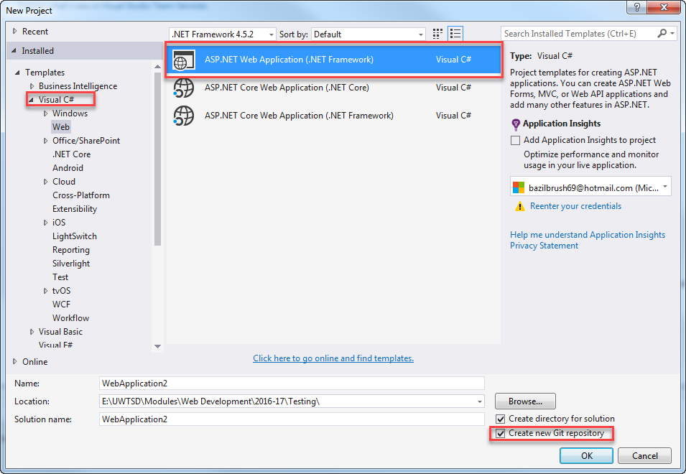

- In the next window, select the following:
  - Template: MVC
  - Check “Add Unit Tests”
  - Authentication: Individual User Accounts
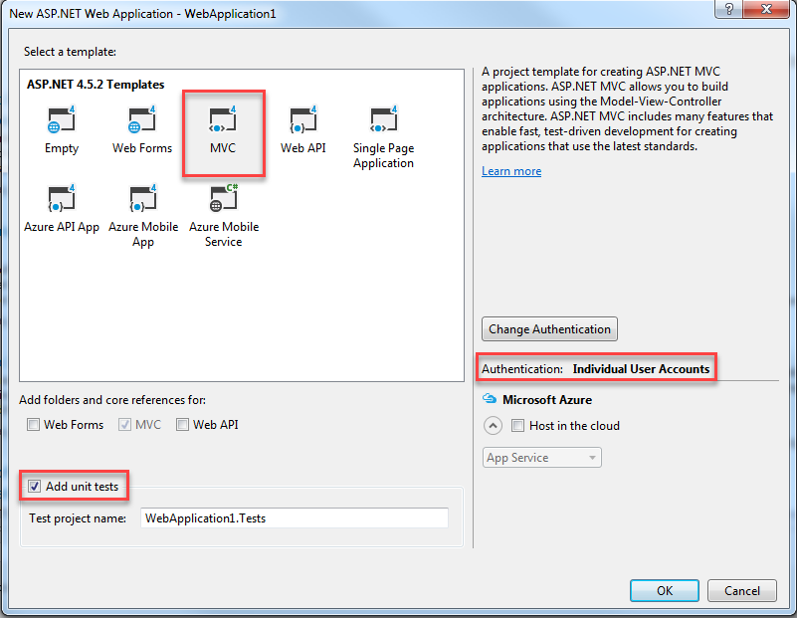
- Be patient it takes a while to load.

Exercise 2: Adding Project to Source Control
It is good practice to use version control on your software development projects. You do not have to do this, it is just a suggestion. The instructions provided here are for Bit Bucket, but you are free to use anything else.
You can skip to the next exercise if you know how to do this already or you do not wish to use source control or if you wish to use a different tool.
- Go to https://bitbucket.org/ and create an account using your university email address if you do not already have one.
- As you are working in pairs, you will need to create a team.
  - Add your partner and me to your team.
- Create a new repository and make note of the URL address.
  - Simply go to Repositories Create Repository and follow the instructions – the defaults are fine.
- In Visual Studio, from the menu, go to View Team Explorer. You can also switch to it using the Team Explorer tab in the solution explorer area.
- Click the little arrow as shown below to bring up the menu and select Sync from the menu options.
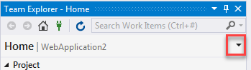
- Next scroll down and look for the Publish to Remote Repository section.
  - Click the Publish Git Repo button
  - You should get a text field prompting for the URL address of your repository. Paste in the URL of the repository you created earlier on BitBucket.
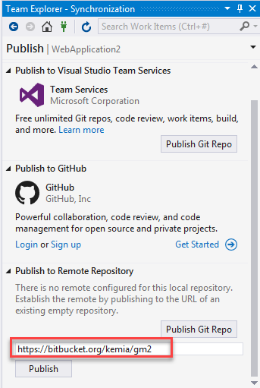
- You can go back to Bitbucket to confirm that it has published your new project.

Exercise 3: Checking in your Changes
- As you are using version control, it is good to check in changes frequently.
- Go to the TeamExplorer window. If the changes to commit are not visible, click the little arrow to bring up the menu and select changes
  - You can also right-click on the Project node in solution explorer and select Source Control Commit…
- You should see a list of any pending changes.
- You will also be asked for a commit message. It is good practice to identify your commits (a group of changes). Give your changes a name, for example:
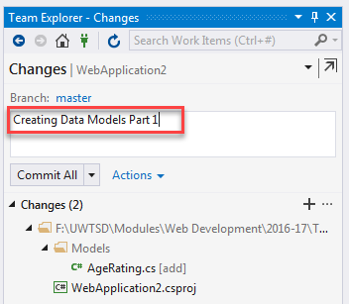
- For the Commit All button, you have three choices (click the little arrow to see them). You probably want the second option (Commit and Push) at the minimum.
  - Commit will simply make record of your changes that you have made on your local machine. It will not mark the change in the remote repository.
  - Commit and Push will do the above and push it to the remote repository. This means that any changes you have made will be saved to the remote repository as well.
  - Commit and Sync does three things. First, it will commit. Second, it will perform a pull (grabs the updated information from the remote repo). Finally, it will push.
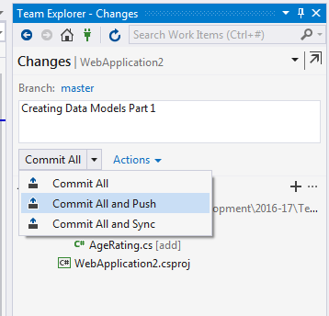
- Click the Commit All button with the right choice to save the changes and upload them to bitbucket.
- You can go to Bitbucket to confirm that the changes were saved.
- That’s all for today.

Git Behind a Proxy Server
https://forum.freecodecamp.org/t/git-behind-a-proxy-server/13187

