In 2020 we saw the birth of a new world due to the covid-19 pandemic. Learning from home took place from the beginning of lockdown in late March 2020 which saw a lot of kids missing out on vital learning. “On the 9 July the Minister for Education confirmed that all pupils will be able to return to school in September.” (Welsh Government, 2020). Re-opening the schools was a challenge having so many pupils with limited space and teaching numbers with a whole new set of rules to be rolled out. The Welsh Government have given guidelines for each school to follow, but it is at the school’s discretion as to what should be put in place. One teacher said: "School life has changed dramatically, and classroom teaching can be quite stressful with masks and social distancing," (BBC, 2020).
Bird’s research has shown that “leisure activities in natural settings are important for helping people to cope with stress as well as meeting other needs unrelated to stress. (RSPB, 2007).
The redevelopment of the outdoor spaces around the school grounds would put currently natural grounds into good use. Over the last two months around 450 teachers in Wales have enrolled on outdoor learning courses in Wales “compared to 350 for the whole of last year” (BBC, 2020). This is a huge push by teaching staff to bring teaching outside. In January 2020 before the pandemic hit the Welsh government published the Curriculum for Wales guidance which had four key objectives to help our children and young be:
- “ambitious, capable learners, ready to learn throughout their lives.
- enterprising, creative contributors, ready to play a full part in life and work.
- ethical, informed citizens of Wales and the world.
- healthy, confident individuals, ready to lead fulfilling lives as valued members of society.” (Welsh Government, 2020).
Although these changes are not planned to set in until September 2022, with the current re-modelling of schools due to the pandemic, there is no reason not to implement these changes sooner rather than later, so all current students Have the opportunity to fulfil their potential they deserve. The redevelopment of Welsh Curriculum will see 6 areas of focus (Expressive Arts / Health & Well-Being / Humanities / Languages, Literacy & Communication / Mathematics & Numeracy / Science & Technology); although these are not set subjects they should be covered and reflected on throughout the entire learning experience. Using the outdoors to its advantage makes meeting the new requirements from the Welsh Government a breeze. "I try to take the class outdoors as much as possible, whatever the weather. We learn a whole range of subjects, from maths and science to language and art.” (BBC, 2020). Not only are the learning outcomes endless but it also gives children’s development a push in the right direction. “Outdoor experiences promote a child’s cognitive, emotional and physical development (Harding, 2005) in particular ways that are different from, or significantly extend, the experiences available indoors.’ (Waite, 2011, p. 23). Another recent change we saw in Wales was the introduction to the Well-Being of Future Generations Act 2015 which has 7 well-being goals. “The Act makes it clear the listed public bodies must work to achieve all of the goals, not just one or two” (Future Generations Wales, 2020). The legislation although is aimed at the entire population of Wales it does cross-over with the new curriculum. While in lockdown a lot of children would have missed out on their weekly exercise which is part of curriculum in school. The future generations act also includes ‘A Healthier Wales’ which has 4 key Factors, they are;
- Compassionate Nation: Support people to act with compassion, to facilitate understanding of mental wellbeing.
- An active nation to increase the benefits of physical activity for everyone.
- Place-making and designing the community health and well-being; This enables places to support the health and well-being of people and communities
- Seamless, preventative organisations and service: This ensures Services support people to understand behaviours and choices that benefit future health.
(Future Generations Wales, 2020).
Using the school grounds to place-make for the students will give the students a more enjoyable time while in lessons; this will have a positive affect towards their motivation and willingness to take part. From the re-development we can create affordances to teach in a more active way for every subject; this meaning a hands-on approach for students and the benefit from experiential learning while also in a safe open-aired environment. "There's plenty of space to socially-distance and room for children to have real-life memorable experiences without being stuck in a classroom, and masks, and feeling under pressure.” (BBC, 2020).
Another one of the 7 key features of the act is ‘A Resilient Wales’ which has five key factors. They are:
1: Biodiversity and Soil: Maintain and enhance the natural environment through managing land appropriately to create healthy functioning ecosystems.
2: Natural Green Space: Support social resilience and community well-being.
3: Knowledge of Nature: Increase awareness of the importance of a biodiverse natural environment with healthy functioning ecosystems.
4: Water and Air Quality: Support ecological resilience, making the environment healthier for wildlife and people.
5: Using Natural Resources: Be adaptive to a changing environment where there is a need to use resources efficiently. (Future Generations Wales, 2020).
Using the current environment of the school grounds, a re-development has the potential to immerse the students into their own habitat. “School Grounds are an inexpensive yet versatile resource, which offer a unique setting to promote positive health and well-being (McKendrick, 2005). Not only will learning in an outdoor environment give the students a more active and safer environment during the pandemic but it will also help them build their knowledge and compassion towards nature and build on their topophilia. “A healthy, properly functioning natural environment is the foundation of sustained economic growth, prospering communities and personal wellbeing.” (DEFRA, 2011).

One big impact we have seen due to the pandemic is the change in educational visits. Although since September they have been allowed to continue, this excludes overnight visits. The Institute for Outdoor Learning stated: “that a lack of school trips during the pandemic has cost the outdoor education sector £500m and caused the loss of 6,000 jobs.” (BBC, 2020). Not only has this had a wider impact on the community but the children are now missing out on what is some of the only coverage they have on adventurous activities under the current curriculum. It is important that we develop school grounds to continue this vital education. Holdstock stated “it's almost turning into a generation now that could potentially miss out on its outdoor education, especially if the guidance doesn't change and these centres close down." (BBC, 2020). With this in mind, school grounds should be adapted to best equip students with the affordances to develop their physical literacy and understanding of their natural world. Not only could we develop the grounds to enable this, but also students will be better prepared for when residential centres re-open. That way the time spent at the centres could be in pursuit of more adventurous activities than they currently offer.

The Greenman Highway.
The Greenman highway is designed to link up the entire school grounds by using the outdoor space to link building to building. The Greenman is a symbol of rebirth, a symbol of new growth that occurs every spring. This makes the Greenman the perfect mascot for this venture to create a new concept to create a new system for the school to follow. It will comprise of two main routes and lots of bus stops (Little side routes) which will have various facilities. The routes will be tarmacked to make it accessible for all children however, there will be different features with alternative terrains to challenge the physically able. Each area along the route will have its own affordances towards different parts of the curriculum and its unique learning potentials, “enabling their learners to develop towards the four purposes of the curriculum” (Welsh Government, 2020). This highway will be usable for all to access but also be usable as a cross country running route, suitable for bikes and should be left accessible out of school hours as somewhere for children to use.

Bus stop 1: Percussion Junction.
This area is dedicated to music with physical activity. Specific outdoor designed instruments will be placed, giving the chance to be creative in and out of lessons. These instruments will be percussive which will require physical movement with arms and legs to use. There will be various xylophones & glockenspiels, which will be adapted from our current music departments. A handful of these will be tuned into scales so they can be used solely for creativity and experiential learning. There will also be a selection of drums, cymbals and a PVC pipe organ.
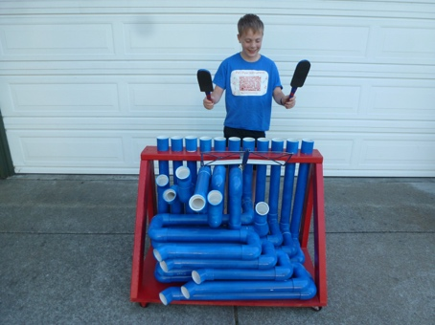
This area will also have natural materials which can be used to put together the students own instruments. Using the sounds of breaking sticks, crunching leaves and so on, giving the student a new connection to music and nature.
Bus stop 2: Stable Street
Stable street will be made up with balance apparatus and a large waterproof canvas hung from trees. This area will have a multi-use of building up one’s inner and outer balance. With wooden seating under the canvas, it provides a great area for lessons. The Welsh Government want to “develop understanding of relationships and sexuality education, human rights education and diversity, and careers and work-related experiences.” (Welsh Government, 2020). This area will provide a great place for discussion and being able for pupils to get a balanced idea on their future. Ideally the area will be managed as a quieter zone compared to the others where students can use this space for mindfulness and deep thought.

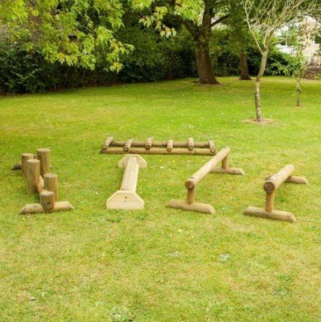

Bus stop 3: Parkour Place/Plaza.

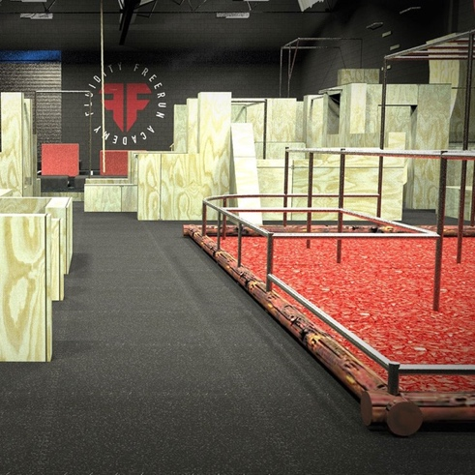
“Students playing with equipment to experiment, explore and push boundaries is intimately like the process of learning. Given that capacities to think creatively are influenced by a setting” (Howard-Jones, et al. 2008). This area brings gymnastics outside to give an urban touch to the already creative sport. Created by moveable bars/poles and wooden structure, it provides the opportunity for the children to be creative in their personal movement. Not only will this area create an extra area affordance towards physical literacy, but the area will also be a blank canvas for art. The wooden features will be perfect for practicing painting on, but also by being able to re-arrange the course into new shapes it gives the ability to express creativity in objects. As the area will be adaptable by students there is no limit to how easy or difficult the student chooses to make it. Taking physical activity away from a competitive and sometimes ego-focussed traditional sports this should help with less confident students taking part in physical activity.

Bus stop 4: Wood’s Walk.
Wood’s walk is a roundhouse structure with open sides. Having sufficient air and ventilation has been a major concern for bringing children back into the classroom during the pandemic. Teachers, pupils and parents have been hesitant in returning back due to the long hours expected to be spent in a confined indoor space. To combat this, we would look at introducing an open walled round house which can be used as a design & technology workshop. This Design & Technology workshop will be able to be used for a broader reach within the curriculum. Not only will it bring in the use of tools and an understanding of raw materials but can also be used for a range of science lessons. The lifting and moving of materials will help towards the pupils’ physical literacy and keep them moving throughout the lesson. Having this facility available means that the pupils can get engaged with multiple subjects in an outdoor environment and not be limited by Covid-19 restrictions. This workshop will give the entire school the ability to further any further bus stops along the Greenman highway and even contribute to already existing ones.

Bus stop 5: Garden Grove.
Garden Grove will set out to adapt the abandoned allotment and bring it back to life. In this area students from each year group will have their own plots on the go to prepare and plant throughout the academic year. Planting throughout the academic year means the students will gain a solid understanding about seasons but also learn how our food sources are grown and what is involved in getting them on their plate. Gardening can be a hard-physical activity but by working as a class, this task is minimised and can be more about engagement with the process. The care behind looking after an allotment is a big responsibility and will not only be a valuable learning experience for the children but will give key responsibility skills for future. This links well with sustainability and will be a great learning block for the pupils to think more about the process of food and the natural resources needed to feed the human population. It will hit can hit all 5 requirements under the future generations act for ‘A Resilient Wales’.
The concept of the Greenman highway is designed so that there are endless possibilities and always room for additions. It will provide more indoor space while students are having their lessons outside. It will link up buildings so create a one-way system, reducing the risk of covid-19 infections. Bringing the classroom outside will get the children to engage with their environment and give them a whole new outlook on learning.
The CDC recommend as a minimum that “Children and adolescents ages 6 through 17 years should do 60 minutes (1 hour) or more of moderate-to-vigorous intensity physical activity each day, including daily aerobic – and activities that strengthen bones (like running or jumping) – 3 days each week, and that build muscles (like climbing or doing push-ups) – 3 days each week.” (CDC, 2020).
As schools are currently, we see children lacking the affordance of being able to move about in the classrooms, especially now there are new distance rules being applied in schools. The Greenman highway will give the children the opportunity to meet and potentially excel their movement targets. It is important to remember that the 1 hour a day recommended is a minimum and should be aligned to the individuals capabilities.

Wordcount : 2392
Reference list.

BBC. (2020) Loss of school trips in pandemic 'has cost £500m'. Available at: https://www.bbc.co.uk/news/uk-wales-54560126 (Accessed: 16th December, 2020).

BBC. (2020) More teachers turn to outdoor classes. Available at: https://www.bbc.co.uk/news/uk-wales-55305712?fbclid=IwAR2Gak6ia0DFB3SAzpmtACJX8u-Sf6hkm7a_Poao-tGQPunNk64wlDWWWAU (Accessed: 15th December, 2020).

CDC. (2020) How much physical activity do children need? Available at: https://www.cdc.gov/physicalactivity/basics/children/index.htm#:~:text=Children%20and%20adolescents%20ages%206,doing%20push%2Dups)%20%E2%80%93%203 (Accessed: 15th December, 2020).

Defra. (2011) 2011 guidelines toDefra/DECC’s greenhouse gas conversion factors for company reporting: Methodology paper for emission factors. Available at: https://www.gov.uk/government/publications/2011-guidelines-to-defra-decc-s-greenhouse-gas-conversion-factors-for-company-reporting-methodology-paper-for-emission-factors (Accessed 16th December, 2020).

McKendrick, J,H. (2005) School grounds in Scotland: research report. Available at: www.playscotland.org/wp-content/uploads/assets/Documents/SchoolGroundsResearchReport.pdf
(Accessed: 15th December, 2020).

RSPB. (2007) Natural Thinking. Available at: http://ww2.rspb.org.uk/Images/naturalthinking_tcm9-161856.pdf (Accessed: 27th February, 2020).

Well-being of Future Generations (Wales). (2020) About us. Available at: https://www.futuregenerations.wales/about-us/future-generations-act (Accessed: 27th February, 2020).
Welsh Government. (2020). Curriculum for Wales. Available at: https://hwb.gov.wales/curriculum-for-wales/ (Accessed: 15th November, 2020).

