

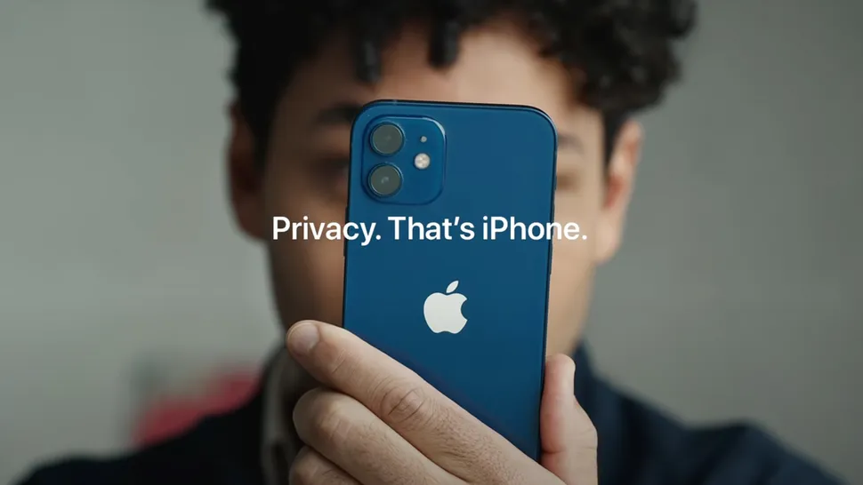
Dissertation Proposal
Dissertation Topic:
Elevating the Apple Brand: Exploring
Current Trends and Future Prospects in
Digital Marketing with AI
Name: Crystal Hall
Student ID: 2237516
Module: Dissertation Proposal
Code: LCMB7020
Supervisor: Tushara Balendran
Word count: 2000

2023
Table of Contents
1. Introduction 3
1.1. Purpose of the Study 3
1.2. Rationale 3
1.3. Aims 3
1.4. Objectives and Questions for the Research 4
2. Literature Review 4
2.1. three definitions of digital marketing 4
2.2. Two definitions of AI Applications 5
2.3. Brand Image 5
2.4. The current digital marketing strategies utilised by Apple. 5
2.5. Future AI Trends in Marketing 6
2.6. The impact of AI on the brand image of Apple 6
3. Methodology 7
3.1. Definition of methodology 7
3.2. Choices 7
3.3. Chosen choice - Mono methods quantitative (Choice) 7
3.4. Understanding the Random Sampling Method for Accurate Research Results 8
3.5. Data Collection Methods (talking about the survey) 8
3.6. Analysis of data Quantitative 9
4. References 10

Introduction

Purpose of the Study
To establish Apple as a market leader, this study on AI-driven digital marketing trends tries to comprehend present dynamics and anticipate future opportunities. The knowledge gained will enable Apple to develop cutting-edge marketing tactics, improve user interaction, and guarantee the brand's ongoing appeal and relevance in the rapidly changing technology industry (Amin, 2021, Edwards, 2023). What is the issue?

Rationale
The objective of this study is to research the consumer electronics and software industries, analysing consumer behaviour and their purchasing decisions also aiming to elevate the Apple brand through an exploration of current trends and prospects in digital marketing with AI. By thoroughly understanding the landscape of AI-driven digital marketing, this research aims to provide invaluable insights that will strategically position Apple for future success. The exploration of emerging trends and the potential impact of AI on digital marketing will empower Apple to adapt, innovate, and lead in an era where technological convergence and marketing are crucial elements for sustained brand success.

Aims
This study delves into cutting-edge AI-driven digital marketing trends and how Apple can use AI to strengthen its brand and connect with customers. It will explore AI's role in optimising campaigns, predicting customer behaviour, and tailoring content for maximum impact. These insights can guide Apple in shaping its digital marketing strategies and maintaining its position as the world leader in innovation and technology. Making Effective Use of AI that can enhance Apple's brand identity, foster personal connections with customers, and secure a competitive edge in the rapidly evolving digital landscape. This research offers vital recommendations for Apple to stay at the forefront of the industry (Pathak, 2021).

Objectives and Questions for the Research
- Examine current digital marketing strategies employed by Apple.
- Identify areas for innovation in the integration of AI in Apple's marketing strategies.
- Analyse the impact of AI on Apple's brand image.
- Assess how AI-driven marketing strategies influence consumer perceptions of the Apple brand.
- What are the current digital marketing strategies employed by Apple?
- What are the areas for innovation in the integration of AI in Apple's marketing strategies?
- Analyse the impact of AI on Apple's brand image?
- How do AI-driven marketing strategies influence consumer perceptions of the Apple brand?

Literature Review

three definitions of digital marketing
- Social media marketing platforms are for content creation and audience engagement. Using images, videos, and other tools to boost brand visibility and, customer interaction, (Hayes, 2023).

- Content marketing promotes and engages the target audience through various forms like blog posts and videos. It builds trust and drives customer action by aligning with audience interests and needs (Oracle, 2021)..

Two definitions of AI Applications
- Natural Language Processing (NLP) relates computers to human language. Linguists, computer scientists, and machine learners produce and interpret language. Parsing, sentiment analysis, and named entity recognition assist computers understand human language in sectors such as customer service to education (SAS, 2019).
- Smart assistants, AI assistants, or smart assistants, reply to voice or text commands to aid with tasks, give information, and simplify tech use. From Siri to Alexa, smartphones, to other electronic gadgets to help with information and service access. (IBM, 2023).

Brand Image
From iPhones' face recognition technology to Siri's speech recognition, Apple has skilfully incorporated AI into its devices. This has improved the user experience and strengthened Apple's reputation as a creative and forward-thinking company. Apple has enhanced its brand image by personalising suggestions, enhancing security, and streamlining daily chores. It has also positioned itself as a pioneer in providing cutting-edge technology that makes people's lives more convenient and valuable (Cook, 2023).

The current digital marketing strategies utilised by Apple.
Apple uses the R.A.C.E. model strategically to direct its efforts in digital marketing. Apple, which focuses on building a strong brand image by delivering user-centric experiences across all platforms, showcases cutting-edge technology with interactive experiences via AR and VR. Apple's initiatives like "Privacy on iPhone" express corporate ideas via narrative, while advertisements like "Shot on iPhone," which capture private moments, create emotional ties. Apple places a high priority on security, reliability, and quality in the B2B market via developer partnerships and enterprise-grade products (Arica, 2020).

Future AI Trends in Marketing
Looking at Apple’s future, there are endless possibilities? Apple itself has been diving into AI and machine learning for some time now, and they're making waves with Apple’s custom-made M3 chips. These chips are set to pave the way for personalised user experiences, thanks to AI-driven recommendations for apps, services, and content. Plus, Siri, Apple's virtual assistant, is in for some AI-powered enhancements that'll make it more intelligent and proactive, offering personalized suggestions and seamless integration with third-party apps. And, in the realm of health and fitness, Apple is exploring how AI can advance health tracking, deliver personalized fitness recommendations, and even detect health issues early on. So, exciting times ahead for Apple users! (Kelly, 2023)

The impact of AI on the brand image of Apple
AI has had a revolutionary and beneficial effect on Apple's brand image. It has improved the user experience, encouraged product uniqueness, and highlighted Apple's commitment to privacy and security. This shows how AI has improved the user experience, encouraged innovation and uniqueness, highlighted privacy, and security, and shown a dedication to sustainability, all of which have improved Apple's brand image. Apple's image as a high-end, customer-focused, and inventive brand in the IT sector has been strengthened by the company's incorporation of AI into its goods and services (Mao et al., 2020).

Methodology

Definition of methodology
The methodical approach checks study validity. The study examines how academics achieve their research aims with credible outcomes. First, use industry standards for research. Using industry-accepted practices is the key element that supports the whole research process (Sreekumar, 2023).

Choices
- Quantitative data, such as height in feet, age in years, and weight in pounds, allows exact mean estimates. (Soetewey, 2019).
- Qualitative data includes observations, diaries, and interviews are qualitative data. Text, images, and descriptions are included. (Soetewey, 2019)

Chosen choice - Mono methods quantitative (Choice)
- The chosen approach for this paper within the context of monomethod quantitative research involves the utilisation of quantitative techniques to gather and analyse data related to specific choices made by consumers or users. Apple uses this approach to quantify and measure customer preferences, behaviours, and reactions to brand decisions. It may include numerical estimates of customer satisfaction with product features, design preferences, or price methods. Apple may use this mono-method quantitative approach to understand customer decision-making and improve their goods and marketing methods (Dudovskiy, 2023).

Understanding the Random Sampling Method for Accurate Research Results
- Sample size: The number of people or observations in a sample greatly affects statistical reliability and precision (Zamboni, 2018). The study will focus 50 diverse participants through client, friend, and family contacts, forming a targeted group.
- Sample type: Probability sampling provides population generalisation by random selection, but non-probability sampling may add bias or limit the applicability of the results (Mcleod, 2019) Capturing the demographic and geographics will include participants of varying ages, genders, and generations, ensuring representation across different segments of the population.
- Sample method: Simple random, stratified, cluster, and convenience sampling may be used to get reliable study findings. The latter strategy makes use of participant availability, making research efficient. Personal and professional relationships may ensure different participant viewpoints.

Data Collection Methods (talking about the survey)
- There are ten carefully designed questions in the survey for this study. Its goal is to gather specific data about upcoming AI developments and existing digital marketing tactics. With this simplified method, participants may quickly and effectively provide insightful responses, guaranteeing a controllable survey approach.
- This survey will use both JotForm and Google Forms as the data collection platforms.
- To make sure that the survey process is quick and convenient for participants, a maximum time limit of 10 minutes will be set.

Analysis of data Quantitative
Analyses Excel that will be used to create graphs and a table.
- Research ethics include planning, performing, and reporting research. This concept emphasises ethics, especially in safeguarding humans and animals. Research ethics are concepts and practices that ensure the moral conduct of research. (Kalichman, 2010).
- Gantt Chart
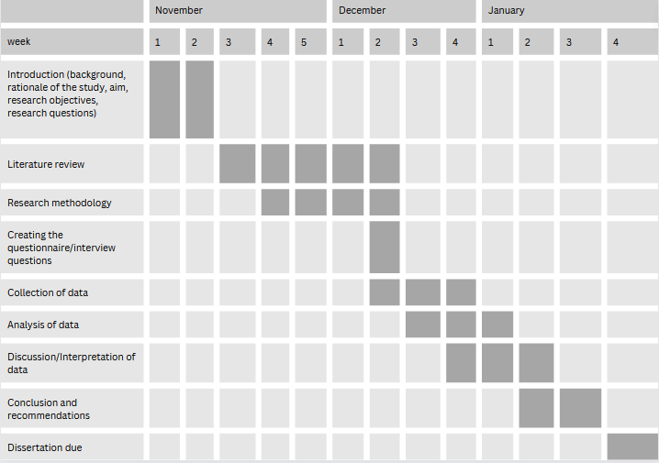

References
Allinson, M. (2021). The Use of Artificial Intelligence Technology in Apple Devices. [online] Robotics & Automation News. Available at: https://roboticsandautomationnews.com/2021/06/14/the-use-of-artificial-intelligence-technology-in-apple-devices/43866/ [Accessed 9 Nov. 2023].
Amin, Z. (2021). Apple’s Marketing Strategy: 12 Key Lessons to Learn. [online] squeezegrowth.com. Available at: https://squeezegrowth.com/apple-marketing-strategy/ [Accessed 1 Sep. 2023].
Arica, A. (2020). An Ultimate Guide For Apple’s Digital Marketing Strategy. [online] Digital Agency Network. Available at: https://digitalagencynetwork.com/an-ultimate-guide-for-apples-digital-marketing-strategy/ [Accessed 16 Nov. 2023].
Axon, S. (2020). Here’s why Apple believes it’s an AI leader—and why it says critics have it all wrong. [online] Ars Technica. Available at: https://arstechnica.com/gadgets/2020/08/apple-explains-how-it-uses-machine-learning-across-ios-and-soon-macos/ [Accessed 16 Nov. 2023].
Cook, J. (2023). 6 Predictions On How Apple Will Join The AI Business Race. [online] Forbes. Available at: https://www.forbes.com/sites/jodiecook/2023/05/22/6-predictions-on-how-apple-will-join-the-ai-business-race/.
Dudovskiy, J. (2023). Apple Segmentation, Targeting and Positioning . [online] Business Research Methodology. Available at: https://research-methodology.net/apple-segmentation-targeting-and-positioning/ [Accessed 16 Oct. 2023].
Edwards, B. (2023). Meta’s ‘massively multilingual’ AI model translates up to 100 languages, speech or text. [online] Ars Technica. Available at: https://arstechnica.com/information-technology/2023/08/metas-massively-multilingual-ai-model-translates-up-to-100-languages-speech-or-text/ [Accessed 1 Sep. 2023].
Fleetwood, D. (2018). Sample: Definition, Methods, Types with Examples | QuestionPro. [online] QuestionPro. Available at: https://www.questionpro.com/blog/sample/ [Accessed 16 Nov. 2023].
IBM (2023). What is Natural Language Processing? | IBM. [online] www.ibm.com. Available at: https://www.ibm.com/topics/natural-language-processing [Accessed 9 Nov. 2023].
Kalichman, M. (2010). Introduction: What is Research Ethics? | Online Ethics. [online] onlineethics.org. Available at: https://onlineethics.org/cases/resources-research-ethics-education/introduction-what-research-ethics [Accessed 16 Nov. 2023].
Kelly, S. (2023). Apple’s ‘scary fast’ upgrades hint at its vision for the AI era | CNN Business. [online] CNN. Available at: https://edition.cnn.com/2023/11/01/tech/apple-ai-upgrades/index.html [Accessed 9 Nov. 2023].
Mao, Y., Lai, Y., Luo, Y., Liu, S., Du, Y., Zhou, J., Ma, J., Bonaiuto, F. and Bonaiuto, M. (2020). Apple or Huawei: Understanding Flow, Brand Image, Brand Identity, Brand Personality and Purchase Intention of Smartphone. Sustainability, [online] 12(8), p.3391. doi:https://doi.org/10.3390/su12083391.
Mauro, A.D., Sestino, A. and Bacconi, A. (2022). Machine learning and artificial intelligence use in marketing: a general taxonomy. Italian Journal of Marketing. [online] doi:https://doi.org/10.1007/s43039-022-00057-w.
Mckinsey (2023). The AI-native telco: Radical transformation to thrive in turbulent times | McKinsey. [online] www.mckinsey.com. Available at: https://www.mckinsey.com/industries/technology-media-and-telecommunications/our-insights/the-ai-native-telco-radical-transformation-to-thrive-in-turbulent-times.
McLeod, S. (2023). Qualitative Vs Quantitative Research Methods & Data Analysis. [online] Simply Psychology. Available at: https://www.simplypsychology.org/qualitative-quantitative.html [Accessed 9 Nov. 2023].
Mcleod, S. (2019). Sampling Methods | Simply Psychology. [online] Simplypsychology.org. Available at: https://www.simplypsychology.org/sampling.html [Accessed 16 Nov. 2023].
Oracle (2021). What is Content Marketing. [online] Oracle.com. Available at: https://www.oracle.com/cx/marketing/content-marketing/ [Accessed 9 Nov. 2023].
SAS (2019). What is Natural Language Processing? [online] Sas.com. Available at: https://www.sas.com/en_us/insights/analytics/what-is-natural-language-processing-nlp.html [Accessed 9 Nov. 2023].
Soetewey, A. (2019). Variable types and examples. [online] Stats and R. Available at: https://statsandr.com/blog/variable-types-and-examples/.
Sreekumar, D. (2023). What is Research Methodology? Definition, Types, and Examples | Paperpal. [online] Paperpal Blog. Available at: https://paperpal.com/blog/academic-writing-guides/what-is-research-methodology [Accessed 16 Nov. 2023].
Zamboni, J. (2018). What Is the Meaning of Sample Size? [online] Sciencing. Available at: https://sciencing.com/meaning-sample-size-5988804.html [Accessed 16 Nov. 2023].

