Title: Modernising Business Information Systems: Evaluation and Recommendations
Course: BA (Hons) Leadership and Management Skills for the Workplace
Module: Managing Business Information
Lecturer: Joy Botu, Samuel Ofori
Samuel cureja
2244692

Slide 1: Title Slide
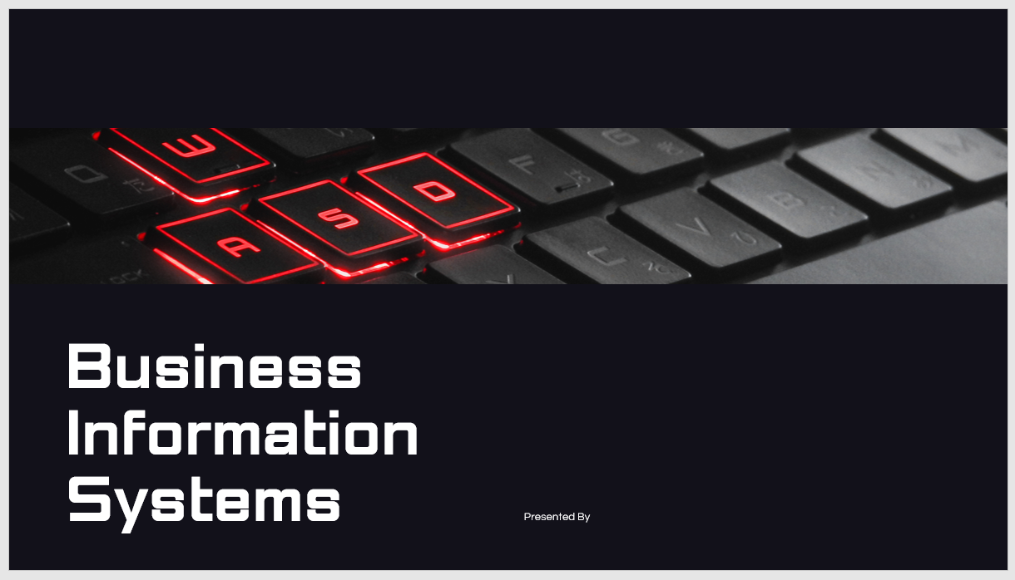

Slide 2: Introduction to Information Systems
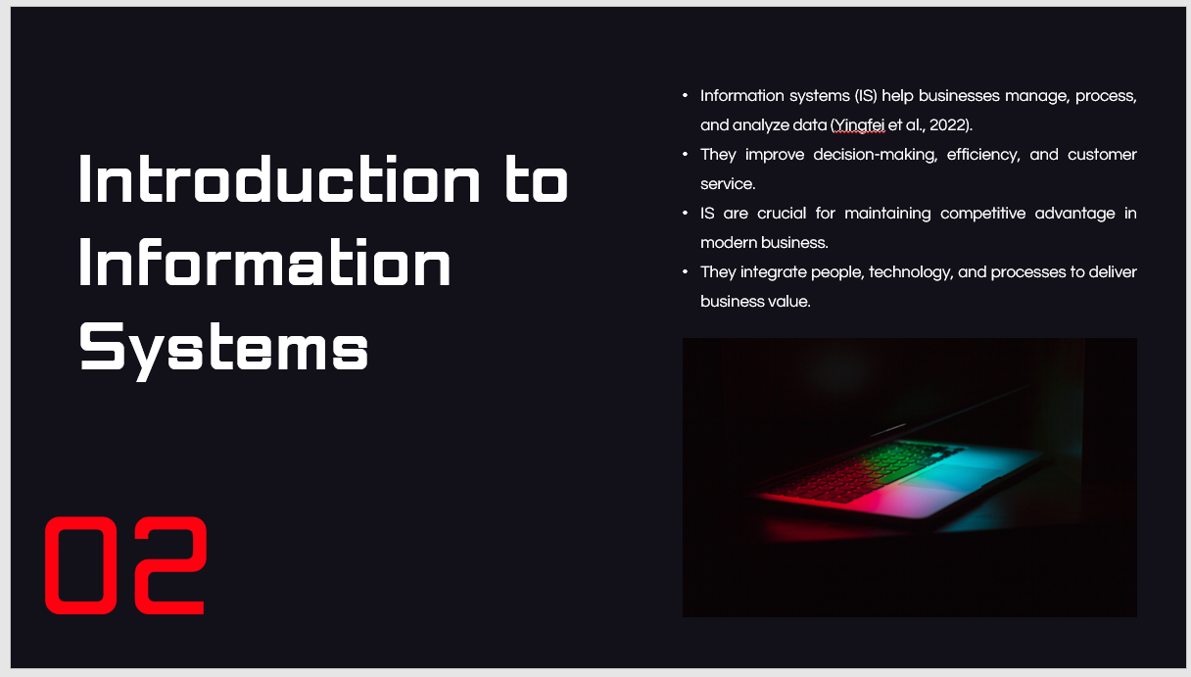
Modern businesses have information systems that help them manage large volumes of data. They are very important in decision-making as they promptly give precise information. The service quality and the improvements in efficiency provided by IS help companies create a competitive advantage. IS can transform operational performance and bring much value by integrating people, technology and processes (Yingfei et al., 2022). IS not only has implications for technology because it entails the interaction of human resources, processes, and infrastructure, which are vital in the attainment of business goals.

Slide 3: Types of Information Systems
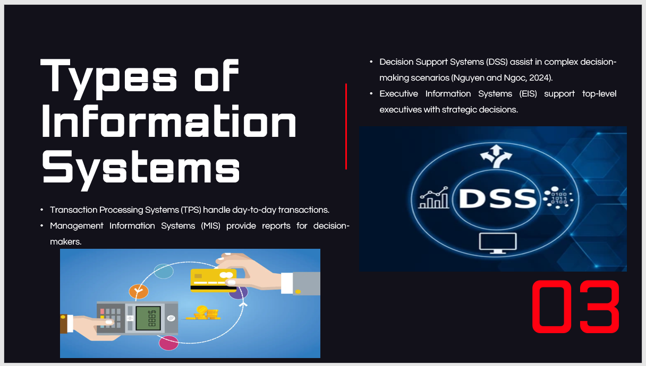
Business information systems come in various forms, which are applied to run the business, aid in decision-making, and improve strategic planning. Transactions are automated using the Transaction Processing Systems (TPS), and the reports provided by the Management Information Systems (MIS) are used by managers to make decisions regularly. Complex decision-making tools provided by DSS are analytical tools (Nguyen and Ngoc, 2024). Finally, the Executive Information Systems (EIS) supply executives with high-level, strategic data to help them achieve long-term objectives. All systems have their own purposes, and they contribute differently to an organisation's operation and strategic objectives.

Slide 4: Functions of Information Systems in Business
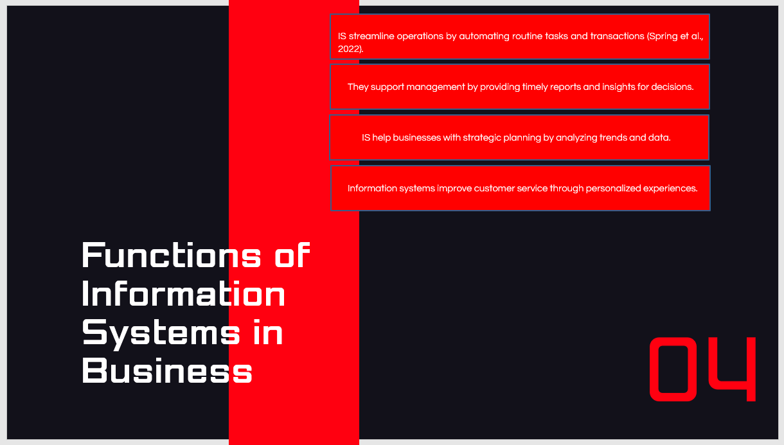
Information systems also optimise business by automating daily business activities, thus eliminating the manual workforce involved in transactions. IS can help management make wise decisions by providing timely and accurate reports. The importance of IS in strategic planning also plays a central role since it works with huge amounts of data to determine trends that will dictate the future of the business (Spring et al., 2022). Also, the IS can enhance customer service, providing a personalised experience relying on customer data. Such a combination of operational, managerial and strategic processes renders IS inseparable in fulfilling overall business objectives.

Slide 5: Analysis and Comparison of Information Systems (Part 1)
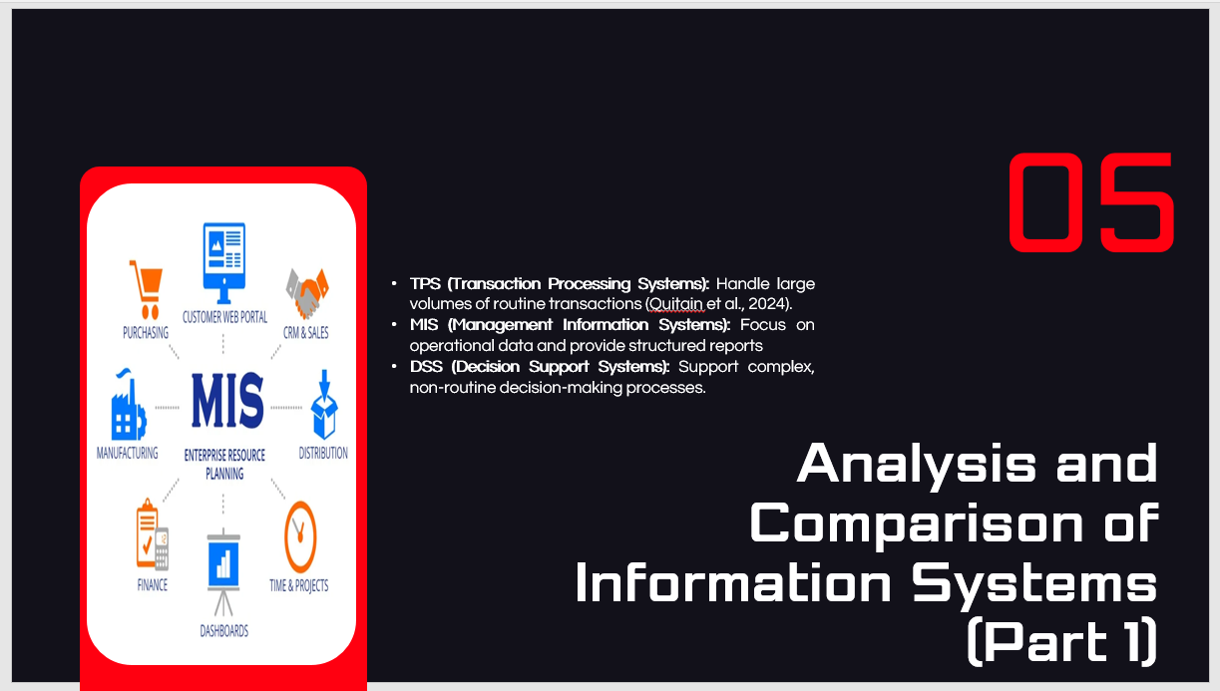
In the comparison between these systems, it is TPS that deals with massive, monotonous operations, which are mainly processing customer orders or payroll. Management Information Systems (MIS) are concerned with offering structured data to managers to assess the performance of operations. They develop periodic reports, which help track business operations (Quitain et al., 2024). Decision Support Systems (DSS) are differentiated in that they assist in more complex decision-making settings, as they offer analytical tools and models that aid in navigating non-routine and high-risk decisions by decision-makers. The capabilities of each system serve other functions of a business, which have made them complementary to each other in an organisation.

Slide 6: Analysis and Comparison of Information Systems (Part 2)
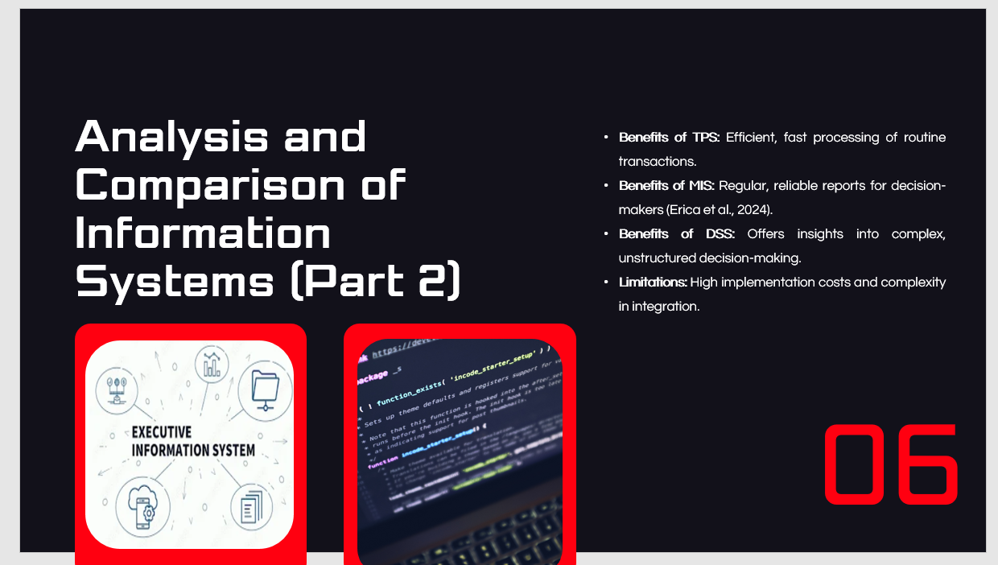
These systems have different advantages depending on the functions. TPS enhances efficiency by automating transactional processes and making processes faster and error-free. Regular reports provided by MIS give managers quality data that helps them make decisions. DSS is good at delivering sophisticated decision-making tools, which can guide companies to make hard choices (Erica et al., 2024). Nevertheless, although these systems have advantages, they have limitations such as the high cost of implementation and integration difficulty. Different businesses should be keen to evaluate the costs and benefits in deciding the type of systems to use, depending on their unique business requirements.

Slide 7: Benefits and Limitations of Information Systems
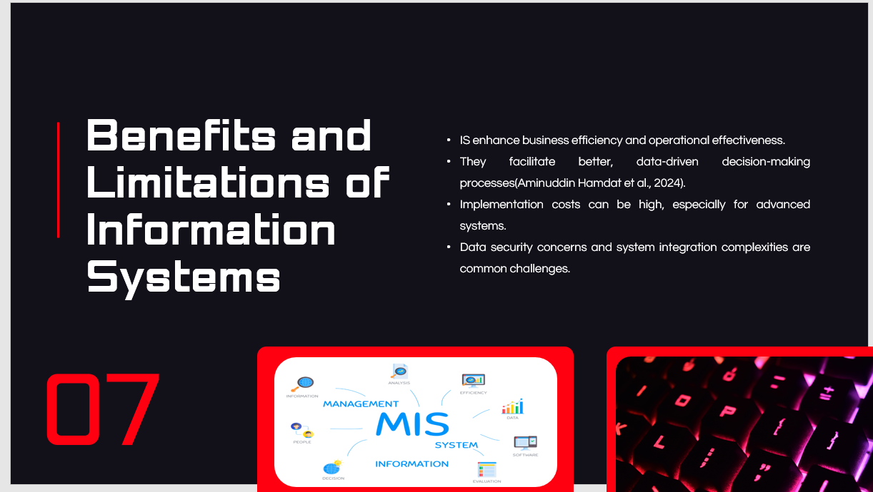
Information systems have many advantages, including better efficiency of the business and better decision-making with the help of timely data. They allow organisations to make well-informed decisions using real-time information, which has helped improve business performance. Nevertheless, such systems may be expensive to implement, especially advanced technologies (Aminuddin Hamdat et al., 2024). Data protection is also an urgent matter, and companies should ensure that the valuable information is private and undamaged. Introducing new systems into the existing infrastructures may also be difficult; it should also be properly planned, and compatibility should be considered.

Slide 8: Ethical Considerations in Information Systems
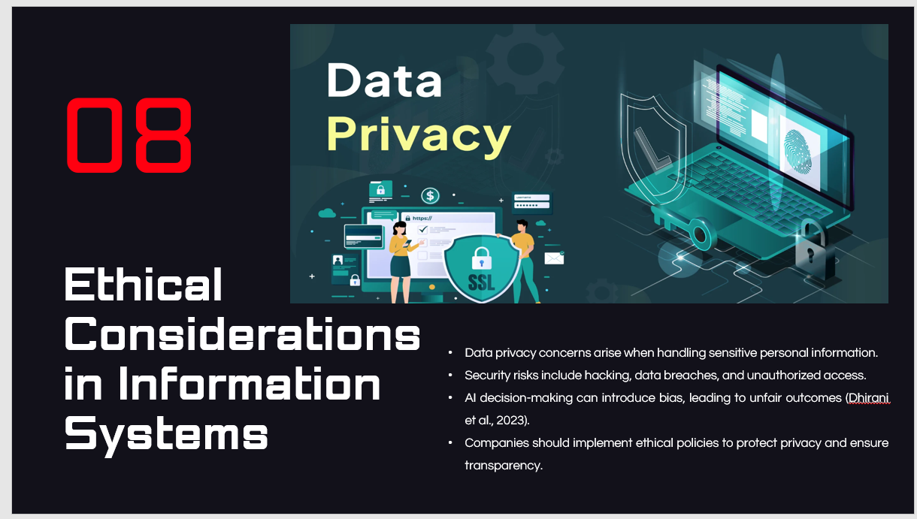
Ethical issues are the most crucial problem of the adoption of information systems. Data privacy is a highly serious matter, particularly when one operates with personal or financial information which is comparatively sensitive. The companies should have sufficient security measures to prevent data breaches and hacking. Moreover, with the increased use of AI in decision-making, it is feared that it will bias the algorithms and lead to unfair or discriminatory outcomes (Dhirani et al., 2023). To reduce these threats, businesses should possess good ethical principles that encourage information preservation, openness, and responsibility within the artificial intelligence systems to ensure the information is utilised responsibly.

Slide 9: Real-World Case Studies (Part 1)
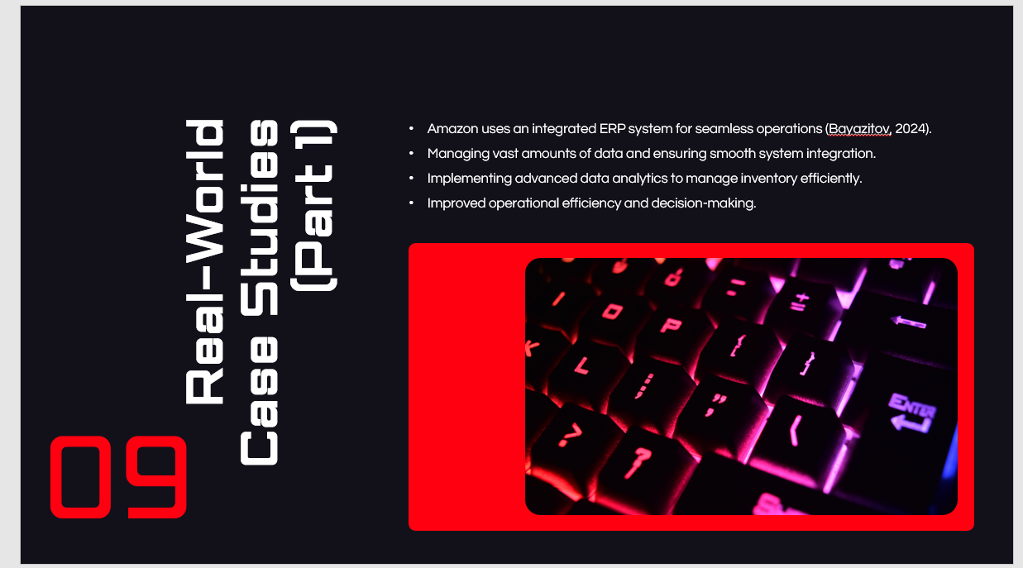
Amazon is an ideal example of how an integrated Enterprise Resource Planning (ERP) system can support the enterprise's operations. The company also faced issues managing large volumes of data and integrating the systems across the various departments. To address these issues, Amazon applied data analytics tools based on high-tech methods to solve inventory matters more efficiently, resulting in increased processing time and decision-making (Bayazitov, 2024). The introduction of this information system enabled Amazon to control the increase in customer demand, which further led to the overall effectiveness of its supply chain, and this demonstrates the huge impact that IS can have in realising success in its operations.

Slide 10: Real-World Case Studies (Part 2)
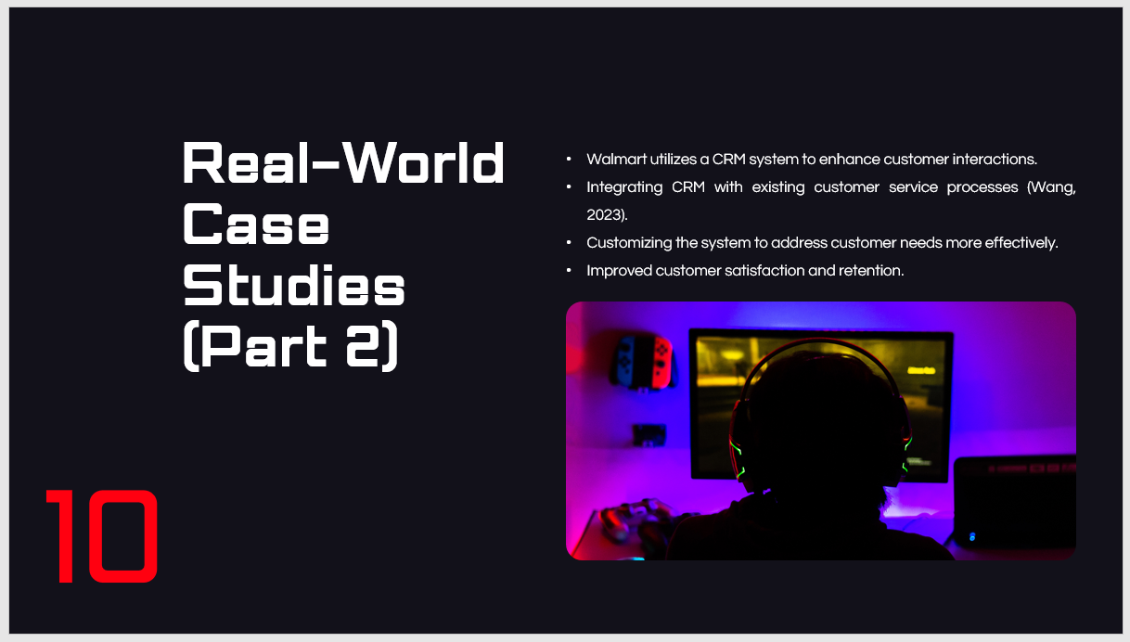
A Customer Relationship Management (CRM) system at Walmart explains why companies can enhance customer relations. Another issue that the company encountered was that its early adoption of the CRM system in its existing customer service operations had to be highly tailored to accommodate the specific needs of its clientele. After modifying the system to align it with the objectives of its customer service, Walmart may be able to improve the level of customer satisfaction and retention (Wang, 2023). The case study indicates how important it is to tailor the information systems to meet the individual needs of a business and the large benefits it offers in managing customer relationships.

Slide 11: Recommendations for Information Systems
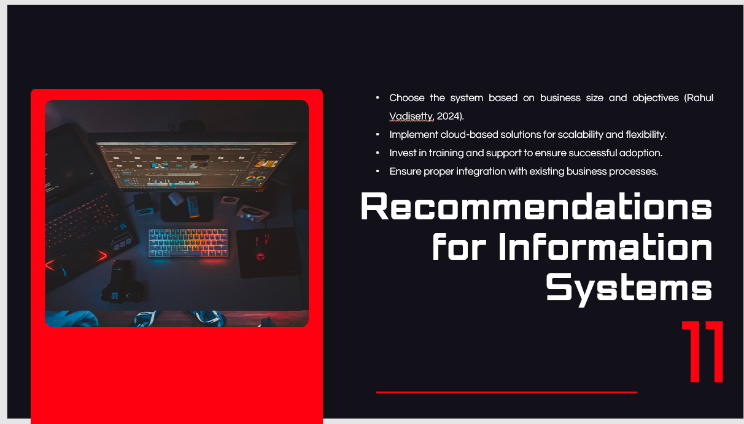
In the case of businesses that are interested in modernising their information systems, the system's selection must reflect the business's size and strategic goals. Cloud-based solutions can benefit smaller companies because of their cost-effectiveness and scalability, whereas larger organisations may need more sophisticated systems to manage all the data. It is important to invest in training and continuous assistance so that the employees can use these systems effectively (Rahul Vadisetty, 2024). In addition, businesses must consider integrating with the existing business processes as the highest priority to prevent disruptions and ensure that the system has the maximum potential to improve performance and efficiency.

Slide 12: Conclusion
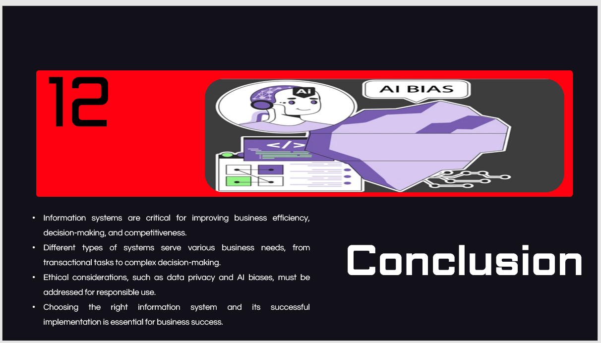
Information systems are crucial in improving business operations, decisions, and competitiveness. IS enables businesses to automate their routine operations and deliver valuable data to assist businesses in streamlining their operations and effectively responding to challenges. Information systems are available in different forms i.e. TPS, MIS, and DSS, which serve various organisational requirements, and it is important to know the differences when choosing the appropriate information system. In addition, the ethical issues of data privacy and AI bias need to be addressed to make their use responsible and fair. Finally, the process of choice and introduction of the relevant information system is a key to the future business growth and operational success.

Slide 13: References
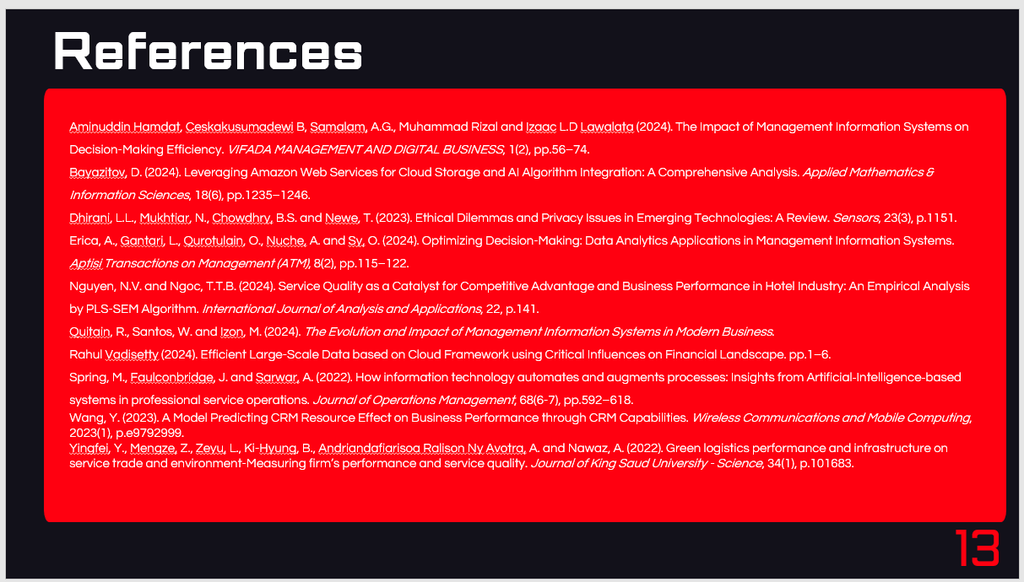
Aminuddin Hamdat, Ceskakusumadewi B, Samalam, A.G., Muhammad Rizal and Izaac L.D Lawalata (2024). The Impact of Management Information Systems on Decision-Making Efficiency. VIFADA MANAGEMENT AND DIGITAL BUSINESS, 1(2), pp.56–74.
Bayazitov, D. (2024). Leveraging Amazon Web Services for Cloud Storage and AI Algorithm Integration: A Comprehensive Analysis. Applied Mathematics & Information Sciences, 18(6), pp.1235–1246.
Dhirani, L.L., Mukhtiar, N., Chowdhry, B.S. and Newe, T. (2023). Ethical Dilemmas and Privacy Issues in Emerging Technologies: A Review. Sensors, 23(3), p.1151.
Erica, A., Gantari, L., Qurotulain, O., Nuche, A. and Sy, O. (2024). Optimizing Decision-Making: Data Analytics Applications in Management Information Systems. Aptisi Transactions on Management (ATM), 8(2), pp.115–122.
Nguyen, N.V. and Ngoc, T.T.B. (2024). Service Quality as a Catalyst for Competitive Advantage and Business Performance in Hotel Industry: An Empirical Analysis by PLS-SEM Algorithm. International Journal of Analysis and Applications, 22, p.141.
Quitain, R., Santos, W. and Izon, M. (2024). The Evolution and Impact of Management Information Systems in Modern Business.
Rahul Vadisetty (2024). Efficient Large-Scale Data based on Cloud Framework using Critical Influences on Financial Landscape. pp.1–6.
Spring, M., Faulconbridge, J. and Sarwar, A. (2022). How information technology automates and augments processes: Insights from Artificial‐Intelligence‐based systems in professional service operations. Journal of Operations Management, 68(6-7), pp.592–618.
Wang, Y. (2023). A Model Predicting CRM Resource Effect on Business Performance through CRM Capabilities. Wireless Communications and Mobile Computing, 2023(1), p.e9792999.
Yingfei, Y., Mengze, Z., Zeyu, L., Ki-Hyung, B., Andriandafiarisoa Ralison Ny Avotra, A. and Nawaz, A. (2022). Green logistics performance and infrastructure on service trade and environment-Measuring firm’s performance and service quality. Journal of King Saud University - Science, 34(1), p.101683.

