
REPORT: UP-CYCLE
“Don’t Buy, Up-Cycle”
Contents

Executive Summary 2
Introduction 2
Innovation 3
Justification 4
The Up-Cycle Scheme 4
Cycle Provider 5
Cycling Hub 5
Benefits of cycling 7
Funding and Stakeholder Theory 8
Sustainable development goals 9
Future waste management and end of life cycles 11
Conclusion 11
References 12

Executive Summary
This report has been commissioned to identify an innovation plan for Cilgerran and surrounding areas. Meeting sustainable development goals and the Well-being of Future Generations Act (Wales) 2015. Justification is explored for Up-Cycle as a non- for-profit social enterprise, run by the community in collaboration with other agencies. Consideration has been given to the sustainability, funding and source of the bicycles provided by the scheme. The projects aim is to provide bicycles to the community, promoting opportunity and inclusion for all.

Introduction
Mass consumerism and the waste we create is becoming an increasing worry for individuals. With the quest for sustainability some will look for ways to prepare for the changes ahead. Regarding climate change and sustainable lifestyle (Barr, Gilg, & Shaw, 2013) propose that “The dominance of neo-liberal approaches to encouraging pro-environmental behaviours rests on an irresistible fusion between collective responsibility and a desire for consumer goods and services”. It is inevitable that our collective ability to dispose of waste will take a drastic turn. Limiting households to what can be disposed of. In this tough financial climate, it is becoming more difficult to meet the needs of our families. Up-Cycle is a community initiative that aims to provide bicycles for the community. Particularly in small villages, this report will focus on Cilgerran, Pembrokeshire and surrounding areas.

Innovation
Innovation is more than just an invention. It is possible to be innovative using an existing product or service. Indeed, Sir James Dyson did not invent the vacuum cleaner. He took an existing product and made it better. When asked about innovation he proposed that its Britain’s greatest strength. Natural ability, design and engineering, are not being utilised. (Kahn, 2019) attains that “At 72, the British inventor has been innovating his whole adult life. His contraptions span from gardening to hair styling”.
Guy Kawasaki, once a former evangelist for multinational Apple ,is a successful innovator and public speaker (Kawasaki, 2015) argues that “Great innovation occurs when you don't listen to your customers - when you use your passion and your vision and insight and you create what you believe they will need, or they will come to need” Following his points for innovation in business, the scheme will address the following 3 points:
Make meaning – The scheme will not set out to make money but make a difference. The aim is to increase well-being, promote independence and create opportunities.
Make a mantra – Don’t Buy, Up-Cycle. This will be the schemes manta to remind participants of the sustainable benefits.
Jump curves- If the scheme were to be rolled out nationwide, cycle companies will still be able to sell cycles, but how many bicycles will be saved from landfill?

Justification
Cilgerran is a small close-knit community, with cardigan only 3 miles away. According to the last census in 2011, there were 2058 people living in the ward of Cilgerran. (Cilgerran population density, 2011). Heavily reliant on tourism and farming, seasonal jobs are commonplace. This area is a mixture of financial statuses. However, (Understanding Poverty in Pembrokeshire, 2018) states that “According to the Joseph Rowntree Foundation, Pembrokeshire has one of the highest risks of poverty amongst people of working age in the UK, resulting from a mix of low wages and high housing costs”. During a recent cycle proficiency test at Ysgol Cilgerran, some parents had admitted that their children had outgrown their bikes, thus using a scooter to participate. However, as this was November it is possible parents were waiting to buy a bike for Christmas. This did however pose a dilemma as children wished to ride a bike. An innovation to provide a community cycle provision was required.

The Up-Cycle Scheme
The cost of bicycles can be very expensive, particularly with children quickly outgrowing them. Up-cycle will give an opportunity for children to move up through different sizes of bikes. This is a collaborative project, run by the community, for the community. (Lai, 2011) suggests that “Collaboration is the “mutual engagement of participants in a coordinated effort to solve a problem together. Collaborative interactions are characterized by shared goals, symmetry of structure, and a high degree of negotiation, interactivity, and interdependence”. The scheme will be also open to adults and teenagers with an equal opportunity to participate. All that will be asked in return is some time donated to the project, if possible. In the case of small children their parents would be approached.
Although the idea of cycle hire is not a new one, there is limited opportunity within the Pembrokeshire area. The cost of hiring a bike from Pembrokeshire cycles in Narbeth is from £35 per day (Bicycle Options, 2019). This may be suitable for tourists, however, would be too expensive for most people. It is interesting to note that the company does not supply children’s cycles. Although, there has been call for shared rental of cycles this can lead to disruption. A new scheme has been championed in China, where you can unlock a bicycle using a smartphone, so its dockless and can potentially be left anywhere. The issues that have arose have been considered a social menace. As displayed in image 1.
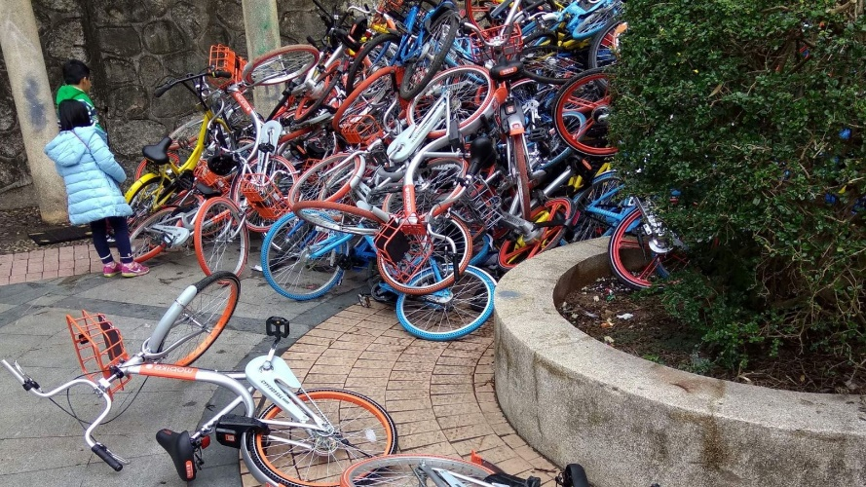
Image 1 ( Stallard, 2018)
( Stallard, 2018) comments that “Depending on your perspective, this is either the best or the worst aspect of the system, with pavements becoming almost impassable at times for pedestrians in the capital, and bikes abandoned in cycle lanes”. This could be due to a feeling of lack of ownership or responsibility. It is too easy to just walk away; it then becomes someone else’s problem. This is a consideration although, Cilgerran cannot be compared to China. Temporary ownership gives a sense of responsibility that could alleviate this issue.

Cycle Provider
When researching a provider sustainability was at the forefront. However, cycles made of sustainable materials can be very expensive. They are usually made overseas and shipped to Britain, increasing carbon emissions. The decision to look for an ethical and sustainable retailer is key to the ethos of the project. Raleigh, a company established in 1887 has been a provider of good quality cycles for over a century. The company also produces electric cycles. According to the Ethical Consumer, Raleigh was rated fourth in over 42 brands, where conflict materials, ethical and environmental records were investigated. (Clayton, 2018). Raleigh will also be approached as a potential sponsor for the project.

Cycling Hub
Community members will assist in the running of the scheme. There will be a structured approach that will require several co-ordinators. (Mason , Kirkbride, & Bryde, 2006) propose that “Social enterprises are created by people who are closely linked with the community they intend to serve. If the ultimate goal is to deliver social beneﬁt, the rationale underpinning these organisations must be ethical. Social enterprises exist to maximise positive social impact.”
This could be run from many community locations, for example the village hall as pictured in Image 2

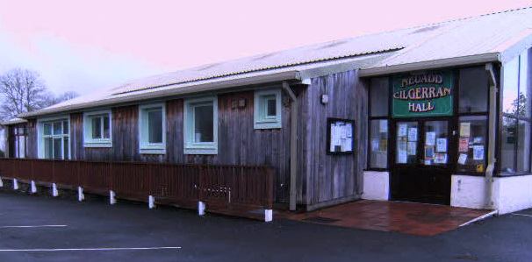
Image 2
The hall is in a central location, and there is ample room for bikes to be stored in sheds and a workshop for repairs. This a close-knit community and volunteers should be easily sourced. Collaboration with local colleges and businesses could bring essential maintenance skills. These skills can be passed on to other members.
Donated cycles from the community will be gratefully accepted. A weekly meeting to discuss any issues will be held. Booking forms can be obtained with terms and conditions, a health and safety and agreement of liability will need to be signed. Safety is paramount and participants must wear a cycle helmet. A company will be approached for donations or funds will be raised for those who cannot afford a hat. The project will involve collaboration between the community and outside agencies.
Sustainable innovation and collaboration have seen an increase in popularity. However, there is a lot of work to be done. (Erta & Leblanc-Proulx, 2018) propose that “The growing field of the collaborative economy is expanding geometrically and little retrospective work on this evolution has been made so far.” The collaborative economy is currently progressing by choice although, at some point in the future we must work together to address the issues our planet faces. It will become imperative rather than a lifestyle choice.
All purchased cycles will be the same colour and will have a temporary tag for identification purposes. Individuals are welcome to personalise their cycle with coloured seats and accessories. The aim of the cycles being uniform is to take away from peer pressure to have a make and model. This in turn relieves pressure away from parents, who possibly cannot afford to purchase outright. Giving all classes a feeling of equality and inclusion, promoting feeling of a cohesive community, as stated in the Wellbeing Act 2015. The project covers wellbeing and sustainable development goals. The act states that the law is needed for Wales as it faces a number of present and future challenges, including poverty, climate change and health inequalities. (Government, 2015). From a funding perspective the initiative meets many of the requirements of the act.
There is a potential in the future, if the project runs well to provide electric cycles. As public transport is infrequent part of the scheme could offer the service to those in employment, seeking employment and voluntary positions. This will assist individuals who do not drive to be able to travel to work within the neighbouring villages and towns. (Boston, 2017) argues that “Many residents in Wales experience limited travel choices for connections between villages, towns and cities, meaning transport is often cited as a significant barrier when looking to participate in the labour market”. Any uptake of employment can only benefit the local economy.

Benefits of cycling
Cycle to school should be an initiative that is encouraged to ease congestion and lower carbon emissions. Ysgol Cilgerran (the local primary school) for example provides cycle proficiency free of charge. They actively encourage pupils to travel to school by other means. A large locked yard has ample storage for the pupil’s bicycles. This is an approach that could be fostered by neighbouring schools. (Department For Transport, 2002) claims that “Cycling has a major role to play in any sustainable transport strategy. It helps tackle congestion and local air pollution, as well as the emissions that cause climate change. 23% of car trips are less than 2 miles”. However, some families live on remote farms and lanes are not suitable for children to ride. In this instance, parking will be made available on the outskirts of the village. If it is possible for parents to bring their bicycle, pupils can continue their journey to school.
(Ducheyne, De Bourdeaudhuij, Lenoir, & Cardon, 2014) state that “For most children, bicycles are the most important means of transportation as they make it possible to cover greater distances independently”. However, there is still an element of risk to safety, this must be managed effectively. Congestion in the village should be relieved if enough pupils participate, high visibility clothing is another important consideration. In an ideal world, cars would not be permitted into the village at school times. Although, this is not viable due to onward travel and work commitments, Parents are welcomed to escort children, if this is not possible the community would be encouraged to get involved, becoming voluntary escorts and assisting groups.
Aside from the environmental benefits, there are health and wellbeing considerations. In 2013 a study was undertaken to compare inactive people and their quality of life, to those who cycle regularly, though many conclusions were reached (Lovretic, Benjak, & Gorka, 2013) attain that “Cycling for transport or as a leisure time activity demonstrates an ideal form of exercise, which can significantly increase the life satisfaction and sense of personal wellbeing”.

Funding and Stakeholder Theory
As this is a green initiative and will be a not-for-profit social enterprise. Funding for the purchase of the cycles will be required. Funding is available to community projects that support green initiatives. The Landfill Disposals Tax Community Scheme is a government initiative. In its second year the scheme aims to provide funding for community projects that contribute to minimising waste and supporting biodiversity. (Government, 2019) states that grants between £5,000 and £50,000 are obtainable. There is an opportunity for the community to participate in fundraising for the project. This could be in collaboration with schools and local businesses. There is a value in raising money for community projects promoting inclusion and a sense of purpose. There is an element of risk with all projects and this would need to be manged appropriately
It is important to recognise that there is a limit to the providers funding for social enterprise. A good justification and sustainable innovation are key. (Sinclair, Mazzei, Baglioni , & Roy, 2018) attain that “A vital competitive context for social enterprise and social innovations is for scarce public resources (in the form of grants and contracts) and government patronage rather than the conventional paying customers of mainstream markets”. It is difficult to give a precise figure on the amount of funds needed. If the project is only able to raise limited funds initially, bicycles will be prioritised to those in need initially.
There are several individuals and organisations that will have a vested interest. They will need to be managed and categorised in order of importance. An example of a power and interest grid for Up-cycle, displayed in image 3.

High

Power

Low
Keep Satisfied  Raleigh as a provider and potential sponsor.  Green initiative funding | Manage Closely  Government  Pembrokeshire County Council  Volunteers
Monitor  Cilgerran Community Council | Keep Informed  Community members
Low Influence High
Image 3 (Stakeholder Power and Interest Model).

The importance of recognising and managing stakeholders can have an impact on the success of social enterprises. Although, possibly not as much as it would in a large organisation. It is good practise, to consider those who choose to commit to a not for profit scheme in high regard.

Sustainable development goals

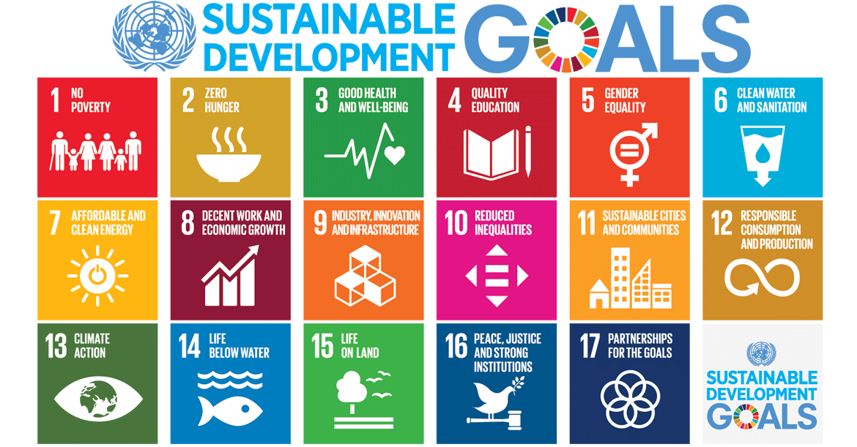
Image 4 (About the Sustainable Development Goals, 2019)
Up-cycle meets several of the United Nations Sustainable Development Goals, as shown in image 4, but lends itself particularly to the following;
3. Good health and well-being
10. Reduced inequality
11. Sustainable cities and communities
12. Responsible consumption and production
The united nations states that “The Sustainable Development Goals are the blueprint to achieve a better and more sustainable future for all” (About the Sustainable Development Goals, 2019). Although, the initiative links to several, all 17 goals are connected, and must be reached by 2030.
(University of Minesota, 2016) “Community wellbeing is the combination of social, economic, environmental, cultural, and political conditions identified by individuals and their communities as essential for them to flourish and fulfil their potential”. Communities need to find solutions to current issues and work collaboratively to achieve a common goal. It is possibly easier to accomplish in smaller rural communities, there are already strong relationships. Although, adaptation would bring the scheme to towns and cities.

Future waste management and end of life cycles
The department for Environment Food and Rural affairs has set out a 25-year environment plan. They have stated that they plan to minimise waste According to their report the plans aim is to fulfil all current waste targets, with regards to landfill, recycling and reusing. Developing pioneering new future objectives and waypoints. Although, there is no specific detail of how this will be achieved or statistics to support this hypothesis. (Summary of targets in our 25 year environment plan , 2019)
The advantage of bicycles is that most of the parts can be recycled at the end of their life. There will come a point where we will not be able to send items to landfill, it is imperative therefore that the project looks to other sustainable practises (Messenger, 2019) states that "If we genuinely want to enable people to share more and waste less then we need to see this ambition matched with support for businesses already operating in the sharing economy and those companies wanting to develop circular economy practices”.

Conclusion
Firstly, innovation will continue to bring renewed ideas, in the quest for sustainable products. Recycling and reusing of products, will likely become less of a niche lifestyle choice but common practise. With targets set and goals to be reached, a collaborative approach is needed. There is a financial future in the green and circular economy. However, the main aim of a sustainable innovation is not always profitability, but the collaborative desire to make a difference. Secondly, community run projects have the capability to inspire others and be the catalyst for change. We have a shared responsibility, looking for innovations that will enable the economy to reduce our consumption and the waste we produce. To conclude, ultimately a community that works together can only have a positive effect on the economy.Innovation implemented well, has the potential to transform lives, improve the environment and unite communities.

References

Stallard, K. (2018, January 1st). In China, rental bikes have become a social menace . Retrieved from Skynewscom: https://news.sky.com/story/in-china-rental-bikes-have-become-a-social-menace-11191053
About the Sustainable Development Goals. (2019, December 10th ). Retrieved from UN.org: https://www.un.org/sustainabledevelopment/sustainable-development-goals/
Barr, S., Gilg, A., & Shaw, G. (2013). ‘Helping People Make Better Choices’: exploring the behaviour change agenda for environmental sustainability. Applied Geography, 1-39.
Bicycle Options. (2019, December 10th). Retrieved from Pebrokeshire bike hire: https://pembrokeshirebikehire.co.uk/
Boston, C. (2017, June 13th). Transport challenges are keeping people trapped in a cycle of poverty. Retrieved January 17th, 2020, from iwa click on wales: https://www.iwa.wales/click/2017/06/transport-challenges-keeping-people-trapped-cycle-poverty/
Cilgerran population density. (2011, March 27th). Retrieved 2019, from Uk sensus data: http://www.ukcensusdata.com/cilgerran-w05000949/population-density-qs102ew#sthash.9gW0oHG1.dpbs
Clayton, A. (2018, August 10th). Bikes. Retrieved from The Ethical Consumer: https://www.ethicalconsumer.org/transport-travel/shopping-guide/bikes
Department For Transport. (2002). A Sustainable Future for Cycling. London: Department For Transport. Retrieved January 14th, 2020, from https://www.sustainabilityexchange.ac.uk/files/cyclingfuture.pdf
Ducheyne, F., De Bourdeaudhuij, l., Lenoir, M., & Cardon, G. (2014). Effects of a cycle training course on children's cycling skills and levels of cycling to school. Accident Analysis and Prevention, 49-60.
Erta, M., & Leblanc-Proulx, S. (2018). Sustainability in the colaborative economy: A bibliometric analysis reveals emerging interest. Journal of Cleaner Production, 1073-1085.
Government, W. (2015). Well-being of Future Generations (Wales) Act 2015 . Cardiff: gov.wales.
Government, W. (2019, June 10th). More than half a million pounds of Welsh Government funding for environmental and community projects. Retrieved from Gov.wales: https://gov.wales/more-half-million-pounds-welsh-government-funding-environmental-and-community-projects
Kahn, J. (2019). James Dysons Electric Shock. Fortune, 180, 110-118.
Kawasaki, G. (2015, May 6th). I lived in complete and utter fear of Steve. Retrieved 2019, from CIO.com: https://www.cio.com/article/3492496/i-lived-in-complete-and-utter-fear-of-steve-guy-kawasaki.html
Lai, E. R. (2011). Collaboration: A Literature Review. London: Pearson.
Lovretic, V., Benjak, T., & Gorka, V. (2013). SUBJECTIVE WELLBEING OF CYCLISTS AND PHYSICALLY INACTIVE SUBJECTS. Kinesiology, 45, 101-107.
Mason , C., Kirkbride, J., & Bryde, D. (2006). From stakeholders to institutions: the changing face of social enterprise governance theory. Management Decision, 284-301.
Messenger, S. (2019, December 20th). Waste: How will Wales end landfill and incinerator use by 2050? Retrieved January 17th, 2020, from BBC News: https://www.bbc.co.uk/news/uk-wales-50853509
Sinclair, S., Mazzei, M., Baglioni , S., & Roy, M. J. (2018). Social innovation, social enterprise, and local public services: Undertaking transformation? Social Policy & Administration, 1317-1331.
Summary of targets in our 25 year environment plan . (2019, May 16th ). Retrieved from Gov.uk: https://www.gov.uk/government/publications/25-year-environment-plan/25-year-environment-plan-our-targets-at-a-glance#minimising-waste
Understanding Poverty in Pembrokeshire. (2018, February 8th). Retrieved from Bevan Foundation: https://www.bevanfoundation.org/news/2018/02/understanding-poverty-pembrokeshire/
University of Minesota. (2016). What Is Community Wellbeing? Retrieved January 14th, 2020, from University of Minesota: https://www.takingcharge.csh.umn.edu/enhance-your-wellbeing/community/what-community-wellbeing

