St. John’s vision of the apocalypse commentary

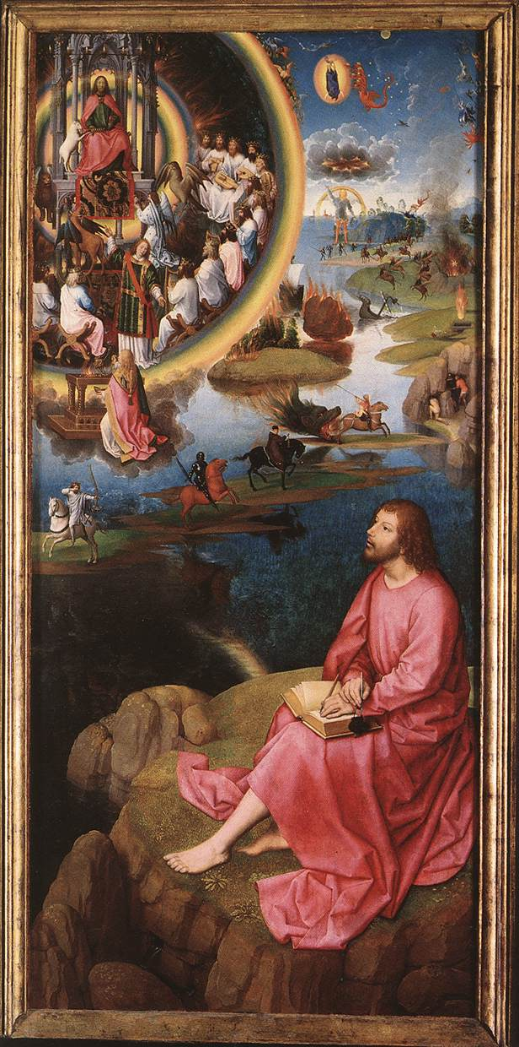
The painting of St. John’s vision of the Apocalypse was created 1475-1480 and is considered a key piece in the change of painting tradition in the Netherlands.
St. John’s vision of the Apocalypse
Hans Memling, The St. John Altarpiece (right wing), 1474-1479
Bruges, Memling Museum, St. John Hospital

Hans Memling was commissioned to create the St. John Altarpiece for the Sint-Janshospitaal in Bruges 1475-1480 (Greenwood, 2000: 15, Ormond, 2006: 162). The painting is the right panel of a winged triptych (painting on three panels) (Greenwood, 2000: 15). The larger central panel portrays the Virgin and child, while the smaller left panel shows John the Baptist Death (Greenwood, 2000: 16-18, Ridderbos et al, 1995: 136). The Masters and Prioresses who ordered this work are depicted on the back of either wing with their patron saints (Greenwood, 2000: 15-16, O’Hear 2016: 106). The installation of this series of paintings coincides with the construction of the apse in the hospitals church (Greenwood, 2000: 15, Ribberdos et al, 1995: 136). Until the church renovations in 1637 the painting remained at the high altar (Greenwood, 2000: 15). The triptych has remained in its original frame and remains at the restored hospital which is now the Memling Museum (Greenwood, 2000: 15).
The painting features a young, bearded Saint John seated on Patmos as he envisions the apocalypse (Greenwood, 2000: 19). John is seated in the foreground with the earthly events taking place behind him, and a window into heaven in the top left. The circular window to Heaven in the top left corner is outlined by a rainbow that features God enthroned (Greenwood, 2000: 23). He is holding a book with a lamb by his side, surrounded by four beasts and twenty-four elders (Ribberdos et al, 1995: 138, Greenwood, 2000: 21). Ribberdos et al (1995: 138) and Greenwood (2000: 21) all write that the lamb is important, as it is the one to break the seven seals that will unleash the apocalypse. The breaking of the first four seals unleash the Four Horsemen of the Apocalypse (Revelations, 6:2.). They are pictured on island-like terrain between John and his vision (Greenwood, 2000: 20-22). The breaking of the fifth seal which returns religious souls to Heaven is left out by Memling (Greenwood, 2000: 23). The breaking of the sixth seal which unleashes earthquakes and other celestial events such as the blood moon is present behind John (Greenwood, 2000: 23, Revelations, 8:12). Due to all of these similarities I believe that Memling is merely illustrating the events that take place in the Book of Revelations.

When looking at this painting I thought it odd that the book upon John’s lap was empty, even though he is supposed to be recording his vision. Ribberdos et al (1995: 138) believes that in the painting, all seven seals are broken and all the apocalyptic events are taking place, so John is merely witness and will transcribe later. However, Greenwood (2000: 24) writes that seventh seal remains unbroken and the angel responsible for the later acts is in fact kneeling underneath the window of Heaven. Greenwood’s (2000: 24) idea would mean that Memling is painting the apocalypse at its half-way point. This would explain why the book on John’s lap is empty, as he is only half way through his vision (Greenwood, 2000: 24, Revelations, 8: 7-8).
Although I thought that this painting is supposed to detail the Apocalypse, the main focus is Saint John. In the background of this painting every space is taken up by the events of the Apocalypse, all of which are dwarfed by the large prominent figure of Saint John on Patmos (Greenwood, 2000: 23-28). Emmerson and McGinn (1992: 328) write that the size of John is intentional as to draw your eye and make him the first subject to focus on. Arguably, the Saint John Altarpiece was not painted to have the observer focus on the events of the Apocalypse, instead to focus on John witnessing them (Emmerson and McGinn, 1992: 288). I found it unusual for Saint John to be gazing into space when he is supposed to be the witness to these events. Emmerson and McGinn (1992: 288) suggest that his unfocused gaze is due to John being in the middle of his vision. However, Greenwood (2000: 128) thinks that the unfocused gaze of Saint John is intended as it will redirect the viewers attention to the central panel of The Mystic Marriage of St Catherine.

The St. John Altarpiece has no solid borders between the events or subjects of the painting, instead it is a very open piece with every space having activity (Greenwood, 2000: 28). With the creation of this triptych, Memling leaves behind the tradition of panel painting which is evident in Master Bertram’s Apocalypse Panel (Greenwood 2000: 28-34). This piece of art uses a grid system on both the central and side panels to display forty-five scenes in episodic fashion, this presents the apocalypse “in a very literal way” (O’Hear, 2016: 106, Greenwood 2000: 35). While it has been restored, each individually framed piece shows a story from sixteen chapters from the Book of Revelation (Greenwood, 2000: 34). This is similar to illuminated manuscripts, each compartment is in sequential order with included text from the bible and a thirteenth century commentary (Greenwood 2000: 35). Although Memling’s altarpiece may seem chaotic without any borders, there are some subtle similarities to that of Master Bertram’s altarpiece. Instead of using solid squares to break up the story, Memling uses circles and islands to create borders between the three main subjects, Saint John, Heaven and the apocalyptic events on earth. Greenwood (2000: 28) believes that Hans Memling’s St. John’s vision of the Apocalypse was a key piece of art that attributed to the transition of the meaning of the Apocalypse to the Dutch people.
Left, Central and Right panel from an altarpiece depicting the Apocalypse, by Master Bertram, Hamburg, Germany, about 1380. Museum no. 5940-1859

In conclusion, Hans Memling uses the St. John’s vision of the Apocalypse to tell the story of the Book of Revelations while breaking away from tradition that in turn changes peoples view of the subject.

Bibliography

Greenwood, K.C., 2005. The art of revelation in the Apocalypse panel of Hans Memling's Altarpiece of St. John the Baptist and St. John the Evangelist, Sint-Janshospitaal (Memlingmuseum), Bruges.
Emmerson, R and McGinn, B (eds) 1992. The Apocalypse in the Middle Ages. New York: Cornell University Press
Ribberdos, B. Van Buren, A. Van Veen, H. (eds) 1995. Early Netherlandish Paintings: Rediscovery, Reception and Research. Amsterdam: Amsertdam University Press
O’Hear, N. 2016. Seeing the Apocalypse: Pre-1700 Visualisations of Revelation, in I. Boxall and R. Tresley (eds) The Book of Revelation and Its Interpreters: Short Studies and an Annotated Bibliography. 84-124. Maryland: Rowman & Littlefield
Left, Central and Right panel from an altarpiece depicting the Apocalypse, by Master Bertram, Hamburg, Germany, about 1380. Museum no. 5940-1859 [online] Available from: http://www.vam.ac.uk/content/journals/conservation-journal/autumn-2009-issue-58/master-bertrams-apocalypse-triptych-to-clean-or-not-to-clean/

