
Module Name: Academic Skills in the Digital Era
Module Code: BMSW4013
Assessment 1: E-Portfolio
Student Name: Asara Ben-Saoud
Student Number:2515050
Lecturer: Ffion Cumberpatch
Deadline: Friday 21st November 23:59PM

Contents
Component 1 – Research and Planning Template 3
Planning Your Report 4
Timeline for Component 2 4
Component 2 5
Introduction 5
Challenges Students Face 5
opportunities Digital Tools Provide 6
How Students Can Adapt 7
Conclusion 8
Component 3 – Reflective Presentation 9
Slide 1 (Overview) 9
Slide 2 (Research) 9
Slide 3 (Planning & Writing) 10
Slide 4 (Challenges) 10
Slide 5 (Successes) 11
Reference List 12

AI Acknowledgement
“AI tools were used for library research assistance and proofreading suggestions; no content was generated or rewritten by the AI.”

Component 1 – Research and Planning Template
This source is an article called Exploring the Impact of Digital Distraction on Learning: A Qualitative Analysis of University Students’ Experiences and Strategies, written by Prodeep Kumar Mondal and published in 2024.
The article looks at how digital devices impact university students’ learning.
Using these tools for studying and researching can help students access information, understand subjects better, and get higher grades.
On the other hand, social media, games, notifications, and poor time management can distract students and lower their focus and learning.
overall, digital tools can be helpful for learning, but only if students use them carefully and purposefully.
Key Challenge for Students
According to the study, the main challenges students face when using digital tools include frequent distractions from social media, games, and constant notifications, which make it difficult to focus on their studies. These distractions affect students’ ability to understand and remember information, additionally many students struggle with time management and self-control, often multitasking on their devices, which lowers concentration and overall learning quality, as a result while digital tools can be helpful, these challenges prevent students from using them effectively for academic success.
For example, from my own experience, my phone often distracts me while I’m studying, when I receive a notification, I check it and then browse apps, which makes it difficult to regain focus.
This challenge is important because it affects students’ concentration, time management, and productivity. Students need to manage these distractions to work more effectively and improve their academic performance.

Key Opportunity for Students
According to the study, the biggest benefit digital tools offer is that they can improve learning when they are used only for studying. When students use their phones, laptops, or tablets to research information, take notes, review slides, or complete assignments, they usually perform better in their studies. The study shows that these academic uses of digital devices help students understand their work more easily, stay organised, and achieve higher grades.
For example, when I’m working on an assignment, I use my laptop to research information and revisit lecture slides and videos to help me study and review what we’ve learned.
This opportunity is important because it shows how digital tools, when used properly, can genuinely support student learning and help them achieve better academic results.

Planning Your Report
In Component 2, I will focus on both the benefits and challenges of digital tools, as I believe both significantly impact university students’ learning in the digital era. My aim is to explore different perspectives on how some digital tools can be both helpful and challenging.
The plan is to include three strategies: using digital self-control tools to limit distractions, applying AI tools like SRLbot to support self-regulated learning, and organizing a focused digital study environment.

The report will follow this structure:
∙Introduction →Challenges students face→ opportunities digital tools provide → How students can adapt → Conclusion

Timeline for Component 2
Task | Date/ Deadline
Finish research | 05/11/2025-12/11/2025
Draft first section | 07/11/2025
Complete first draft | 10/11/2025
Final editing | 15/11/2025

Component 2

Introduction
Some research shows that university students’ acceptance of digital academic reading tools is mainly influenced by their attitudes, confidence, and perceived ease of use (Lin & Yu, 2023). While these tools provide major advantages such as convenience, quick access to learning materials, and better organisation students also face some challenges like eye strain, social media distractions, and they can also face some technical difficulties (Petratos et al., 2024; Čančer et al., 2025)
In this report I will cover some of the advantages and disadvantages of the use of digital tools and its impact on university students.

Challenges Students Face
One significant challenge university student’s face in the digital era is the distracting and potentially harmful impact of social media. While it can offer learning opportunities, its use often leads to reduced focus, exposure to misinformation, and privacy risks, which can negatively affect academic performance (Petratos, S., 2024).
Students face several challenges when using digital tools in higher education. Digital distractions, such as social media, notifications, and multitasking, can significantly reduce focus and engagement during learning activities. The constant flow of information increases cognitive load, making it harder for students to process and retain knowledge effectively (Prodeep Kumar Mondal, 2024). Additionally, the social environment created by technology can pressure students to remain continuously connected, further encouraging distraction. Finally, learning may be less meaningful because students struggle to link information to its proper context when attention is divided (Prodeep Kumar Mondal, 2024). These challenges highlight the need for strategies to manage technology use effectively in academic settings.
Students also encounter technical difficulties when using digital learning tools, such as managing various platforms, software problems, and device incompatibility, along with limited digital skills. These issues can interrupt learning, lower engagement, and negatively affect academic performance. Providing reliable infrastructure, technical assistance, and digital literacy training is crucial for students to use technology effectively and enhance their learning (Petratos et al., 2024).
Distractions from digital tools and technical problems can make it harder for students to concentrate and participate fully in learning. These challenges can slow their progress, reduce understanding, and negatively affect their overall academic success. Another example is what Stella Cottrell wrote in the Study Skills book (2024). She realised she could easily spend hours on Instagram, WhatsApp, and games, thinking she could study at the same time, but when she tracked her study time, she was shocked by how little she achieved. She now stays away from those apps while studying because she finds it much easier to concentrate.

opportunities Digital Tools Provide
Digital communication plays an important role in modern higher education, offering numerous benefits that enhance both learning and social experiences for students. One key advantage is accessibility, digital tools allow students to reach educational resources anytime and anywhere, supporting flexible and self-directed learning (Allam et al., 2025). These tools also increase engagement, as students can participate in online discussions, virtual classes, and collaborative projects, which promotes active involvement with the course content, by enabling interaction with peers and instructors, technology fosters collaboration and knowledge sharing, helping students develop teamwork, problem-solving, and communication skills (Saad Belmadani & Belabes, 2024).
When used effectively, digital tools can improve learning outcomes. Interactive platforms, discussion forums, and collaborative applications allow students to engage deeply with material, analyse concepts critically, and apply knowledge in meaningful ways. Multimedia resources, digital simulations, and online assessments further enhance understanding by offering visual, practical, and hands-on experiences. Technology also supports personalized learning, allowing students to learn at their own pace, revisit difficult topics, and adapt their learning to individual needs (Ng et al., 2024).
Additionally, digital communication strengthens students’ academic and social connections, creating networks for peer support, idea exchange, and motivation, it also encourages the development of digital literacy, which is an essential skill in today’s workforce (Saad Belmadani & Belabes, 2024). Overall, when used thoughtfully digital communication tools enhance engagement, collaboration, knowledge retention, and skill development, making learning more interactive, effective, and meaningful. Their proper integration into higher education can significantly improve both academic performance and overall student experience. (Allam et al., 2025).

How Students Can Adapt
One practical strategy for succeeding in a digital learning environment is using digital self-control tools (DSCTs), these include website blockers that prevent access to distracting sites, screen-time tracking apps that monitor device use, and built-in phone features like Apple’s Focus Mode or Android’s Digital Wellbeing. Recent research by Biedermann et al. (2023) shows that DSCTs can help students reduce digital distractions and stay on task by limiting interruptions from notifications and social media. This strategy works because it removes the immediate temptation to check non-academic content, allowing students to maintain concentration for longer periods. By reducing distractions at the source, students are better able to manage their workload, remain productive, and develop more consistent study habits.
Another effective strategy is using AI tools such as SRLbot, which supports students’ self-regulated learning. SRLbot helps students set goals, plan their study time, organise their work, and seek help when they need it. Research found that students who used SRLbot during a science learning programme showed better motivation, engagement, and academic performance compared to those who used a rule-based chatbot (Chan et al., 2023). This tool works well because it acts like a personalised study coach, providing reminders, explanations, and advice tailored to the student’s learning needs.
By receiving regular guidance, students strengthen their self-regulation skills, avoid procrastination, and develop more productive learning habits.
A third practical strategy is organising a digital learning environment that minimises distractions, students can do this by clearing their workspace, turning off unnecessary notifications, and setting specific times for tasks. Research shows that when students reduce digital clutter and create a focused environment, their concentration improves and their ability to retain information increases (Pérez-Juárez et al., 2024). This approach works because it reduces cognitive overload and prevents multitasking, allowing students to engage more deeply with their learning. A well-organised environment supports better time management, improves academic performance, and makes digital learning more manageable and less stressful.

Conclusion
In conclusion, digital tools provide university students with many advantages, including easy access to learning materials, opportunities for collaboration, and personalized study experiences. However, they also bring challenges, such as distractions, technical difficulties, and information overload, which can affect focus and academic performance. Students can overcome these issues by using strategies like digital self-control apps, AI tools such as SRLbot, and creating organized, distraction-free study environments. These approaches help improve concentration, time management, and self-regulation, enabling students to make the most of digital learning, enhance their understanding, and achieve better academic outcomes while developing essential skills for the future.

Component 3 – Reflective Presentation

Slide 1 (Overview)
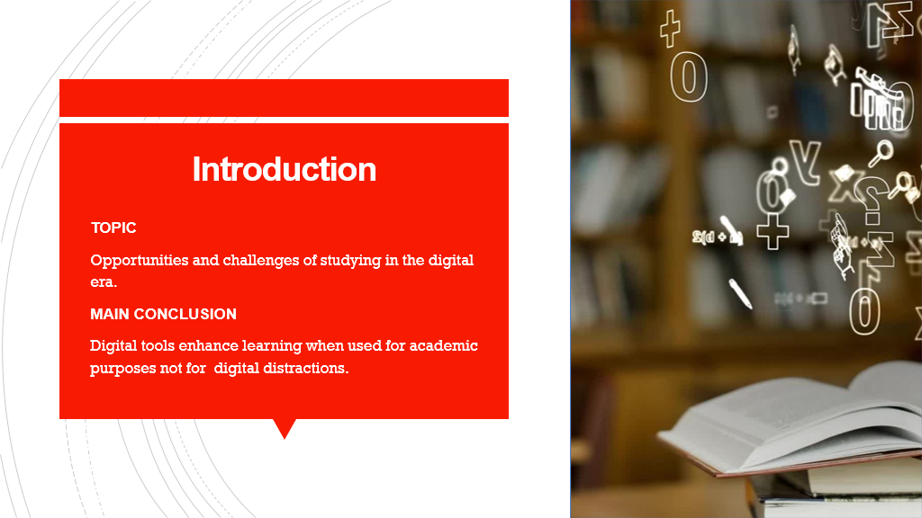

Slide 2 (Research)
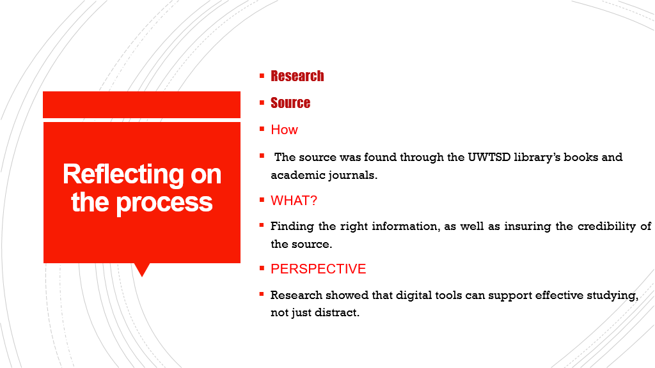

Slide 3 (Planning & Writing)
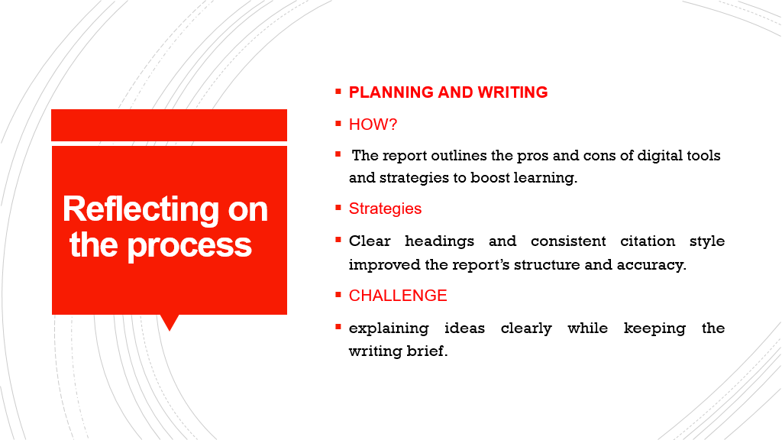

Slide 4 (Challenges)
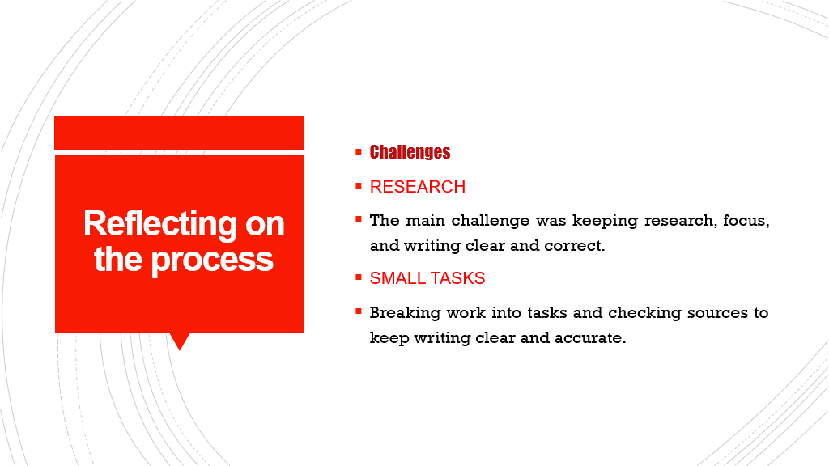

Slide 5 (Successes)
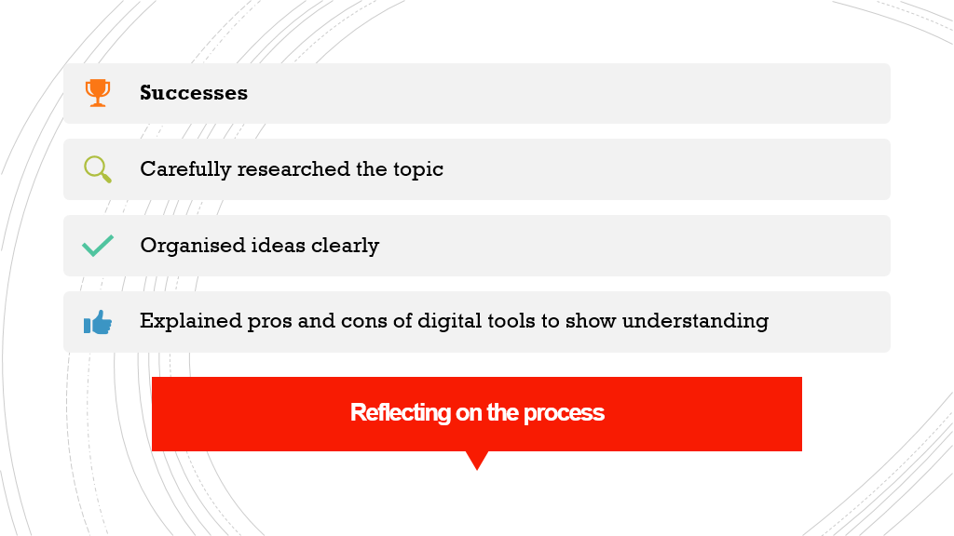

Reference List
∙Allam, H. M., Gyamfi, B., & AlOmar, B. (2025). Sustainable Innovation: Harnessing AI and Living Intelligence to Transform Higher Education. Education Sciences, 15(4), 398. https://doi.org/10.3390/educsci15040398
∙Biedermann, D., Kister, S., Breitwieser, J., Weidlich, J., & Drachsler, H. (2024). Use of digital self-control tools in higher education – a survey study. Education and Information Technologies, 29(8), 9645–9666. https://doi.org/10.1007/s10639-023-12198-2
∙Čančer, V., Tominc, P., & Rožman, M. (2025). Measuring Students’ Use of Digital Technology to Support Their Studies. Education Sciences, 15(7), 842. https://doi.org/10.3390/educsci15070842
∙Cottrell, S. (2024). The study skills handbook (Sixth edition.). Bloomsbury Academic, Bloomsbury Publishing Plc.
∙Lin, Y., & Yu, Z. (2023). Extending Technology Acceptance Model to higher-education students’ use of digital academic reading tools on computers. International Journal of Educational Technology in Higher Education, 20(1), Article 34. https://doi.org/10.1186/s41239-023-00403-8
∙ Pérez-Juárez, M,A. González-Ortega, D., & Aguiar-Pérez, J. M. (2024). Digital Distractions from the Point of View of Higher Education Students. arXiv.Org. https://doi.org/10.48550/arxiv.2402.05249
∙Petratos, S., Botha, R., & Mtshabe, M. (2024). Digital Skills’ Impact on the Use of Digital Learning Tools. Proceedings of the ... European Conference on e-Learning (Online), 23(1), 299–306. https://doi.org/10.34190/ecel.23.1.2995
∙Prodeep Kumar Mondal (2024). Exploring the Impact of Digital Distraction on Learning: A Qualitative Analysis of University Students Experiences and Strategies, International Journal of Emerging Knowledge Studies. 3(9), pp.625-632. https://doi.org/10.70333/ijeks-03-09-023
∙Ng, D. T. K., Tan, C. W., & Leung, J. K. L. (2024). Empowering student self‐regulated learning and science education through ChatGPT: A pioneering pilot study. British Journal of Educational Technology, 55(4), 1328–1353. https://doi.org/10.1111/bjet.13454
∙Saad BELMADANI & Taqiyeddine BELABES. (2024). Impact of Digital Communication on Academic Performance and Social Interaction Among University Students: A Study at Laghouat University. Akofena, 6(13). https://doi.org/10.48734/akofena.n013.vol.6.16.2024

