a Concrete frame building: swansea civic centre

Material Science ACBA 4006

Tom McGaw (2305689)

Contents
A A Concrete Frame Building: Swansea Civic Centre 2
1.1 Introduction 2
1.2 Building structure design 3
1.3 Design plan 4
1.4 Construction method 5
1.5 Social and Environmental sustainability 8
B The Framing Material 8
1. Introduction 9
2. Durability and Climatic Resistance 9
3. Original Production Process Including Social and Ecological Impacts 10
4. Ease of Assembly/Building Services Provision/Adaptability Compared to Steel Frame 11
Appendix 1 Weaver Building 12
Appendix 2 Rationale for the Civic Centre 13
References 15

Table 1 Timeline of dates of Construction 4

A A Concrete Frame Building: Swansea Civic Centre
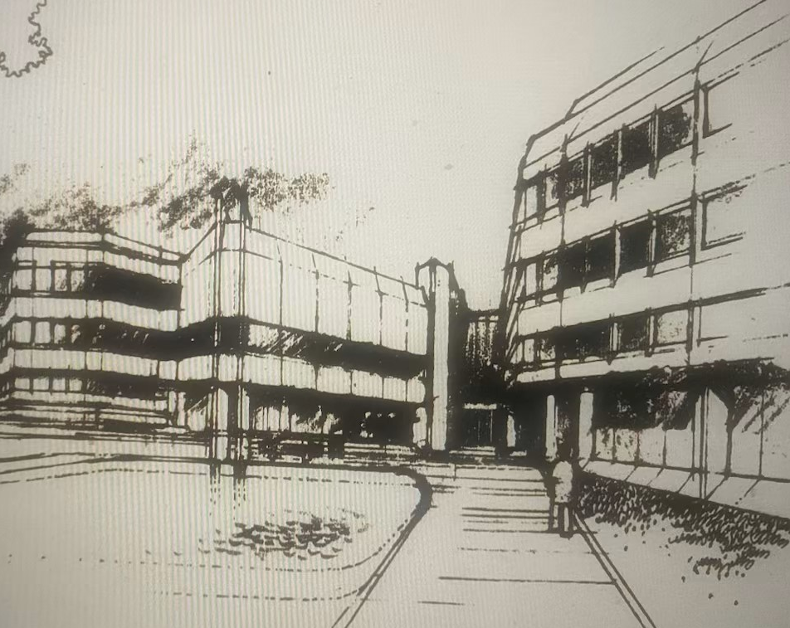 Fig.1.

Introduction
There is a good example of a modern and habitable concrete frame building in Swansea: County Hall, on the Swansea Bay waterfront to the west of the Marina, completed in 1982 and since 2008 re-named the Swansea Civic Centre.

The design received a commendation in the 1983 Concrete Society Concrete Awards. The assessors considered that ‘it demonstrates that a prestigious building in an exacting climatic situation can be very attractive in concrete when the architect’s careful detailing is supported by excellent framework and casting on the part of the contractor’.

1.2 Building structure design
It can be said that Swansea is rightly famous for concrete frame buildings. Such as the Weaver building (See Appendix 1 for information about the Weaver building.)

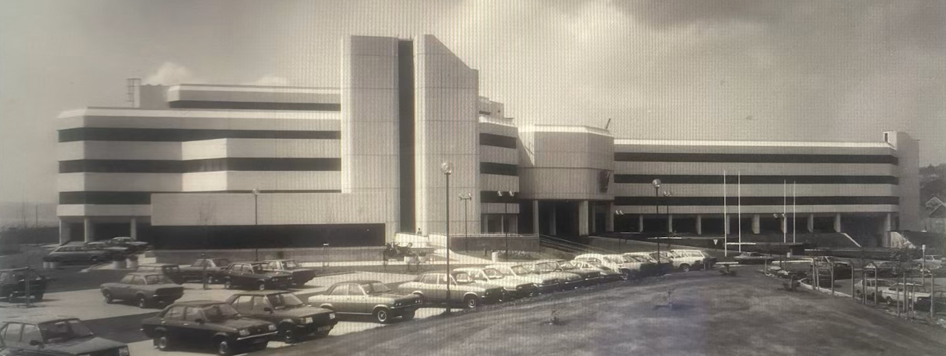 Fig.2.

The Swansea Civic Centre is also a good choice because it is an example of 1970s ‘Brutalist’ architecture. As the City and County of Swansea intends to demolish the Civic Centre, the influential 20th Century Society included it in its 2021 list of ten Buildings at Risk and is said to be seeking its Grade II listing.

Brutalist architecture originated in the United Kingdom in the 1950s and can be described as ‘minimalist constructions that showcase the bare building materials and structural elements over decorative design, and commonly makes use of exposed, unpainted concrete or brick, angular geometric shapes and a monochrome colour palette’. In maritime climates, Brutalist concrete facades become streaked with dirt and moss, and rust stains appear from cracks exposing reinforcing bars to the elements; cleaning and maintenance budgets get cut. The use of concrete projects an atmosphere of totalitarianism. Because many instances of the style were social housing, these attract graffiti. Often the buildings are publicly unpopular.

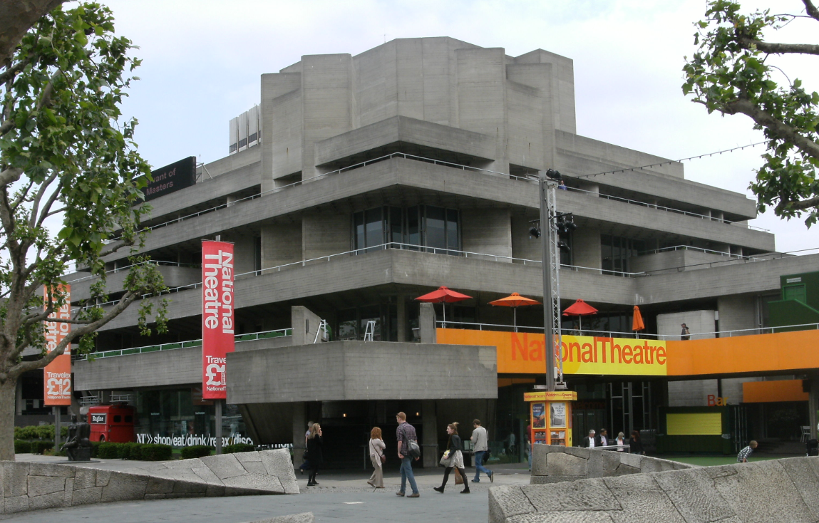 Fig.3.
The Swansea Civic Centre was completed just as the Brutalist movement was largely over, although since 2015 there has been a resurgence of interest in Brutalism as an important phase in architectural history that ought to be preserved.

1.3 Design plan
Table 1 Timeline of dates of Construction
Date | Progress made
October 1975 | Outline planning permission granted
December 1975 | Approval for the ‘general massing arrangement’ for the whole County Hall development
June 1976 | Approval of the design of the 16,670 sq m Phase 1 of the new County Hall (the eastern half, including the main Council Chamber)
July 1977 | Approval of detailed design proposals with a view to commencing construction in December 1978 and completion in June 1981

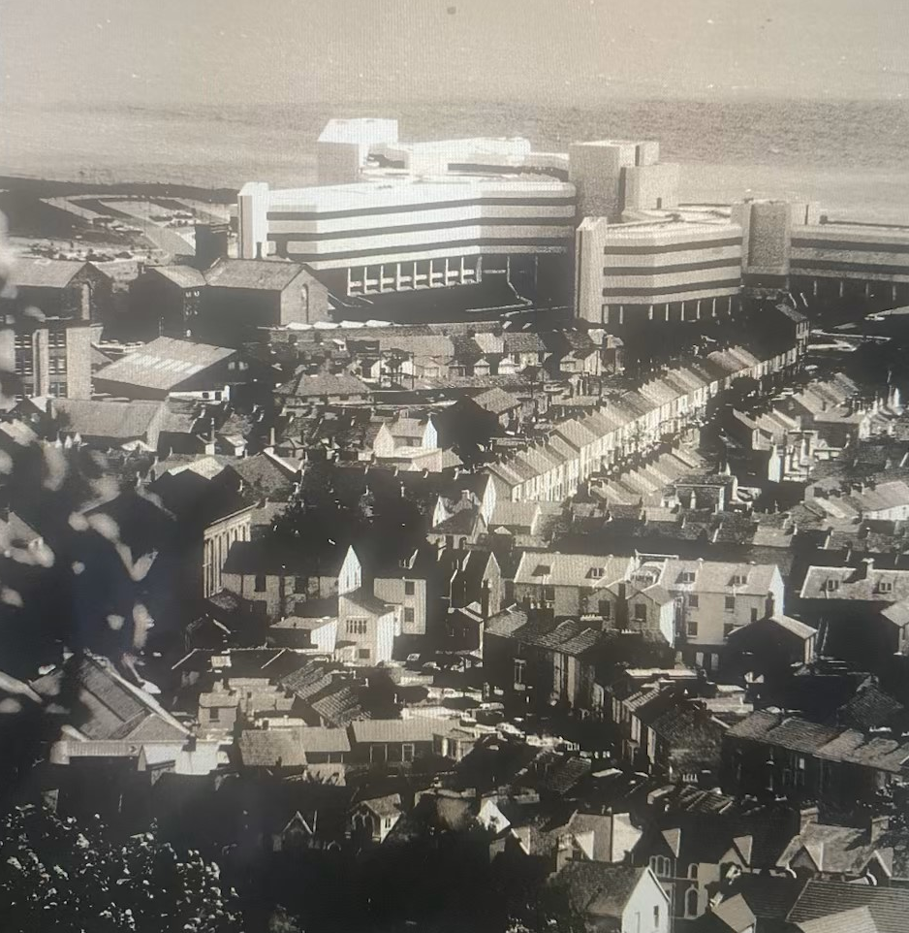 Fig.4.

1.4 Construction method
The site to be developed was principally a disused railway yard, including a series of railway arches, named the Victoria Viaduct, let to a variety of small businesses. The land assembly, for which possession of most of the business premises was obtained by March 1977, also involved the demolition of a chemical works off Oystermouth Road opposite Christ Church and the Prison, an Engine Mens’ Barracks, a school, and (in retrospect, unnecessarily) the disappearance of all or part of several roads lined with modest terrace houses – the entirety of Sloan Street and those parts of Paxton and Bathurst Streets south of the Oystermouth Road. The new County Hall was referred to in correspondence as being located on Paxton Street, but that part of the site remains a large parking lot.

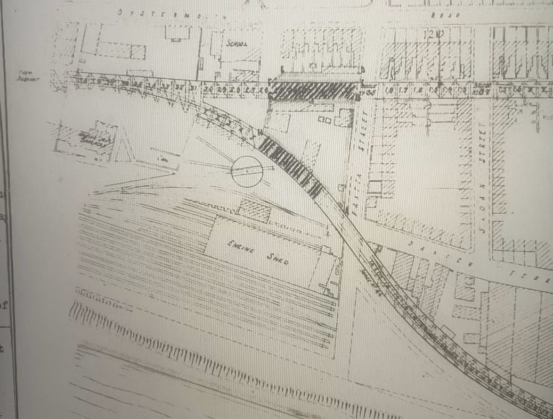 Fig.5.

It is clear that notwithstanding intervening changes – such as omission of the 1500 seat multi-purpose theatre – the building would have a reinforced concrete frame, clad with bronze-tinted glazing and off-white exposed aggregate pre-cast concrete panels. The design was by the West Glamorgan County Council Architect’s Department, the records of the activities of which no longer exist.

A general arrangement drawing with a cross-section depicts a five- to six-storey structure resting on a reinforced concrete slab spanning a series of pile caps. The site investigation for the building and the sea wall works was based on two trial pits and five boreholes.

As was explained to the County Hall committee in June 1976, six alternative forms of structure had been analysed and costed before arriving at the final solution which consisted of reinforce concrete columns and concrete floor and roof slabs.
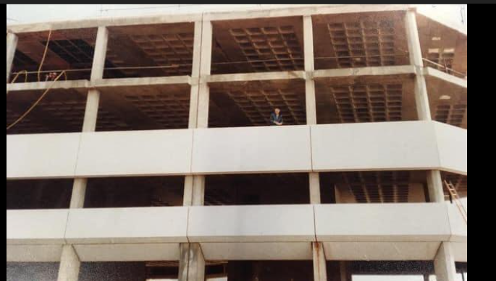 Fig.6.

The basement was to be in waterproofed reinforced concrete, with the whole building raised to ensure that the general lower ground floor level was above the existing ground water level. The basement wall and floor slab were to be combined with concrete pile caps forming a continuous strip between pile groups on the outside of the building. As the site investigation had established that the general sub-strata were of a compacted sand nature, the foundations solution was piles, a combination of bored end-bearing and friction type, to a depth of approximately 10 m to below the level of peat and clay beds. The report alluded to the need to engage a specialist acoustic consultant to ensure that noise and vibration from basement and roof plant was isolated. Additional sea defence work was also contemplated. By the spring of 1979, Frankipile has been appointed to carry out the piling and French Kier was the general contractor. Records of when it was completed and of the design, construction and completion of Phase 2 are lacking. Both phases were complete by 1982.

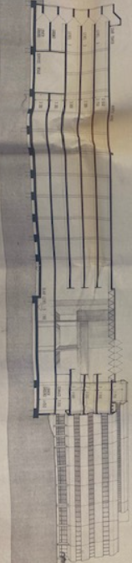 Fig.7.

1.5 Social and Environmental sustainability
I have already referred above to the serious concerns that the residents, as well as people from the wider Swansea community, about the scale, design and location of the County Hall, and how these came to nothing.
Knowing as we do now that the objection, that the scheme was misconceived at a time when the structure of Welsh local government was unsettled, was demonstrated to be correct with the abolition of the West Glamorgan County Council.
The experience suggests that in relation to the future of the Civic Centre, deference to experts and politicians may not be appropriate.
Far more so than in the past, environmental impact is a factor to be balanced with other considerations in achieving a good design solution. It is now well understood that the production of concrete is very damaging to the environment. Timber is more sustainable, but usually inappropriate for large buildings. Steel also is environmentally damaging in its production, so for large buildings there is a trade-off between the use of steel and concrete to execute a design at the lowest reasonable environmental cost, but also the demands of sustainability considerations require developers to pause at the threshold of undertaking new projects to consider whether the building is needed, at that size, and whether refurbishment and adaptation of any existing building is the best solution.
Concrete is the most widely used substance on Earth, responsible for 4-8% of the world’s CO2 and requiring 10% of the world’s industrial water use and its production has increased by 2500% since 1950. Furthermore, the cement and concrete industry is notoriously corrupt, not only in the Third World but even in Britain.

B The Framing Material

1. Introduction
As already stated, the designers considered six different forms of structure before arriving at the final solution of reinforced concrete columns and concrete floor and roof slabs.
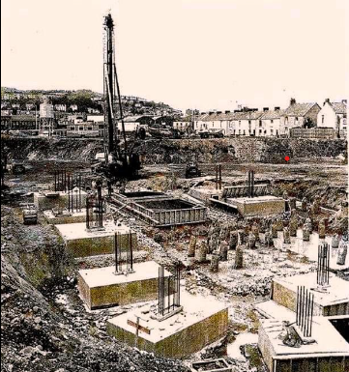
The piling and foundations solution was informed by that design selection, creating pile caps to bear reinforce concrete beams and posts to raise the structure above the water table and provide a sound base upon which to build.
Concrete framing construction involves following a basic pattern: assemble and erect formwork; prepare and place reinforcement; pour and compact or vibrate concrete; strike and remove formwork in stages as curing proceeds. When the concrete is firstly mixed it will be in a slurry state and can then take the form it is set by shape, size and position by being placed in a mould, ie the formwork.
Fig. 8.
When reinforcing it, it can be reinforced with steel bars. The steel bars are set in place then covered over by the concrete. When all that is finished, the surface of the concrete will needs to be smooth (or with whatever surface treatment is desired aesthetically), which will depend on cement content, water content, degree of compaction, pin holes caused by the formworks, pin holes caused by entrapped air and rough patches caused by adhesion to parts of the formworks. Figure 9 shows the underside of the reinforced concrete floor slabs, the result of using moulded formwork to produce an aesthetically pleasing but structurally efficient grid.

2. Durability and Climatic Resistance
There are two aspects to the issues of durability and climatic resistance – workmanship and the inherent nature of the materials. The County Hall was praised for its workmanship but other projects are not so lucky. A classic problem arising from poor workmanship arising from inadequate concrete cover to the reinforcement, where due to water ingress, especially where iron-rich aggregates and pyrites are used, rust-brown stains become visible, and in serious cases, corrosion of the steel reinforcement can cause cracking and failure of the structural element. In the case of precast panels manufactured offsite, there are greater opportunities for achieving good quality control. Concrete itself is highly durable, as is reflected in the preserved remains of Roman constructions.
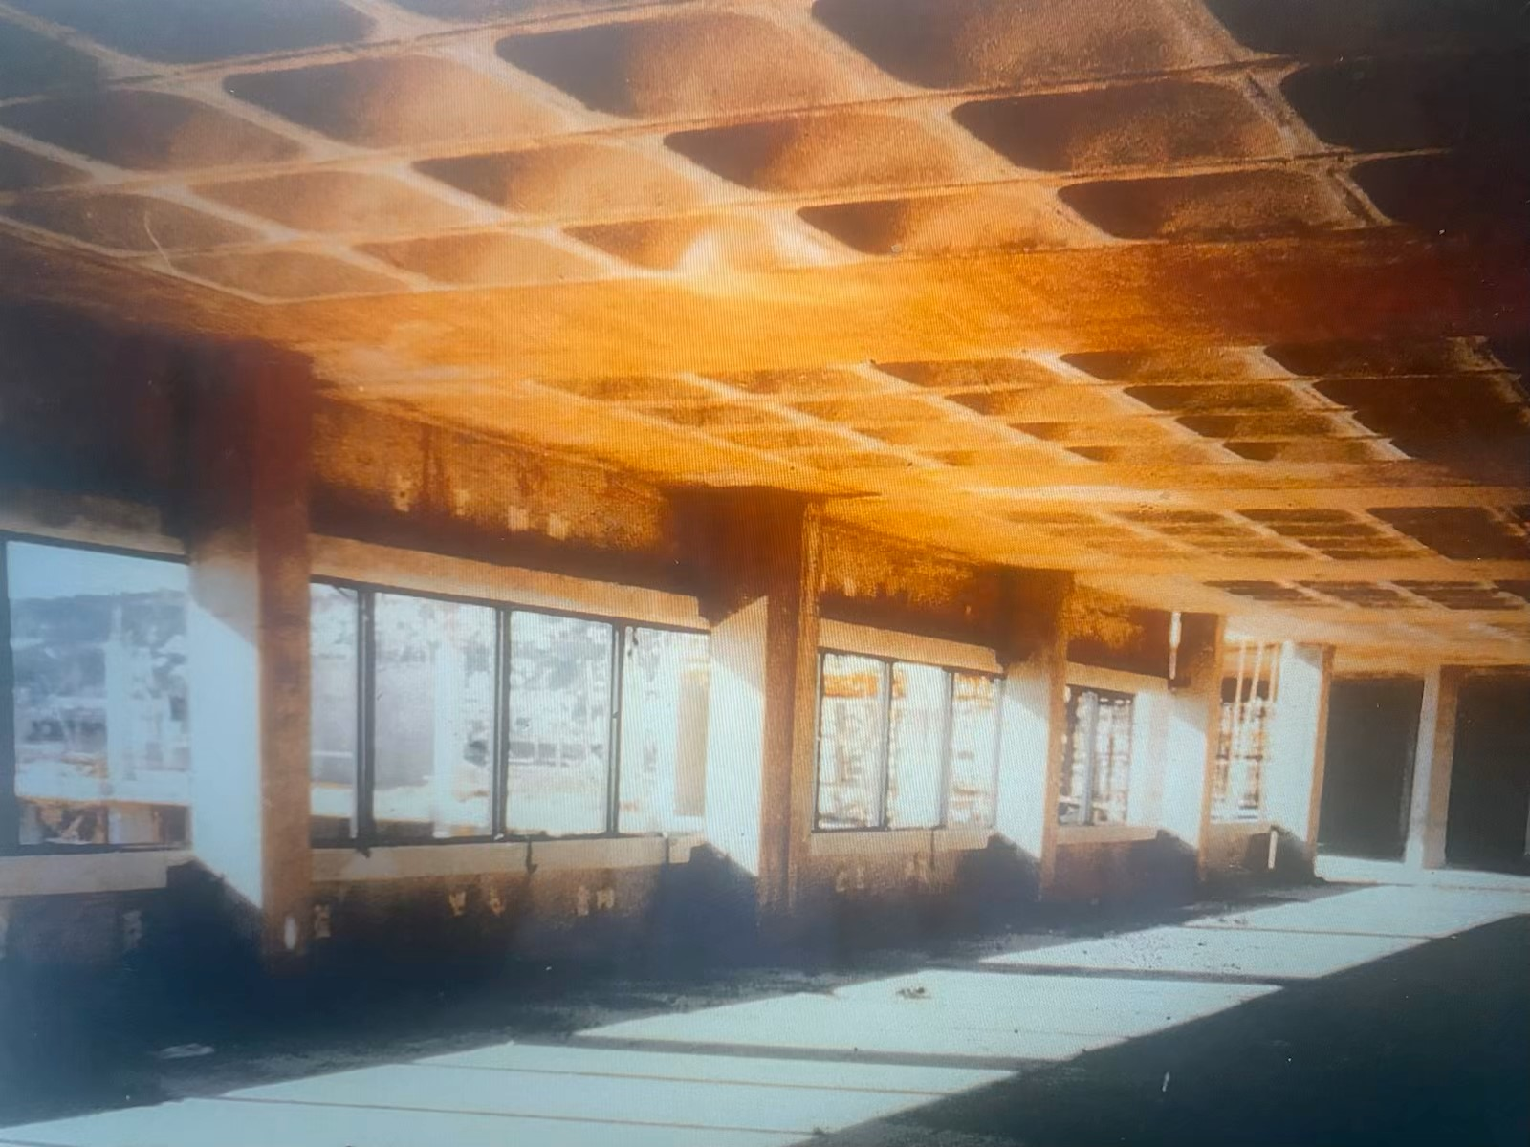
Fig.9.

3. Original Production Process Including Social and Ecological Impacts

I have already addressed the social and environmental aspects of the original production process associated with concrete structures in section 1.5.

4. Ease of Assembly/Building Services Provision/Adaptability Compared to Steel Frame
There is little doubt that a steel frame has some advantages over a concrete frame, however steel as a material is considerably more expensive than concrete and the designer is always needing to strike a balance between the amount of steel and the cost, and other factors such as availability of labour and materials, capital cost and personal preference. A reinforced concrete frame is also bulkier than an all-steel design, and this can be a factor especially in high-rise office buildings, where the design solution is usually a reinforced concrete elevator and services core with the occupied floors tying off this and constructed in steel, with priority placed on maximizing unrestricted floor space. Steel has the advantage in adaptability in the sense that tying new structures to a steel frame, or changing the arrangement of ducting and other building services-related components are less challenging than a masonry construction. On site phases of construction may be more prolonged with reinforced concrete framing due to curing times and greater vulnerability to delays due to weather conditions, yet a steel frame may be associated with its own vulnerabilities in terms of supply and competing demands on the production capacity of specialist steelwork manufacturers and on-site installers. Here is an instance of the general tension between the costs and advantages of onsite versus offsite construction, the resolving of which is reliant on the professional expertise of the developer’s consultant team and the contractor.

Tom McGaw
26 July 2024

Appendix 1 Weaver Building
The first reinforced concrete structure built in Britain was the Weaver Building, a six-storey grain elevator beside the old North Dock off the River Tawe, built in 1897 and demolished in 1984 to make way for a Sainsburys. Its French designer, François Hennebique had, like others, originally used concrete as fire protection for cast iron, but in 1892 patented a method, based on a concrete slab with steel bars on its bottom face, which shifted the emphasis to the structural use of concrete, using its strength in compression and emphasizing reliance on reinforcing bar where the structure was under tension. The builder was Louis Mouchel (a famous name in British engineering until disappearing in a 2017 rebranding), a Frenchman armed with a license from Hennebique who founded LG Mouchel & Partners Ltd in Brittan Ferry, and whose first project was the Weaver Building. The design is sufficiently important that a column is preserved by the Science Museum in London.

Appendix 2 Rationale for the Civic Centre
The rationale for the project was the consolidation of staff, then housed in a number of buildings, in one location. The project was not without controversy, and in the archive files (now publicly available after a 30 year embargo), there was a June 1978 Plaid Cymru-organized petition signed by 1,129 maintaining that it was ‘immoral for the Council to spend public money on luxury accommodation at a time when it is curtailing its social service and education expenditure’, and a petition to the Welsh Office by a Four Districts County Hall Committee for a public inquiry, and threat of a judicial review, to make the County adopt a less ambitious scheme. Along with other individual complaints about inadequate parking provision, the cost, uncertainty about the future direction of how Wales was locally governed, and about its location (arguably contrary to the County Structural Plan), none of this opposition came to anything. Fig.4 indicates how intrusive the project was in the existing streetscape. In retrospect, the complainants were probably right, and the design was a municipal vanity project.

References
Anon. undated. ‘Brutalist architecture’, Wikipedia. Available at https://en.wikipedia.org/wiki/Brutalist_architecture. (Accessed 25 July 2024).
Anon, undated. ‘François_Hennebique’, Wikipedia. Available at https://en.wikipedia.org/wiki/François_Hennebique. (Accessed 25 July 2024).
Anon, The Guardian (2019) ‘Concrete: the most destructive material on Earth’ (25 February 2019).
Anon, UK Gov’t, undated ‘Construction companies: construction cartel’. Available at www.gov.uk/government/case-studies/concrete-companies-construction-cartel. (Accessed 26 July 2024).
Anon, Science Museum (undated) ‘Fourth floor column from Weavers mill’. Available at https://collection.sciencemuseumgroup.org.uk/objects/co50108/fourth-floor-column-from-weavers-mill-the-first-reinforced-concretee-building-in-britain-1898-reinforced-concrete-column. (Accessed 27 July 2024).
Anon, undated, ‘Weaver building’, Wikipedia. Available at https://en.wikipedia.org/wiki/Weaver_building. (Accessed 25 July 2024).
Anon, 20th Century Society, undated, untitled. Available at https://c20society.org.uk/buildings-at-risk. (Accessed 25 July 2024).
Banham, R (1966) The New Brutalism London: The Architecture Press.
Cassie, WF (1955) ‘Early reinforced concrete in Newcastle upon Tyne’ 7 Magazine of Concrete Research 25.
Collins, P (2004) The Vision of a New Architecture 2nd edn Montreal: McGill-Queen’s University Press.
Chudley, R and Greeno, R (2014) Building Construction Handbook London: Routledge.
Harwood, E (2022) Brutalist Britain. Buildings of the 1960s and 1970s London: Batsford.
Riley, M and Cotgrave, A (2014) Construction Technology 2: Industrial & Commercial Building 3rd edn London: Bloomsbury.

Fig.1: West Glamorgan Archive Service (WCAS), untitled, undated, Swansea, WGCC/EH 34/10/1-34 (Architect’s sketch). Originally built to house the West Glamorgan County Council, abolished in 1996, the name change reflected the intervening changes in the structure of local government in Wales and the building’s internal re-development to house both the City and County of Swansea administration, the Swansea Central Library and the West Glamorgan Archive Service.
Harwood (2022) p.152.
See Anon, 20th Century Society (2024). Fig.2 (WCAS untitled, undated, Swansea, WGCC/EH 34/10/1-34 (County Hall) as completed. The cars are parked where terrace houses once stood.
See Banham (1966); Anon, Wikipedia, Brutalist Architecture. The most famous British Brutalism structure is the National Theatre, London (fig.3 (Anon, Wikipedia, Brutalist Architecture)).
See Anon, Wikipedia, Brutalist Architecture.
See Anon, Wikipedia, Brutalist Architecture; Harwood (2022).
There had formerly been a Swansea Victoria station, serving the Central Wales line to Shrewsbury (closed in 1964), adjacent to the terminus of the Swansea and Mumbles Railway at Rutland Street (no longer in existence).
WGAS untitled, undated, Swansea, WGCC file 4/4 marked 513(A). See Fig.5 (WGAS untitled, undated, Swansea, WGCC/SS 12/12-16, Plan of Swansea).
WGAS undated, untitled, Swansea, WGCC/C 3/1, Anon, note.
WGAS undated, Drwg No GA.-200-6, Swansea, WGCC/C 3/1. See Fig.7 (WGAS undated, JH Webb, Phase 2 Link with Phase 1, Swansea, WGCC/EH 34/10/1-4.
WGAS undated, Drawing No. B & S 267/703.a, Swansea, WGCC/CA 12/14.
WGAS June 1976, J Webb, Design for Phase One, Swansea, WGCC/C/1/1 para.3.1.
WGAS June 1976, J Webb, Design for Phase One, Swansea, WGCC/C/1/1 paras.3.2-.3.
WGAS 3 May 1979, Services Meeting No.45, Swansea, WGCC/CA 12/16.
Riley and Cotgrave (2014) p.76.
Riley and Cotgrave (2014) p.216.
See Anon, The Guardian, 25 February 2019.
See eg Anon, UK Govt (2024).
Chudley and Greeno (2014) p.721.
Riley & Cotgrave (2014) p.175.
See the graphic cash flow comparison between steel frame and in-situ concrete frame buildings at Riley & Cotgrave (2014) p.215.
See Weaver Building, Wikipedia; François Hennebique, Wikipedia.
See L Mouchel, Wikipedia. The invention of reinforced concrete is usually attributed to William Wilkinson in the mid-19th century: Cassie (1955) p.25; Collins (2004).
See Anon, Science Museum, ‘fourth floor column from weavers mill’ (2024).
WGAS 12 August 1978, South Wales Evening Post, Swansea, WGCC/CS 14.

