University of Wales Trinity Saint David
Wales Institute of Science & Art

Sustainability Challenges in Industry
Automotive Materials & Sustainability ACHA6012

Rhys Ewin
2004294
Date (03/2024)

Contents
Contents 1
Table of figures 2
Acknowledgments 2
1 Introduction 3
2 Environmental Impact 4
2.1 The duty of engineers 4
2.2 Environmental concerns in motorsport 4
2.3 Environmental impact on a global scale 5
3 Sustainable Practices & Legislations 7
3.1 Situation report 7
3.2 Alternatives 7
3.2.1 Technology 7
3.2.2 Fuelling 7
3.2.3 Viewing 8
3.3 Situation analysis 8
4 Sustainability and Technological Challenges 9
4.1 Political challenges 9
4.1.1 International events 9
4.1.2 Carbon offsetting 9
4.2 Social challenges 9
4.3 Technological challenges 10
4.4 Juxtaposition 10
5 Outlook 12
6 References 14

Table of figures
Figure 1 - Carbon footprint map of motorsports. (FIA, 2023) 5
Figure 2 - Maritime transport compared to car transport in Europe. (McCarthy, 2019) 6
Figure 3 - Sustainable fuelling roadmap. (FIA, 2023) 8

Acknowledgments
This report has been written with the use of artificial intelligence software, ChatGPT 3.5. The use of AI was to condense and rewrite sections of own work. Not to gather information or validate any points made.

Introduction
Racing holds relevance even in the modern world due to the entertainment provided to fans across the globe, companies use it as a marketing tool, athletes compete for the drive to be the best. It trickles down into club level where people come together to enjoy a mutual hobby even just to improve and test their skills with likeminded individuals.
Sustainability is gaining prominence in the racing industry, influencing legislations, homologation, and social validation. On average, a distinct generational divide is evident in public opinion: the younger generation leans towards a future-oriented perspective, while the older generation desires the industry to maintain its traditional roots.
Adversity from activist has reached an all-time high, fuelling government legislation that becomes the catalyst behind technological, but sustainable, advancement. Sport overall is inherently political, but if the younger generation can envision a greener, more environmentally sustainable future through their motorsport heroes, the repercussions can only be positive, influencing the next generation of engineers.
Optimally, conversations include the perspectives of all involved parties on the likes of sustainability in the future of motorsports, the highest level of awareness is required to pursue a mutually acceptable pathway towards increased sustainability throughout motorsport. (Balestrieri et al, 2023)
The lessons learned in motorsport will facilitate the advancement of all vehicles, current F1 engines can be up to 150% more efficient than the average road car in converting fuel to kinetic energy. Motorsport allows the public to benefit from the entertainment of watching vehicular development happen in front of their eyes as opposed to behind the scenes. (Schieren, 2019)
Motorsport holds an interesting ultimatum in terms of engineering advancement, the core fanbase of this industry demands the noise, the excitement and the technology that realise the exact environmental consequences that are rapidly increasing in global concern. This dichotomy poses the question; how does motorsport advance, but remain the sport the fans love?

Environmental Impact

The duty of engineers
It is the essence of an engineer to abide and uphold morality and principles in industry, motorsport is no different. Qualified engineers fall into some form of council or group they represent when they conduct their profession. The Engineering Council, IMechE & the Royal Academy of Engineering have clear values dictating the need to be sustainable and consider the environmental impact of projects, underlined by the respect for life, law, the environment & public good. (Engineering Council, 2005)
Sustainability is at the forefront of the motorsport industry with the FIA Environment and Sustainability Commission President, Felipe Calderon, declaring the intent to reach a state of net zero carbon emissions by 2030. The three strategic goals in place consist of: climate action, technology and innovation and sustainable practices. (FIA, 2023)

Environmental concerns in motorsport
The main areas of environmental concern within motorsports are not limited to but include: the degradation of natural environments through erosion for example in motorcross or rally, and destruction of land to create tracks and venues for motorsport to take place, the noise pollution (UK Public Generals Act, 1990) and the inherent effect on wildlife and habitats in the area, and air pollution through vehicle emissions. (Doytchev, 2019)
Cost reduction will lead to the inevitable increase in sustainable practices in motorsport. Worldclass championships often harbour budget caps, meaning R&D, testing, manufacturing, and production must be carefully considered when developing new vehicles. Consequently, producing technological advancements in a sustainable direction inherently incurs costs manufacturers may not deem necessary in the strive to be competitive and victorious in their domains. Reducing the cost to manufacturers of developing and producing these sustainable means of advancement, will only prove to mitigate environmental impact in the future. (Cooper & Blevins, 2023)
A key part of reducing environmental impact often not considered, is the way in which fans engage with events, fans provide economic benefits for local communities, travel companies and the event organisers, however, the logistics, accommodation, and entertainment in place, incurs a social and environmental impact. (Lewis, 2010) Organising regular waste disposal points, declaring specified camping areas, utilising shuttle/public transport to circuits and diminishing the necessity of personal vehicles provides a large reduction in carbon footprint formed by spectators. (ADAC Motorsport, 2018) Some events have even taken the step of altogether banning public attendance, such as the Extreme E racing series, and developing a sophisticated digital viewing stream for fans to still feel engaged with the event. (Cooper & Blevins, 2023)
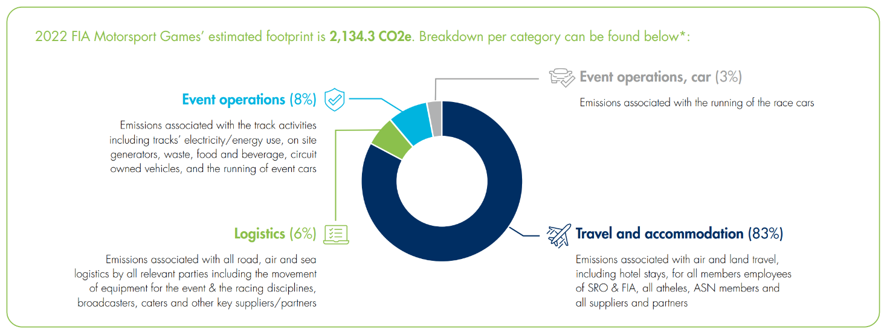
Figure 1 - Carbon footprint map of motorsports. (FIA, 2023)
Figure 1 is a graph to show the methods in which carbon emissions are generated by the motorsport industry. Travel and accommodation is by far the leading contributor, this report extensively covers the ways to mitigate the impact especially of the fan emissions created.

Environmental impact on a global scale
Globally, carbon production is contributing to climate change on an unprecedented scale, the ice caps are melting at an alarming rate causing climate disaster for islands and coastlines around the world, habitats of entire species are being completely eroded away, and the Ozone Layer is experiencing detrimental damage. The loss of the ice caps represents a more pressing issue, the reduction in UV ray reflection from the earth’s surfaces. (Barua, Bardhan & Banerjee, 2022)
Motorsports, obviously, is not the sole perpetrator to climate change; it is not even a major instigator. However, this does not reduce the fact that motorsports must adapt to do its part in averting this potential crisis.
In 2022, Dorna provided their annual ESG (environmental, social and governance) report which confirmed that throughout all the events held in that championship the total carbon footprint amounted to 101,079 tCO2e. The number of emissions from racing the motorcycles came to 163 tCO2e, 0.16% of the year’s total output. The main contributor was shipping by sea, land, and air between venues, delivering 32,163 tCO2e or 31.82%. When compared to the maritime transport industry which produces over 2.5% of the entire globes CO2 emissions, with over 1 billion tCO2e per year, it is easy to pass aside the role in which motorsport plays in the future of sustainability, similarly, it is not unreasonable to suggest motorsports can play a large part in raising awareness of this global issue. (Karaś, 2023) & (Dyson, 2023)
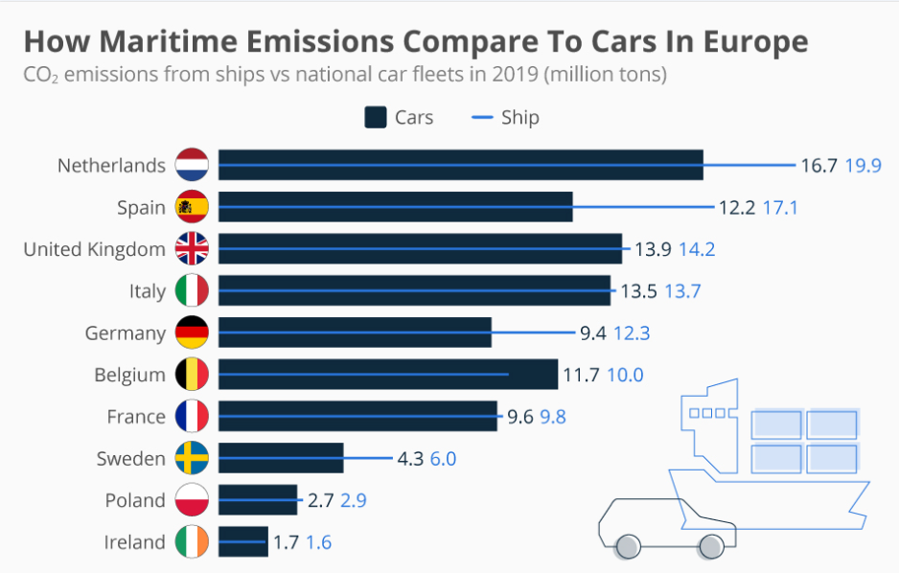
Figure 2 - Maritime transport compared to car transport in Europe. (McCarthy, 2019)
Figure 2 is important as it outlines the fact that maritime transport accounts for a large proportion of the emissions for transport. This shows the scale and size of the shipping industry, when considering maritime transport causes the lowest amount of CO2 emissions per tonne of cargo in commercial transport, emitting on average around 26 times less carbon than heavy good trucks per tonne of cargo. It should be noted maritime transport is also undergoing plans to cut CO2 emissions by 50% from the 2008 value and carbon neutrality by 2050. (Spilman, 2021) & (International Chamber of Shipping, 2024)

Sustainable Practices & Legislations

Situation report
All aspects of motorsports are increasing their efforts in sustainability and management of the carbon footprint. BT Sports (now TNT Sports) reduced the crew size in their coverage of the MotoGP series, cutting the emissions from 53.9 tonnes to 26 tonnes. (Miller, 2022) This goes to show that within motorsport there are currently multiple methods of increasing the sustainability in development or being utilised. As with all testing phases, the effectiveness of the solutions are infividually evaluated and therefore filtered into those deserving of further advancement, and those that don’t bolster such regard. Following this, examples of alternatives to traditional motorsports currently in development are explored in the drive towards sustainability.

Alternatives

Technology
The urgency of sustainability in motorsports aligns with the broader push towards a greener future, as reflected in the current UK Government legislation mandating the phasing-out of new petrol and diesel vehicles by 2030. This legislative impetus propels the motorsport industry into the realm of alternate propulsion technologies, although challenges persist, as seen in the varying levels of fan engagement between traditional racing series and their electric counterparts like MotoE and Formula E. For reference, Formula E had 216million live viewers in 21/22 whereas F1 had 1.5billion in 2021. (Burgess, 2023)
Michelin, the tyre provider for MotoGP and MotoE announced a goal that for the 2022 season, tyre compounds would be made of an average of 40% sustainable material for MotoE. Michelin provide support alongside their tyre production for related industries such as maritime transport, hydrogen mobility, gastronomy (with the Michelin star award) and by preserving biodiversity in their campaign to decrease their overall carbon footprint and promote environmental sustainability. (Michelin, 2024) MotoGP back up these claims matching Michelin’s claims of 40%+ sustainable material. (MotoGP, 2022)

Fuelling
MotoGP announced the start of a move towards 100% non-fossil fuel by 2027, beginning with 40% non-fossil fuel in 2024. This is not to say that the fuel used will not be carbon-based, but to take carbon from means other than the mining of fossil fuels. Carbon for fuel can be procured by reusing the carbon already in the air or extracting it from plants. These methods of producing fuel allow for a sustainable fuel future, not a fully environmentally friendly solution as the fuels are still combusted. (Emmett, 2023)
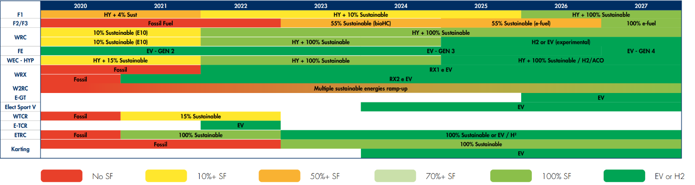
Figure 3 - Sustainable fuelling roadmap. (FIA, 2023)
Figure 3 shows the timeline that major car racing series have laid out for their conversion to sustainable fuelling, this has been documented by FIA who oversee the progress made.

Viewing
Previously mentioned in this report was the idea of banning live spectators and creating digital viewing streams instead. This can be further explored, harbouring a miniscule proportion of the emissions, by introducing Esports. Esports take place entirely online; viewers can watch along live with streams and interact with the event directly. The COVID pandemic introduced the idea of Virtual Grand-Prix’s which replaced the lack of usual racing, viewers ultimately enjoyed the concept with it continuing to take place past the course of the pandemic. (Tudor, 2020)

Situation analysis
Incontrovertibly, sustainable practices in motorsports face inherent obstacles. While methods aimed at reducing the environmental impact are undeniably positive, there is a justifiable argument against the introduction of alternate propulsion technology and alternate fuelling, along with the necessary infrastructure. Questions about the break-even point for the entire carbon footprint of electric vehicles, the moral implications of resource extraction, and the true impact of measures like fan bans and staffing reductions arise. The answers, it seems, lies in the continued development of technology for road-going transportation.

Sustainability and Technological Challenges

Political challenges
Politically, there has been constant challenges for international motorsports. Governments observe differing views and legislations regarding the outlook on environmental progression, motorsports in general, and even spectator rights.

International events
Events held in international regard, such as COP 26, allow countries to display and contrast environmental goals in which they will attempt to layout roadmaps to achieve. One crucial concern communicated is the sharing of financial burden to countries with increasing sustainable goalposts. The responsibilities of which countries fill this financial hole is debated, considered and ultimately relies upon the concerns of the leaderships in place. Elected governments in essence, hold the future of motorsports in their hands. (Prys-Hansen & Klenke, 2021)

Carbon offsetting
Carbon offsetting is the system established to allow companies, governments and individuals the opportunity to balance out their carbon footprint by paying for carbon credits. (Carbon Footprint Ltd, 2024) These carbon credits relate to the emissions savings elsewhere when it is not possible in the industry or circumstance utilised by the consumer. Although, carbon offsetting systematically failed in some regard due to corruption and corporate greed, developed countries purchased carbon credits from undeveloped nations in order to meet their environmental quotas, and the undeveloped nations didn’t see any growth from the added income as corrupt officials inherited the finances instead. This ties into green washing, which is the process of trying to appear environmentally friendly whilst not actually reducing emissions. Carbon offsetting harbours other issues such as the balancing of carbon emitting/saving activities. Planting trees is a method of carbon offsetting, however, if the trees don’t reach full maturity, they may not offset the total carbon emissions. (Polonsky, Grau & Garma, 2010)

Social challenges
Primarily, the social problem regarding travel is the cost and time required to navigate sustainably. Finding greener means of accommodation and travel incurs costs upon the consumer. Published reports export contradicting results in terms of the premium tourists will pay for a more environmentally viable option, with ranges between ~$10 premiums to 3% inflations. This does not take into consideration carbon-neutral flights which subsequently increment more costs upon the consumer, as well as costs of sustainable food at events. (Bachman, 2020)
Electric racing series heavily mitigates noise pollution, this prevents the need for racing circuits meaning road circuits can be used with less disruption. Road circuits can be constructed with temporary traffic restrictions planned far in advance to traverse any public dismay, animal habitats do not require destruction, or at least to a far lesser extent than that of an entire racetrack. (Standaert & Jarvenpa, 2016) Cost-reductions from the lack of renting and hosting racetracks can be passed onto the consumer, allowing for sustainable investment where savings can be garnered by spectators.
Noise at racetracks is a major hindrance for motorsports. Between fans arriving in loud vehicles (especially motorcycle events) and the noise of the racing itself, councils are intervening to reduce the impact that noise has on local residents and even wildlife. Sound barriers are erected where necessary for houses in close proximity to the track, noise monitoring equipment is utilised to maintain the necessary decibel restrictions imposed at tracks. (Walker, 2023)
Legislation's impact on amateur racers, particularly regarding sustainability standards set by Motorsport UK, warrants consideration. Increased costs associated with sustainability measures may deter less affluent participants, potentially reducing the pool of competitors and impacting club racing's vitality in the UK. (Chambers, 2023)

Technological challenges
Improvements in technology lead to sustainable practices, although implementing the newfound methods and systems takes time. One of the improvements is material repurposing, this can be especially useful when recycling materials for components such as batteries, tyres and parts. Developing infrastructure for racetracks such as energy-efficient lighting, electric vehicle charging, waste management and renewable energy sources to power such systems will lead to smaller carbon footprint at no detriment to fan entertainment and engagement. (DiBella, 2022)
Positively implementing the use of kinetic energy recovery systems (KERS) will lead to minimising the wasted energy of vehicles and in turn aid development of publicly accessible transportation. Battery technology is under development to increase longevity, energy density and sustainability through the recharging and repurposing of old materials.

Juxtaposition
Socially and politically the challenges faced are similar in the world of motorsports. The theme of this report transpired to be that the advancement of motorsports in general, is entirely respondent on the engagement of fans and the willingness to support the technological developments seen within the industry. Governments will continue to impose legislation to meet sustainability quotas agreed internationally, the intertwining effect is that the response of the fans and manufacturers alike must meet mutually to propagate optimal results for entertainment. Such is true that local communities economically benefit from large sporting events, removing this source of income is not within the best interest of the governments. The juxtaposition remains: economically viable, environmentally sustainable advances in technology without the reduction in entertainment for fans.

Outlook
Globally, the impact of the motorsport industry remains small. The logistics remains the major contributor to the environmental damage caused with up to 45% of the emissions registered from air, sea, and land travel. Considering maritime transport accounted for over 2796 times more CO2 emissions than the MotoGP and Formula 1 championships combined, legislations can be implemented elsewhere to reduce environmental impact of carbon emissions more rapidly. (Dyson, 2023) The maritime industry primarily uses ‘Bunker Oil’ as fuel for the diesel engines which account for 95% of the industry, bunker fuel is a lower quality fuel than diesel and produces more emissions in terms of sulphur and hydrocarbons. The carbon content is around the same at ~86%. Studies on reducing maritime fuel consumption has found strategies that can reduce consumption by up to 7%. (Işıklı et al, 2020)
Throughout this report there has been mention of solutions to the environmental problems facing the industry. Herein, solutions shall be analysed to conclude on the direction the author believes the motorsport industry should and should not navigate towards.
While one proposed solution involves restricting fans' track access and promoting digital viewing (Cooper & Blevins, 2023), this should be a last resort. This risks diminishing fans' connection with venues, athletes, and vehicles, especially among younger generations. Additionally, it could harm the local economy and revenue streams necessary for sustainable technology development in the future. To foster sustainable fan engagement, circuits should offer public transport like trains and buses. Sonoma Raceway implements generator curfews to reduce noise and energy waste. Implementing such measures, along with eco-friendly infrastructure like energy-efficient lighting, promotes environmental responsibility. (Sonoma Raceway, 2024)
Furthermore, social problems arise due to the marketing of motorsport events. Companies such as Repsol, who sponsor the Factory Honda team in MotoGP, supply energy and provide oil-based products globally. However, they also adhere to environmental sustainability legislation instilled by governments in their operative domains. (Repsol, 2024) When stakeholders have this global impact and leverage, it generates conflict of interest in the industry and the developments that take place. Fans also view these sponsors as positive companies, inherently negating the social push necessary to demand environmental sustainability. (Tranter & Lowes, 2009)
Electric racing's infancy raises intriguing questions with varied data interpretations. While it's growing globally, the sustainability-driven sport's future trajectory remains uncertain. Despite Formula E's increasing viewership year by year, it still lags behind traditional ICE racing in popularity. The potential of electric racing's latent prowess remains unexplored. (Pace, 2019)
In conclusion, the motorsports industry faces a delicate balance between tradition and sustainability. From environmental concerns to technological advancements, the report has explored the multifaceted challenges and potential solutions. This report does not however, conclude upon a terminal answer. There is no figure available to decipher the entire impact of motorsports compared to the benefits the future development holds. As the industry contemplates the future, the question lingers: Does the future have a place for motorsports?

References
ADAC Motorsport (2018) Commitment to environmental protection stepped up: ADAC Rallye Deutschland adds new measures. Available at: https://www.adac-motorsport.de/en/adac-rallye-deutschland/news/2018/commitment-to-environmental-protection-stepped-up-adac-rallye-deutschland-adds-new-measures/ Accessed: 26/01/2024.
Bachman, J.R. (2020) ‘Motorsport event attendees: Who are they, what is their environmental worldview, and how does it relate to trip spending?’, Event management, 24(5), pp. 629–644. Available at: https://doi.org/10.3727/152599519X15506259856264.
Balestrieri, S., et al., (2023) 'ACI for safety and sustainability in motorsport,' Transportation Research Procedia, Vol 69(1), pp. 871-877. doi:10.1016/j.trpro.2023.02.247
Barua, R., Bardhan, N., & Banerjee, D. (2022) ‘Impact of the polar ice caps melting on ecosystems and climates.’ The Handbook of Research on Water Sciences and Society. Vol.1(1) pp.1-14. doi:10.4018/978-1-7998-7356-3.ch034
Burgess, H. (2023) Will Formula E become as popular as Formula 1? Available at: https://hannahburgesspr.com/will-formula-e-become-as-popular-as-formula-1/ Accessed: 29/01/2024.
Carbon Footprint Ltd (2024) ‘Carbon Offsetting’ Available at: https://www.carbonfootprint.com/carbonoffset.html#:~:text=What%20is%20a%20Carbon%20Offset,driving%2C%20flying%20and%20heating%20buildings. Accessed: 08/02/2024.
Chambers, H. (2023) Environmental policy. Available at: https://www.motorsportuk.org/about-us/environmental-sustainability/environmental-policy/ Accessed: 05/02/2024.
Cooper, S., Blevins, S. (2023) The future of motorsports: Trends, opportunities and challenges to look out for over the next decade. Available at: https://www.ricardo.com/en/news-and-insights/insights/future-of-motorsport-opportunities-and-challenges Accessed: 25/01/2024.
DiBella, N.C. (2022) ‘Race to net zero: redesigning formula one tracks for the betterment of communities.’ Master Thesis. University of Maryland.
Doytchev, B. (2019) ‘Impact of automotive and motorcycle sport on the environment.’ Trakia Journal of Sciences. Vol 17(1), pp. 860-863. doi:10.15547/tjs.2019.s.01.141
Dyson, J (2023) MotoGP to begin the switch to non-fossil fuels in 2024 – but are its sustainability efforts going far enough? Available at: https://www.zerocarbonacademy.com/posts/motogp-to-begin-switch-to-non-fossil-fuels-in-2024-but-are-its-sustainability-efforts-going-far-enough#:~:text=Last%20year's%20ESG%20Annual%20Report,was%20101%2C079%20tCO2e. Accessed: 26/01/2024.
Emmett, D. (2023) Corrado Cecchinelli on the future of MotoGP: part 3 – sustainable fuels and the future of the combustion engine. Available at: https://motomatters.com/interview/2023/11/07/corrado_cecchinelli_on_the_future_of.html Accessed: 29/01/2024.
Engineering Council (2005) Statement of Ethical Principles. Available at: https://www.engc.org.uk/ethics Accessed: 25/01/2024.
Federation Internationale de l’Automobile. (2023) FIA Environmental Report 2023. FIA.
Federation Internationale de l'Automobile. (2023) Environment. Available at: https://purposedriven.fia.com/page/environment Accessed: 25/01/2024.
Internation Chamber of Shipping. (2024) ‘Environmental performance: comparison of CO2 emissions by different modes of transport’. https://www.ics-shipping.org/shipping-fact/environmental-performance-environmental-performance/#:~:text=In%20terms%20of%20CO2%20emissions,efficient%20form%20of%20commercial%20transport. Accessed: 08/02/2024.
Işıklı, E., Aydın, N., Bilgili, L., & Toprak, A. (2020) ‘Estimating fuel consumption in maritime transport’ Journal of Cleaner Production. Vol.275(1) https://doi.org/10.1016/j.jclepro.2020.124142.
Karaś, A (2023) ‘An Analysis of the Carbon Footprint in Maritime Transport: Challenges and Opportunities for Reducing Greenhouse Gas Emissions’ The International Journal on Marine Navigation and Safety of Sea Transportation. Vol.17(1) doi:10.12716/1001.17.01.22
Lewis, Jan. (2010). ‘World Superbikes and MotoGP: a global sport tourism phenomenon.’ International conference on sustainable tourism: issues, debates & challenges. Anissaras-Hersonissos, Crete. April 2010.
Michelin (2024) Innovating to design the new generation of tyres. Available at: https://www.michelin.co.uk/why-michelin-sustainability Accessed: 29/01/2024.
Miller, M. (2022) ‘BT Sport and North One take MotoGP remote.’ Trade Journal: London.
MotoGP (2022) MotoE: a parallel path of sustainable innovation. Available at: https://racingtogether.motogp.com/makingadifference/motoe/ Accessed: 29/01/2024.
Pace, C. (2019) ‘Low-carbon sustainable transitions in the motorsport industry the case of FIA Formula E’ Doctoral Thesis. Coventry University.
Polonsky, M.J., Grau, S.L. and Garma, R. (2010) “The New Greenwash?: Potential Marketing Problems with Carbon Offsets,” International journal of business studies, 18(1), pp. 49–54.
Prys-Hansen, M., & Klenke, J. (2021). Requirements for a Successful COP 26: Commitment, Responsibilities, Trust. (GIGA Focus Global, 7). Hamburg: German Institute for Global and Area Studies. Available at: https://nbn-resolving.org/urn:nbn:de:0168-ssoar-75501-2 Accessed 30/01/2024.
Repsol (2024) Energy and the future. Available at: https://www.repsol.com/en/energy-and-the-future/index.cshtml Accessed: 31/01/2024.
Schieren, A. (2019) Motorsports – is motorsport still relevant in today’s world? Available at: https://alexandraschieren.com/is-motorsport-still-relevant/ Accessed: 25/01/2024.
Sonoma Raceway (2024) Rules & Restrictions. Available at: https://www.sonomaraceway.com/fans/rules-restrictions/ Accessed: 31/01/2024.
Spilman, R. (2021) ‘Comparing Carbon Footprints — Ships, Planes, Trucks & Germany’ Available at: https://www.oldsaltblog.com/2021/04/comparing-carbon-footprints-ships-planes-trucks-germany/ Accessed: 08/02/2024.
Standaert, W & Jarvenpa, S.L. (2016) ‘Formula E: Next generation motorsport with next generation fans.’ Thirty-Seventh International Conference on Information Systems, Dublin.
McCarthy, N (2019) ‘How maritime emissions compare to cars in Europe’. Transport and Environment: Statista. Available at: https://www.statista.com/chart/20243/co2-from-ships-vs-emissions-from-national-car-fleets/ Accessed: 08/02/2024.
Tranter, P.J. & Lowes, M. (2009) ‘Life in the fast lane.’ Journal of Sport and Social Issues. Vol.33(2) pp. 150-168. SAGE Publications: California. Doi:10.1177/0193723509334171.
Tudor, E. (2020) "The Emergence of eSport During Covid-19: How Sim Racing Replaced Live Motorsport in 2020," Journal of Motorsport Culture & History: Vol. 1(1) Available at: https://scholars.unh.edu/jmotorsportculturehistory/vol1/iss1/8UK Accessed: 29/01/2024.
UK Government. (2020) Government takes historic step towards net-zero with end of sale of new petrol and diesel cars by 2030. Available at: https://www.gov.uk/government/news/government-takes-historic-step-towards-net-zero-with-end-of-sale-of-new-petrol-and-diesel-cars-by-2030 Accessed: 29/01/2024.
UK Public Generals Act (1990) Environmental Protection Act 1990. London: HMSO. (DES c.43/90)
Walker, M. (2023) ‘Noise and motorsport venues: a deep dive’ Available at: https://www.theracetorque.com/2023/10/noise-and-motorsport-venues-a-deep-dive/ Accessed: 08/02/2024.

