“In submitting this work, I affirm that my work adheres to the scholarly and intellectual standards of honesty and integrity. I affirm that this work is my work only and that in the preparation of this work I have not consulted any person. I affirm that I have not plagiarised or misrepresented the ideas or language of someone else as my own and that I have fully and accurately attributed any ideas or text of others to the sources and documented each source”.

University of Wales Trinity Saint David
Student Name: Alexandra Andreea Anca
Student ID number: 1916189
Lecturer’s name: Emad Elkhashen
Module name: Introducing the Modern Workplace
Assignment tile: Accounting Fundamentals Assessment 1

Executive Summary
According to the general business accounting studies, application of business financial statements including income statement and balance sheet are used to provide admission details of business financial performances that generally incurred during the present financial period. On the contrary application of business financial ratios is also applied to recognition of the efficient volume of business growth and drawbacks for implementing some significant business strategic plans. At the ending, this report providing the application of general accounting theoretical concepts which are also necessary for efficient understanding of business for performing details.

Table of Contents
Introduction 4
Answer for Question 1 4
Answer for Question 2 9
Answer for Question 3 13
Conclusion 14
References 15

Introduction
According to the concepts of accounting studies, applications of general provisions are necessary to be followed during the processing of accounting presentations. Those provisions are generally issued by GAAP and standards through IFRS. Following the same circumstances, presentations of business financial statements are also necessary for providing efficient financial details to the stakeholders on behalf of current accounting transactions. On the contrary, applications of business financial ratios are recognised for evaluating the present volume of business growth or drawbacks more efficiently (Karaawy and Baaj, 2018).

Answer for Question 1
For the purpose of computing the present volume of business financial statement business trial balance is applied. Along with the available information the overall Income statement and Balance sheet for Wales PLC has been computed for the period of 2019.
Computing IncomeStatement for Wales PLC
In the Books of Wales PLC
Income statement
For the period ended 31-12-19
Particulars | Note | Amount (‘000) | Amount  (‘000)
Business Revenues |  |  | 30300
Less: Cost of sales volume of business | Note 1 |  | 18780
Gross profit |  |  | 11520
Distribution expenses |  | 2160
Administrative expenses | Note 2 | 3905
Total operating cost |  |  | 6065
Operating profit |  |  | 5455
12% Debenture interest | Note 3 | 480
Bad debt |  | 240
Income Tax Payable |  | 1600
 |  |  | 2320
Net profit |  |  | 3135

Significant working Notes for presenting business income statement
Working Note 1: Cost of sales
Particulars | Amount (‘000)
Cost of sales | 16220
Add: Depreciation on Plant | 2560
Total Cost of sales | 18780

Working Note 2: Administrative expenses
Particulars | Amount (‘000)
Administrative expenses | 2920
Add: Depreciation on building | 320
Add: Outstanding insurance fees | 500
Add: Provision for bad debt | 165
Total Administrative expenses | 3905

Working Note 3: 12% business debenture interest
Particulars | Amount (‘000)
12% Debenture interest | 240
Add: Outstanding (4000*12%) | 240
Total debenture interest | 480

Computing Retained earnings of business
In the Books of Wales PLC
Retained Earnings Account
For the period ended 31-12-19
Particulars | Amount (‘000)
Retained profit as on 01-01-19 | 8380
Add: Net profit of business | 3135
Add: Appreciation of business Land | 5000
Total balance | 16515
Less: Dividend Paid | 560
Retained profit as on 31-12-19 | 15955

Computing Balance sheet of the business
In the Books of Wales PLC
Balance sheet
For the period ended 31-12-19
Particulars | Note | Amount | Amount
Non-current assets
Land of business | Note 4 | 20000
Building of business | Note 5 | 11420
Plant of business | Note 6 | 18080
Total non-current assets |  |  | 49500
Current assets
Trade Receivables | WN 7 | 8075
Inventories at 31-12-19 |  | 3120
Bank |  | 320
Total Current assets |  |  | 11515
Total Assets of Business |  |  | 61015
Current Liabilities
Trade Payable |  | 4480
Outstanding Insurances |  | 500
Income tax payable |  | 1600
Total current assets |  |  | 6580
Secured Liabilities
12% debentures 2024 |  | 4000
Add: Debenture interest |  | 480
Total Secured liabilities |  |  | 4480
Equity Capital
Ordinary shares @ £1 |  | 29000
Retained profit on 31-12-19 |  | 15955
Share premium |  | 5000
Total Business equity capital |  |  | 49955
Total Liabilities of Business |  |  | 61015

Working Note 4: Value of business Land
Particulars | Amount
Land at cost | 15000
Add: Revaluation or appreciation of assets | 5000
Actual volume of business Land | 20000

Working Note 5: Value of business building
Particulars | Amount
Building at cost | 16000
Less: Buildings accumulated depreciation | 4260
Written down value | 11740
Less: Present depreciation (16000*2%) | 320
Actual value of Building | 11420

Working Note 6: Value of business Plant
Particulars | Amount
Plant at cost | 25600
Less: Plant accumulated depreciation | 4960
Written down value | 20640
Less: Present depreciation (25600*10%) | 2560
Actual value of Plant | 18080

Working Note 7: Value of business Trade receivables
Particulars | Amount
Trade Receivables | 8240
Less: Provision for bad debt (8240*2%) | 165
Net Trade receivables | 8075

Answer for Question 2
(a) Computation of business financial ratios for the period of 2018 and 2019
Financial evaluations of business can be analysed through the using of financial ratios along with some significant formulas. In accordance with the available information related to business income statement and balance sheet the ratios of Jerry PLC has been computed for the period of 2018 and 2019.
1. Calculation of Return on capital employed
Formula = Profit before interest and tax / (Equity + long term loans)
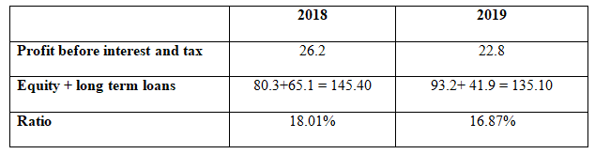
2. Calculation of Return on equity
Formula= Profit after tax / Equity capital
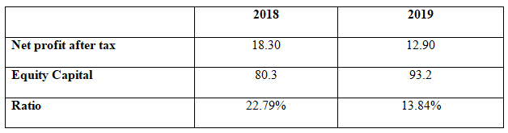

3. Calculation of Earnings per share (EPS)
Formula= Net profit after tax / No of equity shares
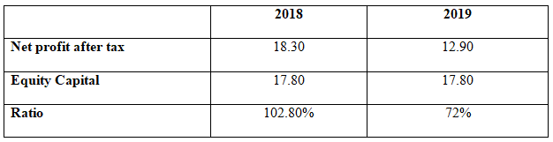
4. Calculation of Gross profit margin
Formula= Gross profit / Revenues
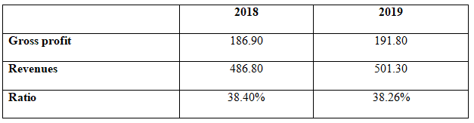
5. Calculation of Assets Turnover ratio
Formula= Revenues / Total assets
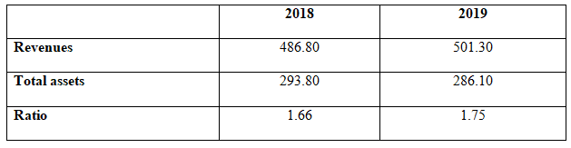
6. Calculation of Stock holding period
Formula= (Inventories / Cost of sales) *365 days
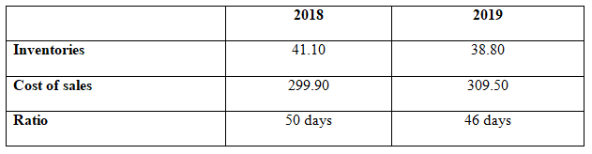

7. Calculation of Debtors collection period
Formula= (Trade receivables / Revenues) *365 days
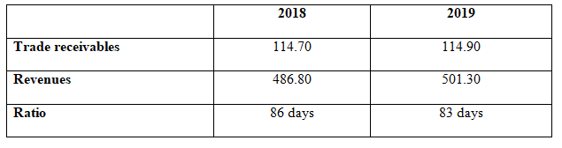
8. Calculation of Current ratio
Formula= (Current assets / Current Liabilities)
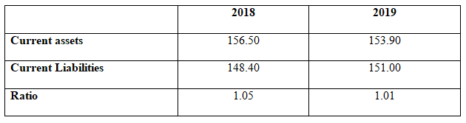
9. Calculation of gearing ratio
Formula= Total Debts / Equity capital
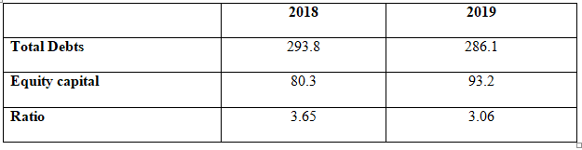
10. Calculation of Interest cover ratio
Formula= Profit before interest and tax / Financial cost (Interest)
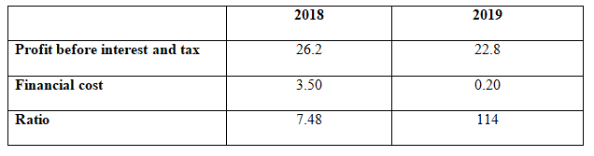

(b) Interpretation of financial performances using financial ratios
According to the general concept of business accounting application of several ratios are used to provide the benefits of financial performance evaluation compared with the previous year financial condition. With the application of Return on capital employed ratio the evaluator can positively recognise the present volume of business return for profit earning capacity compared with the equity capital and liability volume (Lisek et al. 2020). According to the present computation generally a volume of reduction is noticed in case of this business, which resulted in 18.01% during the period of 2018 and 16.87% in the present financial period of 2019.
Earnings per share ratio of the business are used to recognise the present market capitalisation value of the business compared with the other companies. Generally the highest volume of EPS is indicating the efficient level of business capacities compared with the actual share capital volume (Jasman and Kasran, 2017). In the case of this business generally a significant reduction is noticed which resulted in 102.80% during the period of 2018 and 72% during 2019.
Gross profit margin of the business is generally used to provide the current profit earning capacity of the business relating to the cost of business manufacturing expenses. According to the computation, if the volume of such a ratio is increased that means the present business capacity is in an efficient position (Bionda and Mahdar, 2017).
Asset turnover ratio of the company is used to measure the present earning capacity of the business in accordance with the total assets volume. It is basically computed through net sales as a percentage of its total asset, however compared with the other ratios, this specific ratio is increasing which means compared with the volume of business assets the organization gains efficient profitability (Sunjoko and Arilyn, 2016)
Current ratio of the business is applied for recognising of the current availablecash amount of the business in order to pay back current liabilities (Mahardhika and Marbun, 2016). In case of this particular business at the present financial year 2018 volume was 1.05 while at current financial period it was decreased to 1.01, which indicates the inefficient liquidity position of business in the present invention period.

Answer for Question 3
a. Basic user of financial statement
Shareholders of company (both internal and external): Shareholders are recognised as the owner of business who is generally used to invest a significant amount over the business performances. Generally, the internal shareholders of the business are used to access the financial statements for the primary approach of recognising present financial capacities and also the profitability approaches for the preceding time period (Robinson, 2020).
Company suppliers (External parties): Generally the suppliers are used to access financial statements for recognising the present liquidity amount availability in the business in order to pay back the outstanding business liabilities. Even also use such statements for recognising the present market capitalisation volume and condition in a more efficient manner (Das and Pandit, 2020).
Government (External parties): Whether a business establishment is engaged along with any illegal activities or not for recognising such the government sometimes used to access the financial statement efficiently.
b. Basic benefits and drawbacks of using regulated financial reports
Benefits: Application of business income statement is used to provide the present volume of business income and expenditure that incurred during the current accounting period, while the application of balance sheet provides the significant details related to business Assets and liabilities volume including the capital position more efficiently. However the application of a cash flow statement is used to provide only the beneficial aspects of the present business liquidity structure based on which the organisation can initiate its efficient investment project (Leuz and Wysocki, 2016).
Drawbacks: Application of financial report can also create some significant drawbacks related to the financial presentation. Additionally, Income statement is not competent to provide the non-monetary transactions of the business, while the balance sheet does not used to follow the market valuation process in case of computing present value of any business assets in order to provide efficient financial details of the business.
c. Disadvantages of using financial statement
Generally the financial statement is totally based on the historical costing approaches in case of evaluating individual business assets volume instead of applying the present market capital or written down value process. With the application of such statements the potential authorities can easily manipulate the overall financial conditions in order to derive some personal benefits (Ahn et al. 2017).

Conclusion
Application of business financial statements are used to provide efficient financial details of business based on which the potential authorities and other decision makers of the business can implement some significant strategic plans. Following the same prospect application of business financial ratios are also used to provide the benefits of business growth or drawbacks recognition which are basically competent to influence external investors to invest in organisation capital in accordance with the present marketing demand.

References
Ahn, R., Woodbridge, A., Abraham, A., Saba, S., Korenstein, D., Madden, E., Boscardin, W.J. and Keyhani, S., 2017. Financial ties of principal investigators and randomized controlled trial outcomes: cross sectional study. bmj, 356.
Bionda, A.R. and Mahdar, N.M., 2017. Pengaruh gross profit margin, net profit margin, return on asset, dan return on equity terhadap pertumbuhan laba pada perusahaan manufaktur di bursa efek indonesia. Kalbisocio Jurnal Bisnis dan Komunikasi, 4(1).
Das, S. and Pandit, S., 2020. Financial Statement Analysis and Forecasting. Equity Markets, Valuation, and Analysis.
Jasman, J. and Kasran, M., 2017. Profitability, Earnings Per Share on Stock Return with Size as Moderation. TRIKONOMIKA, 16(2), pp.88-94.
Karaawy, N.A.A.A. and Baaj, Q.M.A.A., 2018. The impact of international taxation systems variations on the application of financial accounting principles. Academy of Accounting and Financial Studies Journal, 22(2), p.1z.
Leuz, C. and Wysocki, P.D., 2016. The economics of disclosure and financial reporting regulation: Evidence and suggestions for future research. Journal of accounting research, 54(2), pp.525-622.
Lisek, S., Luty, L. and Zioło, M., 2020. The measurement of return on capital employed in assessment of company’s condition. Zeszyty Naukowe Małopolskiej Wyższej Szkoły Ekonomicznej w Tarnowie, 46(2), pp.55-67.
Mahardhika, P.A. and Marbun, D., 2016. Pengaruh Current Ratio Dan Debt To Equity Ratio Terhadap Return On Assets. Widyakala: Journal Of Pembangunan Jaya University, 3, pp.23-28.
Robinson, T.R., 2020. International financial statement analysis. John Wiley & Sons.
Sunjoko, M.I. and ARILYN, E.J., 2016. Effects of inventory turnover, total asset turnover, fixed asset turnover, current ratio and average collection period on profitability. Jurnal Bisnis dan Akuntansi, 18(1), pp.79-83.

