
APPENDIX GA36a

LEVEL 4 ASSESSMENT SPECIFICATION

Student name: |  | Student ID number:
Programme: | BEng Motorsport & Automotive Engineering Programmes
Module: | Automotive / Motorsport Technology
Module code: | ACHA4028  ACHA4018 | Contribution to Overall Module Assessment (%): | 100
Lecturer: | Tim Tudor | Internal Verifier: | Andrew Noble
Assignment Title: | Suspension Kinematics and performance Analysis | Word count (or equivalent): | 2000
Submission deadline: | 14th December @ 22:00Hrs  (on Moodle) | Return date of provisional marks & written feedback: | Within 20 working term time days of submission date
Submission method: | All written assessments, where practical and possible, must be submitted via Turnitin unless otherwise instructed by the Lecturer. (Please DO NOT put this assessment specification into Turnitin or it will match many similarities with other students’ submissions.)  Alternative submission method (if applicable):  Late submission of the assessment will result in a late penalty mark:  Work which is submitted up to 1 week late will be capped at 40% for the first attempt and will be awarded a mark of 0% for re-assessment. Late submission penalties may be lifted only if there is an approved extenuating circumstances claim.  Work submitted more than 1 week late will be considered as a non-submission and will not be marked. The work may be considered as a submission for reassessment if offered by an Examining Board or if there is an approved extenuating circumstances claim.
Academic honesty / referencing: | Academic honesty is required. In the main body of your submission you must give credit to authors on whose research and ideas your work is based. Append to your submission a reference list that indicates the books, articles, etc. that you have used, cited or quoted in order to complete this assessment.

Module Learning Outcomes
(from module syllabus)
- Show a detailed knowledge and understanding of the underlying principles of engine and vehicle technologies and practices for analysis of powertrain and chassis systems in a motorsport/automotive application
- demonstrate subject specific practical and cognitive skills applied to a motorsport application problem, obtaining and interpreting data in a laboratory environment and drawing relevant conclusions

AHEP3 Version 3 outcomes to be met:
SM1b, P1, P3

Use of Generative AI in Assessment
(Lecturer to indicate Yes or Not against each element)

RESEARCH | For this assessment, you can use Generative AI to support you in research, including searching for bibliography, using tools to summarise, compare and interrogate materials. | Yes ☒  No ☐
STRUCTURE | For this assessment, you can use Generative AI to support you in structuring your submission, including creating a draft argument structure, identifying parts and headings, etc. | Yes ☒  No ☐
PROOFREADING | For this assessment, you can use Generative AI to check your own text/creation for grammatical and syntactical mistakes, including rephrasing of your own work within specific standards. | Yes ☒  No ☐
WRITING | For this assessment, you can use Generative AI to create text for submission. | Yes ☒  No ☐
CREATIVE | For this assessment, you can use Generative AI to create creative materials, such as images. | Yes ☒  No ☐
PROGRAMING | For this assessment, you can use Generative AI to create and check code. | Yes ☒  No ☐
NONE | For this assessment, you are not allowed to use any type of Generative AI support. This includes research support, structure support, writing/proofreading support and creative support. | Yes ☐  No ☒

TASK DESCRIPTION

This assignment will investigate the characteristics of a Van Diemen single seater front suspension system.



Task 1 : Laboratory / Workshop Sessions

You will be allocated a number of workshop sessions to carry out measurement of the formula ford front suspension system. These sessions will be supported by technical staff and carried out in small groups. You should take notes (and pictures) during these sessions and present your methodology and results of the measurements in the report with discussion.

- Video Demonstration
  - Watch the video demonstrations so that you are prepared for the laboratory sessions.

- Lab Tasks 1 (1 Hour)
  - Measure Spring Rate
  - Measure Tyre Stiffness and Dimensions
  - Measure Unsprung Mass (On & Off vehicle)

- Lab Tasks 2 (1 Hour)
  - Measure Toe Steer Versus Wheel Displacement (~+/- 25mm in 2 turn increments*)
  - Measure Camber Change Versus Wheel Displacement (~+/- 25mm in 2 turn increments*)
  - Measure Motion Ratio Versus Wheel Displacement (~+/- 25mm in 2 turn increments*)
*Increments of wheel displacement are controlled by turning the bar which replaces the spring. You should turn this 2 times for each increment.

Task 2 : Laboratory Results and Analysis

Use the measurements from your laboratory to state/calculate/produce the following;

Graphs
- Camber Vs Wheel Displacement (+/- 25mm)
- Change in Spring Length Vs Wheel Position (0-50 mm)
- Toesteer Vs Wheel Displacement (+/- 25mm)
- Spring Deflection Vs Spring Load (Maximum deflection 1inch in 0.1inch increments)
- Tyre Deflection Vs Tyre Load (Maximum deflection 14mm in 2mm increments)

Data/Values
- Motion Ratio, MR (Gradient of graph b)
- Average Spring Stiffness, K_{s} (N/m) (Gradient of graph d)
- Average Vertical Tyre Stiffness, K_{t} (N/m) (Gradient of graph e)
- Unsprung Mass (M_{us})
- Tyre Radius & Width

Comment on the characteristics observed and what they tell you about the suspension system.

Task 3 : WinGeo – Kinematic Simulation

Use the provided WinGeo software and the kinematic model of the suspension supplied, to assess the suspension characteristics in heave (bump) and roll. You should, as a minimum, produce the following graphs/diagrams/data. Comment on your results and discuss their implications to vehicle performance.

Graphs
- Camber Vs Bump (+/- 25mm in 5mm increments)
- Camber L Vs Roll Angle (0>1.5degrees in 0.1 degree increments)
- Camber R Vs Roll Angle (0>1.5degrees in 0.1 degree increments)
- Motion Ratio Vs Wheel Bump (+/- 25mm in 5mm increments)
- Toesteer (Steer) Vs Wheel Bump (+/- 25mm in 5mm increments)
Data/Values
- Motion Ratio @ Rideheight (Bump= 0mm)
- Roll Centre Height and Lateral Position (Bump= 0 mm, Roll=0 degrees)
- Instant Centre Height and Lateral Position (Bump= 0 mm, Roll=0 degrees)
Diagrams
- WinGeo Model (Standard, top and offset views)

Task 4 : Suspension Calculations+

Calculate the following suspension characteristics using the measurements from your workshop sessions and comment (with the aid of research) on the suitability of these for a single seater race vehicle and how they may differ for a road going passenger vehicle.

- Wheel Rate (Use MR, Spring Stiffness in N/m)
- Front Suspension Ride Frequency (Assume an total front corner mass of 115Kg)
- Front Unsprung Mass Natural Frequency (Tyre stiffness comes from your lab results)

Task 5 : Validation

Compare the camber change and bump steer observed in the laboratory with that predicted by the WinGeo3 software in task 3. Discuss the agreement between these and any sources of potential error.

Task 6 : Investigate Geometry

Using the WinGeo model, investigate how the wishbone and steering pickup point co-ordinates impact key kinematic characteristics. Discuss the results obtained explaining how camber, toe and scrub change with various geometries and the impact this could have on vehicle performance.

Task 7 : Document

Summarise your findings of the tasks above in a technical report document of no more than 2000 Words – Please state word count on front page. Make sure you reference the technical report guidelines available on Teams

Guidance specific to this assessment: Your report should be well presented and concise please consult the engineering the report writing handbook and the following university rules on exceeding word count.

- Different assessments have varying word lengths specified for them; it is important that the student keeps to the word length specified for each assessment at all times on the following grounds:
- To encourage succinct and clear writing by students.
- To ensure equity between all the students doing that particular assessment

ii. If the specified word limit for an assessment has been exceeded, the following penalties would normally apply. The penalty cannot take the work into the fail category.
- Up to 10% above the word limit – No deduction off final mark
- Between 10% and 25% above the word limit – Deduction of 5 marks off final mark, or reduce the mark to the capped mark, whichever is the lesser penalty. For example, for an undergraduate student achieving a final mark of 44%, the mark would be reduced to the capped mark of 40%; whereas for an undergraduate student achieving a final mark of 49%, the mark would be reduced to 44%.
- Between 25% and 50% above the word limit – Deduction of 10 marks off final mark, or reduce the mark to the capped mark, whichever is the lesser penalty. For example, for an undergraduate student achieving a final mark of 47%, the mark would be reduced to the capped mark of 40%; whereas for an undergraduate student achieving a final mark of 55%, the mark would be reduced to 45%.
- 50% or more over length – Maximum mark of capped mark

- A failure to meet the word limit (or minimum word limit if a range is given) may result in lower marks based on the quality of the work because the work may not include the necessary information required for the assessment to meet the stated learning outcomes.

- The feedback on the assessment should explicitly mention any mark deduction and the reason for it.

 | Word Limit to 10% | 10-25% over | 25-50% over | 50%+ over
Word count | 2000-2200 | 2201-2500 | 2501-3000 | 3001+
Deduction (to 40% cap) | 0% | 5% | 10% | Mark capped to 40%

.
Useful assumptions, definitions and hints

Assume (unless you have other information)
- Total Corner Mass of: 115 Kg
- Tyre Stiffness (Kt) of : 156 000 N/m

Definitions

- Sprung Corner Mass (Ms) = Total corner mass – Unsprung corner mass (Mus)

- Motion Ratio (MR) = ratio of spring compression to wheel movement

MR = Spring Compression / Wheel Movement

- Wheel Rate (Kw) of the spring rate (Ks) acting through the motion ratio (MR)

Kw = Ks * MR ²

*Note Spring Rate (Ks) MUST be in N/m – (1 Lb/in = 175.12 N/m)
- Natural frequency (f) of the sprung mass (Ms) also known as the Ride Frequency

- The natural frequency (fus) of the UNSPRUNG mass (Mus)

Hints

- The gradient of spring load vs change in length found is the spring rate. Convert the lbs and inch values obtained from the Longacre equipment to Newtons and mm and record this. Calculate the spring rate (Ks). (Note that the units for the calculations will be N/m)

- The gradient of the spring length vs wheel travel is the Motion Ratio (MR)

- See example graph layout below;
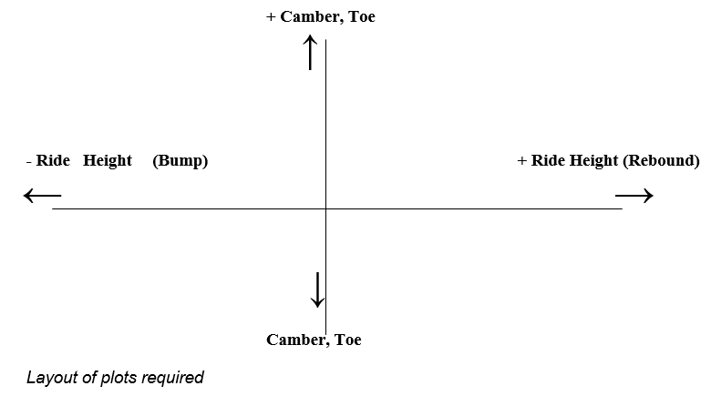

laboratory results

Laboratory Wheel Position Test Results Table

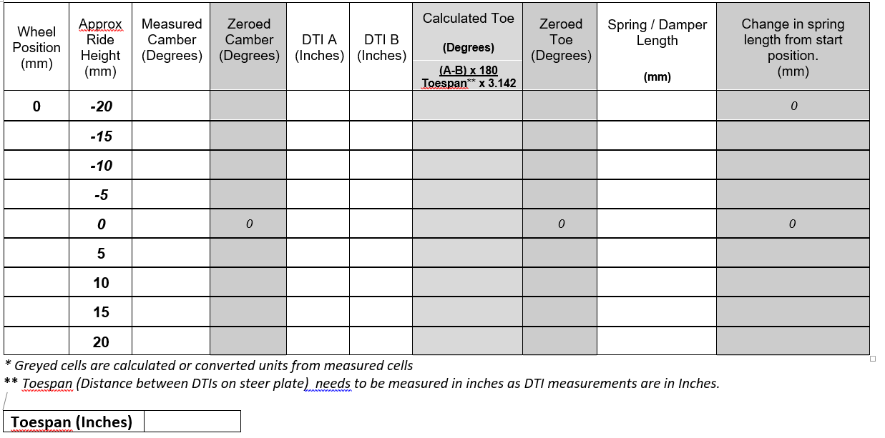

Measurement of Toe Steer values
DTI A
DTI B
Toespan
HUB
Toe Plate
- +
- +

Top View

NB The DTIs are calibrated in thousandths of an inch so measure the toe span in inches to obtain correct magnitude of toe angle. If the DTI A moves in + direction and DTI B moves -ve direction or less than A in the +ve direction then the toe will become more +ve etc.

Zeroing of Camber and Toe Steer Results

To arrange the results obtained so that they are comparable with the results obtained from WinGeo they need to be Zeroed, so that there is zero camber and toe at zero ride height.

Measurement of spring length change vs Ride height change

For the purpose of this exercise spring/damper length will be taken as the distance between chassis pivot mount and bell crank pivot.

GUIDANCE FOR Students IN THE COMPLETION OF TASKS

NOTE: The guidance offered below is linked to the five generic assessment criteria overleaf.

- Engagement with Literature Skills
Your work must be informed and supported by scholarly material that is relevant to and focused on the task(s) set. You should provide evidence that you have accessed an appropriate range of sources, which may be academic, governmental and industrial; these sources may include academic journal articles, textbooks, current news articles, organisational documents, and websites. You should consider the credibility of your sources; academic journals are normally highly credible sources while websites require careful consideration/selection and should be used sparingly. Any sources you use should be current and up-to-date, mostly published within the last five years or so, though seminal/important works in the field may be older. You must provide evidence of your research/own reading throughout your work, using a suitable referencing system, including in-text citations in the main body of your work and a reference list at the end of your work.

- Knowledge and Understanding Skills
At level 4, you should be able to demonstrate knowledge of the underlying concepts and principles associated with your area(s) of study. Knowledge relates to the facts, information and skills you have acquired through your learning. You demonstrate your understanding by interpreting the meaning of the facts and information (knowledge). This means that you need to select and include in your work the concepts, techniques, models, theories, etc. appropriate to the task(s) set. You should be able to explain the theories, concepts, etc. to show your understanding. Your mark/grade will also depend upon the extent to which you demonstrate your knowledge and understanding.

- Cognitive and Intellectual Skills
You should be able to present, evaluate and interpret qualitative and quantitative data, in order to develop lines of argument and make sound judgements in accordance with basic theories and concepts of your subject(s) of study. You should be able to evaluate the appropriateness of different approaches to solving problems related to your area(s) of study and/or work. Your work must contain evidence of logical, analytical thinking. For example, to examine and break information down into parts, make inferences, compile, compare and contrast information. This means not just describing what! But also justifying: Why? How? When? Who? Where? At what cost? You should provide justification for your arguments and judgements using evidence that you have reflected upon the ideas of others within the subject area and that you are able to make sound judgements and arguments using data and concepts. Where relevant, alternative solutions and recommendations may be proposed.

- Practical Skills
At level 4, you should be able to apply the basic underlying concepts and principles to evaluate and interpret these within the context of your area of study. You should be able to demonstrate how the subject-related concepts and ideas relate to real world situations and/or a particular context. How do they work in practice? You will deploy models, methods, techniques, and/or theories, in that context, to assess current situations, perhaps to formulate plans or solutions to solve problems, or to create artefacts. This is likely to involve, for instance, the use of real world artefacts, examples and cases, the application of a model within an organisation and/or benchmarking one theory or organisation against others based on stated criteria.

- Transferable Skills for Life and Professional Practice
Your work must provide evidence of the qualities and transferable skills necessary for employment requiring the exercise of some personal responsibility. This includes demonstrating: that you can communicate the results of your study/work accurately and reliably, and with structured and coherent arguments; that you can initiate and complete tasks and procedures, whether individually and/or collaboratively; fluency of expression; clarity and effectiveness in presentation and organisation. Work should be coherent and well-structured in presentation and organisation.

Student FEEDBACK FORM

This section details the extent to which the assessment criteria are demonstrated by you, which in turn determines your mark. The marks available for each category of skill are shown. Lecturers will use the space provided to comment on the achievement of the task(s), including those areas in which you have performed well and areas that would benefit from development/improvement.

Generic Assessment Criteria | Marks available | Marks  awarded
1. Engagement with Literature Skills
.
Evidence of further reading and research to assess findings and characteristics.

 | 5
2. Knowledge and Understanding Skills

Consideration of test methods and simulation model.
The use of WinGeo 3 and results to produce camber and toe steer graphs
Assessment of geometry changes to kinematic response and vehicle performance impact.
 | 15
3. Cognitive and Intellectual Skills

Results table and graphs clearly demonstrate the information required

Clear and accurate calculations of Ks, Kt, MR and Kw

Determination of natural frequency of sprung and unsprung mass

Combined evaluation of results is perceptive and critical
 | 40
4. Practical Application Skills

Equipment used for each task is described accurately and in sufficient detail.  Methodology is complete and clearly describes the processes used for each laboratory task | 30
5. Transferable Skills for Life and Professional Practice

Presentation, clarity and accuracy of the graphs and results produced.  A well-structured report is produced with all required sections included | 10

Assessment Mark (Assessment marks are subject to ratification at the Exam Board. These comments and marks are to give feedback on module work and are for guidance only until they are confirmed. ) | Late Submission Penalties (tick if appropriate) |  | %
 | Up to 1 week late (40% Max) |  | %
 | Over 1 week late (0%) |  | %

GENERIC ASSESSMENT CRITERIA

Level 4
In accordance with the Framework for Higher Education Qualifications, at the end of Level 4 students will be expected to have demonstrated knowledge of the basic underlying concepts and principles of a subject, and an ability to evaluate and interpret these within the context of that area of study. They should be able to present, evaluate and interpret qualitative and quantitative data in order to develop lines of argument and make sound judgements in accordance with basic theories and concepts of their subject(s) of study. They will have learned how to evaluate different approaches to solving problems, and will be able to communicate the results of their study/work accurately and reliably, and with structured and coherent arguments. They will be able to undertake further training and develop new skills within a structured and managed environment and will have the qualities and transferable skills necessary for employment requiring the exercise of some personal responsibility.

Level 4 | FAIL | MARGINAL FAIL | SATISFACTORY  (3rd / Pass) | GOOD  (2.2 / Pass) | VERY GOOD  (2.1 / Merit) | EXCELLENT  (1st / Distinction) | EXCEPTIONAL  (1st / Distinction)
Category | 0-29% | 30-39% | 40-49% | 50-59% | 60-69% | 70-84% | 85-100%
Engagement with literature (including reading, referencing,  academic conventions and  academic honesty) | Little or no evidence of reading and/or reliance on inappropriate sources.  Views and findings mostly unsupported and non-authoritative.  Referencing conventions used incoherently or largely absent. | Poor engagement with essential reading. No evidence of wider reading. Reliance on inappropriate sources, and/or indiscriminate use of sources. Heavily reliant on information gained through class contact. Inconsistent and weak use of referencing. | Engagement with a limited range of mostly relevant and credible sources but with some reliance on information gained through class contact. Some omissions and minor errors.  Referencing conventions evident though not always applied accurately or consistently. | Engagement with an appropriate range of literature, including sources retrieved independently. Some over-reliance on texts rather than other sources. Referencing may show minor inaccuracies or inconsistencies. | Engagement with a wide range of literature, including sources retrieved independently.  Selection of relevant and credible sources. Generally sound referencing, with no/very few inaccuracies or inconsistencies. | Engagement with an extensive range of relevant and credible literature. Consistently accurate application of referencing. | Exceptional engagement with an extensive range of relevant and credible literature. High-level referencing skills consistently applied.
Knowledge and understanding (Knowledge of the basic underlying concepts and principles of a subject.) | Major gaps in knowledge and understanding of the basic underlying concepts and principles of the subject matter. Inclusion of irrelevant material. Substantial inaccuracies. | Gaps in knowledge of the basic underlying concepts and principles, with flawed or superficial understanding. Some significant inaccuracies and/or irrelevant material. | Limited knowledge and understanding of the basic underlying concepts and principles within the subject area. Some elements may be missing. | Knowledge of the basic underlying concepts and principles is accurate with a good understanding of the field of study but lacks depth and/or breadth. | Competent knowledge of the basic underlying concepts and principles. Exhibits very good understanding. | Excellent knowledge and understanding of the basic underlying concepts and principles of the subject. | Exceptional, detailed knowledge and understanding of the basic underlying concepts and principles
Cognitive and intellectual skills  (Evaluate underlying concepts and principles of a subject and interpret qualitative and quantitative data in order to develop lines of argument and make sound judgements.) | Wholly or almost wholly descriptive work. Little or no evaluation of the underlying concepts and principles.  Failure to develop arguments, leading to illogical or invalid judgements. Minimal or no use of  evidence to back up views. | Largely descriptive work, with superficial evaluation of the underlying concepts and principles. Weak interpretation of data, flawed development of arguments and judgements. Information accepted uncritically, uses generalised statements made with scant evidence and unsubstantiated opinions. Ideas sometimes illogical and contradictory. | Limited attempt at evaluation of the underlying concepts and principles, tending towards description.  Can interpret qualitative and quantitative data but with some errors. Some evidence to support emerging arguments and judgements but these may be underdeveloped or with a little inconsistency / mis-interpretation. | Good evaluation of the underlying concepts and principles. Can interpret qualitative and quantitative data, with minor errors.  An emerging ability to use evidence to support the argument.  Mostly valid arguments and logical judgements. | Sound evaluation of the underlying concepts and principles. Can interpret qualitative and quantitative data accurately. Ability to devise arguments using evidence to make mostly appropriate and valid judgements. | Excellent evaluation of the underlying concepts and principles. Can interpret qualitative and quantitative data accurately and with some insight. Excellent ability to devise arguments using evidence and make appropriate and valid judgements. | Exceptional evaluation of the underlying concepts and principles based evidence. Outstanding interpretation of qualitative and quantitative data.  Exceptional ability to devise arguments using evidence and make wholly appropriate and valid judgements.
Practical skills  (Different approaches to solving problems in particular contexts.) | Limited or no use of taught, basic methods, materials, tools and/or techniques.  Little or no appreciation of the context of the application.  Very weak evidence of different approaches to problem-solving in particular contexts. | Rudimentary application of taught, basic methods, materials, tools and/or techniques but without consideration and competence. Flawed appreciation of the context of the application.  Weak evidence of different approaches to problem-solving in particular contexts. | An adequate awareness and mostly appropriate application of basic methods, materials, tools and/or techniques.  Basic appreciation of the context of the application.  Can identify problems in particular contexts and propose basic alternative approaches or solutions though there may be errors. | A good and appropriate application of basic methods, materials, tools and/or techniques.  Clear appreciation of the context of the application.  Good evidence of different approaches to problem-solving in particular contexts and proposes mostly appropriate solutions. | A very good application of a range of basic methods, materials, tools and/or techniques.  Very good consideration of the context of the application. Very good evidence of different approaches to problem-solving in particular contexts and proposes appropriate solutions. | An advanced application of a range of taught, basic methods, materials, tools and/or techniques.  The context of the application is well considered, and insightful.  Excellent evidence of different approaches to problem-solving in particular contexts and proposes appropriate solutions. | Exceptional levels of application and deployment skills in particular practical contexts. Outstanding identification of problems in particular contexts and formulation of wholly appropriate, thoughtful solutions / different approaches.
Transferable skills for life and professional practice  (Communicate the results of their study/work accurately and reliably, and with structured and coherent arguments; the qualities needed for employment requiring the exercise of some personal responsibility within a structured and managed environment.) | Work is poorly structured, disorganised, inaccurate and/or confusingly expressed. Very weak use of language and/or very inappropriate style. Failure to work effectively individual or as part of a group. Little or no evidence of the skills for employment requiring the exercise of some personal responsibility. | Work is poorly presented in a disjointed manner. It is loosely, and at times incoherently, structured, with information and ideas often poorly expressed. Weak use of language and/or inappropriate style. Flawed approach to individual or group work, meeting only partial obligations to others. Limited evidence of the skills for employment requiring the exercise of some personal responsibility. | Mostly ordered presentation and structure in which relevant ideas / concepts are reasonably expressed. Work may lack coherence and/or accuracy in places. Can work as part of a group, meeting most obligations to others but perhaps with limited involvement in group activities.  Demonstrates the basic skills for employment requiring the exercise of some personal responsibility, with some areas of minor weakness. | Mostly coherent, organised and accurate work, in a suitable structure and is for the most part clearly expressed. Can work effectively independently and/or as part of a team, with clear contribution to group activities.  Demonstrates the skills for employment requiring the exercise of some personal responsibility, with some areas of strength and some of minor weakness. | Work is accurate, coherent, fluent, well-structured and organised.  Can work effectively independently and/or as part of a team, with very good contribution to group activities. Demonstrates very good skills for employment requiring the exercise of some personal responsibility, with just occasional minor weakness. | Work is coherent, very fluent and is presented professionally. Can work effectively independently and/or as part of a team, with an excellent contribution to group activities. Demonstrates excellent skills for employment requiring the exercise of some personal responsibility with an appetite for further development. | Work is accurate, exceptionally coherent, very fluent and presented well. Can work effectively independently and/or as part of a team, with an exceptional contribution to group activities. Demonstrates exceptional skills for employment requiring the exercise of some personal responsibility with an appetite for further development.

THIS DOCUMENT IS ALSO AVAILABLE IN WELSH

