Ryan Williams 1908507
Manufacturing systems engineering
Applying lean techniques

Contents
Table of figures 1
1 – Executive Summary 2
2 – The Process 3
2.1 – Production Machines and Production Parts. 3
2.2 – Current Process and potential wastes. 6
3 – Process Improvements and Potential Problems 8
3.1 - The Engineering department manufacturing 3d printed parts 8
Potential problems and related costs 8
3.2 - Move parts to stores and stores personnel kitting required parts 8
Potential problems and related costs 9
3.3 - Stores person determining stock levels and making ‘just in case’ stock 9
Potential problems and costs 9
4 – Conclusion 10
Works Cited 11

Table of figures
Figure 1 Ultimaker s5 pro at the engineering dept at LWS 3
Figure 2 Mercury wire stripping machine 4
Figure 3 Images of 3D printed extraction system components 4
Figure 4 Cycle time and raw material used by the 3d printer 4

1 – Executive Summary

This report aims to focus on a process performed by Laser Wire Solutions and consider how this could be made leaner. Laser Wire Solutions is at the cutting edge of laser technology and are a pioneering force in precision wire stripping and connection. Laser Wire solutions produce machines capable of removing sections of insulation and micro-soldering delicate high value wires used in aeronautical, electric vehicle and medical applications.
Lean philosophy can be traced back to as early as the 1780s and was used by the Royal Navy in what is now known as standard ops and quick change over, to enable them to be able to deliver a broadside twice as fast as the French or Spanish Navy’s. It was adopted within ‘mass production’ by Henry Ford in the early 1900’s and expanded upon by the Japanese and Toyota cars and has evolved since then (Holweg, 2009).
Lean manufacturing is the application of lean principles, practices, and tools to enable the manufacture of physical products while removing and eliminating waste. Within a lean manufacturing environment, waste is described as something that doesn’t add value to the customer (Lynn, n.d.)
This report intends on identifying some of the following possible areas of waste: transport, inventory, movement/motion, waiting, overproduction, over processing, knowledge/skills, and defects within the process. The report will consider ways to reduce those wastes, as well as identify some potential problems in implementing the process improvements.

2 – The Process

Within the Engineering department at Laser wire Solutions there is a comprehensive added manufacturing facility in the form of four high end 3d printers, which are Ultimaker s5 pro’s.
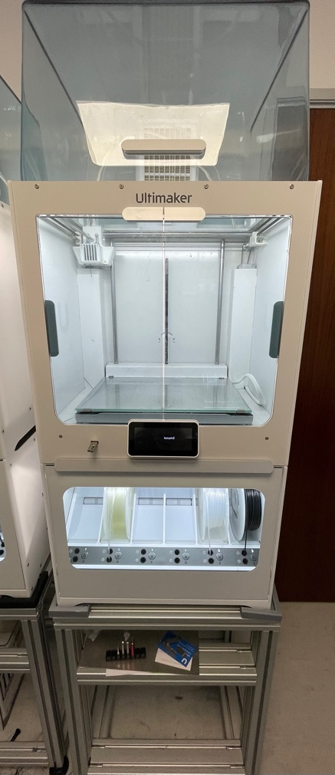
Figure 1 Ultimaker s5 pro at the engineering dept at LWS
These printers feature a material handling station with six spool bays, as well as humidity management, which is critical to the quality of the printed component and automatic material handling. The printer is capable of a layer height of just 0.25mm and resolution of 2.5- 6 micron.
The 3d printers are used for rapid prototyping and components for their in-house contract wire machines but also a great deal of 3d printed components that feature on production machines. It is these production parts that the report will focus on.

2.1 – Production Machines and Production Parts.

The Mercury series of wire strippers feature industry standard carbon dioxide laser technology which is ideal for stripping cables and dielectrics due to the absorption by the insulation and complete reflection by the conductor or shield. Available in dual axis and high-speed ablation models these are used to strip single conductors, coax, FFC’s(Flexible, flat, Cable), ribbon jackets and dielectrics.
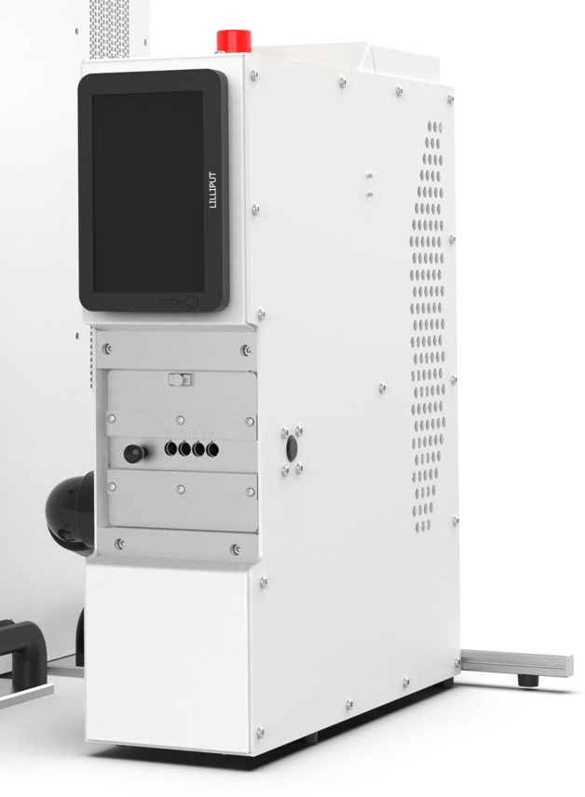
Figure 2 Mercury wire stripping machine
The Mercury machines feature the following 3d printed manufactured parts within its extraction systems. An extraction nozzle used at the site of the wire stripping procedure to remove harmful gasses; a manifold to fit standard size extraction tubing; and a filter cover to fit the filter within the system.
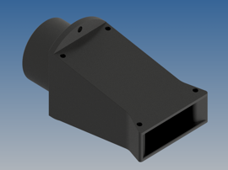

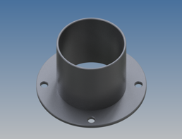

Figure 3 Images of 3D printed extraction system components

Based on current production levels, Laser Wire Solutions produces four Mercury machines per week. One 3d printer takes 21 hours 32 minutes to make a set. One set uses 137g of printer filament.
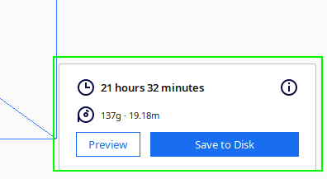
Figure 4 Cycle time and raw material used by the 3d printer

The material used is Ultimaker branded ABS filament. One roll of filament costs £39.99 and is supplied in rolls of 750g.
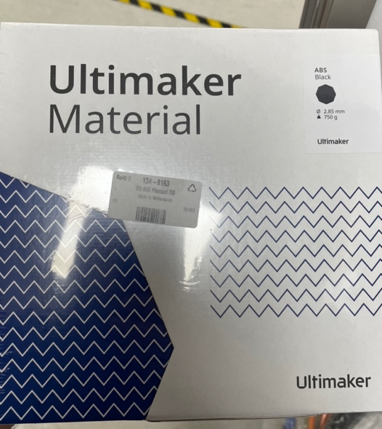
Figure 5 Raw material - 3d printer filament

Therefore:
$$sets per roll=750 ÷137 =5.47 sets per roll$$
$$cost per set= £39.99 ÷5.47 =£7.31 per set.$$

2.2 – Current Process and potential wastes.

The current process to request and maintain stock levels of these parts to meet production levels are identified in the simple process map below. When parts are required for production, the stores are electronically notified. One stores person has to ‘kit’ all the required parts. The person kitting the components manually checks the stock of 3d printed parts and based on experience, determines if there is enough stock of 3d printed parts in store. If there is stock available, the stores will kit enough components to meet the request of production. However, if there is not enough, stores must raise a purchase order against the engineering department for more stock of 3d printed parts. The engineering department receives the purchase order and makes the stock requested from stores. The engineering department always makes more stock than requested and retains these within the department, to enable it to have a head-start on the next order of 3d printed parts it receives from stores.

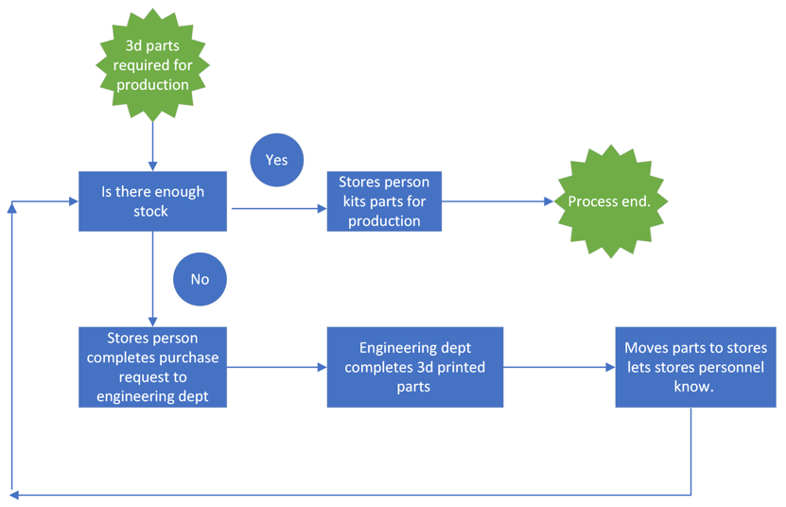
Figure 6 Simple process flow diagram

Value stream mapping is an essential tool in identifying waste. It helps to visualise the flow of the process and identifying the sources of the waste. It can form the basis of an implementation plan and design a process that incorporates the whole door-to-door system.
The current value stream map would look like this:
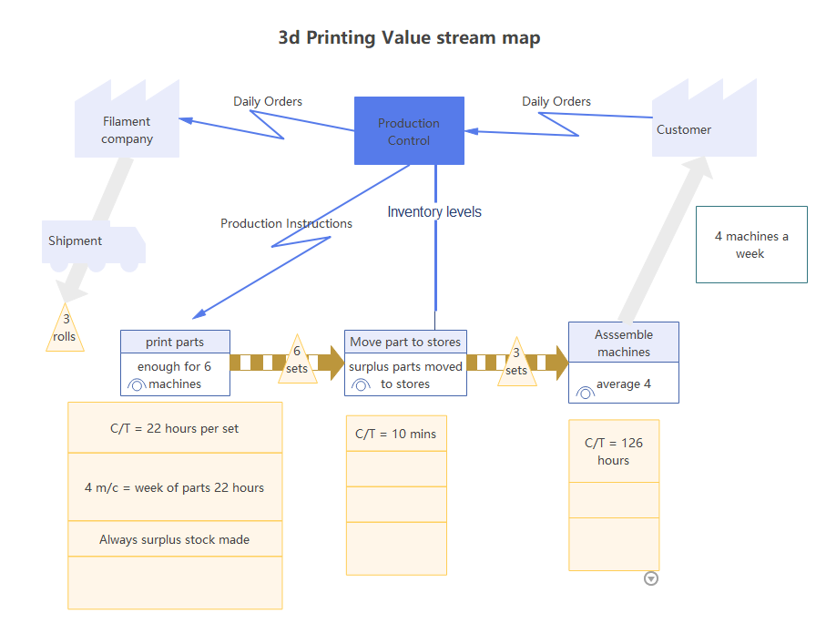
Figure 7 Current Value Stream map of the process
Based on the process and current value stream map waste or Muda activities and/or process can be identified. ‘Muda’ is Japanese for waste and can be categorised to two different types, Type 1 Muda are activities that create no value but are necessary to maintain operations. Type 2 Muda is pure waste and creates no value. (Holweg, 2009)
Based on the maps, the following are type 2 Muda and add no value to the process:
- Engineering printing parts, the components have been designed by the engineering department and unless they need to be revised there is no value to the customer in having engineering personnel print them. This step of the process could also be classed as over processing.
- Move parts to stores, this is an extra step in the process that has no value. If there is room, the components could go straight to the production area ‘lineside’. Stores can have an electronic notification of stock levels via an Enterprise Resource system
- Stores person kits components, if the parts were ‘lineside’ this would also reduce a step of the process and reduce transport within the process
- Stores person determining stock levels, if the parts where to have Kanban levels identified, this would take guess work out of the process.
- Over production, as the engineering department has no projected requirements or feedback of the number in the parts in stock, there is a tendency to print plenty of ‘just-in-case’ stock to be stored within the department.

3 – Process Improvements and Potential Problems
Here I will consider the points from the type 2 Muda identified above and consider some possible process improvements and potential pitfalls with implementation of these.

3.1 - The Engineering department manufacturing 3d printed parts

Currently, the engineering departments consists of four design engineers and five control and software engineers. Using the engineering department to produce production parts adds no value for the customer. Currently, all four printers are located within the engineering department at least two of these printers would need to be relocated to the production department to enable them to meet the current production schedule of four machines per week or additional printers would need to be purchased. A process owner from the production team could be identified. Process owners are vital in lean projects and having ownership from process level can have an impact on whether a new process is sustainable.

Potential problems and related costs
The main issue with completing this would be that space is required within production to house two large scale 3d printers. The printers rely on regulated temperature control environments. This enables the machines to produce the highest quality parts needed for production machines. Due to outgrowing their current premises Laser Wire Solutions are currently in the process of purchasing a new building and if 3d printed parts are going to feature in their machines in the future, serious consideration should be taken to provide a suitable area within production to house ‘production’ machines.
Removing the need for engineering department to print the parts would understandably require supplying a small amount of training for the production operatives. This would incur some cost but could be handled internally within the company, as the software required for using the 3d printers is free software and fairly user friendly and minimal up-skilling would be needed.
Training to production staff could be implemented with a widely adopted lean tool: the single point lesson. Single point lessons contain key points, a diagram or photograph and address the main stages of learning - awareness, understanding competence and ability to train others. This would also encourage standardized work. By standardizing the work required the process would benefit from: reduced variability and continuous improvement.
Purchasing two new printers would incur a significant cost, as the printers used by Laser Wire Solutions cost between £9000 - £10,000 per unit. This wouldn’t be justifiable at current production levels. four machines between the two departments are more than adequate to produce current production and Research and development components to be produced.

3.2 - Move parts to stores and stores personnel kitting required parts
The processes of moving parts to stores and stores personnel kitting required parts are a transport and skills waste. Any transport of materials is waste and has no value. However, it is a waste that can never be totally eradicated, only reduced. Holweg, (2009, pg23) states that ‘the number of transport operations is directly proportional to the likelihood of damage and deterioration’. Double handing is a waste that effects productivity and quality. Completed parts could go straight to production and kept close to the point of fit.

Potential problems and related costs
If the stores need to know stock levels and still raise a purchase order when new parts are required, this prevents a problem. This would need to be managed by some sort of Enterprise Resource system which could be costly if purchasing an ‘off the shelf’ system.
The price of ERP software depends on many things, such as the industry of the business, the size of the business, how many users require access to the software, and whether the business is currently using other software that needs integrating. These products are usually licenced on a monthly or annual subscription plan and can range between £6 - £50 per month.
To reduce costs a system could be created with readily available software/database, such as Microsoft Access and be maintained within the company.

3.3 - Stores person determining stock levels and making ‘just in case’ stock
To avoid the stores person determining stock levels based on ‘operator experience’ and the engineering department over producing components, a Kanban system is required. Kanban creates ‘pull production’ systems where production is based on consumption at a previous process. This creates a ‘pull’ from downstream to initiate stock replenishment. For a simple system like this, a product Kanban or single card system can be used. With product Kanban, whenever a product is called from it, it is simply replaced. If there is no call, then there is no production of 3d printed parts. If parts are now stored ‘lineside’ a fax ban or ‘e-ban’ can be used.
For small production parts such as these, Kanban squares or a first-in first-out lane can be utilized. Kanban squares are a particular type of visualization process that uses physical space, usually at the factory floor level to help identify when the parts need replenishing. The Kanban square can be made of up of four containers, each container featuring 1 set of 3d printed parts. Enough for a week’s worth of production are stored close to the point of fit. When the container is completely empty it is removed and placed by the 3d printer. It is this empty square that determines that only then should a set of components be printed and the Kanban square replenished. To help create a visual signal, red coloured squares can be used in the position of the containers, that is only visible when a container is missing.
A FIFO lane is a similar system. This ensures the oldest stock is used first.

Potential problems and costs
There are very little potential problems with utilizing a Kanban system, as long as there is room at ‘lineside’ to accommodate it. If there is not, the same system could be used in the current storage space as a minimum. This improvement would require very little cost, as any type of container and visual indicator can be used in the Kanban system.

4 – Conclusion

It is clear from researching Lean manufacturing that a Lean business benefits from increased productivity and quality while reducing lead times.
Laser wire solutions is a relatively small and very young business and hasn’t seen the need to work towards a leaner facility to date. However, the business is rapidly growing in size and revenue therefore is starting to look towards implementing leaner processes.
As design engineer currently working on one-of-a-kind machines, with very little involvement with production, is has been a challenge to apply lean techniques within my daily work.
However, this report aims to touch on the philosophy of lean and seeking the ideal way. With efficiency being so important to the manufacturing industry, can manufacturing businesses be competitive or survive without applying any sort of lean philosophy?

Works Cited
Holweg, J. B. (2009). The Lean Toolbox. Buckinghamshire : PICSIE Books.
Jamie Flinchbaugh, A. C. (2019). The HItchhickers guide to lean lessons from the road. Dearborn: Society of Manufacturing engineers.
Lynn, R. (n.d.). Plan view . Retrieved from https://www.planview.com/resources/guide/what-is-lean-manufacturing/

