University of Wales Trinity Saint David
Motorcycle Technology


Benjamin Hilton 2220555
ACHA 4003

Contents
Motorcycle schematic diagrams 3
BMW s1000rr 2018 4
(MCN, n.d.) 5
KTM 350 EXC-F 2022 5
Kalex Moto 2 2022 6
KTM rally replica 2021 6
Analyse 6
Trail and Rake 6
Wheelbase 7
Centre Of Gravity 7
Gearing 8
Race spec bikes 9
Kalex 2022 Moto 2 bike 9
Trail and Rake 9
Wheelbase 9
KTM 450 rally replica 9
Trail and Rake 9
Wheelbase 9
Potential improvements 9
BMW S1000rr 2018 9
Bibliography 10

Centre of gravity - COG

Motorcycle schematic diagrams

BMW s1000rr 2018
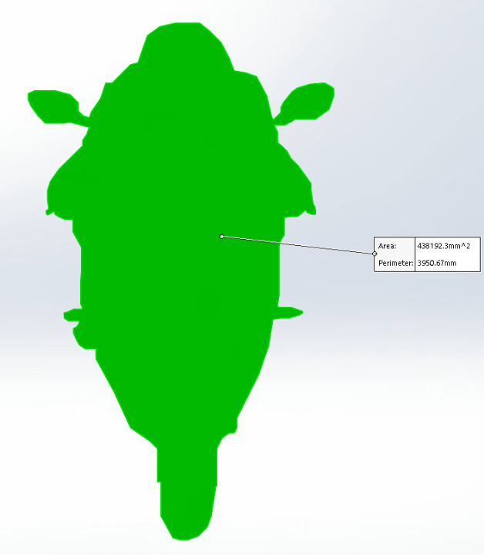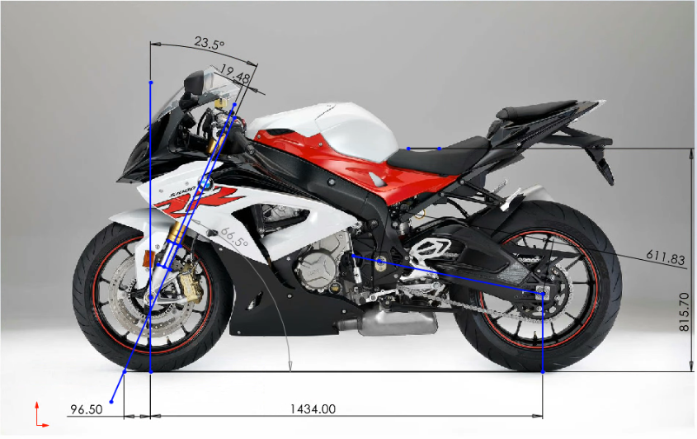
(CKA-DASH)
(Dealerspike)

(MCN, n.d.)

KTM 350 EXC-F 2022
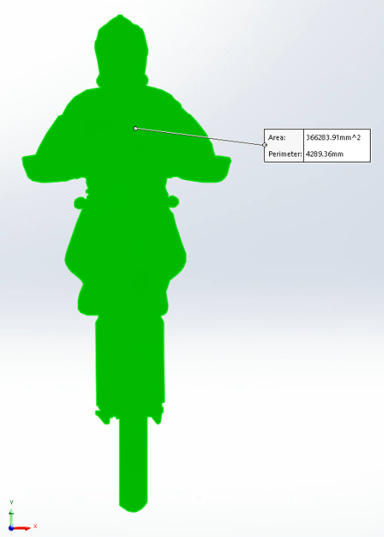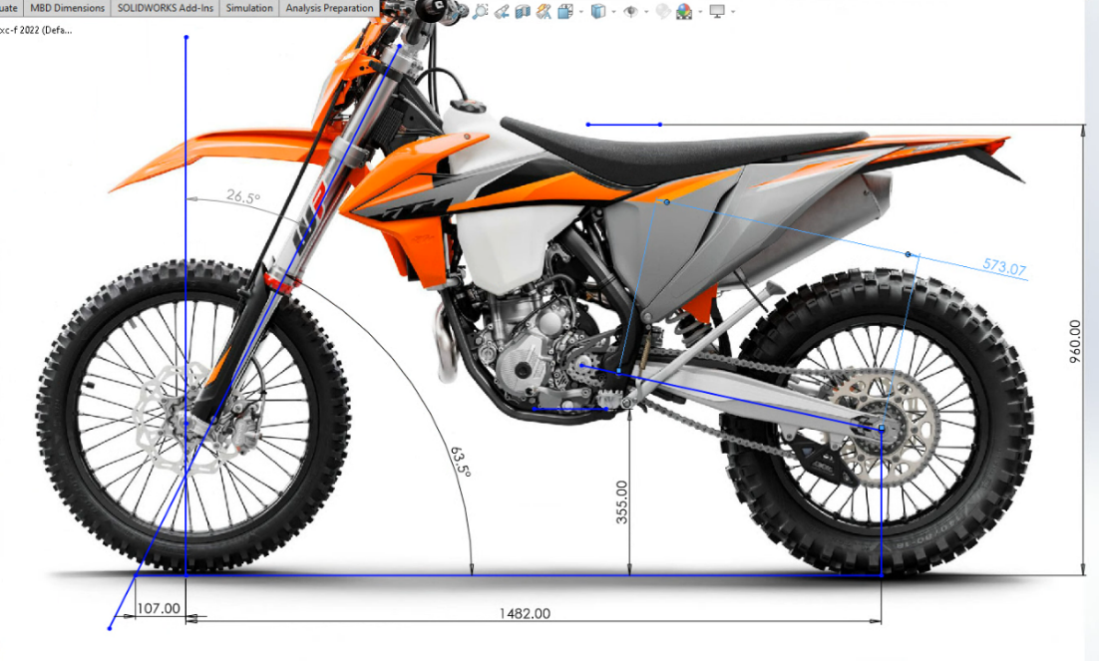
https://mxvice.com/wp-content/uploads/2020/06/Banner-KTM-1-1024x524.jpg
(KTM)

Kalex Moto 2 2022
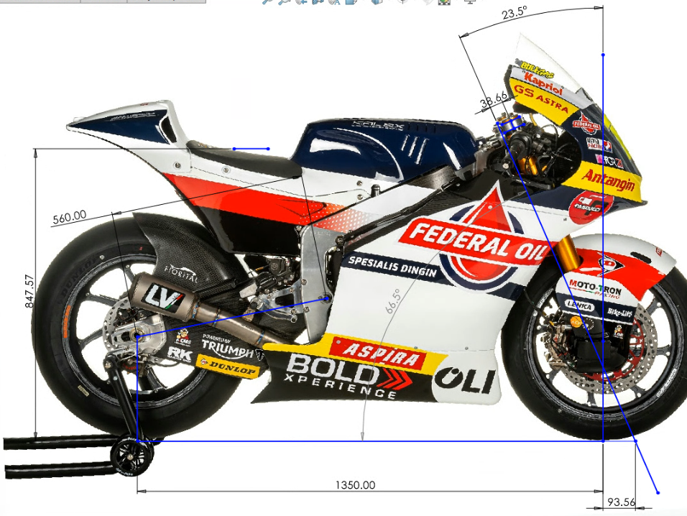

KTM rally replica 2021

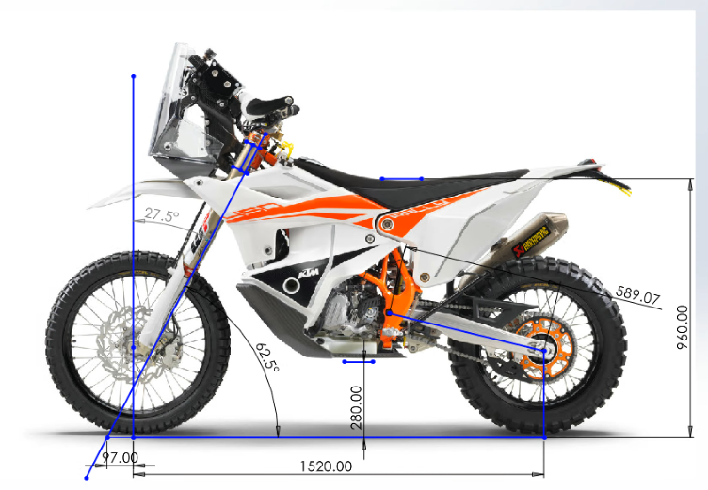
(KTM 450 Rally replica)

Analyse

Trail and Rake
The trail is calculated by using the distance between the front tyres contact patch with the ground and the line from the steering stem, then measuring the distance between the two points at ground level as shown in the figures above. The trail has a direct link with the rank angle as if you add a higher angle of rake, you will increase the Trail. The trail allows the bike to turn into a corner when leaned Aswell as allow the bike to go straight when at 0 degrees of lean. Having too much trail will cause the bike to understeer as it takes a lot more effort to cause the bike to turn, too little amount of trail can create oversteer Aswell as make the bike less stable causing tank slappers.
The rake is calculated by using the angle between the steering stem and a vertical line from the centre of the axle as shown in the figures above. With rake and trial being linked together we can see the same effects from increasing and decreasing these values. Therefor having a high angle of rake allows the bike to have more stability and self-centring effect but will suffer on handling as it will be less manoeuvrable going through slow speed corners, whereas a low rake will allow the bike to turn much easier and faster but will reduce the front stability of the bike.

The BMW s1000rr has a trail of 96.50 mm what is a lot lower compared to the KTM 350 EXC-F what has a Trail of 107mm. This allows the BMW to be able to turn easier and change direction faster to allow it to get to a lean angle into corner. The BMW is a road-based bike meaning its geometry is built around the grip that is available to it this is why the BMW can run much lower trail compared to the KTM as it has a lot more grip especially at lean due to the surface it is riding on, The BMW also makes use of a factory steering damper to stop potential tank slappers and to increase the stability due to the lower trail. The KTM uses a higher trail as it is built to go over rough terrain and need the extra stability and allows the rider to be faster as they don’t need to fight the bike as much.

Wheelbase
The wheelbase is the distance from the front contact patch to the rear contact patch as shown in Figures above. Having a longer wheelbase will allow the bike to be more stable especially though long high-speed corners, Aswell as having a reduced amount of wheelie. By having a shorter wheelbase, you have a more agile bike allowing the bike to turn faster making better in slow speed corners.

The BMW and the KTM both make use of a wheelbase with the BMW having a 1434 and the KTM having a 1482mm. They both use a long wheelbase to increase the stability of the bike at speed for the BMW this will allow the bike to go through high-speed corners at high lean angles with more stability and the KTM to be more stable whilst going at speed though rough terrain. They also have long wheelbases to reduce the amount of wheelie this is mainly for the BMW as it makes 200hp and wheelie will slow it down massively.

Centre Of Gravity
The Y COG refers to the hight of the COG. The Y COG is calculated by using the weights from the COG calculator, wheelbase, bike weight and stool height shown in the excel file. The Y COG has a major effect on the handing of the bike, with a high Y COG it will allow the bike to turn easier making it more agile allowing to it turn faster and easier, having a low COG will give the bike more stability at the cost of less agility.
The KTM has a much higher Y COG than the BMW especially with the rider present this is because the KTM’s riding style is more stood up compared to the sports bike riding style. The KTM also has a high COG as the bike must be higher to make sure it has a lot of ground clearance to clear terrain. The BMW doesn’t need to have a large amount of ground clearance as its make to go on tarmac what is level. The KTM has a y COG of 0.93311 meters with rider compared to the BMW’s 0.595458 meters with rider. Having a lower COG allows the BMW to be easier to steer into a corner as well as gives it more in corner grip at the cost of using leaner angle for a given speed, the KTM with a higher COG will require more force to lean the bike over with less stability but doesn’t need as much lean angle to go round a corner As well as changing direction faster. The BMW makes use of the lower COG as it can operate under high lean angle due to the grip given from the surface its used on compared to the supermoto that can use high lean angles as it is used on low grip surfaces.
The X COG refers to the distance from the front wheel the COG is or the percentage of weight on the front wheel compared to the rear wheel. The X COG has a large role in weight transfer and the amount of traction on both the front a rear wheel of the motorbike. By having a front based COG allows the bike to need less weight transfer to gain grip on to the front tyre during braking but when leaving a corner, you will need more weight transfer to gain traction on the rear tyre, if you have a rear based bike you will need less weight transfer on the exit of corners but more when braking and using the front tyre.

The KTM rear based bike with 42.74% on the front and 57.25% on the rear, this allows the bike to require less weight transfer towards the rear allowing it to have more initial rear grip. This is important for enduro bike especially when riding on Terrain like sand where you a lot of weight on the rear of the bike to prevent losing the front in the sand. Compared to the BMW what has a near 50/50 split at 49.09% front with 50.90% rear this give the BMW more of a balanced COG allowing for the front and rear to require a similar amount of weight transfer relative to the COG. Compared to the KTM the BMW needs more front-end grip as it relies on it to carry the bike through a corner As well as a large amount of rear grip to allow the rear to handle the near 200hp machine, the BMW also uses a lot of front end when under braking and requires you to brake harder than the KTM due to the increased contact patch and surface grip.

Gearing
The gearing is extremely important when developing the motorcycle as you need to make sure all 6 gear are in the powerband and also you don’t redline the bike in 6th gear
The BMW s1000rr has much longer rations than the KTM as it got a lot more power and consequently goes a lot faster with a top speed of 310kph
As shown in the excel document both of these bikes with riders on them can reach there theoretical top speed with the hp they are currently making
(KTM, KTM 350 Exc-f 2022 owners manual)
(BMW)

Race spec bikes

Kalex 2022 Moto 2 bike

Trail and Rake
The Moto 2 bikes use a shorter rake and trail compared to with BMW s1000rr. The moto 2 bikes have 93.56 mm and a rake of 23.5 degrees this allows the bike to turn much faster than street bikes and are willing to remove some of the stability as its not getting mate for your average rider on the road but for a racer on the track. The moto 2 bikes are also fitted with the top-of-the-line race speced steering dampeners allowing the bike to reduce head shakes. The moto 2 bikes also can adjust the bikes rake and trail for different bike by changing the fork offset what can't be done on normal sports bike like the BMW.

Wheelbase
The moto 2 bike has a short wheelbase of 1350mm this allows the bike to turn faster and become more agile. The moto 2 bike can get away with using a short wheelbase than the BMW as it produces less power, so it doesn’t need as much high-speed stability or less wheelie. The Moto 2 bike also has more adjustment in the set-up of the wheelbase as there swing arms allow for a total of 560mm to 575mm giving the team the ability to change the wheelbase for each track.

KTM 450 rally replica

Trail and Rake
The KTM 450 rally replica bikes use a shorter rake and trail compared to with KTM 350 exc-f. The Rally replica bikes have 97mm of trail and a rake of 27.5 degrees this allows the bike to turn much faster than a standard enduro and are willing to remove some of the stability and add a steering dampener what are commonly seen on road race bikes due to low trial.

Wheelbase
The Rally replica bike has a longer wheelbase of 1520mm compared to the KTM 350 EXC-F this allows the bike to become more stable compared to the standard enduro. The Rally replica need to use a longer wheelbase due to the increase in engine size and power meaning a long wheelbase can reduce the wheel. The rally replica also has a lot of adjustability with 10mm +or- to the swingarm length
(KTM, KTM 450 rally factory replica 2021)

Potential improvements

BMW S1000rr 2018

To improve the BMW S1000rr I would add a triple tree with an adjustable offset this allows the owner of the bike to change the rake and trail without changing other properties on the bike. This will allow the owner to choose if they want to have a more stable bike for the road or a racer more agile bike for the track.
Another improvement I would do is increase the swing arm length as with modern bike becoming more and more power full wheelies are slowing bike down more. By increasing the swing arm length, we can reduce wheelie and increase stability for road use. Also allowing more adjustability in the swingarm for changes in geometry instead of just to make sure your chain is tight.
KTM 350 EXC-F

To improve the KTM 350 EXC-F I would reduce the trail of the motorcycle to allow it to become more agile, and to counter act the instability by using a steering dampener like seen on the KTM replica rally.
I would also reduce the swingarm length as for a 350 with less power than a 450 it doesn’t need as long as it doesn’t reach the same top speed or deal with as many wheelies.

Bibliography
(n.d.). Retrieved from Dealerspike: https://cdn.dealerspike.com/imglib/v1/800x600/imglib/trimsdb/11054851-0-76652731.jpg
(n.d.). Retrieved from CKA-DASH: https://cka-dash.s3.amazonaws.com/002-0119-CWO1200/slider1.jpg
BMW. (n.d.). bmw 1000 rr 2018. Retrieved from manua.ls: https://www.manua.ls/bmw/s-1000-rr-2018/manual?p=215
KTM. (n.d.). Retrieved from Mxvice: https://mxvice.com/wp-content/uploads/2020/06/Banner-KTM-1-1024x524.jpg
KTM 450 Rally replica. (n.d.). Retrieved from Enduro21: https://enduro21.com/images/2022/june-2022/quick-look-2023-ktm-450-rally/2023-ktm-450-rally-replica.jpg
KTM. (n.d.). KTM 350 Exc-f 2022 owners manual. Retrieved from Ownersmanuals2: https://ownersmanuals2.com/ktm/350-exc-f-2022-owners-manual-83199/page-14
KTM. (n.d.). KTM 450 rally factory replica 2021. Retrieved from Manualslib: https://www.manualslib.com/download/2057056/Ktm-450-Rally-Factory-Replica-2021.html
MCN. (n.d.). Bmw s1000rr . Retrieved from MCN: https://www.motorcyclenews.com/bike-reviews/bmw/s1000rr/2015/

