BMSW5102 - Developing Relationships and Workplace Achievement

Lecturer: Sujeewa Herath

Student Name: Jahura Begum
Student Number: 1807431

Contents
Critically evaluate the role and importance of employee engagement using your chosen organisation. 3
Employee Engagement (udayalathukoral, 2018) 3
Critically discuss the difference between Performance Appraisal and Performance Management and evaluate the methods of your chosen organisation use to monitor employee performance. 6
Critically evaluate how reward makes an impact on organisational performance using your chosen organization. 8
Conclusion 10
SWOT of the Coventry Council 10
Personal Development Plan for an individual working inside Coventry Council 11
References 12

Introduction

It is crucial in every work environment to generate meaningful bonds between employer and employees in order to instil meaningful connection and loyalty, provide incentives of motivation, and promote workplace positivity and performance. Through clear engagement between employer and employee, the communication can aid in generating win-win outcomes for any organisation and therefore assist in performing helping, supporting and sustaining their local community. Coventry Council at Friargate is a service that is governmentally directed to support, and serve reliable council and service to their local environment. (Hook, 2021)

Critically evaluate the role and importance of employee engagement using your chosen organization.

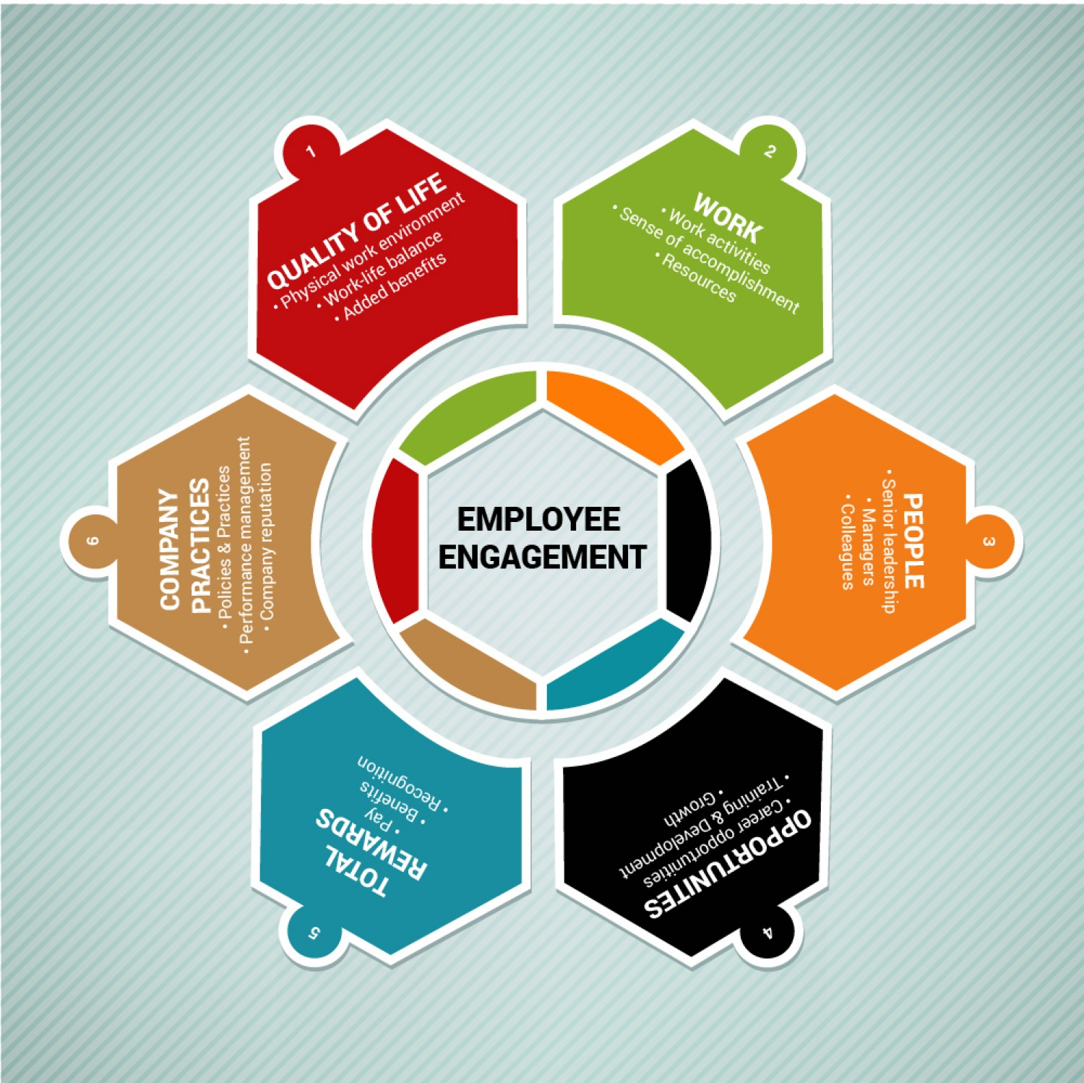

(udayalathukoral, 2018)

Before any analysis of employee engagement can take place, the definition of employee engagement needs to be defined. Macey Williams defines employee engagement as a desirable condition that ‘connotes involvement, commitment, passion, enthusiasm, focused effort, and energy.’ (Macey, 2008). Employee engagement is often described as a practise of trust and morals, and the practise of fair and lawful communication within an organisation and its affiliates. Bakker defines engagement as an energy, an involvement of professional efficacy. The opposite of a burnout. (Bakker, 2009). Here, employee engagement concerns adhering to employee’s organisational and individual performance, productivity and well-being concerns. Udayalathukorala applied a diagram defining the key topics concerning employee engagement. (udayalathukoral, 2018). Quality of Life, work, people, opportunities, total rewards and company practises. At the Coventry Council, employee engagement is extremely important as verbal communication remains to be heart of the business and service they provide, supporting and providing for all in their local community. The Coventry City Council is the local government body in charge of governing of the city of Coventry. The city is divided up into 18 Wards. The Full Council Meetings consist of 54 elected Councillors who are in charge of making ultimate decisions. The current Council leader is George Duggins. (Coventry City Council, 2019)These public meeting can be attended or viewed live or as an archived webcast. All who work at the council are responsible for sharing the same dream of developing Coventry into a place where people are looked after, and everyone has a voice. ‘Engaged employees feel that their jobs are an important part of who they are’ and that ‘the feeling of engagement cannot occur without a specific purpose or objective’. (Macey, et al., 2009). It implies those who actively engage with the Coventry Council add to the meaningful desires of the community. Macey et al reinforce the notion of how employee engagement can work as a motivational tool, as those who work for the Council are a part of a system that can transform the lives of those in need. ‘When the work itself is meaningful it is also said to have intrinsic motivation. This means that it is not the pay or recognition that yields positive feelings of engagement but the work itself’. (Macey, et al., 2009).
The key drivers of engagement are described by Bakker as ‘job and personal resources’. (Bakker, 2009) Job resources such as care from managers, performance critique, skill learning, practising autonomy, and developing learning opportunities are all completely associated with employee engagement. Here job resources aid in achieving work goals and generate learning, development and personal growth in every employee. Employees who are engaged are often depicted as possessing more personal resources ‘including optimism, self-efficacy, self-esteem, resilience, and an active coping style’. (Bakker, 2009) than those who are not engaged as adequately.
As with all large companies and services, the more workers you work with and engage within a company, the more miscommunication can occur, and therefore more misunderstandings, hence decreasing the employee morale and productivity. Poor communication is usually the key problem with issues cropping up regarding employee engagement. As every employee has different key priorities, disagreements and personal opinions, such differences can become difficulties when managing a large number of people. Having organised meetings individual and team meetings at the council, where every employee’s voice is listened to, valued and respected becomes a necessity for employee engagement. (Alfes, et al., 2010). Saks further expressed how employee engagement is provided by social exchange theory: ‘Social exchange theory argues that obligations are generated through a series of interactions between parties who are in a state of mutual interdependence.’ (Saks, 2006). Different individuals with different needs, requires different tactics, and therefore receive and respond differently to different methods of communication to reach out to meet the needs of employees and provide them the tools to communicate their needs.
To conclude, working for the Council means you make a positive contribution every day. There is a sense of togetherness and unity where everyone gets rewarded for the work they do. In order to be successful and connect on a worldwide stage, all employees need to be encouraged to engaged with both the public and employees so that everyone has experience engaging in a community that welcome’s others to be themselves. (Markos & Sridevi, 2010).

Critically discuss the difference between Performance Appraisal and Performance Management and evaluate the methods of your chosen organisation use to monitor employee performance.

The term management is defined from the Italian word ‘maneggiare’ which translates as ‘to handle a horse’ (Harper, 2021). The term management has evolved to mean the handling, the directing, and the monitoring an organisation’s resources in order to accomplish its objectives. Performance management specifies on prospect performance and development in contrast to reflective performance appraisal. The part of performance management in any establishment is to label the progress of performance improvement due to repeated coach correspondence between manager and employee. Michael Armstrong comments how performance appraisal and performance management can be incorrectly assumed to be the same thing. (Armstrong, 2014) The key differences is how Performance appraisal is regarded as a formal assessment and rating done by managers at an annual review, while performance management is the endless, organic process of management where a line manager takes more of a role of a ‘coach as opposed to a judge’, and tries to push the potential of individual employees into a role that suits their best capacity. (Armstrong, 2006). Subsequently, when employees are not managed without an appraisal, they can get confused about their role in the organisation. Hence, performance appraisal is a system that aligns individuals to the expectations of the company and provides a solid framework that others must follow.
Performance appraisal can be defined as a system and not a process. (Armstrong, 2014) Performance Appraisal is directed by the Human Resource department of the company, whereas managers take care of performance management. The procedure of Performance Appraisal is more structured and strict, however, it allows for the ‘customization of key performance areas’ which vary from employee to employee (Armstrong, 2006). Performance management is less controlled and strict compared to the confines of performance appraisal. Performance appraisal can be described in a negative light as it is usually associated with the working of HR as opposed to line managers themselves. Line managers have been known to reject performance appraisal schemes as they seem to be time consuming and treated as superficial and irrelevant. Armstrong set up a table of Performance appraisal compared with performance management. Performance appraisal is defined by Armstrong as ‘a dishonest annual ritual’ (Armstrong, 2006, p. 170). Performance appraisal empowers an organization to appraise the skills and true potential of the employees and therefore upturn their output. Performance appraisals are used at Coventry Council to identify the employees that are doing good in their job and the ones who are not meeting the traffic light green commitments. An assessment using performance appraisal helps the organization equate an employees’ actual performance with pre-set standards. The results of performance appraisal can be documented based on which feedback can be provided to the employees. It helps them understand their individual performance and where they need to improve in order to meet the needs of the organisation.
Traditionally, the Human Resources personnel department are recognised as a policing role – they check all the performance appraisal forms are filled in correctly, and received on time for assessment. However, performance appraisal notes express nothing about the value of the appraisal meeting or the feelings of individual. Some of the prejudiced reports may be rejected or amended by higher authority. Performance appraisals are commonly defined as an ineffective HR policy, and that the system was too complicated and time consuming. DeNisi and Pritchard express how the process of test validation appraisal forms is critical in any organization, as it sets up a link between scores on a test and performance on the job. If the test is irrelevant to the job duties, the appraisal can therefore be defined as a meaningless predictor of job performance and rendered obsolete to assessing accurate individual performance. (DeNisi & Pritchard, 2006)
Performance management can be clear method for improving organisational performance by increasing the performance of individuals and teams in the organisation. When better information and records are brought into the performance management meetings, they can work within an individual agreed framework of planned goals, standards and capability requirements. Procedures exist to develop employees in the Coventry Council through direct correspondence with line management.
The Coventry Council’s annual review is an opportunity for employees and management to actively participate and draw effort into manifesting development opportunities, and celebrating strategies in how to improve. Linking job performance to the achievement of the Council’s term corporate strategy and service plans aligns the County Council’s goals with the employee. Here, an illustration is made revealing how the Council succeeds as does the employee when targets are reached. This alignment reveals how succeeding in an individual objective with the council’s leads to a win-win outcome with department/divisional and corporate plans. The presentation of the council’s annual meeting goals is measured with a traffic light system and the goals are clearly defined and measured numerically. Performance aligns against target and the graphs show the performance trends though a traffic light, green, amber or red system.
Performance management at the Coventry Council provides employees and employers an opportunity to combine objectives that can be achieved together, with results that can collectively benefit the community as a whole. These objectives aid in supporting the Council’s growth through the performance results of their employees. The goal of performance management is to create a high performance culture, where employees are noted for their services, talents and offerings. Performance management is concerned with outputs (the achievement of results) and it is also concerned with the processes required to achieve these results (competencies) and the inputs in terms of capabilities (knowledge, skill and competence) expected from the teams and individuals involved. (Armstrong, 2014) Performance is often defined simply in output terms – the achievement of measured objectives that the Council board desire to achieve for that annual. Although there are many differences, there are parallels among performance management and performance appraisal. These parallels lie in the setting of targets, and the framed guideline for measuring success, reviewing whether targets were achieved or not, identifying barriers towards effective performance and new ways to help employees meet these targets.
To conclude, all who work at the council need to perform in conditions of change, variability and irregularity. Performance appraisals offer a simplistic framework while performance management offers a coaching opportunity for managers to train their colleagues to become the best they can within the business. Council managers may have to be specialists in adapting to new rules and legislation processes that fit in alignment with the requirements of the current Council leader requires for their community.

Critically evaluate how reward makes an impact on organisational performance using your chosen organization.

Rewards are known to make an impact on organisational performance in the Council due to several issues. Michael Armstrong relayed how rewards exist as way to recognise employees for doing what they do well. (Armstrong, 2014) There are multiple kinds of rewards that the Council offer to reward their loyal employees, and their rewards can have differing impacts on employee performance. The Council is known to provide both financial and non-financial rewards gifted by the government, which can be defined as intrinsic and extrinsic. With the implementation of Total Reward Strategies, the Coventry Council’s goal is to provide rewards that positively impact the performance of their employees and make them stay loyal and committed.
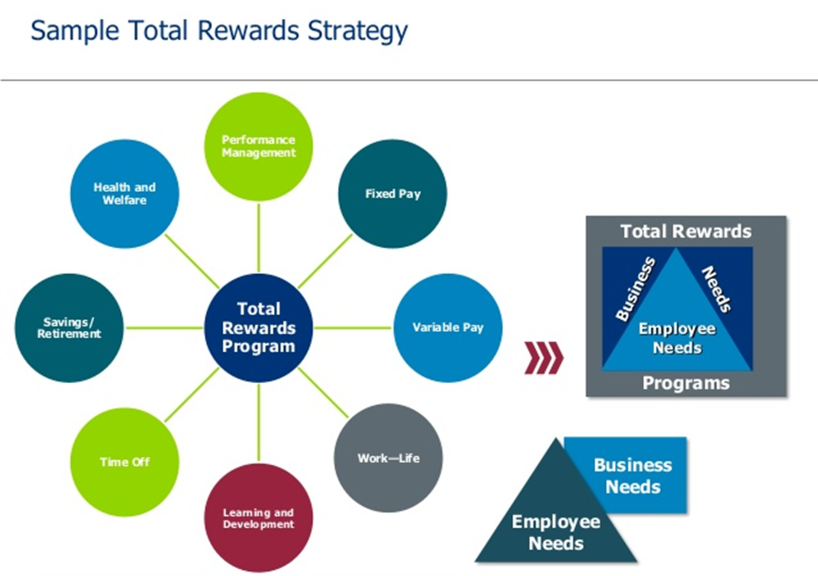
A Total Rewards Strategy is a system applied by any organisation that seeks to provide monetary, and non-monetary rewards to their employees who achieve specific business goals (SRHM, 2017). Coventry Council offers non-financial rewards to motivate the morale and performance of those who work for them. The packages Coventry Council provides are flexible working arrangements, substantial annual leave, secure pay progression, a fantastic government pension scheme, opportunities to develop and learn with local courses, and access to award winning occupational health and positive employee networks. Offering total reward systems then inspires workers at the council to perform at their best, for they deliver a high performance for their community in exchange of the Council supporting them to improve their individual quality of life. (Alfes, et al., 2010). The benefits Coventry Council offers are developing job opportunities, from job shadowing to professional qualifications, wellbeing initiatives and enrolment into their pension scheme. With a hefty Annual leave and a 23-day holiday entitlement with additional leave entitlement for those who have committed for a long service. Flexible working plans to help staff achieve a better work life balance and opportunities for family leave. Child care vouchers scheme, private health insurance, give as you earn scheme, special discounts to local events, travel allowance and even a bicycle salary sacrifice scheme where you can lease a new bicycle with the option of buying it at the end of the leasing period.
Monthly recognition and praise for a job well done, then becomes an additional reward at the Councils to inspire employees to improve and or maintain high performance goals. For example, when admin receive positive feedback from members of the public for helpful assistance regarding the information they received from the council, that employee’s name would be treated as a motivational asset, and verbal positive acclaim would be associated with that employee. The effect of such positive feedback on their performance is that recognition becomes the reward, and this can inspire the rest of the office to work harder to gain similar results.
Coventry Council applies Armstrong’s reward system strategy, where strategies are put in place to make sure management reward their employees fairly based on the performance they deliver within the company. The Government pay the Council and payment is divided into job position that is formed by performance appraisal. Coventry Council works to a time-based pay initiative, as all employees are paid for the hours they put in attendance, as opposed to being paid per case study or event they contribute to within the organisation. Being paid by the hour means every employee in the council gets rewarded equally based on time input, and that they always receive a fair, predictable and manageable output.
Coventry Council chooses to reward the performance of employees who provide a ‘job well done’. From monetary and non-monetary rewards. Additional rewards are distributed throughout the year from having their own bicycle to commute to work with, to seasonal tickets to entertaining events. To conclude, the Coventry Council is aware how rewards affect the performance of their employees. Being aware of Armstrong’s Total Reward’s system then becomes a reassuring blue print which mirrors the output that is available as long as employees are willing to input the same energy the Council seek. (Armstrong, 2014). As employees today seek for more than a basic salary, working at the council can be enough of a reward as those who work there know they are a part of a well-established group that rewards employees based on their performance to help and aid those in their community.

Conclusion
Relationships compose an essential part in the office environment, as it offers chances for employees to engage, share their performances, and celebrate successful result with extrinsic rewards. The of gratifying the employees and motivating them with rewards satisfying enough that they will offer their best performance is a goal of management and the senior team who work inside any organisation. To connect on a worldwide stage of greater diversity they need to be competent in engaging with their employees, ‘bringing employers and employees closer together’ and ‘experience a sense of community and the space to be themselves.’ (Markos & Sridevi, 2010).

SWOT of the Coventry Council

STRENGTHS  Council services are a stable and well established part of the community - a recognisable and trusted brand. | WEAKNESSES  Although the council has a recognisable market presence, providing support for people eligible for Adult social care, they can only offer support between morning/afternoon constraints. With budget cuts can significantly reduce the diversity of people who can use the services.
OPPORTUNITIES  A willingness to work with individuals who share similar aspirations in aiding and supporting the local community, and looking to use the council budgets in creative and collective ways | THREATS  The potential withdrawal of funding and potential redundancy fears

Personal Development Plan for an individual working inside Coventry Council

Development objective | Specific Actions to be Completed | Evidence of completion | Time scale for completion of task
Work independently creating appointments for social workers | To answer phone and set up recorded appointments/amend times and dates where appropriate. | When after 6 mths there are no reported errors or complaints | 6 mths
Work independently doing repeated phone/email correspondence and creating certificates | Clerical duties. Written marked and checked by senior administrator. All phone communications noted | When after 6 mths admin is not needing to be shadowed | 6 mths
Upskilled on Office/ Microsoft and Admin training | All word Training packages to be done and signed pff | 12 mth targets that are reviewed annually with a traffic light system | Ongoing

References
Alfes, K. M. et al., 2010. Creating an Engaged Workforce. London: CIPD.
Armstrong, M., 2006. PERFORMANCE MANAGEMENT KEY STRATEGIES AND PRACTICAL GUIDELINES. 3rd ed. London: Kogan Page.
Armstrong, T. &. T. S., 2014. Armstrong's Handbook of Human Resource Management Practice. 13 ed. London: Kogan Page Limited.
Bakker, A. B., 2009. BUILDING ENGAGEMENT IN THE WORKPLACE. 1 ed. Oxon: Routledge.
Coventry City Council, 2019. Coventry City Council. [Online]
Available at: https://www.coventry.gov.uk/.
[Accessed 29 July 2021].
DeNisi, A. S. & Pritchard, R. D., 2006. Performance Appraisal, Performance Management and Improving Individual Performance:. Management and Organization Review, 2(2), pp. 253-277.
Harper, D., 2021. www.etymonline.com. (n.d.). manage | Origin and meaning of manage by Online Etymology Dictionary. [online] Available at:. [Online]
Available at: https://www.etymonline.com/word/manage.
[Accessed 29 July 2021].
Hook, A., 2021. One Friargate. [Online]
Available at: https://www.coventry.gov.uk/directory_record/35071/one_friargate
[Accessed 29 July 2021].
Macey, W., 2008. The Meaning of Employee Engagement. Industrial and Organizational Psychology, 3(30).
Macey, W. H., Young, S., Schneider, B. & Barbera , K. M., 2009. Employee Engagement. Malden,: Wiley-Blackwell,.
Markos, S. & Sridevi, M. S., 2010. Employee Engagement: The Key to Improving Performance. International Journal of Business and Management, 5(12), pp. 1-8.
Saks, M. A., 2006. Antecedents and consequences of employee engagement. Journal of Managerial Psychology, 21(6), pp. 600-619.
SRHM, 2017. Society for Human Resource Management - Q&A. [Online]
Available at: https://www.shrm.org/resourcesandtools/tools-and-samples/hr-qa/pages/totalrewardsstrategies.aspx
[Accessed 29 July 2021].
udayalathukoral, 2018. Employee Engagement. [Online]
Available at: http://udayalathukorala.blogspot.com/2018/06/employee-engagement-week-7.html
[Accessed 27 July 2021].

