PROBLEM SOLVING AND DECISION MAKING

task 2

BMSK4004
Lecturer: Magdalena Wronska
Student: Katarzyna Szymczak (1907183)
University of Wales Trinity Saint David
27.08.2020

Table of Contents
Introduction 3
Task 2 - Individual Report 4
Workplace problem and the scope and impact 4
Analysis of the problem for taking inform the decision-making process 5
SWOT Analysis 5
PESTLE analysis 6
Proposing a range of alternate solutions 7
PMI chart for taking decisions 8
Plan to implement the solution for eradicating racism at the workplace 9
Stakeholder Communication Plan 10
Communicating the plan 10
Relevant monitoring and review methods for successfully implementing the solution 11
Conclusion 11
Reference 13

Introduction
People are faced with different sorts of problems when they are socializing with others at any sort of informal or any workplace setting. This part of the report has also provided an in-depth analysis of the problem by investigating the overall problem along with presenting the problem by evaluating and presenting different forms of a problem-solving model to attain a concrete decision for the problems that have surfaced. The report reflects on the problem faced by the care home employee who has faced derogatory remarks from the coworkers due to the person’s ethnicity.

Task 2 - Individual Report

Workplace problem and the scope and impact
Introduction to the Problem
During my service as the caregiver, I came across some problems that were more contextual to my workplace environment, rather than analytical. The reason here was that I always wanted to pursue a career in the care delivery sector. I also took my work sincerely and gave my full effort to ensure that the service users are provided with the best care. However, the problems started to occur within my workplace setting and the problem was associated more with the discriminatory attitude that was shown by my coworkers towards me. As I came from a different race and ethnicity, my English accent was different from my other coworkers. Their attitude towards me also included; making racist comments towards me and they also showed a lack of empathy towards me. I felt depressed and felt de-motivated due to the attitude shown towards me by my coworkers at the care home. The attitude of the coworkers also made me feel that their racist behavior towards me will affect the people, who I was caring for at the care home. If the service users were to show such attitude towards me, I would grow a distaste for my work and this would also affect my working process and this would, therefore, led to, me losing my overall passion as the caregiver. Hence, such attitude within the workplace, in my opinion, is unacceptable as this is related to my mental well being and my focus on the work that I am carrying out at the care home.
Scope and Impact
As stated by sociologists and historians, two aspects result in an individual to act rather superior to the people that come from other race, culture, ethnicity, or religion. Different ideas reflect upon the scope of racism. Other theories have been proposed by more renowned scholars. For instance; the conflict theory was proposed by Marx and the theory reflects upon the power and its unequal distribution, among the more powerful people and mainly the rich people of the society, and this class has been marked as Bourgeoisie by Marx (Jalata, 2013). On the other hand, western sociologists also blame the slave trade as one of the main reasons behind racism, in the modern era. But the impact of racism has been rather distressing in the sense that the racist behavior has been compared with dehumanization where the racist person may inflict psychological and physical torture towards the victim. The racist attitude based on segregation and class and discrimination has also sparked protests and also resulted in clashes among the people of a different ethnicity or religious background. Racism has also driven different legislative and governing bodies of the nations to make amendments to their legislation. This would mainly include; mass protests carried on by influential leaders (Sabaratnam, 2019). The impact of racism for instance; made the government of the UK introduce the race relations act, in the year 1968. This also included; ensuring, that people are treated with respect, despite their color or religion.

Analysis of the problem for taking inform the decision-making process

SWOT Analysis
Here to solve the problem that I was facing at my care service organization, I need to interact with personal strengths and weaknesses factors to evaluate the opportunities and threats for me at the organization.
Strengths  - I have an interest in this job which motivates me to retain my career in this organization.  - I have proper qualifications for this profession.  - The management is not involved in discriminatory activities, which will be helpful for me. | Weakness  - I don’t have much support from my colleagues.  - I was among the minor group of employees in this organization.  - Difficulty in English speaking prohibited me from consulting with the management and other employees.
Opportunities  - The management of the organization had fair rules and regulations.  - An operational manager is an honest man who can help me with this matter.  - The governmental laws and regulations also against discrimination which will be helpful for me. | Threats  - Most of the employees stand against me.  - I don’t have the opportunity to collaborate with my colleagues.

PESTLE analysis
The PESTLE analysis is such a tool that explains the impact of external factors on an organization. In this case, the organization that I have been working for is facing the issue of discrimination. So here, the PESTLE analysis for the organization regarding the issue is explained below:
Political factors: There are different laws and regulations regarding discrimination in the workplace. The current government is implementing different laws and regulations for reducing discrimination in the workplace (Sabaratnam, 2019). The organization that I work for has to maintain the rules and regulations regarding discrimination in the workplace.
Economic factors: To survive and develop in the economy, the organization has to improve the performance which requires the optimization of employee performance. And the optimization of the performance of employees requires an efficient working environment without any harassment or discrimination to workers and employees (Jalata, 2013).
Social Factors: The social system of the UK supports equal distribution and equal behavior for all human beings. This implies the organization to reduce discrimination in the workplace. This impacts the implications of organizational rules and formulates equal culture at the workplace in the organization where I am working.
Technological factors: The technologies have made operations and tasks easy and efficient for care organizations. The monitoring system also developed with which the management can monitor the activities and contribute to the reduction of discrimination at the workplace.
Legal factors: The care organizations have to follow the rules and regulations for maintaining workplace environment and culture. The rules and regulations are against any discrimination and inequality. There are several acts and provisions against discrimination.
Environmental factors: Discrimination in the workplace create an adverse working environment for workers. The care organization looks for improving the working environment and reducing the discrimination at workplace which also drives this organization to reduce discrimination.

Proposing a range of alternate solutions
Fishbone analysis
The model was introduced by Ishiwaka in the year 1968 and the main purpose for using the Fishbone diagram was to understand the cause and effect of any aspect along with investigating the reason behind any sort of imperfect aspect and the cause of failures. As seen in the diagram below, the cause includes; referring the problem at the head of the diagram, and then identifying at least four causes that are associated with the problem. This is followed by the questioning method that includes questioning the main cause of the problem. The next step in the diagram is associated with breaking down each cause so that they can attain any sort of outcome for the analysis of the problem (Ishikawa, 1968). Hence, for the racist attitude of the employees at the care home, had a cultural prejudice, were more verbally competent to use the English accent, and were also less informed on the repercussions of racism.
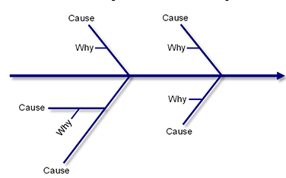
(Source; Fishbone, Kaoru Ishikawa, 1968)
Fishbone analysis of the aforementioned problem
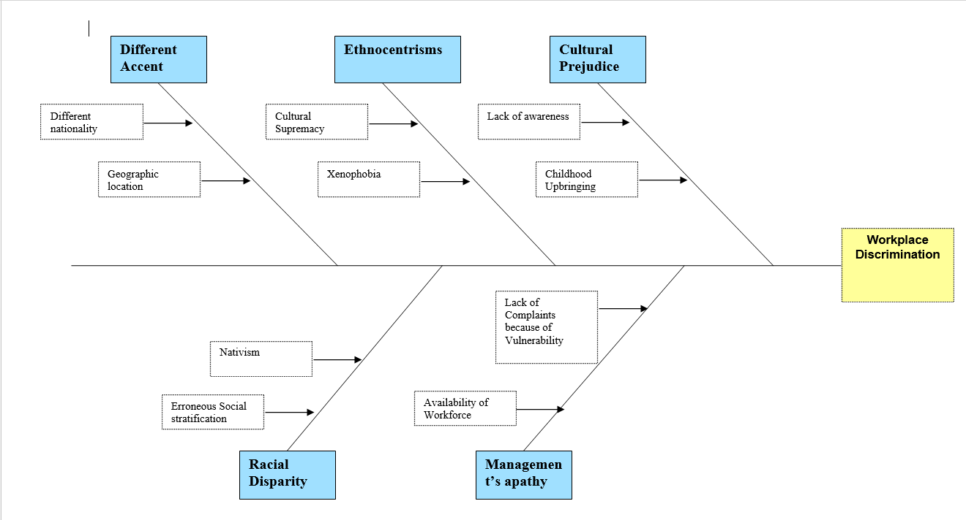

Proposed solution
I believe the best solution, by the Fishbone model analysis, is to ensure that the employee and the senior management of the care home get involved as authoritative support is essential to carry out such campaigns that are associated with creating awareness among the employees of the care home. On the other hand, certain employee relation programs can be also effective to create awareness against racism in the care home. This will be effective since the more employees blend and become informed of each other’s cultural background, the more they become empathetic towards others' cultural and social norms (Belton et al, 2001). I believe the last solution here would be to ensure that the race relations act of 1968, is implemented thoroughly and effectively so that any sort of racist attitude is tackled by the use of the legislative frameworks.

PMI chart for taking decisions
The PMI or the Plus, Minus, and Interesting strategy that is aimed to carry out critical thinking for the individual those are trying to reach any sort of decision (Adair, 2013). The main reason for carrying out the PMI analysis is to investigate ideas that can be derived from different perspectives. The ideas and concepts are also awarded marking based on the problem that has surfaced (Straus, 2002). The PMI marking for the problem of racism has been charted below. The analysis here also reflects on the fact that the care home is required to be more focused on implementing the initiatives that can eradicate racism.
Plus | Remarks | Minus | Remarks | Interesting | Remarks
Reducing racist activity within the care home. | +7 | The racist attitude of the employees must be eradicated. But the racist ideologies still persists among many. | -8 | The people that are facing racism can become friendly with such initiatives. | +5
Ensuring that the employee relations program will be successful. | +6 | The people that face racism are in increased mental distress. | -3 | The proposed initiatives to stop racist activity can bring fruitful outcomes. | +6
 | +13 |  | -11 |  | +11

Plan to implement the solution for eradicating racism at the workplace
- The plan is to initiate an employee relations program where the senior management of the care home will be included.
- The plan would also include arranging an event where all the British born Caucasian employees and the employees from diverse cultures will be invited.
- The main plan is to ensure that the employees are educated upon the positive aspects of a multicultural setting free of racism along with keeping them informed on the aspects that are related to positive sides for working within a multicultural setting.

Stakeholder Communication Plan
Stakeholder | Power/Interest | Key interest and issues | Communication vehicle | Frequency
Care home Management | Trustees | 5 | Email | Monthly assessment on the upcoming event.
Employees (Caucasian) | Caregivers | 4 | Through the use of a memo | The daily memo delivered to each of the caregivers.
Local authorities | NHS | 6 | Email | Monthly review of the activities carried on by the care homes.
Employees (Multicultural) | Caregivers | 8 | Through the use of a memo | The daily memo provided to each of the employees.
Care, home employees, | Care, home manager, | 7 | Email | A monthly review was provided by the managers.

Communicating the plan
To communicate the plan with the stakeholders, this can concur that the participation and the conformity of the different stakeholders of the care home will be required (Pizlo, 2012). The three basic communication platforms that have been mentioned in the stakeholder plan above will be used for interacting with each of the employees of the organization. The communication platforms are also effective to explain the main reason for the care home to undertake this initiative.

Relevant monitoring and review methods for successfully implementing the solution
Indicator | Data source | Timing
A number of racist incidents. | Complaints are placed by the employees. | Every month
A number of verbal abuses. | Abuses made by patients. | Every week
A number of racial attitudes shown by the care home staff. | Complaints are placed by caregivers from diverse cultures. | Every week
A number of physical abuses experienced by the multicultural employees of the workplace. | Complaints are placed by employees from diverse cultures after they have faced any physical abuse. | Every month

Conclusion
The report therefore includes the discussions that are focused at understanding the problems and the complexities that are related to the problem. The report also focuses on evaluating problem so that the available decision for the problems can be taken by the individual, experiencing the problem. The solution for the problem has been also analyzed strategized before the final verdict for the problem can be stated and the stakeholder chart has been also presented in the report to communicate the problem, with the stakeholders of the organization. The report also reflects on the source of the problem and the impact of the problem on the individuals that are working within the workplace context.

Reference
Adair, J. (2013) Decision making and problem solving strategies. 2nd edn. London: Kogan Page.
Belton, V. and Stewart, T.J. (2001) Multiple criteria decision analysis: An integrated approach. 2nd edn. Boston, MA: Kluwer Academic Publishers.
Ishikawa, K. (1968). Guide to Quality Control, JUSE, Tokyo
Jalata, A., (2013). The Impacts of English Colonial Terrorism and Genocide on Indigenous/Black Australians. SAGE Open, 3(3).
Pizlo, Z. (2012) ‘Human problem solving in 2010’, The Journal of Problem Solving, 4(1). doi: 10.7771/1932-6246.1120.
Sabaratnam, M., (2019). Postcolonial and Decolonial Approaches. In: J. Baylis, S. Smith and P. Owens, ed., The Globalization of World Politics: An Introduction to International Relations, 8th ed. Oxford: Oxford University Press.
Straus, D. (2002) How to make Collaboration Work: powerful ways to build consensus, solve problems and make decisions. Berrett-Koehler.

