Steel & concrete frame in construction

Construction materials: ACBA4016
Osian Davies (2418350)

In my project for investigating the construction of Steel and Concrete frames, I've developed two extensive case studies of liveable buildings of these materials around the world. In this report I will discuss in more detail the construction methods used for both buildings and the considerations that were made during the planning stage of construction such as the environment and climate. I will also reflect on how these materials have affected the construction process and their potential impact on the surrounding community and environment, as well as the maintainability of these buildings depending on their design and configuration. The following are the two structures I chose to analyse:
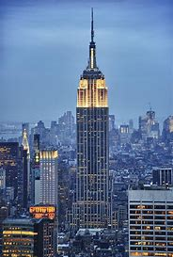
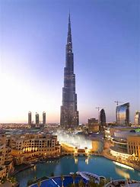

The Burj Khalifa Empire State
Concrete frame Steel frame
Completion in 2010 Completed in 1931

The Burj Khalifa:
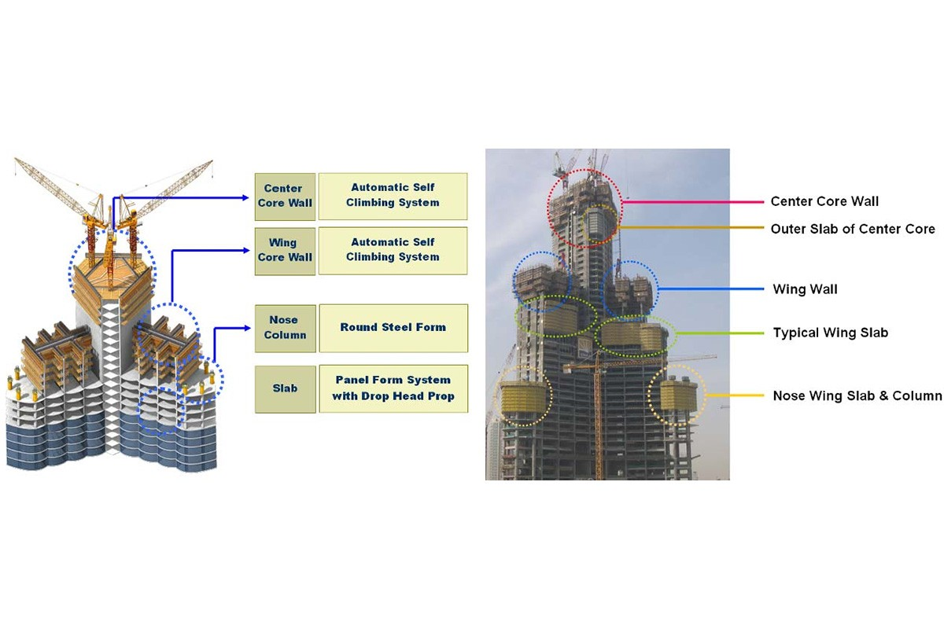
Burj Khalifa which is the tallest building in the world. Standing at 828 meters and 163 floors, it is a mixed-use superstructure for residential, commercial, and hospitality use. Designed by Adrian Smith (of Skidmore, Owings & Merrill), the tower features a Y-shaped floor plan to help maximize the limited space available to residents and hotel visitors. Its architecture borrows from Islamic architecture, more specifically the Great Mosque of Samarra.
The Burj Khalifa was built using a buttressed core structural system that mainly uses high performance reinforced concrete. This configuration is crucial in providing the structure strength, long life and resistance against the region’s unforgiving climate.
The buttressed cories consists of a hexagonal concrete core with three deployable wings protruding from three sides, designed to resist torsion force better, as well as provide greater stability against lateral loads such as earthquake or wind. This ingenious design allows for the transfer of the gravity loads but also horizontally loads much more efficient than with the older horizontal diaphragm method and allows for much greater overall strength of the building.
And to survive Dubai’s erosive groundwater and hot summer temperatures, the company said a high-performance concrete was specified with strength grading C60 to C80. This fly ash-and-aggregate concrete is also low-permeability, which protects the environment. Furthermore, to take care of the corrosion risk from aggressive chemicals in the groundwater, cathodic protection systems were applied around the foundation.
The structure is clad in mirror glazing, aluminium and brushed stainless steel spandrel panels. This cladding system was designed with a purpose being to withstand the unbearably high heat experienced in Dubai as well as acting as an insulator to prevent the heat being accidentally transferred into the building thus increasing energy efficiency and comfort limitations.

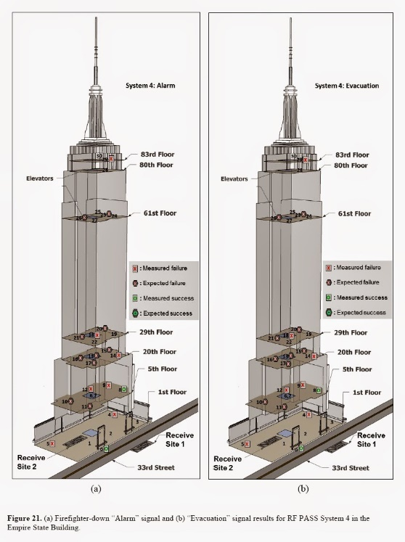
The Empire state:
The Empire State Building is an iconic 102-story Art Deco skyscraper at the 3500 block of Midtown Manhattan, New York City designed by the firms of Shreve, Lamb & Harmon. It was supposed to be the world’s tallest building, the first to soar past 100 stories. Construction began on March 17, 1930, and moved at an astonishing pace — the steel frame went up about 4½ stories per week. On April 11, 1931 — fewer than 410 days after actual construction began — the building was deemed structurally complete; it opened on May 1, 1931. When it was finished, the Empire State Building was the tallest building in the world, a status it maintained until 1970.
The primary structural element employed in the Empire State Building, finished in 1931, is a riveted steel frame.
Flexibility: The steel skeleton is lightweight and sufficiently elastic to bend and deform, so that the building can “harvest” wind gusts rather than oppose them. The limestone facade not only provides protection but also adds durability to its internal steel structure. Improvements, such as storm-rated windows, offer extra protection against extreme weather.
Durability: Indiana limestone panels give the facade a beguiling but also durable, weather-resistant face. That limestone — and granite and brick as well — is meant to shield the steel framework from moisture and fluctuations that can lead to corrosion. The building involves 6,514 stainless steel-framed windows — a money-saving choice that did away with stone finishes around the windows.
Climate of resistance: New York’s climate exposes buildings to temperature fluctuation, rain and wind load. When constructed, an extensive resistance against such climate impacts is provided by the steel structure and limestone and granite facade combination. It also contains wind-breaking this make every thing stable during storm.
Its riveted steel frame will keep standing strong and unflinching against the environmental challenges of its urban environment for the present and years to come.

The impact of the framing material’s original production process:
The Burj Khalifa:
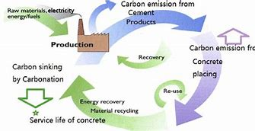
Building the Burj Khalifa required significant amounts of materials such as concrete, steel, and glass, which all have inherent environmental and social impacts in their respective production processes.
Environmental Impact:
Concrete Manufacturing: Cement, one of the components of concrete, is extremely energy-intensive to produce and will therefore contribute significantly to CO₂ emissions. It will surely cause habitat disruption and depletion of natural resources.
Steel Manufacturing: Steel production does extract iron ore as well as coal, both of which lead to environmental degradation. The smelting stage also emits greenhouse gases and other pollutants that can impact air quality.
Glass Production: Glass production process requires a lot of energy and emits CO₂ and other pollutants. In addition, the mining of the raw materials like silica sand may be destructive to the environment.
Community Impact:
The Burj Khalifa was largely constructed by migrant workers from South and East Asia. Many reports have sounded the alarm about poor working conditions, low wages and cramped housing for these workers. Such methods of labour have raised serious human rights abuses and drawn widespread global condemnation.

The Empire State:
It took approximately 60,000 tons of steel to construct the Empire State Building. The reason being that during that time, steel production was mainly employed with the Basic Oxygen Furnace process, which demanded a high amount of energy and led to large greenhouse gas emissions. Additionally, iron ore and coal mining for the production of steel led to habitat destruction and over-exploitation of resources.
Producing that much steel had environmental consequences: it contributed to air pollution and higher carbon emissions. That's important because while that number is low, structural steel and rebar in particular are now about 90% recycled at the domestic level, so it is otherwise showing positive signs.

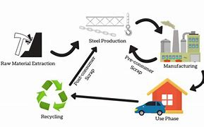
Additionally, it had an economic impact by creating jobs during the Great Depression, providing employment for thousands of workers during a time of pronounced economic struggle. This surge in employment provided critical financial assistance to many households, and also helped fuel New York City’s economic recovery at a challenging time.
Final Thoughts: Although the steel production phase alone for the Empire State Building had significant environmental consequences, the construction project also played an important role in providing desperately needed jobs to the surrounding community during a time of economic hardship.

The frames ease of assembly and the potential ease of its adaptation:
The Burj Khalifa:
The structure features a buttressed core structural system, with a central hexagonal base that includes three buttresses arranged in a Y-shape. These kinds of architectural are incredibly sound and durable, enabling the tower to reach phenomenal heights.
Ease of Assembly:
The symmetrical Y-shaped floor plan streamlines the construction process by using the same floor plans and structural members. It also helps with efficiency and reduces the possibility of mistakes during assembly. In addition, the use of high-performance concrete and reinforced steel ensures structural integrity while allowing for a more streamlined construction schedule.
Adaptability:
This buttressed core system also gives variability to the building's shape and functionality. The most notable aspect of the design is its ability to tackle a variety of floor plans and usages, combining residential, commercial and hospitality into a single building. This flexibility allows for future renovations or changes in function, thus extending the building’s life.
Overall, the chosen structural system for the Burj Khalifa serves four fundamental purposes: Supports the highest structure in the world to successfully stand, . Allows for an efficient assembly allowing for maximum construction speed, . Adapts to mixed use with multiple occupants using the tower at once, and . Meets various user needs over the course of the buildings life.

The Empire State:
The Empire State Building is a demonstration of not only the incredible efficiency of construction methodologies developed in the first half of the 20th century, but also their versatility. Its structural steel frame made it possible to reuse the building for various types of functions over the years, building out enclosure (walls and floor) at low cost.
Ease of Assembly:
Off-site prefabrication: Many components were manufactured off-site, delivered pre-assembled for installation. Not only did this streamline the assembly process, it also guaranteed we adhered to high-quality standards. ascemetsection.org
Gig-Scheduled: Steel beams made in Pennsylvania moved quickly, with some lifted into position within 80 hours of leaving the foundry. This just-in-time delivery process minimized on-site storage and accelerated the construction schedule. LinkedIn
Construction is nearing completion, with the building reached completion in a little over a year with the construction team achieving an average of 4.5 stories built per week. The fast track was achieved by systematic use of standard steel elements and the dedication of the personnel.
Adaptability:
The steel frame design has allowed the Empire State Building to adjust for various changes as its needs have evolved:
Functional Flexibility: Originally designed as an office space, over the last century the building has welcomed a variety of tenants and uses, from radio stations to observation decks. These transitions have been made possible by the open floor plans enabled by the steel structure.
Updates for Sustainability: Over the past few years, the building has been fitted with equipment for more energy-efficient structures, including adaptive lighting technology and improved insulation. These upgrades have been made without compromising the building’s historic character, further showcasing the frame’s capacity to support modern sustainability efforts.
The Empire State Building's steel framework permitted the quick construction, and later brought an adaptable foundation that remained functional with changing uses and standards over its lifetime.

Below I have stated the advantages and disadvantages of using steel or concrete frame in construction.
Steel:-
Advantages: | Disadvantages:
High Strength-to-Weight Ratio: Steel has the highest strength-to-weight ratio, which allows it to support much more weight with less material than concrete or wood. | Susceptibility to Corrosion:  Steel has high tendency to rust and corrode in most environmental conditions with moisture atmosphere, such as humid area and coastal area.
Speed of Construction:  Steel elements can also be prefabricated off-site in advance, drastically reducing construction periods. | High Initial Cost:  Steel generally has a higher up-front capital cost for building due to the relative cost of procurement and fabrication.
Design Flexibility: Steel's malleability, weldability, and bolt ability give architects and engineers greater flexibility to create complex forms, spacious interiors, and adaptable floor plans. | Thermal Conductivity  Steel has elevated thermal conductivity, which may cause poor insulating property unless extra insulating materials are enforced, which increases overall cost.
Durability and Resistance: Steel, when suitably protected, demonstrates outstanding durability and resistance to vermin, decay, and fire. It can withstand harsh weather conditions and needs little maintenance over its life. | Impact of Manufacturing on the Environment During its production phase, its formation process consumes large amounts of energy which generates high levels of CO₂ emissions, thus leading to environmental degradation.

Concrete:-

Advantages: | Disadvantages:
High Compressive Strength: Concrete has strong compressive strength, so that it's perfect for large-scale structures which need to bear a heavy load. | Needs gifted self-weights: A cubic metre of concrete weighs heavier than any other building material, by all other building materials combined.
High Compressive Strength: Concrete has strong compressive strength, so that it's perfect for large-scale structures which need to bear a heavy load. | Low tensile strength: But does a concept of reinforced concrete miss the point that what it needs above all is lot tensile strength? For example, take a concrete column.
Durability and Low Maintenance:  Concrete frameworks are very strong and they are not subject to environmental wear, corrosion or pest infestations. | Extended hardening time: This is different from steel structures.in that steel structures can be fabricated and constructed quickly.
Thermal Mass Efficiency: With a fair amount of heat taken in, concrete can also accumulate heat. | Impact on the environment: This has caused extensive destruction to the environment and militates against sustainable development.

References:
Go Construct. “Iconic Construction Projects – Burj Khalifa.” Go Construct, 1 Dec. 2019, www.goconstruct.org/news-and-features/iconic-construction-projects-burj-khalifa?.Accessed 25 Mar. 2025.
“Structures.” Burj Khalifa, 13 Sept. 2024, www.burjkhalifa.ae/the-tower/structures/. Accessed 25 Mar. 2025.
“History of the New York City Landmark | Empire State Building.” Esbnyc.com, 12 Jan. 2025, History of the New York City Landmark | Empire State Building Accessed 25 Mar. 2025.
Williams, Amanda. “How Long Will the Empire State Building Last? - Christian Website.” Christian Website, 14 Jan. 2024, How Long Will The Empire State Building Last? - Christian WebsiteAccessed 25 Mar. 2025.
Donovan, Robert. “How Is the Empire State Building Strong and Stable? - ANSWERTICA, 9 Oct. 2023, How Is The Empire State Building Strong And Stable? - ANSWERTICA Accessed 25 Mar. 2025.
in. “Burj Khalifa, the Tallest Skyscraper in the World - Tomorrow.City - the Biggest Platform about Urban Innovation.” Tomorrow.City - the Biggest Platform about Urban Innovation, 30 June 2022, Burj Khalifa, the tallest skyscraper in the world - Tomorrow.City - The biggest platform about urban innovation Accessed 25 Mar. 2025.

Donlevy, Katherine. “How Darth Vader Ended up Projected onto the Side of the Empire State Building.” New York Post, 12 Sept. 2024, How Darth Vader ended up projected onto the side of the Empire State Building Accessed 25 Mar. 2025.

