1/8/2024
Kelly Casey (2106451)

Design and Implementation of a Centralized Relational Database System for MelodyHwb
ACCA5026

Contents
Introduction 2
Schema 3
Tables: 3
Categories: 3
Customers: 3
Suppliers: 3
Products: 3
Orders: 3
OrderInformation: 4
Problem Solving and Documentation 8
Database Performance Tuning 8
Potential performance issues 8
Solutions 8
Data security and Access Control 9
Identify Security risks. 9
Proposed actions 9
Problem Solving and Documentation 10
ERD 10
Fields 10
Constraints 10
Relationships 11
Systems Architecture 11
Application 11
Deployment instructions 11
Scalability. 11
Security and validation 11
Security measures 12
Validation procedures 12
Encryption 12
User access 12
Authentication 12
Future enchantments 12
Conclusion 13

Introduction
In the busy music retail scene, staying organized is key. MelodyHwb, a popular music store, wants to upgrade its game with a smart database system. This system will handle instruments, orders, and customer stuff smoothly behind the scenes. The aim of this assignment is to create a database that runs MelodyHwb's business smoothly. We'll map how things connect and keep the store running smoothly, even during busy times. Also, we'll test pretend orders to see how this digital system handles them. By setting up this database system, MelodyHwb aims to nail the essentials—providing excellent service, ensuring customer satisfaction, and cranking up their success in the music retail world.

Schema

Tables:

Categories:
- CategoryID(primary key)
- CategoryName

Customers:
- CustomerID(primary key)
- FirstName
- LastName
- PhoneNumber
- Address
- Postcode
- Town
- City
- Email

Suppliers:
- SupplierID(primary Key)
- SupplierName
- ContactName
- PhoneNumber
- Address
- Postcode
- Town
- City
- Email

Products:
- ProductID(primary key)
- CategoryID(foreign key to categories)
- ProductName
- Price
- Brand
- SupplierID(foreign key to suppliers)
- CostPrice
- TotalInStock

Orders:
- OrderID(primary key)
- CustomerID(foreign key to customers)
- OrderDate
- PostedDate
- postedAddress
- postedPostcode
- postedTown
- postedCity
- Courier

OrderInformation:
- OrderID(Foreign key to orders)
- OrderInfo(primary key)
- ProductID(Foreign key to products)
- Quantity
- UnitPrice
- Discount

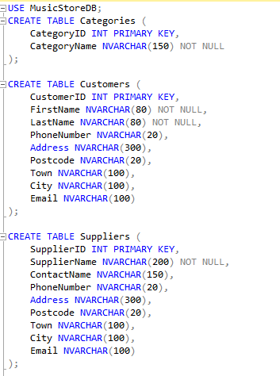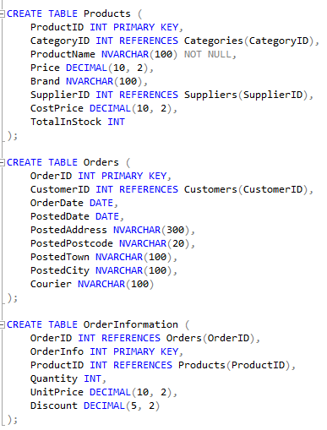

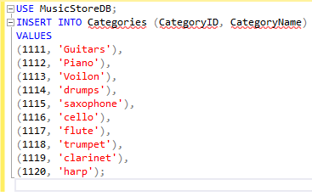
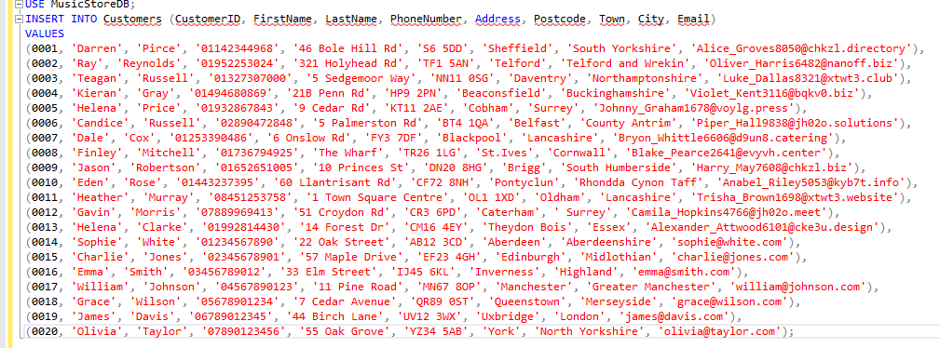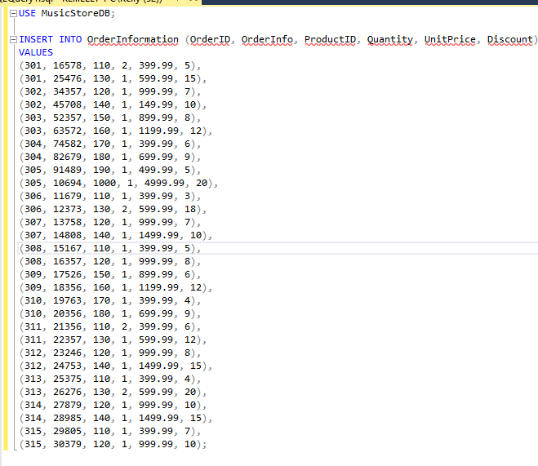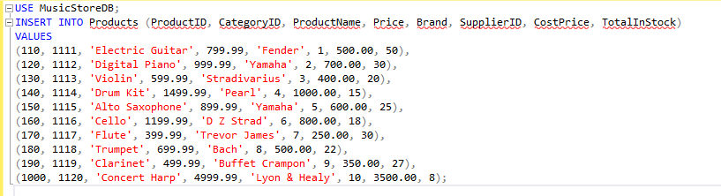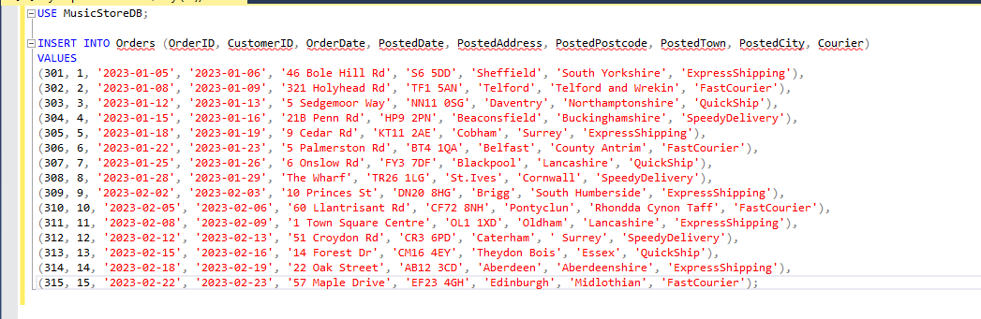
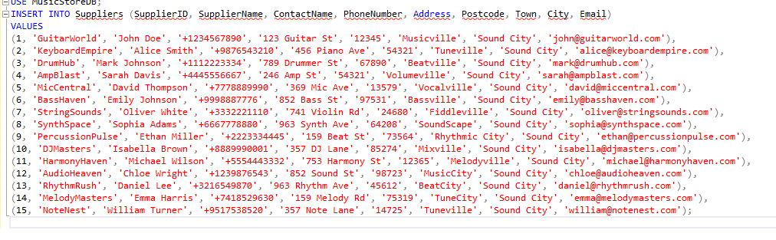

Problem Solving and Documentation

Database Performance Tuning

Potential performance issues

Query Analysis
Examine queries demonstrating slow performance, analyse recurring patterns within them, and scrutinize their execution plans to pinpoint precise performance bottlenecks impacting query speed and overall database responsiveness.

Resource Utilization Monitoring
Monitor system resource utilization, focusing on CPU, memory, and disk I/O, particularly during high activity periods, to pinpoint any potential constraints affecting the database's performance.

Index Strategies Assessment
Study query patterns to identify opportunities for strategic indexing, aiming to boost data retrieval speed and streamline query execution, ultimately improving overall database performance.

Table structure Evaluation
Review table structures to identify opportunities for normalization and optimization. This assessment aims to refine the database schema design, improving performance and more efficient data management.

Solutions

Index optimisation
Implement relevant indexes identified through query analysis to enhance database performance.
Such as:
creating an index on the 'ProductName' column in the 'Products' table to improve speed.
CREATE INDEX idx_Products_ProductName ON Products (ProductName);

Improve Queries
Improve Queries: Refine inefficient queries by eliminating redundant operations and utilizing appropriate JOINs for optimized performance.
Such as: retrieving OrderID, OrderDate, FirstName, and LastName of customers who placed orders by combining the Orders and Customers tables using the CustomerID as a common identifier through a JOIN operation.
SELECT Orders.OrderID, Orders.OrderDate, Customers.FirstName, Customers.LastName
FROM Orders
INNER JOIN Customers ON Orders.CustomerID = Customers.CustomerID;

Implement caching.
implement strategies to cache frequently accessed data, optimizing retrieval speed for improved system performance.

Hardware upgrades
If the system routinely faces high resource usage, consider hardware upgrades as a solution to alleviate this ongoing strain.

Data security and Access Control

Identify Security risks.

Data exposure
Identify the specific sections within the system where sensitive data is either stored or transmitted.

Access vulnerabilities
Identify and analyse potential points within the system vulnerable to unauthorized access or security breaches.

User authorization
Assess the access levels granted to different user roles within the system to guarantee proper authorization.

Proposed actions

Backup
Ensure data integrity and continuous operations through regular backups and a robust recovery strategy.

Encryption
Implement encryption protocols to protect sensitive data at rest and during transmission.

Regular audits
Perform regular security audits to identify vulnerabilities and maintain system integrity.

Access control
Implement a strong access control system that aligns with user roles and permissions, ensuring secure and restricted data access.

Problem Solving and Documentation

ERD

Fields
- ProductID(PK) - identifies each product.
- CategoryID(FK) - Refers to the CategoryID within the Categories table.
- ProductName – shows the name of the product.
- Price – shows the selling price of the product.
- Brand – shows the brand/manufacturer of the product.
- SupplerID – Identifies the SupplierID in the Suppliers table.
- CostPrice – shows the cost price of the product.
- TotalInStock – shows the quantity of the product.

Constraints
- ProductID – primary key restriction to guarantee uniqueness.
- CategoryID – Foreign Key restriction representing the Categories Table.
- SupplierID - Foreign Key restriction representing the Suppliers Table
- Price > 0 – price restriction making sure the price is always greater than zero.

Relationships
- One – many categories table – each product which is linked to one category; however, the category can link to many products.
- One – many suppliers table – each product supplied by one supplier; however, a supplier can supply multiple products.

Systems Architecture
The system architecture consists of the front interface, the backend serves and database which work together for overall functionality. The deployment instructions smooth the path for setup. Scalability ensures that the system’s capacity it managed for heightened user loads and increased demands.

Application
- Frontend – the frontend interface interacts with users and displays information by collecting input data.
- Backend – backend server manages data processing and communicates between the frontend and the database.
- Database – stores and manages all data.

Deployment instructions
- Frontend – deploys code and hosts web application and pages, whilst also configuring the hosting environment for smooth running.
- Backend – set up server environments, make connections with databases and deploys the application code.
- Database – database management sets up schemes, tables, and initial data.

Scalability.
- Database scaling – adjust the database scaling horizontally and vertically depending on the data volume and usage patterns.
- Caching – store frequently used data in memory to be able to retrieve it faster making the load on the database faster.
- Load balancing – distribute traffic across several servers to improve the performance.
- Monitoring – make sure to regularly monitor the performance to improve components which will maintain efficiency.

Security and validation

Security measures
- Firewalls – employ firewall protection to safeguard the database from unauthorized access which works by filtering network traffic.
- Security updates – make sure to do regular security updates to make sure the software and systems are kept up to date with all the latest patches and fixes.

Validation procedures
- Integrity checks – ensure data integrity checks are done to keep the consistency and accuracy of the data correct.
- Input validation – filter and validate user input to prevent SQL injection or any malicious attacks.

Encryption
- Data at rest – make sure to use AES-256 encryption to store data top stop unauthorized access.
- Data in transit – ensure the usage of SSL/TLS protocols to encrypt data which is moved between servers and users’ devices.

User access
- Two-factor authentication – will add an extra layer of protection for the user.
- Role-based access – make sure to assign access privilege to the correct person based on roles such as admin, employee etc. to ensure limit data accessibility.

Authentication
- Multi factor authentication – implementing multi factor authentication will require multiple forms of verification for the user which will make the system safer.
- Passwords – implementing strong passwords requirements will also keep the system safer, such as complexity of the password, adding numbers or special characters.

By using the measures, the Music Store Database will ensure the security, accuracy, and accessibility of the data to the correct authorized people. It will also safeguard confidentiality and the integrity of the both the customer and the business.

Future enchantments
Employing distributing database solutions is very important for both the scalability and the fault tolerance of the Music Store Database. This method distributes data throughout several nodes or severs which then enables:

- Scalability – this will allow the system to be able to handle increased loads by dispersing the workload across many different nodes which will in turn prevent bottlenecking during busy periods. It allowed for horizontal scaling and enables growth.
- Fault tolerance – redundancy among the distributed nodes reduces the risk of loss of data or system failure. If one of the nodes should fail the system will be able to seamlessly use another node making sure the system is always available.
- Data consistency - making sure to keep data consistent across all the nodes will maintain a cohesive database.
- Load balancing – dispersing the data and any processing tasks correctly across the nodes will improve performance and will stop overloading certain nodes which will then ensure the system runs more smoothly and improve stability.

Conclusion
This database will be able to manage instruments, orders, customer information and anything else MelodyHwb may need to add. By implementing the database system created for the assignment it will ensure the smooth and seamless running of their operations even at busy periods.
The database design involves structured tables and relationships created to handle data as well as ways to optimise performance and security enhancements.
With a strategic system architecture, deployment guidelines, and plans for distributed databases, MelodyHwb is well-prepared to meet the dynamic demands of the music retail industry.

