James Dunhill

Software Development

Software Development

Abstract 2
Introduction 2
Part A 3
2.1 Variable 3
What is a variable? 3
Why are variables important in writing programs? 3
2.2 For-Loop 4
Why the for-loop can also be referred to as a counting-loop 4
Example of use it 4
2.3 Array 5
What is an array? 5
An example of an array: 5
Part B 6
3.1 Program 1 - Age & Height 6
3.2 Program 2 - Calculate The Area of The Circular 8
3.3 Program 3 - VAT Calculator 9
3.4 Program 4 - Lucky 7s 9
Part C 10
Program 5 - Matching Card Game 10
Conclusion 10
References 10
Part A 11

Abstract
This report contains information about C programming, and different elements of the language Explained with examples of them being used in a real environment, you will also see that there are programmes made in Visual Studio with documentation on how they were made and explanations to what they do and how they work.

This report here will give the primary reader the understanding of what basic principles of programming are and how they are used to create effective programs that can enhance a user to make there own basic programs. There will be 4 examples of programs made in this report will contain different types of results in the code, to give the uses a different experience at the end of each exercise.

Introduction
Computer programming has become a massive part of everyday life, everything we do in our lives revolves around something to do with computers and to get a real understanding of much computers have become apart of everyday life it can be seen with kids. As the UK average child by the age of 10 will have their smartphone in their pocket‌ [2,3,4]. However, for the kids and us to be able to use these computers and phone to the ease of comfort we have they must be programmed by a developer first.

As progression in future with technology grows more and more with items, we use every day it is clear to see that everything is getting connected to the internet. Our cars have software built into them to allow us to make an update to the system inside the car, to allow for better navigate on maps and even update the control of the car for better efficiency [5].

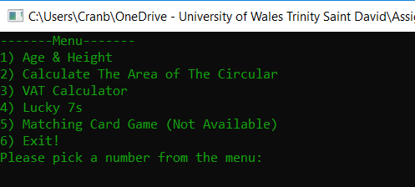
For this developer must learn languages to be able to make the applications that we use, and these languages are computer languages that are a compiled language from machine code into a form of English that humans can understand to write programs [6]. There are lots of different languages that can be used to write programs in some program languages have been around for decades like cobalt and Java.

Part A

2.1 Variable

What is a variable?
Variables are data values that are subject to change when an application is sending an update to replace the old data value with new values that a user may input, or the program might auto-updating from an application. variables are stored in memory locations that are inside the RAM of the system [1].

An example of this would be with a registration form on Facebook, you would sign up with your name, and this would be entered as a variable into a field. Facebook would store your name as a variable and would only change it if you updated your name on the Facebook form, so if you changed your name from Alex to Jake the variable would be updated from the old name to the new name.

Why are variables important in writing programs?
Variables of very important when it comes to writing programs as they are used to Symbolic names that are used for variables standards for any possible values that the program they may wish to input. Variables are the main fundamentals and call property when it comes to program as they are built in to every language there is a variable is a part of program without a variable you will not be able to create any programs as you would not be able to store data and reference it later on everything would have to run constantly without being able to input any data.[1,7]
‌
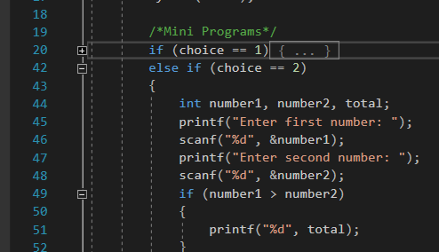
This is a screenshot from is from a project that displays the use of variables, it can be seen used next to the int “int number1, number2, total”. The “number1” is used to store the data from the %d and is the same is done for the “number2”.

2.2 For-Loop

Why the for-loop can also be referred to as a counting-loop
Both for Loops and counting Loops of used and designed to do the same job which is to execute lines of code multiple times until told to stop. A for loop is most commonly found used to repeat a specific section of code x amount of times needed [8]. A counting loop is controlled by an integer that is used from an initial value to count, time is something that the accountant would use to help [9].

The reason why they can be referred to each other is that of the iterations. They both keep looking until they are told to stop whether this be a return in code, or they hit a certain statement which forces them to move onto another block of code.

Example of use it
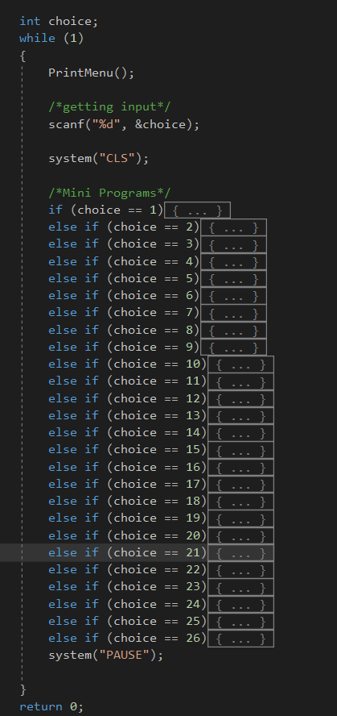
An example of where you could find a loop would be in a small custom menu that was developed while working through some practical lessons, the loop works by creating a menu that allows the user to input a number that will take them to their choice for a mini program.

Once they are done and the mini-program has finished the code would end on a return statement then it will return them to the main menu where they can pick another program, or they can exit the program. This here has been developed and placed inside of the upcoming examples that you will find further into this report. There are 6 options in total allowing for the user to be able to pick one of the 5 programs or exit the program on the 6th buy closing the application completely.

2.3 Array

What is an array?
Array work like variables to a degree, erase all the data in memory locations that can be accessed by the program and updated as well. The differences are that an array can hold multiple data under the same name allowing for 10 entries of data where a variable can only hold 1 entry of data [10]. If any item holds more than one item of data this would be known commonly as a data structure, the data structure is just an array.

Variables have no additional information on them, but arrays have brackets at the end of their name with a number inside this here represents the amount of data the array can hold inside. An example below will show you an array in action and how it is stored differently to a variable.

On arrival start by filling up the first element and then move on to the second one that is empty until it gets to the last one and when it is full.

An example of an array:
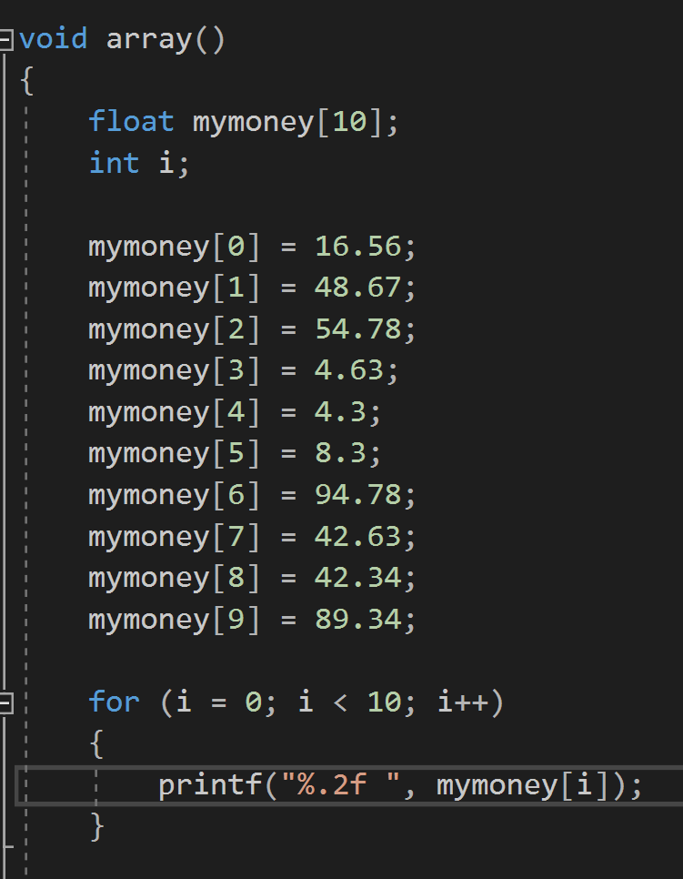
The example here shows you an array that has a value of ten inside, there are ten data entry locations starting at zero as programming starts with a zero instead of a one this is very important to remember when writing out a ring as this can cause problems within the program on its own as well.

At the bottom of the program, there is a for Loop this here shows that it starts off with 0 and then we'll work its way up to 10 which is the limit that it has been set to go up to.

Part B

3.1 Program 1 - Age & Height
This program here allows users to input their age and height as live data into the programme this will then store it into a variable where it can be contained in different ways that a variable can be declared. The three ways that this program has been developed is with using int, char and float as data types.

As explained above there are different types of variables that will need to be used allowing for the user to input their name or require them to import a “char” Setting the character limit to 16 should stop them from flooding any more characters than needed. The height will need to use a “float” “%0.2f” This he will then round up the height of the user to decimal to place allowing for it to be a lot smoother than having loads of digits after.

This program is very easy and didn't take long to make, there was nothing difficult to overcome.

Pseudo Code
int age
char username
float height

print “Welcome Message”
print “name”
scan
print “age”
scan
print “height”
scan

print “All collected data”

Here is a pseudo code showing how the process works with the program.

C Code
int userage; // int value, used to store the user age
char username[16]; // char value, used to store the user name
float height; // float value, used to store the height value

printf("This VAT calculator will add all the values up and then add 20%\n\n"); // prints a welcome message
printf("Please enter your name (Max 16 char): "); //Prints information for user input
scanf(" %s", username); //Scans user input

printf("Please enter your age: "); //Prints information for user input
scanf("%d", &userage); //Scans user input

printf("Please enter your height(M): "); //Prints information for user input
scanf("%f", &height); //Scans user input

printf("Thank You, %s\n", username); //prints out information with the user date outputted
printf("You are %d years old\n", userage); //prints out information with the user date outputted
printf("and you are %0.2f in meters\n", height); //prints out information with the user date outputted

Testing
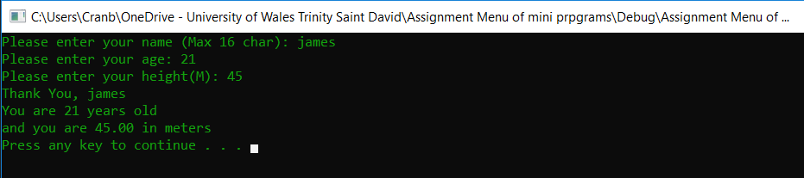

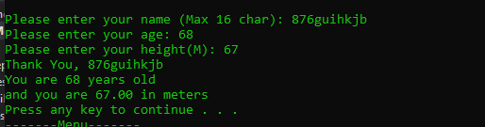
Any value for the name number or letters.

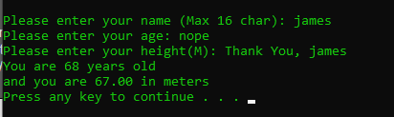
If you enter text in to the age or height field, it will use old data.

3.2 Program 2 - Calculate the Area of The Circular
Creating this program did offer a challenged for trying to work out some of the component, this first part that was trying to get the calculation for the maths as this was a difficult challenge. After plenty failed attempts it works, this was done by putting the calculation in the bottom of the code so it would calculate the end results.

Pseudo Code
float - pi at 3.14
float - radius, base, height
print “circle radius”
scan
print “height of triangle”
scan
print “base of triangle”
scan
print “Message + (pi*radius*radius) - (0.5*base*radius)”

C Code
float pi = 3.1415; // Represents pi to work out the area
float radius, base, height; // Stores the values for the area
printf("Write circle radius: "); //Prints information for user input
scanf("%f", &radius); //Scans user input
printf("Write height of triangle: "); //Prints information for user input
scanf("%f", &height); //Scans user input
printf("Write base of triangle: "); //Prints information for user input
scanf("%f", &base); //Scans user input
printf("Area is equals to %.2f", (pi*radius*radius) - (0.5*base*radius)); // The total is added up and displayed here

Testing

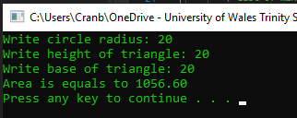

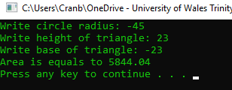
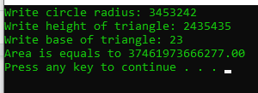

3.3 Program 3 - VAT Calculator
A VAT Calculator had 2 big problems, that was found while developing. The first problem was trying to add up the array, taking all the values from the user input and then adding them up to too give you a number was hard challenge. The next problem was adding the VAT to the total number, this took some time to figure out.

Pseudo Code
float array[5]
vatt = 1.2
i

for = 0 < 5, i + 1
{
print ”price”
scan
}
float sum = 0
for (i = 0; i < 5; i++)
{
sum += array
}
print “message + output”

C Code
float values[5]; //creates array that contains 5 elements
float vat = 1.2; //creates a value for vat at 20%
int i;

for (i = 0; i < 5; i++) // Loops the printf and scanf until it hits the limit
{
printf("Price (%d): ", i + 1); // Prints the messaged for the user and repeats x amount of time needed (5)
scanf("%f", &values[i]); // Takes the user input values
}

float sum = 0; // Store value
for (i = 0; i < 5; i++) // loop for the calculation
{
sum += values[i];
}
printf("Total cost including Vat is: %.2f\n\n", sum * vat); // Total output and message

Testing
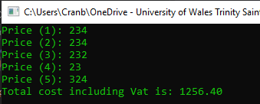

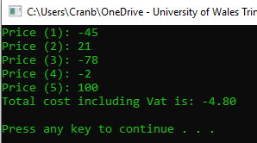

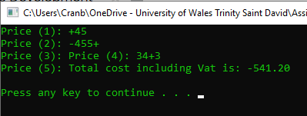

3.4 Program 4 - Lucky 7s
The amount of for, if and else made it hard to and took ages to overcome the errors in getting this to work, the way this was fixed was by having to test this is small pieces and build it up slowly, this made it easy to understand and work with. the other half of this was the trying to make the score system save the points, this was accomplished by allowing the system to save the winning points in to a variable that was made to store the winning.

Pseudo Code
DECLAIR seed, number [3], count, points
loop
{
print “roll”
scan
number [1] = rand
number [2] = rand
number [3] = rand
count - 0
print “output”
for i = 0 to 0< 3
{
for j = 0 to j < 3
{
if
{
continue
}

if number [] equal numbers[]
{
count
}

if count = 0
{
break
}
}

if count is 0
{
print “Your loss”
}
else if (count =1 to ((numbers [0] == 5 to numbers[1] == 5) || (numbers[1] == 5 to numbers[2] == 5) || (numbers[0] == 5 to numbers[2] == 5)))
points+100
print “You have won points”

else if count equal 2
{
points = 2000
print “you won points”
}

else
{
points = 20
print "You won points”
}
}
else
{
print"You lost points”
}
}

C Code
int seed;
time_t tt;
seed = time(&tt);
srand(seed); //Defining RNG seed

int numbers[3];
char choice;
int count;

int points = 0;
while (1)
{
printf("Roll? ");
scanf(" %c", &choice);
if (tolower(choice) != 'y') break;
numbers[0] = rand() % 5 + 1;
numbers[1] = rand() % 5 + 1;
numbers[2] = rand() % 5 + 1;
count = 0;
printf("%d %d %d\n", numbers[0], numbers[1], numbers[2]);
for (int i = 0; i < 3; i++)
{
for (int j = 0; j < 3; j++)
{
if (i == j)
{
continue;
}

if (numbers[i] == numbers[j])
{
count++;
}
}

if (count != 0)
{
break;
}

}

if (count == 0)
{
printf("You lost and your points are now %d\n", points);
}
else if (count == 1 && ((numbers[0] == 5 && numbers[1] == 5) || (numbers[1] == 5 && numbers[2] == 5) || (numbers[0] == 5 && numbers[2] == 5)))
{
points += 100;
printf("You won and your points are now %d\n", points);
}
else if (count == 2)
{
if (numbers[0] == 5)
{
points += 2000;
printf("You won and your points are now %d\n", points);
}
else
{
points += 20;
printf("You won and your points are now %d\n", points);
}
}
else
{
printf("You lost and your points are now %d\n", points);
}
}

Testing

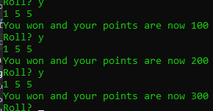
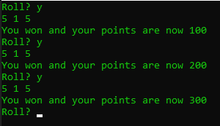
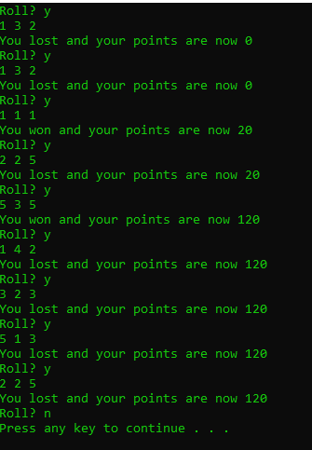

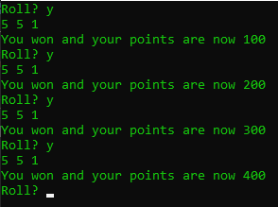
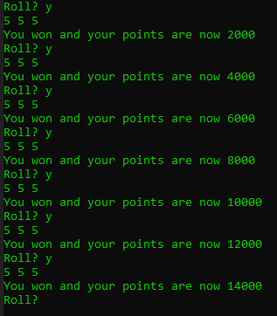

Part C - N/A

Program 5 - Matching Card Game - N/A

- Identify specific problems in completing the exercise.
You may also constrain a problem (simplify it) to produce a simpler solution that may act as a stepping stone to solving the real problem

- Write a clear analysis of the solutions (the thought process behind them) – what logical stages are required. You could use a flowchart or pseudocode.

- Show a C code listing with annotations

- Show testing (screenshots) that clearly demonstrate that the solutions work under all
circumstances.

Conclusion
/* UWTSD - Assignment */
/* Software Development */
/* By James Dunhill */
/* 12/01/2019 */

#include <stdio.h> // printf's and scanf's
#include <stdlib.h> // Random number generator
#include <time.h> // Time measuring
#include <ctype.h> // Changing char value (character like 'c', 'b' or '5') to lower version e.g. 'A' -> 'a'

void PrintMenu(); // Funtion for loading the menu options

int main() // entry point
{
int choice; // This will take the value from the user and open the program
while (1) // This is the loop for the menu so, once a program has finished it will fall back to the menu
{
PrintMenu(); // Calls the menu though a funtion

scanf("%d", &choice); // Taking inputs

system("CLS"); // Requires a liberry

/*List of mini programs running though if statments*/
if (choice == 1) // Program - Name, Age and Height
{
int userage; // int value, used to store the user age
char username[16]; // char value, used to store the user name
float height; // float value, used to store the height value

printf("Welcome Please enter your name to start!\n\n"); // prints a welcome message
printf("Please enter your name (Max 16 char): "); //Prints information for user input
scanf(" %s", username); //Scans user input

printf("Please enter your age: "); //Prints information for user input
scanf("%d", &userage); //Scans user input

printf("Please enter your height(M): "); //Prints information for user input
scanf("%f", &height); //Scans user input

printf("Thank You, %s\n", username); //prints out information with the user date outputted
printf("You are %d years old\n", userage); //prints out information with the user date outputted
printf("and you are %0.2f in meters\n", height); //prints out information with the user date outputted
}
else if (choice == 2) // Program - Calculate The Area of The Circular
{
float pi = 3.1415; // Represents pi to work out the area
float radius, base, height; // Stores the values for the area
printf("Write circle radius: "); //Prints information for user input
scanf("%f", &radius); //Scans user input
printf("Write height of triangle: "); //Prints information for user input
scanf("%f", &height); //Scans user input
printf("Write base of triangle: "); //Prints information for user input
scanf("%f", &base); //Scans user input
printf("Area is equals to %.2f\n", (pi*radius*radius) - (0.5*base*radius)); // The total is added up and displayed here
}
else if (choice == 3) // Program - VAT Calculator
{
float values[5]; //creates array that contains 5 elements
float vat = 1.2; //acreates a value for vat at 20%
int i;
for (i = 0; i < 5; i++) // Loops the printf and scanf untill it hits the limit
{
printf("Price (%d): ", i + 1); // Prints the messaged for the user and repeats x amount of time needed (5)
scanf("%f", &values[i]); // Takes the user in put values
}
float sum = 0; // Store value
for (i = 0; i < 5; i++) // loop for the callulation
{
sum += values[i]; // Taking sum adding the value
//sum = values[0] + values[1] + values[2] + values[3] + values[4]
}
printf("Total cost including Vat is: %.2f\n\n", sum * vat); // Total output and message
}
else if (choice == 4) // Program - Lucky 7 Games
{
int seed;
time_t tt;
seed = time(&tt);
srand(seed); //Defining RNG seed

int numbers[3]; // Ararry to store the three random numbers
char choice; // Stores User Y or N
int count;

int points = 0; //Stores the points
while (1) // Creates a loop
{
printf("Roll? "); //Prints information for user input
scanf(" %c", &choice);
if (tolower(choice) != 'y') break;
//numbers[0] = rand() % 5 + 1;
//numbers[1] = rand() % 5 + 1;
//numbers[2] = rand() % 5 + 1;
numbers[0] = 5;
numbers[1] = 5;
numbers[2] = 5;
count = 0;
printf("%d %d %d\n", numbers[0], numbers[1], numbers[2]); //Prints information from the randomly generated numbers in the array
for (int i = 0; i < 3; i++)
{
for (int j = 0; j < 3; j++)
{
if (i == j)
{
continue;
}

if (numbers[i] == numbers[j])
{
count++;
}
}

if (count != 0)
{
break;
}

}

if (count == 0)
{
printf("You lost and your points are now %d\n", points);
}
else if (count == 1 && ((numbers[0] == 5 && numbers[1] == 5) || (numbers[1] == 5 && numbers[2] == 5) || (numbers[0] == 5 && numbers[2] == 5)))
{
points += 100;
printf("You won and your points are now %d\n", points);
}
else if (count == 2)
{
if (numbers[0] == 5)
{
points += 2000;
printf("You won and your points are now %d\n", points);
}
else
{
points += 20;
printf("You won and your points are now %d\n", points);
}
}
else
{
printf("You lost and your points are now %d\n", points);
}
}
}
else if (choice == 5) // Program - Pair's Game
{

}
else if (choice == 6)
{

}
system("PAUSE");

}
return 0;
}

void PrintMenu() {
/*Displaing on screen*/
printf("-------Menu-------\n");
printf("1) Age & Height\n");
printf("2) Calculate The Area of The Circular\n");
printf("3) VAT Calculator\n");
printf("4) Lucky 7s\n");
printf("5) Matching Card Game (Not Available)\n");
printf("6) Exit!\n");
printf("Please pick a number from the menu: ");
}

Websites Used to Help:
https://www.learn-c.org/
https://www.programiz.com/c-programming
https://www.cprogramming.com/

References
Bibliography

[1]“BBC Bitesize - GCSE Computer Science - Constants, variables and data types - Revision 5,” BBC Bitesize, 01-Jan-2000. [Online]. Available: https://www.bbc.com/bitesize/guides/zc6s4wx/revision/5. [Accessed: 26-Jan-2019].
[2]J. Donovan, “The average age for a child getting their first smartphone is now 10.3 years,” TechCrunch, 19-May-2016. [Online]. Available: https://techcrunch.com/2016/05/19/the-average-age-for-a-child-getting-their-first-smartphone-is-now-10-3-years/. [Accessed: 28-Jan-2019].
[3]J. Howard, “When kids get first cell phone around the world,” CNN, 01-Jan-2017. [Online]. Available: https://edition.cnn.com/2017/12/11/health/cell-phones-for-kids-parenting-without-borders-explainer-intl/index.html. [Accessed: 28-Jan-2019].
[4]G. Harrison, “How old should my kids be before I get them a mobile phone and what is the best way to keep them safe?,” The Sun, 03-Sep-2018. [Online]. Available: https://www.thesun.co.uk/fabulous/5138142/mobile-phone-children-safety-online-age-internet-kids/. [Accessed: 28-Jan-2019].
[5]“How can a software update make a car faster? - The Boston Globe,” BostonGlobe.com, 18-May-2015. [Online]. Available: https://www.bostonglobe.com/ideas/2015/05/18/how-can-software-update-make-car-faster/om0R1W1rLvRbS98xNWJ2WK/story.html. [Accessed: 28-Jan-2019].
[6]K. Bouwkamp, “The 9 Most In-Demand Programming Languages of 2016 - Coding Dojo Blog,” Coding Dojo Blog, 07-Feb-2018. [Online]. Available: https://www.codingdojo.com/blog/9-most-in-demand-programming-languages-of-2016/. [Accessed: 28-Jan-2019].
[7]“Programming - Variables,” Utah.edu, 01-Jan-2008. [Online]. Available: https://www.cs.utah.edu/~germain/PPS/Topics/variables.html. [Accessed: 03-Feb-2019].
[8]“C for loop - w3resource,” w3resource, 14-Apr-2018. [Online]. Available: https://www.w3resource.com/c-programming/c-for-loop.php. [Accessed: 06-Feb-2019].
[9]B. Kjell, “Counting Loop,” Ccsu.edu, 01-Jan-2004. [Online]. Available: http://chortle.ccsu.edu/assemblytutorial/Chapter-18/ass18_10.html. [Accessed: 06-Feb-2019].
[10]“BBC Bitesize - KS3 Computer Science - Arrays and lists - Revision 1,” BBC Bitesize, 01-Jan-2000. [Online]. Available: https://www.bbc.com/bitesize/guides/zy9thyc/revision/1. [Accessed: 06-Feb-2019].
‌

