
APPENDIX GA36c

LEVEL 6 ASSESSMENT SPECIFICATION

Student name: | Ellis Jane Smith | Student ID number: | 1803607
Programme: | Secondary PGCE
Module: | Curriculum Development and Enhancement
Module code: | ECSP7002 | Contribution to Overall Module Assessment (%): | 100%
Lecturer: | Helen Denny | Internal Verifier:
Assignment Title: | Research Study including  Ethics Form | Word count (or equivalent): | 10.000 words in  total including an  Ethics form (to be  given in on  January 11th 2019
Submission deadline: | May 13th 2019 | Return date of provisional marks & written feedback: | June 10th 2019
Submission method: | All written assessments, where practical and possible, must be submitted via Turnitin unless otherwise instructed by the Lecturer. (Please DO NOT put this assessment specification into Turnitin or it will match many similarities with other students’ submissions.)  Alternative submission method (if applicable):  Late submission of the assessment will result in a late penalty mark. Penalties for late submission: Up to one week late, maximum mark of 40%. Over one week late, 0%. Only the Extenuating Circumstances Panel may approve a change to submission dates.
Academic honesty / referencing: | Academic honesty is required. In the main body of your submission you must give credit to authors on whose research and ideas your work is based. Append to your submission a reference list that indicates the books, articles, etc. that you have used, cited or quoted in order to complete this assessment.

Does the use of inference squares aid the ability to tackle PISA style questions?

Table of Contents
Introduction 2
Literature Review 3
School Policy and Practice 11
Methodology 13
Ethics 15
Evaluation 16
Analysis and Results 20
Limitations and Future Development 22
Conclusion 24
References 25
Appendix 1 – Ethical Approval Application 29
Appendix 2 – Pre-test 49
Appendix 3 – Post-test 51
Appendix 4 – Intervention Material 52
Appendix 5 – Results 55

Introduction
The school, situated in the South of Wales, where the research was carried out is a leading school in the pioneering of the new curriculum and one recognised for its participation in educational research. The school is a relatively large mixed comprehensive school, with approximately two thousand pupils, with a very low level of Free School Meal (FSM) pupils compared to the Welsh national average. Only 10% of pupils in attendance at this school come from the most deprived areas in Wales, therefore it can be considered to be an affluent school. As previously stated this school is renowned for their research that develops and evaluates different teaching techniques to be implemented in the curriculum.
The class that was chosen for the research was a mixed ability set of year eight pupils, aged between 12 and 13-years-old. There were only two pupils where English was their second language (English as an Additional Language – EAL) although due to absences and withdrawal of consent, they were not included in the research. In addition there was one dyslexic pupil, but similarly their data was not included in this report due to absenteeism.
The research question that was investigated was whether the use of inference squares aids a pupil’s ability in successfully completing Programme for International Student Assessment (PISA) style questions. This is an area of increasing relevancy in scientific education, as the emphasis on the importance of scientific literacy is mounting. This attention on improving pupils’ scientific literacy skills is one of the fundamental concepts within the new curriculum outlined in Donaldson’s paper (2015) Successful Futures. This prominence being placed on scientific literacy within Wales could be contributed to the importance that media attention has put on the PISA tests conducted by the Organisation for Economic Co-operation and Development (OECD).
Within this report, the definition of scientific literacy will be investigated, along with its links to the current curriculum changes and how scientific literacy can be improved. The research methods will be outlined, as well as an explanation of the sequence of lessons, linking to the literature highlighted. The results and analysis collected will allow for objective conclusions to be drawn. This will be followed by an evaluation of the method, along with the limitations being defined. Then the implications of the restrictions of the research will be considered and suggested improvements for future development of this research will be outlined.

Literature Review
In order to investigate what it means to be scientifically literate and how to improve this skill, firstly a definition needed to be found. This was immediately complicated by the fact that on examination no two academics have agreed on a singular definition.
The term was first used by Hurd (1958), where it was used to describe “as the goal of science education” (Hurd, 1998, p. 408). Which remains still true today, with many still being concerned to ensure that learners are leaving education being scientifically literate (Bybee, 1997; Roth and Barton, 2004; Abell and Lederman, 2007).
One could initially take the meaning of scientific literacy as being linked to literacy; the ability to read and write (Stevenson, 2010) and how you can in turn apply this to scientific context. Hodson (2008) makes the point that without a reasonable level of literacy, pupils would not be able to advance beyond the point of just replication. Norris and Phillips (2003) take this further through their belief that literacy skills are a fundamental component to being scientifically literate, as the ability to comprehend, interpret, analyse and criticise texts are all major skills within science. Osborne (2002) agrees that literacy skills are central to science and that the largest form of interaction with the general public is through scientific texts or journalism, where they can then form opinions or consider the repercussions. This ability to interpret and form ideas is what Osbourne (2002; 2007) and Shortland (1988) believe what it is to be scientific literate, but this does not address subject knowledge.
This leads to the most basic interpretation of what it is meant to be scientifically literate, where it is the ability to understand the science that affects their lives on a daily basis (Roth and Barton, 2004). This definition focuses on the practicality of scientific knowledge and skills, which in turn makes learners and then the general public aware, functional and contributing citizens within the twenty-first century and further into the future (Roth and Barton, 2004).
However, the idea that everyone needs to be scientifically literate could seem impossible or unnecessary (DeBoer, 2000). DeBoer (2000) makes the argument that the level people need scientific knowledge and skills will vary from each person and place, and furthermore that society has and continues to function with citizens of limited understanding of science and technology. This trepidation about the importance of everyone being scientifically literate is mirrored by Nodding (1992), who believes that experts within their own fields tend to exaggerate the importance of their own subject to others and claim that a fully comprehensive knowledge is vital for everyone.
From this, it is evident that the need for everyone to have the same abilities when it comes to scientific literacy is not a necessity, but there is a need for some people to be more capable than others, so therefore how do we ensure that future scientists are not disadvantaged by this?
Roberts (2007) proposes that scientific literacy has two separate visions and builds upon the before mentioned idea that the general public should know about the science that affects their everyday lives, while ensuring that future scientists are not disadvantaged.
The first vision focuses on knowledge within science and is specifically aimed at ensuring that there is an understanding of the processes and concepts within science (Roberts, 2007). This idea grows on the concern that expertise is required and ensures that there are always experts within fields of knowledge. The second vision focused on scientific context and therefore the scientific components to situations that the general public experience, a more functional scientific knowledge (Roberts, 2007). This vision echoes the belief that people need to be aware of the science that affects their day to day life within the twenty-first century (Roth and Barton, 2004). These two visions have contrasting ideals of what scientific literacy is, but both should be used together within curriculums and assessment development for it to be successful and beneficial (Roberts, 2004).
Within the review by Haglund and Hultèn (2017), they concluded that Roberts is more positive about vision two than its counterpart, with regards to Roberts’s ambition for everyone to be able to make informed decisions due to science. The preference towards vision two could be due to when vision one is implemented into practice, it leads to a more traditional assessment-based curriculum, whereas vision two leads to a merger where the previous vision still holds a place within the curriculum (Aikenhead, 2007).
Additionally, Haglund and Hultèn (2017) bring to light the lack of consideration of critical thinking on scientific discoveries and the effects of society. Work by Sjöström et al. (2016) and Osborne (2007) calls for the needs of the educational system to include socio-critical perspectives of scientific issues so that both professionals and the general public can understand the consequences and complexities of the world that we inhabit. The main notions of Sjöström et al (2017) are based on the idea that “the modern world be described as a globalized risk society” (p. 321), where there is an increasing difficulty in navigating the consequences of scientific and technological innovations to the environment and society. Some academics, such as Hodson (2003) take it further and cry out that current curriculums don’t address the needs and aspirations of the future generations, to produce both scientific and politically literate people, who are fit to deal with current social and environmental concerns. Zeidler (2007) believes that a more inclusive version of Roberts’ (2004) vision two, where moral and ethical reasoning is also considered along with the awareness of the effects of science on the environment and society.
From this, it is again further evident that simply two main focuses to scientific literacy is not enough and that more needs to be considered than purely knowledge and awareness. That within current concerns over the environment and consequences of scientific advancements, a level of perspective is required for us to navigate through these issues.
The idea that there are three areas to scientific literacy is shared by Durant, who defines the three areas as breadth of knowledge, understanding and the ability to explain, reason and think critically (Durant 1994). A breadth of knowledge ensures that there is sufficient scientific content known; however, Durant (1994) believes that having a comprehensive knowledge of scientific concepts is not the same as having a high understanding of science. Which is where the second area comes in, as knowing something is not acceptable and the ability to understand it practically and explain it is more valuable (Durant, 1994).
The third part that Durant discusses is the link of science and social practice (Durant, 1994). What this looks at in particular is societies view of scientists and attitudes towards science, and how without critically looking at or being aware of the scientific process of hypothesis, testing, publication, peer reviewing before general acceptance. This third idea of scientific literacy has similarities between Haglund and Hultèn (2017) and Sjöström et al (2017) work, identifying the need of the addition of critical thinking within scientific literacy. However, what is distinct in Durant’s (1994) idea is the required understanding of the scientific method or process, which is something that Durant believes that the general public lack. Furthermore, Durant holds the opinion that formal education is partly to blame for this and a more inquiry-based science education is ideal, where there is exposure to the curiosity, sense of discovery alongside the scientific process.
These three areas reflect the opinions explored before and take a much more realistic and current approach to the idea of what scientific literacy encompasses, which has direct links to how the curriculum is changing in Wales. In Donaldson’s Successful Futures (2015) he suggests that there should be six learning areas each having its own rationale. The rationale for the learning area, science and technology, where there is an explicit reference to encourage pupils’ curiosity to think and investigate, along with the ability to understand and explain to others (Donaldson, 2015). There is also mention of pupils being able to be conscientious of the impact of science and technology on society and the environment (Donaldson, 2015). This format for a new curriculum has direct links to integral parts of what is to be scientifically literate. With the pupils being aware of not only the scientific process, but knowledge and understanding of the natural, physical and technological world around them.
This shift within the educational system in Wales from the traditional science education to a more holistic, inquiry-based learning is discussed by academics and it seems that it will have a general positive effect. Roth and Barton (2004) criticise the current educational system for the “insist[ance] that we acquire specialised knowledge about the world that is simply inaccessible to our experiences” (p.4). So, taking a step back to look at practical, real-world experiences allows pupils to be aware of how the world works around them. Sjöström et al (2017) discusses the importance of pupils being able to critically engage with scientific topics, looking at the consequence or effect it has on the environment or people. This is again a crucial part of the learning awareness that Donaldson has proposed in the new curriculum (Donaldson, 2015).
An additional part of Donaldson’s proposed curriculum that reflects partly on the current Welsh programmes and a component in being scientifically literate is the Education for Sustainable Development and Global Citizenship (ESDGC). Within Donaldson’s curriculum, there are four purposes underpinning the whole curriculum, one of them being the pupils should be ethically informed (Donaldson, 2015). In the scientific context, this means that pupils should be able to use information to make informed decisions or opinions that have impacts on other people or the environment. To engage in critical thinking and being aware of concepts such as sustainability and other peoples’ cultures or beliefs when all play a significant part in what it means to be scientifically literate. This directly links to what academics such as Haglund and Hultèn (2017), Sjöström et al (2017) and Durant, (1994) believe that are key features of scientific literacy.
There is some criticism to the proposal of Donaldson’s new curriculum and the move away from a traditional curriculum. The trepidation is mainly over the concern that although knowledge of a topic does not always mean that a pupil has a good understanding; it is still an essential part of being able to progress and develop (Newton, 2018). As without pupils reaching a recognised level of achievement, they may not have the opportunity to experience higher education or certain careers (Newton, 2018). Within his report, Donaldson shows an aversion to a proscribed and accountability-based curriculum, due to the damage that it can have on pupils’ learning. However, as stated by Lemek and Zhu (2018), the curriculum that is laid out in the report is proscribed and driven by accountability. Lemak and Zhu (2018) believe that the curriculum proposed is more attuned for developing business skills, rather than the supposedly critical thinking and rights-based learning. They believe that the previously thought of progressive curriculum, is still in line with England’s education system, being market-driven, and ignores other research that demonstrates that learning and teaching is damaged with increasing accountability (Lemek and Zhu, 2018).
The push for the curriculum to ensure that the pupils that are leaving are scientifically literate, could be accounted for from the emphasis that the Welsh Government has placed on improving the scores of scientific literacy in international testing. Which also could be a contributing factor as to why the new curriculum seems set towards a more business-based, accountability approach, as believed by Lemek and Zhu (2018). The Program for International Student Assessment (PISA) is a test set out by the Organisation for Economic Cooperation and Development (OECD), with numerous countries participating every three years (Bybee, 2012). The OECD measures the competencies of 15-year-olds in the three domains: reading literacy, mathematical literacy and science literacy, with one being the main-focus each year (Bybee, 2012). In 2009, Wales performed the worst out of the countries that make up the United Kingdom in all three domains, and significantly worse than the OECD average (Bradshaw, 2010). This led to a flurry of media attention that negatively portrayed Wales in headlines such as PISA Tests Show Students in Wales Falling Behind (BBC Wales, 2010) and PISA Ranks Wales’ Education the Worst in the UK (BBC Wales, 2013). This media coverage is linked to the implementation of the Literacy and Numeracy Framework (LNF) becoming a statutory requirement in September 2013 (Welsh Government, 2013). The LNF was a national programme to replace the Skills Framework, in raising the outcomes of pupils’ in the annual test of Year 2 to Year 9 pupils (Dauncey, 2013). However, in 2012 Wales remained the worst in all three domains compared with their United Kingdom counterparts and the OECD average (Jerrim and Shure, 2016).
Within the report carried out by the National Foundation for Educational Research (NFER) (2015), the analysis was done to pinpoint areas that Welsh pupils are struggling in and spot any trends. Within this paper, it is noted that learners find it quite difficult to link the given information to other information within the question (National Foundation for Educational Research, 2015). Alongside this, there was also an identification of Welsh learners struggling with questions that had lengthy introductions, which was suggested to be caused by the learners not being familiar with solving real-life situation questions, which are prominent in PISA (National Foundation of Educational Research, 2015). It was suggested by that there should be more emphasis within the classroom to let the pupils engage in real-world problems, to help pupils deal with PISA style questioning (National Foundation of Educational Research, 2015).
This highlights the needs for Welsh learners to have improved scientific literacy, as one of the core concepts within scientific literacy is to be able to understand the science around them, which affects their everyday lives. This need has been recognised by the Welsh Government, who as a result have created a variety of resources that are available on the online website Hwb, which is an online resource that all schools in Wales have access to. The resources available are tailored towards pupils using their knowledge of science and applying it to the real world, with consideration to the effects and consequences. This is in line with the LNF (Welsh Government, 2013), ESDGC (Welsh Assembly Government, 2008) and Donaldson’s four purposes (2015).
In searching for additional material to support improving pupils’ scientific literacy, in addition to example material on Hwb, the author found out that there is a lack of material or reports suggesting appropriate techniques or sources that improve or support pupils in scientific literacy from the Welsh Government. This led to a search of academic literature, where opinions such as Dale’s (2016), who believes that even though there is such an emphasis placed on science and scientific literacy for pupils, whilst there is not adequate practice within schools. Dale (2016) also believes that during education reforms too much importance is placed on literacy and numeracy skills, and that this leaves limited time and focus on science education. This is complicated even further by the debate over which is the best way to improve scientific literacy (Dale, 2016).
However, there is some research that states that a pupil being aware of their own thinking, metacognition has a significant role in improving the ability to engage in reading science texts (Glynn and Muth, 1994). Metacognition is highlighted by Choi et al. (2011) as a crucial part of improving scientific literacy skills, as they will be able to interpret new information or be aware when they require additional information. Choi et al. (2011) view is that scientific literacy should also include people abilities to make appropriate decisions with justification in terms of the ever-changing and developing scientific world, the sustainability of the planet and protection of peoples’ rights. Avargil et al. (2018) states that metacognition is so vital to science education that it should be implemented at a very early stage and continued through to higher education.
Although there is not much research about an alternative method to improve scientific literacy, research by Gucluer and Kesercioglu (2012) suggests that engaging in activities that develop scientific literacy increases pupils’ achievement in scientific literacy. It can therefore be assumed then that any activity that is aimed at improving scientific literacy, could within reason have a positive effect, but hopefully will not negatively impact the learner.

School Policy and Practice
The school that the research was conducted at has taken on board all of the suggestions from Donaldson’s report Successful Futures (2015), as they are a pioneer in trialling their own brand of the new curriculum. They have adopted the six learning areas, with the four purposes underpinning all the learning and there is full integration of all the Welsh Government programmes such as the Literacy and Numeracy Framework (LNF), Digital Competency Framework (DCF) and Educational for Sustainable Development and Global Citizenship (ESDGC). There are clear references made with each of the learning areas’ schemes of work, so that as many of the criteria can be met at a time.
Within the learning area, science and technology, the importance that is placed on PISA questions is prominent, with each end of topic test including a PISA style question for years 7 to 9. In lessons, there is the chance for pupils to guide their own investigations, within certain respects, and to engage critically with scientific issues or developments. However, there are no strategies or resources in place to help increase pupils’ ability in scientific literacy apart from engagement within the curriculum, even though the school is renowned for their work in educational research. Additionally, there is no major effort in place to improve literacy and numeracy skills within the science subject area, only engagement with tasks that are literacy or numeracy rich. Where the emphasis is on pupils’ oracy, writing or numeracy skills in order that progression marks can be obtained by the pupils.
This lack of effort in place to improve pupils’ scientific literacy could be taken as understandable, since the priority here remains the subject content, not improving pupils reading or writing skills within science lessons. However, there is a level of hypocrisy in the insistence of the use of PISA style questions in the end of topic tests, although there is nothing in place to actively improve pupils’ performance apart from exposure to PISA style questions in end of topic tests and the insistence of literacy and numeracy rich tasks within science.
However, within other learning areas, there are resources put in place to improve pupils’ literacy and critical thinking skills that were not evident within science. Although they are considered crucial components to be scientifically literate, and the pupils would of already have been familiar with them.
In the English area of learning, there were resources that were used across all years such as the PEE structure to writing, which could aid pupils in forming and building arguments or opinions or engaging in critical thinking. In the Humanities area of learning, there were further resources to aid in pupils’ critical thinking, which worked closely with that which was being used in the English department. One example was inference squares, where the learner engaged with an image or text and was asked to look at what they can find out from the image/ text, what they already knew and what they could in turn infer.
The use of such resources or techniques within other areas of learning led the author to use inference squares as the basis to the research in this paper. In order to examine if such resources could be altered and used in science, so there is more continuity and a positive effect on the pupils, and ideally their scientific literacy skills.

Methodology
In this report the author conducted action research, investigating the benefits of using inference squares in the comprehension and success in PISA style questions. The aim of this research was to choose and enact research on an area that is prominent within the author’s area of specialism, but also in developing and improving their teaching practice. As described by McAteer (2013), action research is a key method in reflecting upon one’s own practice and ways to improve. This process is ideally a cyclic process, where initial action is informed by research, which then informs further actions (Kemmis and McTaggart, 1981). However, the method of how this research is carried out needs to be discussed before the analysis of results and reflection on practice takes place.
The format of this research follows the simple structure of an initial pre-test, to investigate and gauge prior ability, followed by an intervention, closing with a post-test, determining the beneficial, null or adverse effects of the intervention. This method uses quantitative data to measure the effects of the inference squares on the pupils by direct comparison of the pre and post-test results. This is beneficial, as the results analysis will be objective without influence by the opinions of others (Carr, 1994; Antonius, 2003). However, in being objective and unaffected by opinion, it limits the responses of the participants, in that they are not able to explain or express their reasoning or choices (Carr, 1994). Therefore, caution needs to be considered when assumptions are made that could be linked to the reasoning behind the participants’ choices. There is another fault with this method style; which is if the authors own opinions on the topic being investigated can cause bias conclusions to be drawn, with other aspects being forgotten or ignored (McLeod, 2017). This limitation is linked to the major assumption that what is being measured is an actual fixed and measurable concept, and does not allow for any consideration that the participants are real people, who are affected by unknown external factors that are out of the control of the researcher. (Minichiello, 1990).
Additionally, another limitation of this method should be considered in the conclusion of this research, which is, this method requires large sample sizes (Denscombe, 2010). As without a sufficiently large sample size, the results collected could be unreliable, and therefore any conclusions made could possibly be incorrect (Denscombe, 2010). This does bring up a concern, since this research was conducted using a maximum of 31 participants within a classroom setting.
However, two of the reasons as to why this method was picked and used, even after the consideration of its drawbacks, is that this style of method is becoming increasingly more prominent in education research and recognised and used by Governments (Brady and O’Regan, 2009, McAteer, 2013). Also research such as this is becoming more noticeable and relevant within the teaching profession, with teachers, and for professional development (McAteer, 2013). Secondly, with a format of the pre and post-test, where the questions remain the same allows for the direct comparison of results. This facilitates that the possible benefit of the inference squares can be directly measured, and conclusions drawn.
The intervention between the two tests will be underpinned with as much practice of a variety of PISA questions to ensure that they have enough time and that the support is slowly taken away. The amount of time that is required for a new skill to be learnt is very dependent on the time spent on it, with more time linked to more learning (Singley and Anderson, 1989). As providing pupils with more time allows for enough time for them to process the information (Bransford et al., 2000), leading to the idea that learning cannot be rushed (Pezdek and Miceli, 1982).
Also, throughout the intervention the format will be the author modelling the solutions initially, then going on to scaffold, and then finally removing all support and having the pupils independently working through questions on their own. This will also include many opportunities for group, small and one-on-one discussions. This method of teaching follows a procedural facilitation model, which is praised for aiding problem solving and comprehension (Baker et al, 2002). Where the questions in the inference squares are used to guide and prompt the user to better tackle the PISA style questions (Baker et al., 2002).

Ethics
In line with the university procedure, an ethics form was sent for approval by an ethics committee before the research could be conducted. This form outlined the method, ethical implications and precautions that the author took to ensure that best practice carried out. One of the core guidance documents that was used was the British Educational Research Association (BERA) (1992) ethical guidelines for educational research, which provides guidelines for educational researchers, so that the participants’ privacy, dignity and autonomy is respected.
After ethical approval was granted, the author outlined to the participants the research that was to be conducted. Within this, it was highlighted to the participants that they had the right to withdraw their data from the research at any moment. It was also explained that all data used would be made anonymous and kept securely until the write up was complete, then destroyed securely. The data was kept confidential through the use of an encoded memory stick, with only the author able to access the information, which was in accordance of the University of Wales Trinity Saint David’s data management guidelines and the data protection act. Although the risks from this research were minimal, all efforts were made to limit or prevent any undesirable effects or outcomes.
Further details can be found in the application for ethical approval, which is located in Appendix 1.

Evaluation
Due to the lack of materials about how to improve scientific literacy, the author focused on the impact that inference squares, a resource used in other learning areas. This is because the ability to break down, extract relevant information and synthesise ideas is an essential component in scientific literacy and in answering PISA style questions.
The more common format of an inference square is three concentric boxes with the questions: what can you see, what do you know and what can you infer? This format is ideal for analysing images or text, but to ensure that they are suitable for use in PISA style questions, they needed to be altered. The new format that was chosen was a flow diagram of three boxes, each box addressing its own question. The first box addresses the question that is being asked, to ensure that the user understands what is being asked of them, so to help reduce irrelevant information in the answer. This is also useful, as the questions asked in PISA style questions could be considered as ambiguous or slightly misleading, if not properly analysed. The second box is very similar to the original layout, asking what information can you get from the question? This is slightly different as this is focusing on the participants' ability to take and infer from information given, not to test subject knowledge. The final box is what can be inferred from the information given? This box starts to get the participant to link the information that was given, what is being asked and what can you infer from this or the absence of information. This method of breaking down a question is in line with metacognition, specifically procedural facilitation, as these boxes break down the problem to aid finding solutions (Baker et al, 2002). Figure 1 shows an example of the inference squares used in the research and within the post-test.
What information can you get from the question?
What is the question asking?
What can you infer from the information?
Figure 1: Example of the inference squares used in the research.
The unfamiliar format of this inference square could have had an impact on the participants’ acceptance of the resource. In that, although they may have used inference squares in other subject areas, this varied format and altered questions could have made them less likely to engage in using them. Due to the restricted time scale, the inference squares were not able to be redesigned after focus groups with pupils, to make them more helpful and comprehensive. Further discussion over this will continue in the limitation and future development section of this report.
The tests included past year questions from the OECD PISA test, specifically the questions focusing on scientific literacy. The questions that were chosen focused on the participants’ skills in reading comprehension and making judgements from the information given to them within the question. Every effort was made to ensure that the topic areas of the questions where topics that the participants would have engaged with recently, so that they were still relevant to their current learning.
The full pre-test can be found in Appendix 2.
The research took place over four lessons, each one hour in duration over a time period of two weeks. As briefly discussed in the ethics part of this report, the research was outlined to the participants, along with the clear statement that they had the right to withdraw their data from this report at any time. Seven of the participants made the author aware of their withdrawal before the research was conducted; alongside the eight people who were absent for the following four lessons. This was not ideal, as the initial participant sample numbers dropped from thirty to fifteen. This alongside the use of quantitative data, which was outlined previously to require large sample sizes to make the results reliable, means that caution needs to be taken when conclusions are drawn from the results.
The participants then had 45-minutes to complete the pre-test, which included four questions that were relevant to the topics that the participants were learning about currently. However, as formerly noted the questions were looking at comprehension and application, not subject knowledge. The participants were asked to complete this task in exam style conditions, which was not adhered to. Throughout the test, participants talked to one another even though participants were moved around, so that they were more spread out, to discourage talking. It was noted that the participants finished at significantly different times and that an additional task for completion such as a puzzle would be an appropriate tool in ensuring that finished participants remained quiet whilst other participants finished the pre-test. The test papers were collected and marked, ready for the next lesson, where the intervention would start, and participants were introduced to inference squares.
In the first intervention lesson, participants were introduced to the idea of inference squares. This was done by initially going through the three distinct boxes and ensuring that they understood the meaning and purpose of the boxes; as a tool to help break down a question into manageable chunks, so to aid extracting and inferring information. The last question from the pre-test was used as the first example and the use of the inference squares, which was followed through as a whole group, step-by-step. Time had to be taken to ensure that the language being used was understood, the term ‘inference’ was unfamiliar to many, alongside some of the other language within the questions. This could be due to the fact that the PISA questions used are aimed at 15-year-olds, and the participants were between the age of 12 and 13. This point and its effects will be further reflected upon in the limitations and future development section of the report. One more question was completed will the participants, engaging and guiding the discussion as the whole class worked through the question together. The questions chosen were again looking at the participants’ comprehension and reasoning abilities, not content knowledge, but were again topics that they would have been familiar with. The questions used throughout the intervention lesson can be found in Appendix 4.
The second lesson was wholly dedicated to the participants working more independently with the inference squares and further PISA style questions. Time was given to the participants to work on one question at a time, with a whole class discussion over the reasoning over decisions or inferences made. Unfortunately, there was again a level of disengagement from some participants that in turn distracted other participants off task. This could have had a negative effect on the participants full understanding of how to use inference squares for PISA style questions.
The post-test comprised of the same four questions as the pre-test apart from the last question which was omitted. This is because the question had been gone through with the participants in the intervention lessons. All participants were given multiple copies of the inference squares, so that there was a sufficient amount for all questions, along with spares should they be required. There was an additional task ready for participants once they had finished the test, following the suggestion from the pre-test. This, however, did not make much of an impact in ensuring that all participants were focused and on the task, with many participants again being distracted, talking and not engaging.
Unexpectedly, many of the participants did not use the inference squares provided. This had major implications in the results that were collected, as the research was to measure the effect of the inference squares on the ability to answer PISA style questions. So, it was additionally noted which of the participants used the inference squares in the post-test along with the accompanying test results.

Analysis and Results

For the analysis of the results, the percentages of correct and incorrect answers were directly compared to see the overall effect of the inference squares. There are also comparisons of the participants that used the inferences squares alongside with the post-test.
Figure 2 shows the direct comparison of the pre and post-test for all the participants that consented to be included in the research. It shows the percentages for each question individually so that the variation from pre and post-test for each question can be shown.

Figure 2: Comparison of the individual question within the pre and post-test for all participants.

As shown by Figure 2, there was a general increase in the scores from the pre and post-test, with a decrease in the scores for question 2a. This increase could be due to familiarity with the questions, as the pre and post-test questions were the same. Therefore, it could just be a natural increase in scores due to the repetition.
This comparison is not a valid one. This is due to only three participants out the fifteen using the inference squares in the post-test. Which led to the separate analysis of only the participants that used the inference squares in the post-test. This is shown in Figure 3, in the same format as Figure 2.

Figure 3: Comparison of the results of the participants that use inference squares in the post-test.

In Figure 3, it is clear again that there is a general improvement, with question 2a results not changing from the two tests. When this graph is compared to Figure 2, again this can be attributed to familiarity of the questions.
It is vital to note that participant K overall did not improve, due to getting full marks in both the pre and post-test. However, the other two participants that used the inference squares saw a significant improvement in their responses. As they both only got 25% correct in their pre-test, with one getting 100% and the other 50% in their post-tests. It could then be concluded that the use of inference squares is beneficial when used alongside PISA style questions. But it would be unjust to make such a conclusion since the sample size was extremely small to begin with, and then further diminished by not all participants using inference squares.
It is also not considered that there could have been external factors along with bad behaviour that could have affected the results of each participant. This is one of the constraints that comes with using quantitative data, where the participant is not able to explain or show their reasoning behind decisions. So, any speculation regarding the reasoning behind participant’s choices would be complete conjecture. Additionally, within this research there is no consideration of pastoral issues with participants which could have had an effect of their performance in both of and/ or just one of the tests. This could have been the reasoning behind the bad behaviour that manifested itself throughout the research process.

Limitations and Future Development

Within this research there were many limitations, therefore conclusions made from the data collected needs to be viewed objectively. One of the major limitations of this research activity is the sample size. It was discussed in the methodology section about the importance of large sample sizes to allow for the quantitative data to be reliable. Unfortunately, the number of participants that exercised their right to withdraw, along with absences, resulted in an extremely small sample size. Additionally, this was made more complicated by only three of the fifteen participants using the inference squares in the post-test.
It should be noted that the limited sample size was due to the nature of the research. As this was an action research project that would take place in the classroom, identifying an area that needs improvement within the author’s specialist subject area of science. Due to this, there were several restraints along with the sample size. One of the other major restraints to this research was the time scale, the research could take no longer than six lessons, even though the research carried out related to the pupils’ work. This has a significant impact on the embedding of the resource during the research, as the time scale by the nature of the type of research was highly lacking.
Therefore, for the future development of this research, it would be highly beneficial if this research could take place over a significantly longer period of time with the participation of more participants. Potentially testing the progress of participants in numerous tests throughout a year, would allow for a more comprehensive view of the improvement of inference squares. Additionally, having a variety of participants from a wider range of abilities, of an ideal age range would again hopefully increase the reliability of the conclusion that could be drawn from this research.
It should also be recognised that PISA style questions are aimed for testing literacy, numeracy and scientific skills of 15-year-olds. This research was conducted using pupils between the age of 12 and 13-years-old, which was due to limitations of available and suitable classes to use in the research. Therefore, the language and the maturity of it could be out of the scope of the pupils involved, resulting in the questions used being beyond their ability. However, it should be noted that in the School Policy and Practice section of this report, it was highlighted that the school where the research took place used PISA style questions within their end of topic test in the science. Which would mean that the pupils used in this specific research should have been familiar with or aware of this style of questioning. If this research was to be taken further within other schools, significant consideration would need to be taken as pupils could have never been exposed to such a specific style of questioning. This could be in the form of the introduction of such questions into the department, lessons, or by ensuring that the age of the pupils engaging in further research are of a suitable age.
The inference square used in the research was the first version of this resource, which as discussed in the evaluation could have been a further cause of the lack of use of inference squares along with lack of embedding. Where the inference squares could have been improved through the use of focus groups to ensure that the squares are user-friendly and appropriate for their intended use.
It is then suggested that this research could have been improved through more consideration and development with the pupils to ensure that they were tailored for the pupils and easy to use. Therefore, a series of sessions developing the inference squares with either other professionals or pupils to ensure that the subsequent or final versions of the inference squares will be even better suited to the role of helping improve pupils’ ability to deal with PISA style questions. By doing this it would further investigate the benefits of inference squares, in other contexts with larger sample sizes.
For future development, the use of a control group could also be considered to see if there is a natural improvement in the performance of the post-test due to familiarity with the questions. However, there will need to be considerable ethical consideration to be taken in the use of control groups, so to ensure that the participants in the control group are initially disadvantaged and then subsequently taught how the use inference squares as well.

Conclusion
From the results collected in this research, it is unclear whether the use of inference squares influenced the users when engaging in PISA style questions remains unanswered. This is mainly due to the restrictions of this research in terms of the sample size, time scale and the primitiveness of the inference squares used. All the factors identified that have negatively affected this research process highlight key components that need improvement in the future development of this research. Also ensuring that the age of the participants is suitable for the language in the PISA style questions is imperative, as this was brought up as being a potential drawback, even though the participants of this particular research should have already been exposed to such questions due to the school practice. The time scale again would have been more beneficial if it could have been extended to a longer period, so that the resource could have been embedded into normal classroom practice, and therefore familiar and more likely to be used by participants. Also the sample size as previously discussed was out of the control of the author, though the implementation of this over several different classes and abilities would hopefully improve the reliability of future conclusion. Although the inference squares were not based on previous research, as the author was unable to find literature that outlined the use of them in science; the inference squares used in this research where the first version of them, and therefore could benefit from further development with the input of focus groups.
This research could be a new line of inquiry in how to improve pupils’ ability to tackle PISA style questions, which have become more prominent in the Welsh education system and within the world of scientific literacy. This is justified further by scientific literacy being an area that is growing within science education, with a very limited number of solutions in place at this time.

References
Abell, S. and Lederman, N. (Eds.) (2007) Handbook of research on science education. Mahwah, NJ: Lawrence Erlbaum.
Aikenhead, G.S. (2007). Expanding the Research Agenda for Scientific Literacy. Paper presented at the Linnaeus Tercentenary 2007 Symposium “Promoting Scientific Literacy,” Uppsala University, Uppsala, Sweden (May).
Antonius, R. (2003). Interpreting quantitative data with SPSS. Sage.
Avargil, S. et al. (2018) Students’ metacognition and metacognitive strategies in science education. In Cognition, Metacognition, and Culture in STEM Education Springer, Cham. pp. 33-64.
Baker, S. et al. (2002). Procedural Facilitators and Cognitive Strategies: Tools for Unraveling the Mysteries of Comprehension and the Writing Process, and for Providing Meaningful Access to the General Curriculum. Learning Disabilities Research & Practice. 17(1) pp. 65 - 77.
BBC Wales (2010) Pisa tests show students in Wales falling behind. 7 December. Available at: http://www.bbc.com/news/uk-wales-11930257 (accessed 5 May 2019).
BBC Wales (2013) PISA ranks Wales’ education the worst in the UK. 3 December. Available at: http://www.bbc.com/news/uk-wales-25196974 (accessed 5 May 2019).
Bradshaw et al. (2010) PISA 2009: Achievement of 15-year-olds in Wales. Slough: NFER.
Brady, B. and O’ Regan, C. (2009) Meeting the Challenge of Doing an RCT Evaluation of Youth Mentoring in Ireland: A Journey in Mixed Methods. Journal of Mixed Methods Research, 3(3), pp. 265–280.
Bransford et al. (2000) How people learn. Washington, DC: National academy press. 1(11).
British Educational Research Association (1992) Ethical guidelines for educational research. Southwell, BERA
Bybee R.W. (2012) Scientific Literacy in Environmental and Health Education. In: Zeyer A., Kyburz-Graber R. (eds) In Science | Environment | Health. Springer, Dordrech
Bybee, R. (1997) Achieving scientific literacy: From purposes to practical action. Portsmouth, NH: Heinemann.
Carr, L. T. (1994) The strengths and weaknesses of quantitative and qualitative research: what method for nursing? Journal of advanced nursing, 20(4), pp. 716-721.
Choi et al. (2011) Re‐conceptualization of scientific literacy in South Korea for the 21st century. Journal of research in science teaching, 48(6), pp.670-697.
Dale, Gemma Joanne (2016) The Current State of Scientific Literacy in Wales. PhD thesis, Prifysgol Bangor University.
DeBoer, G.E. (2000) Scientific literacy: Another look at its historical and contemporary meanings and its relationship to science education reform. Journal of Research in Science Teaching: The Official Journal of the National Association for Research in Science Teaching, 37(6), pp.582-601.
Denscombe, M. (2010) The Good Research Guide: for small-scale social research. McGraw Hill.
Derek Hodson (2003) Time for action: Science education for an alternative future, International Journal of Science Education, 25:6, 645-670.
Donaldson, G (2015) Successful futures: Independent review of curriculum and assessment arrangements in Wales. Wales, UK: Crown.
Durant, J. (1994) What is scientific literacy? European Review, 2(1), 83-89.
Glynn, S.M. and Muth, K.D. (1994) Reading and writing to learn science: Achieving scientific literacy. Journal of research in science teaching, 31(9), pp.1057-1073.
Gucluer, E. and Kesercioglu, T. (2012) The Effect of Using Activities Improving Scientific Literacy on Students' Achievement in Science and Technology Lesson. 1(1), pp.8-13.
Haglund, J. and Hultén, M. (2017) Tension Between Visions of Science Education. Science & Education, 26(3-4), pp.323-344.
Hodson, D. (2008) Towards scientific literacy: A teachers' guide to the history, philosophy and sociology of science. Brill Sense.
Hurd, P. D. (1958) Science literacy: Its meaning for American schools. Educational Leadership, 16, pp. 13–16.
Hurd, P.D. (1998) Scientific literacy: New minds for a changing world. Science Education - SCI EDUC. 82, pp. 407-416.
Jerrim, J. and Shure, N. (2016) Achievement of 15-Year-Olds in England: PISA 2015 National Report: December 2016.
Kemmis and McTaggart (1981) The Action Research Planner. Victoria, Australia: Deakin University Press
Lemke, M. and Zhu, L. (2018) ‘Successful futures? New economy business logics, child rights, and Welsh educational reform’, Policy Futures in Education, 16(3), pp. 251–276.
McAteer, M. (2013) Action research in education. Sage.
McLeod, S. A. (2017). Qualitative vs. quantitative research.
Michael Dauncey (2013) Literacy and Numeracy in Wales. Cardiff: Research Services, National Assembly for Wales
Minichiello, V. et al. (1990) In-Depth Interviewing: Researching People, Melbourne: Longman Cheshire
National Foundation for Educational Research (2015). PISA 2012: Wales Item Analysis. Slough: NFER.
Newton, N. (2018) The why, what & how of Successful Futures - a discussion paper on curriculum reform and development.
Noddings, N. (1992) The challenge to care in schools: An alternative approach to education. New York: Columbia University Teachers College Press.
Norris, S.P. and Phillips, L.M. (2003) How literacy in its fundamental sense is central to scientific literacy. Science education, 87(2), pp.224-240.
Osborne, J. (2002) Science Without Literacy: A ship without a sail?, Cambridge Journal of Education, 32:2, 203-218
Osborne, J. (2007) Science Education for the Twenty First Century. Eurasia Journal of Mathematics, Science & Technology Education, 3(3).
Osborne, J., (2007) Science Education for the Twenty First Century. Eurasia Journal of Mathematics, Science & Technology Education, 3(3).
Pezdek, K. and Miceli, L. (1982) Life-span differences in memory integration as a function of processing time. Developmental Psychology, 18(3), p.485.
Roberts, D. A. (2007) Scientific literacy/science literacy. In S. K. Abell & N. G. Lederman (Eds.), Handbook of research on science education (pp. 729–780). Mahwah: Lawrence Erlbaum Associates.
Roth, W.M. and Barton, A.C. (2004) Rethinking scientific literacy. Psychology Press.
Shortland, M. (1988) Advocating science: Literacy and public understanding. Impact of Science on Society, 38, 305–316
Singley, M.K. and Anderson, J.R., 1989. The transfer of cognitive skill (No. 9). Harvard University Press.
Sjöström, J. et al. (2016) Towards eco-reflexive science education. Science & Education, 25(3-4), pp.321-341.
Stevenson, A. (Ed.) (2010) Oxford Dictionary of English: Oxford University Press.
Welsh Assembly Government (2008) Education for Sustainable Development and Global Citizenship, Cardiff: Crown Copyright
Welsh Government (2013) National Literacy and Numeracy Framework. Cardiff: Crown Copyright
Zeidler, D.L. and Sadler, T.D. (2007) An inclusive view of scientific literacy: Core issues and future directions. Promoting scientific literacy: Science education research in transaction, pp.72-84.

Appendix 1 – Ethical Approval Application
APPLICATION FOR ETHICAL APPROVAL

In order for research to result in benefit and minimise risk of harm, it must be conducted ethically. A researcher may not be covered by the University’s insurance if ethical approval has not been obtained prior to commencement.

The University follows the OECD Frascati manual definition of research activity: “creative work undertaken on a systematic basis in order to increase the stock of knowledge, including knowledge of man, culture and society, and the use of this stock of knowledge to devise new applications”. As such this covers activities undertaken by members of staff, postgraduate research students, and both taught postgraduate and undergraduate students working on dissertations/projects.

The individual undertaking the research activity is known as the “principal researcher”.

Ethical approval is not required for routine audits, performance reviews, quality assurance studies, testing within normal educational requirements, and literary or artistic criticism.

Please read the notes for guidance before completing ALL sections of the form.

This form must be completed and approved prior to undertaking any research activity. Please see Checklist for details of process for different categories of application.

SECTION A: About You (Principal Researcher)

Full Name: |  |  | Ellis Smith
Tick all boxes which apply:
Member of staff: | ☐ | Student: |  | ☒ | Honorary research fellow: | ☐

Faculty/School/Centre: | Education and Communities/ Yr Athrofa: Institute of Education
Campus: | Swansea SA1
E-mail address: | 1803607@student.uwtsd.ac.uk
Contact Telephone Number: | 07807556960
For students:
Student Number: | 1803607 | Undergraduate | ☐
Programme of Study: | PGCE Secondary Physics with science | Taught Postgraduate | ☒
Director of Studies/Supervisor: | Pete Lloyd | Research | ☐

SECTION B: Approval for Research Activity

Has the research activity received approval in principle?  (please check the Guidance Notes as to the appropriate approval process for different levels of research by different categories of individual) |  | YES | ☒ | NO | ☐
 |  |  |  | Date
If Yes, please indicate source of approval (and date where known): | Research Degrees Committee |  | ☐
 | Faculty Research Committee |  | ☐
 | Other (write in)  Helen Denny – Module Lead |  | ☒ | 9/01/19
Approval in principle must be obtained from the relevant source prior to seeking ethical approval.

SECTION C: External Ethical Guidance Materials

Please list the core ethical guidance documents that have been referred to during the completion of this form (including any discipline-specific codes of research ethics, and also any specific ethical guidance relating to the proposed methodology). Please tick to confirm that your research proposal adheres to these codes and guidelines.
UWTSD Code of ethics:  Research Ethics & Integrity Code of Practice 2017-2020 | ☒
BERA (2011): ETHICAL GUIDELINES FOR EDUCATIONAL RESEARCH | ☒
Data Protection Act  University’s Research | ☒

SECTION D: External Collaborative Research Activity

Does the research activity involve collaborators outside of the University? |  | YES | ☐ | NO | ☒
If Yes, please provide the name of the external organisation and name and contact details for the main contact person:
Institution
Contact person name
Contact person e-mail address

Where research activity is carried out in collaboration with an external organisation
Does this organisation have its own ethics approval system? | YES | ☐ | NO | ☐
If Yes, please attach a copy of any final approval (or interim approval) from the organisation

SECTION E: Details of Research Activity

Indicative title: | Research into Improving Pupils’ Scientific Literacy Through the Use of Inference Squares
Proposed start date: | 10/02/2019 | Proposed end date: | 13/05/2019
Purpose of research activity (including aims and objectives)
Outline the purpose, aims and objectives of the research activity, including key research questions. Show briefly how existing research has informed the proposed activity and explain what the research activity will add and how it addresses an area of importance. (Maximum 300 words)
The purpose of this research will be to look into how pupils’ scientific literacy skills can be improved, with the aim being to determine what effect inference squares have on pupils’ ability to complete Programme of International Student Assessment (PISA)/ Quality of Extended Response (QER) questions. This will be investigated through pre- and post- diagnostic testing using PISA/ QER questions and an intervention teaching the pupils on how to apply inference squares to such questions. The key research question is whether using inference squares can improve pupils’ ability to tackle PISA or QER style questions, and in turn develop their scientific literacy.

This research activity has been informed by other existing research from the Organisation for Economic Co-Operation and Development (OECDE)’s PISA tests which identify Wales as being weak in the area of scientific literacy, particularly when compared to the rest of the United Kingdom. The influence of inference squares on improving pupils’ ability to answer PISA or QER style questions is an area that is lacking research, yet they’re commonly used in schools to aid pupils in breaking down questions. This is an important area to research as it has been noted by not only the Welsh Government but by other educational or political leaders of other countries as an area of improvement. There is very little research currently investigating different methods that can be used to improve pupil’s scientific literacy skills and the individual efficiencies of these methods.

(this box should expand as you type)
Proposed methods
Provide a brief summary of all the methods that may be used in the research activity, making it clear what specific techniques may be used. If methods other than those listed in this section are deemed appropriate later, additional ethical approval for those methods will be needed. (Maximum 600 words)
- Pre-diagnostic testing
  - The participants will be given PISA/ QER questions to assess their scientific literacy skills.
- Intervention
  - The participants will receive an intervention to improve their scientific literacy, through introducing and demonstrating inference squares before getting the participants to use inference squares when answering PISA/ QER questions.
- Post-diagnostic testing
  - The participants will be given similar PISA/ QER questions to assess the improvements made from the intervention compared to initial results.

(this box should expand as you type)
Location of research activity
Identify all locations where research activity will take place.
PTE Placement School - Olchfa School

(this box should expand as you type)
Research activity outside of the UK
If research activity will take place overseas, you are responsible for ensuring that local ethical considerations are complied with and that the relevant permissions are sought. Specify any local guidelines (e.g. from local professional associations/learned societies/universities) that exist and whether these involve any ethical stipulations beyond those usual in the UK (provide details of any licenses or permissions required). Also specify whether there are any specific ethical issues raised by the local context in which the research activity is taking place, for example, particular cultural sensitivities or vulnerabilities of participants.
(this box should expand as you type)

SECTION F: Scope of Research Activity

Will the research activity include: | YES | NO
Use of a questionnaire or similar research instrument? | ☐ | ☒
Use of interviews? | ☐ | ☒
Use of diaries? | ☐ | ☒
Participant observation with their knowledge? | ☒ | ☐
Participant observation without their knowledge? | ☐ | ☒
Use of video or audio recording? | ☐ | ☒
Access to personal or confidential information without the participants’ specific consent? | ☐ | ☒
Administration of any questions, test stimuli, presentation that may be experienced as physically, mentally or emotionally harmful / offensive? | ☐ | ☒
Performance of any acts which may cause embarrassment or affect self-esteem? | ☐ | ☒
Investigation of participants involved in illegal activities? | ☐ | ☒
Use of procedures that involve deception? | ☐ | ☒
Administration of any substance, agent or placebo? | ☐ | ☒
Working with live vertebrate animals? | ☐ | ☒
Other primary data collection methods, please explain in this box  Data collected from pre – and post-diagnostic tests. | ☒ | ☐

If NO to every question, then the research activity is (ethically) low risk and may be exempt from some of the following sections (please refer to Guidance Notes).

If YES to any question, then no research activity should be undertaken until full ethical approval has been obtained. CTION G: Intended Participants

Who are the intended participants: | YES | NO
Students or staff at the University? | ☐ | ☒
Adults (over the age of 18 and competent to give consent)? | ☐ | ☒
Vulnerable adults? | ☐ | ☒
Children under 18? | ☒ | ☐
Prisoners? | ☐ | ☒
Young offenders? | ☐ | ☒
Those who could be considered to have a particularly dependent relationship with the investigator or a gatekeeper? | ☐ | ☒
People engaged in illegal activities? | ☐ | ☒
Others (please identify): | ☐ | ☒

Participant numbers and source
Provide an estimate of the expected number of participants. How will you identify participants and how will they be recruited?
28-34 participants.

They will be sampled by convenience. The participants will be in a class that is already being taught by the researcher.

this box should expand as you type)

Information for participants: | YES | NO | N/A
Will you describe the main research procedures to participants in advance, so that they are informed about what to expect? | ☒ | ☐ | ☐
Will you tell participants that their participation is voluntary? | ☒ | ☐ | ☐
Will you obtain written consent for participation? | ☒ | ☐ | ☐
Will you explain to participants that refusal to participate in the research will not affect their treatment or education (if relevant)? | ☒ | ☐ | ☐
If the research is observational, will you ask participants for their consent to being observed? | ☒ | ☐ | ☐
Will you tell participants that they may withdraw from the research at any time and for any reason? | ☒ | ☐ | ☐
With questionnaires, will you give participants the option of omitting questions they do not want to answer? | ☐ | ☐ | ☒
Will you tell participants that their data will be treated with full confidentiality and that, if published, it will not be identifiable as theirs? | ☒ | ☐ | ☐
Will you debrief participants at the end of their participation, in a way appropriate to the type of research undertaken? | ☒ | ☐ | ☐
If NO to any of above questions, please give an explanation
(this box should expand as you type)

Information for participants: | YES | NO | N/A
Will participants be paid? | ☐ | ☒ | ☐
Is specialist electrical or other equipment to be used with participants? | ☐ | ☒ | ☐
Are there any financial or other interests to the investigator or University arising from this study? | ☐ | ☒ | ☐
Will the research activity involve deliberately misleading participants in any way, or the partial or full concealment of the specific study aims? | ☐ | ☒ | ☐
If YES to any question, please provide full details
(this box should expand as you type)

SECTION H: Anticipated Risks

Outline any anticipated risks that may adversely affect any of the participants, the researchers and/or the University, and the steps that will be taken to address them.

If you have completed a full risk assessment (for example as required by a laboratory, or external research collaborator) you may append that to this form.
Full risk assessment completed and appended?

Yes ☐
No ☒

Risks to participants
For example: emotional distress, financial disclosure, physical harm, transfer of personal data, sensitive organisational information
The participants may feel pressure by taking part in the research, due to the power dynamic between pupils and teachers. This will be minimised through explaining the informed consent process and that through participating there will be no impact on their progress or attainment by taking part.
All the participants will be informed that their data is kept confidentially and will be anonymous in the write up.
Also, participants will have the right to withdraw from the research at any point.
(this box should expand as you type)
If research activity may include sensitive, embarrassing or upsetting topics (e.g. sexual activity, drug use) or issues likely to disclose information requiring further action (e.g. criminal activity), give details of the procedures to deal with these issues, including any support/advice (e.g. helpline numbers) to be offered to participants. Note that where applicable, consent procedures should make it clear that if something potentially or actually illegal is discovered in the course of a project, it may need to be disclosed to the proper authorities
N/A

(this box should expand as you type)
Risks to investigator
For example: personal safety, physical harm, emotional distress, risk of accusation of harm/impropriety, conflict of interest
There is the possible risk of conflict of interest as the researcher is also the class teacher. This risk can be minimised by explaining to the participants that there will be no repercussions arising from the research to their progress or attainment.
There is a risk that none of the participants want to take part in the research, which can be minimised by using a sample from a different class.
(this box should expand as you type)
University/institutional risks
For example: adverse publicity, financial loss, data protection
There is a data protection risk if the data is not stored properly in accordance with data protection. This could lead to the university receiving adverse publicity if the data does not remain confidential. This will be minimised by storing the data on a password protected memory stick and in accordance with the data protection act and the university data management guidelines. All data will be kept confidential and will only be accessible to the participant and the researcher. All data will also be anonymised.
(this box should expand as you type)
Adverse outcomes
List measures put in place to limit any adverse effects or outcomes of research activity where appropriate. Include any emergency protocols.
The risks involved will be minimal due to the measures being taken as stated above. In addition, the researcher will follow the university’s guidance, BERA and data protection procedures to limit any possible undesirable effects or outcomes from the research activities.
(this box should expand as you type)

Disclosure and Barring Service
If the research activity involves children or vulnerable adults, a Disclosure and Barring Service (DBS) certificate must be obtained before any contact with such participants. | YES | NO | N/A
Has a DBS certificate been obtained? | ☒ | ☐ | ☐
SECTION I: Feedback, Consent and Confidentiality

Feedback
What feedback will be provided to participants, how will this be done and when?
The feedback from both the pre- and post-diagnostic tests will be provided to the participants during the lesson at the end of the research. The feedback from the research will be available to the participants and the school when requested after the assignment is complete.

(this box should expand as you type)
Informed consent
Describe the arrangements to inform potential participants, before providing consent, of what is involved in participating. Describe the arrangements for participants to provide full consent before data collection begins. If gaining consent in this way is inappropriate, explain how consent will be obtained and recorded.
All pupils will be asked if they wish to consent to this research before it is conducted, where they will be informed explicitly of the research that’ll take place and of their right to withdraw at any point throughout.

Alongside this, as stated in the Secondary PGCE partnership book, page 30, all partnership school have been provided with a letter from the assistance dean, Dr Jane Waters, outlining the ethical procedures for this research. This letter asks for the partnership schools to inform the parents and guardians of the participants of the research that will be taking place.

(this box should expand as you type)
Confidentiality / Anonymity
Set out how anonymity of participants and confidentiality will be ensured in any outputs. If anonymity is not being offered, explain why this is the case.
The participants confidentiality will be preserved by using pseudonyms such as Pupil A, Class B and School C, ensuring that the participants will be anonymous in the write up of the research. Only the researcher will know the identity of the participants.
It will also be explicitly clear to the participants that they will be able to withdraw from the research at any time, by informing the researcher. Therefore, the data from the participants that do not wish to be included in the research will be omitted from the write up.

(this box should expand as you type)
SECTION J: Data Protection and Storage

In completing this section refer to the University’s Research Data Management Policy and the extensive resources on the University’s Research Data Management web pages (http://uwtsd.ac.uk/library/research-data-management/).
 | YES | NO
Does the research activity involve personal data (as defined by the Data Protection Act)?  “personal data” means data which relate to a living individual who can be identified—  (a) from those data, or  (b) from those data and other information which is in the possession of, or is likely to come into the possession of, the data controller, and includes any expression of opinion about the individual and any indication of the intentions of the data controller or any other person in respect of the individual. | ☐ | ☒
If YES, provide a description of the data and explain why this data needs to be collected:
(this box should expand as you type)
Does it involve sensitive personal data (as defined by the Data Protection Act)?  “Sensitive personal data” means personal data consisting of information as to –  (a) the racial or ethnic origin of the data subject,  (b) his political opinions,  (c ) his religious beliefs or other beliefs of a similar nature,  (d) whether he is a member of a trade union (within the meaning of the Trade Union and Labour Relations (Consolidation) Act 1992),  (e) his physical or mental health or condition,  (f) his sexual life,  (g) the commission or alleged commission by him of any offence, or  (h) any proceedings for any offence committed or alleged to have been committed by him, the disposal of such proceedings or the sentence of any court in such proceedings. | ☐ | ☒
If YES, provide a description of the data and explain why this data needs to be collected:
(this box should expand as you type)

Will the research activity involve storing personal data on one of the following: | YES | NO
Manual files (i.e. in paper form)? | ☐ | ☒
University computers? | ☐ | ☒
Private company computers? | ☐ | ☒
Home or other personal computers? | ☐ | ☒
Laptop computers/ CDs/ Portable disk-drives/ memory sticks? | ☒ | ☐
“Cloud” storage or websites? | ☐ | ☒
Other – specify: | ☐ | ☒
For all stored data, explain the measures in place to ensure data confidentiality, including details of password protection, encryption and anonymisation:
All data for the purpose of the research will be encrypted, anonymised and stored on a password protected memory stick in accordance with University’s Research Data Management information.
The data will be destroyed after transcription.

(this box should expand as you type)

Will the research activity involve any of the following activities: | YES | NO
Electronic transfer of data in any form? | ☐ | ☒
Sharing of data with others at the University? | ☐ | ☒
Sharing of data with other organisations? | ☐ | ☒
Export of data outside the European Union or importing of data from outside the UK? | ☐ | ☒
Use of personal addresses, postcodes, faxes, emails or telephone numbers? | ☐ | ☒
Publication of data that might allow identification of individuals? | ☐ | ☒
Use of data management system? | ☐ | ☒
Data archiving? | ☒ | ☐
If YES to any question, please provide full details, explaining how this will be conducted in accordance with the Data Protection Act (and/or any international equivalent):
All data will be archived in accordance with the Data Protection Act.

(this box should expand as you type)

List all who will have access to the data generated by the research activity:
The researcher.

(this box should expand as you type)
List who will have control of, and act as custodian(s) for, data generated by the research activity:
The researcher.

(this box should expand as you type)
Give details of data storage arrangements, including where data will be stored, how long for, and in what form. Will data be archived – if so how and if not why not.
The data will be stored on a password protected and encrypted memory stick, which will only available to the researcher. All raw data will be destroyed after transcription.

(this box should expand as you type)
ECTION K: Declaration

The information which I have provided is correct and complete to the best of my knowledge. I have attempted to identify any risks and issues related to the research activity and acknowledge my obligations and the rights of the participants.

In submitting this application I hereby confirm that I undertake to ensure that the above named research activity will meet the University’s Research Ethics and Integrity Code of Practice
Signature of applicant: | 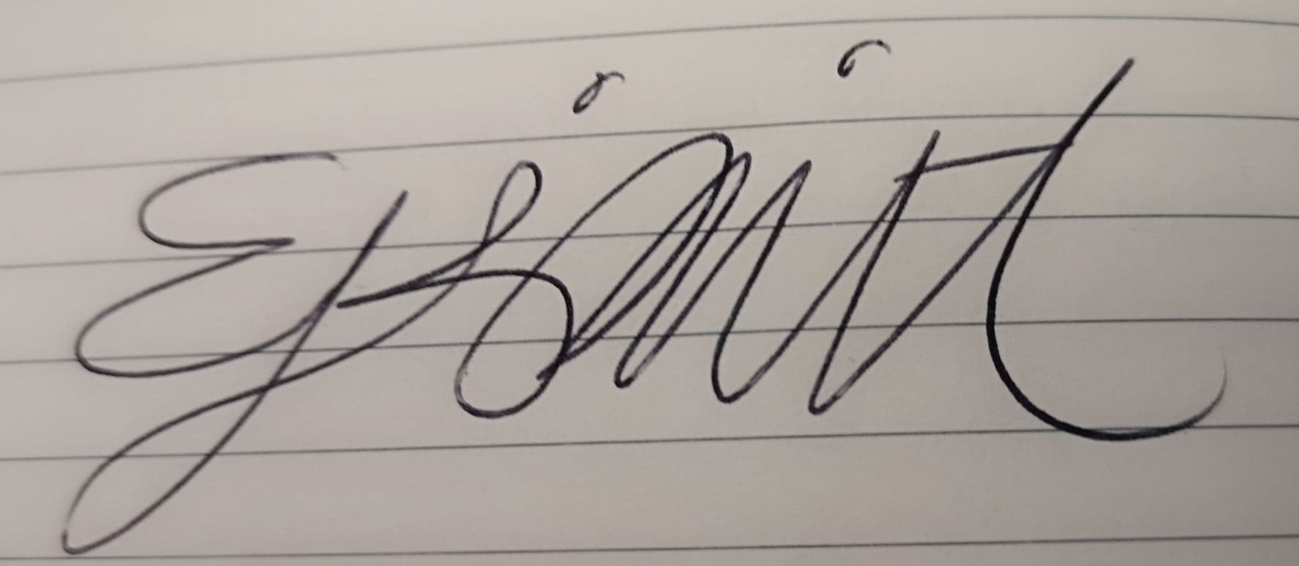 | Date: | 09/01/2019

For students:
Director of Studies/Supervisor:
Signature:
Date:

For staff:
Head of School/Assistant Dean:
Signature:
Date:

Checklist: Please complete the checklist below to ensure that you have completed the form according to the guidelines and attached any required documentation:
☒ | I have read the guidance notes supplied before completing the form.
☒ | I have completed ALL RELEVANT sections of the form in full.
☒ | I confirm that the research activity has received approval in principle
☐ | I have attached a copy of final/interim approval from external organisation (where appropriate)
☐ | I have attached a full risk assessment (and have NOT completed Section H of this form) (where appropriate)
☒ | I understand that it is my responsibility to ensure that the above named research activity will meet the University’s Research Ethics and Integrity Code of Practice.
☒ | I understand that before commencing data collection all documents aimed at respondents (including information sheets, consent forms, questionnaires, interview schedules etc.) must be confirmed by the DoS/Supervisor, module tutor or Head of School.

RESEARCH STUDENTS AND STAFF ONLY
All communications relating to this application during its processing must be in writing and emailed to pgresearch@uwtsd.ac.uk , with the title ‘Ethical Approval’ followed by your name.
You will be informed of the outcome of your claim by email; therefore it is important that you check your University and personal email accounts regularly.

STUDENTS ON UNDERGRADUATE OR TAUGHT MASTERS PROGRAMMES should submit this form (and receive the outcome) via systems explained to you by the supervisor/module leader.

This form is available electronically from the Academic Office web pages: http://www.uwtsd.ac.uk/academic-office/

Application Process

All staff research projects and all research students must submit the Ethical Approval Form to the University Ethics Committee via the Academic Office (pgresearch@uwtsd.ac.uk). Staff research directly in relation to personal study for taught undergraduate or Masters programmes should be submitted via the Faculty procedures explained below.

Taught masters and taught undergraduate research Ethical Approval Forms are considered within Faculties. Faculties will provide details of the specific processes for this. Where the Ethical issues within any single ethical application are of particular concern the Faculty will refer these to the University Ethics Committee. Any student activity that involves the collection of primary data needs to undergo Ethical approval, this includes assignment work as well as dissertations.

Notes for guidance in completion of this form

Section A: About You
Please complete all relevant sections

Section B: Approval for research activity
Research proposals must be approved in principle before applying for Ethical Approval. The proposal approval only becomes final when the ethical approval is received.

The process for proposal approval varies according the individual and programme of study:
- Research students, by application on form PG1 to the Research Degrees Committee
- Taught students by review of research proposal within Faculties (Faculties provide specific details of these processes)
- Staff, by agreement by the Head of School/Assistant Dean

Section C: External Ethical Guidance materials
Many discipline areas are required to operate with the discipline specific codes of research ethics (for example health, psychology, education etc.), any such codes must be listed and you must tick to confirm that you have consulted with these.

Section D: External Collaborative Research Activity
Provide details of the external collaborative partners, where appropriate you might want to submit a copy of the external collaboration agreement with the Ethical Approval Form. If the partner requires the research to be subject to its own internal Ethical approval process then please provide details of that process and a copy of any final (or interim) approvals received from the organisation.

Section E: Details of Research Activity
Remember that the individuals reviewing this Ethical Approval Form may not have seen your research proposal, and also may not be experts in the specific area of your research. The information provided should therefore be jargon free and clearly stated.
Indicative Title: please use the same title as used on the research proposal.
Purpose: the Ethical approval process will want to ensure that the methods you propose are adequate and appropriate to address the research aims and objectives. Excessive additional data collection can be seen as unethical.
Proposed Methods: the Ethical approval process seeks to ensure that you understand the methods that are intended, and that the implementation of those methods will be appropriate and without unnecessary impact on respondents. Please be specific.
Location: this needs to mention geographical location and also local situation (for example, within Local Authority Offices in Cardiff, using a private room but close to other individuals). If you are collecting data within an organisational setting then you need to explain the permissions that you have obtained to do this.
Research Activity outside of the UK: please complete this section in detail, and note any guidance you have received. Also describe your own familiarity (or not) with the location that you will be utilising.
Section F: Scope of Research Activity
Please tick ALL of the research activities that might be undertaken. If any additional types of activity are intended then please add an extra box and describe these.
If you have answered no to all questions in F then sections G and J do not need to be completed. Section H should be considered, and may be completed. Signatures are still required in section K.

Section G: Intended Participants
Please tick all categories that might apply.
Numbers & Source: if you are using a series of different methods or research activities please list numbers for each stage/phase. Be clear about how you will find respondents. Will you use intermediaries, and if so how? How will you ensure compliance with your sampling strategy?
Information for participants: all participants should be appropriately informed about the research, what is expected of them and what will happen to the information that they provide. The Ethical review process does not ask to see this documentation, but requires this to be reviewed and approved by the Director of Studies in the case of research students, the supervisor/module tutor in relation to students on taught programmes and the Head of School/Assistant Dean in relation to staff research.

Section H: Anticipate Risks
All research carries some level of risk. The answers you provide to questions in this section will be reviewed to ensure that you have an appropriate understanding of the type of risks involved and how you can mitigate against these risks. If you have completed a full risk assessment, as required for example for laboratory work, field work, clinical tests, diving operations, or by a collaborative partner, you may append that to this form. In that case, please tick the box indicating this has been provided. You will not then be required to complete Section H.
Risk to participants Think very carefully about how your actions/questions/discussions might affect the people you are involving as participants. You might identify the risk as small but it would still be a risk. Many types of question have the potential to make respondents less content with their life / job; you need to recognise and try to ameliorate any such effects
If these are business owners, time with you may reduce profit.
In some locations physical risk is very real to both participants and yourself, please consider this.
Risk to you, the researcher Think about where you will meet people, if there are any dangers involved in the location. If you are meeting people as individuals think about using a public place. In general do not visit people in their own homes or remote locations. If you are talking to individuals about certain issues think about how their responses might affect you emotionally. What about the risk of collecting insufficient data?
Risk to the University When undertaking your research, you are acting as a member of the University (student or staff). Professionalism is important, so it is important to be well organised and well prepared. Punctuality, clarity etc. are all part of this. What will you do to ensure this? You must ensure you do not harm the good name of the University in any way and do nothing to undermine the reputation of the research it conducts and sponsors. Upholding high standards of conduct and integrity are vital in this regard. You must also conduct the research in such a way to minimise the potential for claims of negligence made against the University, its researchers and any collaborating individual or organisation. In this respect you should always comply with ethical, legal and professional frameworks, obligations and standards as required by statutory and regulatory authorities, as well as the university’s Research Integrity and Ethics Code of Practice. Research misconduct in this respect can take many forms, including:
- fabrication: making up results or other outputs (eg, artefacts) and presenting them as if they were real
- falsification: manipulating research processes or changing or omitting data without good cause
- plagiarism: using other people’s material without giving proper credit
- failure to meet ethical, legal and professional obligations: for example failure to declare competing interests; misrepresentation of involvement or authorship; misrepresentation of interests; breach of confidentiality; lack of informed consent; misuse of personal data; and abuse of research subjects or material
- improper dealing with allegations of misconduct: failing to address possible infringements such as attempts to cover up misconduct and reprisals against whistle-blowers

Adverse Outcomes. Think carefully about the possibilities, and cover here

Section I: Feedback, Consent and Confidentiality
Feedback to participants: outline your approach. Will interview transcripts be shared with respondents to check accuracy? Will summaries of questionnaire analysis be made available to respondents in some way? Will an overview report be provided? How and when?
Informed consent: Draft letter / e-mail / or heading (or footer) section of questionnaire must be approved by DoS/supervisor (if research student), supervisor/module tutor if taught student, or Head of School / Assistant Dean if a member of staff.
Confidentiality/Anonymity. Explain clearly how you will ensure confidentiality and anonymity.

Section J: Data Protection and Storage
Before completing this section it is necessary to read the University’s Research Data Management information. The questions that follow are designed to ensure compliance with the Data Protection Act as well as established research protocols.

Many research activities will involve electronic transfer of data and use of data management systems in the summarisation and analysis of data. You will need to explain these in relation to compliance with the Data Protection Act.
Think carefully about who will have access to your data, this will include supervisors and examiners. Also that a thesis will be made available via the University library and the British Library system. If you are seeking an access bar for a period of time after completion then mention it here. If you will provide a copy of your findings, or intend to give a presentation, to a facilitating/ supporting/accessing organisation then explain that in this section. But also think about the general principle of data sharing, as explained in the Research Data Management information.
In terms of storage of data please ensure security, and also mitigate against loss of data.

Section K: Declaration
Ensure the appropriate countersignatures have been provided
Look carefully at the checklist and ensure that you comply with and tick all that are relevant to your research.

Appendix 2 – Pre-test
Hydroponics
Hydroponics is a way of growing plants without soil. The plants grow in an insoluble porous material, e.g. sand, which is regularly soaked in water.
A simple hydroponics system is shown below.
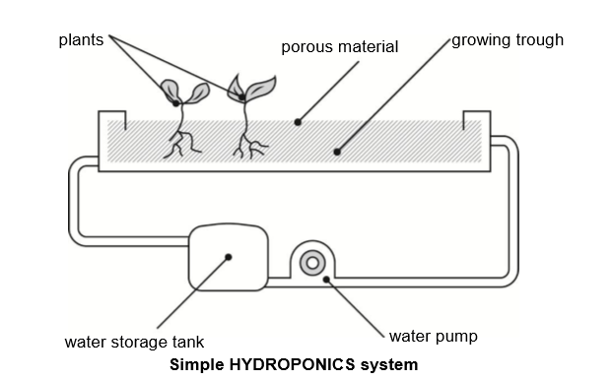
Water is pumped through the system four to six times a day depending on plant type. Once the pumping stops, any excess water drains away and collects in the water storage tank.
Question 1
Studies have shown that plants grow hydroponically use less water than plants grown in soil.
A key reason for this lies in the design of hydroponics systems.
What feature of the hydroponics system saves water compared to the plants grown in soil?
- The porous materials hold the water in the growing trough.
- Because water is not present all the time there is less evaporation.
- Plants watered at regular intervals absorb less water.
- Water flow over the roots cools the plant, so the plant uses less water.
Genetically Modified Crops
GM Corn Should Be Banned
Wildlife conservation groups are demanding that a new genetically modified (GM) corn be banned.
This GM corn is designed to be unaffected by a powerful new herbicide that kills conventional corn plants. This new herbicide will kill most of the weeds that grow in cornfields.
The conservationists say that because these weeds are feed for small animals, especially insects, the use of new herbicide with GM corn will be bad for the environment. Supporters of the use of GM corn say that a scientific study has shown that this will not happen.

Here are details of the scientific study mentioned in the above article:
- Corn was planted in 200 fields across the country.
- Each field was divided into two. The genetically modified (GM) corn treated with the powerful new herbicide was grown in one half, and the conventional corn treated with a conventional herbicide was grown in the other half.
- The number of insects found in the GM corn, treated with the new herbicide, was about the same as the insects in the conventional corn, treated with the conventional herbicide.
Question 1
What factors were deliberately varied in the scientific study mentioned in the article? Circle “yes” or “no” for each of the following factors.
The number of insects in the environment | Yes / No
The type of herbicide used | Yes / No

Question 2
Corn was planted in 200 fields across the country. Why did scientists use more than one site?
- So that many farmers could try the new GM corn.
- To see how much GM corn they could grow.
- To cover as much land as possible with the GM crop.
- To include various growth conditions for corn.

Health Risk?
Imagine that you live near a large chemical factory that produces fertilisers for use in agriculture. In recent years there have been several cases if people in the area suffering from long-term breathing problems. Many local people believe that these symptoms are caused by the emission of toxic fumes from the nearby chemical fertiliser factory.
A public meeting was held to discuss the potential dangers of the chemical factory to the health of local residents. Scientists made the following statements at the meeting.
Statement by scientists working for the chemical company
“We have made a study of the toxicity of soil in the local area. We have found no evidence of toxic chemicals in the samples we have taken.”

Statement by scientists working for concerned citizens in the local community
“We have looked at the number of cases of long-term breathing problems in the local area and compared this with the number of cases in an area far away from the chemical factory. There are more incidents in the area close to the chemical factory.”

Question 1
The owners of the chemical factory used the statements of the scientists working for the company to argue that “the emission fumes from the factory are not a health risk to local residents”.
Give one reason, other that the statement by scientists working for the concerned citizens, for doubting that the statement by scientists working for the company supports the owner’s argument.
……………………………………………………………………………………………………………………………………………………………
…………………………………………………………………………………………………………………………………………………………….
Question 2
The scientists working for the concerned citizens compared the number of people with long-term breathing problems close to the chemical factory with those in an area far away from the factory.
Describe one possible difference in the two areas that would make you think that the comparison was not valid one.
……………………………………………………………………………………………………………………………………………………………
…………………………………………………………………………………………………………………………………………………………….
……………………………………………………………………………………………………………………………………………………………

Appendix 3 – Post-test

Hydroponics
Hydroponics is a way of growing plants without soil. The plants grow in an insoluble porous material, e.g. sand, which is regularly soaked in water.
A simple hydroponics system is shown below.
Water is pumped through the system four to six times a day depending on plant type. Once the pumping stops, any excess water drains away and collects in the water storage tank.
Question 1
Studies have shown that plants grow hydroponically use less water than plants grown in soil.
A key reason for this lies in the design of hydroponics systems.
What feature of the hydroponics system saves water compared to the plants grown in soil?
- The porous materials hold the water in the growing trough.
- Because water is not present all the time there is less evaporation.
- Plants watered at regular intervals absorb less water.
- Water flow over the roots cools the plant, so the plant uses less water.
Genetically Modified Crops
GM Corn Should Be Banned
Wildlife conservation groups are demanding that a new genetically modified (GM) corn be banned.
This GM corn is designed to be unaffected by a powerful new herbicide that kills conventional corn plants. This new herbicide will kill most of the weeds that grow in cornfields.
The conservationists say that because these weeds are feed for small animals, especially insects, the use of new herbicide with GM corn will be bad for the environment. Supporters of the use of GM corn say that a scientific study has shown that this will not happen.

Here are details of the scientific study mentioned in the above article:
- Corn was planted in 200 fields across the country.
- Each field was divided into two. The genetically modified (GM) corn treated with the powerful new herbicide was grown in one half, and the conventional corn treated with a conventional herbicide was grown in the other half.
- The number of insects found in the GM corn, treated with the new herbicide, was about the same as the insects in the conventional corn, treated with the conventional herbicide.
Question 1
What factors were deliberately varied in the scientific study mentioned in the article? Circle “yes” or “no” for each of the following factors.
The number of insects in the environment | Yes / No
The type of herbicide used | Yes / No

Question 2
Corn was planted in 200 fields across the country. Why did scientists use more than one site?
- So that many farmers could try the new GM corn.
- To see how much GM corn they could grow.
- To cover as much land as possible with the GM crop.
- To include various growth conditions for corn.

Appendix 4 – Intervention Material

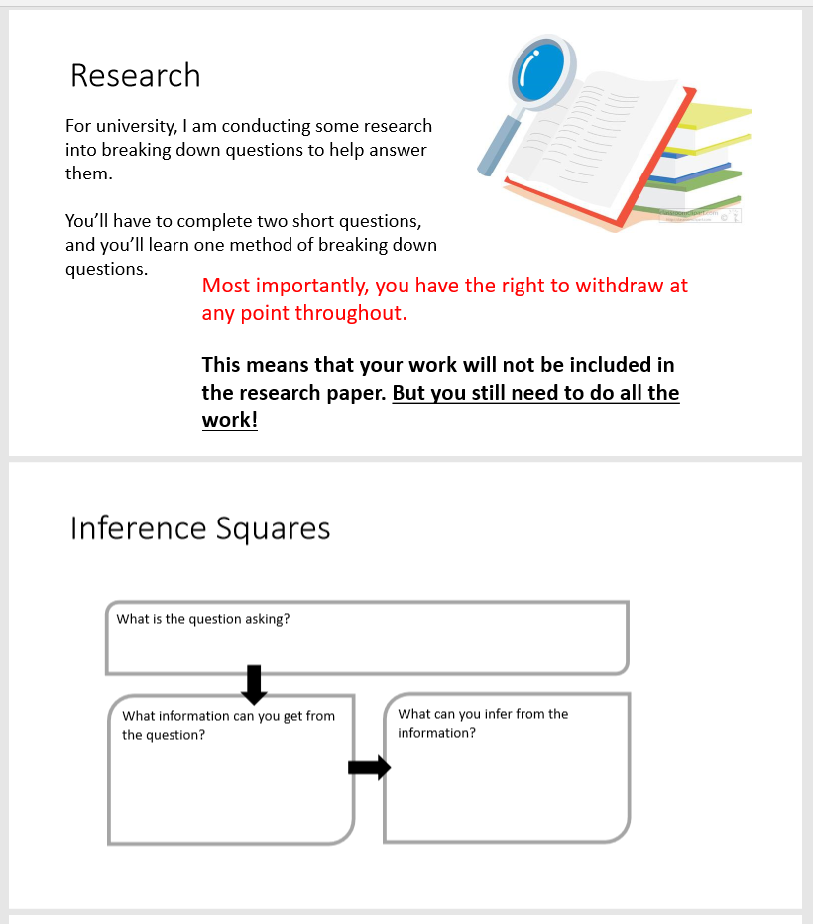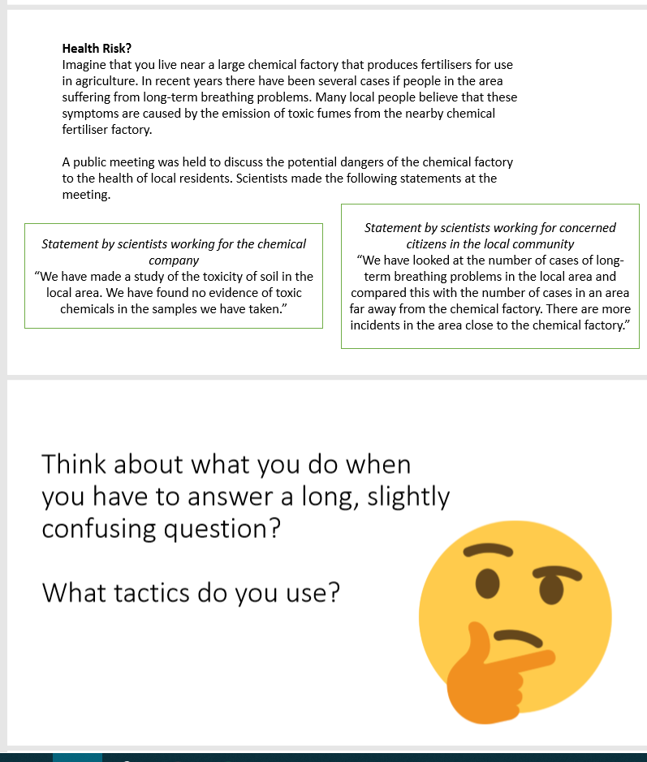

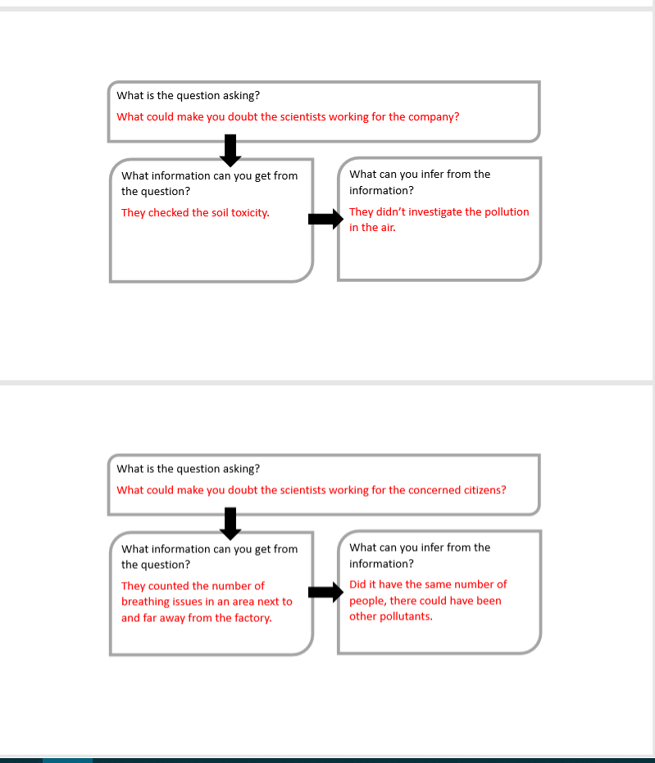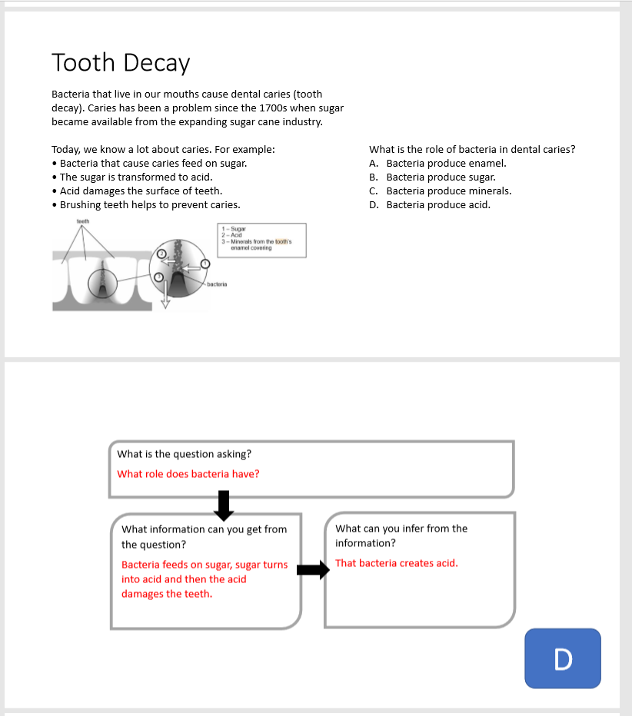

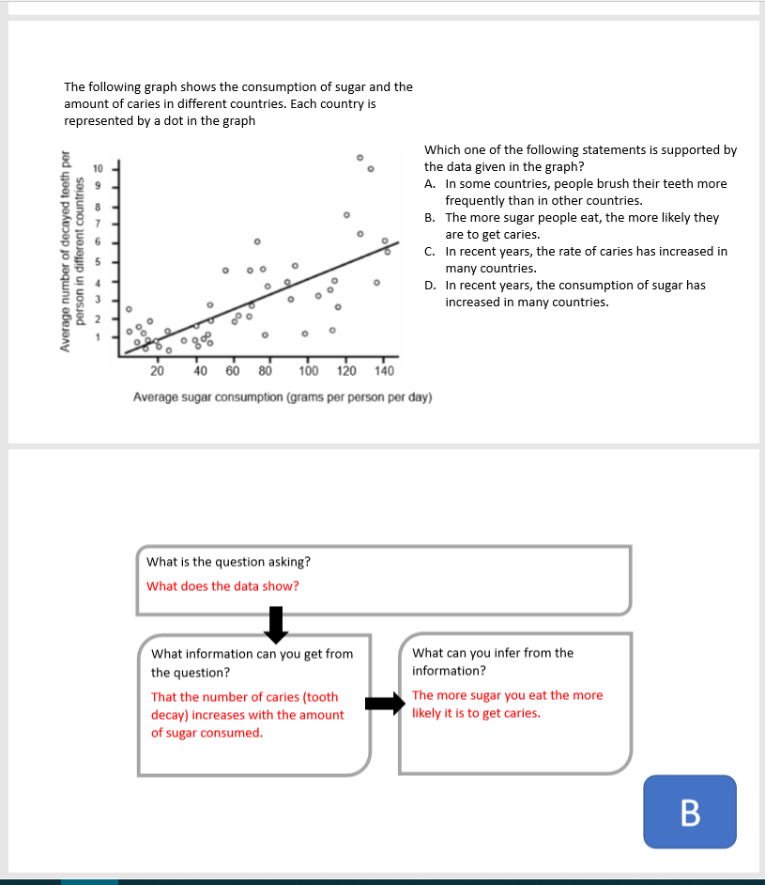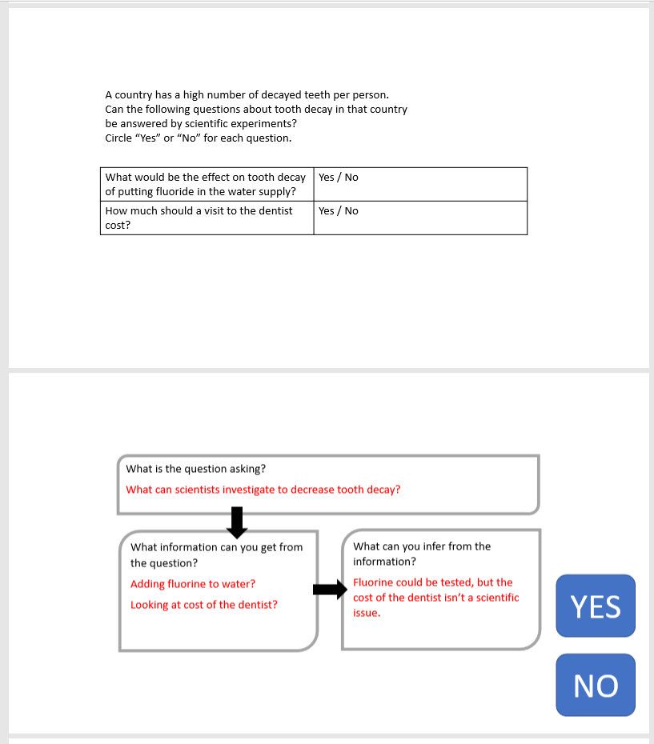

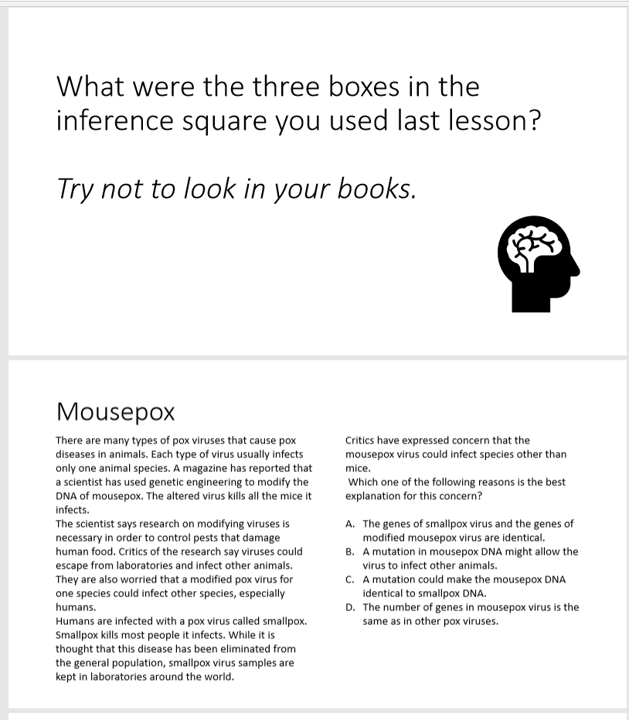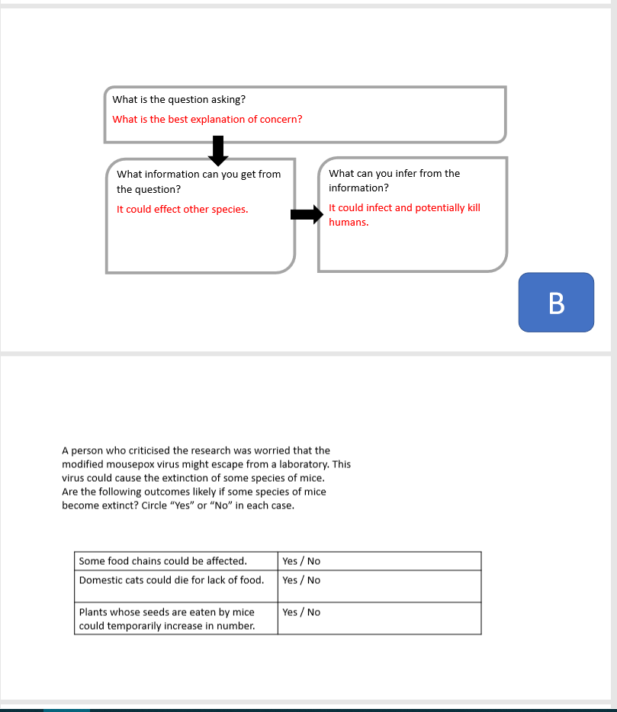

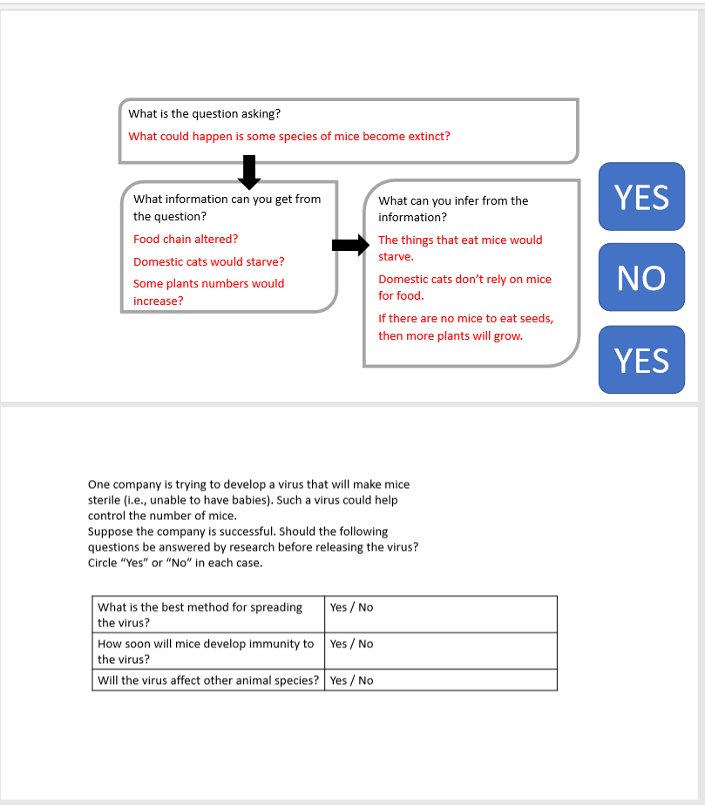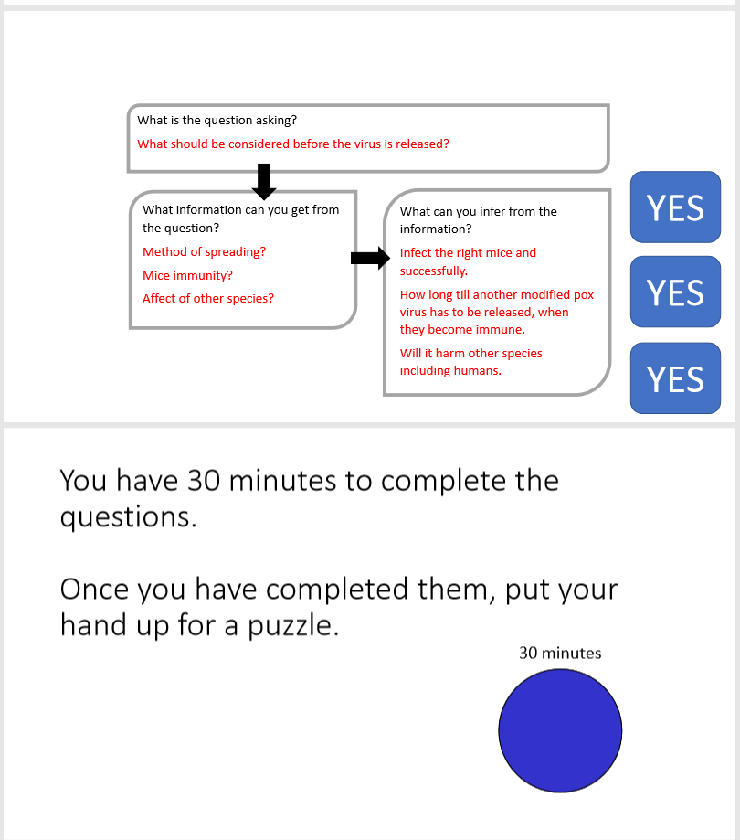

Appendix 5 – Results

Table 1: Shows the results of the pre-test with all consenting participants. Where green represents full marks, orange is half marks and red is no marks.
Participant | Q1 | Q2 A | Q2 B | Q3
A | 0 | 2 | 2 | 2
B | 0 | 2 | 2 | 0
C | 0 | 2 | 2 | 2
D | 2 | 2 | 2 | 2
E | 0 | 2 | 2 | 2
F | 0 | 2 | 2 | 2
G | 0 | 2 | 2 | 2
H | 2 | 2 | 2 | 2
I | 2 | 2 | 2 | 2
J | 0 | 0 | 0 | 0
K | 2 | 2 | 2 | 2
L | 2 | 2 | 2 | 2
M | 2 | 0 | 2 | 0
N | 0 | 0 | 0 | 2
O | 0 | 2 | 0 | 0

Table 2: Shows the results of the post-test with all the consenting participants. The participants that used the inference squares have been highlighted in yellow. Where green represents full marks, orange is half marks and red is no marks.
Participant | Used Squares | Q1 | Q2A | Q2B | Q3
A | No | 2 | 2 | 2 | 2
B | No | 0 | 2 | 2 | 0
C | No | 0 | 2 | 2 | 0
D | No | 2 | 2 | 2 | 2
E | No | 0 | 2 | 2 | 2
F | No | 2 | 0 | 2 | 2
G | No | 0 | 2 | 2 | 2
H | No | 2 | 2 | 2 | 2
I | No | 0 | 2 | 2 | 0
J | No | 0 | 0 | 2 | 2
K | Yes | 2 | 2 | 2 | 2
L | No | 0 | 0 | 2 | 2
M | No | 2 | 0 | 2 | 2
N | Yes | 2 | 2 | 2 | 2
O | Yes | 0 | 0 | 2 | 2

Table 3: Results from all participants, pre and post-test.
 | Pre-test |  | Post-test
 | Right | Wrong | Right | Wrong
Qu 1 | 40% | 60% | 47% | 53%
Qu 2a | 80% | 20% | 67% | 33%
Qu 2b | 80% | 20% | 100% | 0%
Qu 3 | 73% | 27% | 80% | 20%

Table 4:Participants that used inference squares in the post-test comparison with pre-test.
 | Pre-test |  | Post-test
 | Right | Wrong | Right | Wrong
Qu 1 | 33% | 67% | 67% | 33%
Qu 2a | 67% | 33% | 67% | 33%
Qu 2b | 33% | 67% | 100% | 0%
Qu 3 | 67% | 33% | 100% | 0%

