 University of Wales Trinity Saint David

Management economics
LCBB5003

Ionela Huanita Peltea September 2022
2023156
Executive Summary
The renowned restaurant chain Domino’s was founded by Tom Monaghan and his brothers in 1960 and took over from a small pizza restaurant chain Dominick. Ypsilanti, Michigan in the United States has been its headquarters at the time of the inception of this valuable restaurant chain. The report has evaluated different concepts of economics concerning the chosen product of the respective company. Pizza has been chosen as the product to explain the concepts such as demand and market equilibrium, price elasticity of demand, and so on. Apart from these, the pricing policy that the company could employ to expand its business has been elaborated as well.

Contents
Introduction 4
Chosen Company and Product 5
Identifying Demand and Market Equilibrium 6
Factors that influence the Price Elasticity of Demand 12
Conclusion 15
References 16

Introduction
This report has discussed some of the concepts of demand or market equilibrium that affect a business organisation which is the most crucial part in terms of market perspectives. Additionally, the report will also evaluate the business of the restaurant chain Domino’s and its valuable product Pizza which will be used to illustrate the concepts of consumer income, consumer tastes and preferences substitution effects as well as elasticity of demand. The concepts and their effect on business decision-making will also be explained in the report. Apart from these, the necessary pricing policy that can be adopted by the company for expansion purposes will be discussed as well.

Chosen Company and Product
About the Company
The American multinational restaurant chain, Domino’s has been chosen as the company that delivers gazillions of products to its customers (dominos, 2022). The company started as a small restaurant with only one store in Ypsilanti, Michigan in the United States of America in 1960 and has been spread over 1700 locations around the world within 60 years of its inception. This signifies that the restaurant chain truly delivers a valuable service to its customers throughout the years. The two brothers, Tom Monaghan and James Monaghan took over the existing small pizza restaurant delivery chain Dominick owned by Dominick DeVarti in the year 1960 (SOLANKI, 2019). Now, with the Chief Executive Officer Russell Weiner and its headquarters in Domino’s Farms Office Park, Ann Arbor, Michigan in the United States, it serves its customers worldwide. The company sells its products as well as runs several franchise stores for its valuable customers worldwide. The company also adopted technological innovation to cope with the ensuing challenges due to the competitive business environment. It offers digital ordering services to its customers with real-time tracking features that enhance its brand value as well. More than 75 per cent of the international market Domino’s comprises online ordering services which greatly enhanced its business (Wolfer, 2022 pp.161-161).
Chosen Product
Domino’s delivers a number of products such as pizza, chicken, pasta, desserts, and so on among which Pizza has been the most valuable product since its inception. Its popular Pizza varieties include Mexican Green Wave Pizza, Country Special Pizza, Seventh Heaven Pizza, Grand Supreme Pizza, and so on which customers are fond of eating. The Pizza of this valuable restaurant chain has a unique taste that is made of bread-based dough with a higher gluten content in its crust. While most of the competitors of the company use a traditional dough with lower gluten, this company’s speciality of making Pizza with higher gluten content made it noticeable as well as attracted customers widely. Among its huge customer base of Pizza globally, the major target customer of the company includes working professionals, youth, and business professionals. Along with that, the company delivers gluten-free Pizza as well to cope with the competition (Trede, 2019). The reasonable price of the product made it possible to attract a wide range of customers as well as generate a huge profit for the company.

Identifying Demand and Market Equilibrium
Market Equilibrium
Market equilibrium refers to the state when the quantity demanded and quantity supplied at a specific price become equal. This state is also known as an economic equilibrium where the economic forces of market demand and supply become balanced (economicsonline, 2020). The market equilibrium can be derived with the help of a figure. The quantity demanded and quantity supplied can be drawn along the horizontal axis and the price of the product along the vertical axis. The supply curve is upward sloping and the demand curve is upward sloping which implies that if the price of Pizza rises the demand will fall accordingly and vice-versa. On the other hand, the company would like to sell more Pizza to the customers to generate more profit. However, higher prices will lead to less consumption of Pizza by the buyers and will create a gap between the demand and supply. As a result, the price of Pizza will fall which will help to raise the demand until the equilibrium price is reached where the demand and supply curve will intersect each other. At this point of intersection, the market price of Pizza will be settled as shown in the figure below. The P1 and Q1 will be the equilibrium price of Pizza and quantity demand and supply respectively.
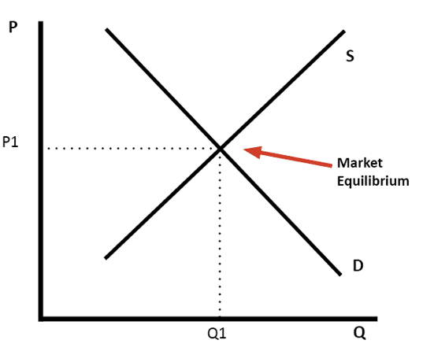
Source: (Pettinger, 2019)
Price of the Product of the Competitor
The price of Domino’s Pizza is £8.75 whereas the Pizza of Pizza Hut is £9.85 which is much higher than the price of Domino’s Pizza which is a noticeable reason for the flourishing business of Domino’s. The reasonable price of its products without compromising the quality of the product made it more attractive to its customers globally. Thus, Domino’s Pizza became able to eliminate its competitors and retain its customers as well.
Price of Substitutes
Domino’s also serves substitute products for Pizza such as Meatballs on Tortillas, Bagel with Tomatoes or Portobello Caps, or Hummus the main substitutes for Pizza that are delivered by Domino’s. These substitutes are delivered by Domino’s to retain its customer base who are more health conscious as well as not fond of Pizza. The price of these substitute products must be close to the main product otherwise the customers will not be willing to buy the product at a different or higher cost.
Complementary Good
Dominos and pizza hut company increased their revenue by selling more items to their customers with the main food items like pizza. For example, the company used its complementary food items like coke, dessert and French fries to increase the and made a combo deal for the consumers. It is a concept of the company to turn the snack item into a meal with the support of this type of complementary goods. Moreover, the company also make some attractive pricing of the complete meals that attract more consumers and help to make itself more profitable in the market.
Consumer Income
The customers’ income is playing a significant role in the market demand for any individual product. However, the customers’ demand affects the habit of purchasing of customers. Along with this, the people of the UK try to increase their income which influences their purchasing habit of fast food. However, The customers’ income has been affected after the pandemic era. It has been estimated that 15.2 million people have faced low income during and post-pandemic era (Deloitte, 2022).
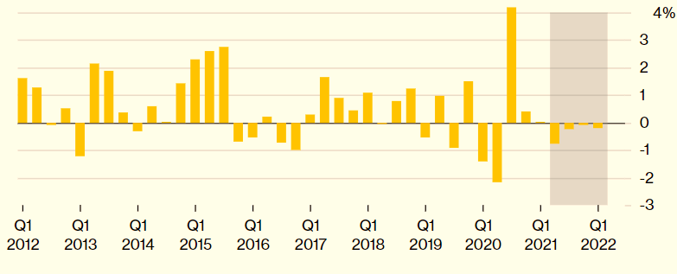
Source: (Atkinson, 2022)
The above graph has interpreted that real disposable income has decreased by 0.2% in the first three months of 2021. The company Dominos sells most of the pizzas whose prices are high. For example, the price of a large pizza at Domino's is £14.99 which indicates the highly expensive products of Domino's (Atkinson, 2022). In this context, it can be said, the low income of UK people has affected the demand for pizza at Domino. However, the low income has affected the sales of products of Dominos. The company faces a fall of 50.9 million pounds in profit due to the low income of the people of the UK.
Consumer tastes and preferences
The tastes and preferences of the customers are changing day to day in this modern era. However, the customers’ tastes and preferences are changed due to the existence of various types of products in the market. This change of preference the Dominos occurred as Dominos provides good quality exclusive product and focus on offering the value of money to the customer. The most demand for the pizza of Dominos is Pepperoni which is sold the most (Amelia, 2022). Along with this, people are craving Pepperoni Passion which is added to the menu list of Dominos. However, the company is enhancing the quality of products so that demand for products such as Pizza is increased in the market. Along with this, people are focusing on their income after the pandemic era as their choices, preferences are turned towards good products (Aigner-Walder, 2015).
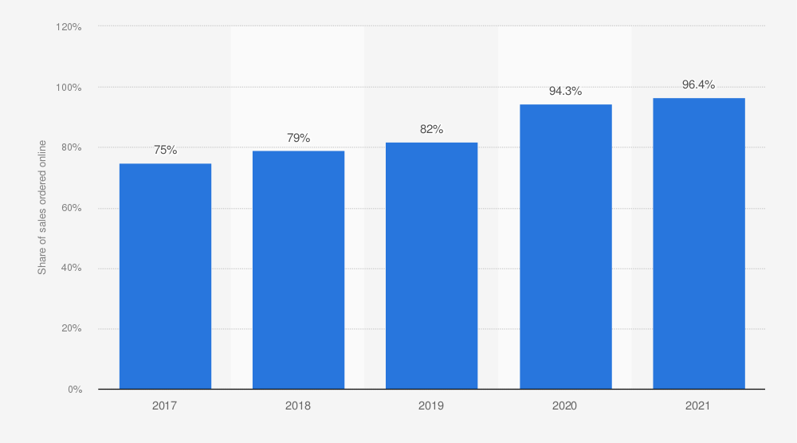
Source: (Andreyeva et al., 2010)
The above graph has highlighted that the online sales of Dominos are increasing day to day. The graph shows that online sales of Pizza are raised by 96.4% in 2021 after the pandemic era. Thus, the taste and preferences of customers on Domino’s pizza influence the demand for products of the company. The main concept is illustrating that change in the demand is affected by the production of good quality and variety of products of Dominos (Bagwell, 2005).
Consumer expectations of price
The people of the UK are expecting the products at low cost from the company. Mostly, food products such as pizza, and burgers are high in demand in the market. Dominos is segregate the pricing style of their products according to the size and variation of the pizza of Dominos. Along with this, the company is targeting people who like to explore new foods from reputed companies in the UK. The dominos are increasing the prices of food products as there is inflation in the country along with the high fuel prices in the UK(Bagwell, 2005). The high prices of the pizza occurred due to the good quality of the materials and other costs such as the labour cost of the company. The customers’ income has been affected after the pandemic era. It has been estimated that people have faced low income during and post-pandemic era. Thus, they are expecting Dominos to sell pizza at a reasonable price. Thus, the company is trying to set the pricing strategies of products as per the purchasing habit of UK people and preferences.
Demographics
The people in the UK who are adults or young prefer most fast foods. Most school and college-going students are preferring to visit restaurants or hotels in the present day. The pandemic era or lockdown influences people to order online foods from restaurants and hotels other different types of food hubs in the UK (Baker, 2003). It has been identified from the survey on Dominos that most of the products have been purchased by people who are belonged to the age group 18 and 35. On the other hand, the purchasing habit of
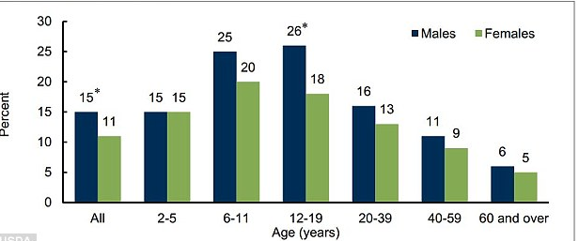
Source: (Ellickson, 2013)
The above graph has reflected that pizza is consumed by people in the UK of all ages. However, the graph has interpreted that, the consumption of pizza by 6 to 11 years old boys is 25% and the consumption of pizza by 6 to 11 years girls is 20%. On the other hand, the consumption of pizza by 12 to 19 years old boys is 26% and 12 to 19 years old girls is 18% (Ellickson, 2013). Besides this, the pizza purchasing by males of 20 to 39 years old is 16% and among females of 20 to 39 years old is 13%. The pizza consumption by males above 60 years is 6% and among females above 60 years is 5%. Thus, thus, Dominos targets the people in the UK who are adult or young and prefers most fast foods.

Factors that influence the Price Elasticity of Demand
Price elasticity is referring the percentage of the change in the quantity which is demanded in the market. However, the division of the percentage change of goods and services of the company is influenced by the percentage change in the price of the products.
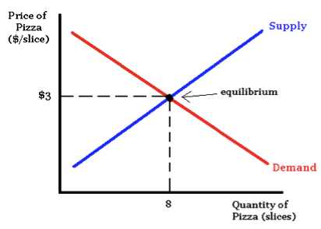
Source: (Foot and Gomez, 2006)
The above diagram has reflected the change in demands of products by the pricing strategies of the company. However, the above diagram has shown that the demand for pizza at Dominos is affected by the pricing strategies of the products. For example, Dominos is increasing the prices of some products according to the market demand. The foods products such as pizza, and burgers are high in demand in the market. Thus, the company is trying to set the pricing strategies of products as per the purchasing habit of UK people and preferences. This is important to maintain the equilibrium in the number of products and their price in the market.
Substitution Effects
People like to purchase the products as per their needs or requirements on that products. In this context, the expensive products of Dominos are luxurious products in the daily life of UK people (Griffith, 2003). Thus, the demand of UK people for Pizza purchasing is needed to be made elastic so that management of Dominos set the prices according to the purchasing quantity by customers.
Income effects
The respective business company Dominoes has a high demand for their products, especially Pizza. However, a slighter change in income can have an impact on the demand for the pizza of the respective business company Dominoes. Therefore, the proportion of the income that is spent by the consumers on the consumption of pizza as the reason is that the price elasticity of the demand for the products of the respective business company Dominoes tends to be low (Atkinson, 2022). Moreover, any changes in the income of the consumers or households will have a direct impact on the demand for the product pizza if the income of the same tends to be high, then automatically the price elasticity of demand for pizza for the respective business company Dominoes will automatically rise. The opposite will happen if the income of the general or the potential consumers went down, then the price elasticity of demand for pizza will go down as well as it will go beyond the purchasing power of the consumers.
Pricing policy
The respective business company Dominoes needs to set up an effective price that will help them to attract consumers and through this process, the annual revenues of the respective business company Dominoes will rise up. Therefore, there is a relationship between the price elasticity of demand and the pricing policy. In addition to this, if the price of an elastic commodity say pizza is set higher by the respective business company Dominoes, then there will be a corresponding impact on the product of dominoes (Deloitte, 2022). A smaller quantity of pizza will get sold and this will tend the respective business company Dominoes to earn a lower amount of revenue as well. Furthermore, the lower will be the price elasticity of demand for any elastic commodity say pizza, will have less response toward the amount of quantity demanded the given change in the price of the pizza.

Conclusion
The report is based on management economics which highlights the market demand for the products of Dominos. The report has illustrated information about the business and its main product or service of Dominos. Along with this, Demand and Market Equilibrium have been defined in terms of the business context of Dominos. Various types of factors that influence Demand have been evaluated that influence Demand for the main product or service of the company. In addition to this, the impact of the Price of substitutes, Price of complements, Consumer Income, Consumer expectations and Demographics on the demand for products of Dominos has been reflected in the report. Factors that influence the Price Elasticity of Demand for products of the company have been analysed in the report.

References
Aigner-Walder, B. (2015) Effects of the Demographic Changes on Private Consumption: An Almost Ideal Demand System Analysis for Austria. Journal of Economic and Social Studies, 5, 1, 33-57
Amelia, (2022). Domino’s Pizza forecasts soaring food costs in 2022, reiterates long-term sales outlook. [Online] Available at: https://www.cnbc.com/2022/01/11/dominos-pizza-expects-soaring-food-costs-in-2022-backs-long-term-outlook.html
Andreyeva, T., Long, M. and Brownell, K. (2010) The Impact of Food Prices on Consumption: A Systematic Review of Research on the Price Elasticity of Demand for Food. American Journal of Public Health, 100, 2, 216-222.
Atkinson, A., (2022). UK Household Incomes Are in The Longest-Ever Run of Declines. [Online] Available at: https://www.bloomberg.com/news/articles/2022-06-30/uk-real-household-incomes-fall-for-an-unprecedented-4th-quarter
Bagwell, K. (2005) The Economic Analysis of Advertising. Columbia University Discussion Papers No. : 0506-01
Baker, J. (2003) Competitive Price Discrimination: The Exercise of Market Power Without AnticompetitiveEffects (Comment on Klein and Wiley). Articles in Law Reviews & Other Academic Journals. Paper 278.
deloitte, (2022). Consumer disposable income confidence falls to record low, as rising cost of living takes hold. [Online] Available at: https://www2.deloitte.com/uk/en/pages/press-releases/articles/consumer-disposable-income-confidence-falls-to-record-low-as-rising-cost-of-living-takes-hold.html
dominos, (2022). COMPANY HISTORY. [Online] Available at: https://biz.dominos.com/about-us/history/
economicsonline, (2020). Equilibrium. [Online] Available at: https://www.economicsonline.co.uk/definitions/equilibrium.html/
Ellickson, P. (2013) Market Structure and Performance. International Encyclopedia of the Social & Behavioral Sciences, Forthcoming; Simon School Working Paper No. 13-21
Foot, D. and Gomez, R. (2006) Population ageing and sectorial growth: the case study of the UK, 2006- 2026. OJBE, 5:1
Griffith, G. (2003) The Impact of Supermarkets on Farm Suppliers. The Australian Economic Review, 37,3, 329–336
Pettinger, T., (2019). Market equilibrium. [Online] Available at: https://www.economicshelp.org/microessays/equilibrium/market-equilibrium/
SOLANKI, M., (2019). Case Study on Domino's Pizza UK - Msrblog. [Online] Available at: http://www.msrblog.com/business/case-study-on-dominos-pizza-uk.html
Trede, I., (2019). The American Gluten Craze: Its Origins, Persistence, and Impacts on the Safety of Gluten-Free Boulder Restaurant Foods.
Wolfer, K., (2022). The Domino's Story: How the Innovative Pizza Giant Used Technology to Deliver a Customer Experience Revolution by Marcia Layton Turner. Michigan Historical Review, 48(1), pp.161-161.

