Investigating the impact of loyalty apps on customer retention in uk grocery stores – A case of tesco
DISSERTATION BMMB7003
Varun CHEKURI
2424040
12TH DEC 2025
UNIVERSITY OF WALES TRINITY SAINT DAVID
Abstract
This study focused upon analysing the impact of the Tesco Clubcard mobile application on customer satisfaction, online interactions, and loyalty in a UK grocery setting. Based on Expectation-Confirmation Theory and the study of app continuance, the analysis determines the role of such core app attributes as ease of use, perceived usefulness, personalised offers, rewards attractiveness, gamified features, push notifications, and perceived app performance. Descriptive statistics, correlation and multiple regression were used in the analysis of results from a quantitative survey conducted among 150 Clubcard app users. Descriptive results show an overall positive orientation towards usability, usefulness, relevance, rewards value, and overall experience and a more mixed attitude towards gamification and push-notification effectiveness. The trends of correlation indicate that both functional and value-based features of apps are positively correlated with satisfaction and other results related to loyalty. The results of the regression analysis show that perceived usefulness and rewards value can be considered the most powerful predictors of satisfaction, and the notifications and gamification exhibit less significant direct effects in the analysed model. The results indicate that the most effective components of the digital ecosystem of Tesco to promote sustained loyalty include trusted performance, sensible shopping value, and trusted, personalised savings as opposed to engagement tools. The study is an addition to retail app literature as it helps understand which digital loyalty drivers most significantly convert into satisfaction-based continuance and behavioural loyalty within a fully-developed and competitive grocery market.

DECLARATION & STATEMENT
DECLARATION

This work has not previously been accepted in substance for any degree and is not being concurrently submitted in candidature for any degree.

Signed ...................................................................... (candidate)

Date ...............12th Dec 2025.........................................................

STATEMENT 1

This work is the result of my own investigations, except where otherwise stated.

Other sources are acknowledged by footnotes giving explicit references. A bibliography is appended.

Signed ..................................................................... (candidate)

Date .................12th Dec 2025.......................................................

STATEMENT 2

I hereby give consent for my work, if accepted, to be available for photocopying and for inter-library loan, and for the title and summary to be made available to outside organisations.

Signed ..................................................................... (candidate)

Date ...................12th Dec 2025....................................................

Acknowledgement
My supervisor is the one whom I would like to thank with all my heart because of the constant guidance, constructive feedback and encouragement given to me during this research. I acknowledge the contribution of all respondents who took part in the survey and provided their experiences of using the Tesco Clubcard app, as their experience and contributions made this study possible. It is thanks to my family and friends who encouraged and supported me throughout this phase.
Table of Contents
Abstract 1
Declaration & Statement……………………………………………………………………….2
Acknowledgement 3
1. INTRODUCTION 7
1.1 Introduction 7
1.2 Rationale of Study 8
1.3 Research Objectives 9
1.4 Research Questions 9
1.5 Justification 10
1.6 Scope 11
1.7 Limitations 12
1.8 Structure of the thesis 12
2. LITERATURE REVIEW 14
2.1 Overview 14
2.2 Theoretical Evolution in Expectation-confirmation models 15
2.2.1 Evolution of the Model 15
2.2.1 The Expectation Confirmation Model Extensions. 16
2.2.2. Price Sensitivity and Post Adoption Adjustment 17
2.3 Behavioural Constructs: Trust, Flow and Social Comparison. 17
2.3.1 The Role of Trust 17
2.3.2 Flow Experience and Habitual Use. 18
2.3.3 Generational behaviour and Technological Adaptation. 18
2.4 Service Quality, Expectation, and Digital Satisfaction. 19
2.4.1 Service Quality in Retail Situations. 19
2.4.2 Gaps in Expectation and confirmation dynamics. 19
2.5 Digital Transformation and Operational Infrastructure. 20
2.6 Tesco-Specific Evidence and Market Background 22
2.6.1. Customer Behaviour Insights 22
2.6.2 Crisis Management and Operation Resilience. 23
2.6.3 Service and Digital Experience Incorporation. 24
2.7 Theoretical Framework 25
2.8 Gaps in Literature 26
2.9 Summary 27
3. RESEARCH METHODOLOGY 28
3.1 Introduction 28
3.2 Research Onion 28
3.3 Philosophy of Research 29
3.4 Research approach 29
3.5 Research Strategy: Quantitative Survey Strategy. 30
3.6 Data Collection Method 30
3.7 Data Analysis Methods 31
3.8 Ethical Considerations 32
3.9 Constraints of the Research 32
3.10 Summary 32
4. DATA ANALYSIS 34
4.1 Introduction 34
4.2 Graphical Analysis: Demographic Statistics 34
4.3 SPSS analysis 45
4.4 Interpretation of findings 53
4.5 Summary 55
5. DISCUSSION 56
5.1 Introduction 56
5.2 Findings of the discussion 56
5.2. 1 Relationship between Tesco Clubcard app features and customer satisfaction RO 1 56
5.2.2 Mediating role of satisfaction between app usage and loyalty RO 2 57
5.2.3 Customer perceptions of gamification and push-notification engagement RO 3 58
5.2.4 Statistically significant predictors of loyalty among Tesco app users RO 4 58
5.3 Integration and critical interpretation (theoretical). 59
5.4 Summary of discussion 60
6. CONCLUSION AND RECOMMENDATIONS 61
6.1 Conclusion 61
6.2 Recommendations 63
6.3 Practical implications 64
6.4 Concluding statement 64
References 65

1. INTRODUCTION
The introduction chapter lays emphasis on presenting the background and focus of the study. The chapter presents the rationale and importance of the research, while describing the problem, defining the aim and objectives, scope, and theoretical backgrounds that support the investigation of Tesco digital loyalty strategies and their role in customer retention.

1.1 Introduction
In recent times, customer loyalty in grocery retail sector has shifted its character from in-store relationships to a matter of data-driven and technology-enabled interactions. In this context, opportunities like personalisation of offers, monitoring of buying behaviour, and retention with the help of analytics are offered by mobile-based loyalty applications. The Tesco PLC Annual Report 2024 revealed that nowadays more than 80 percent of UK transactions are connected with its Clubcard loyalty app program, which supports 23 million households and over 11 million monthly active users of the app (Tesco PLC, 2024). This places Tesco as one of the leaders in the digital retail analytics and customer relationship management across the globe.
In terms of digital services, it has been found that trust and satisfaction are key determinants in customer retention and repeat purchases. Talwar et al. (2020) asserted that perceived risk during initial trust is reduced and post-adoption satisfaction is increased in mobile-payment systems. Poromatikul et al. (2020) claimed that perceived usefulness, reliability and ease of use lead to repeat intention in mobile-banking applications. These lessons are reflected on Tesco digital loyalty ecosystem, where retention is based on technological reliability and user trust.
In the Tesco marketing model, the customers become actively involved in the co-creation of loyalty. As Patel and Swamy (2023) observed, Tesco is dynamic in how it seeks feedback and evolves the services based on its customer responses to maintain engagement by making customers the partners of the company instead of a passive recipient. The perceived fairness and personalisation of Clubcard and the development of emotional attachment and brand trust to create long-term commitment were also confirmed by Azan and Karimah (2022).
This strategy is supported by operational capability. According to Meng (2024), one of the essential enablers of customer-focused implementation at Tesco is automation and real-time analytics with the help of Dunnhumby data integration. These systems enable micro-segmentation, predictive marketing and coordinated logistics that bring raw data to actionable insights and enhanced satisfaction. On a more general level, Hughes (2021) found that incentives based on Clubcard affect non-grocery consumer spending, including housing spending, which indicates that digital loyalty platforms can redefine more economic behaviours.
All in all, the literature represents Tesco as Clubcard both as a data-heavy infrastructure and a behavioural engine that binds trust, personalisation and operational accuracy to long-term customer relationships.

1.2 Rationale of Study
Although it has been widely adopted, digital saturation and the ability to compete on a level playing field jeopardise the long-term differentiation of Tesco. Shoppers in the UK now have a number of retailer applications, which has eroded brand loyalty. It has been empirically indicated that sustainable advantage depends on post adoption continuance, as opposed to initial sign-up. Talwar et al. (2020) proved that the first-time use is based on trust, however, the repeat usage is based on ongoing satisfaction, whereas Poromatikul et al. (2020) established that continuance intention hinges on unchanging reliability and usefulness instead of novelty.
According to the reports provided by Tesco, the use is high, but the growth in active involvement is slowing down, which means that the effect of novelty could have reached its limits (Tesco PLC, 2024). Retention maintenance consequently means being constantly up to the task and avoiding experience burnout. The physical environment confirms this warning: Singh et al. (2021) with the SERVQUAL discovered that the scores of all service-quality gaps in Tesco Malaysia were negative, that is, expectations were higher than performance was perceived. This highlights the fact that even high-quality brands have delicate satisfaction levels associated with reliability and responsiveness.
These dynamics are also complicated by digitisation. Wolniak et al. (2024) noted that AI, augmentation reality, and self-scanning can increase efficiency, but can also undermine trust or usability among specific customers. Therefore, technological innovation does not necessarily mean satisfaction, and its success depends on its intelligent design, transparency, and value. In the case of Tesco, a loss of convenience or clarity in pricing will result in compromised trust even though the number of users is high.
Moreover, the equality of data-analytics among large retailers reduces differentiation. Hartfield (2024) suggested that the competitive ability to overcome data barriers has become the hallmark of competitive strength, due to its greater and greater influence on market advantage. Failure to create higher perceived value (in terms of the appropriate offers, fair pricing, and ethical data handling) by the ecosystem of Tesco means that this company may lose its strategic advantage. The issue at hand then is on whether digital loyalty is a viable retention tool in the event that technological convenience is unanimous among competitors.

1.3 Research Objectives
The purpose of this study is to discuss the efficacy of Tesco’s Clubcard loyalty application in maintaining customer loyalty within the UK grocery sector.
The specific objectives are:
1. To evaluate the relationship between Tesco Clubcard app features and customer satisfaction
2. To assess whether customer satisfaction mediates the relationship between app usage and loyalty
3. To measure customer perceptions of digital engagement tools such as gamification and push notifications
4. To identify the most statistically significant predictors of loyalty among Tesco’s app users

1.4 Research Questions
1. How does the app features (such as ease of use, usefulness, personalisation, rewards) of Tesco Clubcard influence the satisfaction level of customers?
2. What is the mediating role played by customer satisfaction between app usage and loyalty?
3. What are perceptions of customers regarding digital engagement tools such as gamification and push notifications in Tesco Clubcard app?
4. How do predictors (such as ease of use, usefulness, personalisation, rewards, gamification, notifications, satisfaction, expectation confirmation) influence loyalty among app users of Tesco?

1.5 Justification
The motivation behind this study can be explained by the insight into how the concepts of service quality, technology acceptance, and loyalty interactions align in a digitally advanced grocery shop. The 2024 report by Tesco also documents the ongoing increase in the digital interactions and a positive 7-point Net Promoter Score, which is a promise of better advocacy (Tesco PLC, 2024). However, these aggregate figures mask differences in customer segment drivers of satisfaction. The way to stay competitive today is to turn passive implementation into active and sustainable use.
Previous research steadily states that the pillars of continuity after adoption are trust, satisfaction, and confirmation of expectations (Holzwarth, 1997; Francalanci, 2005; Dennis et al., 2016). Talwar et al. (2020) determined that first trust is required but not enough, which requires ongoing use based on the performance meeting expectations. Poromatikul et al. (2020) also have shown that to stay committed to digital services, responsiveness and reliability are the key factors. In the retail context, this becomes not about incentivizing people to adopt but about maintaining the sense of perceived value and relevance as the consumer needs keep changing.
There are behavioural mechanisms that empirical evidence in the ecosystem of Tesco support. Patel and Swamy (2023) discovered that relationship marketing effectiveness depends on customers themselves creating value as opposed to a situation of receiving transactional rewards passively. The same was also echoed by Azan and Karimah (2022), as the study established that loyalty programmes in Tesco help to boost retention in a scenario where customers feel that there is a sense of genuine reciprocity and personalisation. They warned that fixed rewards may result in a situation of disengagement when perceived newness is lost (Azan and Karimah, 2022). These marketing impacts are in operational alignment. Meng (2024) found success with loyalty strategies to be dependent on data integration and response to refresh their offers via automation and real-time analytics. Taken together, these research works indicate a necessity to redefine the concept of digital loyalty in producing long-term behavioural commitment instead of one-time participation.
Greater industry scans depict the macro-economic and functioning importance of the information-founded reward infrastructure at Tesco. Hughes (2021) noted that Clubcard incentives are associated with more widespread household financial choices, which implies that loyalty programmes affect non-grocery spending behaviour. Rose et al. (2024) demonstrated that the data on loyalty cards can be used to predict shopping behaviour in case of external forces like weather conditions, and thus, Tesco data has an analytical and prognostic character. Nonetheless, Winter et al. (2024) cautioned that advanced digital interaction is not enough to counter the vulnerabilities in the supply chain; physical availability is crucial to keeping customers trustful. Combined these results are reason to look into whether the digital loyalty mechanisms at Tesco can turn the operational data and engagement design into real behavioural retention.

1.6 Scope
This study is entirely concerned with the UK operations and Tesco Clubcard mobile application as a customer retention strategy. Whereas the study of Singh et al. (2021) examined physical service quality in Malaysian hypermarkets, the current research question is based on the digital service quality, which includes the perceptions of usefulness, personalisation, trust, and satisfaction and loyalty intention. The results will also be received by conducting a quantitative survey of 80 active Clubcard-app users that will allow testing the relationship between these constructs statistically.
Its theoretical background is the Expectation-Confirmation Theory (ECT) where satisfaction is developed as the perceived performance is similar or surpasses the previous expectations, further fuelling continuance intention. The digitization of a transformed grocery market using ECT can be used to explore the working of expectation confirmation in mobile-app contexts where convenience, personalisation, and reliability are the most important factors. The UK market offers a suitable empirical context, as Tesco has progressed in digital transformation the most there and due to the presence of established loyalty ecosystems, like Sainsbury and Aldi, Nectar and Shop and Go, the market is saturated and presents a real test of the post-adoption loyalty dynamics.

1.7 Limitations
This study has a number of limitations on its generalisability. The sample used of 80 is a limitation to the statistical power and might not be a sample that represents the total population of UK Clubcard users. The cross-sectional format measures the perceptions at one point and longitudinal examination of variations in satisfaction or loyalty is not possible. The survey can be prone to common-method bias or social-desirability effects as it is a self-reported summary. Satisfaction might also be influenced by external variables (price inflation, competitor promotions, or disruption of the supply-chain) without depending on the quality of the app.
These limitations reflect those that have been recognised in the previous studies. According to Singh et al. (2021), SERVQUAL determines the areas of perception differences as opposed to quantifiable service performance, and Wolniak et al. (2024) pointed out that the technological measurements usually fail to consider user diversity and situational factors. The awareness of these limits will also make it clear that the results will be reflective of perceptual and not universal realities, which will lead to a more transparent interpretation of the findings in their operational and temporal conditions.

1.8 Structure of the thesis
Chapter 1: Introduction
Offers background, problem statement, research aim, objectives, questions, justification, scope and limitations.
Chapter 2: Literature Review
Thoughtfully reviews the scholarly concepts and empirical research, maps out the conceptual themes, gaps in the research, and the theoretical framework.
Chapter 3: Methodology
Outlines the philosophy of research (positivism), design (quantitative survey), sampling, questionnaire design, data collection, ethical issues, and analysis processes.
Chapter 4: Analysis and results of the data.
Presents will provide descriptive statistics, reliability tests, and correlation of variables after which results of the surveys will be interpreted.
Chapter 5: Discussion
Relates findings to the available literature, discusses theoretical and practical implications, and assesses how the results respond to the objectives of the researches.
Chapter 6: Conclusion and Recommendations.
Comments on the main findings, gives the recommendations to Tesco, highlights limitations, and suggests the further research.

2. LITERATURE REVIEW
The literature review chapter is aimed at critically analysing available theories and evidence to determine the conceptual background and research gap that represents the focus of the study. The review will lay emphasis on identifying and reviewing the current state of knowledge related to digital transformation and customer behaviour and loyalty in the retail sector, while identify gaps in the overall literature body.

2.1 Overview
Online shopping is becoming more and more about follow-up than about first-mover. Mobile loyalty apps have transformed the transactional-based frequency loyalty to the digital long-term loyalty in the case of grocery markets. The Tesco Clubcard App demonstrates that retailers can use analytics, personalisation, and user-friendly design to keep millions of clients loyal and keep engaging with them (Tesco PLC, 2024).
As the Expectation-Confirmation Model (ECM) was found to be one of the foundations of the explanations of further technology use by Tam et al., the framework has become heavily utilised to examine the influence of expectation confirmation, perceived usefulness, and satisfaction on continuance intention in unison (Tam et al., 2020). Subsequent research indicated that these associations can be reinforced or undermined by contextual variables, such as trust, user adaptation, price sensitivity, and flow experience (Nguyen and Ha, 2021; Nguyen and Thi Dao, 2024; Susanto et al., 2023).
In this regard, the literature applicable to the case of Tesco falls into four overlapping strands: (1) theoretical developments in expectation-confirmation and continuance intention, (2) behavioural and trust-related construction in the use of mobile-apps, (3) service-quality and digital-transformation in retail operations, and (4) Tesco-specific results on loyalty, operations, and customer-data infrastructure.

2.2 Theoretical Evolution in Expectation-confirmation models

2.2.1 Evolution of the Model
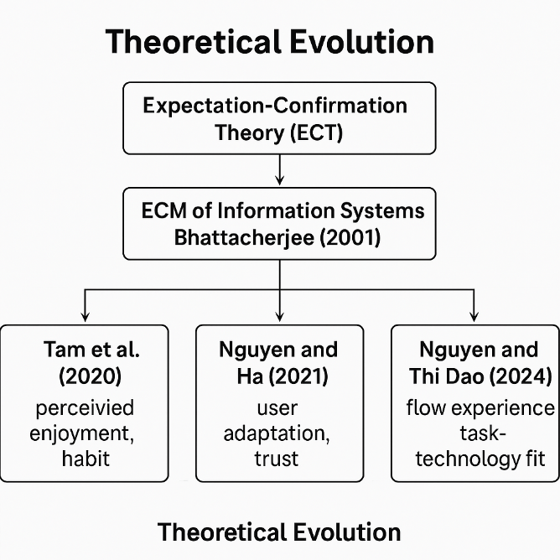
Fig: Theoretical evolution
(Source: self-developed)
Expectation Confirmation Theory (ECT) is rooted in consumer-satisfaction studies, in which it is presumed that satisfaction is achieved when actual performance falls in line with or surpasses the pre- purchase expectations which results in post purchase loyalty or continuance intention (Bhattacherjee, 2001). Later Bhattacherjee re-conceived the model to the digital environment to create the Expectation-Confirmation Model (ECM) of Information Systems, in which the original expectation variable was replaced by post-adoption perceived usefulness. This change enabled the framework to describe the behaviour of users following the adoption of technology especially in the systems in which constant usage is the indicator of success and not initial acceptance (Bhattacherjee, 2001). The same logic was extended in later studies using Technology Acceptance Model (TAM), Task Technology Fit (TTF) and Self-Determination Theory (SDT) constructs to consider motivational, contextual and experiential factors of post adoption behaviour (Tam et al., 2020).

2.2.1 The Expectation Confirmation Model Extensions.
Because Tam et al. applied the ECM to mobile-app settings, the model has offered essential insights into the interactions of perceived enjoyment and habitual use with confirmation and satisfaction to determine outcomes on continuance intention (Tam et al., 2020). They found that their empirical model revealed that confirmation and satisfaction have the most significant direct effects on continued use and perceived usefulness mediates this effect, indicating that the judgments made by the users of reliability have a more significant impact on continuing engagement compared to design novelty.
Likewise, Nguyen and Ha proposed the user adaptation and trust as moderators in the mobile-shopping context, and through the structural-equation modelling, they found that adaptive behaviour, which is the skills of the consumer to match the functionality of the app, augmented the relationship between confirmation and satisfaction (Nguyen and Ha, 2021). The effect of satisfaction on continuance is also enhanced by trust, which shows that, emotional assurance increases cognitive confirmation effects.
Based on these results, Nguyen and Thi Dao (2024) combined flow experience and task-technology fit into a new model of m-commerce continuance and demonstrated that ease of interaction and intrinsic enjoyment have a joint positive effect on the satisfaction-continuance relationship. Their research suggests that the slight inconsistency in the services can hardly defuse satisfaction when the consumers feel like they are in a flawless integration between the personal objective and technological assistance (Nguyen and Thi Dao, 2024). All of these empirical advances indicate that continuance intention is a changing consequence of trust, flexibility, and experiential immersion, but not a fixed effect of met expectations.
Included in the theoretical developments applied to retail loyalty apps like Tesco Clubcard, these theoretical developments imply that retention of customers depends not on the motivational aspects of transactions but on the credibility, flexibility and engagement design of the platform. Put another way, the continuity to use arises when the personalisation, reliability, and informational transparency are constantly combined with confirming consumer anticipations (Tesco PLC, 2024).

2.2.2. Price Sensitivity and Post Adoption Adjustment
ECM has been furthered to examine behaviour of the economy. Susanto et al. investigated m-commerce continuance and price sensitivity and found that satisfaction mediates the confirmation-continuance relationship but the latter relationship is weaker when price sensitivity is high (Susanto et al., 2023). Acutely price sensitive consumers need better performance assurance to be loyal. What it means is that any loyalty programmes such as Tesco Clubcard that relies on discounts need to balance emotional and experience value failure to which users will do away with it once the incentives have reduced.
Simultaneously, Rahi et al. integrated Self-Determination Theory (SDT) and ECM within the framework of internet banking and discovered that intrinsic motivation complies with confirmation and perceived usefulness in the description of continuance intention (Rahi et al., 2021). Autonomous and competent psychological fulfilment was a better predictor of loyalty compared to monetary rewards. Applying this to Tesco context, allowing the users to be in control of the data and giving them self-service options may bring more satisfaction than promotions on the price, further strengthening the loyalty by creating the sense of autonomy and trust.

2.3 Behavioural Constructs: Trust, Flow and Social Comparison.

2.3.1 The Role of Trust
One of the most conclusive antecedents of a post-adoption loyalty is trust. Nguyen and Dao revealed that instead of being a heightening factor of satisfaction, perceived trust also has a direct impact on continuance intention in mobile banking applications (Nguyen and Dao, 2024). When the users trust the integrity and safety of the data on the platform, then this trust is more important than convenience in estimating the long-term usage. On the same note, the researchers of Talwar et al. have determined that preliminary trust forms the basis of mobile-payment continuance, particularly high-risk financial transactions (Talwar et al., 2020).
Similarly, trust, in the case of Tesco’s digital retail ecosystems, is the basis of the relationship between the user and data infrastructure of the firm. Cybersecurity, transparency and responsible AI are a few of the building blocks of customer confidence discussed in the Tesco Annual Report 2024, which directly attributes digital trustworthiness to brand equity (Tesco PLC, 2024). Thus, the key tenets of trust in online banking, such as security, reliability and integrity, are exactly applicable to the level of consumer trust in data-driven loyalty at Tesco.

2.3.2 Flow Experience and Habitual Use.
Flow, which is a state of immersive psychological involvement has become an important moderator of digital loyalty studies. Nguyen and Thi Dao empirically demonstrated that flow boosts both perceived usefulness and enjoyment in parallel reinforcing satisfaction and continuance intention (Nguyen and Thi Dao, 2024). Recurring exposure then results in a habitual interaction wherein the further loading of such interaction is out of behavioural inertia and not conscious consideration.
To substantiate this idea, Chiu et al. introduced a hybrid of ECM and Investment Model to examine health-app continuance and discovered that user satisfaction is connected with investment size -time, effort, and emotional energy, to form long-term commitment (Chiu et al., 2021). On the same note, Gupta et al. applied ECT to smart-wearables and found out that social comparison positively affects perceived value and emotional attachment, promoting continuance intention (Gupta et al., 2021). Such results suggest that gamified experiences, competitive ratings, and belonging to the community can be used to strengthen the loyalty mechanisms. In connexion to Tesco, this can be replicated by incorporating gamification into the online space of Clubcard to create emotional attachment and habitual behaviour that is not purely utilitarian.

2.3.3 Generational behaviour and Technological Adaptation.
The reaction of the user to technology is influenced by generation trends and adaptability. Ngubelanga and Duffett conceptualised mobile-commerce satisfaction among the millennials, based on an extended Technology Acceptance Model (TAM) and discovered the core antecedents of perceived usefulness, ease of use, and value (Ngubelanga and Duffett, 2021). The intermediating role of ease of use between the technological characteristics and the satisfaction emphasises the ergonomic importance of interface design as used in the digital setting. Jain et al. further refined this view by proposing the Technology Continuance Theory (TCT), to find out that convenient, trustful, and hedonic motivation are all positive predictors of continuance intention in mobile shopping (Jain et al., 2022). Their results revealed that both utilitarian (efficiency) and hedonic (enjoyment) gratifications are required to be sustained.
Generational diversity, in the case of Tesco, influences patterns of engagement younger shoppers are more attracted to gamified convenience, but older customers are more concerned with reliability and transparency. These lessons highlight the idea that different user groups have different adaptation mechanisms that demand special communication, design interface needs and reward systems that ensure that satisfaction levels are maintained among various demographic groups.

2.4 Service Quality, Expectation, and Digital Satisfaction.

2.4.1 Service Quality in Retail Situations.
The operationalisation of service quality in the traditional retail research is based on the SERVQUAL model which includes the elements of tangibility, reliability, responsiveness, assurance, and empathy. Singh et al. used SERVQUAL to Tesco hypermarkets in Malaysia and established that all five dimensions have a significant effect on satisfaction, and reliability and assurance were strongest predictors (Singh et al., 2021). The way of consistent performance and staff competence were on the list of the most appreciated features by customers compared to the atmospheric and emotional aspects. These findings emphasise the fact that satisfaction is motivated by assurance and reliability, which are functional equivalents of trust, prior to the digital mediation process.
These aspects in digital retail translate to reliability of the system, responsiveness of the system, and assurance of data-security. Since human service interfaces become less necessary and self-service interfaces become more prevalent, perceived reliability substitutes empathy as a motivator of critical satisfaction. In the case of the Clubcard App of Tesco, functional reliability along with clear communication and quick resolution of any issue directly translates the satisfaction processes that are evident in the conventional service setting.

2.4.2 Gaps in Expectation and confirmation dynamics.
Confirmation, in ECM, is similar to SERVQUAL, in terms of expectation-perception gaps. Negative gaps where perceived performance is below the expectation show those areas where satisfaction can be low. Singh et al. (2021) noted that Tesco Malaysia has continued to show negative differences along the dimensions without improvement, which portrays that customer expectations are changing at a faster rate than service delivery development. In digital ecosystems, this inflation of expectation is exacerbated by the fact that the technological innovation keeps reshaping the understanding of what consumers consider as the normal quality of the services.
Wolniak et al. confirmed this assertion, indicating that self-scanning, AI, and augmented-reality systems enhance efficiency, but at the same time increase the pace at which expectations are made in terms of speed, accuracy, and personalisation (Wolniak et al., 2024). Satisfaction is hence temporary and dependent on the level of technological parity. In the case of Tesco, being highly invested in AI-based personalisation, the perception of modernity will be positively affected; however, the customer standards will also increase; their unmet expectations may consequently turn into acuter dissatisfaction (Tesco PLC, 2024). To maintain loyalty, there is a need to balance innovation and stability to avoid the problem known as expectation overshoot where the demands by consumers exceed the capability of the system.

2.5 Digital Transformation and Operational Infrastructure.
Grocery retail digital transformation entails the integration of customer front-end interfaces and back-end analytics and logistics platforms. Wolniak et al. summarised the new technologies included in-store scanners, AI recommendation engines, and augmented-reality navigation tools, concluding that all new technologies can be successful only with the help of interoperability and user trust (Wolniak et al., 2024). Retailers that can combine the reliability of operations with user- friendly front end experiences have the capacity to create the sense of convenience which has continued to be one of the antecedents of satisfaction.
This is the model of integration that can be found in Tesco infrastructure. It uses real time analytics to customise offers, forecast inventory requirements and strategize promotions with behavioural data through partnership with Dunnhumby (Tesco PLC, 2024). This system connects the experience of the customer directly to the operational agility, which proves that the digital loyalty is not provided solely through the design of marketing, but also through the technical implementation. Similar to world-betters, like the introduction of physical and digital touchpoints at Apple, the strategy of Tesco will improve the continuity in data analytics, consumer trust, and their satisfaction.
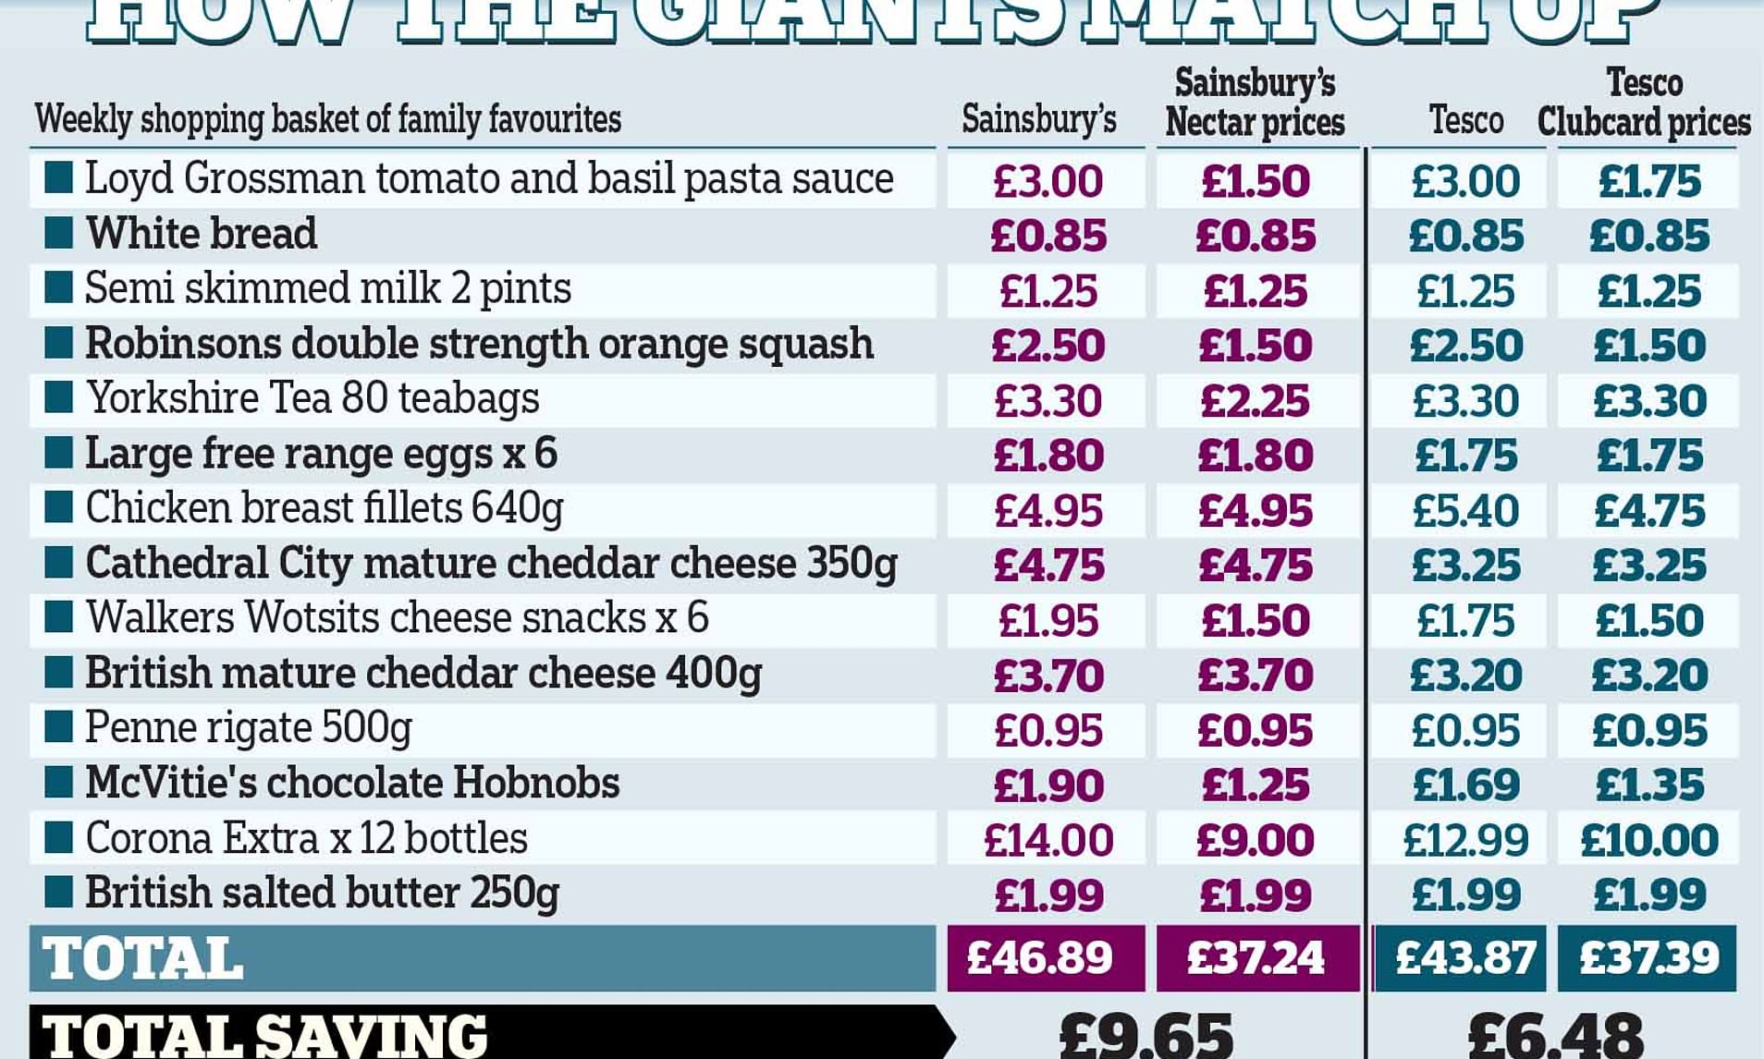
Fig: club card prices of Tesco
(Source: The Sun., 2025)
A comparative analysis shows that the Tesco Clubcard is the cheapest overall price of a typical grocery basket at about £6.48 cheaper than regular Tesco prices and 9.50 cheaper than its equivalent at Sainsbury which shows the cost-based advantage and loyalty prospects of data-driven retail programmes in the UK market (This is Money, 2025). Tesco 2024 Annual Report notes that automation and real-time analytics of Dunnhumby have facilitated increased personalisation and improved supply-chain responsiveness with meaningful increases in Trust Index and Net Promoter Score growing by three and seven points respectively (Tesco PLC, 2024). These results underscore the fact that operational efficiency driven by data insight, becomes a visible customer loyalty enhancement.
Nevertheless, the issue of loyalty analytics creates an intricate ethical aspect. Customers are more likely to be willing to give their personal data when they feel that there is a fair and equal value exchange. The data on the research of digital-banking also indicate that the continuance intention is greatly influenced by the trust towards data processing since the transparent and safe management increases the level of satisfaction and usage frequency (Nguyen and Dao, 2024). The same premise is applied to the retail industry: intrusive targeting may compromise satisfaction irrespective of functional efficiency. Ethical AI practises and openly administered data is thus a compliance factor and a long-term customer trust strategy of Tesco (Tesco PLC, 2024).
Moreover, the price sensitivity has such a drastic impact in moderating the loyalty. Susanto et al. (2023) found out that highly price sensitive buyers do not have a strong continuance intention unless there is strongly confirmed performance expectation. In the dual-level pricing scheme at Tesco, members of the Clubcard obtain discounted prices, but long-term success can only be attained by whether the consumers are convinced that these differences are genuine offers and not over-inflated base prices. This balance of value impression, fairness, and trust ends up determining the sustainability of digital loyalty within the competitive grocery retailing.

2.6 Tesco-Specific Evidence and Market Background

2.6.1. Customer Behaviour Insights
The loyalty-card information of Tesco gives one of the most detailed behavioural datasets in retailing all over the world. These data were utilized by Rose et al. (2024) to investigate the influence of weather conditions on the purchasing pattern of the so-called click and collect, with the study discovering that the poor weather condition elevated the time of ordering online more frequently but decreased the number of impulse purchases. Their machine-learning model found temporal and regional variation and, therefore, validated the predictive value of loyalty analytics. This fact points to the ability of Tesco to convert data on behaviour to operational forecasting an ability that enhances customer satisfaction based on the ability to keep stock on hand and make reliable services.
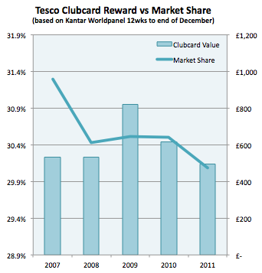
Fig: Tesco reward vs market share for club card
(Source: Sage, 2012)
The comparison demonstrates that during 2007-2011, as the value of the Tesco reward Clubcard grew, the market share of the company reduced, which shows that more significant investments in loyalty did not always guarantee equal returns on the retention (CustomerThink, 2025). This trend indicates that other than financial rewards, loyalty effectiveness is based on the perceived relevance and experience of the programme. Hughes (2021) provided a more socio-economic explanation that the impact of Clubcard was not just on retail sales but on the activity in other related sectors like the local housing markets. According to his findings, Tesco loyalty ecosystem is a macro-economic tool, which influences the household spending and the behaviour of the community. Taken together, those lessons suggest that brand embeddedness is deeper than transactional loyalty in Tesco - it represents a complex system in which marketing, data, and socio-economic trust interrelate to create a sustained engagement between customers.

2.6.2 Crisis Management and Operation Resilience.
Digital infrastructure and data agility are becoming critical in terms of crisis resilience in retail operations. Winter et al. (2024) depicted that clearly, in their case study of Tesco performance during national crises, the company used its Loyalty database infrastructure to communicate effectively with customers, distribute food products and food stock sustainably. Throughout these times, the Clubcard system of Tesco stopped being a marketing tool and became an adaptability tool of strategy that maintained customer satisfaction and loyalty during high levels of uncertainty. These results support the thesis that digital loyalty programmes serve as marketing and logistical instruments and trust-building mechanisms.
Hartfield (2024), in his turn, has also noted that one of the primary entry obstacles in the UK food retail has become data-driven differentiation. According to the case study, the Tesco and other incumbent companies have proprietary data systems, which generate significant strategic value by generating unique information about consumer behaviour. This proves correct the idea that loyalty analytics are not a supportive marketing deliverable but a competitive resource foundation in the long run market place. Making use of predictive modelling and supply-chain synchronisation, Tesco uses its Clubcard data to guarantee inventory efficiency and strengthen the consistency of engagement. Analytics combined with the ability to operate therefore transforms loyalty into strategic capability with quantifiable resilience advantages.

2.6.3 Service and Digital Experience Incorporation.
The merging of the physical and digital service space is one of the characteristic elements of the hybrid operations in Tesco. The boundaries between the convenience of online and in-store retailer interaction have been erased by the introduction of self-service checkouts and mobile payment interfaces by the retailer. Singh et al. (2021) emphasised that assurance and reliability are the most common motivators of satisfaction in the traditional retail setting, and Wolniak et al. (2024) discovered that in the digital setting, user-friendliness and trialability take the first place. The omnichannel strategy of Tesco thus has to undertake a delicate balance between the two dimensions so that trust and comfort are always passed over touchpoints.
This composition is also a manifestation of the Expectation-Confirmation rationale: the perceived credibility of the channel delivery of services as the customer evolves by gaining more digital experience turns into the basis of satisfaction. The consistency of the interaction quality, be it through the app or the in-store interface, is what makes the perceived usefulness and reliability of the brand to be the same and, therefore, strengthens the behavioural loyalty.

2.7 Theoretical Framework
The theoretical model developed based on the literature review is a synthesis of the Expectation-Confirmation Model (ECM) developed along with the variables of trust, perceived usefulness, satisfaction, and continuance intention.
Expectation Confirmation is based on the relationship between the expected performance and actual performance. Satisfaction is improved by positive confirmation, where the personalisation of apps and reward delivery are above the expectations (Tam et al., 2020).
Perceived Usefulness is a measure that includes how the consumer perceives the capability of the app to enhance the convenience of shopping and financial efficiency (Ngubelanga and Duffett, 2021).
Trust serves as an antecedent and a moderator, which increases satisfaction and directly directly affects the continuance intention (Nguyen and Dao, 2024; Talwar et al., 2020).
Satisfaction is a cognitive appraisal that is transformed into behavioural loyalty but in an emotional state (Chiu et al., 2021).
Continuance Intention is the probability of the user to continue with the usage, which is reinforced with the presence of habitual behaviour and immersive interaction (Nguyen and Thi Dao, 2024).
The model can be supplemented with the price sensitivity (Susanto et al., 2023) and service reliability (Singh et al., 2021) as secondary moderators to consider the context and operational factors. Together, all these constructs present post-adoption loyalty as a multidimensional process whereby satisfaction is driven by confirmation, relationship stabilised through the trusting relationship and usage maintained through perceived value.
The framework places the confirmation of expectations in the middle of a network between the cognitive, affective, and behavioural parts. The perception and intention are mediated by satisfaction and the strength of the relationships is moderated by trust. The continuance behaviour is influenced by contextual moderators, such as price fairness, reliability, and digital ethics, and satisfaction, which are perceived usefulness, ease of use, and value. This combined framework is used in the case of the Tesco Clubcard; it can be seen that reliability of the technology, ethical data processing and perceived reciprocity are intertwined to maintain customer loyalty in an established digital retail channel.

2.8 Gaps in Literature
The current body of literature is overloaded with the continuance of mobile applications based on Expectation-Confirmation and Technology Acceptance theories, but there are gaps in the context of retail usage. There are very limited researches that measure the loyalty apps within the grocery markets with a specific focus on the influence of trust, data morals, and AI-based personalisation on satisfaction and retention. There is a lack of empirical studies on Tesco digital loyalty environment. The empirical evidence affirms the three pillars of digital loyalty, including trust, confirmation and habitual satisfaction across fields. Nevertheless, methodological diversity shows contextual peculiarities. Risk perception and data security are one of the primary focus of banking and payment studies (Talwar et al., 2020; Nguyen and Dao, 2024), and hedonic and utilitarian balance is one of the major areas of retail applications (Jain et al., 2022). The variability of the results indicates that the continuance intention is multi-causal where cognitive, affective and contextual fulfilment have to occur simultaneously.
More importantly, in the literature, there is a gap to be filled in terms of tension between technological innovation and expectation management. Digital transformation is constantly raising consumer standards in line with Wolniak et al. (2024) and it is therefore impossible to achieve perpetual satisfaction. This means that loyalty plans which only rely on the novelty of technology face the threat of becoming obsolete when innovations begin to spread. The long-term retention is therefore based on the stability of the trust and the sense of the fairness and not upon the cycles of innovation.
These theoretical insights are united in the ecosystem of Tesco. The corporate reports and empirical research on retail show that consumer satisfaction is supported by data analytics and automation and service reliability (Tesco PLC, 2024; Singh et al., 2021). However, with the decline of differentiation via discount, sustenance of loyalty depends upon emotional trust, ethical information utilisation, and personalised return-to, exactly the variables highlighted in protracted ECM models.
Lastly, the literature cautions as a whole on how adoption measures are being compared to loyalty outputs. The high enrolment rates can mask the poor levels of engagement when the level of satisfaction or trust reduces. This cannot be better explained by the argument that the psychological and experiential processes of post-adoption behaviour are better explicative in the sense of digital loyalty retention in adult retail markets.

2.9 Summary
The current literature body reviewed creates a consistent and dynamic concept of post-adoption loyalty in online retailing. The theoretical base is still based on expectation-confirmation, but when combined with the trust, motivation, and experiential constructs, the explanatory ability of this theory rises. When these models are considered in the context of the Clubcard app developed by Tesco, it is important to focus on the interactions between confirmation, perceived usefulness, and satisfaction in a highly digitised data-rich retail setting. The subsequent level of analysis thus sits in the empirical testing of those constructs in the consumer base of Tesco to ascertain which ones are most predictive of sustained loyalty behaviour.

3. RESEARCH METHODOLOGY

3.1 Introduction
This chapter is meant to discuss and justify the methodological decisions that were made in this study to investigate how Tesco Clubcard mobile app is influencing customer retention in the UK grocery market. The design is based on a systematic methodological reasoning, which conforms philosophical placement, research design, research strategies, sampling, data-collection processes, data-analytical methods, and ethical guidelines. All decisions would be based on literature on methodological rigour to be rigorous, transparent, and in line with the overall objectives of the study.

3.2 Research Onion
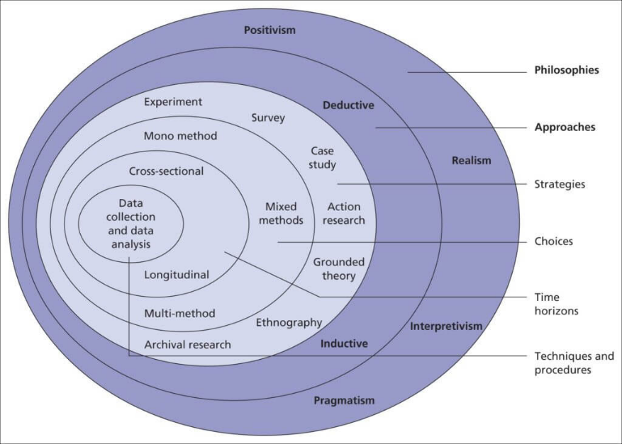
Fig: Research onion
(Source: Saunders et al. 2007)
Saunders et al. interpreted the research onion as a model of methodically making decisions during methodology and the approach starts with philosophical underpinnings and becomes increasingly small to data-collection instruments and techniques of data analysis (Saunders et al., 2007). This stratified model facilitates consistency among epistemology, methodological design and execution. Adhering to this framework enhances the consistency within it as well as makes certain that the methodological decisions are logically tied down between ontology and the analytical output.

3.3 Philosophy of Research
This research philosophy assumes the positivism research philosophy that the reality can be measured, quantified and analysed based on empirical indicators. Positivism concomitant with the studies that are based on observable and measurable phenomena, which are usually operationalised by means of numerical data and structured tools. Positivism is based on the assumption that systematic measurement and statistical relationships allow the generalisability of knowledge, the argument that is strengthened by methodological conversations about the objective and replicability (Alharahsheh and Pius, 2020).
Another difference between positivism and interpretivism is that the former relies on hypothesis testing, detachment, and impartiality of the researcher compared to the latter, which focuses on interpretation and subjective meaning-making of the survey results (Pham, 2018). This philosophic position makes it possible to measure the relationships between the features of the apps, expectation confirmation, trust, satisfaction and continuance intention without making researcher interpretation an independent variable. According to Žukauskas et al., positivism advises empirical measurement with the use of probability as well as deduction and structured data (Žukauskas et al., 2018). Positivism would be the right epistemological basis to the study, as it will involve quantifying drivers of digital loyalty.

3.4 Research approach
The reason why the deductive method is taken is that it starts with the theory, develops theories and then tests these by use of empirical observations. Deduction is appropriate in studies that are based on pre-existing theoretical models, especially when one wants to understand the applicability of previously existing theory in a new setting (Woiceshyn and Daellenbach, 2018).
Such deductive strategies are orderly, systematic, and confirmatory and are appropriate to a study that aims at testing connections between variables reported in the literature, e.g., expectation confirmation, perceived usefulness, trust, satisfaction and continuance intention. According to Azungah, deduction is suitable when logical movement is toward the general to the specific one (Azungah, 2018). This paper adheres to this rule, as it uses the Expectation-Confirmation Model (ECM) and its variations to a particular scenario using Tesco Clubcard users.
Even though some of the researchers emphasize the difficulty of inductive and deductive reasoning separation in practice (Armat et al., 2018), Pearse depicted that deductive analysis is especially applicable when priori constructs are used to define the coding and measurement process (Pearse, 2019). The survey research method is therefore quite congruent with a deductive mode of inquiry due to the structured nature of the research.

3.5 Research Strategy: Quantitative Survey Strategy.
The quantitative survey strategy is selected due to the possibility of obtaining standardised data by a large sample and statistically analysing the relationship of the variables. Consumer research Surveys are a common tool in analysing attitudes, satisfaction, patterns associated with behaviour and retention. According to Ponto, surveys prove to be efficient in terms of self-reported perceptions and correlational tests across demographics (Ponto, 2015).
The plan is highly consistent with the positivism and deduction approaches, as it provides a numerical value of the relationship between Clubcard app features and customer retention results. The generalisability is also supported through the use of survey design but through proper sampling of the instrument and validity and reliability of the instrument used.

3.6 Data Collection Method
Survey Instrument
The structured online questionnaire will be used to collect the data, and it will include the closed-ended items measured on Likert scales in order to determine the levels of expectation confirmation, perceived usefulness, trust, satisfaction, continuance intention, and price/value perceptions. They are quantitative traditions and are compatible with statistical modelling.
Online distribution, which involves LinkedIn, Facebook groups, and online forums of consumers, assisted in quick access to active Clubcard users. Through online surveys, geographical limits are minimized and the participants have the time to fill questionnaires at their own convenience. Taherdoost (2016) described that the validity of the survey was based on its clarity, structure, and measurement of the constructs that were in accordance with theoretical definitions. This is why all questions are based on the constructs that have been proved in researches about ECM.
Sampling Strategy
The purposive sampling strategy is a non-probability strategy. The purposive sampling is appropriate in situations where one wants to sample participants with a certain knowledge or experience as far as the research question is concerned i.e. in this case the participants who are actively utilizing Tesco Clubcard mobile application. Rahi contended that purposive sampling would be suitable in quantitative research studies where certain groups of users will be needed to verify theoretical hypotheses (Rahi, 2017).
It has a target population of 150 respondents who are located in the UK and those who consider themselves to be active users of Clubcard app. This is a small sample size, which will enable enough variability to be statistically analysed and is within the scope of a postgraduate research project. Since the number of users of Clubcard is very large, the sample is not supposed to be statistically representative but analytically representative.
Recruitment and Inclusion Criteria.
The sample will be obtained by posting the survey link in LinkedIn networks, UK-based customer forums, and customer retailing consumer groups. Eligible participants must:
- Be 18 years or older.
- Live in the United Kingdom.
- Redeem the Tesco Clubcard mobile application at least once a month.
- The exclusion criteria are non-users and non-UK persons.

3.7 Data Analysis Methods
The quantitative analysis will be based on descriptive statistics, correlation analysis, and analysis of the relationship between the factors. The online survey platform will be exported to spreadsheets where the data will be cleansed, coded, and structured.
Descriptive statistics will be used to generalise demographic distributions and general trends that are associated with the usage of the app, satisfaction, and retention. Four constructs (trust, expectation confirmation, usefulness, and satisfaction) will be examined in terms of correlation with each other. Using the deductive framework, it will be necessary to test whether the relationships between these constructs are consistent as observed in ECM and other associated models.
Though there are no details given about what particular software was used, it will be analysed in accordance with the logic of analysing the differences and relationships of the means and patterns in a way that is in situational compliance with the quantitative survey approach.

3.8 Ethical Considerations
The upholding of ethical integrity is achieved by adhering to institutional research governance. Every participant will get an information sheet on the purpose of the study, voluntary involvement, and the possibility to quit any time with no penalty. No personal identifiers are going to be gathered; anonymity and confidentiality are ensured.
Consumers involved in the surveys must make informed consent before they have access to the survey. Data will be stored and encrypted using passwords. This is not a deceptive study and there is minimum exposure to risk to the participants.
The procedures are consistent with the general ethical standards in survey research and respect, autonomy, and data protection.

3.9 Constraints of the Research
There are a number of limitations on the generalisability of findings. To begin with, the external generalisability is limited by purposive sampling as the sample might not accurately represent the demographics of the UK Clubcard users on the whole. Second, online surveys are prone to self-selection bias because more opinionated people or those more inclined towards digitization might be willing to take part. Third, the cross-sectional design also restricts the possibility of examining the changes over time, i.e. it is impossible to draw causation.
Moreover, self-reported perceptions can be biased due to a recall bias or the social desirability bias. Lastly, even though the theoretical framework is used to direct the analysis, the lack of longitudinal data limits the level of understanding behaviour change.

3.10 Summary
The methodological decisions on the relationship between Tesco Clubcard app usage and the customer retention have been justified in this chapter. The research is guided by the research onion thus follows positivist philosophy, deductive reasoning and quantitative survey approach. A sample of 150 active users will be sampled purposively and surveyed online and the findings analysed using descriptive and correlational methods. The protection of ethics and limitations in methodology have been recognised in order to maintain transparency and rigour.

4. DATA ANALYSIS

4.1 Introduction
The chapter reports and explains the empirical results of the survey of customers of Tesco Clubcard mobile app in the United Kingdom. The analysis aims at exploring the impact of expectation confirmation, perceived usefulness, trust, satisfaction, and other factors on continuance intention and loyalty to the digital loyalty ecosystem in Tesco among customers.
The chapter has been divided into four major sections. To begin with, the demographic profile and simple usage patterns of the sample are described and analysed graphically. Second, the findings of statistical analysis (SPSS-based procedures) are presented, such as reliability analysis, and correlation of the major constructs. Third, the results are interpreted providing a connexion between the results and the Expectation-Confirmation Model (ECM) and the broader literature covered in the last chapter. Lastly, the chapter ends with a brief wrap up, which sets the stage of discussion and conclusion during Chapter 5.

4.2 Graphical Analysis: Demographic Statistics
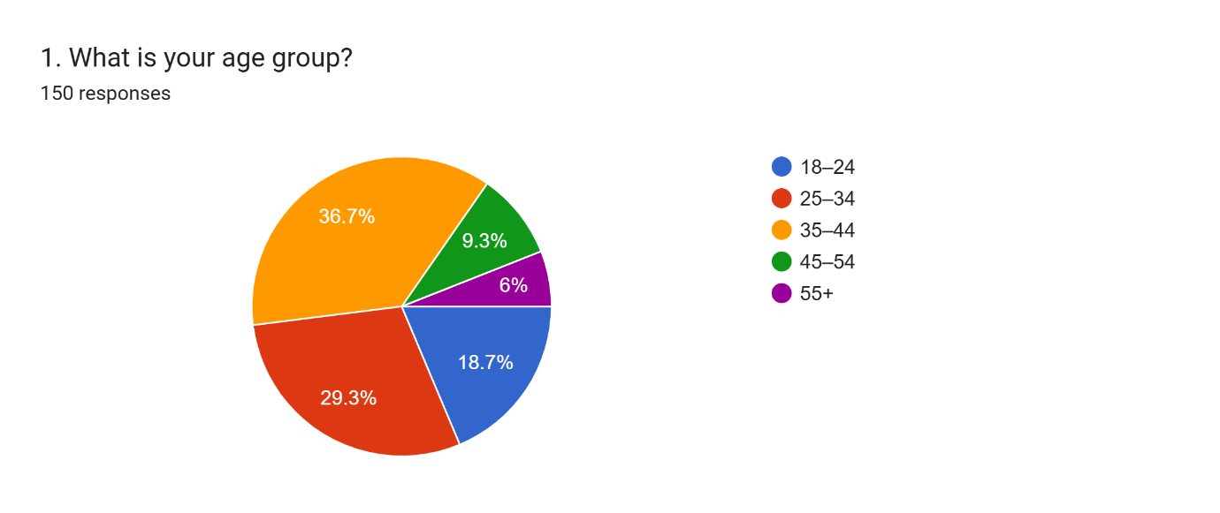
Age Distribution of the Respondents.
Age structure is somewhat average and in the middle adult bands. Out of 150 respondents, 36.7 percent of the respondents are within 35-44 age group,29.3 percent are within the 25-34 age group which is two-thirds of the respondents. Another 18.7% are 18–24 and only 9.3% 45-54 and 6. Such a distribution means that the dataset is strongly skewed towards younger and middle-aged adults who tend to be more digital and familiar with mobile interfaces. The existing study on mobile financial and loyalty apps reveals that these groups tend to be early and heavy adopters as they indicate better technology adoption and use of digital services (Malik et al., 2025). The comparatively low sample size of older users indicates that the results will be most applicable to a tech-savvy group instead of the entire age range of Tesco customers, which has consequences on the extent to which any conclusions can be made on the applicability of the findings to a wider age group (Huma et al., 2024).

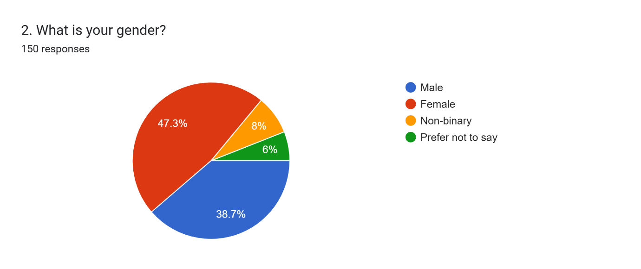
Gender Distribution
The gender distribution has been female majority with 47.3 percent of the respondents indicating that they are female, 38.7 percent are male, 8 percent are non-binary, and 6 percent do not identify. The fact that the non-binary and prefer not to say group is also a relatively large one means that the sample is fairly representative in terms of gender identity and this is valuable when it comes to studying how digital loyalty tools are viewed by diverse users. Research on mobile services indicates that the differences in gender with respect to satisfaction and continuance intention are apt to be mediated by involvement, perceived control and perceived value as opposed to gender per se (Hussain et al., 2025).
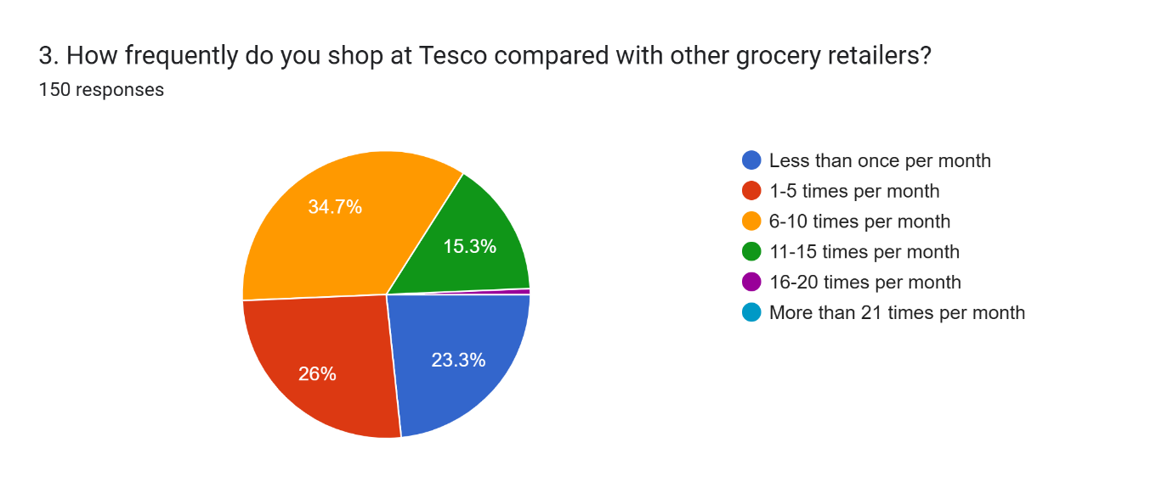
Tesco Frequency of Shopping.
Responses on shopping frequency show that Tesco is visited relatively frequently by the majority of the participants; 34.7% of the respondents shop in Tesco 6-10 times a month, 26 percent shop there 1-5 times a month, and 15.3 percent shop there 11-15 times a month. A further 23.3% visit the shop less than once a month, 0.7% visit 1620 times per month and 0% visit over 21 times per month. Combined, over three-quarters of the sample shop at Tesco at least once monthly, with a minority quite frequently (once a week and more) doing so. This trend is in line with the context of consumption at high frequencies whereby loyalty programmes and mobile applications can generate recurring behavioural interaction (Santosa and Ruslim, 2024).
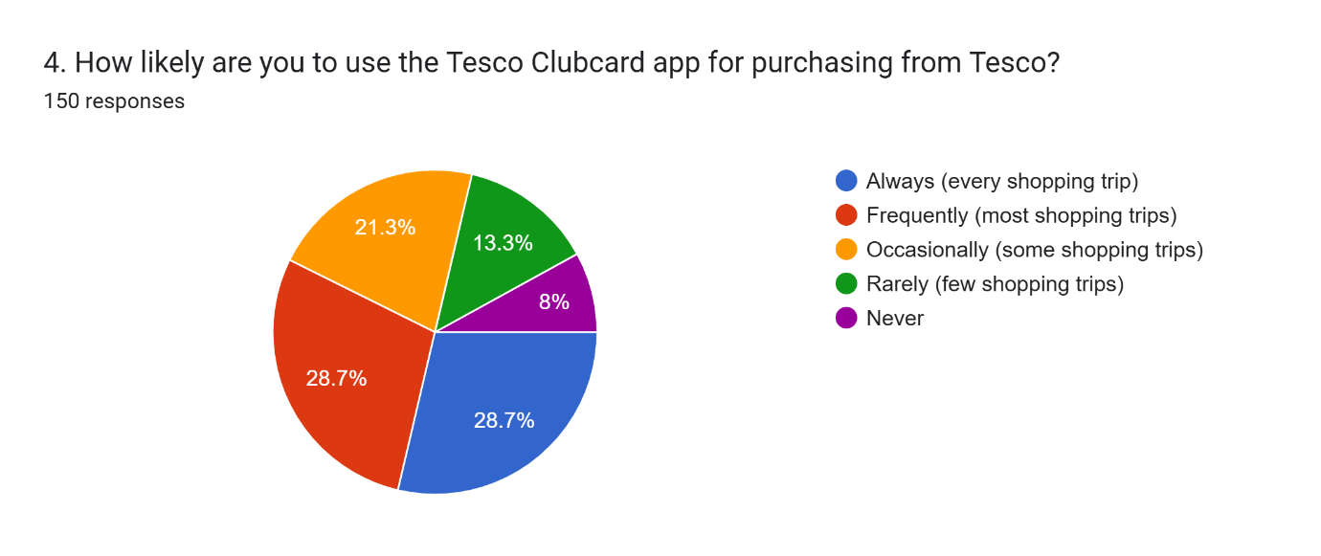
Tesco Clubcard App frequency of Use.
In terms of the Clubcard app, there is a high level of usage at 28.7% saying that they will use the app on every shopping trip and 28.7% indicating that they use it on the majority of shopping trips. 21.3% indicated that they use the app occasionally and 13.3% indicated that they use it rarely and 8% said that they never use the app despite them being shoppers. It implies that approximately 57.4 per cent. can be called heavy or frequent app users, with a little more than this fifth being those who are only sporadically active. The divide is reflected by the results of the mobile wallet and banking literature, where a segment of more engaged users would coexist with a bigger population which utilises digital instruments selectively and could still be served by the traditional ones (Malik et al., 2025; Santosa and Ruslim, 2024).

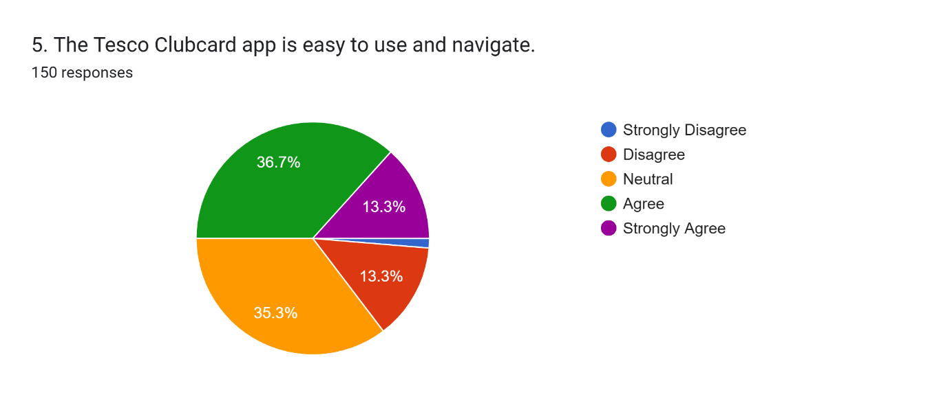
Perceived Ease of Use and Navigation.
In ease-of-use item, the responses are more positive even with marked ambivalence. It is only 1.3 percent strong disagree and 13.3 percent disagree that the Clubcard app is easy to use and navigate. The proportion of 35.3% neutral, 36.7% agree, and 13.3% strongly agree is very large. Differently put, approximately one-half of the sample (50 percent) is straightforwardly agreeable with the usability of the app, with over a third occupying the middle ground. This trend indicates that although there is no mass usability disaster, the interface is not necessarily one that is intuitively seamless to a large percentage of the users. It is a consistent finding of research on mobile services that ease of use and system quality are perceived central antecedents of satisfaction and continuance intention (Honglin et al., 2024; Huma et al., 2024). When this construct is characterised by high levels of neutrality, this is a bad sign: an application that is only acceptable, not actually effortless, will not produce the type of flow and habit that result in high levels of loyalty (Omran et al., 2025).

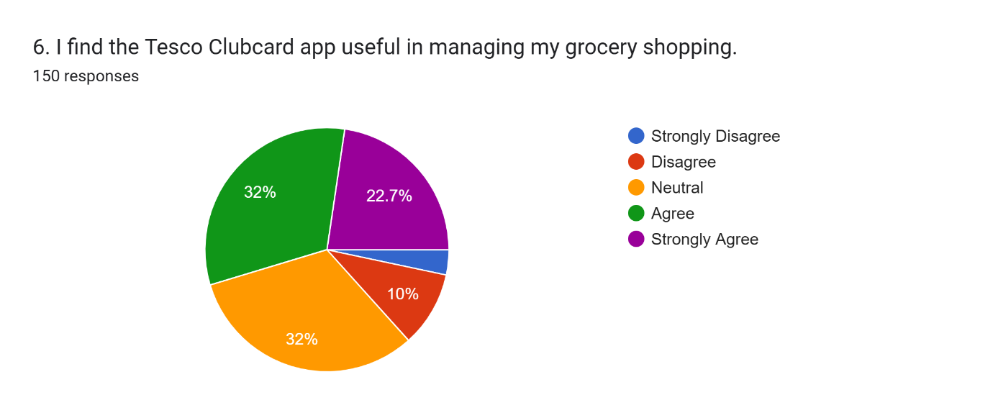
Perceived Usefulness in the Management of Groceries Shopping.
Clearer support of the perceived usefulness of the Clubcard app is observed with 3.3% strongly disagree and 10% disagreeing that the app is useful to grocery shopping management, with 32% of the respondents being neutral. Another 32 percent say that they agree and 22.7 percent strongly agree, which implies that 54.7 percent of the participants obviously say that they find a helpful functionality, either seeing offers, tracking expenditures or organising purchases. Mobile app literature in the financial and retail background shows that perceived usefulness is frequently the most powerful factor in creating satisfaction and loyalty due to its ability to capture the functional value as well as time conservation (Huma et al., 2024; Santosa and Ruslim, 2024). The fact that approximately one-third of respondents were in the neutral category, though, points to the fact that the value proposition of the app is not salient to all people, customer engagement and task-technology fit has been demonstrated to influence the extent to which users feel that features of the apps truly serve their purposes (Khattak et al., 2024; Hussain et al., 2025). This neutral part might be less inclined to further their involvement as time progresses.

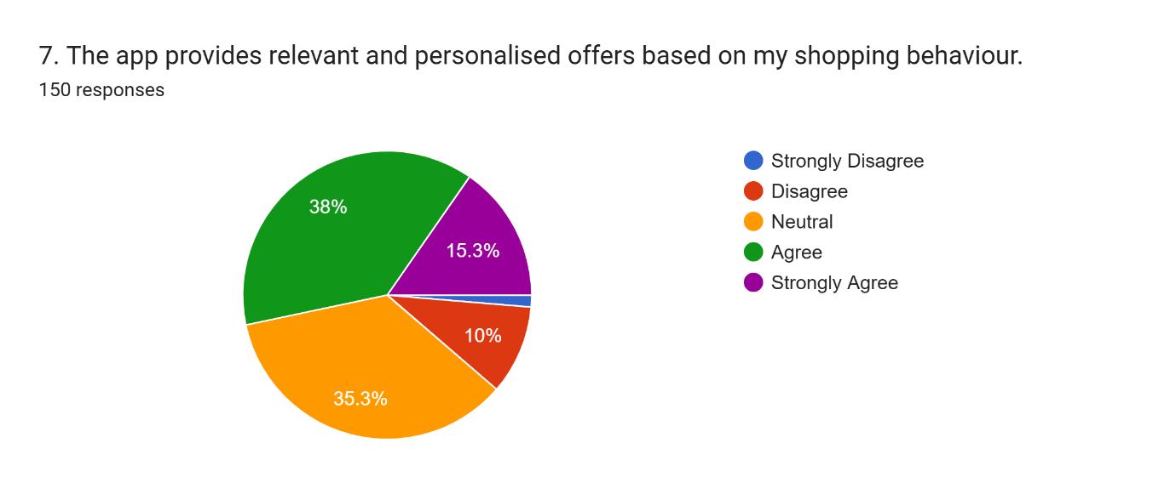
Inferred Personalisation and Relevance of Offers.
When posed the question of whether the app offers relevant and personalised offers, a mostly favourable yet once again mixed picture presents itself. The percentage of those who strongly disagree is only 1.3%, disagree is 10 percent and 35.3 percent show neutrality. In the meantime, there are 38 percent in agreement and 15.3 percent strongly agree (or 53.3 percent positively assess personalisation). Relevance of offers is at the core of both perceived fairness and perceived value in digital loyalty research and its lack is commonly attributed to promotional fatigue and reduced attention (Si et al., 2025). The percentage of those who still cannot choose (more than a third of the respondents) is evidence that most users might not find the offers as fully relevant to their needs. According to the prior work, successful personalisation implies not only the availability of data but also advanced analytics and the careful design of how the behavioural data can be transformed into relevant propositions (Khalufi et al., 2025; Khattak et al., 2024). The descriptive statistics are thus suggesting that personalisation at Tesco is successful to most but might not be yet fully capitalising on the Tesco data resources to a considerable percentage.
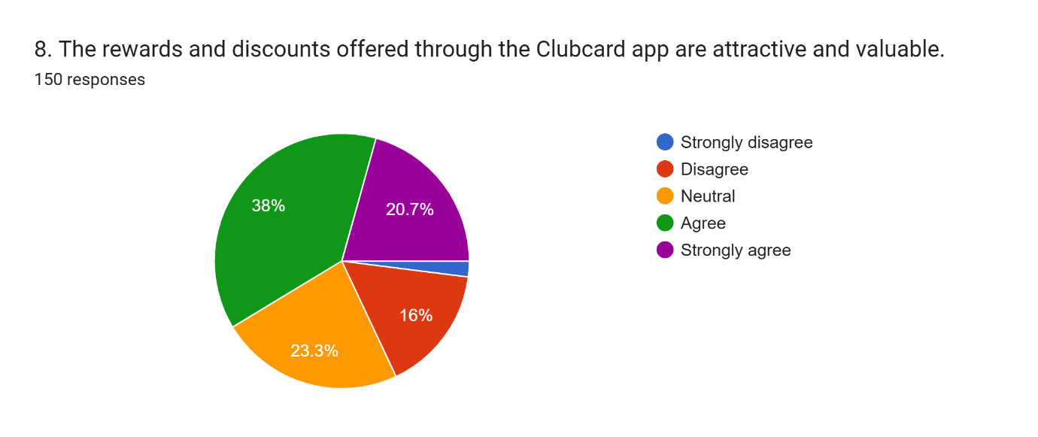
Value of Rewards and Perceived Attractiveness.
Evaluation of rewards and discounts indicate a comparatively higher positive tilt. It is only 1.3 percent strongly disagree and 16 percent disagree that the Clubcard rewards are attractive and valuable with 23.3 percent being neutral. Conversely, 38% concur and 20.7% strongly concur, that is, almost 59 percent of the respondents have a clear perception of tangible value. This is in line with general evidence that well-constructed discounts and rewards are vital in enhancing loyalty in mobile apps especially in price-sensitive market (Malik et al., 2025; Santosa and Ruslim, 2024). Nevertheless, these total 17.3% directions of the outright disagreement show that there is possibly a non-trivial fraction of users who will believe that the price differentials are not generous and that rewards are not given in good faith, but as an attempt to control them. The point on churn indicates that customers who develop the perception that strategies based on gamification or discounts favour the company more than they do the customers, the loyalty performance worsens regardless of the reward systems being nominal (Si et al., 2025).

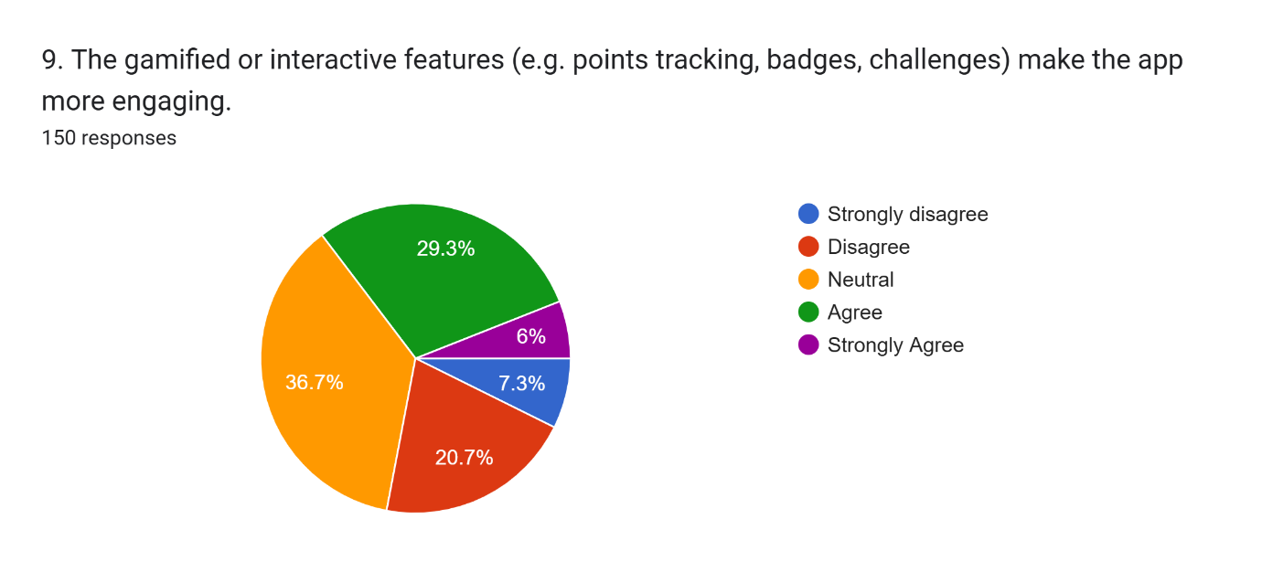
Perceived involvement through Gamified Functions.
The aspect about gamified or interactive elements (e.g. points tracking, badges, challenges) is the one that has a relatively neutral position: 7.3% strongly disagree and 20.7% disagree that the app becomes more engaging with such features, 36.7% have neutral attitudes. The percentage that agrees and strongly agree is only 29.3 and 6 percent, therefore, less than 36 percent obviously find gamification interesting. This is particularly lower than the positive perception registered on usefulness and rewards. The empirical evidence of digital marketing offers a possibility that gamification will decrease the churn and enhance the emotional bond in the case when it is substantially combined with brand appeal and customer engagement (Si et al., 2025). The large neutral and negative scores in this case can be a hint that the existing gamified aspects of Tesco are not salient, poorly comprehended, or merely considered rewarding enough in comparison to the amount of effort invested. This backs up concerns according to which gamification should be well-planned, with its goals and rewards, to prevent the perception of gimmicks or irrelevance (Omran et al., 2025).

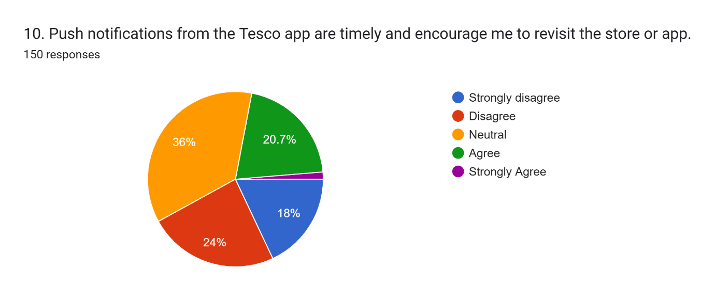
Perceptions of Push Notifications
A key aspect in online shopping is the perception of push notifications. A large percentage of 18 strongly disagree and 24 disagree with notifications being timely and encouraging revisits, that is, 42 percent expressly negative opinion, 36 percent are neutral and only 20.7 percent agree with 1.3 strongly agreeing. Therefore, less than a quarter of the respondents believe that notifications are productive, and almost two times more have an unfavourable opinion of them. The previous literature on the topic of mobile engagement emphasises that inappropriately delivered notifications or excessive frequency may cause irritation, perceived intrusion, and disengagement eventually (Huma et al., 2024). The analysis of mobile wallet and service application highlights that engagement and perceived control over the frequency of communication is an essential factor to keep satisfaction and loyalty (Malik et al., 2025; Hussain et al., 2025).
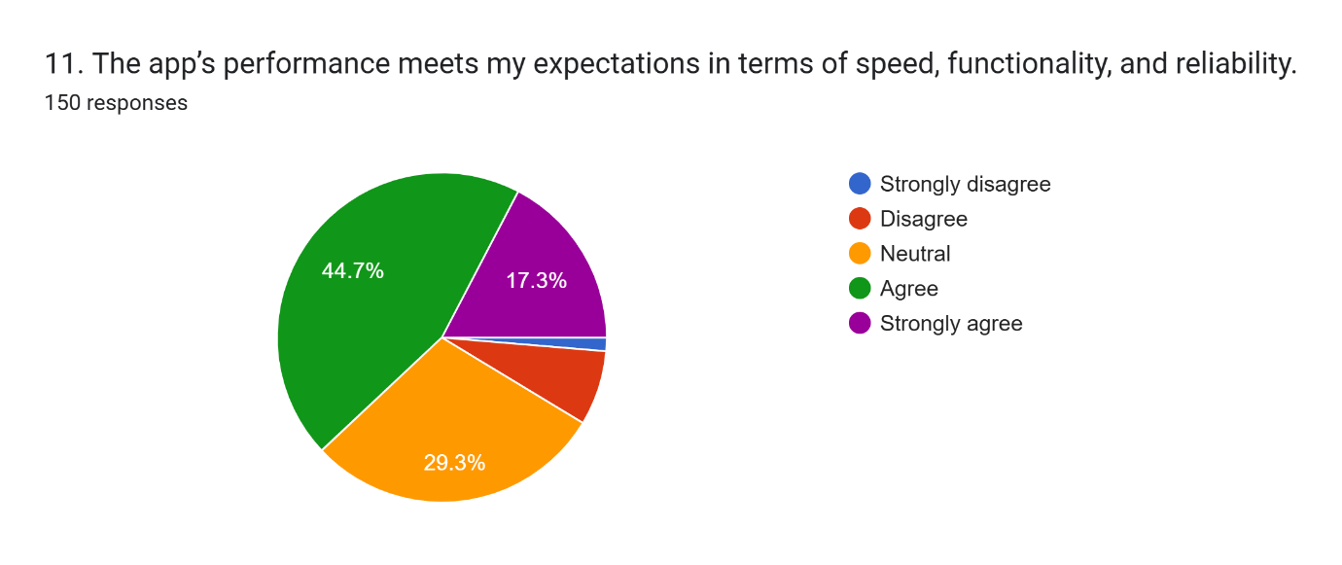
Perceived Performance: Speed, Functionality and Reliability
In item 11, 1.3% of the respondents strongly disagree, 7.3% disagree, 29.3% are indifferent, 44.7% agree and 17.3% strongly agree to the question that the performance of the Clubcard app is up to their expectation. Therefore, approximately 62% are either very satisfied with the speed of the app, its functionality and reliability, which agrees with findings on the key role of the technical quality as a determinant of mobile-service satisfaction and continuance intention (Honglin et al., 2024). The large neutral fraction indicates that performance is satisfactory but not striking to almost one-third of users, which is consistent with the research literature in which secondary system lags or even glitches undermine perceived quality despite its infrequent incidental failure (Huma et al., 2024).
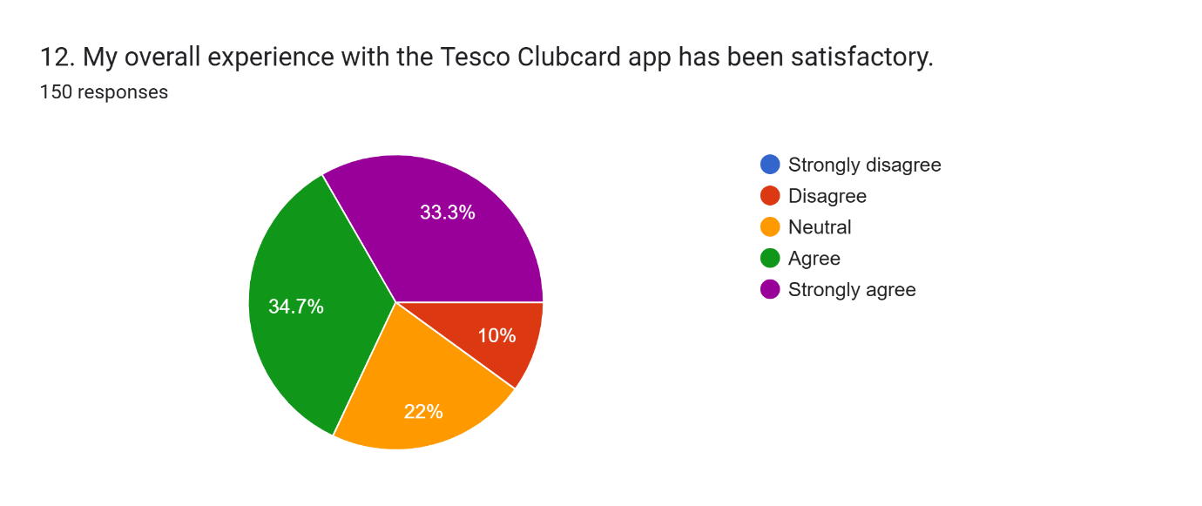
Overall Satisfaction with the Tesco Clubcard App
On overall experience (item 12), 10% disagree that the app has been satisfactory and 22% are neutral whereas 34.7% agree and 33.3% strongly agree, which presents 68% with express satisfaction. This trend suggests that the application is widely popular but it still fails to convince almost a third of users. This partial satisfaction is imperative in the field of loyalty research since only highly satisfied users are likely to change their positive assessments into strong loyalty and advocacy behaviours (Santoso and Ruslim, 2024). The experience in mobile wallet and telecom settings indicates that a moderate level of satisfaction, coupled with a high degree of expectation, can be easily converted into churn in case of competitors providing a smoother or more rewarding experience (Malik et al., 2025; Hussain et al., 2025).

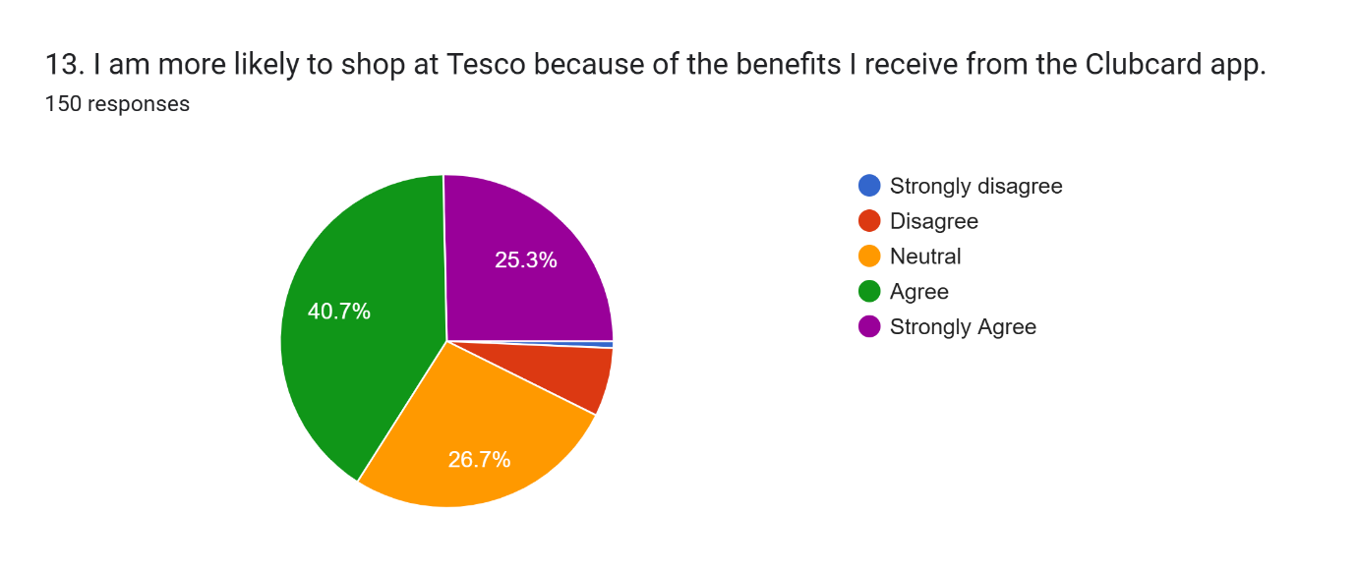
Impact of Perceived Loyalty: More Shopping at Tesco.
Question 13 determines behavioural impact. It is only 0.7 percent that strongly do not agree and 6.7 percent disagree that they are more likely to shop at Tesco due to the benefits of Clubcard thus 26.7 percent are neutral. There is a considerable 40.7 per cent agree and 25.3 per cent strongly agree, thus approximately 66 per cent consider that the application is pushing them towards Tesco. This is consistent with the results that mobile rewards and convenience have the ability to change the store preference and reinforce behavioural loyalty when perceived to be useful and enjoyable (Huma et al., 2024; Si et al., 2025). One fifth of the neutral respondents, however, indicates that benefits can be perceived as additive, not conclusive to most shoppers, which is in line with the literature that loyalty apps tend to strengthen, but not necessarily form, preference toward a specific store (Omran et al., 2025).
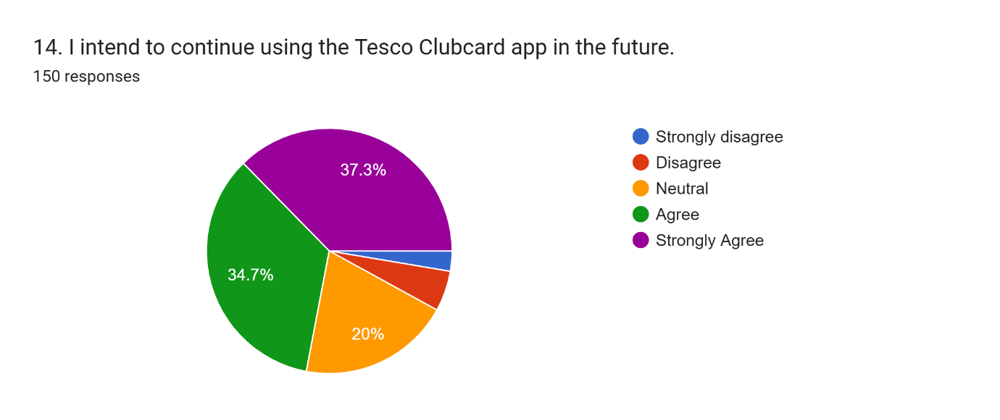
Continuance Intention
To use in the future (item 14), 1.3% strongly disagree and 6.7% disagree that they will still use the Clubcard app, 20% are neutral and the intentions to use it strongly are most common as 34.7% agreed and 37.3% strongly agreed. This is an approximate of 72 percent who expect to continue using the app, which aligns with expectation-confirmation and loyalty theory where satisfaction and perceived value drives continuance intention and quality of relationship in the long-term (Khattak et al., 2024; Khalufi et al., 2025). The 28 percent of neutral or negative answers indicate a strategic valuable segment whose usage cannot be presupposed and whose attitude towards notifications, gamification and personalisation can be a weak foundation of the further loyalty (Malik et al., 2025).

4.3 SPSS analysis
Frequency Table
1. What is your age group?
 |  | Frequency | Percent | Valid Percent | Cumulative Percent
Valid | 18–24 | 34 | 20.5 | 20.5 | 20.5
Valid | 25–34 | 49 | 29.5 | 29.5 | 50.0
Valid | 35–44 | 60 | 36.1 | 36.1 | 86.1
Valid | 45–54 | 14 | 8.4 | 8.4 | 94.6
Valid | 55+ | 9 | 5.4 | 5.4 | 100.0
Valid | Total | 150 | 100.0 | 100.0

2. What is your gender?
 |  | Frequency | Percent | Valid Percent | Cumulative Percent
Valid | Female | 80 | 48.2 | 48.2 | 48.2
Valid | Male | 65 | 39.2 | 39.2 | 87.3
Valid | Non-binary | 12 | 7.2 | 7.2 | 94.6
Valid | Prefer not to say | 9 | 5.4 | 5.4 | 100.0
Valid | Total | 150 | 100.0 | 100.0

3. How frequently do you shop at Tesco compared with other grocery retailers?
 |  | Frequency | Percent | Valid Percent | Cumulative Percent
Valid | 1-5 times per month | 44 | 26.5 | 26.5 | 26.5
Valid | 11-15 times per month | 27 | 16.3 | 16.3 | 42.8
Valid | 16-20 times per month | 1 | .6 | .6 | 43.4
Valid | 6-10 times per month | 57 | 34.3 | 34.3 | 77.7
Valid | Less than once per month | 37 | 22.3 | 22.3 | 100.0
Valid | Total | 150 | 100.0 | 100.0

4. How likely are you to use the Tesco Clubcard app for purchasing from Tesco?
 |  | Frequency | Percent | Valid Percent | Cumulative Percent
Valid | Always (every shopping trip) | 47 | 28.3 | 28.3 | 28.3
Valid | Frequently (most shopping trips) | 51 | 30.7 | 30.7 | 59.0
Valid | Never | 13 | 7.8 | 7.8 | 66.9
Valid | Occasionally (some shopping trips) | 34 | 20.5 | 20.5 | 87.3
Valid | Rarely (few shopping trips) | 21 | 12.7 | 12.7 | 100.0
Valid | Total | 150 | 100.0 | 100.0

Correlations
 |  | ease_n | useful_n | personal_n | rewards_n | game_n | notif_n | performance_n | satisf_n | shopmore_n | contint_n
ease_n | Pearson Correlation | 1 | .596** | .522** | .251** | .326** | .114 | .442** | .478** | .421** | .487**
ease_n | Sig. (2-tailed) |  | .000 | .000 | .004 | .000 | .182 | .000 | .000 | .000 | .000
ease_n | N | 165 | 165 | 165 | 128 | 154 | 138 | 132 | 112 | 163 | 159
useful_n | Pearson Correlation | .596** | 1 | .584** | .188* | .178* | .053 | .332** | .493** | .439** | .536**
useful_n | Sig. (2-tailed) | .000 |  | .000 | .033 | .027 | .534 | .000 | .000 | .000 | .000
useful_n | N | 165 | 165 | 165 | 128 | 154 | 138 | 132 | 112 | 163 | 159
personal_n | Pearson Correlation | .522** | .584** | 1 | .340** | .239** | .296** | .366** | .445** | .419** | .504**
personal_n | Sig. (2-tailed) | .000 | .000 |  | .000 | .003 | .000 | .000 | .000 | .000 | .000
personal_n | N | 165 | 165 | 165 | 128 | 154 | 138 | 132 | 112 | 163 | 159
rewards_n | Pearson Correlation | .251** | .188* | .340** | 1 | .371** | .261** | .400** | .494** | .381** | .359**
rewards_n | Sig. (2-tailed) | .004 | .033 | .000 |  | .000 | .007 | .000 | .000 | .000 | .000
rewards_n | N | 128 | 128 | 128 | 128 | 121 | 105 | 110 | 92 | 126 | 123
game_n | Pearson Correlation | .326** | .178* | .239** | .371** | 1 | .467** | .229* | .279** | .299** | .261**
game_n | Sig. (2-tailed) | .000 | .027 | .003 | .000 |  | .000 | .011 | .005 | .000 | .001
game_n | N | 154 | 154 | 154 | 121 | 155 | 134 | 123 | 102 | 153 | 150
notif_n | Pearson Correlation | .114 | .053 | .296** | .261** | .467** | 1 | .081 | .109 | .080 | .163
notif_n | Sig. (2-tailed) | .182 | .534 | .000 | .007 | .000 |  | .404 | .314 | .351 | .059
notif_n | N | 138 | 138 | 138 | 105 | 134 | 138 | 108 | 88 | 137 | 135
performance_n | Pearson Correlation | .442** | .332** | .366** | .400** | .229* | .081 | 1 | .444** | .359** | .482**
performance_n | Sig. (2-tailed) | .000 | .000 | .000 | .000 | .011 | .404 |  | .000 | .000 | .000
performance_n | N | 132 | 132 | 132 | 110 | 123 | 108 | 133 | 101 | 130 | 127
satisf_n | Pearson Correlation | .478** | .493** | .445** | .494** | .279** | .109 | .444** | 1 | .614** | .575**
satisf_n | Sig. (2-tailed) | .000 | .000 | .000 | .000 | .005 | .314 | .000 |  | .000 | .000
satisf_n | N | 112 | 112 | 112 | 92 | 102 | 88 | 101 | 113 | 110 | 107
shopmore_n | Pearson Correlation | .421** | .439** | .419** | .381** | .299** | .080 | .359** | .614** | 1 | .673**
shopmore_n | Sig. (2-tailed) | .000 | .000 | .000 | .000 | .000 | .351 | .000 | .000 |  | .000
shopmore_n | N | 163 | 163 | 163 | 126 | 153 | 137 | 130 | 110 | 163 | 158
contint_n | Pearson Correlation | .487** | .536** | .504** | .359** | .261** | .163 | .482** | .575** | .673** | 1
contint_n | Sig. (2-tailed) | .000 | .000 | .000 | .000 | .001 | .059 | .000 | .000 | .000
contint_n | N | 159 | 159 | 159 | 123 | 150 | 135 | 127 | 107 | 158 | 159
**. Correlation is significant at the 0.01 level (2-tailed).
*. Correlation is significant at the 0.05 level (2-tailed).

Regression
Variables Entered/Removedª
Model | Variables Entered | Variables Removed | Method
1 | performance_n, notif_n, useful_n, game_n, personal_n, rewards_n, ease_n^{b} | . | Enter
a. Dependent Variable: satisf_n
b. All requested variables entered.

Model Summary
Model | R | R Square | Adjusted R Square | Std. Error of the Estimate | Change Statistics
 |  |  |  |  | R Square Change | F Change | df1 | df2 | Sig. F Change
1 | .638ª | .407 | .336 | .47934 | .407 | 5.694 | 7 | 58 | .000
a. Predictors: (Constant), performance_n, notif_n, useful_n, game_n, personal_n, rewards_n, ease_n

ANOVAª
Model |  | Sum of Squares | df | Mean Square | F | Sig.
1 | Regression | 9.158 | 7 | 1.308 | 5.694 | .000^{b}
1 | Residual | 13.327 | 58 | .230
1 | Total | 22.485 | 65
a. Dependent Variable: satisf_n
b. Predictors: (Constant), performance_n, notif_n, useful_n, game_n, personal_n, rewards_n, ease_n

Coefficientsª
Model |  | Unstandardized Coefficients |  | Standardized Coefficients | t | Sig. | Collinearity Statistics
 |  | B | Std. Error | Beta | t | Sig. | Tolerance | VIF
1 | (Constant) | .645 | .511 |  | 1.264 | .211
1 | ease_n | .047 | .093 | .068 | .510 | .612 | .580 | 1.723
1 | useful_n | .233 | .085 | .363 | 2.740 | .008 | .584 | 1.714
1 | personal_n | .040 | .095 | .054 | .425 | .672 | .629 | 1.590
1 | rewards_n | .236 | .094 | .307 | 2.493 | .016 | .675 | 1.482
1 | game_n | .045 | .087 | .063 | .518 | .607 | .701 | 1.427
1 | notif_n | .022 | .084 | .031 | .265 | .792 | .753 | 1.327
1 | performance_n | .209 | .110 | .219 | 1.908 | .061 | .779 | 1.283
a. Dependent Variable: satisf_n
The initial outputs of the SPSS give descriptive statistics of the sample (N = 150). The age distribution is biassed towards the working-age population, with 36.1 and 29.5% of the population belonging to 35 -44 and 25 -34 age groups, respectively, and only 5.4% of the population is aged 55 or above, which means that the dataset consists mainly of digitally active consumers, who tend to be more willing to use mobile services. The gender is comparatively equal but somewhat slightly female: 48.2% female, 39.2% male, 7.2% non-binary and 5.4% prefer not to say. The data about shopping frequency indicate that 34.3% of the people shop at Tesco 6-10 times a month and 26.5% shop 1-5 times a month, with only 22.3% shopping less than once in a month, which is a good combination of frequent and light shoppers. Regarding the use of app, 28.3% use the Clubcard app on every trip and 30.7% use the app frequently; 7.8% claim to never use the app. It means that most of the respondents are frequent app users, which is significant to study post-adoption behaviour.
Correlations Likert-scale key construct between each other were then determined based on bivariate correlation. Each of the core feature variables (ease of use, usefulness, personalisation, rewards, gamification, notifications, and performance) has a positive correlation with satisfaction although the strength is different. Most pronounced zero-order correlations with satisfaction are found with rewards (r = 0.494), perceived usefulness (r = 0.493), ease of use (r = 0.478), personalisation (r = 0.445) and performance (r = 0.444) and gamification has a less significant though significant association (r = 0.279). The notion of notification shows a small and insignificant relationship with satisfaction (r = 0.109, p > 0.05). Satisfaction is also related to shopping more at Tesco (r = 0.614) and continuance intention (r = 0.575) and these two loyalty measures are inter-related in a consistent manner (r = 0.673), which indicates a consistent loyalty construct.
The standard multiple regression was used to determine the key predictors of the satisfaction with the main independent variable being the satisfaction and all the seven feature variables were used as the independent variables at the same time. The model is statistically significant (F(7,58) = 5.694, p < 0.001) and has an ability to explain 40.7 percent of the variation in the level of satisfaction (R 2 = 0.407; adjusted R 2 = 0.336). The diagnostics of collinearity indicate that there is no severe multicollinearity since the tolerances are equal to 0.58-0.78 and the VIF measures 1.28-1.72. There are three predictors that are notable in the coefficients table. The largest standardised effect ( 0.363, p = 0.008) is perceived usefulness and then rewards value ( 0.307, p = 0.016). The performance of the app is also favourable and has a proximity to conventional significance ( 0.219, p = 0.061), but the remaining variables do not hold any significant value when ease of use, personalisation, gamification and notifications are considered. This trend indicates that, after removing the overlap of variables, the usefulness of the app and the appeal of the rewards are the most important sources of satisfaction.
Reliability and validity
Reliability and validity were also taken into consideration so that the findings of the survey could be believable and readable. The questionnaire questions were made in a way that they adapted known constructs of digital continuance and loyalty including perceived ease of use, usefulness, personalisation, rewards worth, gamification, effectiveness in notification, perceived performance, satisfaction and continuance intention. Internal consistency of the attitudinal items can be determined by using Cronbachs alpha in SPSS after data cleaning and recoding. When several items are employed to denote one construct, an acceptable level of alpha would be able to support the idea that the items have a consistent measurement of the same underlying concept. In the case where a construct is captured by a single item, internal consistency testing cannot be used and instead the reliability is supported by a proper wording of an item and correspondence with previous empirical measures. Certain aspects such as face and content validity were enhanced by making sure that the items were in line with the objectives of the study and portrayed commonly used dimensions in branded app engagement and digital loyalty researches. In general, these measures back the reliability and validity of the dataset that was employed to perform the correlation and regression tests.

4.4 Interpretation of findings
The descriptive profile proves that Tesco Clubcard app is primarily adopted by rather young to middle-aged adults, which have been demonstrated to be at ease with mobile banking, wallet and branded apps (Santoso and Ruslim, 2024). This correlation leads to a belief that the sample can be used to assess the dynamics of digital loyalty in a mainstream grocery context. The large percentage of frequent app users also shows that the respondents are experienced enough to make evaluative judgments, which is essential in the analysis of continuance intention as opposed to initial adoption (Putri and Aprianingsih, 2024).
Patterns of correlation support the logic of expectations confirmation that underlies the theoretical base. Close ties between usefulness, rewards and satisfaction reflect comparable research in mobile financial and shopping applications in which the perceived usefulness value and economic gain are key to long-term user retention (Santoso and Ruslim, 2024; Dyatmika et al., 2025). The pronounced correlations between satisfaction and both the indicators of loyalty are in line with the models where satisfaction acts as an intermediary between digital experience and behavioural consequences, including repeat purchase and brand loyalty (Nanta et al., 2025).
The regression findings provide additional details revealing the features that are still relevant when taken into account. After the elimination of the overlapping variance, perceived usefulness and rewards become significant factors in predicting the satisfaction but performance has a secondary influence. This is consistent with the results that utilitarian profits and infrastructure level tend to prevail over aesthetic or hedonic features when forming app ratings, especially at high frequency transactional settings such as banking or payments (Alamsyah et al., 2025). The ease of use, personalisation and gamification are obviously appreciated at the bivariate level and in Tesco case but fail to influence the level of satisfaction independently compared with the feeling that the app saves time, money or efforts and can consistently deliver an attractive discount.
The comparatively low power of gamification and notification is worth mentioning regarding the literature that emphasises the digital touchpoints and engagement mechanics as avenues to more in-depth loyalty and brand affection within the app ecosystems (Tran et al., 2024; Nanta et al., 2025). One of the explanations is that in the case of grocery shoppers, game-like features are seen as secondary nice-to-have features that complement but are not able to fill gaps in usefulness or tangible reward value. A second option could be that the existing gamification and push notifications at Tesco are not differentiated or customised enough to be perceived as an engaging nature instead of intrusive, which has been identified in the general body of research on digital relationship management (Khattak et al., 2024).
These high correlations of feature perceptions with both loyalty measures, as well as the high value of the satisfaction loyalty connexion, reflect the mediated relationships in recent app-loyalty literature, with customer satisfaction being an intermediary where the quality of digital services transforms into long-term attachment (Santoso and Ruslim, 2024; Dyatmika et al., 2025). The data provided by Tesco indicates that users with a positive opinion of the app as useful, rewarding, and reliable will tend to purchase more items at Tesco and state that they will continue using the Clubcard app. It supports claims that branded apps will become strategic loyalty assets as they constantly generate value and convenience, rather than be functional access points (Tran et al., 2024).
Strategically, the findings represent how vital data and online touchpoints should be viewed as a primary resource instead of a supplementary marketing instrument. In the context of data valuation, efforts have focused on the idea that the economic value of customer data is based on the performance of customer data in transforming into customer experience and profit-making activities (Coyle and Gamberi, 2024). The responsible use of the Clubcard data by Tesco in generating personalised but really useful offers will mean the difference between the massive data resource that the loyalty ecosystem incorporates into its system and creating competitive advantage. The significance of the quality of performance and infrastructure in the regression model also goes hand in hand with the fact that resilient digital back-end infrastructure is instrumental in the high-frequency service like smart payment and shopping apps (Alamsyah et al., 2025).
Lastly, the high behavioural loyalty indications resonate with wider literature that indicates that grocery store transaction data can indicate greater depths of household behaviour and even food access inequalities by space (Broadbridge et al., 2025). Even though the current analysis is on the level of individual level satisfaction and loyalty, the stability of associations between digital features, satisfaction and shopping intensities alludes to the societal level of the impact of large-scale retail data infrastructures.

4.5 Summary
Generally, the SPSS analysis illustrates that the Tesco Clubcard app is highly used by a comparatively young and digitally active customer segment with majority (respondents) saying that they often used the app whenever they shop at Tesco. Correlations indicate that the perceptions of usefulness, reward value, ease of use, personalisation and performance are all positively correlated with satisfaction which is associated with a strong correlation in turn with shopping more at Tesco and intending to use the app.
The results of multiple regression analysis show that perceived usefulness and rewards have the most significant unique effect on satisfaction when used together, with the performance of the app also added, and other features have supportive roles. These trends are generally in line with the current evidence-based findings on digital business and branded apps, where usefulness, trusted infrastructure and satisfaction are placed in the middle of the loyalty, engagement and brand attachment (Santosa and Ruslim, 2024; Dyatmika et al., 2025; Tran et al., 2024; Alamsyah et al., 2025).
The results thus confirm an image of Tesco Clubcard App as a data-driven loyalty programme whereby positive results are dependent on provision of tangible value and performance with gamified features and communications serving as supplements to the formation of satisfaction and loyalty rather than as determinants of such satisfaction and loyalty.

5. DISCUSSION

5.1 Introduction
In this discussion chapter, the findings of this study will be critically understood with regard to the four objectives mentioned. It bases it on the quantitative findings and locates them in the broader academic literature in the area of continuance intention, satisfaction, loyalty and gamification in mobile app ecosystems.

5.2 Findings of the discussion

5.2. 1 Relationship between Tesco Clubcard app features and customer satisfaction RO 1
The results provide an indication that customer satisfaction has a positive correlation with core Clubcard app features, especially ease of use, perceived usefulness, relevance of offer, and attractiveness of reward. This trend is consistent with the general branded app literature where satisfaction levels generally rise when there is high functional quality and trust perception that ensures a positive post-adoption value. A Malaysian study demonstrates that satisfaction and trust mediate the correlation between perceived app quality and continuance intention in branded mobile environment together (Seridaran et al., 2024).
The Tesco findings also support the studies of digital payments where perceived usefulness and enjoyment increases satisfaction and continuation interest (Amelia et al., 2024). Applied to a grocery situation, this would imply that satisfaction is also reinforced when the app makes the shopping experience easier, assists users to manage the savings, and provide distinctively personalised value other than generic promotions.
Gamification seems to be a factor that leads to satisfaction in cases where it promotes recognisable utility. Travel application studies reveal that gamified features can affect continuance intention because of the perceived enjoyment and usefulness, which suggests that fun is most effective in fostering loyalty when it co-exists with functional value (Kaur et al., 2025). The evidence of the Clubcard indicates the same rationale: interactive tools like the visibility of the points or progress-type incentives are valued when they can be converted to tangible discounts and do not interfere with the effectiveness of the shopping process.
The other probable enhancer of satisfaction is personalisation. The studies on AI-powered service quality indicate that there is a multidimensional relationship between trust, convenience, and customized experiences that enhance consumer satisfaction and engagement among Malaysian e-commerce consumers (Kanapathipillai et al., 2024). This justifies the conclusion that data-driven relevance of the offer related to the Clubcard can enhance the satisfaction in case the customers consider the value exchange as reasonable and worthwhile.

5.2.2 Mediating role of satisfaction between app usage and loyalty RO 2
The results indicate that customer satisfaction has a significant mediating role in between app engagement and loyalty outcomes. The increased app usage is seen to be correlated with increased levels of app satisfaction that in turn is correlated with increased levels of behavioural loyalty in terms of intent to continue using the app and preference to Tesco. This trend is congruent with a steady flow of continuance literature in which satisfaction serves as the critical conversion process to turn the experience into loyalty intentions.
The researches on brand commitment indicate that emotional involvement may be intensified with repeated contact and positive experiences in the apps, enhancing the satisfaction and prolonged loyalty (Amoroso and Ackaradejruangsri, 2024). This is supported by the evidence of hybrid models in payment apps, where satisfaction and trust have been shown to be the most potent outcomes of continuance intention, outdoing the impact of habit and performance expectancy (Kunja et al., 2024).
The mediating logic is also aligned with the long-term ECM studies in mobile banking, where the satisfaction is very much connected with the continuance intention in the presence of confirmation of expectations with AI features and security concerns influencing the post adoption appraisal (Rokhimah and Suhermin, 2024). In the case of Tesco, it suggests that loyalty should be developed as the customers use it again and again, with the feeling that application performance and rewards are genuinely working to live up to their expectation of quality and fairness.
The attitudinal effects of satisfaction can also be broader. According to the online music stream evidence, the wellbeing of users and their intentions to recommend the app may be improved with the help of satisfaction and continuance intention, meaning that social diffusion of loyalty may occur due to the positive post-adoption experience (Soaloon and Handayani, 2025). This helps prove the point that happy users of Clubcard will tend to recommend the app to others, which increases retention advantages.

5.2.3 Customer perceptions of gamification and push-notification engagement RO 3
The moderately positive perception of gamification and push notifications among the users is influenced by their relevance, association of value, and control of the users. The results suggest that gamified tools work best when users can well visualize the transformation of engagement into actual benefits of shopping. This is consistent with the studies that components of gamification enhance attitude and satisfaction in the case of a proper challenge-reward balance and its perceived significance as meaningful instead of superficial (Nugroho, 2024).
The data of travel apps also suggests that fun triggered by properly implemented gamified features can easily contribute to a continuance intention, yet only in the case the user experiences the parallel usefulness of functions (Kaur et al., 2025). In the case of Tesco, it would be recommended that interactive capabilities be structured around shopping missions, savings goals or individual value targets as opposed to generalised-game-like interaction.
A mixed pattern is observed with push notifications. Even though prompting can aid interaction, too many or misplaced prompts can lower perceived value. The findings of social commerce studies verify that the quality of information and its contextual relevance enhance satisfaction and usage, and disruptive messages may lead to poor user experience (Chong et al., 2024). The Tesco results thus, suggest the importance of notification personalisation and frequency control in the process of making sure that reminders complement but do not disrupt the customer experience.

5.2.4 Statistically significant predictors of loyalty among Tesco app users RO 4
The results show that satisfaction, perceived usefulness, trust-related perceptions, and continued value experience have likely the highest relevance of driving loyalty in the Clubcard ecosystem. Such a trend is consistent with evidence in all types of apps where trusted performance and perceived value are the key predictors of repeat use.
The study of food-delivery apps has found performance expectancy and satisfaction to be significant predictors of their further usage, which supports the need to continually rely on reliable functionality as a factor in retention (Munday and Humbani, 2024). Equally, judging by Gen Z mobile shopping is evidence that point of continuance intention and enjoyment are major antecedents of use, and trust are strength of loyalty stability amidst competitive markets in the digital arena (Shetu, 2025). The Tesco outcomes seem alignable with this perception, which indicates that long-term utility and plausible reward value should be employed to prevent loyalty loss once shoppers possess the option of numerous retailer applications.
It is also found that when using branded-app and satisfaction, trust can be reinforced by continuance intention and thereby supported by a layered loyalty pathway as opposed to a unified factor (Seridaran et al., 2024). Along with this, convenience and personalisation are also important in strategy. In European e-retailing research, it was identified that convenience and personalisation enhance customer value and engagement, which enhances the repeat behaviours likelihood (Rodríguez-Ardura et al., 2025). It helps reinforce the meaning that the personalised offers and friction-reducing features of Clubcard help in generating loyalty not only due to novelty but also due to constant provision of meaningful, daily value.

5.3 Integration and critical interpretation (theoretical).
The overall results confirm the existence of the expectation-confirmation model (ECM) and the technology-continuance model, identification of satisfaction as the decisive post-adoption variable associated with perceived value, confirmation and loyalty. Nevertheless, the current research introduces a more sophisticated aspect since it combines gamification and AI personalisation as psychological and technological facilitators of satisfaction.
Importantly, the results can be extended to further insights on the research of loyalty formation, as they are not only in the context of functional performance, but also in the context of experience and relationship. The satisfaction in the Clubcard setting seems to be realised through the joint production of emotional pleasure, belief in data processing, and the belief in fair value delivery. Such layers of engagement can be related to hybrid frameworks of UTAUT2 and relational marketing constructs, in which the interaction of hedonic motivation and habit with satisfaction can forecast loyalty (Kunja et al., 2024).
In addition to this, the discussion also shows how transactional loyalty is being replaced by relational loyalty in mobile ecosystems. With the users developing a habitual trust in the platform the satisfaction will no longer be an effective response but a cognitive assessment that is reaffirmed by repeated positive experience. This development is essential in retail applications in which recurrent purchases generate data feedback loops that enhance the accuracy of personalisation the phenomenon that has been noticed in AI-enabled e-commerce settings (Kanapathipillai et al., 2024).
However, in spite of these strengths, causality is constrained due to the cross-sectional nature of both the present and the comparative studies. Longitudinal designs have been suggested by a number of authors to obtain dynamic behaviour on post adoption as time progresses, and particularly in cases where trust and satisfaction are affected by technological changes (Seridaran et al., 2024). Thus, although the present evidence is strong enough to prove that there is a mediating effect of satisfaction, long-term loyalty retention should be monitored in the future.

5.4 Summary of discussion
The discussion confirms that the usability, personalisation, and gamification are the features of the apps that have a positive effect on satisfaction. On its part, satisfaction mediates the relationship between app use and loyalty whereas digital engagement tools are triggering factors when they are seen as relevant and rewarding. The largest predictors of loyalty in Tesco Clubcard users, which are satisfaction, trust, usefulness, and habit are the same determinants found in similar empirical research. Altogether, the provided insights prove that customer satisfaction is the most solid mediator of digital interaction and long-term loyalty in technology-based retail ecosystems.

6. CONCLUSION AND RECOMMENDATIONS

6.1 Conclusion
This paper analysed the impact of the Tesco Clubcard app features on the customer satisfaction and loyalty within the grocery industry in the UK, and more specifically, the role of engagement features, including rewards, gamification, and notifications, was investigated. The results will answer the research questions and objectives because they will help to understand what digital features seem to have the most relationships with customer satisfaction and which engagement processes are more likely to drive loyalty intentions via the satisfaction pathway. The research thus assists in addressing a practical gap in the research on app-based grocery loyalty, which tends to address digital engagement on a broad level, as opposed to considering which specific elements of such features are the most plausible to maintain retention in the more established retail markets.
The evidence, in general, supports the hypothesis of the stronger correlation of loyalty outcomes in the Clubcard ecosystem with functional and value-properly-related app perceptions, rather than with novelty-driven engagement. This also makes sense in the larger context that loyalty within mobile applications is most likely to stabilize when people are able to see and have a tangible value but not merely being exposed to the interactive aspect of design. This finding aligns with other research that has placed rewards, convenience, and perceived value at the center of the digital interaction process that can provide loyalty in the event that the experience is perceived as just, clear, and convenient.
The findings also indicate that gamification is not necessarily a driver of loyalty unless when it is contextualized and higher-order shopping results. The results of grocery and broader digital settings make it clear that gamified elements are most effective when they are connected to actual behavioural objectives, including location-based relevance, healthy selections, or definite savings results. The internship is designed to help students gain experience across four job categories: clinical laboratory technologist, clinical laboratory manager, medical technologist, and laboratory manager When this occurred, an epidemic was triggered, prompting numerous countries to issue travel warnings to tourists in impacted areas to prevent infection transmission. At the moment when this happened, it caused an epidemic and many countries advised their tourists against traveling to the affected regions in order to avoid the spread of the infection. On the other hand, the literature also cautions that in the event that gamification becomes perceived as shallow, over persuasive or excessive competition, it may create resistance or it may cause a decrease in trust among some sections of the consumers. The next step involves the creation of a program that includes both online and offline activities.
Another conclusion is that satisfaction is an important process via which digital features can be converted into loyalty intentions. The trends determined in this research are consistent with the broader gamification and rewards body of work, which states that engagement tools can only maintain long-term loyalty by supporting an overall positive experience and not as an independent engagement strategy. Researchers have offered support for the aforementioned claim in their works; however, the article by Parapanos and Michopoulou (2025) also provides the evidence to confirm the truthfulness of the hypothesis presented in the paper. The support of the above-presented claim by the researchers is done in their works, but the article by Parapanos and Michopoulou (2025) also includes the evidence to prove the validity of the hypothesis made in the article. This confirms the opinion that the competitive value of the Clubcard app is not necessarily its size or the amount and volume of data, but rather the perceived usability, credibility, and the equitability of the customer experience of the app in the context of daily shopping. (Grant et al., 2025; Oliveira et al., 2024).
Relative to the research gap, the paper can help advance the knowledge on the topic of grocery app loyalty by demonstrating that the value clarity and service-like reliability can be considered decisive even in highly digitalised, incentive-dense ecosystems. This builds upon existing information by placing gamification and nudging within a grocery-specific context in which convenience, price salience and trust in benefit structures are more influential over everyday behaviour than just entertainment. The approach involves applying the most suitable method to address a particular issue.
The chapter on the methodology presented limitations that were discussed again in the interpretation of results, such as cross-sectional characteristic of the survey, relying on self-reported perceptions, and limited focus on one retailer. These limits suggest that the relationships are to be interpreted as suggestive associations, but not as causal ones, and that longitudinal design and comparative multi-retailer samples should be used in future studies.

6.2 Recommendations
Judging by the trends provided by the empirical research and considering the literature supporting gamification, digital nudging, and satisfaction, a number of issues can be suggested to enhance the satisfaction-based loyalty in the Clubcard app-based ecosystem.
1. Value clarity is more important than feature volume.
Tesco should also make the process of explaining and visualising savings, points, and member benefits simpler. Perceptions of fairness would be enhanced with clear and category-based savings summaries and regular communications that differentiate between normal pricing and member pricing that would reduce confusion. When the benefits can be easily interpreted and made to seem proportional to the effort and expenditure of the user, then it is likely that rewards systems will increase commitment. (Hossain and Magar, 2025; Oliveira et al., 2024).
2. Rebrand gamification as encouraging goal-based nudging.
Instead of using gamification as a broadly applicable engagement surface, Tesco might embrace light, consensual missions associated with realistic grocery objectives like healthier baskets, seasonal budgeting, or sustainable purchasing. Specific to grocery evidence indicates that context-based gamification, like location-based or goal-congruent, is more acceptable and is seen as having greater value. (Zandi and Sekhavat, 2024; Grant et al., 2025).
3. To prevent fatigue with novelty, use time-bound micro-rewards.
Timed deals can be planned according to the shopping habits, which can be observed due to more or less constant shopping events like family shopping during the weekend or first-day shopping. Studies indicate that the schedule of rewards can influence the perception of attractiveness and the outcome of engagement, i.e., that rhythmic-based incentives can maintain interest without generating too much stimulation. (Mehrotra and Roy, 2025).
4. Do not use pressure or excessively competitive mechanisms.
The application must make sure that streaks, leaderboards or competition challenges are optional and low-stress. Emerging research points out that gamification may develop the unwanted psychological impact in case it seems addictive, performance-intensive, or socially pressurizing, especially because of younger users. Social change in media is driven by political factors, representing a form of resistance to the continuously growing media-generated culture.
5. Trial healthy-basket moral incentives.
Clubcard might also have small voluntary, game-based discounts on fruits and vegetables, which are not based on social comparison but on individual goals. The goal and benefit are immediate and well communicated game-based incentives have been demonstrated to boost purchase intention towards healthier items. (Stolk, 2025).
6. Tactics to engage the segment based on age and motivation.
Younger users might react more to optional challenges of interest whereas older or value-oriented groups might need simplified navigation and transparency of savings. Engagement frameworks postulate that gamification must be calculated based on differentiated motivational drivers as opposed to application-wide logic. (Marisa et al., 2025).

6.3 Practical implications
These suggestions underline the fact that the best path to the digital loyalty of Tesco is the balance between the functional excellence and ethical and selective engagement design. The Clubcard application can stay a long-lasting strategic resource provided that it goes on delivering data-driven personalisation into an experience that can look trustworthy, just and assistance in the real life of shopping behaviour. (Grant et al., 2025; Oliveira et al., 2024).

6.4 Concluding statement
To conclude, this paper verifies that perceived usefulness, reliability, and fair value exchange are more likely to drive satisfaction-led loyalty in grocery loyalty applications than gamification. Long-term loyalty can be reinforced best through the Clubcard app when the engagement tools are formulated as helpful instruments to bolster real shopping performance as opposed to the ones that produce entertainment strata disconnected with consumer values priorities. Hossain and Magar (2025) note that this situation is the same case with developing countries like North and South Korea.

References
Alamsyah, F., Usman, I. and Lestari, Y.D., 2025. The influence of infrastructure quality on usage smart mobile applications and digital payments. Sustainable Futures, 10, p.100983.
Alharahsheh, H.H. and Pius, A., 2020. A review of key paradigms: Positivism VS interpretivism. Global Academic Journal of Humanities and Social Sciences, 2(3), pp.39-43. https://gajrc.com/media/articles/GAJHSS_23_39-43_VMGJbOK.pdf
Al-Khalfa, S. and Hameed, P.A., 2025. Cheap, fast and addictive? A Study of How Gamification Shapes Young Consumers’. In Proceedings of the International Conference on Software Business (Vol. 51, p. 66).
Amelia, E., Hurriyati, R., Rahayu, A., Wibowo, L.A., Widjajanta, B. and Christianingrum, C., 2024, June. Perceived enjoyment and perceived usefulness to mobile payment users continuance intention. In 8th global conference on business, management, and entrepreneurship (GCBME 2023) (pp. 522-530). Atlantis Press.
Amoroso, D.L. and Ackaradejruangsri, P., 2024. Brand commitment as predecessor to the factors of continuance intention. Journal of Marketing Analytics, pp.1-15.
Armat, M.R., Assarroudi, A., Rad, M., Sharifi, H. and Heydari, A., 2018. Inductive and deductive: Ambiguous labels in qualitative content analysis. The Qualitative Report, 23(1), pp.219-221.
Azan, M.E.M. and Karimah, W.N., 2022. The Relationship between Customer Loyalty Program and Customer Retention at Tesco. Research in Management of Technology and Business, 3(2), pp.174-184.
Azungah, T., 2018. Qualitative research: deductive and inductive approaches to data analysis. Qualitative research journal. https://doi.org/10.1108/QRJ-D-18-00035
Broadbridge, T.P., Green, J.E.F., Preston, S.P., Fadai, N.T. and Maclean, J., 2025. Food purchase data reveals the locations of London’s ‘food deserts’. PLOS Complex Systems, 2(11), p.e0000072.
Chiu, W., Cho, H. and Chi, C.G., 2021. Consumers' continuance intention to use fitness and health apps: an integration of the expectation–confirmation model and investment model. Information Technology & People, 34(3), pp.978-998.
Chong, S.E., Ng, S.I., Basha, N.K. and Lim, X.J., 2024. Social commerce in the social media age: understanding how interactive commerce enhancements navigate app continuance intention. Journal of Research in Interactive Marketing, 18(5), pp.865-899.
Coyle, D. and Gamberi, L., 2024. A real options approach to data valuation. Business Economics, 59(4), pp.227-234.
Dyatmika, S.W., Suyanto, B., Setijaningrum, E., Rizky, A. and Mkhize, T., 2025. Enhancing brand loyalty through customer satisfaction strategies in digital business. Aptisi Transactions on Technopreneurship (ATT), 7(2), pp.556-566.
Grant, K., Hollywood, L., Simmons, G., Bucher, T. and Burns, A., 2025. Nudging and food shopping: A review of technological interventions within the grocery environment. Critical Reviews in Food Science and Nutrition, pp.1-18.
Gupta, A., Dhiman, N., Yousaf, A. and Arora, N., 2021. Social comparison and continuance intention of smart fitness wearables: An extended expectation confirmation theory perspective. Behaviour & Information Technology, 40(13), pp.1341-1354.
Hartfield, T.R., 2024. Overcoming Data Barriers: Strategies for New Entrants to Achieve Differentiation in the UK Food Retail Market. Journal of World Economy, 3(3), pp.68-83.
Honglin, D., Jianghua, Z. and Hui, C., 2024. Quality factors affecting the continued use of mobile health apps in ethnic minority regions of Southwest China using PLS-SEM and ANN. Scientific Reports, 14(1), p.25469.
Hossain, M.A. and Magar, S.T., 2025. Using Rewards to Increase Consumer Engagement and Build Brand Loyalty On-Demand Service Platforms.
Hughes, D., 2021. Supermarket Sweep: How House Prices Respond to Changes in Credit Supply–and Clubcard Points. Available at SSRN 3965500.
Huma, S., Ahmed, W., Ikram, M. and Najmi, A., 2024. Influence of mobile application service quality and convenience on young customer retention. Spanish Journal of Marketing-ESIC.
Hussain, K., Abbasi, A.Z., Tsiotsou, R.H. and Ting, D.H., 2025. Antecedences and consequences of customer satisfaction in mobile telecom services using PLS-SEM and NCA: the moderating role of involvement with ICTs. Journal of Systems and Information Technology.
Jain, N.K., Kaul, D. and Sanyal, P., 2022. What drives customers towards mobile shopping? An integrative technology continuance theory perspective. Asia Pacific Journal of Marketing and Logistics, 34(5), pp.922-943.
Kanapathipillai, K., Singkaravalah, L.M., Balam, M.S. and Nararajan, S., 2024. The future of personalised customer experience in e-commerce: decoding the power of ai in building trust, enhancing convenience, and elevating service quality for malaysian consumers. European Journal of Social Sciences Studies, 10(5).
Kaur, N., Jamwal, M., Singh, P. and Rana, A., 2025. Game on: Exploring the impact of gamified features on travel app continuance intention. Multidisciplinary Science Journal, 7(1), pp.2025056-2025056.
Khalufi, N.A.M., Sheikh, R.A., Khan, S.M.F.A. and Onn, C.W., 2025. Evaluating the Impact of Sustainability Practices on Customer Relationship Quality: An SEM-PLS Approach to Align with SDG. Sustainability (2071-1050), 17(2).
Khattak, K.N., Hassan, Z., Shehryar Ali Naqvi, S., Khan, M.A., Qayyum, F. and Ullah, I., 2024. A Conceptual Framework Based on PLS-SEM Approach for Sustainable Customer Relationship Management in Enterprise Software Development: Insights from Developers. Sustainability, 16(6), p.2507.
Kunja, A., VARADARAJAN, D.S., Kranthi, A.K., Muschert, G. and Subramaniam, K.P., Determinants of Mobile App Payment Continuance Intentions: A Hybrid Sem-Ann Investigation. Available at SSRN 5295870.
Lee, J.C., Tang, Y. and Jiang, S., 2023. Understanding continuance intention of artificial intelligence (AI)-enabled mobile banking applications: an extension of AI characteristics to an expectation confirmation model. Humanities and Social Sciences Communications, 10(1), pp.1-12.
Malik, H.A.S., Abdullah, N.A.H.N. and Fakhrorazi, A., 2025. Understanding customer loyalty in mobile wallet apps: A post-pandemic analysis with customer involvement as moderator. Innovative Marketing, 21(1), p.338.
Marisa, F., Istiadi, I., Ahmad, S.S.S., Handajani, E.T.E., NoerTjahyana, A. and Maukar, A.L., 2025. Strategic Recommendations in Increasing Gen Z User Engagement towards Gamification Elements with Fuzzy AHP and Octalysis Approaches. JOIV: International Journal on Informatics Visualization, 9(6).
Mehrotra, V. and Roy, R., 2025. Rhythm of the game: how time-of-day and gamification rewards influence pay-what-you-want payments. European Journal of Marketing, 59(13), pp.146-174.
Meng, S., 2024. Operation Management of Grocery Retailer in the UK: A Case of Tesco. Pacific International Journal, 7(2), pp.136-142.
Munday, M. and Humbani, M., 2024. Determining the drivers of continued mobile food delivery app (MFDA) usage during a pandemic period. Cogent Business & Management, 11(1), p.2308086.
Nanta, T.M., Noermijati, N., Rohman, F. and Hussein, A.S., 2025. The effect of digital touchpoint usage experience on customer loyalty mediated by digital engagement and customer satisfaction. Businesses, 5(1), p.3.
Ngubelanga, A. and Duffett, R., 2021. Modeling mobile commerce applications’ antecedents of customer satisfaction among millennials: An extended tam perspective. Sustainability, 13(11), p.5973.
Nguyen, G.D. and Dao, T.H.T., 2024. Factors influencing continuance intention to use mobile banking: an extended expectation-confirmation model with moderating role of trust. Humanities and Social Sciences Communications, 11(1), pp.1-14.
Nguyen, G.D. and Ha, M.T., 2021. The role of user adaptation and trust in understanding continuance intention towards mobile shopping: An extended expectation-confirmation model. Cogent Business & Management, 8(1), p.1980248.
Nguyen, G.D. and Thi Dao, T.H., 2024. The moderating role of flow experience on mobile commerce continuance intention: The Integrative View of user adaptation, Expectation-confirmation, and task-technology models. Sage Open, 14(2), p.21582440241253889.
Nugroho, S.S., 2024. Gamification aspects affecting mobile app continued use, attitude, and satisfaction. Jurnal Siasat Bisnis, pp.19-36.
Oliveira, M., Abelha, A., Sousa, R. and Peixoto, H., 2024. Gamification in mobile applications: techniques, benefits and challenges. Procedia Computer Science, 251, pp.678-683.
Omran, W., Casais, B. and Ramos, R.F., 2025. Attributes of virtual and augmented reality tourism mobile applications predicting tourist behavioral engagement. International Journal of Human–Computer Interaction, pp.1-14.
Parapanos, D. and Michopoulou, E., 2025. Unveiling the dynamics of user engagement: exploring factors shaping user intentions and return behavior in hotel gamified mobile applications. Strategic Change.
Patel, K.S. and Swamy, D., 2023. Customer Role in Relationship Marketing in Acquisition and Retention of Customers: TESCO. Modern Research in Consumer Behaviour and Marketing Research, p.87.
Pearse, N., 2019, June. An illustration of deductive analysis in qualitative research. In 18th European conference on research methodology for business and management studies (p. 264). https://eprints.lincoln.ac.uk/36421/1/ECRM19-Proceedings-Download.pdf#page=279
Pham, L.T.M., 2018. Qualitative approach to research a review of advantages and disadvantages of three paradigms: Positivism, interpretivism and critical inquiry. University of Adelaide. https://www.researchgate.net/profile/Lan-Pham-3/publication/324486854_A_Review_of_key_paradigms_positivism_interpretivism_and_critical_inquiry/links/5acffa880f7e9b18965cd52f/A-Review-of-key-paradigms-positivism-interpretivism-and-critical-inquiry.pdf
Ponto, J., 2015. Understanding and evaluating survey research. Journal of the advanced practitioner in oncology, 6(2), p.168. https://www.ncbi.nlm.nih.gov/pmc/articles/PMC4601897/
Poromatikul, C., De Maeyer, P., Leelapanyalert, K. and Zaby, S., 2020. Drivers of continuance intention with mobile banking apps. International Journal of Bank Marketing, 38(1), pp.242-262.
Putri, M.R. and Aprianingsih, A., 2024. The impact of customer satisfaction on loyalty of goto: the application of technology adoption model (tam). Indonesian Journal of Business and Entrepreneurship (IJBE), 10(1), pp.214-214.
Rahi, S., 2017. Research design and methods: A systematic review of research paradigms, sampling issues and instruments development. International Journal of Economics & Management Sciences, 6(2), pp.1-5.
Rahi, S., Othman Mansour, M.M., Alharafsheh, M. and Alghizzawi, M., 2021. The post-adoption behavior of internet banking users through the eyes of self-determination theory and expectation confirmation model. Journal of Enterprise Information Management, 34(6), pp.1874-1892.
Rodríguez-Ardura, I., Meseguer-Artola, A., Herzallah, D. and Fu, Q., 2025. Pumping up customer value with convenience and personalisation strategies in e-retailing: an analysis of the engagement connection. Journal of Research in Interactive Marketing, 19(1), pp.35-58.
Rokhimah, R. and Suhermin, S., 2024, November. FACTORS INFLUENCING CONTINUATION INTENTION OF MOBILE BANKING USAGE: EXTENDING EXPECTANCY CONFIRMATION MODEL (ECM) AND ARTIFICIAL INTELLIGENCE (AI) WITH SECURITY AS MODERATION. In International Conference of Business and Social Sciences (pp. 162-178).
Rose, N., Dolega, L. and Rowe, F., 2024. Using loyalty card data to understand the impact of weather on click & collect behaviours in UK retailing. The International Review of Retail, Distribution and Consumer Research, 34(5), pp.571-592.
Sage, M. (2012) ‘Tesco profit warning – how much was Clubcard responsible?’, CustomerThink, 22 Jan. Available at: https://customerthink.com/tesco_profit_warning_how_much_was_clubcard_responsible/ (Accessed: 11 July 2025).
Santabarbara, C., Royle, T. and Wei, W., 2025. ‘Beating the App’or Pyrrhic Victories? Gamification, Workaholism and FoMo in UK Food‐Delivery Platforms. New Technology, Work and Employment.
Santoso, G. and Ruslim, T.S., 2024. Influencing factors on BCA Mobile customer loyalty: mediating role of customer satisfaction. Jurnal Ekonomi, 29(1), pp.1-20.
Saunders, M., Lewis, P. and Thornhill, A., 2007. Research methods. Business Students 4th edition Pearson Education Limited, England. https://www.researchgate.net/profile/Mark-Saunders-10/publication/330760964_Research_Methods_for_Business_Students_Chapter_4_Understanding_research_philosophy_and_approaches_to_theory_development/links/5c53056f299bf12be3f0e2cf/Research-Methods-for-Business-Students-Chapter-4-Understanding-research-philosophy-and-approaches-to-theory-development.pdf
Seridaran, S., Sithamparam, A.G., Falahat, M. and Ekmekcioğlu, Ö., 2024. Determinants of continuance usage intentions: the mediating role of satisfaction and trust in branded mobile applications among Malaysians. Cogent Business & Management, 11(1), p.2402082.
Shetu, S.N., 2025. Determinants of generation Z consumers’ mobile online shopping apps continuance intention to use during COVID-19 and beyond—an empirical study. Future Business Journal, 11(1), p.25.
Si, C.E., Oo, Y.H., Noor, N.A.M. and Law, K.L.S., 2025. Digitalisation-Driven Gamification and Customer Churn Reduction: A Mediated PLS-SEM Approach via Brand Attractiveness.
Singh, P., Ranjith, P.V., Fathihah, N., Kee, D.M.H., Nuralina, N., Nurdiyanah, N. and Nursyahirah, N., 2021. Service quality dimension and customers' satisfaction: An empirical study of Tesco hypermarket in Malaysia. International Journal of Applied Business and International Management, 6(3), pp.102-114.
Soaloon, S.K. and Handayani, P.W., 2025. The influence of continuance intention on users’ well-being and intention to recommend online music streaming applications. Cogent Arts & Humanities, 12(1), p.2480445.
Stolk, J.R., 2025. Gamification and Consumer Behaviour: Assessing the Effect of a Game-Based Discount on Fruit and Vegetable Purchase Intention.
Susanto, P., Hoque, M.E., Nisaa, V., Islam, M.A. and Kamarulzaman, Y., 2023. Predicting m-commerce continuance intention and price sensitivity in Indonesia by integrating of expectation-confirmation and post-acceptance model. Sage Open, 13(3), p.21582440231188019.
Taherdoost, H., 2016. Validity and reliability of the research instrument; how to test the validation of a questionnaire/survey in a research. International Journal of Academic Research in Management (IJARM), 5(3), pp. 28-36. https://hal.science/hal-02546799/document
Talwar, S., Dhir, A., Khalil, A., Mohan, G. and Islam, A.N., 2020. Point of adoption and beyond. Initial trust and mobile-payment continuation intention. Journal of Retailing and Consumer Services, 55, p.102086.
Tam, C., Santos, D. and Oliveira, T., 2020. Exploring the influential factors of continuance intention to use mobile Apps: Extending the expectation confirmation model. Information Systems Frontiers, 22(1), pp.243-257.
Tesco PLC. (2024) Annual Report and Financial Statements 2024. Available at: https://www.tescoplc.com/media/zgvhd0dn/tescos_ar24.pdf (Accessed: 11 July 2025).
The Sun. (2025) ‘Tesco-Club Card versus Sainsbury’s-Nectar: Save money’, This Is Money. Available at: https://www.thisismoney.co.uk/money/bills/article-12038453/Tesco-Club-Card-versus-Sainsburys-Nectar-save-money.html (Accessed: 11 July 2025).
Tran, T.P., Zemanek Jr, J.E. and Sakib, M.N., 2024. Improving brand love through branded apps: is that possible?. Journal of Marketing Analytics, pp.1-21.
Winter, M., Guilbert, S., Wilkinson, T., Lobley, M. and Broomfield, C., 2024. Keeping the Supermarket Shelves Stocked. In Feeding People in a Crisis (pp. 35-53). Bristol University Press.
Woiceshyn, J. and Daellenbach, U., 2018. Evaluating inductive vs deductive research in management studies: Implications for authors, editors, and reviewers. Qualitative research in organizations and management: An International Journal. https://www.researchgate.net/profile/Jaana-Woiceshyn-2/publication/324596659_Evaluating_Inductive_versus_Deductive_Research_in_Management_Studies_Implications_for_Authors_Editors_and_Reviewers/links/5b78d9aa92851c1e121f7477/Evaluating-Inductive-versus-Deductive-Research-in-Management-Studies-Implications-for-Authors-Editors-and-Reviewers.pdf
Wolniak, R., Stecuła, K. and Aydın, B., 2024. Digital transformation of grocery in-store shopping-scanners, artificial intelligence, augmented reality and beyond: A review. Foods, 13(18), p.2948.
Zandi, A. and Sekhavat, Y.A., 2024. Gamification in retail: Enhancing grocery customer experience with location-based strategies. International Journal of Serious Games, 11(2), p.43.
Žukauskas, P., Vveinhardt, J. and Andriukaitienė, R., 2018. Philosophy and paradigm of scientific research. Management culture and corporate social responsibility, 121. https://www.intechopen.com/chapters/58890

APPENDIX
Appendix A: Participant Questionnaire
Title: Investigating the impact of loyalty apps on customer retention in UK grocery stores – A case of Tesco
Purpose of the Study
You are invited to take part in a research study being conducted as part of a Master’s dissertation project. This study aims to understand how features of the Tesco Clubcard app, Influence customer satisfaction, engagement, and retention.
Confidentiality and Data Use:
• Your responses will remain anonymous and confidential.
• No personally identifiable information will be collected.
• Data will be used solely for academic research purposes and will not be shared with any third party.
• All data will be stored securely in accordance with data protection and GDPR guidelines.
Voluntary Participation and Withdrawal:
• Participation is entirely voluntary.
• You may choose not to participate or to exit the survey at any point before submission without any consequence.
QUESTIONAIRE
1. What is your age group?*
• 18–24
• 25–34
• 35–44
• 45–54
• 55+

2. What is your gender?*
• Male
• Female
• Non-binary
• Prefer not to say
3. How frequently do you shop at Tesco compared with other grocery retailers?*
• Less than once per month
• 1-5 times per month
• 6-10 times per month
• 11-15 times per month
• 16-20 times per month
• More than 21 times per month
4. How likely are you to use the Tesco Clubcard app for purchasing from Tesco?*
• Always (every shopping trip)
• Frequently (most shopping trips)
• Occasionally (some shopping trips)
• Rarely (few shopping trips)
• Never
5. The Tesco Clubcard app is easy to use and navigate.*
• Strongly Disagree
• Disagree
• Neutral
• Agree
• Strongly Agree
6. I find the Tesco Clubcard app useful in managing my
grocery shopping.*
• Strongly Disagree
• Disagree
• Neutral
• Agree
• Strongly Agree
7. The app provides relevant and personalised offers
based on my shopping behaviour.*
• Strongly Disagree
• Disagree
• Neutral
• Agree
• Strongly Agree
8. The rewards and discounts offered through the
Clubcard app are attractive and valuable.*
• Strongly disagree
• Disagree
• Neutral
• Agree
• Strongly agree
9. The gamified or interactive features (e.g. points
tracking, badges, challenges) make the app more
engaging.*
• Strongly disagree
• Disagree
• Neutral
• Agree
• Strongly Agree
10. Push notifications from the Tesco app are timely
and encourage me to revisit the store or app.*
• Strongly disagree
• Disagree
• Neutral
• Agree
• Strongly Agree
11. The app’s performance meets my expectations in
terms of speed, functionality, and reliability.*
• Strongly disagree
• Disagree
• Neutral
• Agree
• Strongly agree
12. My overall experience with the Tesco Clubcard app
has been satisfactory.*
• Strongly disagree
• Disagree
• Neutral
• Agree
• Strongly agree
13. I am more likely to shop at Tesco because of the
benefits I receive from the Clubcard app.*
• Strongly disagree
• Disagree
• Neutral
• Agree
• Strongly Agree
14. I intend to continue using the Tesco Clubcard app
in the future.*
• Strongly disagree
• Disagree
• Neutral
• Agree
• Strongly Agree

APPENDIX B: Ethics Form
APPLICATION FOR ETHICAL APPROVAL

In order for research to result in benefit and minimise risk of harm, it must be conducted ethically.

The University follows the OECD Frascati manual definition of research activity: “creative work undertaken on a systematic basis in order to increase the stock of knowledge, including knowledge of man, culture and society, and the use of this stock of knowledge to devise new applications”. As such this covers activities undertaken by members of staff, postgraduate research students, and both taught postgraduate and undergraduate students working on dissertations/projects.

The individual undertaking the research activity is known as the “principal researcher”.

This form must be completed and approved prior to undertaking any research activity.

SECTION A: About You (Principal Researcher)
1 | Full Name: | Varun Chekuri
2 | Student Number: | 2424040
3 | Email address: | 2424040@student.uwtsd.ac.uk
4 | Programme of Study: | Master Of Business Administration
5 | Supervisor: | Helen Lee

SECTION B: Internal and External Ethical Guidance Materials
 | Please list the core ethical guidance documents that have been referred to during the completion of this form (including any discipline-specific codes of research ethics, location-specific dodes of research ethics, and also any specific ethical guidance relating to the proposed methodology). Please tick to confirm that your research proposal adheres to these codes and guidelines. You may add rows to this table if needed.
1 | UWTSD Research Ethics & Integrity Code of Practice | ☒
2 | UWTSD Research Data Management Policy | ☒

SECTION C: Details of Research Activity
1 | Indicative title: | Investigating the Impact of Loyalty Apps on Customer Retention in UK shopping centre – A Case of Tesco
2 | Proposed start date: | 1/09/2025 | Proposed end date: | 12/12/2025
Introduction to the Research (maximum 300 words in each section)
Ensure that you write for a Non-Specialist Audience when outlining your response to the three points below:
- Purpose of Research Activity
- Proposed Research Question
- Aims of Research Activity
- Objectives of Research Activity
Demonstrate, briefly, how Existing Research has informed the proposed activity and explain
- What the research activity will add to the body of knowledge
- How it addresses an area of importance.
3 | Purpose of Research Activity  The purpose of this research lies in adopting the survey strategy for reflecting upon the opinion of customers regarding the loyalty app of Tesco, while exploring the concepts of customer retention and satisfaction. This research activity will be guiding a quantitative investigation on the behavioural and performance outcomes of the app.
4 | Research Question  The research questions to be addressed by the research include –  1. How does the app features (such as ease of use, usefulness, personalisation, rewards) of Tesco Clubcard influence the satisfaction level of customers?  2. What is the mediating role played by customer satisfaction between app usage and loyalty?  3. What are perceptions of customers regarding digital engagement tools such as gamification and push notifications in Tesco Clubcard app?  4. How do predictors (such as ease of use, usefulness, personalisation, rewards, gamification, notifications, satisfaction, expectation confirmation) influence loyalty among app users of Tesco?
5 | Aims of Research Activity  The aim of this research lies in investigating the impact of loyalty apps on retaining customers in the shopping centres of UK, specifically focusing on the case of Tesco.
6 | Objectives of Research Activity  The objectives of the research are -  1. To evaluate the relationship between Tesco Clubcard app features and customer satisfaction  2. To assess whether customer satisfaction mediates the relationship between app usage and loyalty  3. To measure customer perceptions of digital engagement tools such as gamification and push notifications  4. To identify the most statistically significant predictors of loyalty among Tesco’s app users
Proposed data collection methods (maximum 600 words)
Provide a brief summary of all the methods that may be used in the research activity to collect data, making it clear what specific techniques may be used. If methods other than those listed in this section are deemed appropriate later, additional ethical approval for those methods will be needed. You do not need to justify the methods here, but should instead describe how you intend to collect the data necessary for you to complete your project.
7 | The proposed study will consider a quantitative research design by conducting an online survey for investigating the topic, supported by positivist research philosophy and the deductive research approach. The aim of the research is to explore the relationship between the Tesco Clubcard app and customer satisfaction and retention, statistically analysing the perspective of customer using the app based on the ease of use, clarity of rewards, personalisation and gamification.  For collecting primary quantitative data, the research will make use of a structured online questionnaire that will be offered to users of Clubcard in the UK. The research will seek to target a sample of at least 80 customers in order to collect the data. Close-ended questions based on the Likert-scale will be employed in the questionnaire to quantify user perceptions on a multi-dimensional scale, which will be related to perceived value, satisfaction, fulfilment of expectations, and the intention to make repeated purchases. This aligns with the theoretical lens of Expectancy Confirmation Theory (ECT), which explains how the gap between expectations and actual performance shapes consumer satisfaction and loyalty.  Interviews and qualitative approaches will not be used in the research. The research will instead focus on a detailed analysis of numerical data in order to reveal patterns, relationships, and correlations between the perceptions of the app features and self-reported loyalty behaviour. This justifies the positivist perspective on objectivity, generalisability, and the testing of causations.  By using a single brand (Tesco) and a defined user base, the research follows a single-case design, but applies statistical inference rather than analytical generalisation. The results will provide evidence-based conclusions relating to the ways in which the characteristics of loyalty apps can shape consumer behaviour within the retail industry in the UK.

 | Will the research activity include: | YES | NO
1 | Use of a questionnaire or similar research instrument? | ☒ | ☐
2 | Use of interviews? | ☐ | ☒
3 | Use of focus groups? | ☐ | ☒
4 | Use of participant diaries? | ☐ | ☒
5 | Use of video or audio recording? | ☐ | ☒
6 | Use of computer-generated log files? | ☐ | ☒
7 | Participant observation with their knowledge? | ☐ | ☒
8 | Participant observation without their knowledge? | ☐ | ☒
9 | Access to personal or confidential information without the participants’ specific consent? | ☐ | ☒
10 | Administration of any questions, test stimuli, presentation that may be experienced as physically, mentally or emotionally harmful / offensive? | ☐ | ☒
11 | Performance of any acts which may cause embarrassment or affect self-esteem? | ☐ | ☒
12 | Investigation of participants involved in illegal activities? | ☐ | ☒
13 | Use of procedures that involve deception? | ☐ | ☒
14 | Administration of any substance, agent or placebo? | ☐ | ☒
15 | Working with live vertebrate animals? | ☐ | ☒
16 | Procedures that may have a negative impact on the environment? | ☐ | ☒
17 | Other primary data collection methods. Please indicate the type of data collection method(s) below. | ☐ | ☒
 | Details of any other primary data collection method:  N/A | ☐ | ☒
SECTION D: Scope of Research Activity

If you have ticked NO to every question then the research activity is (ethically) low risk and you may skip section E and continue to section F.

If YES to any question, then no research activity should be undertaken until full ethical approval has been obtained.

SECTION E: Intended Participants
 | Who are the intended participants: | YES | NO
1 | Students or staff at the University? | ☒ | ☐
2 | Adults (over the age of 18 and competent to give consent)? | ☒ | ☐
3 | Vulnerable adults? | ☐ | ☒
4 | Children and Young People under the age of 18? (Consent from Parent, Carer or Guardian will be required) | ☐ | ☒
5 | Prisoners? | ☐ | ☒
6 | Young offenders? | ☐ | ☒
7 | Those who could be considered to have a particularly dependent relationship with the investigator or a gatekeeper? | ☐ | ☒
8 | People engaged in illegal activities? | ☐ | ☒
9 | Others. Please indicate the participants below, and specifically any group who may be unable to give consent. | ☐ | ☒
 | Details of any other participant groups:  N/A  (this box should expand as you type) | ☐ | ☒

Participant numbers and source
Provide an estimate of the expected number of participants. How will you identify participants and how will they be recruited?
10 | How many participants are expected? | An intended number of 150 respondents will be targeted, which will provide the opportunity to see a particular focus on the customer perception of the Tesco loyalty app and its effects on customer satisfaction and retention.  Using the mobile app of Tesco Clubcard, users will be identified based on the reviews shared by them. This will help in identifying the users and hence, will be approached for the survey.
11 | Who will the participants be? | The intended sample will involve users of Tesco Clubcard, aged 18 years and above within the UK.  The inclusion criteria on which subjects will be chosen will be as follows:  1. Tesco Clubcard mobile app users who are either current or have been in recent past users  2. Have used the app within the past 12 months at least once  3. 18 years and above  4. Consumers of the UK retail consumer market
12 | How will you identify the participants? | The research will make use of the non-probability purposive sampling method for sampling participants.

 | Information for participants: | YES | NO | N/A
13 | Will you describe the main research procedures to participants in advance, so that they are informed about what to expect? | ☒ | ☐ | ☐
14 | Will you tell participants that their participation is voluntary? | ☒ | ☐ | ☐
15 | Will you obtain written consent for participation? | ☒ | ☐ | ☐
16 | Will you explain to participants that refusal to participate in the research will not affect their treatment or education (if relevant)? | ☒ | ☐ | ☐
17 | If the research is observational, will you ask participants for their consent to being observed? | ☐ | ☐ | ☒
18 | Will you tell participants that they may withdraw from the research at any time and for any reason? | ☒ | ☐ | ☐
19 | With questionnaires, will you give participants the option of omitting questions they do not want to answer? | ☒ | ☐ | ☐
20 | Will you tell participants that their data will be treated with full confidentiality and that, if published, it will not be identifiable as theirs? | ☒ | ☐ | ☐
21 | Will you debrief participants at the end of their participation, in a way appropriate to the type of research undertaken? | ☒ | ☐ | ☐
22 | If NO to any of above questions, please give an explanation
 | N/A

 | Information for participants: | YES | NO | N/A
24 | Will participants be paid? | ☐ | ☒ | ☐
25 | Is specialist electrical or other equipment to be used with participants? | ☐ | ☒ | ☐
26 | Are there any financial or other interests to the investigator or University arising from this study? | ☐ | ☒ | ☐
27 | Will the research activity involve deliberately misleading participants in any way, or the partial or full concealment of the specific study aims? | ☐ | ☒ | ☐
28 | If YES to any question, please provide full details
 | N/A

SECTION F: Anticipated Risks

 | Outline any anticipated risks that may adversely affect any of the participants, the researchers and/or the University, and the steps that will be taken to address them.
1 | Risks to participants  For example: sector-specific health & safety, emotional distress, financial disclosure, physical harm, transfer of personal data, sensitive organisational information. If you have identified in section D that there are no participants then enter N/A and go skip to question 3.
 | Risk to participants:  One specific risk is the transfer of personal data.  Data leaking  The participant worry about the issue of data leaking | How you will mitigate the risk to participants:  This will be mitigated by ensuring that even if personal data is transferred, the identity of the participants will not be identifiable  The researcher will follow the UWTSD data handling policy to ensure the data security.Data collected will be kept in files with password protected.  (this box should expand as you type)
2 | If research activity may include sensitive, embarrassing or upsetting topics (e.g. sexual activity, drug use) or issues likely to disclose information requiring further action (e.g. criminal activity), give details of the procedures to deal with these issues, including any support/advice (e.g. helpline numbers) to be offered to participants. Note that where applicable, consent procedures should make it clear that if something potentially or actually illegal is discovered in the course of a project, it may need to be disclosed to the proper authorities
 | The research will not include any upsetting, embarrassing or sensitive issues as this research is not related to such topics.
3 | Risks to the investigator  For example: personal health & safety, physical harm, emotional distress, risk of accusation of harm/impropriety, conflict of interest
 | Risk to the investigator:  There can be risks regarding conflict of interest in which the respondent may misunderstand the question asked.  Data leaking  If the data is not propoerly handled it might lead to data leaking | How you will mitigate the risk to the investigator:  The researcher will ensure that every question is phrased in the right manner. The researcher will also conduct a pilot test and modify the questionnaire accordingly.  The researcher will follow the UWTSD data handling policy to ensure the data security.Data collected will be kept in files with password protected.
4 | University/institutional risks  For example: adverse publicity, financial loss, data protection
 | Risk to the University:  There can be risks regarding data theft and possible institutional reputation damage incurred by violation of ethical policy. | How you will mitigate the risk to the University:  The researcher will keep all raw files in a password protected folder in my personal computer.  For reputational damage, the researcher will ensure that the ethical policy is followed effectively.
5 | Environmental risks  For example: accidental spillage of pollutants, damage to local ecosystems
 | Risk to the environment:  Possibility of environmental damage due to paper based survey. | How you will mitigate the risk to environment:  The researcher will conduct an online survey and not use any paper-based questionnaire.

SECTION G: Feedback, Consent and Confidentiality

1 | Feedback  What de-briefing and feedback will be provided to participants, how will this be done and when?
Participants will be acknolwedged when they complete and submit the e-survey.

The researcher will set up an email address that they will be able to contact for further details and share the results through the email address. The researcher will do this after receiving ethical approval to conduct the research.

2 | Informed consent  Describe the arrangements to inform potential participants, before providing consent, of what is involved in participating. Describe the arrangements for participants to provide full consent before data collection begins. If gaining consent in this way is inappropriate, explain how consent will be obtained and recorded in accordance with prevailing data protection legislation.
 | As the researcher will use an online questionnaire, a mandatory question will be presented before the questions start that acts as a consent form, informing participants that by clicking yes, they are providing consent.
3 | Confidentiality / Anonymity  Set out how anonymity of participants and confidentiality will be ensured in any outputs. If anonymity is not being offered, explain why this is the case.
 | The researcher will not be collecting any names of the participants. It is not needed for my research.
If you have identified in section D that there are no participants then enter skip this section and continue to section H.

SECTION H: Data Protection and Storage
 | Does the research activity involve personal data (as defined by the General Data Protection Regulation 2016 “GDPR” and the Data Protection Act 2018 “DPA”)? | YES | NO
1 | “Personal data” means any information relating to an identified or identifiable natural person (‘data subject’). An identifiable natural person is one who can be identified, directly or indirectly, in particular by reference to an identifier such as a name, an identification number, location data, an online identifier or to one or more factors specific to the physical, physiological, genetic, mental, economic, cultural or social identity of that natural person. Any video or audio recordings of participants is considered to be personal data. | ☒ | ☐
 | If YES, provide a description of the data and explain why this data needs to be collected:
2 | Email addresses will be needed and the researcher will seek consent of the participants through Consent Form.
 | Does it involve special category data (as defined by the GDPR)? | YES | NO
3 | “Special category data” means sensitive personal data consisting of information as to the data subjects’ –  (a) racial or ethnic origin,  (b) political opinions,  (c ) religious beliefs or other beliefs of a similar nature,  (d) membership of a trade union (within the meaning of the Trade Union and Labour Relations (Consolidation) Act 1992),  (e) physical or mental health or condition,  (f) sexual life,  (g) genetics,  (h) biometric data (as used for ID purposes), | ☐ | ☒
 | If YES, provide a description of the special category data and explain why this data needs to be collected:
4 | N/A

 | Will data from the research activity (collected data, drafts of the thesis, or materials for publication) be stored in any of the following ways? | YES | NO
5 | Manual files (i.e. in paper form)? | ☐ | ☒
6 | University computers? | ☐ | ☒
7 | Private company computers? | ☐ | ☒
8 | Home or other personal computers? | ☐ | ☒
9 | Laptop computers/ CDs/ Portable disk-drives/ memory sticks? | ☐ | ☒
10 | “Cloud” storage or websites? | ☒ | ☐
11 | Other – specify: | ☐ | ☒
12 | For all stored data, explain the measures in place to ensure the security of the data collected, data confidentiality, including details of backup procedures, password protection, encryption, anonymisation and pseudonymisation:
All data will be kept in password protected cloud storage on the University Office 365 system which will not be shared.
All participants will be given a unique identifier to ensure confidentiality and this list will be kept securely in the password protected folder.

(this box should expand as you type)
 | Data Protection
 | Will the research activity involve any of the following activities: | YES | NO
13 | Electronic transfer of data in any form? | ☐ | ☒
14 | Sharing of data with others at the University outside of the immediate research team? | ☐ | ☒
15 | Sharing of data with other organisations? | ☐ | ☒
16 | Export of data outside the UK or importing of data from outside the UK? | ☐ | ☒
17 | Use of personal addresses, postcodes, faxes, emails or telephone numbers? | ☐ | ☒
18 | Publication of data that might allow identification of individuals? | ☐ | ☒
19 | If YES to any question, please provide full details, explaining how this will be conducted in accordance with the GDPR and Data Protection Act (2018) (and/or any international equivalent):
 | All data will be encrypted and kept in password protected cloud storage on the University Office 365 system which will not be shared.
20 | List all who will have access to the data generated by the research activity:
 | The researcher will have the access to the data
21 | List who will have control of, and act as custodian(s) for, data generated by the research activity:
 | The researcher will have full control.
22 | Give details of data storage arrangements, including security measures in place to protect the data, where data will be stored, how long for, and in what form.
 | All data will be encrypted and kept in password protected cloud storage on the University Office 365 system which will not be shared. The data will be stored until the completion of the project and then deleted.
22 | Confirm that you have read the UWTSD guidance on data management (see https://www.uwtsd.ac.uk/library/research-data-management/) | ☒
23 | Confirm that you are aware that you need to keep all data until after your research has completed or the end of your funding | ☒

The information which I have provided is correct and complete to the best of my knowledge. I have attempted to identify any risks and issues related to the research activity and acknowledge my obligations and the rights of the participants.

In submitting this application I hereby confirm that I undertake to ensure that the above named research activity will meet the University’s Research Ethics and Integrity Code of Practice which is published on the website: https://www.uwtsd.ac.uk/research/research-ethics/
1 | Signature of applicant: |  | Date: 23/10/2025
2 | Director of Studies/Supervisor: | Helen Lee | Date:23/10/2025
3 | Signature: |  | Date:23/10/2025

