Name: Maria Simona Nica
Student number: 2337077
Module code: LCLM4002
Lecturer Name : Jaya Gopalkrishnan
Assignment title: Digital Skills

PPT Notes

LCLM4002
Digital Skills

Task 2 – Informative Poster

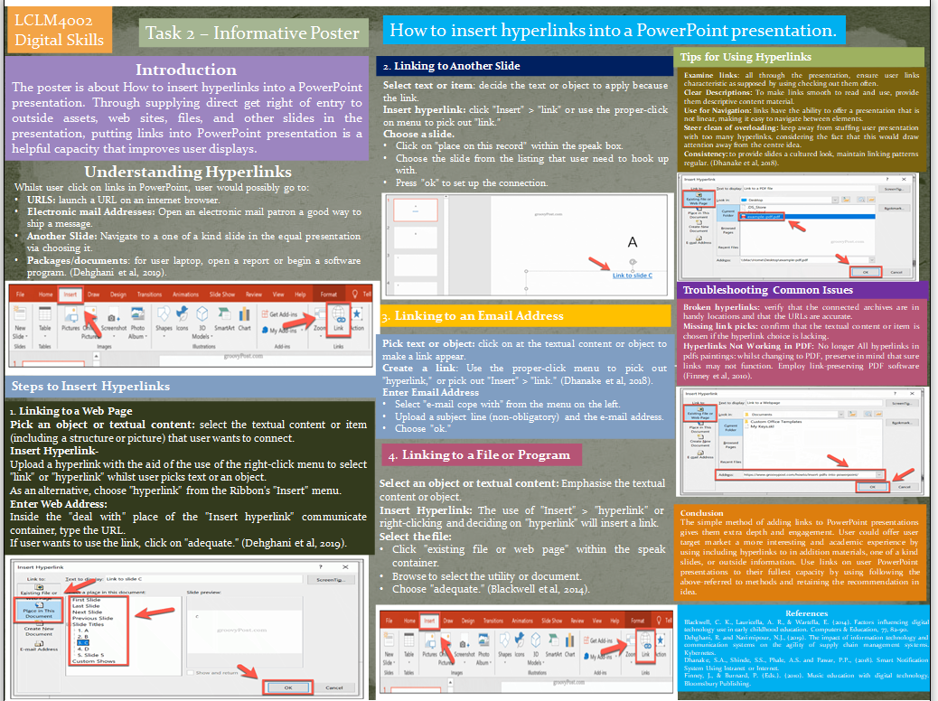

Introduction
The poster is about How to insert hyperlinks into a PowerPoint presentation. Through supplying direct get right of entry to outside assets, web sites, files, and other slides in the presentation, putting links into PowerPoint presentation is a helpful capacity that improves user displays. This is a thorough article so as to show user a way to upload links for user PowerPoint presentation and provide some useful use recommendation.

Understanding Hyperlinks
Whilst user click on links in PowerPoint, user would possibly go to:
- URLS: launch a URL on an internet browser.
- Electronic mail Addresses: Open an electronic mail patron a good way to ship a message.
- Another Slide: Navigate to a one of a kind slide in the equal presentation via choosing it.
- Packages/documents: for user laptop, open a report or begin a software program. (Dehghani et al, 2019).

Steps to Insert Hyperlinks
1. Linking to a Web Page
Pick an object or textual content: select the textual content or item (including a structure or picture) that user wants to connect.
Insert Hyperlink-
- Upload a hyperlink with the aid of the use of the right-click menu to select "link" or "hyperlink" whilst user picks text or an object.
- As an alternative, choose "hyperlink" from the Ribbon's "Insert" menu.
Enter Web Address:
- Inside the "deal with" place of the "Insert hyperlink" communicate container, type the URL.
- If user wants to use the link, click on "adequate." (Dehghani et al, 2019).

2. Linking to Another Slide
Select text or item: decide the text or object to apply because the link.
Insert hyperlink: click "Insert" > "link" or use the proper-click on menu to pick out "link."
Choose a slide.
- Click on "place on this record" within the speak box.
- Choose the slide from the listing that user need to hook up with.
- Press "ok" to set up the connection.
3. Linking to an Email Address
Pick text or object: click on at the textual content or object to make a link appear.
Create a link: Use the proper-click menu to pick out "hyperlink," or pick out "Insert" > "link." (Dhanake et al, 2018).
Enter Email Address
- Select "e-mail cope with" from the menu on the left.
- Upload a subject line (non-obligatory) and the e-mail address.
- Choose "ok."
4. Linking to a File or Program
Select an object or textual content: Emphasise the textual content or object.
Insert Hyperlink: The use of "Insert" > "hyperlink" or right-clicking and deciding on "hyperlink" will insert a link.
Select the file:
- Click "existing file or web page" within the speak container.
- Browse to select the utility or document.
- Choose "adequate." (Blackwell et al, 2014).

Tips for Using Hyperlinks
Examine links: all through the presentation, ensure user links characteristic as supposed by using checking out them often.
Clear Descriptions: To make links smooth to read and use, provide them descriptive content material.
Use for Navigation: links have the ability to offer a presentation that is not linear, making it easy to navigate between elements.
Steer clean of overloading: keep away from stuffing user presentation with too many hyperlinks, considering the fact that this would draw attention away from the centre idea.
Consistency: to provide slides a cultured look, maintain linking patterns regular. (Dhanake et al, 2018).

Troubleshooting Common Issues
Broken hyperlinks: verify that the connected archives are in handy locations and that the URLs are accurate.
Missing link picks: confirm that the textual content or item is chosen if the hyperlink choice is lacking.
Hyperlinks Not Working in PDF: No longer All hyperlinks in pdfs paintings: whilst changing to PDF, preserve in mind that sure links may not function. Employ link-preserving PDF software (Finney et al, 2010).

Conclusion
The simple method of adding links to PowerPoint presentations gives them extra depth and engagement. User could offer user target market a more interesting and academic experience by using including hyperlinks to in addition materials, one of a kind slides, or outside information. Use links on user PowerPoint presentations to their fullest capacity by using following the above-referred to methods and retaining the recommendation in idea.

References
Blackwell, C. K., Lauricella, A. R., & Wartella, E. (2014). Factors influencing digital technology use in early childhood education. Computers & Education, 77, 82-90.
Dehghani, R. and Navimipour, N.J., (2019). The impact of information technology and communication systems on the agility of supply chain management systems. Kybernetes.
Dhanake, S.A., Shinde, S.S., Phale, A.S. and Pawar, P.P., (2018). Smart Notification System Using Intranet or Internet.
Finney, J., & Burnard, P. (Eds.). (2010). Music education with digital technology. Bloomsbury Publishing.

