BSC HEALTH AND SOCIAL CARE
MODULE CODE: BMHP5023
MODULE TITLE: INTRODUCTION TO PHYSIOLOGY
ASSIGNMENT TITLE: COMPONENT 1: WRITTEN ASSIGNMENT (CASE STUDY REPORT)
STUDENT NAME: ABRAHAM KIROS ANDOM
STUDENT NUMBER: 2414479

Executive Summary
Asthma is a growing concern observed across adolescents due to the rise of smoking, vaping or going to crowded places such as crowded areas such as clubs and bars. The impact leads to growing susceptibility of asthma due to inhalation of irritants that generate respective symptoms. The respiratory system comprises a system that manages the inhalation and exhalation of air that help in managing daily activities and gaseous exchange. The process of gaseous exchange is negatively impacted due to smoking and/or vaping that does not occur as per normal health standards. In addition, house dust mites, pollen and animal fur trigger irritation within the human respiratory system. The development of an adequately ventilated environment and proper exercises help in managing asthma.

Table of Contents
a) Introduction 3
b) Structure of the respiratory system and process of mechanical respiration 3
c) Process of gas exchange in the lungs 5
d) Impacts of increased levels of irritants in the respiratory system 6
e) Recording and tracking respiratory functions for managing asthma patients 6
f) Evidence-based recommendations lifestyle changes towards improving conditions 7
g) Conclusion 8
h) References list 10

a) Introduction
Asthma is an acute respiratory ailment that causes chronic inflammation across the airways signifying an impact of pollen, exercise or cold air. During asthma airways across lungs are restricted due to swelling caused by mucus that induces difficulty for human beings to inhale air (Clevelandclinic, 2026). Chest tightness, cough and wheezing are respective symptoms that are observed across patients being diagnosed with asthma
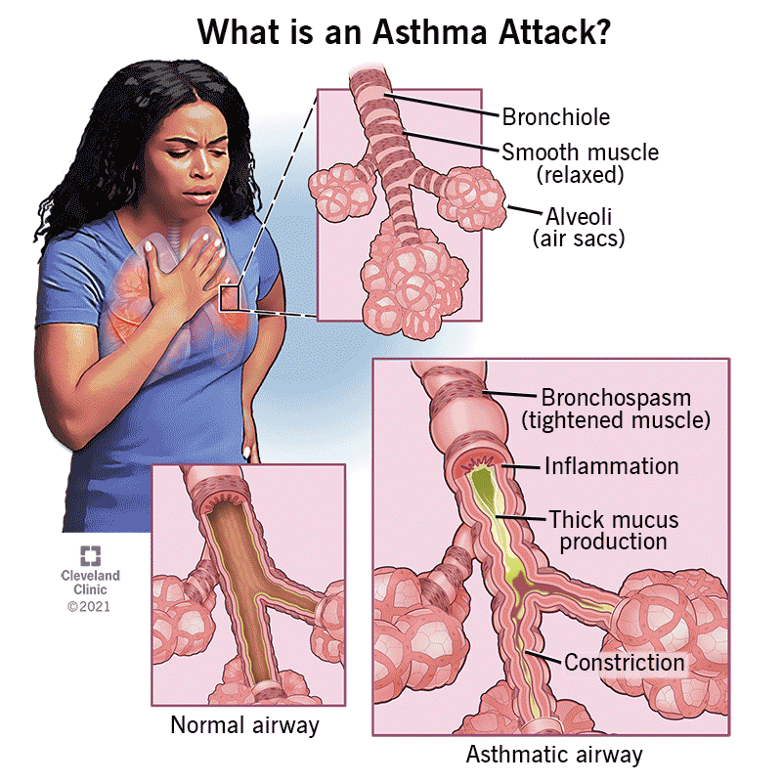
Figure 1: Impacts of Asthma attack
(Source: Clevelandclinic, 2026)
The risk factors triggering asthma include changes in lifestyle during adolescence, smoking or vaping. In addition, attending crowded locations such as bars and clubs increases risk of being exposed to asthma.

b) Structure of the respiratory system and process of mechanical respiration
Structure of the respiratory system
The human respiratory system comprises lungs, trachea, bronchi and bronchioles, diaphragm, voice box and throat. The respiratory system helps in synchronising inhalation and exhalation of air with physiological activities that maintains breathing (Clevelandclinic, 2025). The respiratory system plays an important role in maintaining air ventilation and gas exchange involving diffusion of oxygen into the blood as a biochemical process.
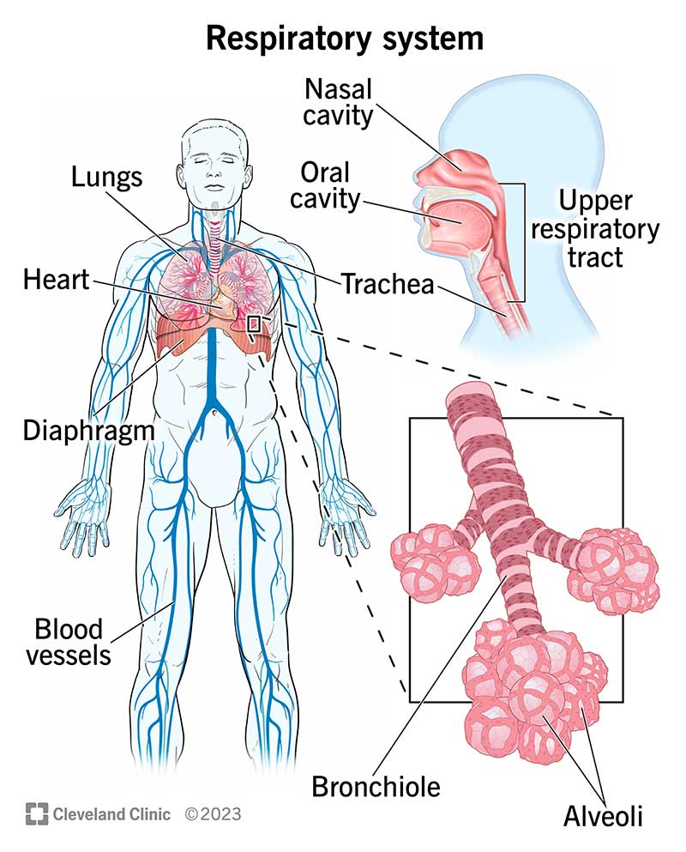
Figure 2: Respiratory system
(Source: Clevelandclinic, 2025)
Air is inhaled through the pharynx, larynx, trachea, bronchi, and then reaches the lungs whereas exhaled air travels through the opposite directions (Clevelandclinic, 2024). The nasal cavity is a large, air-filled space within the respiratory system that helps in trapping the entry of foreign particles into the respiratory tract. The nasal cavity contains chemoreceptors that are essential for sensing smell and that contribute towards detecting taste as well (Kenhub, 2024). The pharynx is a tubular organ located within the upper respiratory tract that connects the mouth and nasal cavity with the larynx for managing passage of both food and air into the trachea and oesophagus respectively (Clevelandclinic, 2023). The larynx, also known as the vocal cords connects the pharynx and trachea that allows the production of vocal sounds and also controls the pitch using latter muscles (Cleveland Clinic, 2023). The trachea, bronchi and bronchioles are important structures of the lower respiratory tract that connect the larynx through the respiratory tract. The trachea is 2.5 cm wide and 10 to 15 cm long that branches to form two bronchial tubes (Clevelandclinic, 2021). The bronchioles end in alveolar ducts comprising minuscule air sacs known as alveoli that play an important role in undertaking gaseous exchange.
Process of mechanical respiration
The process of mechanical respiration involves exchange of gases from the lungs from the atmosphere where labile plays an important role in ensuring the diffusion of gasses. Quevedo‐Moreno et al. (2025) stated that mechanical respiration comprises inhalation and exhalation as significant steps that help in maintaining the breathing rhythms. The management of air demand by the human body and a balance of metabolic activities help in evading from respiratory failure. Mechanical respiration involves inspiration as the first phase where diaphragm contracts and pulls downward (Medlineplus, 2026). Simultaneously, muscles contract behind the ribs and pull upward, leading to decrease the pressure inside the lungs and increase in size of the thoracic cavity. Consequently, air from the atmosphere is entered through the respiratory tract and fills the lungs. Pleil et al. (2021, p.6) stated that humans inhale fresh air with 21% O2 and exhale nearly 16% O₂ and 5% CO₂ respectively. Concentrations of 19.5% O2 are generally considered safe for inhalation, however, impacts of minor headache and irritability are also noticed. The reasons that inhaling beyond such levels of concentration accounting for 100,000 ppm and above can lead to consciousness and asphyxiation. Conversely, the second phase of mechanical respiration involves expiration, where the diaphragm relaxes, and the ribs go back to their original position (Week 4, Slide 13). During exhalation, the pressure inside the lungs releases that forces out the air inhaled and internal intercostal muscles contract to the ribs.

c) Process of gas exchange in the lungs
The process of gaseous exchange involves inhalation of deoxygenated blood into the capillary network from the pulmonary artery. During gaseous exchange within the respiratory system oxygenated blood leaves from the capillary network and enter the pulmonary veins to return to the left side of the heart (Week 4, Slide 30). However, impacts of smoking, vaping and contact with respiratory infections across adolescents leading to respiratory disorders (Case Study). The reason is that gaseous exchange across individuals being exposed to smoking and/or vaping does not occur as per normal health standards. The tidal volume relates to volume of air inhaled normally that accounts for 500 ml across adults (Osmosis, 2023). However, after inhaling oxygen passes across thin alveolar membranes into surrounding capillaries that bind with haemoglobin in red blood cells. Exchange of gasses within the lungs moves from the air sacs in the lung tissue towards blood (Green, 2025, p. 1). The oxygen is then transported throughout the body that influences cellular metabolism and forms carbon dioxide that diffuses from the blood into the alveoli. However, Zwoliński et al. (2025, p. 17) argued that during asthma, inflammation across the respiratory tracts is observed leading to reduction of oxygen intake and causes breathlessness. Despite the fact, during respiration accumulation of respiratory wastes are managed through exchange of gases across the bloodstream (Lung, 2025). There is always some air in the lungs that is not exhausted and helps in managing passage of gases across the alveoli. Gholap et al. (2025, p. 1) commented that exchange of gases in the alveoli allows oxygen to cross the cell membrane and manages air to be exhaled. The statement signifies that exchange of gases taking place in the alveoli sacs are circulated across capillaries that help in completing the respiration process.

d) Impacts of increased levels of irritants in the respiratory system
Increased levels of irritants in the respiratory system causes acute diseases such asthma that are highly observed across the adolescent patients. Instances of lifestyle changes, smoking or vaping negatively impacts health across adolescents and exacerbates their asthma (Case Study). Instances of asthma in the UK affects over five million people, where smoking has accounted for being a primary reason (Makesmokinghistory, 2022). In addition, spread of house dust mites, pollen and animal fur are considered factors that trigger irritation within the human respiratory system. Furthermore, exposure to crowded places such as bars and clubs also induces irritation within the respiratory system due to conveyance of unsafe air pollutants that are inhaled accordingly.
The symptoms of Asthma are observed while lungs become irritated due to the external environment, which leads to inflammation of the respiratory tract, making it difficult to breathe. Major irritants such as dander, hair, varnishes, metals, Plant substances, and gases such as chlorine, sulphur dioxide and smoke cause swelling of lung tissue (Mayoclinic, 2024). The inflammation of lung tissue is triggered by substances that a person may be allergic to such as the irritant mentioned above. Allergens are considered major factors causing asthma development and exacerbation where risk of inhaling irritant and polluted substances increases the risk of deterioration of respiratory conditions. In addition, microbes, viruses, and spores are major irritants that cause swelling of lung tissue, leading to exacerbation of asthma followed by infections (Epa, 2025). The impacts on inhaling the irritants that can cause occupational asthma, due to long exposure to irritants comprising airborne, solid and/or liquid particles.
Increased levels of irritants in the respiratory system have induced a challenge across healthcare professionals in addressing impacts of swelling of lung tissue, causing asthma. Instances of cases regarding adjusts being damaged with asthma in the UK were caused by weather, dust, colds and flu as common triggers or irritants (Statista, 2024). The statement signifies that Asthma, being an inflammatory disease restricts the passage of airways into the lungs as an aftermath of inhaling irritants.

e) Recording and tracking respiratory functions for managing asthma patients
The importance of recording and tracking respiratory functions is anticipated from the feasibility of prescribing effective medication for managing asthma patients. Analysis of chemoreceptors also helps in monitoring the level of oxygen and carbon dioxide in the blood as it passes over them (Week 4, Slide 36). The analysis of chemoreceptors' response helps in interpreting the degree of carbon dioxide concentration in the blood. In addition, Alkobaisi et al. (2025, p. 10) stated that recording respiratory data plays an important role in managing asthma patients based on corresponding readings. The changes in reading coherent with the affected individuals’ physiological conditions help in managing the symptoms of asthma and improving overall respiratory health. A peak flow meter is significant for gaining insight into the capability of exhaling air out of the lungs that is covered with cohort readings (Clevelandclinic, 2024). The instrument is effective for analysing the capability of bronchioles in inhaling and/or exhaling air where a drop in peak flow signifies presence of asthma attacks.
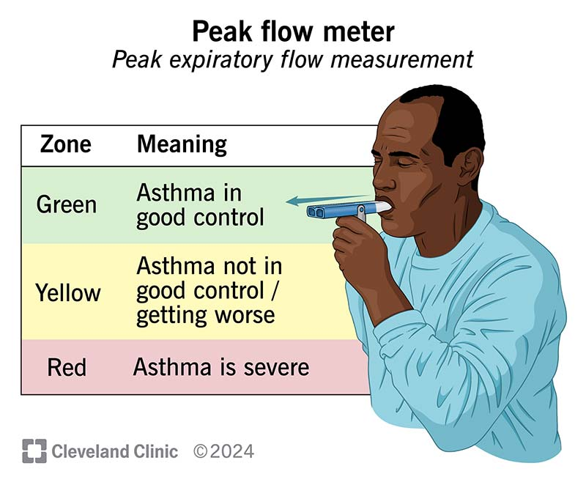
Figure 3: Usage of peak flow meter
(Source: Cleveland Clinic, 2024).
Based on the case study regarding the growing impacts of asthma across adolescents, the evaluation of peak flow can be an essential strategy for understanding the severity of asthma. A peak flow meter may be most useful for people who are diagnosed with asthma including those who are persistent (Lung, 2026). A reading considering men and women accounting for 100 L/min and 85 L/min are normal values of exhaled air (Pt-medical, 2026). The evaluation of respiratory functions across such individuals can be helpful for health professionals in advising necessary measures for controlling individual respiratory health. Thus, the severity of asthma attacks and respiratory complications across such individuals can be managed effectively.

f) Evidence-based recommendations lifestyle changes towards improving conditions
Avoidance of smoking and vaping
Evidence regarding growing concerns on using vapes across young people and adolescents have deteriorated the efficiency of controlling asthma. For instance, 29.6% of people aged 18 years use vapes and rates of using disposable vapes have risen from 0.89% to 56.7% in 2021-22 (Nichs, 2025). In addition, most vapes contain nicotine and are highly addictive, that trigger causes of asthma across adolescents. The necessity of avoiding smoking and vaping is required for restoring the health conditions across affected individuals. However, using e-cigarettes may contribute towards lowering consumption of vapes across existing smokers (Nichs, 2025). Gradually cutting down on smoking and vaping can help in improving the lifestyle of adolescents who might be impacted by asthma.
Reducing exposure to crowded areas
The exposure of poorly ventilated environments along with bars and clubs negatively impacts health and exacerbates asthma across adolescents (Case Study). Adolescents are exposed to indoor air pollutants due to lack of proper ventilation in homes that can trigger asthma. Holden et al. (2023, p. 5) stated that poor ventilation within homes is associated with increasing risk of asthma across individuals and exacerbate respiratory symptoms. The improvement of ventilation systems can play an important role for lowering the impacts of irritants to have been inhaled, leading to management of asthma. Consequently, avoidance in going to crowded areas such as bars and clubs can help in improving the lifestyles of such individuals.
Adherence to proper exercise
Undertaking proper exercises can be effective for enhancing respiratory strength across individuals being diagnosed with asthma. For instance, pursed lip breathing exercise is effective for increasing oxygen levels by reducing the number of breaths and enhances physical fitness (Lung, 2025). In addition, diaphragmatic breathing can also help in enhancing the breathing efficiency of the diaphragm and improving lung functions. The exercises are effective for affected individuals in enhancing lifestyle and managing asthma to a significant extent.

g) Conclusion
Based on the information provided in the report, it can be concluded that asthma is caused due to feeling of chest tightness, cough and wheezing. The human respiratory system plays an important role in maintaining air ventilation that is essential for ensuring proper lifestyle and resilience from worsening respiratory conditions. The process of mechanical respiration helps in management of air demand and balancing metabolic activities help in evading from respiratory failure. Air from the atmosphere enters through the respiratory tract and fills the lungs, signifying proper completion of the respiration cycle and inference regarding not being impacted by asthma. However, growing rates of consuming values and smoking are inducing challenges in addressing the growing trends regarding asthma’s impacts observed across adolescents. Thus, adherence to proper medication, monitoring of air breathing rates and exercises can contribute towards enhancing corresponding lifestyle and managing asthma.

h) References list
Alkobaisi, S., Safdar, M.F., Pałka, P. and Abu Ali, N.A., (2025). Artificial intelligence algorithms in asthma management: a review of data engineering, predictive models, and future implications. Applied Sciences, 15(7), p.3609. Available at: https://doi.org/10.3390/app15073609
Clevelandclinic, (2021). Trachea Available at: https://my.clevelandclinic.org/health/body/21828-trachea (Accessed: 17 February 2026).
Clevelandclinic, (2023). Larynx (Voice Box) Available at: https://my.clevelandclinic.org/health/body/21872-larynx (Accessed: 12 February 2026).
Clevelandclinic, (2023). Pharynx (Throat) Available at: https://my.clevelandclinic.org/health/body/21869-pharynx (Accessed: 10 February 2026).
Clevelandclinic, (2024). Peak Flow Meter Available at: https://my.clevelandclinic.org/health/treatments/peak-flow-meter (Accessed: 14 February 2026).
Clevelandclinic, (2024). What is the respiratory system? Available at: https://my.clevelandclinic.org/health/body/21205-respiratory-system (Accessed: 16 February 2026).
Clevelandclinic, (2025). Asthma Available at: https://my.clevelandclinic.org/health/diseases/6424-asthma (Accessed: 14 February 2026).
Epa, (2025). Particle Pollution and Respiratory Effects Available at: https://www.epa.gov/pmcourse/particle-pollution-and-respiratory-effects (Accessed: 12 February 2026).
Gholap, A., Pardeshi, S., Giram, P., Nangare, S., Sodha, S., Kapare, H., More, M., Sonar, Y., Shukla, R., Naik, J. and Reddy, G., (2025). Breathing new life nanomedicines for pulmonary drug delivery: targeting approaches, experimental models, and regulatory aspects. Beni-Suef University Journal of Basic and Applied Sciences, 14(1), p.65. Available at: https://doi.org/10.3390/ijms27010024
Green, S., (2025). A Fick tool: connecting Fick’s law and principle in teaching pulmonary gas exchange. Advances in Physiology Education. Available at: https://doi.org/10.1152/advan.00044.(2025)
Holden, K.A., Lee, A.R., Hawcutt, D.B. and Sinha, I.P., (2023). The impact of poor housing and indoor air quality on respiratory health in children. Breathe, 19(2). Available at: https://doi.org/10.1183/20734735.0058-(2023)
Kenhub, (2024). Chemoreceptors Available at: https://www.kenhub.com/en/library/physiology/chemoreceptors (Accessed: 17 February 2026).
Lung, (2025). Breathing Exercises Available at: https://www.lung.org/lung-health-diseases/wellness/breathing-exercises (Accessed: 15 February 2026).
Lung, (2025). How Lungs Work Available at: https://www.lung.org/lung-health-diseases/how-lungs-work (Accessed: 17 February 2026).
Lung, (2026). Become a Lung Health Insider Available at: https://www.lung.org/lung-health-diseases/lung-disease-lookup/asthma/treatment/devices/peak-flow (Accessed: 16 February 2026).
Makesmokinghistory, (2022). Everything you need to know about smoking and asthma Available at: https://makesmokinghistory.co.uk/latest/everything-you-need-to-know-about-smoking-and-asthma/ (Accessed: 16 February 2026).
Mayoclinic, (2024). Occupational asthma Available at: https://www.mayoclinic.org/diseases-conditions/occupational-asthma/symptoms-causes/syc-20375772 (Accessed: 17 February 2026).
Medlineplus, (2026). Breathing Available at: https://medlineplus.gov/ency/anatomyvideos/000018.htm (Accessed: 16 February 2026).
Nichs, (2025). Vaping is not that bad for you. Available at: https://nichs.org.uk/vaping (Accessed: 17 February 2026).
Osmosis, (2023). Ventilation Available at: https://www.osmosis.org/learn/Ventilation (Accessed: 17 February 2026).
Pleil, J.D., Ariel Geer Wallace, M., Davis, M.D. and Matty, C.M., 2021. The physics of human breathing: flow, timing, volume, and pressure parameters for normal, on-demand, and ventilator respiration. Journal of breath research, 15(4), p.042002. Available at: https://doi.org/10.1088/1752-7163/ac2589
Pt-medical, (2026). Peak Expiratory Flow Rate Available at: https://www.pt-medical.nl/downloadfile/peak-flow-rate-chart-1.pdf (Accessed: 17 February 2026).
Quevedo‐Moreno, D., Lee, S.Y., Tagoe, J., Emani, V., Bonnemain, J. and Roche, E.T., (2025). Design, Modeling, and Control of a Soft Robotic Diaphragm‐Assist Device in a Respiratory Simulator. Advanced Intelligent Systems, 7(7), p.2401087. Available at: https://advanced.onlinelibrary.wiley.com/doi/abs/10.1002/aisy.(2024)01087
Statista, (2024). Asthma in the United Kingdom - Statistics & Facts Available at: https://www.statista.com/topics/3142/asthma-in-the-united-kingdom/?srsltid=AfmBOooFDTXw8rZ2iwU9OJ-jEv_Bpd_RTrsQLC1CjB1OtW-ViGrrJ9er (Accessed: 15 February 2026).
Zwoliński, M., Hovagimyan, A., Ignatowicz, J., Stelmasiak, M., Lewicka, A., Szopiński, T., Szymański, Ł., Bień-Kalinowska, J., Barbara, B.J. and Lewicki, S., (2025). Exploring Oxygen Therapy as a Supporting Treatment for Asthma: Current Insights and Perspectives. International Journal of Molecular Sciences, 27(1), p.24. Available at: https://doi.org/10.3390/ijms27010024

