
e

Student Name: Neneh Bangura
Student ID: 2130272

Module name: empowering elderly people
Module code: 6027
Supervisor’s name: Arif Ahmed

Acknowledgement
I confirm that I have not used any AI tools in the research and creation of this assignment. I confirm that I have not presented any AI generated materials as my own work. I confirm I have copies of my drafts, notes, and other resources I used, which I may be asked to provide in evidence.

Evidence and theoretical underpinnings  - Person-centred care, the biopsychosocial model and occupational justice all stress the role of choice, environment and meaningful activity.  - Studies indicate that reablement and rehab can enhance function and reduce long-term service use.  - Assistive technology (telecare, mobility equipment, home adaptations) can support independence, but only when well assessed, introduced and accepted (SCIE, 2014; Prestmo et al., 2015). |  | Title  Promoting Independence in Later Life: Reviewing Care and Support for Older People in the UK  1. Introduction  The UK population is ageing, with more people living longer and managing several long-term conditions.  Many older adults want to stay in their own homes, preserving independence and control over daily routines.  Health and social care systems need to hold safety, autonomy, dignity and person-centred practice in balance (Age UK, 2022).  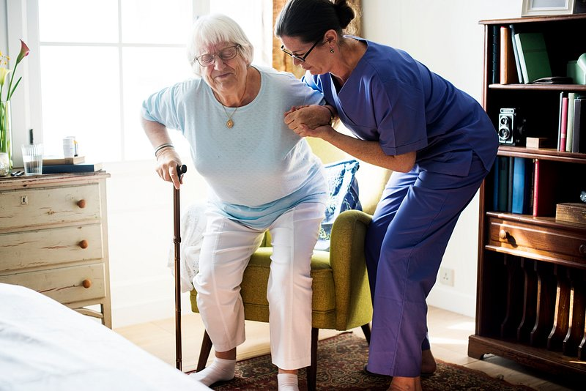 |  | 
Care, empowerment and support needs |  |  |  | . Effectiveness of current approaches and interventions
Core needs of older adults  - Functioning: being able to move around, manage personal care, run a household and think clearly.  - Independence and control: choosing daily activities, accepting or declining risks, and influencing where and how they are supported.  - Social connection: maintaining relationships, community links, valued roles and meaningful occupations.  - Emotional health: sense of identity, self-esteem, dealing with loss, anxiety and low mood.  - Safety: prevention of falls and harm, safeguarding, and reliable, continuous support (King’s Fund, 2014; Age UK, 2022).  - Care, empowerment and support needs Using person centred, strengths-based ways of working.  - Involving older people in shared decisions and supported choices.  - Treating them as knowledgeable partners in care rather than passive recipients (WHO, 2015; Manthorpe and Iliffe, 2017).    This Photo by Unknown Author is licensed under CC BY-SA-NC |  |  |  | Key UK approaches  - Time-limited, goal-oriented reablement and intermediate care delivered at home.  - Community rehabilitation from OTs, physiotherapists and falls teams.  - Personalisation and direct payments within the Care Act 2014 framework.  - Age-friendly strategies and the WHO Healthy Ageing agenda (WHO, 2015; WHO, 2020).  Critical points  - Provision is often fragmented and difficult for older people to navigate.  - Social and digital inequalities shape who can access services and how well they benefit.  - A strong focus on risk avoidance can restrict freedom and choice.  - Staffing shortages and limited time can undermine continuity and quality of care (King’s Fund, 2014; NHS England, 2019).  Recommendations to strengthen services and empowerment  Service-level  - Enhance early intervention: routine screening for falls risk, home safety checks and proactive rehabilitation offers (NICE, 2013; SCIE, 2014).  - Increase availability of reablement, community OT and multidisciplinary input, especially around discharge from hospital (RCOT, 2019; NHS England, 2019).  - Improve coordination between health, social care, housing and voluntary organisations (King’s Fund, 2014; DHSC, 2014).  Practice-level  - Make co-production the norm: include older people and carers in designing and reviewing services (NICE, 2015; RCOT, 2021).  - Apply person-centred, strengths-based methods and shared decision-making consistently.  - Provide clear information, advocacy and navigation support so older adults understand options and rights.  - Tackle inequalities through culturally responsive practice, outreach and accessible/digital-inclusion support (Age UK, 2022; SCIE, 2014).  Policy level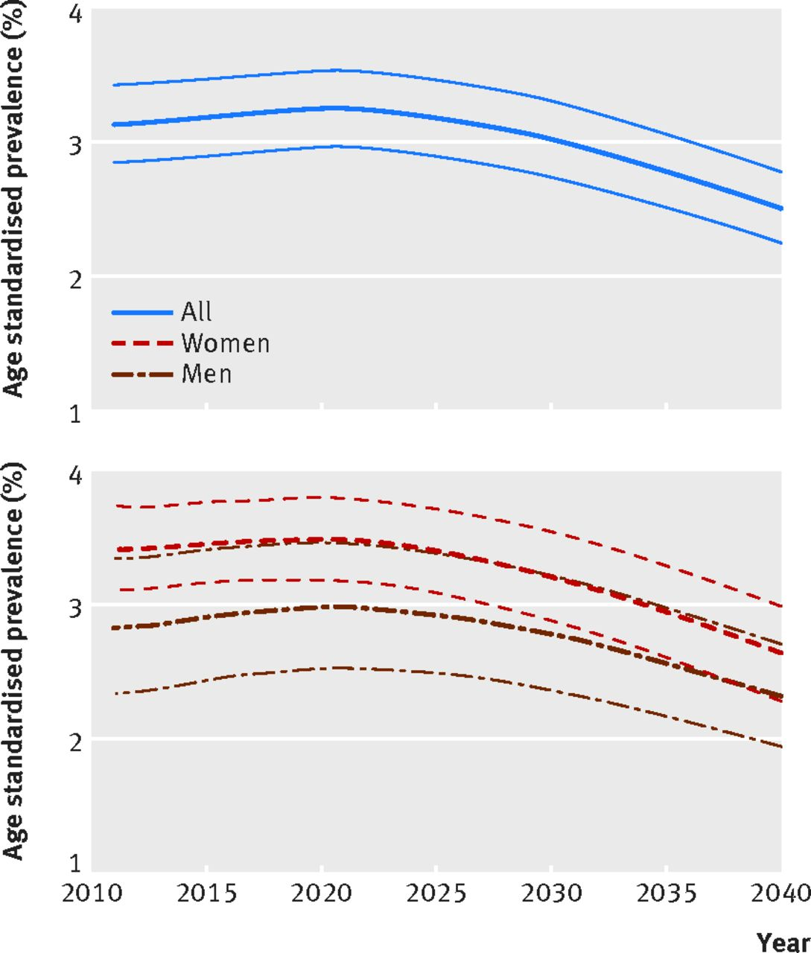  This Photo by Unknown Author is licensed under CC BY  - Fully embed Care Act 2014 principles of wellbeing, prevention, and choice and control (DHSC, 2014).  - Invest in community provision, carer support and age-friendly communities (NHS England, 2019; WHO, 2020).  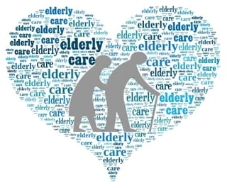  This Photo by Unknown Author is licensed under CC BY-NC-ND

Challenges to independence and functional ability

Personal challenges

• Multiple conditions, frailty, sensory impairments and cognitive decline.

• Falls and fear of falling, pain, reduced stamina.

• Loneliness, bereavement and age-related stigma (NICE, 2015; WHO, 2015).

Environmental and system barriers

• Poorly adapted housing and transport; restricted access to home modifications.

• Financial hardship, high living costs and limited informal support networks.

• Complex, variable local systems and eligibility criteria across councils (Marmot et al., 2020; Age UK, 2022).

Voice and agency

• Ageism in wider society and services can limit older people’s influence over decisions.

• Questions around capacity and consent arise where dementia or cognitive problems are present (NICE, 2015; RCOT, 2021).

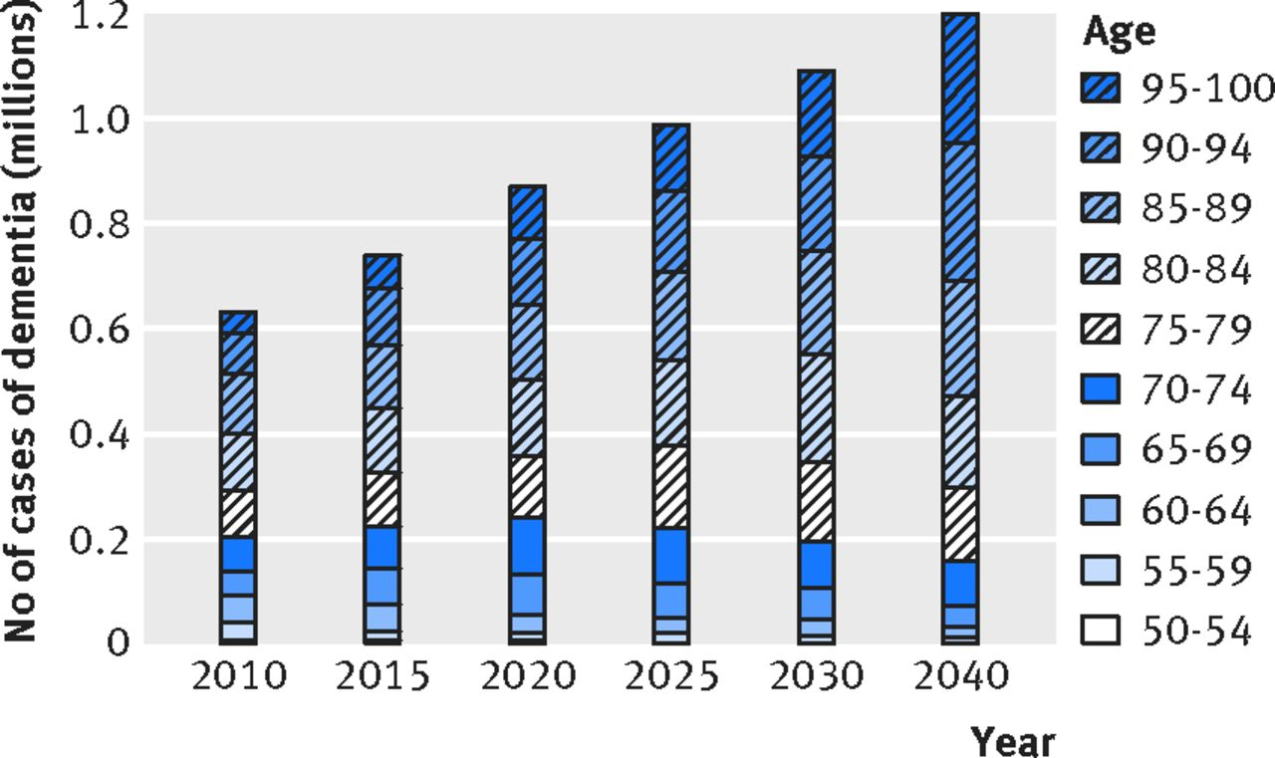
This Photo by Unknown Author is licensed under CC BY

Conclusion
- Older people’s support needs span physical, psychological, social and environmental domains.
- High-quality care depends on coordinated, person-centred, evidence-informed approaches that uphold autonomy, functioning and participation.
- The UK has strong policy intentions and some effective services, but there are ongoing gaps in integration, fairness and genuine empowerment.
- Strengthening early, community-based and co-designed approaches offers a route to better protect the rights and wellbeing of older adults ((WHO, 2015; NICE, 2015).

References
- Age UK (2022) Later life in the United Kingdom 2022. London: Age UK.
- Department of Health and Social Care (2014) Care Act 2014: statutory guidance for implementation. London: DHSC.
- Dorning, H. and Bardsley, M. (2014) Focus on: People with long-term conditions, older people and hospital use. London: The Health Foundation and Nuffield Trust.
- Manthorpe, J. and Iliffe, S. (2017) ‘The care and support of older people: policy themes and emerging challenges’, Working with Older People, 21(3), pp. 145–153.
- Marmot, M. et al. (2020) Health Equity in England: The Marmot Review 10 Years On. London: Institute of Health Equity.
- NHS England (2019) The NHS Long Term Plan. London: NHS England.
- NICE (2015) Older people with social care needs and multiple long-term conditions (NG22). London: National Institute for Health and Care Excellence.
- NICE (2013) Falls in older people: assessing risk and prevention (CG161). London: National Institute for Health and Care Excellence.
- Royal College of Occupational Therapists (RCOT) (2019) Occupational therapy and rehabilitation for older people: Promoting independence and wellbeing. London: RCOT.
- Royal College of Occupational Therapists (RCOT) (2021) Professional standards for occupational therapy practice, conduct and ethics. London: RCOT.
- Social Care Institute for Excellence (SCIE) (2014) Reablement: key issues in commissioning and providing services. London: SCIE.
- The King’s Fund (2014) Making our health and care systems fit for an ageing population. London: The King’s Fund.
- United Nations (2017) World Population Ageing 2017. New York: United Nations Department of Economic and Social Affairs.
- World Health Organization (WHO) (2015) World report on ageing and health. Geneva: WHO.
- World Health Organization (WHO) (2020) Decade of Healthy Ageing 2020–2030. Geneva: WHO.

