Task 1
Name: Sofiya Tupovicharska
Student number: 1817125
Module number: BMSW4001
Assignment title: ACE (Academic and Employability skills)
Lecturer name: Peter Allen

Content:
- Introduction
- Academic skills
    - Verbal (oral) communication
      - Written communication ( paraphrasing and summarising)
        - Independent learning

- Employability skills
    - Communication skills
      - Problem solving
        - Team work
          - Self-management (time management)
              - Technology (IT)
- Conclusion
- References
- Appendix

Introduction

In this academic report I will be talking about academic skills and how they are associated with employability skills and the reflection it has on my own skills. In my view, academic and employability skills are extremely essential for our society. In order for you to get employed in a decent company, you need to have certain level of academic skill that will help you to get a higher position. It is best to have those skills. People that are well rounded and have both skills will have better success with their jobs. This is because they understand the work they are doing better than a person who just has one of these skills. It makes any job easier when you have the academic skills to go along with the professional skills. Being career ready entitles skills such as the capacity to apply those skills to real-life situations, your day-to-day tasks etc.

Academic skills:

- Verbal (oral) communication:

Oral communication is the way of exchanging information by using words. This could include face to face conversations, phone calls, voice notes on social media and others. It is very important you to maintain good body language and facial expressions, because it shows if you are dedicated to the conversation. You need to make sure you choose your words carefully and watch your tone while speaking. In my experience I am extremely confident person and I don’t struggle with communicating with others. However, sometimes I don’t let the other person finish expressing their opinion on the subject and I jump straight into my thoughts. This can be quite rude and I’ve noticed I do it unintentionally and I won’t even realise I’ve done it until the person I’ve talking with says something
- Written communication (paraphrasing and summarising)
- Independent learning

Employability skills:

- Communication skills
- Problem solving
- Team work
- Self-management (time management)
- Technology (IT)

Conclusion

References
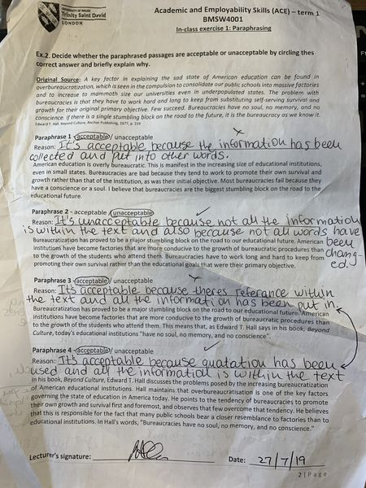
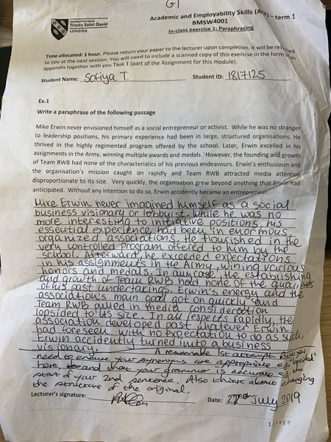
Appendix:



