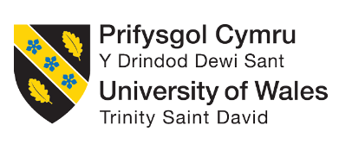

Business Plan
Programme: Certificate in Higher Education Business Skills for the Workplace
Module: Enterprise and Entrepreneurship
Module code: LCLM4006
Name: Mariana Madem 2438457
Lecture:Charles Oham

Executive Summary
This bussines plan present a new venture named BrewBox, a Uk-based start-up focused on transforming the coffee retail experience through automation .BrewBox aims to introduce self-service,AI-powerd coffee kiosk strategically located in high-trafic ares such as universities,libraries,train station and student hubs.
The concept is driven by growing demand for convenience and efficiency in everyday services,often all students face long queues at cafes. BrewBow addresses these challenges by offering a fast accessible and reliable alternative.

Table of Contents
1. Business Idea Overview 4
2. Business Objectives (SMART) 4
3. Market Analysis 5
4. Marketing Strategy (Marketing Communications) 9
5. Management Team 10
6. Operations and Technology Plan 11
7. Financial Plan 11
8. Expansion Plan 13
9. Conclusion 13
10. References 14

1. Business Idea Overview
1.1 Business Concept
This is an individual-written business plan and will shed light on the new venture named BrewBox. This is a UK-originated start-up and is looking to expand across the industry. BrewBox is an automated self-service coffee kiosk. These kiosk machines will be available in the university, libraries, and student hubs. Entrepreneurship is the process of identifying market opportunities and offering products and services that solve people's issues and generate value for stakeholders (Ratten, 2023). Consumers are often faced with several issues, including long queues at cafes and limited availability of cafes during late-night study hours.
1.2 Product / Service Description
The kiosks will be a cost-effective alternative and provide coffee products within 60 seconds. Alongside, it will offer diversified coffee products, including espresso, cappuccino, iced coffee, and so on. Along with this, consumers will be able to make contactless payments and receive loyalty points. In brief, the kiosk machines will be AI-powered, offering recommended products.
1.3 Legal Structure
In this case, BrewBox will be a private limited company, and the main focus will be on value creation. The private limited business structure will ensure legal safeguards for all the investors. Apart from this, as students will be the core consumer base, it will build strategic compliance with universities.

2. Business Objectives (SMART)
Specific | Measurable | Achievable | Relevant | Time-bound
BrewBox will try to install 5 coffee kiosks in universities for short-term achievements. | They will measure their business development by aligning the business objectives. They will introduce subscription coffee plans, which will help them expand the business. | They achieve £15,000 monthly revenue. They will try to achieve national brand recognition. | They will expand their business to 50 universities in the UK for long-term achievements. | They will take 1 year to achieve the short-term goals. They will take 3-4 years to achieve the long-term goals.

3. Market Analysis
3.1 Industry Overview
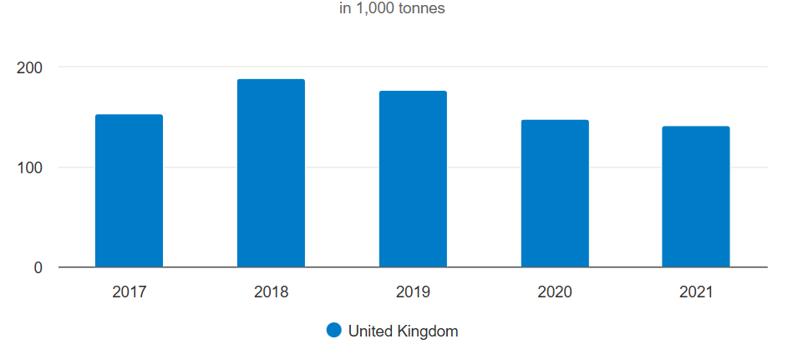
Figure 1: UK coffee growth rate
Source: (Cbi, 2026)
There are 9,540 coffee outlets in the UK, and they achieved a 3.5% growth rate in 2021. Costa Coffee has 2,791 shops, Starbucks has 1,089 shops, and Greggs has 2,176 shops, which are increasing the economic growth in the UK market. It can be expected that 10,500 coffee outlets will increase by 2026. The growth rate of the UK coffee market will be increased 5.8% by 2026 (Cbi, 2026).
3.2 Target Market Segmentation
STP Model (Segmentation, Targeting, Positioning)
Segmentation
Demographic - BrewBox will focus on the university students of the 18-30 age group. They will introduce their coffee plan subscription to the university students.
Behavioural - They will measure the amount of daily coffee consumption to understand the customer behaviour. They will prioritise the convenience preferences of the customers.
Geographic - They will try to introduce their automated coffee kiosks in the UK universities.
Targeting
BrewBox will introduce its automated coffee kiosks in all universities. They will try to establish their business in the UK market, then they will expand their business in the global market (Burns, 2022).
Positioning
BrewBox will utilise AI-powered automated coffee machines, which will differentiate them from competitors. They will give the fastest and most affordable campus coffee solutions, which will increase their brand reputation.
3.3 Environmental Analysis
PESTEL Analysis
Factor | Impact
Political | BrewBox will maintain the university vendor regulations.
Economic | They will sell their coffee at an affordable price for students' budget sensitivity.
Social | They introduce the automated coffee machine for the strong coffee culture.
Technological | They will use AI vending machines and digital and social media platforms.
Environmental | They will use sustainable coffee sourcing and recycled or reusable packaging.
Legal | BrewBox will make its license to avoid food safety compliance.
SWOT analysis
Strengths  BrewBox will use automatic coffee machines.  They will use different technical tools which enhance their digital footprint. | Weakness  They will be the new entrepreneurial company.  It is very challenging to establish a new business in the UK market.
Opportunities  BrewBox will get different opportunities for its digital marketing.  They will get a large number of customers because they will introduce their machines in the UK universities. | Threats  They will get threats from the existing competitors.  They will get some financial threats.
3.4 Competitor Analysis
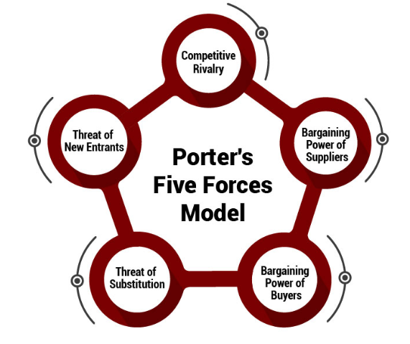
Figure 2: Porter’s Five Forces
Source: (Thestrategyinstitute, 2026)
Porter’s Five Forces involves competitive rivalry, supplier power, buyer power, threats of substitutes and threats of new entrants (Loredana, 2024).
Competitive rivalry (High) - BrewBox will face many competitors, including Starbucks, Campus cafes, Costa Coffee and Vending machines.
Suppliers' power (Moderate) - Sometimes, many suppliers can negotiate with the company.
Buyers' power (High) - BrewBox will sell budget-friendly coffee, which will reduce the buyers' power.
Threats of substitutes (High) - The consumers can choose other companies as substitutes.
Threats of new entrants (Low to moderate) - The UK coffee market is highly competitive.

4. Marketing Strategy (Marketing Communications)
4.1 Industry Overview
Element | Description
Products | BrewBox is an AI-backed, automated brewing coffee kiosk. The product is an alternative to cafe shops that are unavailable in university areas and institutions. The kiosk machine will be incorporated with a seamless UI that will indicate contactless payment.
Price | The cost strategy will be competitive, and the business will opt for a penetration pricing strategy. This particular strategy capitalises on value by attracting more consumers, and firms often focus on lower margins (Renard, 2025). The pricing range of the products will be between £1.80 and £2.50 per coffee.
Place | The company will offer products directly to the consumers and cut out the middleman. It will invest heavily in the logistical systems and supply chains to maintain product availability.
Promotion | In this case, BrewBox will advocate for digital marketing and social media promotions. Through this, it will be able to interact directly with consumers and augment the return on investment.
Table: Marketing strategy for BrewBox
(Source: Self-created)
4.2 Customer Engagement Strategy
In order to maintain a strong customer base, the business will advocate for a relationship marketing strategy. This tactic enables companies to make strong ties with consumers and build long-term relationships with them (Rosário and Casaca, 2023). BrewBox will offer subscription plans to consumers, which is a proven method for long-term consumer interaction. Apart from this, purchasers will receive tokens and loyalty rewards after they make a certain number of purchases. It aims to make the consumers feel valued and belong with the brand, which will ultimately help the venture to achieve the business objectives.

5. Management Team
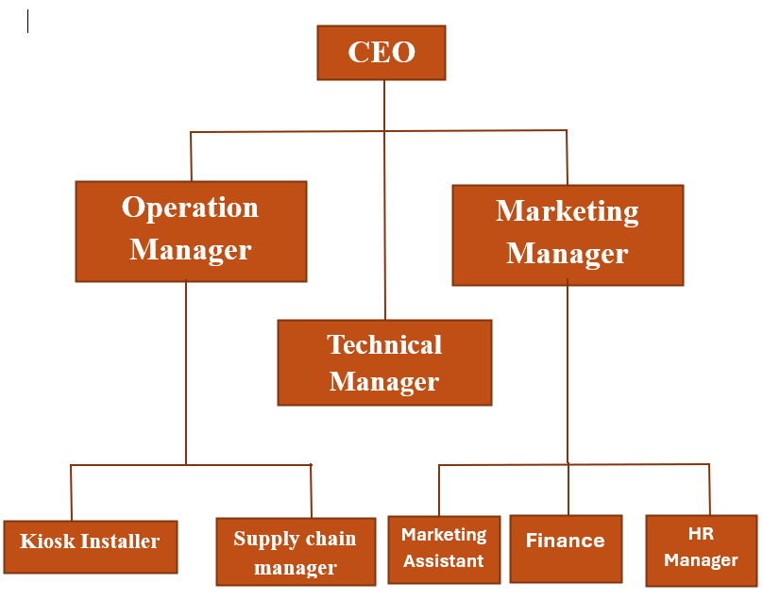
Figure 3: Organisational Chart
Source: Self-made
The CEO is the main founder of the company who is responsible for partnerships and strategy (Wang et al., 2024). The operational managers of BrewBox will manage the business and production operations. They will monitor the kiosk installation and manage the supply chain. The technology manager of BrewBox will develop the technical tools for the development of the technical structure. They will improve AI machines, mobile apps and digital platforms. The marketing manager will be responsible for the digital marketing campaign.

6. Operations and Technology Plan
BrewBox will implement the automated coffee machines, which enhance the user service. They will focus on the coffee beans supplier and milk powder supplier for supply chain development. They will use AI for coffee supply development. They will improve the mobile app and use cloud data analytics, which enhances their digital footprint (Sharma and Dash, 2023). They will use advanced technical tools, which increase their brand reputation and identity, helping them to compete with competitors.

7. Financial Plan
7.1 Startup Cost Estimate
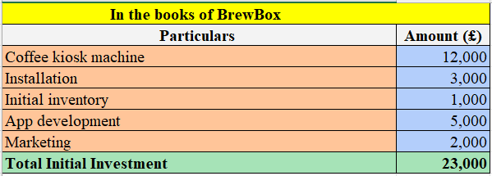
Figure 4: Startup cost of BrewBox
Source: Self-made

7.2 Sales Forecast
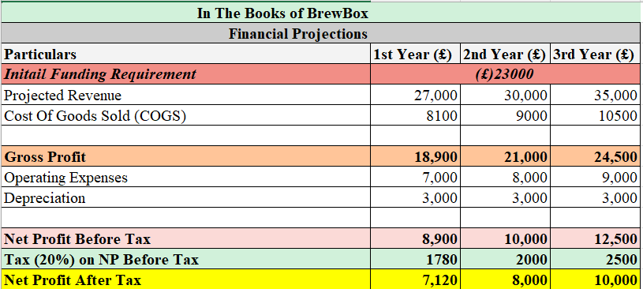
Figure 5: Financial Projection
Source: Self-made
The cash flow forecast depicts the inflow and outflow of cash within the initial year of operation. The university kiosks will bring in money through selling coffee on a day to day basis and the cost will involve raw materials, maintenance of the machines, renting agreement with universities and the cost of marketing. The positive cash flow will be maintained so that there will be no problems with the operations and financial stability.
7.3 Break-Even Analysis
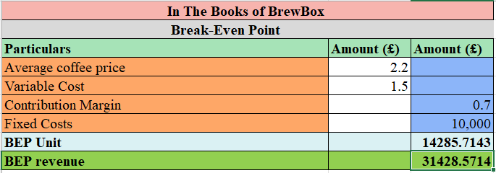
Figure 6: Break-Even Point
Source: Self-made
7.4 Funding Sources
BrewBox will increase the number of angel investors to increase their business founding. They will increase the university innovation grants to increase their investment. They will take some small loans to enhance their business. They will use automated coffee machines, so it will help them to reduce their labour costs.

8. Expansion Plan
BrewBox will focus on the UK universities, and they will implement the coffee kiosks in all the UK universities in 2-3 years. They will increase their partnerships with hospitals, airports and corporate offices in 4-5 years to achieve the long-term vision. They will expand their business in the European market in the future.

9. Conclusion
Concluding this business draft, it can be said that BrewBox is aligned with an innovative business model. It is solving consumer issues and offering them a cost-effective alternative that is easy to access. The industry is growing, and it requires a well-designed marketing plan to reach the consumer base. As it focuses on high margins and business modernisation, it presents an attractive opportunity for investors.

10. References
Burns, P., (2022). Entrepreneurship and small business. Bloomsbury Publishing.
Cbi, (2026) CBI. Available at: https://www.cbi.eu/market-information/coffee/united-kingdom/market-potential (Accessed: 11 March 2026).
Loredana, E.M., (2024). Porter'S 5 Competitive Forces. Annals-Economy Series, 4, pp.142-146.https://www.utgjiu.ro/revista/ec/pdf/2024-04/14_Ecobici.pdf
Ratten, V. (2023) Entrepreneurship: Definitions, opportunities, challenges, and future directions. Global Business and Organizational Excellence, 42(5), pp.79-90. https://onlinelibrary.wiley.com/doi/pdf/10.1002/joe.22217
Renard, O. (2025) Penetration Pricing: Capturing market share through competitive pricing. [online] dinmo.com. Available from: https://www.dinmo.com/marketing-strategy/marketing-mix/penetration-pricing/ (Accessed 11 March 2026).
Rosário, A. and Casaca, J.A. (2023) Relationship marketing and customer retention-a systematic literature review. Studies in Business and Economics, 18(3), pp.44-66. https://reference-global.com/download/article/10.2478/sbe-2023-0044.pdf
Sharma, P. and Dash, B., (2023). The digital carbon footprint: Threat to an environmentally sustainable future. SSRN.
Thestrategyinstitute, (2026) The Strategy Institute. Available at: https://www.thestrategyinstitute.org/insights/porters-five-forces-the-ultimate-competitive-strategy-blueprint (Accessed: 11 March 2026).
Wang, Z., Ye, Y. and Liu, X., (2024). How CEO responsible leadership shapes corporate social responsibility and organization performance: the roles of organizational climates and CEO founder status. International Journal of Contemporary Hospitality Management, 36(6), pp.1944-1962.https://www.emerald.com/ijchm/article/36/6/1944/1212325

