Professional Career Development
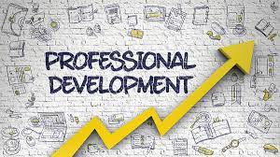

Roman Kotlar
2312435
Submitted on: 09/11/2023

Reflection using Kolb's Model: A SWOT and PDP Analysis

Executive summary:
This executive summary provides an overview of the application of Kolb’s Experimental Learning Model, SWOT analysis and Personal Development Plan (PDP) in professional career development. These frameworks offer valuable insight into an individual’s strengths, weaknesses, opportunities and threats, enabling them to create a strategic plan for personal growth and success.

Introduction:

Professional career development is a lifelong journey that requires continuous learning and self-reflection. In this essay, I will reflect on my own career development using Kolb's Experiential Learning Theory, supported by a SWOT (Strengths, Weaknesses, Opportunities, Threats) analysis and a Personal Development Plan (PDP). By applying these frameworks, I aim to gain insights into my professional growth, identify areas for improvement, and outline strategies for future success.

Kolb's Experiential Learning Theory:

Kolb's model involving four stages: concrete experience, reflective observation, abstract conceptualization, and active experimentation. These stages form a cyclical process, emphasizing the importance of reflection and action in the learning journey.

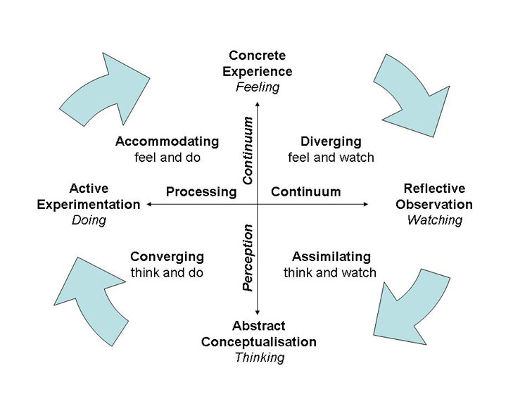

Concrete Experience:

Reflecting on my career journey, I have gained valuable experiences in various roles and industries. These experiences have allowed me to develop a diverse skill set, including effective communication, problem-solving, and leadership skills. I have also had the opportunity to work in cross-functional teams, which has enhanced my collaboration and adaptability.

Reflective Observation:

Through introspection, I have observed both strengths and weaknesses in my career development. One strength is my ability to adapt to new environments and learn quickly. However, a weakness I have identified is a tendency to be overly cautious and risk-averse, which has sometimes hindered my professional growth.
Abstract Conceptualization:

To capitalize on my strengths and address my weaknesses, I have engaged in continuous learning and self-improvement. I have traced professional development opportunities, such as be present workshops and conferences, to enhance my knowledge and skills. Additionally, I have sought feedback from mentors and colleagues to gain different perspectives and insights.

Active Experimentation:

To apply my learning and further develop my career, I have actively sought out new challenges and opportunities. This has included taking on leadership roles in projects, volunteering for cross-functional initiatives, and seeking out stretch assignments. These experiences have allowed me to expand my skill set, build a strong professional network, and gain exposure to some aspects of my field.

SWOT Analysis:

To gain a comprehensive understanding of my career development, I conducted a SWOT analysis.
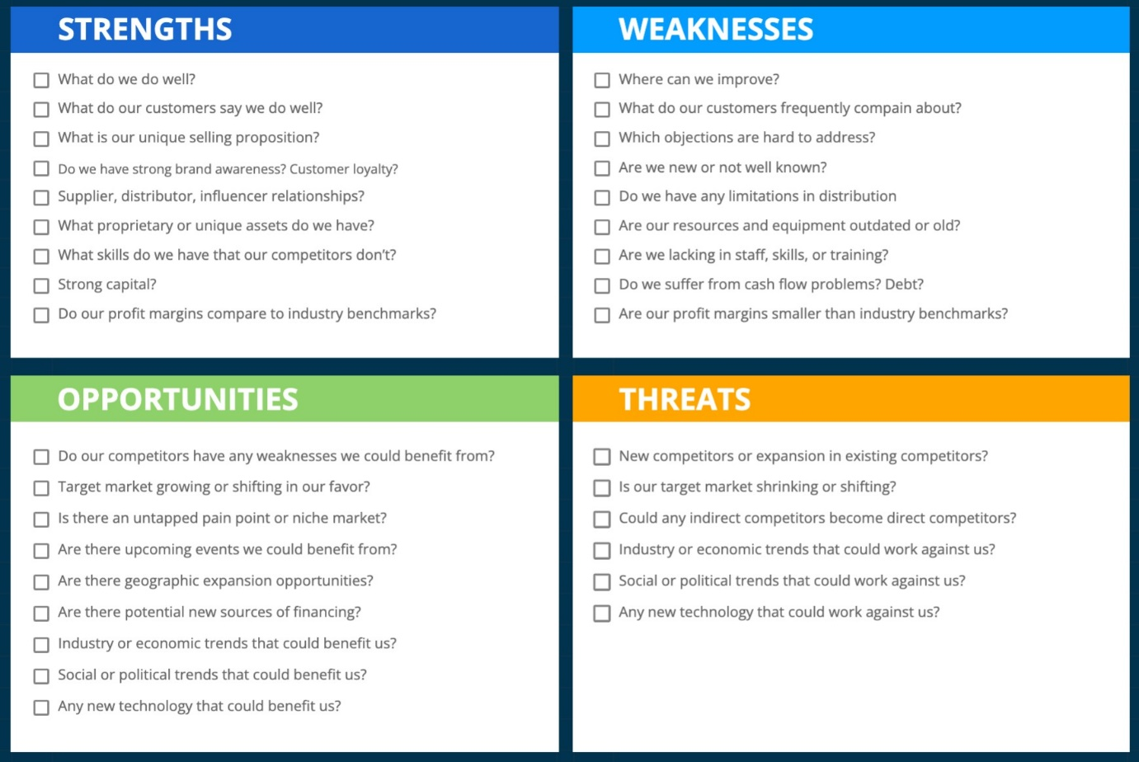

Strengths:
- ﻿﻿Strong communication skills: I can effectively convey ideas and collaborate with diverse stakeholders.
- ﻿﻿Problem-solving abilities: I excel at analyzing complex situations and finding innovative solutions.
- ﻿﻿Leadership skills: I have demonstrated the ability to motivate and inspire teams towards achieving common goals.
Weaknesses:
- ﻿﻿Risk-averse mindset: I tend to be cautious when taking on new challenges, which can limit my growth opportunities.
- ﻿﻿Limited industry-specific knowledge: In certain areas, I lack in-depth expertise, which may hinder my career progression.
- ﻿﻿Time management: I sometimes struggle with making a point of tasks and managing my time effectively.

Opportunities:
- ﻿﻿Professional development programs: I can join in courses or certifications to enhance my industry-specific knowledge and skills.
- ﻿﻿Networking events: Attending industry conferences and events can help me expand my professional network and gain exposure to new opportunities.
- ﻿﻿Mentorship: Seeking guidance from experienced professionals can provide valuable insights and support my career growth.
Threats:
Rapid technological advancements:
The evolving nature of technology may require me to continuously update my skills to remain competitive.
- ﻿﻿Economic uncertainties: Economic fluctuations and market conditions may impact job stability and career opportunities.
- ﻿﻿Global competition: The globalized job market means I need to stay updated with industry trends and be adaptable to changing demands.

Personal Development Plan (PDP):

Based on the insights gained from the
SWOT analysis, I have developed a PDP to guide my future career development.
1. Enhance industry-specific knowledge:
I will join in relevant courses and certifications to deepen my understanding of my field and stay updated with emerging trends.
2. Embrace calculated risks: I will actively seek out challenging assignments and projects that push me out of my comfort zone, allowing me to develop resilience and overcome my risk-averse mindset.
3. Improve time management skills: I will implement effective time management techniques, such as prioritizing tasks, setting realistic deadlines, and delegating when necessary, to enhance productivity and efficiency.
4. Expand professional network: | will attend networking events, join industry associations, and seek mentorship opportunities to build relationships with experienced professionals and gain valuable insights and guidance.
5. Embrace lifelong learning: I will commit to continuous learning by reading industry publications, attending webinars, and participating in online courses to stay updated with the latest developments in my field.

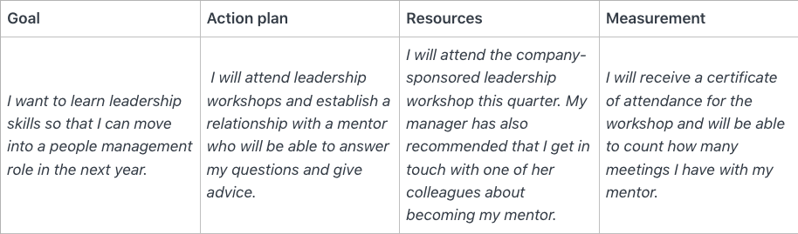

Conclusion:

Reflecting on my career development using Kolb's model, supported by a SWOT analysis and a Personal Development Plan, has provided valuable insights into my strengths, weaknesses, opportunities, and threats. By leveraging my strengths, addressing my weaknesses, and capitalizing on opportunities, I am confident in my ability to navigate the ever-changing professional landscape and achieve long-term success in my career. I understand that personal growth and development are ongoing processes, and I am committed to continuously learning, adapting, and improving.

By embracing new challenges, seeking out learning opportunities, and building a strong professional network, I aim to expand my knowledge, skills, and experiences. I will actively seek feedback from mentors and colleagues to gain different perspectives and identify areas for improvement. Additionally, I will remain adaptable and open to change, recognizing that the professional landscape is constantly evolving. I will stay informed about industry trends, technological advancements, and market conditions to ensure that I am well-prepared to navigate any potential threats or challenges. In conclusion, I am committed to my personal career development and growth. By applying the principles of Kolb's model, conducting a SWOT analysis, and creating a Personal Development Plan, I am confident in my ability to achieve my professional goals and make meaningful contributions in my chosen field. I am excited about the opportunities that lie ahead and look forward to the continuous journey of learning and self-improvement.

References:

1. Professional Development and Career Advancement: Your Guide to Success
by David Ewen | 26 Jul 2023
2. Kolb's Learning Model Example
by Trevor Clinger | 4 Apr 2013
3. The SWOT Analysis
by Lawrence Fine | 25 Mar 2011
4. SWOT Analysis - An easy to understand guide
by Charlie Ioannou | 12 Sept 2012
5. Nike Inc- Strategic Audit: SWOT, PESTLE, COMPETITOR & FINANACIAL ANALYSIS
by Bankim Chandra Pandey | 20 Nov 2017
6. Developing a Personal Development Plan: For Continuous Growth (Dreamers, Setters & Go-Getters)
by Kerry Williams | 25 Jun 2023
7. SWOT Analysis: Complete Guide to Business Success
by Geo Report | 19 Jun 2023
8. Data Analysis in Microsoft Excel: Deliver Awesome Analytics in 3 Easy Steps Using VLOOKUPS, Pivot Tables, Charts And More
by Alex Holloway | 21 Jul 2023

