WORKSHEET 2 – QUESTION

Write a programme to calculate the distance that a person can cover in a day using a vehicle of their choice.

a) We will start with two vehicles, a car and a bike. Allow the user to enter the distance to be covered and select a vehicle, then calculate the number of days of travel required.

Additionally, for our purposes, a car can travel a maximum of 800 miles/day and a bicycle can travel a maximum of 120 miles/day

Your output might look something like this:

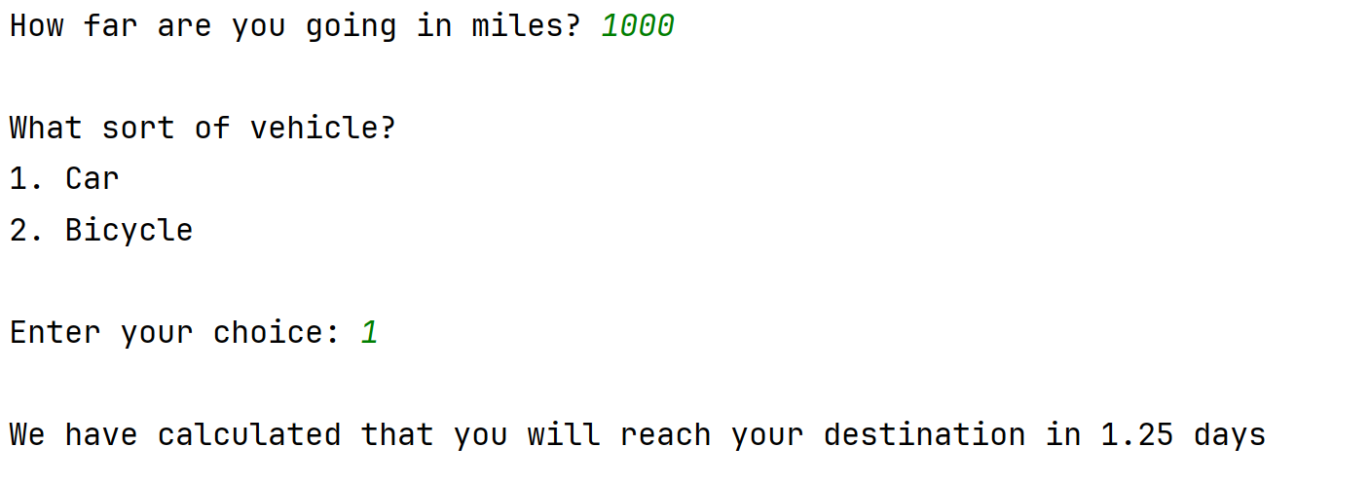

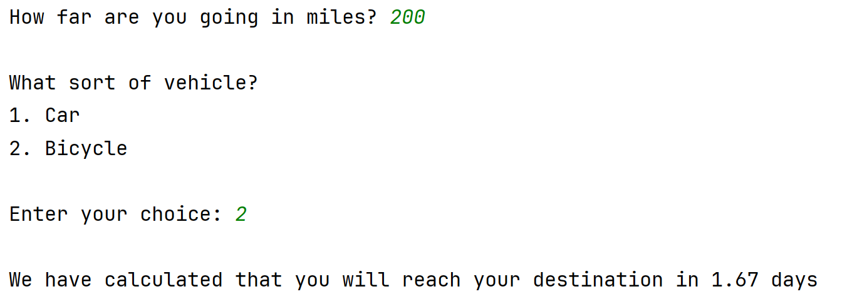

Use validation in your code where appropriate to prevent the user from entering inappropriate values.

b) Extend your program so that the user enters a logically sensible amount of miles.

We should account for outliers. For example, most people would not embark on a cycle ride of 500 miles, but it is not impossible (for example, someone might be doing a charity bike ride)

In the case of an outlier, ask the user to confirm their mileage and ask them re-enter it if they have made a mistake.

(Note: You decide what mileage should considered an outlier)

For example:

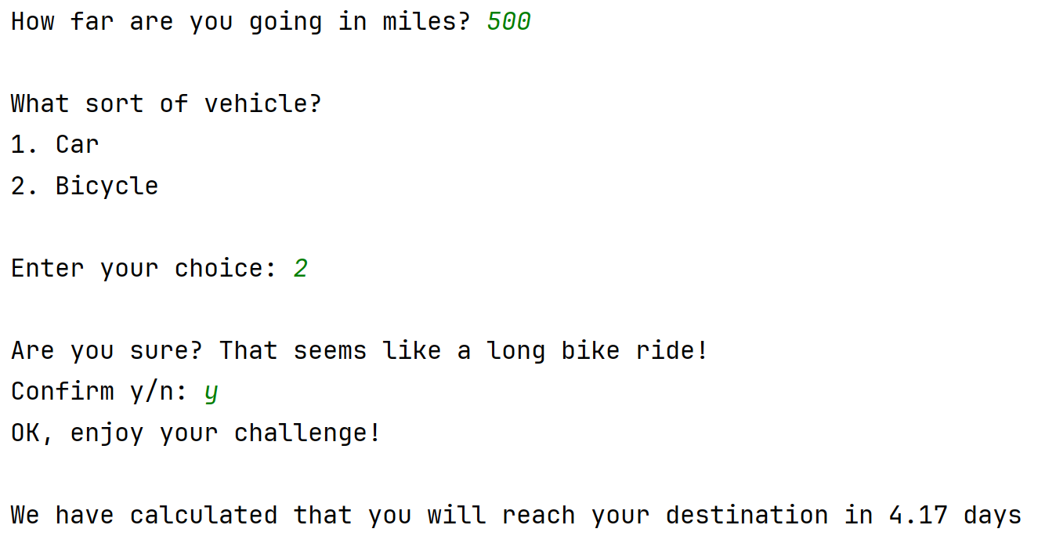

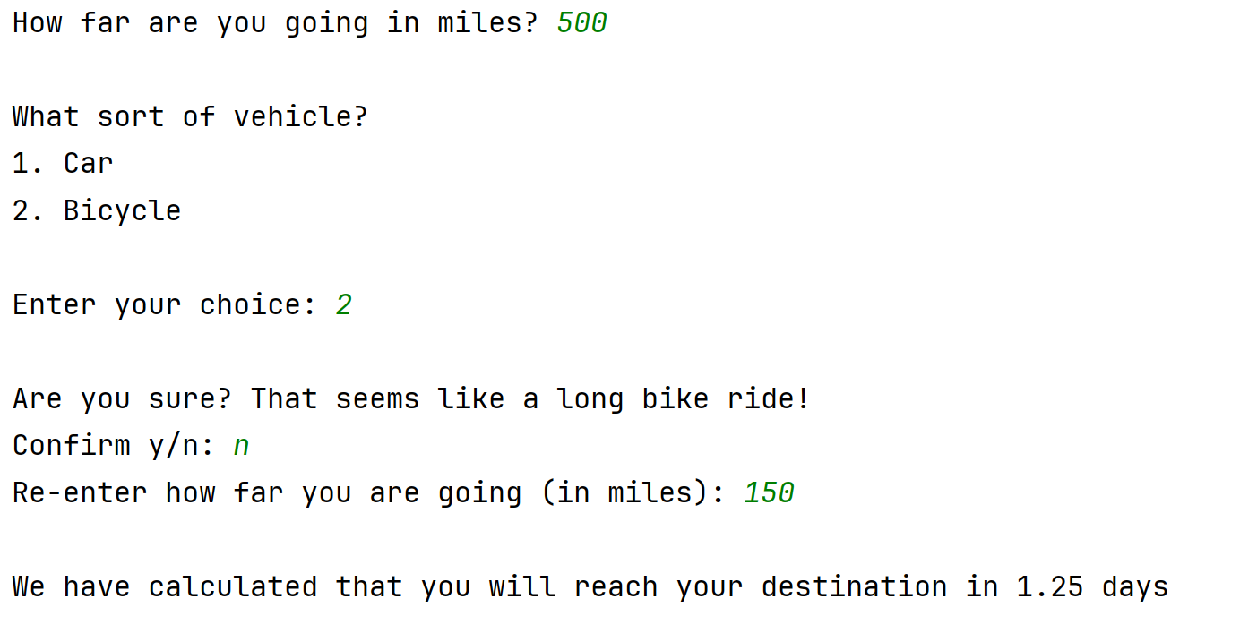

c) Add a third vehicle of your choice (for example, a private jet)



