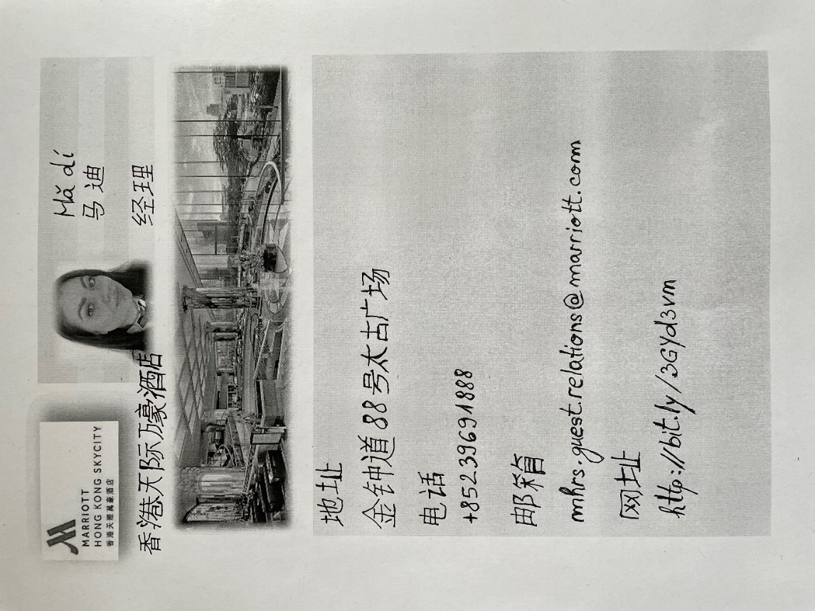
Student: Madalina Nagy
Student number: 2019619
Lecturer’s name: Jinping Li
Module code: BMIH5003
Module name: Mandarin
I am presenting my business card for Hong Kong Marriott Hotel. On this business card can be found phone number, address, postcode, email address, my name and job title.
Was a big challenge for me to create this business card, considering that symbols were handwritten. I am grateful for having this opportunity to learn Mandarin Language.
Thank you very much for all the help and support provided.

Kind Regards,
Madi.

