St Fagans, National Museum of Wales
Drawing on one of the establishments visited, how is both material (‘tangible heritage’) and non-material (‘non-tangible heritage’) aspects of Welsh life represented and how might it develop such representations in the future?
St Fagans as the first national Museum in the U.K. started in 1948 as a Welsh Folk Museum. The museum includes both material and non-material culture (Williams-Davies, 1989). It does so on the 100 acre land outside Cardiff on the grounds of the St Fagans Castle and Gardens. Since the opening of the museum, the museum has re-erected over 50 buildings on the property, making an open-air museum. Buildings include the Derwen Bakehouse to the St Fagans Castle and the Bry Eryr Iron Age Roundhouses (National Museum Wales, 2018).
At St Fagan's, they represent the life and culture of Welsh people across the ages from over 230,000 years ago to the current day (National Museum Wales, 2018). At the museum, both Material and non-material culture are used to present Welsh history.

Non- Material Culture
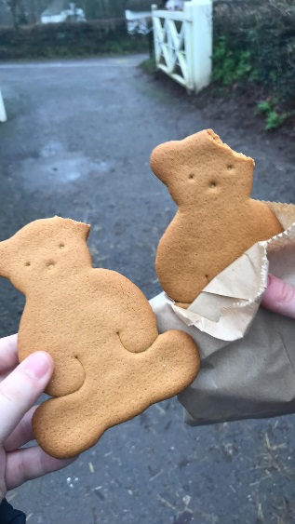
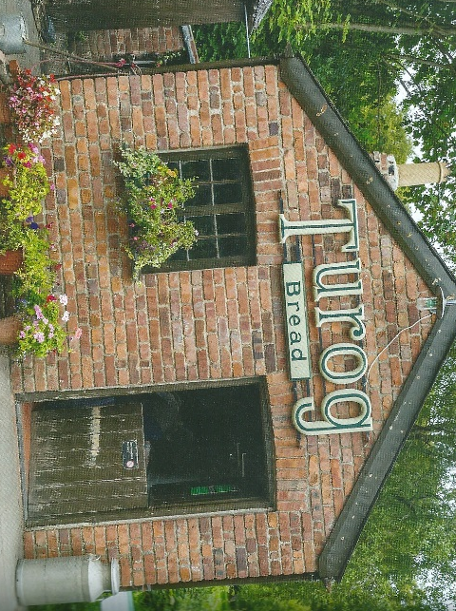
Non-material culture otherwise known as Intangible Heritage is not something that is physical but are still worthy of preservation. This included traditions, handicrafts, rituals, festivals, traditional crafts, culinary, performing arts, music and knowledge concerning medicine and nature. This could also include languages such as pronunciation and accents. Overtime intangible culture can be lost as it is only passed down through generations and is taught but doesn’t always leave a mark. At St Fagan's, Non-material culture is seen in the buildings and the workshops that they hold (Hamilton, 2018) (World Tourism Organization, 2012).

Representation
One of the buildings the Derwen Bakery, built in 1900 in Aberystwyth it was moved to St Fagan's in 1987. The Bakery formed of two rooms one as the preparation room and the room with the oven in it. The intangible heritage of the bakery is that they still bake stuff and then sell it. For example, they sell bread, cakes and at Christmas, they sell gingerbread (seen in the image to the right). This is a form of the culinary intangible heritage they are a form of edible souvenirs for the public and also a form of keeping the story fully alive as it keeps the bakery alive as its being used and not just something on display (World Tourism Organization, 2012).
(National Museum Wales, 2018)
(Seale, 2018)
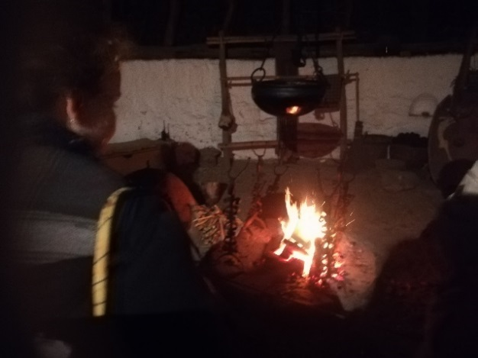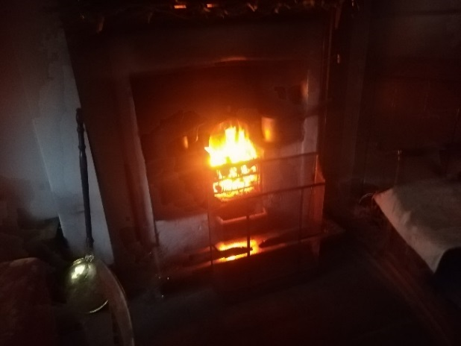
Picture of the fire in the Iron Age Roundhouse and the Rhyd-y-car terraces (Carlton, 2018)
In a couple of the buildings, they create an atmosphere and a better understanding of the past not usually explored through tangible heritage but can be more explored through intangible heritage by creating fires in houses where a fire would have been. This creates a sense of feeling for the public that allows them more to connect to the past. One main example where this occurred was in the Bryn Eryr Iron Age Roundhouses as in Iron Age Wales, life revolved around the fire in the house (seen in the image above on the left). Another place where there was a fire was the Rhyd-y-car terrace houses.

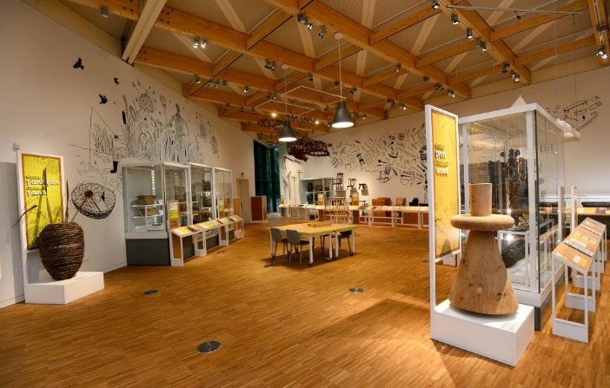
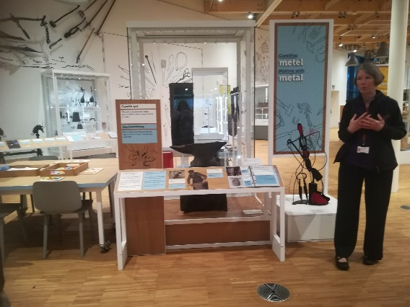
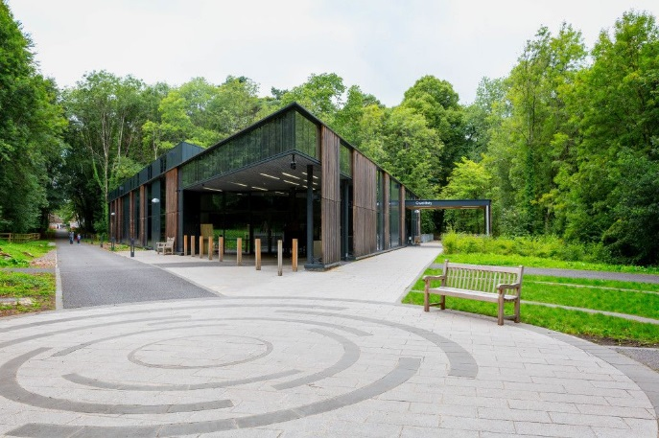
One of the new exhibits installed at St Fagan's is in the Gweithdy building is about the world of making. The exhibits celebrate traditional craft skills and the makers of the past. In this gallery they have interactive displays creating intangible heritage through experiences of crafts and traditions that can’t just be seen in material but the making of the items through the experience of craft traditions. The section is split into different sections of wood, clay, stone, metal, plants and textiles. Interaction in the Gallery includes Mosaics, patchwork, knitting and more.
Welcome to a world of making exhibit (National Museum of Wales, 2018)
Gweithdy Building (National Museum of Wales, 2018)

Welcome to a world of making exhibit (Carlton, 2018)
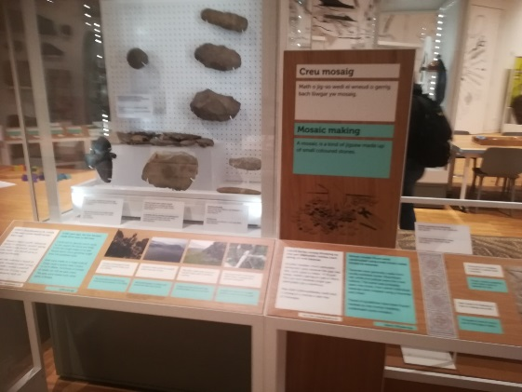
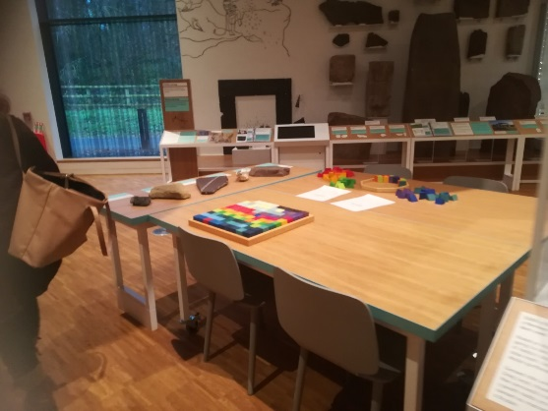
Images from the exhibit a world of making exhibit (Carlton, 2018)

Another thing at St Fagan’s that is a huge part in the intangible heritage that they are doing is with the Handicrafts and the demonstrating of Welsh traditional crafts this is down through workshops and courses. The Museums currently advertises workshops and courses on; Iron Age Blacksmithing, Blacksmithing, spoon carving, dyeing workshops, lambing, enamelling and basket making. This is the big way of passing these crafts to the next generations by getting experts in those fields and then teaching the next generation so that the traditional crafts carry on (National Museum of Wales, 2018).

Future
Intangible heritage is an idea within cultural heritage which is changing about what it is, how to present it and preserve it. The main body that deals with this is the UNWTO, which is the world tourism organization, they hold conferences and the next one due is in December 2019. The future for the museum is that they will also hold the workshops above that are planned and workshops that are in the planning phase or they are hoping to do in the future (World Tourism Organization, 2012).

Material Culture
Tangible Heritage is a cultural heritage that manifests itself in a physical way and is materialistic. This includes buildings, monuments, natural landscapes and artefacts (Hamilton, 2018; World Tourism Organization, 2012). Material culture has been more at the forefront of knowledge about the past due to the fact that they provide a basis for ideas that can validate these ideas and all objects and buildings are witnesses to history in the nurture whether being several thousand years old to 50 years ago. The tangible Heritage of wales can be seen at St Fagan's in the two new museum exhibitions called Wales is … and Life is… It can also be seen in the buildings outside the main galleries of which there are nearly fifty buildings under the museums care (Hamilton, 2018) (World Tourism Organization, 2012).

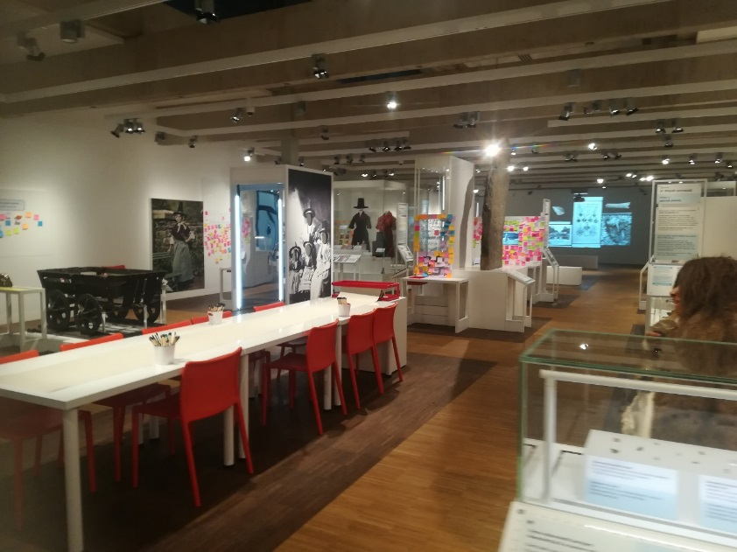
Representation
Image from the Wales is… exhibit (Carlton, 2018)
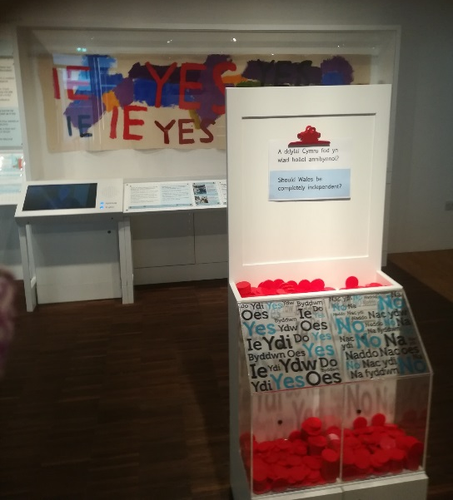
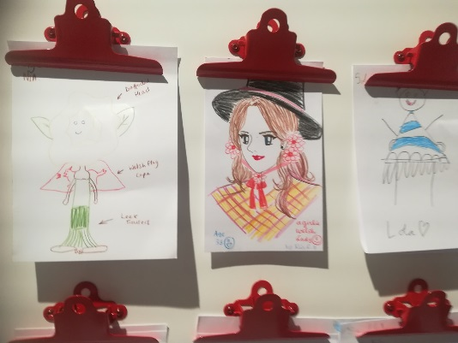
Wales is … the exhibit explores the story of wales through different perspectives of people but also using material culture and creating a space where the visitors interact with the past and exhibit. The museum has created a space in which the public can interact with the public by asking questions which engage the public in the material culture and questions which are relevant. The exhibit is divided into several sections on what wales are and in each of these exhibitions, they hold artefacts relating to that subject. The subjects range from well-connected to farmers to Welsh costume and the Wealthy to 2% Neanderthal and Scarred by War. The exhibitions cover all walks for life in wales. The exhibitions artefacts such as a 230,000 Neanderthal, Musical instrument, Welsh Costumes and Clothing as wells as Roman items. The use of displaying the clothing allows the public to create their own form of Welsh traditional clothing as well. The use of material culture in the exhibits helps to explore the history of wales but to also interpret and illustrate the lives of those who lived in Wales, as it allows to explore Welsh identities.
Asking about independency of wales in the Wales is exhibit (Carlton, 2018)
Image from the Wales is… exhibit (Carlton, 2018)
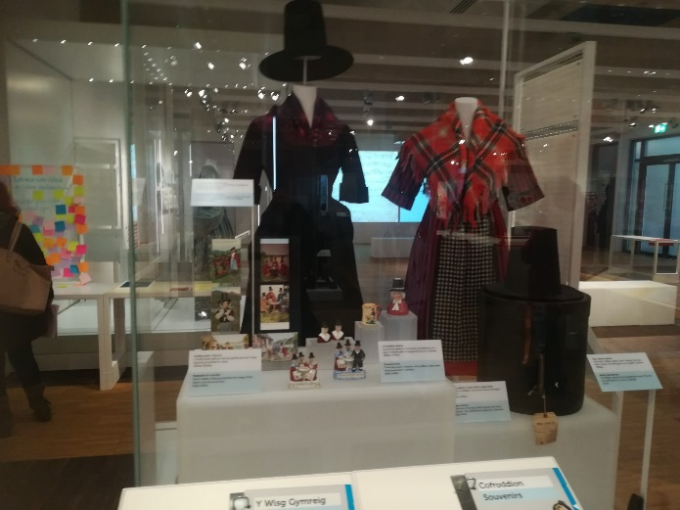
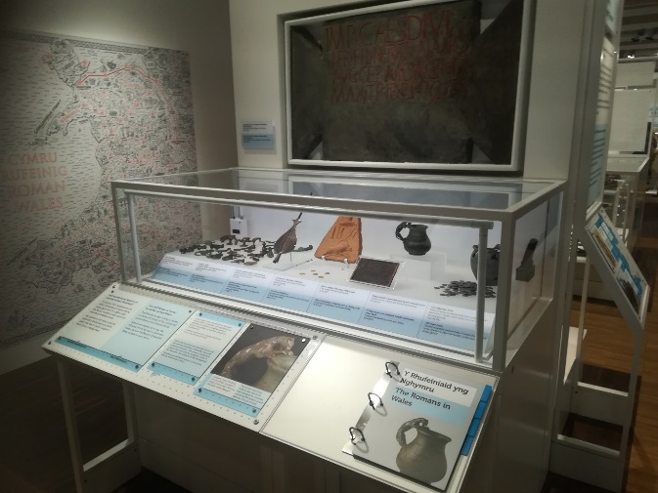
Images from the Wales is… exhibit (Carlton, 2018)

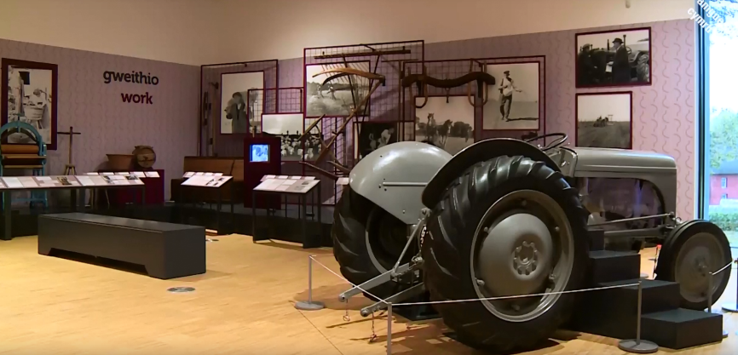
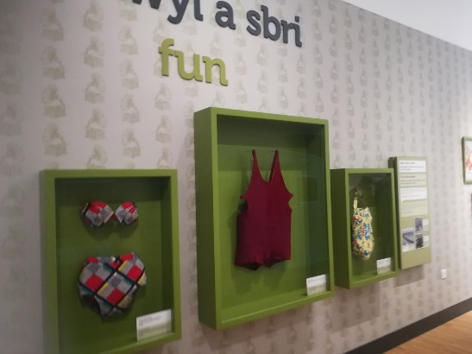
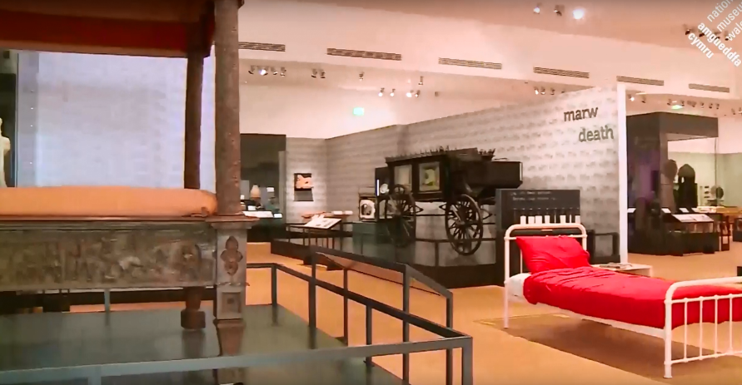
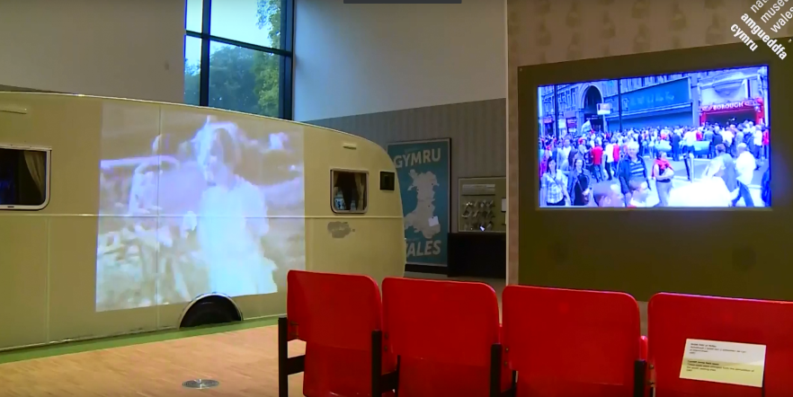
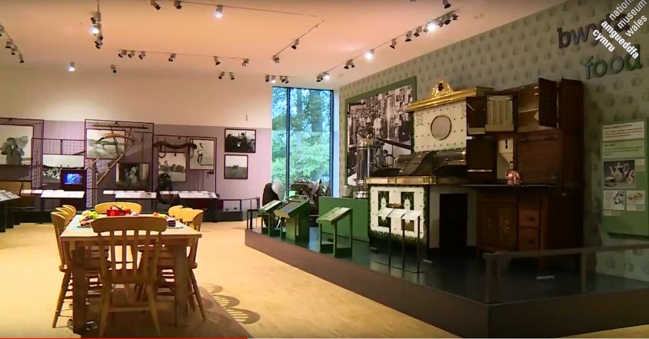
Life is … the exhibit tells the story of life in wales through peoples own words and their objects that they treasured. The gallery has no storyline running throughout the gallery and holds an object that illustrates everyday lives and the gallery exhibits take the everyday objects and display them as extraordinary (National Museum Wales, 2018). Like Wales is exhibit it is divided into different sections and they are; food, looking good, work, fun, bed and death. The material culture on display in the gallery range from Jewellery, clothing, plates, work surfaces and ovens. Also on display are coffee machines and Ferguson in life. From the Holidays by displaying swimwear, a family’s caravan (which you can tractor on working and farm life. The exhibits stories of farming and miners but also the fun see into) and entertainment at home by displaying a piano which you can play to the radio. Also displaying the beds of people and the gravestones to illustrate death.
Life is exhibit (Carlton, 2018)
Life is exhibit (National Museum Wales, 2018)
Life is exhibit (National Museum Wales, 2018)
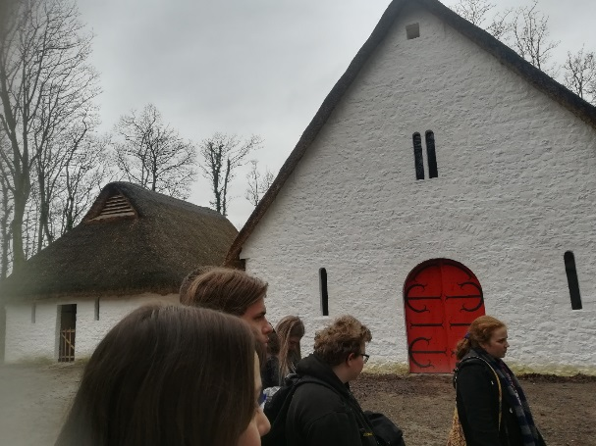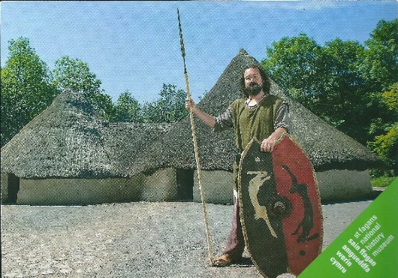
Iron Age Round House (National Museum Wales, 2018)
Llys Llywelyn (Carlton, 2018)
As well as the many exhibits the lands also have over 40 different buildings ranging from different time periods and come from all over Wales and were re-erected. Somewhere even built from scratch and were based on archaeological record and what is known about the buildings. On-site they range from Iron Age Roundhouse, Bakery, Terrace houses to the Gwalia store and sweet shop, to a Tailor’s shop. Some of the buildings have been dissembled and then reassembled at the museum.
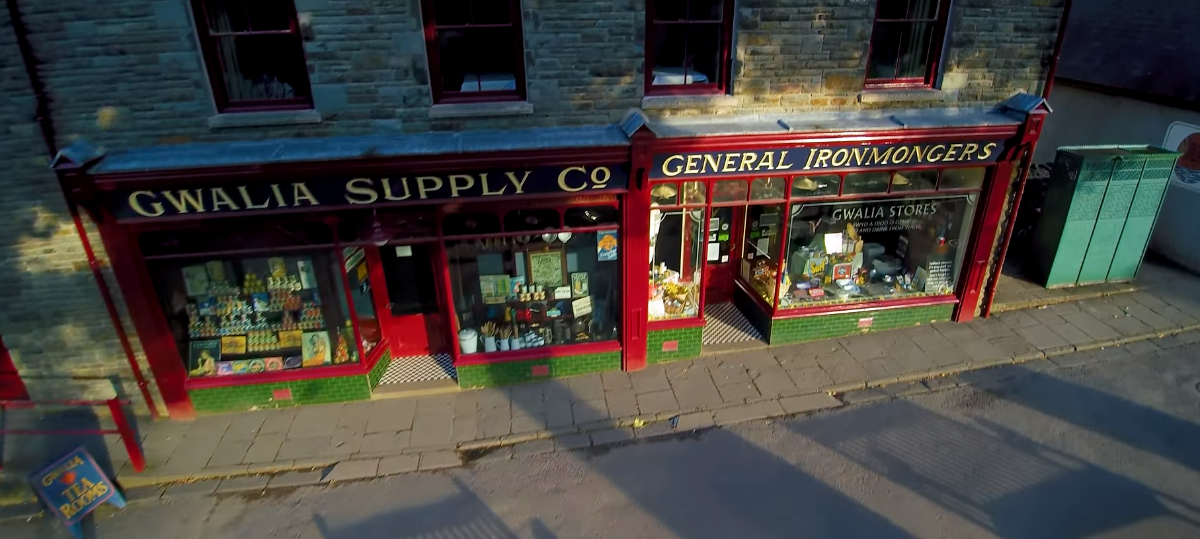
Gwalia Supply shop images (National Museum Wales, 2018)
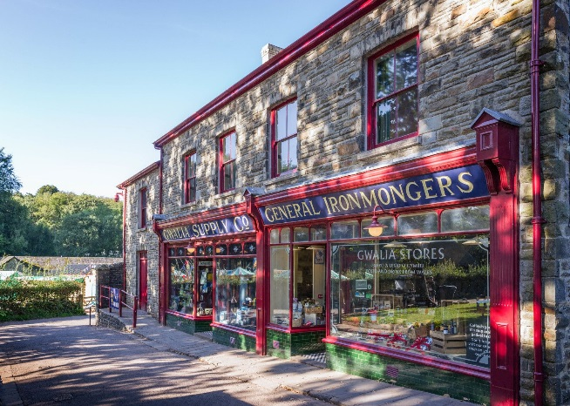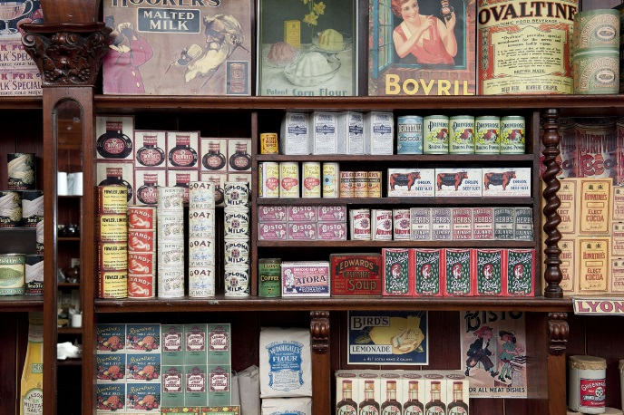

One of the many buildings on site that are the Gwalia Stores. Originally from Ogmore Vale and built in 1880. It was then moved to St Fagan’s in 1988 and is currently furnished as if it was in the 1920s. There are two sides of the store and one side is a fully operational store. Material items here is a key experience as you get to experience a general store from a small town and what it looked like back then but also buy items that come from the items that are produced in Wales.
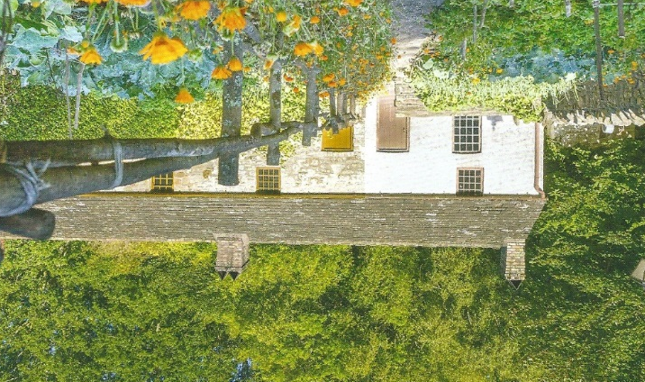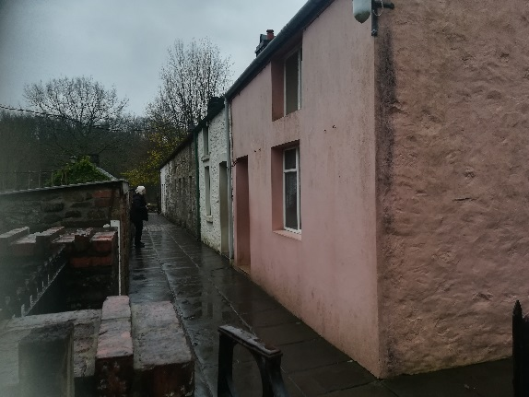
Rhyd-y-car terrace houses (Carlton, 2018)
Rhyd-y-car terrace houses (National Museum Wales, 2018)
Another building is the Rhyd-y-car terrace houses, originally from Glamorgan and built in 1795. As it’s a terrace house there are six houses since it was moved to St Fagan’s in 1982/3, each house you can go in and is furnished and dressed in different years and they are 1805, 1855, 1895, 1925, 1955 and 1985. Each house is recreated into that time period and at the time of our trip some of the houses were decorated with Christmas decorations from the time and some even had fires going. The houses also all have gardens out front on what it was like back then by using material culture to display what life was like 200 years ago to 34 years ago of which adults would be able to connect to the living style through the objects held in the house by saying that they had that in their own house.

Future
The future of the tangible heritage in that they planning on having seasonal exhibits in the main entrance building. They also in the process of moving two more buildings to the site. One of which is the Taff’s Well Police Station and the other the Vulcan Hotel (National Museum Wales, 2018).
To conclude, the St Fagan’s, National Museum of Wales links both tangible and intangible heritage throughout its site and not just in one way displaying material culture. The most museum would have held just artefacts at an already established whereas at St Fagan’s the move buildings across Wales to the site to exhibit that house and furnishing the house or building with artefacts and the artefacts and the house isn’t behind a piece of glass

Bibliography
Carlton, R., 2018. Images from St Fagan's Museum, Cardiff: s.n.
Hafstein, V. T., 2018. Making Intangible Heritage. Indiana: Indiana University Press.
Hamilton, F., 2018. Tangible and Intangible Cultual Heritage. [Online]
Available at: http://designonline.org.au/wp-content/uploads/2018/05/Cultural-Heritage.pdf
[Accessed 01 01 2019].
Hannan, L. & Longair, S., 2017. History through Material Culture. Manchester: Manchester University Press.
McKercher, B. & Du Cros, H., 2006. Cultural Tourism; The Partnership between Tourism and Cultural Heritage Management. 2nd ed. London: The Haworth Press, Inc.
Morgan, G., 2011. A Breif History of Wales. 2nd ed. Talybont: Y Lolfa.
National museum of Wales, 2007. Amgueddfa Cymru national Museums Wales Celebrating the first 100 years. Cardiff: National Museum Wales Books.
National Museum of Wales, 2018. St Fagans National Museum Of History. [Online]
Available at: https://museum.wales/stfagans/
[Accessed 01 01 2019].
National Museum Wales, 2018. Orielau newydd yn Sain Ffagan | New galleries in St Fagans, Cardiff : AmgueddfaCymru.
National Museum Wales, 2018. Your guide to St Fagans National Museum of Wales. Cardiff: National Musuem Wales.
Park, H. y., 2014. Heritage Tourism. 1st ed. Abdingdon: Routledge.
Seale, N., 2018. Image of Ginger Bread from St Fagan's. [Art].
Walsh, K., 1997. The Representation of the Past: Museums and heritage in the post-modern world. 3rd ed. London: Routledge.
Williams-Davies, J., 1989. The Preservation and Interpretation of Traditional Rural Crafts at the Welsh Folk Museum. Journal of design History, 2(2-3), pp. 215-218.
World Tourism Organization, 2012. Tourism and Intangible Cultural Heritage. Madrid: World Tourism Organization.

