ECIE5004
Celebrating Language and culture-belonging to Wales

Jonathon Atter

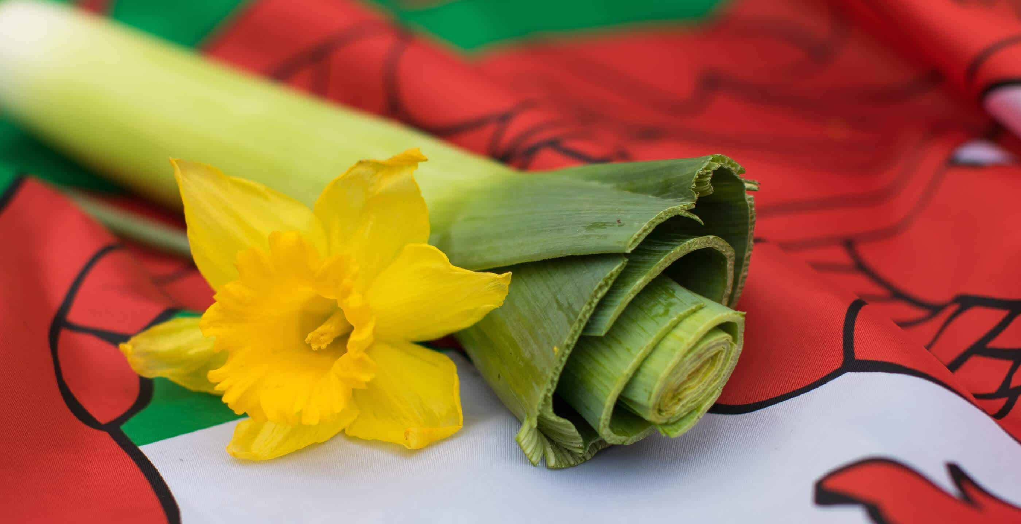
(Johnson, n.d).

CONTEXTS PAGE

Rationale………………………………………………………. P3-P8

Overview……………………………………………………….P9-P12

Evaluation………………………………………………………P13-P14

Appendices……………………………………………………P15

Where is the Welsh Language and its culture today?

What is Wales known for? Its’ Castles? Its’ Culture? Its’ Choirs? Or is it known for its language.
A surprise for many people is that the language known as Crmraeg or Welsh to the non-Welsh speakers is not just spoken just in Wales but spoken in many different pockets around the world and even out of this world. “There was also joy at finding out the first Welsh words spoken in space by a Canadian astronaut in 1998” (BBC, 2019).
The Welsh language has been on an extraordinary journey through time. It started with being the most spoken tongue in the British Isles to later being forced to the brink of extinction and now in the twenty first century, has the Welsh language come full circle? In this modern time has it been injected with a Resurgence as the Welsh Government felt it was time for a change?

Since the census of 2001 the Welsh Government wanted to encourage more people to become Welsh Speakers. (See Appendix B) Reviewing the results from the 2021 census there was an incline in Welsh speakers from the 2001 census. Encouraged by these results, the Welsh government then decided in 2022 to act and set a target for 2050 as the graph shows that since the 2021 census 23,700 people can now speak Welsh which is a massive increase of people from previous years. This is a fantastic start to their outlined arrangements of making one million people Welsh speakers by 2050 but whether this will continue only time will tell.

“The 2011 Census results presented us with an opportunity to have frank conversations and re-evaluate the future that we want to see for the language” (Welsh Government, 2017). or has now the English language completely dominanted Wales with no chance of the Welsh Governments prediction of a million Welsh speakers by 2050 coming to fruition as the rise in Welsh speakers from the 2021 cenus to the 2022 graph shown maybe just the result of the covid 19 pandemic as people where bored being at home during the lockdown.

In the modern era the Welsh language has moved forward and kept up with the times by using music platforms to spread the language around the world. “First band to pass one million plays with a Welsh language song” (theguardian,2018). It looks like Welsh music is flying high on music apps like Spotify. Music plays a big part in promoting the language through many different means. “Whether you’re into indie, rock, punk, funk, folk, electronica, hip hop or anything else, there’s incredible music being made in the Welsh language for you to discover” (Welsh Government, 2023). Or whether people are interested in a more classical theme the Welsh language has got everyone covered. “Wales is a land long shrouded in myth and legend and storytelling and music have, and still do, combine to forge Welsh culture” (Callow, 2023).
The Welsh national anthem is one of the most recognised national anthems in the world and has been played and sung in some of the most famous areas and sporting stadiums in the world. When the anthem is sung at the rugby six nation games and when Wales play international football it is a moving, goosebumps on the arms moment for all who watch, not just for the Welsh people singing. “Social media was awash with praise for Hen Wlad Fy Nhadau, which translates as Land of My Fathers, after it was sung at a World Cup for the first time” (BBC,2022). There are some people in Wales that don’t speak Welsh but when it comes to their national anthem they still able to sing it with pride and gusto as it is well known throughout Wales.

People who live in the United Kingdom but are not born or affiliated with the country of often see it as the land of song and assume that everyone speaks Welsh. When a Welsh person is in England, they are asked countless times by the English person do you speak Welsh? “Can you speak Welsh? Be prepared to be asked this question numerous times” (Studentlife, 2020).
The people in Wales who speak Welsh are typically from the rural areas of the country and not in the built up major city’s “You grow up in Caernarfon, you (probably) speak Welsh. You grow up in Merthyr, you (probably) don’t” (Jones,2018).

There are many different dialects in Wales, these can be heard from one place to another. What can be confusing is that not all the Welsh language is the same, The actual Welsh language can be different depending on whether a person comes from North or South Wales with different words and pronounciations meaning the same thing.
Its not just the Welsh music doing its part in promoting the language the realm of television is also contributing. When S4C started it was sharing its Welsh programming with English programmes on Channel 4 and was only given “2 hours of Welsh language programmes were broadcast every week” (S4C, n.d).
(See Appendix A).“Today, S4C is a wholly Welsh language channel broadcasting over 115 hours of programmes each week” (S4C, n.d).

Origin
The origin of the Welsh language dates to even before the Roman invasion. “Thought to have arrived in Britain around 600 BC” (Brain,n.d). This shows that the Welsh language is one of the oldest languages in Europe. There are many types of Welsh written literature from this early period in time. “The first Welsh poets included Aneirin and Taliesin, whose work descended from the tradition of the druids. Sometime between 400 and 700 AD” (BBC, 2008).
In 1536, Henry VIII passed the act of union which stickly prohibited the use of the Welsh language in any public and legal system. To give a little more background to Henry’s union, under Henry VIII the laws in Wales act 1535 and 1542 uncomplicated the administration and laws in Wales. The Language of England was to be used and replace the supposedly more complex and mixed-up Welsh.

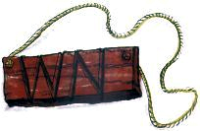
(Woods, 2021)
The Welsh not was first introduced in “A "Welsh Not" was a wooden board designed to be worn around the neck of a schoolchild in a bid to shame them from speaking Welsh”(Evans,2022). The purpose of the not was if any pupil was heard speaking welsh they must wear it around their neck. Then if another pupil was to speak welsh then it was passed on again until the end of the day when the last child wearing the not would receive the lash from the teacher. This must have been a very trouble time for the fluent young Welsh speaker of Wales, as many of these young children’s first and only language would have been Welsh so for them this must have been a very humiliating and painful experience to have gone through.

.

Overview of ativities

At Bishop Gore secondary school, many different types of activity’s are incorporated throughout the year from Dydd Shamae day to Saint Davids Day with all subjects included. The setting even provides training for teachers on inset days called interdental Welsh lessons. By providing the teachers and support staff the training in Wesh, it helps them be prepared for Dydd Shamae day. The inclusion of Welsh in these subjects keeps the Welsh live in the school and helps the Welsh Governments plan of achieving one million Welsh speakers alive by 2050.

What helps children in this setting is having to write the date and the lesson starter in Welsh. By adding simple and little things like this to the everyday school life of the students these Welsh words like the date may become second nature to the pupils.

The Dydd Shamea is a day for the year sevens only and it’s done at the beginning of the school year and its designed to teach the year sevens basic speaking and listening skills while at the same time introducing them to the new members of staff who will be guiding them through school life for the next five years.

On Dydd Shamea day year sevens are divided into separate classes and within their classes are split into groups of 4 and 5. They are then given the task of unlocking and solving a pirate mystery. “Skinner argued that learning should be active, so that the student could make responses that could be evaluated and shaped toward the pedagogical objectives” (Ferguson, 2001). To unlock the different parts of the puzzle the students must obtain the signatures from members of staff by speaking set Welsh phrase and listening to the response.
The group that completes the task sheet in the quickest time will receive a prize. This is a great activity for the year sevens to do as they are new to the school and it forces them to be social with one another as they have rise to the challenge of solving the puzzle and it also makes them talk to the members of staff. “Vygotsky's conception of the cognitive and emotional development of the child as primarily determined by the values of the surrounding culture mediated by the guidance and help of an experienced adult” (Mahameed, 2022).

The positive outcomes of this activity are to ingrate the year sevens into the school through the medium of Welsh by having them speak to pupils in their year group and talk to members of staff in Welsh. This activity works but could be used more effectively by involving the sixth form and other year groups thus making it a school activity and not just allocating to the years sevens. This would enable the new year group to get to know the other year groups and integrate them more effectively but still using the Welsh language to enable this integration and make the school one big community at the same time. This idea is perfect for Bishop Gore as they are a virtual tutoring school. “Vertical tutoring mixes tutor groups in form time by age: tutor groups are typically made up of students from Years 7 to 11” (University wolverhampton, n.d)

The Dydd Shamea is a day that the school likes to celebrate by incorporating the fact that Wales is the land of song and wants all the children to leave at the end the day by knowing at least one song fully in Welsh. At the Start of the day they are introduced to a youtube video clip of Dafydd Iwan singing Yma o Hyd before Wales football international match. (Appendix C) This clip is set to inspire them and ignite their interest as it’s a very moving, passionate, and emotional video that can build up patriotism and will show a will to learn the song through their Dydd Shamea day. The school for many years used the Calon Lan and it work well with the children learning it but there was no passion behind their voices but now when they sing Yma o Hyd the school is blaze with Welsh pride. When the school made the decision to change the songs around, they were worried that this may deter the pupils who are from different parts of the world as the school is vastly multicultural community based. However, in fact it had the revise effect and these children from different ethic backgrounds joined in more as they wanted to be a part of this new school experience.

The activities on Saint Davids’s day are for the whole school to become fully immersed into all things Welsh. The activities from KS3 to KS4 will differ as the year 10 and 11 pupils will be preparing for their Welsh GCSE and will be following the standard curriculum lessons. (See Appendix D) The KS3 will follow very similar types of these games and art actives which will help them learn all about Welsh Culture. One positive outcome from these activities is how the children like to spend time away from the typical style lesson plan and enjoy lessons that are provided. A downside to these activities would appear to be that they provide no connection to the Welsh language and thus lose a fantastic chance to get the children to fully engage into the saint Davids day sprint by giving the pupils mix and match experience of all things that are relating to Welsh culture.

Evaluation

As already stated in the origin section of this portfilo that the Welsh language was a vastly spoken language in olden times but through the years its speakers have dwindled down and it has suffered many attacks to wipe it off the face of the earth. However, it has combated them all and it is still fighting but the main question is will it be making a resurgence to be able to meet the Welsh government target of one million Welsh speaker by 2050. The hype the government have put behind this target maybe setting them up for a fall if not achieved as the newspapers can be unforgiving but hopefully the positives will be taken into account that even if a one million Welsh speakers are not achieved its an achievement in itself and a move in the right direction for obtaining more Welsh speakers than before and this can only benefit the people and keep the Welsh language and its culture alive.

The Welsh language was taken to the brink of genocide by the English with the passing of the act of union and the introduction of the Welsh Not to prevent the youth of Wales from spreading the language and keeping it alive. The recovery of the Welsh language may have started in 1967 as this was the time the Welsh was made legal again and from the act of 1535 to 1967 is a very long time indeed but despite all of these adversities the old language of the Welsh people has prevailed.

23,700 is the number of people that learnt Welsh from 2021 to 2022 and this is fantastic for the Welsh government and the country itself even though it may have been a result of the pandemic and people had more free time at home, but this is now the time for the Welsh Government and the people to capitalise and take full advantage of this and not let it slip away. The Government need to address this and back it 100% then if the rate of growth continues we will see them achieve over 1 million Welsh speakers by 2050.

If the Welsh Government fail in hitting the mark of one million Welsh speaker but 2050 does that make Wales less Welsh? No, does the fact of being unable to speak Welsh make a Welsh person any less Welsh? No. A Welsh person can be very proud of being Welsh without being fluent in Welsh and the language will still be around songs like Yma o Hyd, Calon Lan and the national anthem Hen Wlad Fy Nhadau (Land of my fathers)

“May the language endure for ever” (Classicfm,2022). With lines like this from the Welsh anthem is hard to believe that the Welsh language won’t endure as its been through hard times and survived for thousands of year. During these years and hard times, it didn’t have any back from the Westminster government but now it has the full back from the Senedd and with that backing should be around in a thousand years to come.

Appendix list

Appendix A
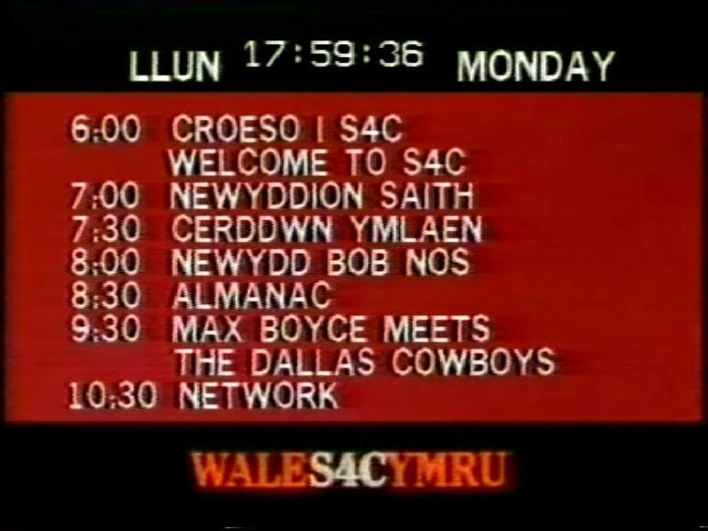

(CST, 2021).
Appendix B
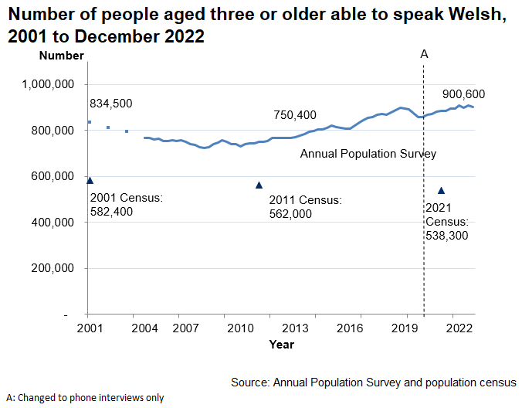
(Welsh Government, 2023)

Appendix C
 (Virginmedia,2022)

Appendix D

Please see St Davids day games & pack
https://easierscouting.com/wp-content/uploads/2015/02/St-Davids-Day-by-Samantha-Eagle.pdf
(Eagle,n.d)

Reference list
BBC, World cup 2022:Welsh Anthem praised around the world
Available at https://www.bbc.co.uk/news/uk-wales-63729674
(Accessed: 4th January 2024)

BBC, (2008) Early Welsh Poerty
Available at https://www.bbc.co.uk/wales/history/sites/themes/society/language_poetry.shtml
(Accessed:27th November 2023).

BBC, (2019) Unexpected Welsh' - where in the world have you heard it?
Available at https://www.bbc.co.uk/news/uk-wales-47002948
(Accessed: 27th November 27th 2023).

Brain,J (n.d) The Welsh Language
Available at https://www.historic-uk.com/HistoryUK/HistoryofWales/Welsh-Language/
(Acccesed: 27th November 2023).

Callow, F (2023) Celebrate the music and myths of Wales this St David’s Day with BBC National Orchestra and Chorus of Wales
Available at https://www.walesonline.co.uk/special-features/celebrate-music-myths-wales-st-26289878
(Accessed:3rd January 2023).

Classical Fm, (2022) Welsh National anthem: what are the English and Welsh lyrics to land of my fathers.
Available at https://www.classicfm.com/discover-music/periods-genres/national-anthems/welsh-national-anthem-lyrics-meaning/
(Accessed: 5th January 2024).

CST Online, (2021) S4C: THE FIRST HOUR – AN INTERVIEW WITH EURYN OGWEN WILLIAMS (PART I) BY DAFYDD SILLS-JONES
Available at https://cstonline.net/s4c-the-first-hour-an-interview-with-euryn-ogwen-williams-part-i-by-dafydd-sills-jones/
(Accessed: 3rd January 2024).

Eagle, S (n.d) St Davids day games & pack
Available at https://easierscouting.com/wp-content/uploads/2015/02/St-Davids-Day-by-Samantha-Eagle.pdf
(Accessed: 5th January 2024).

Evans, M (2021) The cruel history of the Welsh not which tried to shame children into abandoning their language
Available at https://www.dailypost.co.uk/news/north-wales-news/cruel-history-welsh-not-tried-24916977
(Accessed3rd January 2024).

Ferguson,K , O’Donohue,W (2001)
The Psychology of B.F.Skinner
Chapter 8 Applied Behavior Analysis.

Johnson, B (n.d) leek national emblem of the Welsh
Avaible at https://www.historic-uk.com/HistoryUK/HistoryofWales/The-Leek-National-emblem-of-the-Welsh/
(Accessed:6th January 2024).

Jones,A (2018) ARE YOU QUIETLY FURIOUS THAT YOU DON’T SPEAK WELSH?
Available at https://saysomethingin.wordpress.com/2018/12/18/are-you-quietly-furious-that-you-dont-speak-welsh/
(Accessed: 4th January 2024).

Mahameed, M , Yousef, N , (2022) Reading Yeat’s prayer for my daughter in light of Lev Vygotsky’s sociocultural theory of learning.
Theory and practice in language studies Vol 12 ISS 2,

S4C, (n.d) introducing s4c
Available at https://www.s4c.cymru/en/about-us/introducing-s4c/page/17280/introducing-s4c/
Accessed: 3rd January 2024).

S4C, (n.d) introducing s4c
Available at https://www.s4c.cymru/en/about-us/introducing-s4c/page/17280/introducing-s4c/
(Accessed: 3rd January 2024).

Studentlife, (2020) My experience of being a Welsh student at an English University

Available at https://blog.lboro.ac.uk/students/international/my-experience-of-being-a-welsh-student-at-an-english-university/
(Accessed: 4th January 2024).

Theguardian, (2018) teenage due stunned as Welsh language song scores 1m Spotify hits
Available at https://www.theguardian.com/uk-news/2018/dec/07/teenage-duo-make-first-welsh-song-to-reach-one-million-spotify-hits
(Accessed: 3rd January 2024).

University of Wolverhampton, (n.d) vertical tutoring
Available at https://educationobservatory.co.uk/pupilpremiumprimer/vertical-tutoring/
(Accessed:5th January 2024).

Virgin media sport (2022) SPINE-TINGLING! 🏴󠁧󠁢󠁷󠁬󠁳󠁿 Dafydd Iwan belts out Yma o Hyd before Wales vs Austria!
Available at https://www.youtube.com/watch?v=emPhXdwhQoE
(Accessed:5th January 2024).
Welsh Government, (2017) Cymraeg 2050
Available at https://senedd.wales/laid%20documents/gen-ld11108/gen-ld11108-e.pdf
(Accessed:27th November 2023).

Welsh Government, (2023) Welsh Language Music Day
Available at https://www.gov.wales/welsh-language-music-day
(Accessed:3rd January 2024).
Welsh Government, (2023) Welsh language data from the annual population survey
Avaible at https://www.gov.wales/welsh-language-data-annual-population-survey-2022
(Accessed: 5th January 2024).

Woods, S (2021) Welsh not still alive and well
Available at https://www.slwoods.co.uk/?p=8758
(Accessed: 3rd January 2024).

