

Material Science / Structural Appreciation, Science and Materials.

Daniel Lawrence
Student Number - 1706618
Construction Materials
When reporting on original design planning, construction and the potential impact in sustainability at the site of the build of a concrete frame and steel frame building, there are many considerations to assess to get an accurate understanding of the choice of material has on the proposed points.
The Leadenhall building stands at 224 meters in height and incorporates prefabricated steel frame, as seen in figure i). It is supported by an exterior exoskeleton replacing the central core usually required for steel frame building, providing stability. It was famed for the calculated lean to the northside of the building to account for the additional weight and its timed delivery plan of the prefabricated materials. Clearly, the Leadenhall building is a great case study to examine.
As the Leadenhall building is prefabricated in a factory environment there is the ability to produce accurate steel components for the superstructures frame which are governed by quality control. As, ‘Steel is produced to the most exacting specifications under highly controlled conditions, eliminating the risks of onsite variability.’ (Steelconstruction.info, 2018). This enables the execution of the component installation to be planned, predicted and repeated increasing speed and efficiency independent of weather conditions aiding unhindered construction.
Furthermore, faster construction whilst reducing labour requirements, local environmental effects such as dust, pollution, noise and congestion of a typical construction site are mitigated. Indeed, ‘The speed of construction and reduced disruption of the site also gives local environmental benefits.’ (Steelconstruction.info, 2018). As seen on the Leadenhall building where 80% of components used were prefabricated and brought to site in a controlled timed manner reducing the impact on the local environment.
Additionally, due to the frame’s method of assembly, the deconstruction is also significantly easier than the concrete counterpart due to the density and volume of concrete. This enables the reclamation and recycling of the steel frame components. Not only does this have benefits for the deconstruction of the building but also contributes to sustainability of the local area.
However, there is the reduced flexibility of onsite correction of human error. In comparison to the Burj Khalifa where the concrete was pumped into formwork and is produced on site there is reduced amount of inconsistencies in the frames production due to the flexibility of onsite adjustments.
The versatility of steel frame production enables larger spans to be incorporated into the design. This enables a variety of future variations, increasing adaptability. ‘Steel-framed structures provide ‘future-proofing’ against changing service requirements, changes in technology or in building use.’ (Steelconstruction.info, 2018). This is due to the simplicity in the frames structure, the versatility in the steels design to integrate services in the fabrication stage and the ease of additions to the structure through its weldability increasing the life cycle of the building. The versatility in steel frame design is highlighted in the Leadenhall’s utilisation of an exterior exoskeleton, replacing the need for an interior shaft for stability and increasing the interior usable space. Clearly, due to steels superior strength to weight ratio as seen in figure ii), this enables the versatility in design with the reduced volume of material needed. In comparison to a concrete framed building, the adaptability is greatly reduced as the shear mass of material requiring substantial foundations, the hardship to join concrete frame components, labour intensity of concrete frame production, requirements of onsite working space, wet construction and produces noise and dust pollution.
There are impacts to the environment with the use of steel frame buildings through the materials original production process. As, ‘virtually all of the greenhouse gas emissions associated with steel production are from the carbon dioxide emissions related to energy consumption.’ (Greenspec.co.uk, 2018). This is due to the vast amount of energy used in the production of steel. There are two methods of steel production. Firstly, Electric Arc Furnacing, involving recyclable steel being melted and converted to high quality steel. Finally, there is the Basic Oxygen Furnacing where recyclable steel is added to the molten iron in the furnace where it is intensely heated, oxygen is then used to lower the carbon content within the iron, creating steel. Indeed, during the steel production process there are further impacts to the environment such as, emissions to air, water and slag, which is the impurities of limestone and iron ore left on the landscape. Although, through waste management there is the ability to reclaim and reuse steel as its 100% recyclable.
There are many points that contribute to steels durability such as corrosion, mould and vermin resistance which aids the buildings longevity. ‘Steel does not warp, split, crack or corrode when appropriately produced and maintained.’ (Team, 2018). Corrosion prevention is essential for steel but the determination on the severity of prevention depends on the climatic factors of its presented environment. This is due to steel being susceptible to humid and marine environments as steel is a ferrous metal. A barrier that can be painted on can resist corrosion attack from an electrochemical process which requires oxygen and moisture which results in rust, degrading the materials durability potentially requiring replacement over time. Steel is also mould and vermin resistant as it’s an inorganic and hard material where spores and/or vermin are unable to form a habitat that could degrade the material.
However, steels durability, strength and lifespan can be affected by fire. As, ‘Loss of strength …. at 600C a steel beam may lose two thirds of its strength!’ (Highrisefirefighting.co.uk, 2018). This is due to the steel being vulnerable to thermal expansion which could result in the frame losing structural stability and that steel will suffer deformation under extreme temperatures. This can be mitigated through passive barriers of heat protection which work in two different ways such as, absorptive and thermal fire protection. Absorptive fire protection could include a concrete encasing or vermiculite, a spray on barrier which could absorb the heat of the fire and protect the steel. Thermal fire protection reduces the pace in which the heat penetrates and reacts with the steel such as, providing insulation, cladding or intumescent paint.
In comparison, concrete framed buildings have a much high tolerance to heat for a variety of reasons including aggregates. As, ‘aggregate can amount to 60-80% of the total volume of concrete; therefore, the choice of aggregate directly impacts the performance of concrete during a fire.’ (Ashley, 2007). This suggests concrete and its materials within its composition are non-combustible with a low thermal conductivity. This gives concrete the ability to endure contact with high temperatures without losing structural ability and act as a barrier. The aggregates within the composition of concrete enable this due to the low thermal rise in temperature. As carbonate aggregates such as limestone conduct a process called calcining where the magnesium carbonate and calcium reject carbon dioxide leaving magnesium oxide. The process of calcining reaction utilises and absorbs heat. Also, cladding, age, water content within the concrete affect concretes fire resistance.
The Burj Khalifa’, as seen in figure iii), known for being the tallest concrete frame building in the world incorporates a ‘Y’ shaped base with a buttressed core designed to resist wind pressures that could result in torsion. The reinforced concrete frame was pumped to a world record height of 606 meters emphasising the development of one of the oldest materials in history.
The Burj Khalifa’s shear vertical size meant that the design planning of the building needed to incorporate the management of gravity and the aerodynamic design to compliment the resistance to wind pressures. ‘This meant moving the gravity loads to where they would be most useful in resisting the lateral load’ (F. Baker and J. Pawlikowski, 2012). The ‘Y’ design of the building footprint enabled aerodynamic efficiency reducing the climatic pressures of the environment. This was aided by the management of gravity to a side which sustained the prevailing wind strengthening its resistance. This was complimented by the nature of the material forming the structure as concrete is inherently resilient to torsion and is stiff. The development of the ‘Y’ shape footprint of the building coupled with the Buttressed core provided the torsional strength to resist lateral forces, as seen in figure (iiii).
The construction of the concrete frame of the Burj Khalifa was enabled through the use of admixtures and a composition of concrete that was pumped into formwork with steel reinforcement to a 606-meter world record height. As, ‘concrete buildings not only offer designers flexibility in the shapes they’re able to form and designs they’re able to create, but they also offer more uninterrupted and usable floor space than steel-framed buildings’ (Staff, 2010). The use of admixtures for concrete such as plasticisers enable versatility in the concretes use and design capabilities as seen in the Burj Khalifa. Plasticisers are generally used in the pumping of concrete as it increases the fluidity reducing the water-cement ratio, increasing its workability whilst improving or maintaining strength by reducing the water content within the concrete.
However, this can be affected if during the pumping process air voids or uncompacted areas occur during the formwork process leading to a loss of structural strength and stability. In comparison to steel structures with the benefit of quality assurance of a factory environment which can produce consistent products.
Furthermore, the potential use of retardants to slow the curing process due to the climatic temperatures in the local environment could be necessary. ‘Retarders are beneficially used in hot weather conditions in order to overcome accelerating effects of higher temperatures and large masses of concrete on concrete setting time.’ (TheConstructor.org, 2018). The utilisation of retardants such as Gypsum could be necessary for the environment of the Burj Khalifa. This is due to the high temperatures, wind and relative humidity which would contribute to a fast curing time. This is potentially detrimental to the concrete as these factors would increase the rate of hydration causing water to evaporate rapidly, resulting in cracking on the surface of the concrete. If not managed, this could affect the permeability, durability and strength of the concrete.
There are many aspects of concrete as a construction material which are arguable sustainable at the site of the build. As, ‘The predominant raw material for the cement in concrete is limestone, the most abundant mineral on earth.’ (Balogh, 2018). Firstly, as the constituents of concrete such as, aggregate and cement are plentiful this reduces logistical distance, decreasing transport emissions. Secondly, as the materials low cost of production increases its demand, the minimal maintenance required, it’s versatility which can be modified to specification enable it to be a structural material. Thirdly, concrete has a large thermal mass due to the density of the material which decreases the passage of differential temperatures reducing the required energy to regulate temperature. Lastly, due to the durability of the material and its long-life span, it reduces the need to deconstruct and rebuild; minimising the impact on the local environment.
However, there are certain aspects of concrete frame construction which aren’t sustainable within the local environment, as seen in figure v). As, the components are not prefabricated and are all made onsite as ‘wet’ construction. This can affect the sustainability of the local environment as additional construction space requirements, noise and dust pollution, congestion due to the volume of materials required and the additional operatives needed in comparison to steel frame construction.
Although concrete is arguably a sustainable material for many reasons, the original production process of certain constituents can impact the environment. As, ‘producing a ton of cement requires 4.7 million BTU of energy, equivalent to about 400 pounds of coal, and generates nearly a ton of CO2’ (Rubenstein, 2012). This is due to the process of creating ordinary Portland cement, one of the constituents of concrete which involves the quarrying and then heating of limestone to a heat of 1900 degrees centigrade in kilns, creating clinkers which is later ground with calcium carbonate to form cement. The process requires vast amounts of energy and contributes to CO2 production through the logistics and manufacturing of ordinary Portland cement highlighting the potential environmental impacts the process has.
Additionally, as the population continues to rise, the effects of cement and concrete as a composition will parallelly follow due to the demand for further urbanisation, as seen in figure vi). As the upward trend of the demand and use follows the increase in population the effects of CO2 will continue to increase.
However, cement alternatives such as Pulverized fuel ash can contribute to a more environmentally friendly means of composition of concrete. As, ‘a substitution of cement with 30% PFA saves about 20% CO2’ (Weight, 2006). This is due to the reduced amount of cement required for the composition which is the greatest contributor to CO2 within concrete. It’s long life span, using a by-product of other industries, the emission of less CO2 than ordinary Portland cement clearly highlights the potential reduction in environmental effects.
In conclusion, there are many differences between concrete and steel frame buildings which affect the original design planning, construction and sustainability at the site of build which are comparatively different. However, as the development of materials and sustainable methods continue to shape the future of construction, the materials in question will further aid in the construction in future Highrise buildings.

Appendix
Figure i)
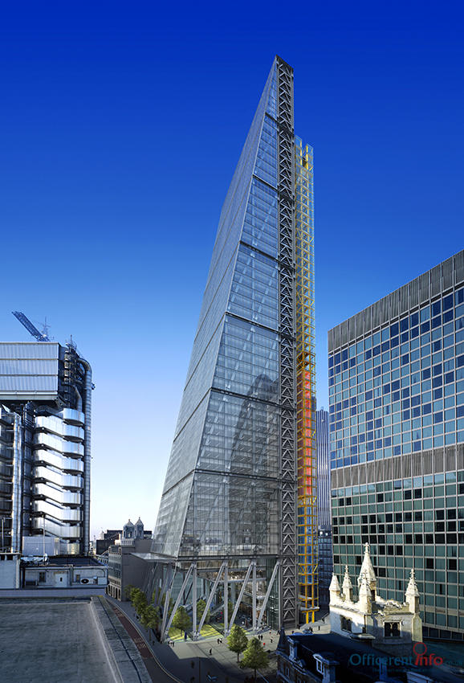
(Naidoo, 2010)
Figure ii)
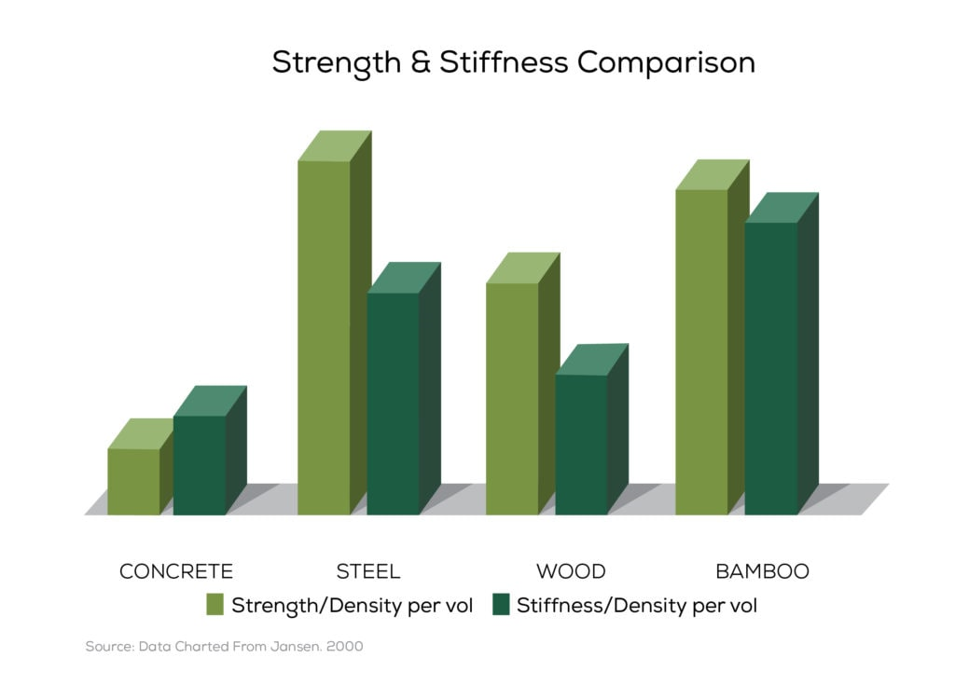
(Jansen, 2000)

Figure iii)
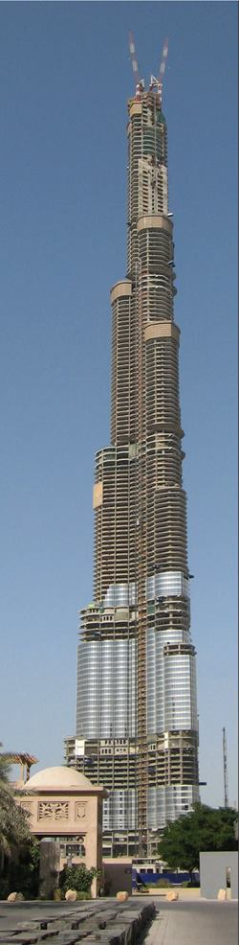
(Nasvik, 2008)

Figure (iiii)
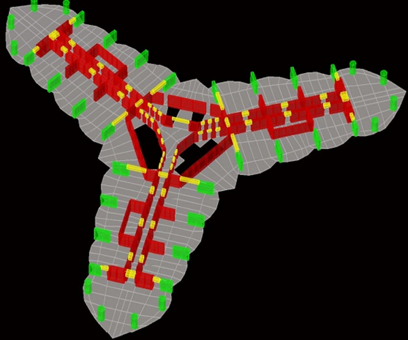
(Jamal, 2017)

Figure v)

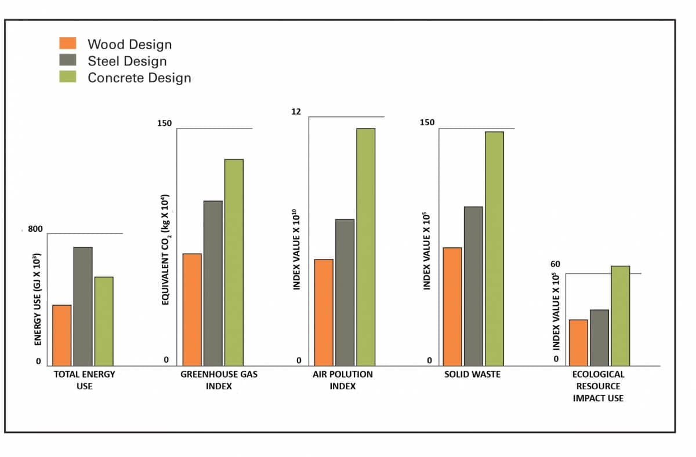
(Alter, 2016)

Figure vi)
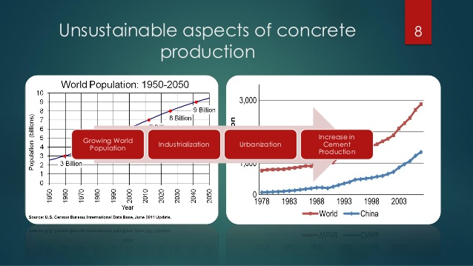
(Alao, 2014)

References
Alter, L. (2016). Ready Mix concrete industry attacks wood construction, says we should "Build with Strength" [Image] Available at: https://www.treehugger.com/green-architecture/washington-state-legislation-promoting-wood-construction-gets-crushed-readymix-concrete-industry.html [Accessed 9 Dec. 2018]
Alao, 0. (2014). Durability of Reinforced Concrete – A major player in Environmental Sustainability [Image] Available at: https://pt.slideshare.net/OlukayodeAlao/durability-of-reinforced-concrete-a-major-player-in-environmental-sustainability [Accessed 6 Dec 2018]
Ashley, E. (2007). Fire Resistance of Concrete Structure. 1st ed. [ebook] UNKNOWN: NRMCA, p.68. Available at: http://www.nrmca.org/research/FireResistance_CIF_Winter_07.pdf. [Accessed 3 Dec. 2018].
Balogh, A. (2018). What Makes Concrete a Sustainable Building Material? - The Concrete Network. [online] Concretenetwork.com. Available at: https://www.concretenetwork.com/concrete/greenbuildinginformation/what_makes.html [Accessed 6 Dec. 2018].
F. Baker, W. and J. Pawlikowski, J. (2012). Higher and Higher: The Evolution of the Buttressed Core. 1st ed. [ebook] UNKNOWN: Civil Engineering, p.61. Available at: http://ttps://academic.csuohio.edu/duffy_s/CVE_601_Struct_1.pdf [Accessed 11 Dec. 2018].
Highrisefirefighting.co.uk. (2018). High Rise Fire-fighting - Construction Materials. [online] Available at: http://highrisefirefighting.co.uk/material.html [Accessed 8 Dec. 2018].
Jansen (2000). Strength and stiffness comparison. [image] Available at: http://bamcore.com/bamboo-info/mechanical-properties-of-timber-bamboo/ [Accessed 8 Dec. 2018].
Jamal, H. (2017). Design and Construction of Burj Khalifa . [Image] Available at: https://www.aboutcivil.org/burj-khalifa-design-construction-structural-details.html [Accessed 9 Dec. 2018]
Steelconstruction.info. (2018). Multi-storey office buildings. [online] Available at: https://www.steelconstruction.info/Multi-storey_office_buildings [Accessed 4 Dec. 2018].
Nasvik, J. (2008). The Burj Khalifa. [image] Available at: https://www.concreteconstruction.net/projects/commercial-industrial/the-burj-dubai_o [Accessed 10 Dec. 2018].
Naidoo, R. (2010). richard rogers leadenhall building to go ahead [Image] Available at: https://www.designboom.com/architecture/richard-rogers-leadenhall-building-to-go-ahead/ [Accessed 2 Dec 2018]
Rubenstein, M. (2012). Emissions from the Cement Industry. [online] State of the Planet. Available at: https://blogs.ei.columbia.edu/2012/05/09/emissions-from-the-cement-industry/ [Accessed 4 Dec. 2018].
Staff, C. (2010). Top 10 world's tallest concrete buildings | ConstructionWeekOnline.com. [online] Constructionweekonline.com. Available at: http://www.constructionweekonline.com/article-9184-top-10-worlds-tallest-concrete-buildings/. [Accessed 4 Dec. 2018].
Greenspec.co.uk. (2018). Steel production & environmental impact. [online] Available at: http://www.greenspec.co.uk/building-design/steel-products-and-environmental-impact/ [Accessed 9 Dec. 2018].
Team, w. (2018). Metal vs. Concrete: Are Metal Buildings as Durable as Concrete?. [Blog] Whirlwind steel. Available at: https://www.whirlwindsteel.com/blog/bid/287419/Metal-vs-Concrete-Are-Metal-Retail-Buildings-as-Durable-as-Concrete Accessed 5 Dec. 2018].
Steelconstruction.info. (2018). The case for steel. [online] Available at: https://www.steelconstruction.info/The_case_for_steel [Accessed 5 Dec. 2018].
Steelconstruction.info. (2018). The case for Steel. [online] Available at: https://www.steelconstruction.info/The_case_for_steel [Accessed 7 Dec. 2018].
TheConstructor.org. (2018). Types of Concrete Chemicals (Admixtures) and their Applications. [online] Available at: https://theconstructor.org/concrete/concrete-chemicals-admixture-types-uses/5978/. [Accessed 5 Dec. 2018].
Weight, D. (2006). Whole-life costs: Concrete vs steel. [online] Building.co.uk. Available at: https://www.building.co.uk/whole-life-costs-concrete-vs-steel/3069406.article [Accessed 8 Dec. 2018].

