

Programme Name: Master of Business Administration
Module Code: LCMB7024
Module Title: Marketing Management
Title: Assessment component 2: Marketing Portfolio

Lecturer Name: Dian Mayasari
Student Name: Raj Nathabhai Parmar
Student ID: 2507754
Submission Date: 19th November 2025

Table of Contents
1. Introduction 3
2. Element 1: STDP Analysis 3
2.1 Segmentation Strategy 3
2.2 Targeting Strategy 3
2.3 Differentiation Strategy 5
2.4 Positioning Strategy 5
3. Element 2: Marketing Mix (7Ps) 6
4. Element 3: Marketing Strategy Pitch (Poster Explanation) 10
1. What Happened? 10
2. STDP Analysis 11
3. Impact on Nike EcoStride 12
4. Marketing Mix (7Ps Highlights) 12
Future Plan 12
5. Element 4: Reflection 13
6. Conclusion 13
7. References 15
Poster 16

1. Introduction
Nike is one of the most famous companies in the world that sells sports shoes, clothes, and other equipment. It is primarily into the marketing and innovation of sporting goods (Nike, 2025). The portfolio presents the “Nike EcoStride,” smart shoes that focus on sustainability for the next-generation athlete. EcoStride’s performance technology, combined with its unwavering commitment to sustainability, reflects consumers’ insatiable desire for eco-friendly products. This marketing portfolio has been designed to thoroughly create a complete brand and marketing strategy for Nike EcoStride. The STDP strategies will be followed by the 7Ps of the marketing mix in this document. Last, there will be a brief presentation of a marketing strategy pitch and a personal reflection on brand creation.

2. Element 1: STDP Analysis

2.1 Segmentation Strategy
Nike EcoStride uses a detailed segmentation approach to cater to different consumer groups as per their needs and wants. The main demographic targets are young adults and teenagers aged 15 to 35 who lead an active lifestyle either engaged in sports or fitness activities and have a moderate to high disposable income which shows their ability to purchase premium performance footwear (Nooh, 2022). Sports culture is increasingly penetrating in urban and suburban areas of developed markets. These include North America Europe, and Asia Pacific that are experiencing high levels of environmental awareness. Nike EcoStride reaches consumers who are “green,” socially-conscious and tech-savvy, for a range of audiences. The consumers under consideration are health conscious and mindful of their wellness, innovative in terms of sport gear, motivated by sustainability (Ho et al., 2023). Behaviourally, the target segment is frequent exercisers, competitive athletes, and technology early adopters who are loyal to the Nike brand but open to new differentiated value-based products. This approach capitalizes on the contemporary trend for health, sustainability, and smart technology being added into daily products.

2.2 Targeting Strategy
Nike EcoStride targets the environmentally conscious next generation athlete who places emphasis on performance for a concentrated strategy. People aged 16-34 years, normally school, university students and working people, are more likely to engage in sports running and gym. Longos make a significant segment of population in many countries. They show a strong commitment to health and wellness; proactive interest in environmental issues; and a preference for technologies that improve performance or daily life (Widian and Dellyana, 2025). People in this social group usually have enough money to spend on expensive sportswear. They are generally willing to pay a higher price for the product as they feel it offers better functionality. In addition, they also prefer to buy sportswear that is ethically produced. People buy high performance gear because they don’t want to compromise. They are environmentally minded buyers, and they see their purchases as an extension of who they are and how they live (Widian and Dellyana, 2025).
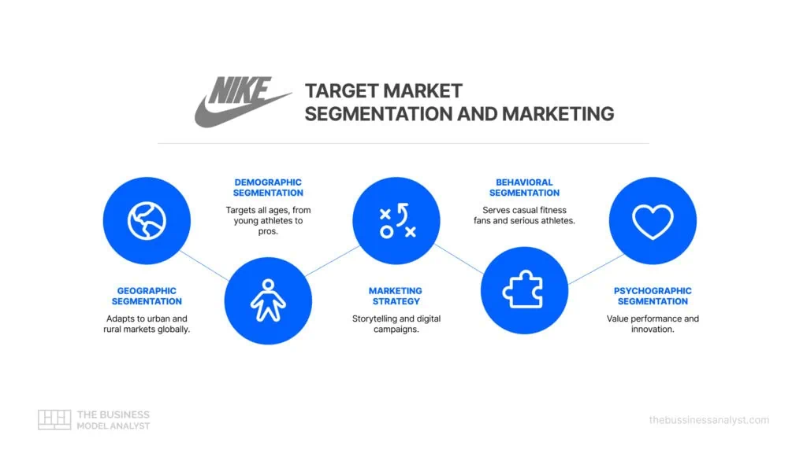
Figure 1: Market Segmentation and Target Audience for Nike EcoStride
(Source: businessmodelanalyst, 2025)
As Nike is innovator and leader in sports performance, using this focused approach is justified as it adds to its existing portfolio and enables it to penetrate and dominate the new growing segment of smart and sustainable technology (Sharma and Ashfaq, 2023). By catering to this niche, Nike can foster strong brand loyalty from an engaged and influential consumer group, further cementing its status as a brand that innovates for the greater good.

2.3 Differentiation Strategy
Nike EcoStride stands out with unique selling point (USP) that is Terrestrial and it should offer superior athletic performance as well as pursue proveable environmental sustainability and embedded smart technology. Nike EcoStride is a complete solution unlike rivals such as the Parley for the Oceans collection from Adidas, which is mostly recycled, or Puma recycled collections. Both Adidas and Puma are increasingly concerned about sustainability, but smart shoes are less integrated or pronounced (Rezaei and Sharifian, 2021). EcoStride smart sensors offer real-time feedback in the form of performance analytics, running style analysis, and training feedback. This shoe is practical and functional, utilizing innovative, reclaimed materials (like Flyknit and Nike Grind) (Widian and Dellyana, 2025). It also features plant-based polymers that offer a comprehensive experience. EcoStride’s design allows the shoe to be reused after usage, unlike competitors whose shoes go to waste. With its advanced mechanisms, powerful performance, and unique orientation towards circularity EcoStride is the better and more responsible athletic shoe choice (Taql, Poursoltani Zarandi and Shajie, 2023).

2.4 Positioning Strategy
Nike EcoStride seeks to establish itself in the eyes of consumers as the first choice for premium performances charged high-tech sustainable athletes. If the positioning of this company will be enhanced there will be a further occupation of the intersection of innovation, performance and sustainability (Rezaei and Sharifian, 2021).
Positioning Map: Price vs. Innovation
 | Low Innovation | High Innovation
Low Price | Budget Sportswear | Value-Tech Footwear
High Price | Premium Basic Footwear | Nike EcoStride
 | (e.g., Decathlon, K-Swiss) | (e.g., Some Under Armour)
 |  | (e.g., Adidas Ultraboost)
Nike EcoStride belongs to the High Innovation, High Price zone of this map. EcoStride sets itself apart from rivals like Adidas whose Ultraboost also rule this space, with its strong sustainability narrative and measurable environmental impact, not performance. This product aims to attract consumers willing to pay a premium price for a product with advanced athletic capabilities that also benefits the environment (Taql, Poursoltani Zarandi and Shajie, 2023).
Positioning Statement:
If you are an athlete who wants sustaiable high-performance footwear before the rest of the world, then this is it. Nike EcoStride is a sustainable smart shoe built with remarkable useable data to track athletic performance and verify eco-impact.

3. Element 2: Marketing Mix (7Ps)
Product
Nike EcoStride is designed to improve the performance of every athlete with athletic footwear with eco-friendly innovations and smart technology. The uppers of this product are adaptive knitted from 100% recycled Flyknit yarns to provide breathability and a sock-like fit (Nike, 2025). The midsole features Nike Grind rubber and a new plant-based foam to bring extra energy return and cushioning. This greatly reduces the use of virgin petroleum-based materials (Li and Kallas, 2021). Inside the sole, a proprietary smart sensor system provides real-time biomechanical feedback, including gait, stride length and foot pressure, available via the Nike Run Club app (Akhtar, Gunasekaran and Kayikci, 2023).
Price
Nike EcoStride’s pricing strategy will be premium-based supplemented by skimming during the first phase when it is launched. This strategy is backed by the product’s high-tech features, premium sustainable materials and the brand equity of Nike (Kotler and Keller, 2021). The first premium price will reflect the heavy investment in research and development for smart technology integration and for sustainable material science (Narayana et al., 2021)
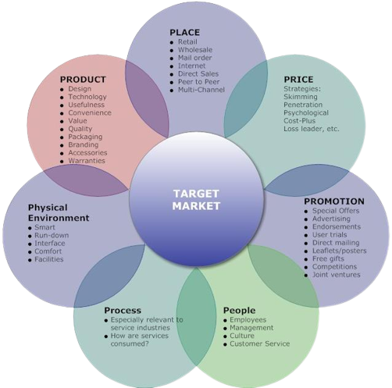
Figure 2: The 7Ps Application Framework for Nike EcoStride
(Source: credofy, 2025)
Place
Nike EcoStride will utilise exclusive distribution strategy through which the product will only be available with select retailers in the country. Initially, EcoStride will be on sale only at flagship Nike stores in major cities that enable people to have an experience where they can play around with the smart technology and learn about the sustainable qualities (Nike, 2025). Nike's sophisticated e-commerce and Nike App (5 words) Digital channels make the ideal case for tech-integrated proposition as they allow for international reach and direct-to-consumer outreach which requires app-reliance. Working with chosen top-class sportswear retailers (like eco-friendly run specialty shops) will help reach more people in addition to boosting access points to the target market. The unified distribution network helps to manage the consumer experience while ensuring brand availability (Kotler and Keller, 2021).
Promotion
To begin with, the marketing strategy of Nike EcoStride will be extensive focusing on digital marketing, influencer tie-ups, and CSR campaigns. Ads will show the smart features and eco-friendly qualities of the cars through attractive visuals and quotes by sports figures and green warriors through interactive online campaigns over the social media platforms like Instagram. TikTok. YouTube. EcoStride plans to use performance athlete ambassadors with a vision to amplify its influencer marketing efforts. They will explain how EcoStride is integrated into their training and how it supports environmental protection. Nike (2025) EcoStride and partner with environmental organisations in its CSR campaigns to promote the circular economy. We will run experiential marketing events in urban centres where customers will get to test the various smart features as well as understand the sustainable impact first hand, like a pop-up “Eco-Challenge” run. The blend of these strategies will send out an efficient message portraying what EcoStride is about to the audience (Akhtar, Gunasekaran and Kayikci, 2023).
People
The term "people" in the Nike EcoStride refers to its internal and external staff. Their help customers properly experience the product. In doing so, Nike also achieves its values. Nike shop sales associates will be trained on EcoStride's smart technology, sustainable materials and circular recycling process to better articulate the value proposition of the smart sneaker (Das, 2024). The sales associates will play a key role in demonstrating the app integration and helping the customer understand their performance data. Besides store staff, the elite athletes representing Nike will also be important. The athletes would promote EcoStride for its performance, but EcoStride also sends a sustainability message which will make them authentic advocates for innovation and sustainability (Nike, 2025). They will assist customers with problems related to technology and the EcoStride app. So, there won’t be any post-purchase issue. When we emphasize real humans and their knowledge, we enhance brand trust.
Process
The journey begins with learning from an advertisement or influencer content. Then, the customer visits Nike.com or the Nike App to view the product. The online purchasing process is streamlined with specifications, sustainability and size guide information complete. Once purchased, the unboxing will be improved with eco-friendly packaging and instructions to sync the app and use smart features for the first time. The Nike App is the main hub which has personalized training plans, performance data in real time, and portal for EcoStride recycling program. Be sure to engage with the digital procedures, which address everything from awareness through to product lifetime management (Li and Kallas, 2021). Additionally, make sure the processes feel modern as the brand is tech-savvy and sustainable. The brand ensures the same with clear as well as eco-friendly return and exchange policies.
Physical Evidence
Nike EcoStride's physical evidence will definitely ensure that the sustainable, smart, premium performance product that it is gets highlighted. EcoStride’s packing will be minimal. The cardboard will be made of 100% recycled and recyclable materials and printed with soy inks. We won’t add anything grand; only our logo and other certification marks (Taql, Poursoltani Zarandi and Shajie, 2023). The shoe will look smart. The car will feature an engaging look, intriguing materials, and subtly integrated smart sensors. EcoStride displays in retails stores will feature screens to show users how the shoe works and its making. You can also feel the recycled materials used. Nike plans to incorporate sustainability in its flagship stores to provide customers with an enriching experience using the latest design developments and sustainable concepts. In particular, colour and material choices will point towards a sustainable future (Nike, 2025). The Nike logo represents performance and innovation. The marking for EcoStride sub-branding will show these brand capabilities that include smart controlling devices and sustainability technology.

4. Element 3: Marketing Strategy Pitch (Poster Explanation)
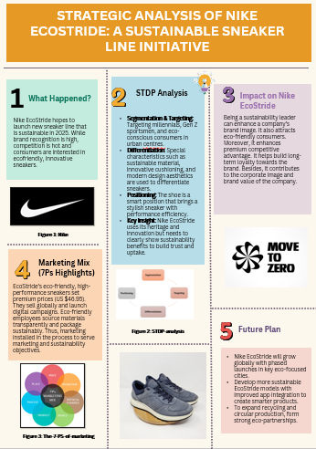

1. What Happened?
Nike EcoStride hopes to launch new sneaker line that is sustainable in 2025. While brand recognition is high, competition is hot and consumers are interested in ecofriendly, innovative sneakers (Slaton and Pookulangara, 2022).

Figure 1: Nike
(Source: nike.com, 2025)

2. STDP Analysis
Segmentation & Targeting: Targeting millennials, Gen Z sportsmen, and eco-conscious consumers in urban centres.
Differentiation: Special characteristics such as sustainable material, innovative cushioning, and modern design aesthetics are used to differentiate sneakers (Specht et al., 2024).
Positioning: The shoe is a smart position that brings a stylish sneaker with performance efficiency.
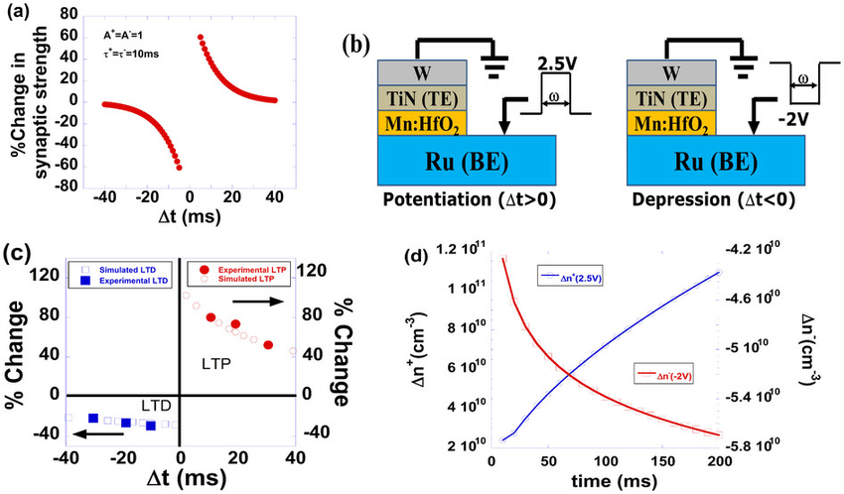
Figure 2: STDP-analysis
(Source: researchgate.net, 2025)
Key Insight:
Nike EcoStride uses its heritage and innovation but needs to clearly show sustainability benefits to build trust and uptake.

3. Impact on Nike EcoStride
Being a sustainability leader can enhance a company’s brand image. It also attracts eco-friendly consumers. It enhances premium competitive advantage. It helps build long-term loyalty towards the brand. Besides, it contributes to the corporate image and brand value of the company.

4. Marketing Mix (7Ps Highlights)
EcoStride’s eco-friendly, high-performance sneakers set premium prices (35.68 £). They sell globally and launch digital campaigns. Eco-friendly employees source materials transparently and package sustainably. Thus, marketing installed in the process to serve marketing and sustainability objectives.
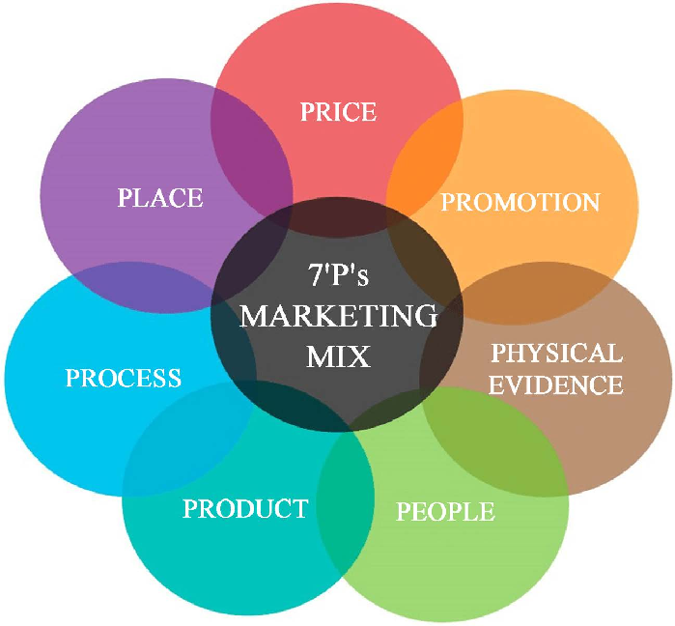
Figure 3: The-7-PS-of-marketing
(Source: researchgate.net, 2025)

Future Plan
- Nike EcoStride will grow globally with phased launches in key eco-focused cities.
- Develop more sustainable EcoStride models with improved app integration to create smarter products.
- To expand recycling and circular production, form strong eco-partnerships.

5. Element 4: Reflection
Through the assembly of the marketing portfolio of Nike EcoStride, I developed an insight into strategic brand development in the global competitive world. By inventing a new product idea and applying the theoretical marketing frameworks enabled a real application of theory into making a practical strategy. It is possible to merge and merge technology with sustainability in a product. You can make it happen by enabling functionality with novelties. This project enhanced key professional skills. I improved my researches and analyses when I learnt to identify reliable and recent sources. Also, I was able to gather data together to find out consumer trends and competition. The brand identity, marketing tools, relationship marketing, and storytelling branding are all successful applications of creativity by NIKE (Akhtar, Gunasekaran and Kayikci, 2023).
It is built around the values Nike represent. Limiting my choices in terms of structure, tone and words made me more precise and concise in my writing. Taking what we learnt in class into reality was not as easy as we thought, and we struggled a lot (Das, 2024). This eco-friendly product has distinctive elements which allow it to transcend the pricing of a more conventional product. When creating any messages about performance or sustainability, we had to be careful. In my upcoming projects, I will pay more attention to scenario planning, collect early consumer feedback for product vision, and create data-driven marketing performance insights (Li and Kallas, 2021). As a result of this portfolio, I will now devise strategies that achieve commercial successes as well as social good – the essence of modern marketing. In the end, the experience made theoretical knowledge practical. Also, I learned how strategy-mapping makes 3M’s brand impactful and strategic through their marketing projects (Taql, Poursoltani Zarandi and Shajie, 2023).

6. Conclusion
In conclusion, the marketing portfolio of Nike EcoStride successfully illustrates the design of the black color the use of which gives it an influence. Nike shows that it is still a leading producer of ethical activewear, thanks to environmentally friendly materials and intelligent technology. The project shows targeting, creativity according to data to stand out from competitors as well as responsible marketing is important.

7. References
Akhtar, M., Gunasekaran, A. and Kayikci, Y., 2023. A novel stochastic fuzzy decision model for agile and sustainable global manufacturing outsourcing partner selection in footwear industry. Journal of Enterprise Information Management, 36(4), pp.979-1007.
Das, S., 2024. The impact of motion graphics in modern branding and marketing. International Journal of Innovative Science and Research Technology, 9, pp.992-994.
Ho, T., Nguyen, S., Nguyen, H., Nguyen, N., Man, D.S. and Le, T.G., 2023. An extended RFM model for customer behaviour and demographic analysis in retail industry. Business Systems Research: International journal of the Society for Advancing Innovation and Research in Economy, 14(1), pp.26-53.
Li, S. and Kallas, Z., 2021. Meta-analysis of consumers' willingness to pay for sustainable food products. Appetite, 163, p.105239.
Narayana, A., Oyama, N., Gough, R. and Calhoun, B., 2021. Nike Inc.: Strategic Communication Plan. Strategies, 8, p.9.
Nooh, M.N., 2022. Designing a sportswear strategic marketing plan: a data analytics approach. ASEAN Entrepreneurship Journal (AEJ), 8(1), pp.53-70.
Rezaei, M. and Sharifian, E., 2021. Assessing the Brand Equity of Majid Brand in Comparison with Nike from the Perspective of Iranian Consumers. Journal of New Studies in Sport Management, 2(2), pp.192-201.
Sharma, M.S. and Ashfaq, R., 2023. Targeting the digital consumer: A study of the role of social media in modern advertising. Journal of Humanities, Music and Dance (JHMD), 3(04), pp.22-35.
Suomi, K., Saraniemi, S., Vähätalo, M., Kallio, T.J. and Tevameri, T., 2021. Employee engagement and internal branding: Two sides of the same coin?. Corporate Reputation Review, 24(1), pp.48-63.
Taql, M., Poursoltani Zarandi, H. and Shajie, R., 2023. The role of market orientation in the relationship between innovation culture and the development of Nike brand marketing strategy in Shiraz. Sports marketing studies, 4(1), pp.13-29.
Widian, R. and Dellyana, D., 2025. Consumer Decision-Making Style of Gen Z and Millennials in Choosing Activewear (Study Case: Eiger Act). Enrichment: Journal of Multidisciplinary Research and Development, 3(4), pp.823-837.
Website
businessmodelanalyst, (2025) Market Segmentation and Target Audience for Nike EcoStride. Available at: https://businessmodelanalyst.com/nike-target-market/?srsltid=AfmBOoqBLasN6n9wsOvXAViBH9P-_CVEpp3N3WBuLO29kpHtlPhjQq_3. [Accessed on: 28-10-2025].
Credofy, (2025) The 7Ps Application Framework for Nike EcoStride. Available at:
https://credofy.com/the-7ps-of-marketing-mix/. [Accessed on: 28-10-2025].
(Nike, 2025) Nike. Available at: https://www.nike.com/in/. [Accessed on: 28-10-2025].

Poster
Journals
Slaton, K. and Pookulangara, S., 2022. Collaborative consumption: An investigation into the secondary sneaker market. International Journal of Consumer Studies, 46(3), pp.763-780.
Specht, I.R., Froehlich, C., Bondan, J. and Nodari, C.H., 2024. Frugal innovation and sustainability in the footwear sector. Revista de Administração Contemporânea, 28, p.e230228.
Yadav, S., Xu, Y. and Hergeth, H., 2024. Walking the talk: unraveling the influence of the sustainability features of leather alternatives on consumer behavior toward running shoes. Sustainability, 16(2), p.830.
Websites
researchgate.net, 2025. Nike. (Online). Available at: https://about.nike.com/en/newsroom/collections/nike-inc-logos [Accessed on: 1.11.2025].
researchgate.net, 2025. STDP-analysis. (Online). Available at: https://www.researchgate.net/figure/STDP-analysis-a-STDP-plot-for-a-biological-synapse-Equations-9-and-10-were-used_fig6_263204730 [Accessed on: 1.11.2025].
researchgate.net, 2025. The-7-PS-of-marketing. (Online). Available at: https://www.researchgate.net/figure/The-seven-PS-of-marketing_fig4_360872640 [Accessed on: 1.11.2025].

