

Student name: Gila Raul Domingos Serrote
Student ID: 2510697
Module name: Introduction to Health and Social Care
Module code: LCHS4003
Lecturer name: Dr. Eleni

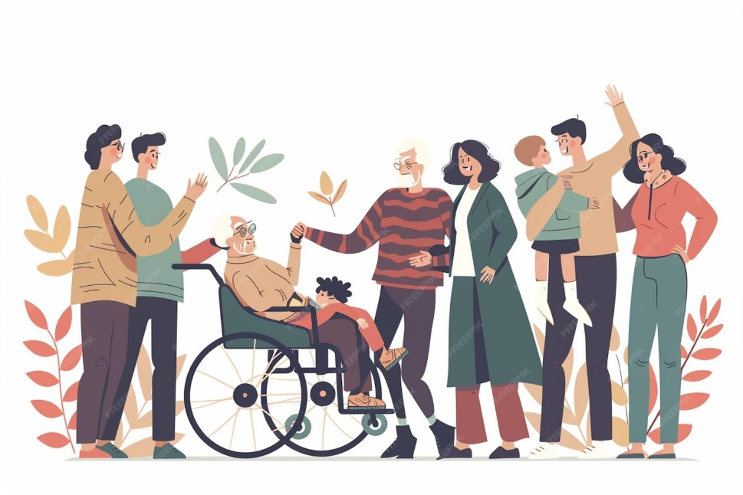
Content page

Element 1 …………………………………………………………….. Page 2

Element 2………………………………………………………………Page 3

References…………………………………………………………….Page 7
5. Conclusion
In conclusion, Community Mental Health Services are a vital part of the healthcare system in the United Kingdom, supporting individuals with mental health conditions while enabling them to live independently in their communities. Shaped by the shift from institutional care to community-based support, these services focus on person-centred care, recovery, and wellbeing. Although challenges such as lack of staff and increasing demand affect service delivery, Community Mental Health Teams continue to provide essential support through early intervention, treatment, and ongoing care.
Mental health supporting mental health, empowering communities - necessary service to enhance independence and wellbeing (NHS, 2023; Glendinning et al., 2021).

References
Brooker, D. and Latham, I. (2016) Person-Centred Dementia Care in the Community. London: Routledge.
Care Quality Commission (CQC) (2025) Monitoring the Mental Health Act in 2024/2025. London: CQC.
Flynn, M. (2021) Residential Care Homes: History and Modern Practice. Bristol: Policy Press.
Glendinning, C. and Kemp, P.A. (2018) ‘Home care in the UK: trends and policy’, Journal of Social Policy, 47(1), pp. 45–65. Glendinning, C. et al. (2021) Social Care in the UK: Policy and Practice. London: SAGE.
McDonald, A. and Burnett, L. (2020) Person-centred Practice in Health and Social Care. London: SAGE.
National Health Service (2023) Community mental health services. Available at: https://www.nhs.uk (Accessed: 21 March 2026).
World Health Organization (2023) Mental health at work: Fact sheet. Geneva: WHO.

- Overview of the Service
Community Mental Health Services is the department who support individuals experiencing mental health difficulties, while allowing them to live in their own homes and communities. In the UK, these services are provided through the National Health Service (NHS) and local authorities.
Overview of the Service 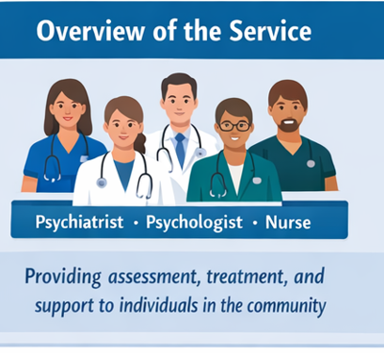
- Offers assistance to those with mental issues.
- Provided by an interdisciplinary team: psychiatrists, psychologists, nurses, social workers, occupational therapists (NHS, 2023; Glendinning et al., 2021).
- Focus: treatment, assessment, counselling, rehabilitation and crisis support.

2. Brief History
Before the 1960s, people with mental health conditions were mainly treated in large psychiatric hospitals or asylums. These institutions often led to isolation and long-term dependency. During the 1960s–1970s, deinstitutionalisation began, shifting care from hospitals to the community.
This developments include:
Mental Health Act 1983 – protected patient rights and guided treatment.
NHS and Community Care Act 1990 – promoted community-based care.
These changes led to the development of modern Community Mental Health Teams ( CMHTs).


3. Current Functioning
Service delivery is primarily carried out by Community Mental Health Teams (CMHTs), coordinated under National Health Service frameworks (NHS, 2023). These services typically follow a structured pathway that includes assessment, diagnosis, treatment, recovery, and ongoing support, often initiated through a referral system from GPs or other professionals (Glendinning et al., 2021).
A key feature of current practice is the development of individualised care plans, ensuring that support is tailored to each service user’s specific mental health needs and circumstances (McDonald & Burnett, 2020). CMHTs work through a multidisciplinary approach, involving psychiatrists, psychologists, nurses, social workers, and occupational therapists to provide holistic care.
There is a strong emphasis on inter-agency collaboration, with coordination between health services, social care, housing, and voluntary organisations to support recovery and social inclusion. Increasingly, services are integrating digital tools and remote support (e.g., telephone or online consultations), improving accessibility for some service users. Recovery-focused practice is central, aiming to promote independence, self-management, and community integration rather than long-term institutional care.

Element 1: Community Mental Health Services

4. Challenges Faced
Community Mental Health Teams (CMHTs) lead to increased workloads for professionals and long waiting times for service users, delaying assessment and treatment (Glendinning et al., 2021).
Limited financial resources restrict service capacity, resulting in reduced access to timely and appropriate treatment and support (Flynn, 2021). Rising demand, particularly among children and young people, places additional pressure on services, contributing to system strain and unmet needs (Glendinning and Kemp, 2018). Fragmentation of services can lead to poor coordination between health, social care, and voluntary sectors, affecting continuity of care. Digital integration challenges, including a lack of training, infrastructure issues, and digital exclusion among some service users, limit the effectiveness of remote support.
Mental health continues to act as a barrier, preventing some individuals from seeking help early, which can worsen conditions over time to a particularly for individuals from disadvantaged or minority backgrounds, leading to differences in outcomes. Long waiting lists for specialist services (e.g., CAMHS, psychological therapies) can result in deterioration of mental health while individuals wait for support.
Workforce burnout and low morale due to high pressure and emotional demands impact staff retention and quality of care. Housing and social issues (e.g., homelessness, unemployment) complicate recovery, as mental health services often need to address broader social determinants of health.

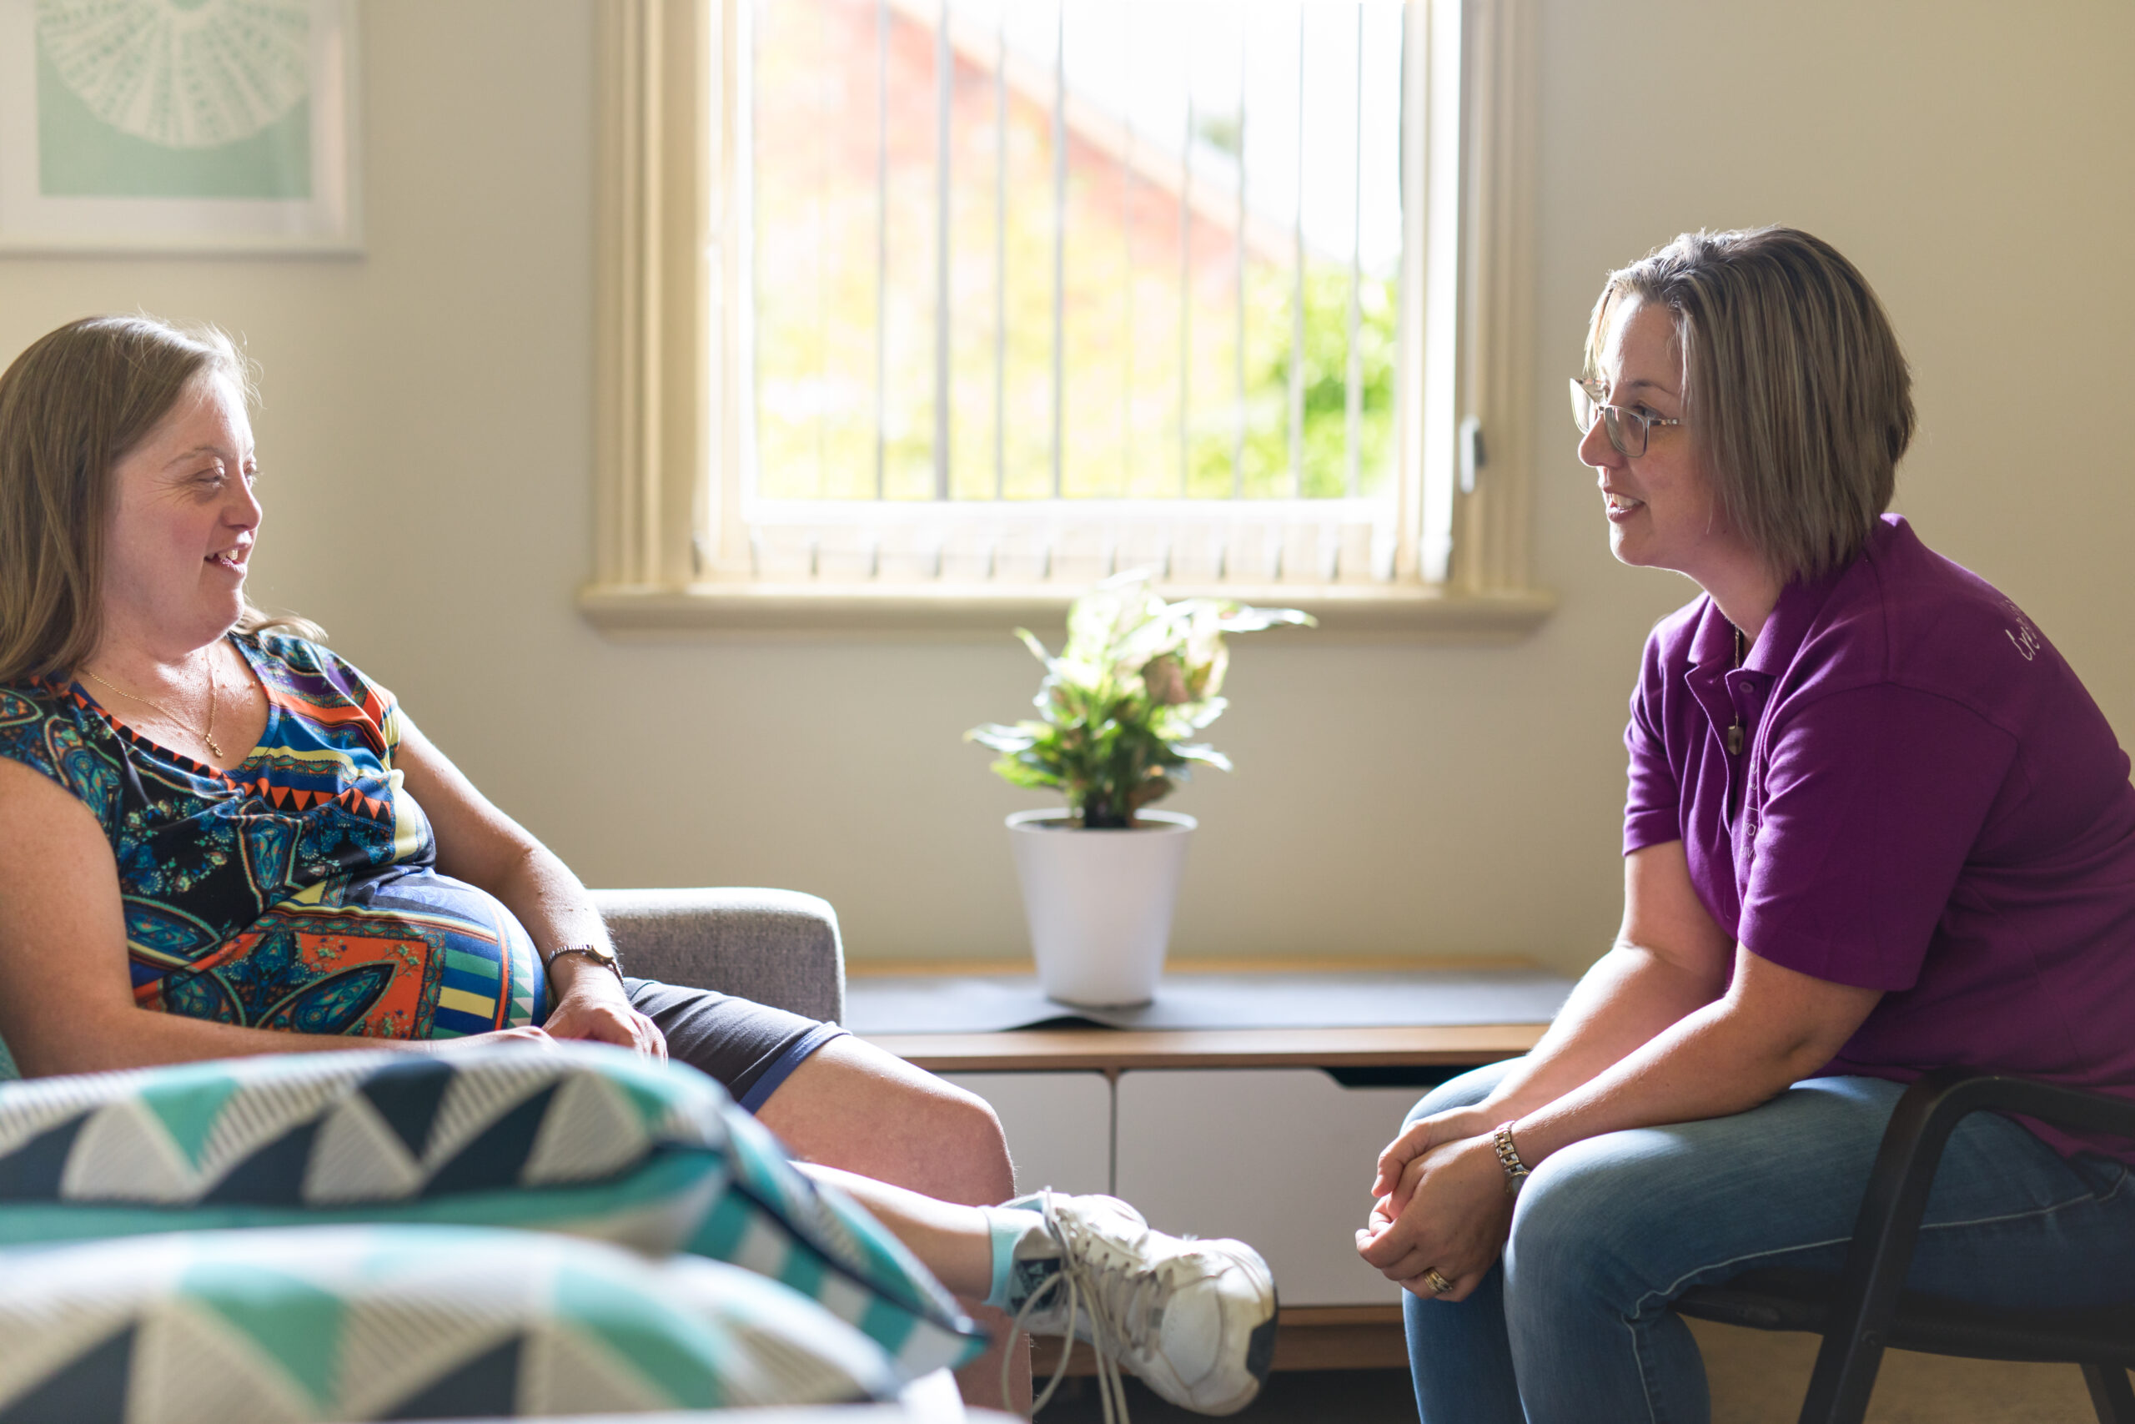

Element 2: Community antenatal midwifery services

Community antenatal midwifery services are a vital part of maternity care in the United Kingdom, delivered through the National Health Service (NHS, 2023). These services aim to support women during pregnancy. The main goal is to promote safe and healthy pregnancies, prevent early complications, and achieve positive outcomes for both mother and baby.
Community antenatal midwifery services have evolved significantly over time due to changes in healthcare policy, medical advancements, and societal attitudes towards childbirth. Before the NHS was established in 1948, maternity care was mainly provided at home by traditional midwives, often with limited medical support, increasing risks for mothers and infants (Flynn, 2021).
During the mid-20th century, there was a shift towards hospital-based births, driven by technological advancements and efforts to reduce mortality rates (Glendinning and Kemp, 2018). However, concerns about over-medicalisation led to an improved focus on community-based and woman-centred care.
The NHS and Community Care Act 1990 encouraged care closer to home, while the Changing Childbirth report (1993) emphasised women’s choice, continuity, and control (Glendinning et al., 2021). More recent NHS developments promote continuity of carer models, ensuring women receive consistent support throughout pregnancy, birth, and postnatal care. Today, community antenatal services balance medical safety with personalised, holistic care.
Community antenatal midwifery services are delivered primarily through the NHS in settings such as GP surgeries, clinics, and home visits (NHS, 2023). Women usually access the service through self-referral or via a GP early in pregnancy.
Care begins with a booking appointment, where a midwife assesses the woman’s physical, psychological, and social needs. This is followed by regular antenatal appointments to monitor the health of both mother and baby, including screening, health checks, and risk assessments (McDonald and Burnett, 2020).
Women are supported by the same midwife or small team, helping to build trust and improve communication (NHS, 2023). Midwives provide health education, emotional and mental health support, early identification of complications, and safeguarding.
There is also strong collaboration between professionals, including obstetricians, health visitors, and social workers, ensuring holistic care (Glendinning et al., 2021). Digital tools such as online consultations and electronic records are increasingly used to improve accessibility and efficiency. The focus is on woman-centred care and positive pregnancy outcomes.
Despite its importance, community antenatal midwifery services face several challenges. Staff shortages and heavy workloads can reduce continuity of care and increase pressure on midwives, affecting service quality (Glendinning et al., 2021).
Health inequalities mean that women from disadvantaged backgrounds may experience poorer access to care (Flynn, 2021).
Late booking can delay screening and early intervention, increasing risks. Complex health needs such as obesity, advanced maternal age, and pre-existing conditions require more intensive monitoring (McDonald and Burnett, 2020). Digital exclusion can limit access to services, while funding constraints restrict service development (Glendinning and Kemp, 2018).
Community antenatal midwifery services significantly improve the quality of life for women, babies, and families. Quality of life refers to physical health, emotional well-being, and overall ability to live comfortably.
These services support physical health by monitoring pregnancy and identifying risks early. They also promote emotional well-being by reducing anxiety through reassurance and support (NHS, 2023).
Midwives empower women through education, enabling informed decision-making and increasing confidence. They also improve social support by linking women with healthcare and community services, reducing isolation (McDonald and Burnett, 2020).

In Conclusion community antenatal midwifery services within the National Health Service are essential for supporting women during pregnancy and ensuring safe outcomes for both mother and baby. They have evolved from home-based care into a modern, woman-centred service focused on continuity, early intervention, and personalised support.
These services improve quality of life by supporting physical health, emotional well-being, and informed decision-making. Despite challenges such as staff shortages and increasing demand, community midwifery remains vital in promoting safe pregnancies and positive outcomes (NHS, 2023; Glendinning et al., 2021).

References
National Health Service (2023) Maternity and antenatal care. Available at: https://www.nhs.uk (Accessed: 22 March 2026).
Brooker, D. and Latham, I. (2016) Person-Centred Dementia Care in the Community. London: Routledge.
Care Quality Commission (CQC) (2025) Monitoring the Mental Health Act in 2024/2025.
Flynn, M. (2021). Residential Care Homes: History and Modern Practice. Bristol: Policy Press.
Glendinning, C. and Kemp, P.A. (2018) ‘Home care in the UK: trends and policy’, Journal of Social Policy, 47(1), pp. 45–65.
McDonald, A. and Burnett, L. (2020) Person-centred Practice in Health and Social Care.
World Health Organisation (2023) Mental health at work: Fact sheet. Geneva: WHO.

