Title Page

Moodle name: Marketing Essential
Moodle Number: BMIH4005
Title: Holiday Inn Hotel Marketing Plan
Student Name :Lenka Milkova
Student Number 2235563
Lecture Name: Luciana Suardi

Introduction
Holiday Inn is a renowned hotel chain that enjoys a great presence worldwide. They are dedicated to providing luxury hospitality and excellent service to Their guests. With its modern comforts, custom amenities and an ever-evolving location based experiential approach, Holiday Inn is the perfect place to stay. They mission is to provide an unique and memorable experience while providing a sense of real relaxation.

Situation Analysis
Holiday Inn is one of the most popular and recognizable brands in the hospitality industry with over 4,000 hotels and resorts in over 100 countries and territories across the globe. With a long history in the market, starting as a pioneering budget hotel in the 1950s, Holiday Inn has established a strong foundation of loyal customers and remains a leader in the hotel industry.
SWOT Analysis Strength 1. Established Brand Recognition: Holiday Inn remains one of the most well-known hotel brands in the world with high brand awareness and strong customer loyalty. 2. Wide Range of Amenities: Holiday Inn has a wide selection of amenities, such as free Wi-Fi, continental breakfast, and on-site restaurants that are sure to please budget-conscious travellers.

Objectives
1 Increase brand visibility of Holiday Inn.
2. Enhance the customer service experience of Holiday Inn by creating a seamless customer journey.
3. Develop a consistent and recognizable visual identity that is unique to Holiday Inn.
4. Boost customer loyalty to Holiday Inn by providing added value and exclusive offers.
5. Create innovative marketing campaigns that promote Holiday Inn’s services and products.
6. Expand the market presence of Holiday Inn by exploring online channels and improving online performance.
7. Promote destination-based holidays and activities that are available at each Holiday Inn.
8. Leverage modern technology such as VR and AR to provide a more interactive customer experience.

Strategy
Collaborate with local businesses and attraction to promote each other services offer special discounts for big groups and tour packages have an emergency contact number in place during the holiday season so that ani problems the guests may face are addressed quickly and efficiently. Hire extra staff or freelancers if necessary to meet the increased demand during the holiday season. Encourage guest feedback so that you can use it to improve your services and increase guest satisfaction during the holiday season. Create a unique campaign and offer loyalty rewards, such as special discounts and exclusive offers, to your regular customers during the holiday season.

Tactics
Leverage Social Media: Social media is an excellent and cost-effective tool for driving awareness and engagement for the Holiday Inn brand. Utilize popular channels such as Facebook, Instagram, and Twitter to create targeted campaigns and gain exposure to a large audience. Introduce Cost-Effective Loyalty Programs: Customer loyalty has a direct impact on your bottom line. Setting up loyalty programs can help customers to save money, and keep the brand top of mind. Use Digital Advertisements: Digital ads such as Google Ads and digital display ads are an effective and affordable way to market the Holiday Inn brand. Focus on targeting the right customers using demographics, interests, and other factors. Connect With Travel Influencers: Reach out to travel influencers and bloggers who can help to build awareness of the Holiday Inn brand. This can be done through sponsored content, sponsored reviews, and cross-promotional deals. Utilize Digital Media Partnerships: Partner with digital local publication websites in your target cities to feature the Holiday Inn hotels. This provides the ability to tap into an established audience of local and international travellers.

Action
Offer discounted stay packages and promotions to guests who book three nights or more. 2. Develop a customer loyalty program that rewards guests who stay frequently at the Holiday Inn. 3. Offer special services and amenities to business travellers, such as flexible check-in and check-out times, dedicated meeting spaces, and complimentary high-speed Wi-Fi. 4. Utilize social media to engage guests and inform them about special events and promotions at the hotel. 5. Provide a range of activities for families, such as poolside events, movie nights, and local excursions. 6. Implement green initiatives to create an environmentally-friendly environment and reduce energy consumption. 7. Create exclusive offers for newly-weds to encourage more couples to host their weddings or honeymoons at the Holiday Inn. 8. Invest in customer service training for staff members to ensure guests are receiving efficient and friendly service during their stay.

Control
All employees must receive appropriate safety, security, and customer service training before handling any guests or customer interactions. All rooms must be inspected to ensure a clean and safe environment for guests. Food handling areas must also be checked for cleanliness and food service regulations followed. All staff must adhere to all hotel policies and procedures including dress code and grooming standards. . Any guest complaints or concerns must be addressed promptly and professionally. All hotel staff must adhere to the hotel's security protocols and follow all OSHA regulations and guidelines. Reception staff must always be available and ready to assist guests 24 hours a day. All visitors must sign in and out at the reception desk and have valid government ID. Strict fire safety regulations must be followed at all times. Lost and found items must be securely stored and information about them logged.

Conclusion
This assignment was about the marketing strategies of Holiday Inn. This project shows how companies like Holiday inn have to do marketing in order to attract customers and sell their products in order to make profits. Marketing department is an important part of an organisation, responsible for up selling of company products by different ways like Advertising, providing seasonal or promotional offers, giving discounts, hiring Influencers for the advertisement of their products.

Appendix

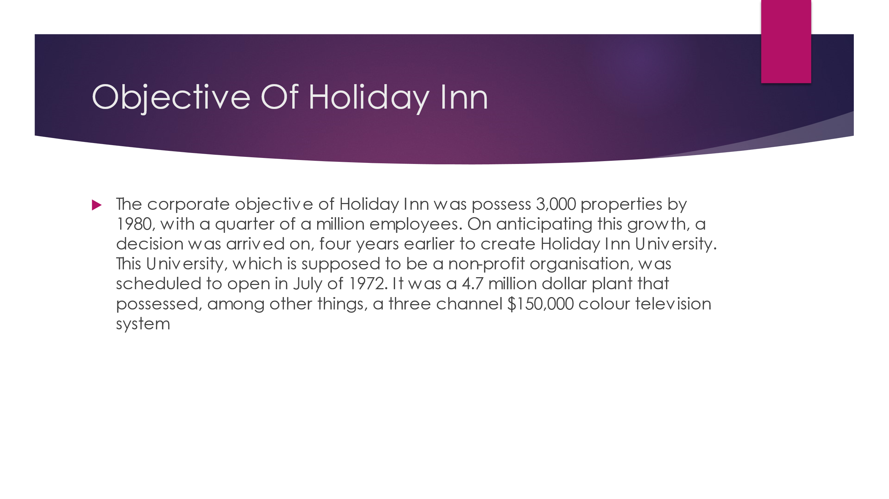
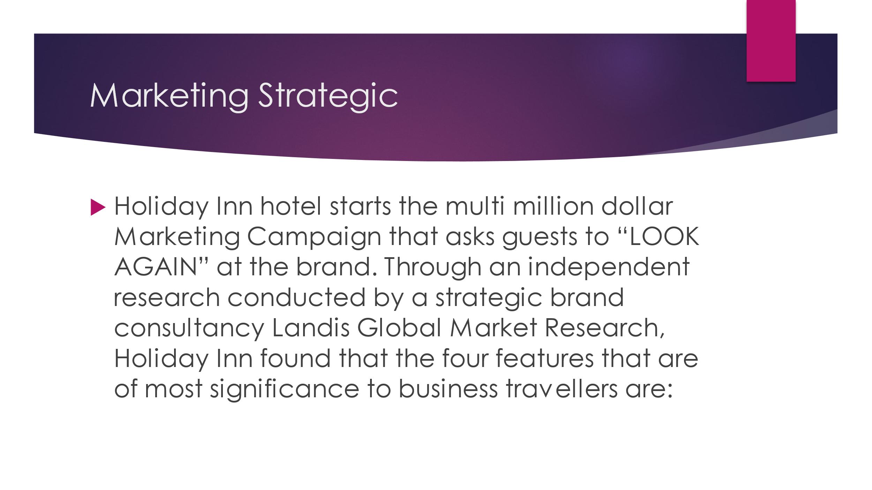
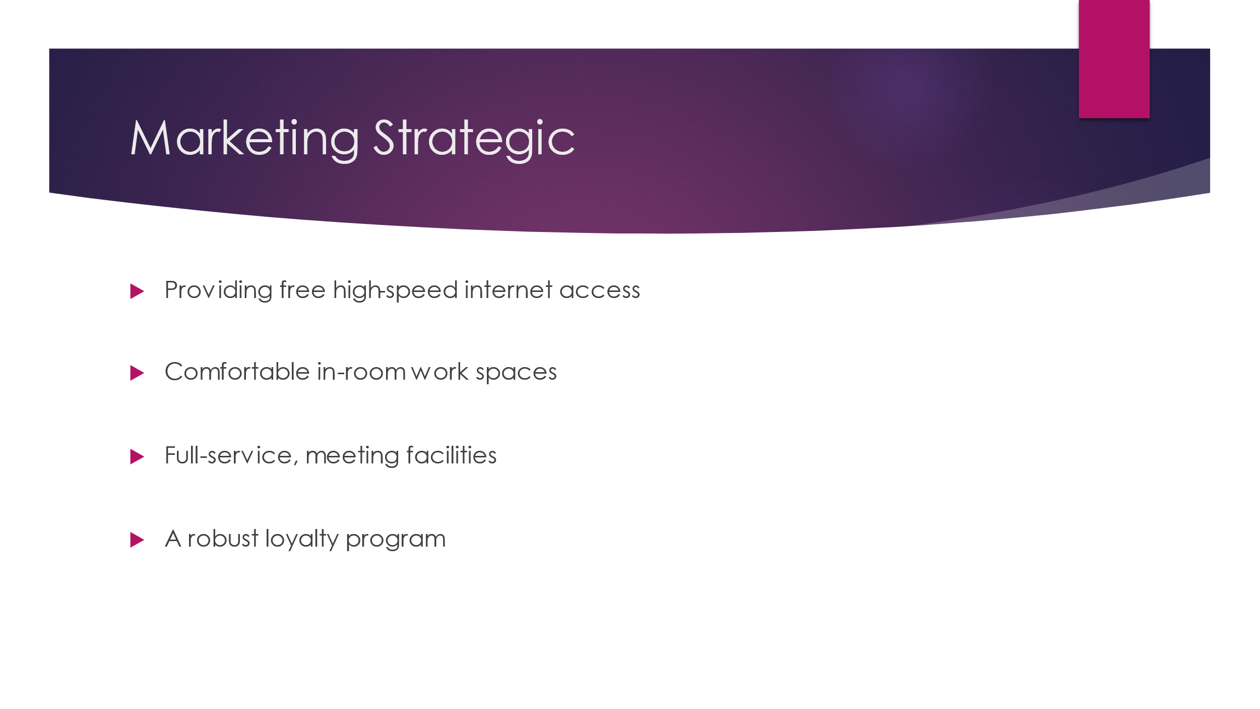
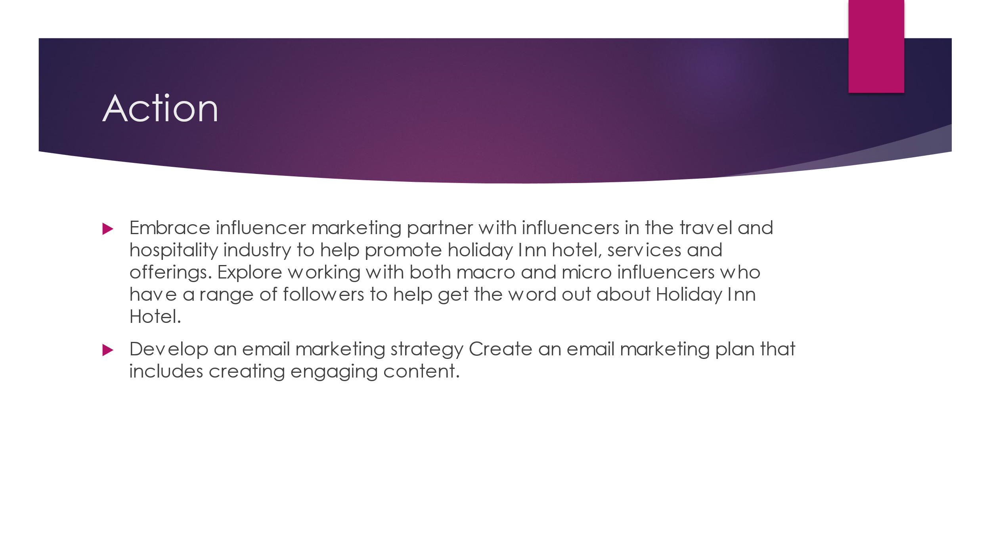
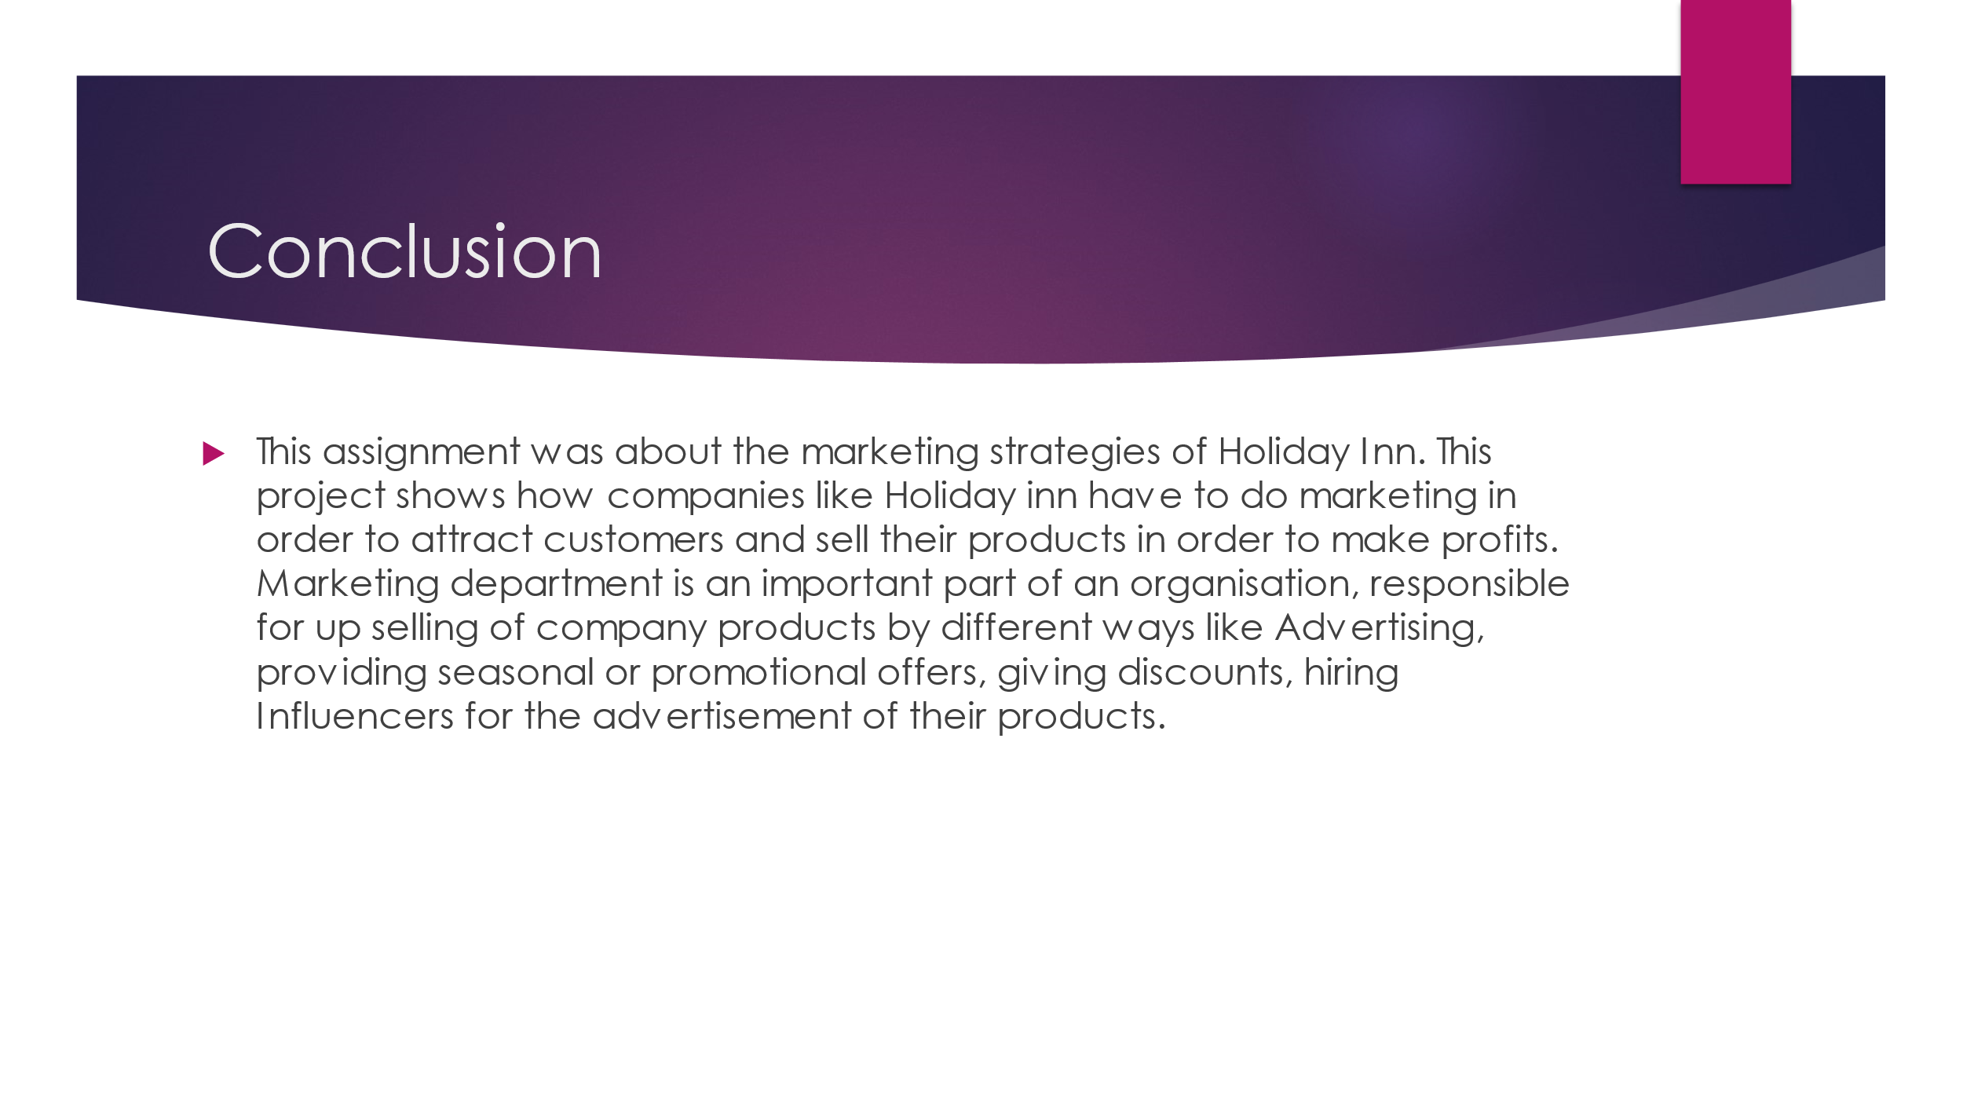
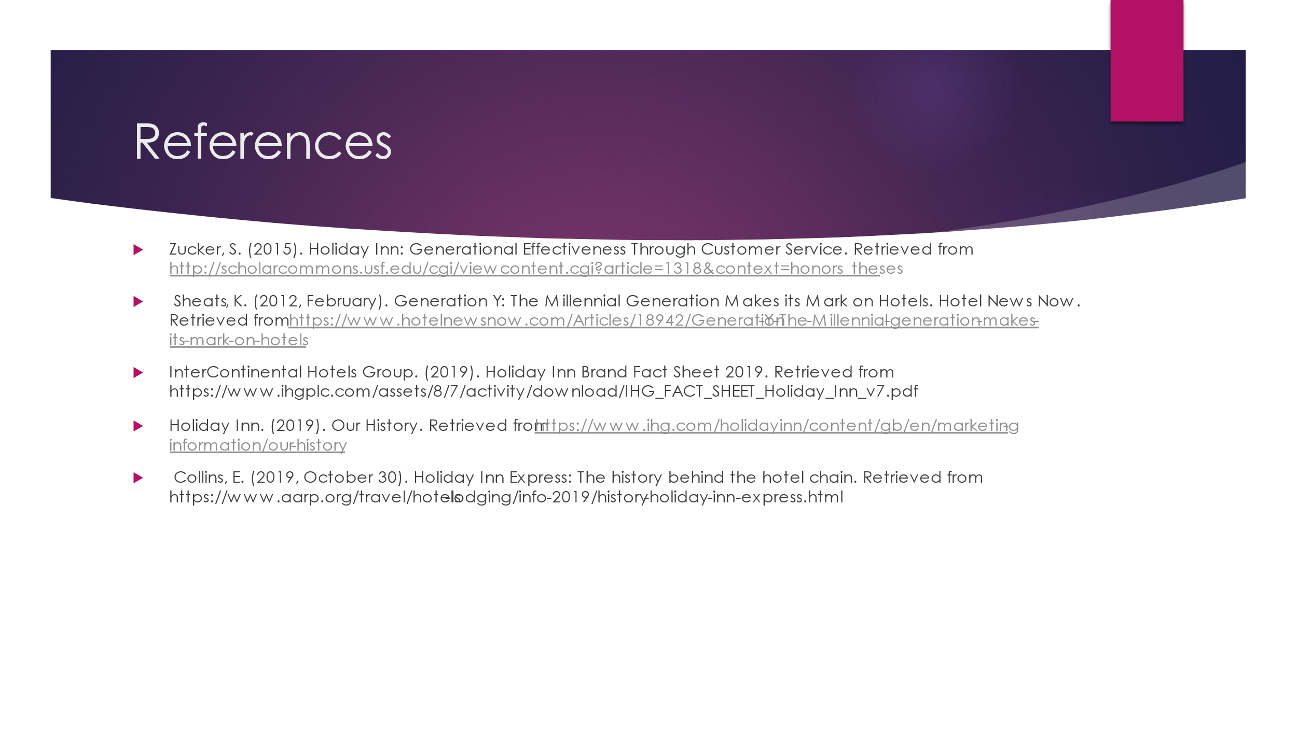

References

Zucker, S. (2015). Holiday Inn: Generational Effectiveness Through Customer Service. Retrieved from http://scholarcommons.usf.edu/cgi/viewcontent.cgi?article=1318&context=honors_theses
Sheats, K. (2012, February). Generation Y: The Millennial Generation Makes its Mark on Hotels. Hotel News Now. Retrieved from https://www.hotelnewsnow.com/Articles/18942/Generation-Y-The-Millennial-generation-makes-its-mark-on-hotels
InterContinental Hotels Group. (2019). Holiday Inn Brand Fact Sheet 2019. Retrieved from https://www.ihgplc.com/assets/8/7/activity/download/IHG_FACT_SHEET_Holiday_Inn_v7.pdf
Holiday Inn. (2019). Our History. Retrieved from https://www.ihg.com/holidayinn/content/gb/en/marketing-information/our-history
Collins, E. (2019, October 30). Holiday Inn Express: The history behind the hotel chain. Retrieved from https://www.aarp.org/travel/hotels-lodging/info-2019/history-holiday-inn-express.html

