Student Name: Julian Gjoka  Student ID: 2230507  Module Title: Foreign Languages & Cultural Awareness  Module Code: BMIH5003  Lecturer: Heidi Prosser  Date: 09/02/2024 | 
ASSIGNMENT 1: PORTFOLIO
(4 Components)

Component 1: Professional Reflection (500 words +/- 10%)

Weighting: 25%

Introduction
The largest hotel chain in the UK is Premier Inn with over 800 hotels and around 72,000 rooms. Premier Inn hires staff from all backgrounds and creates an inclusive working environment for its workforce. However, due to cultural differences, language barriers are common issues that are encountered by the staff and the guests. As a restaurant manager placed in the restaurant, I have encountered similar incidents. The following reflection will depict my experience with cultural barriers and outline ways to overcome them.

Discussion
I recently came face to face with an incident at Premier Inn Leicester that stressed the potential for cultural misunderstandings in the Food and Beverage sector. A similar incident occurred during the dinner service at our hotel's restaurant. One of the guests of the hotel and an employee of the restaurant had a communication breakdown due to cultural differences. This F&B staff did not speak native English and, therefore, faced difficulties in understanding the dietary preferences of the guest. As the guests belonged to a culturally diverse background, they had a few dietary requirements as a result of cultural beliefs. Despite the guests’ continuous efforts to convey their dietary needs, the barrier in language led to major confusion. This led to the serving of a dish that was against the dietary restrictions by the employee. For understanding this incident at our restaurant Hofstede’s Cultural Dimension theory can be applied. Among the six dimensions, the uncertainty avoidance dimension can be aligned with this experience (Wale, 2024 ). A high uncertainty avoidance culture can be represented by the guest’s specific food preferences due to religious beliefs. Hence, it becomes imperative to take care of clear guidelines as well as avoid ambiguity. The potentially lower uncertainty avoidance background of our restaurant staff might have led to the confusion and they failed to adhere to the strict food preferences of the guest. Additionally, cultural misunderstandings in our restaurants among the guests and the employees may also arise due to linguistic nuances. In this scenario, along with unfamiliarity with culture, linguistic barriers also gave rise to such a dire situation (Joseph, 2023). As a result of this incident, I found that it is important to improve cross-cultural communication as well as awareness within our restaurant. In order to avoid similar incidents in future, I will have to enhance communication skills among our F&B employees at Premier Inn. language training sessions are required to be provided to make English more proficient for employees who are from other cultural backgrounds (Lacalle, 2021). Furthermore, training regarding cultural sensitivity must also be provided to create respect and understanding regarding customs as well as practices impacting the guests. As the manager of the restaurant, I must lead by example. Therefore, my leadership skills must reflect communication skills and cultural awareness. This way cultural misunderstandings can be avoided at Premier Inn Leicester’s F&B sector.

Conclusion
From the above discussion, it has been concluded that knowledge of culture and languages is important in the F&B section of the hospitality industry. This industry is full of a workforce from diverse cultural backgrounds along with guests from varied cultures. Therefore, communication skills, cultural awareness and effective leadership can help avoid unwanted circumstances.

References:
Joseph, Y., (2023). The role of cultural sensitivity in the hospitality industry. [Online] Available at: https://medium.com/@yvonnejoseph/the-role-of-cultural-sensitivity-in-the-hospitality-industry-32128a0a1788 [Accessed 17 January 2024].
Lacalle, E., (2021). What is cultural diversity and why is it important in the hospitality industry?. [Online] Available at: https://www.mews.com/en/blog/cultural-diversity-in-hospitality-industry [Accessed 16 January 2024].
Wale, H., (2024) . Hofstede’s Cultural Dimensions Theory. [Online] Available at: https://corporatefinanceinstitute.com/resources/management/hofstedes-cultural-dimensions-theory/ [Accessed 16 January 2024 ].

Component 2: Training Plan (500 words +/- 10%)

Weighting: 25%

Identified cultural misunderstanding (in a few words) :
The cultural misunderstanding that has been identified is mostly language barrier and less knowledge of cultural differences when it comes to food preferences of the guests at Premier Inn.
Training plan (Why/What//Who/Where/When):
Skills to be improved | Format of the training | Key stakeholders | Training partner | Budget allocated
Cross-cultural communication | 1. Workshops and training sessions will be conducted for the employees to understand various cultures, customs, as well as communication styles.  2. Various resources like videos, real-life examples, and feedback from the guests will be provided to educate the staff.  3. For enhancing the primary languages spoken within Premier Inn language classes will be given to the workforce. | The management of Premier Inn, the Human Resources Department, and all F&B staff. | Cultural consultants and language teachers will be hired for the classes and training sessions. | £ 5,000
Enhanced English for F&B | 1. The staff at Premier Inn will be provided with language classes, along with knowledge of basic greetings as well as common phrases in diverse languages to help with initial interactions.  2. The relevance of active listening will be acknowledged in cross-cultural interactions.  3. Training will be provided to fathom the viewpoint of the speaker rather than simply formulating their response during the hearing. | Staff who are native and non-English speaking, the management team of Premier Inn, and HR team and the Manager of the restaurant. | A professional language trainer will be hired and classes will be provided during off-times of the staff. | £ 7,000
Knowledge of diverse customs | 1. Training workshops discussing the customs and traditions of different cultures (Hofstede et al., 2010).  2. An open platform will be created for discussions among the staff for knowledge exchange.  3. Cultural experts will be called in for lectures in the training sessions for specific customs and traditions knowledge.  4. Staff at Premier Inn will be encouraged to share their customs as well as events will be organised to showcasing diversity within the workplace. | Entre team of F&B sector, HR professionals, guest lecturers, and training personnels. | Leadership experts will be called from eminent universities for training and workshops. | £ 9,000
Inclusive leadership | 1. As the leader of the F&B team of Premier Inn restaurant I have to seek feedback and self-reflect to understand the impact of leadership on team dynamics (Hampden-Turner and Trompenaars, 2020).  2. Gain comprehensive knowledge of the current social issues and their possible impact on the workplace to make informed as well as inclusive decisions (Oriade et al., 2021).  3. Involve the members of my team in the process of decision-making for fostering a sense of ownership.  4. Take workshops and seminars from industry leaders who have successfully integrated cultural dimensions in their working teams. | Prime stakeholder is the Manager of the restaurant at Premier Inn, supervisors, and the management. | Expert leaders from hospitality sectors will be hired for dedicated trainings and seminars. | £ 8,000

References:
Hampden-Turner, C. and Trompenaars, F. (2020) Riding the Waves of Culture. 4th Ed. London: John Murray Press.
Hofstede, G., Hofstede, G.J. and Minkov, M. (2010) Cultures and organizations: software of the mind. 3rd Ed. New York: McGraw-Hill.
Oriade, A., Osinaike, A., Aduhene, K. and Wang, Y., (2021). Sustainability awareness, management practices and organisational culture in hotels: Evidence from developing countries. International Journal of Hospitality Management, 92, p.102699.
Component 3: Student Self-Reflection (500 words +/- 10%)

Weighting: 25%
Description
When I first chose the hospitality sector as my career option, I had limited knowledge of the relevance of cultural awareness in this industry. My focus lay mainly on providing excellent service to my customers without giving much thought to cultural intricacies. Although I acknowledged the presence of diverse cultures among the guests, I did not pay much attention to its impact on the daily operations of this industry (ed, 2020). However, during a certain incident that I encountered in the restaurant of my Level 4 placement hotel, that is Premier Inn, I started to acknowledge the importance of cultural awareness in fostering an enhanced guest experience. It was a misunderstanding between an F&B staff working at the restaurant and a guest from a different culture with a different language who was unable to communicate and convey his dietary preferences.
Feelings
Initially, I was surprised as well as confused when the cultural misunderstanding had taken place. Then I realised that it was the lack of awareness and inadequate readiness in handling such situations, that led to such an uncomfortable scenario for the guests as well as the hotel staff. As a result of this incident, a spark of curiosity rose in me to understand the role of imbibing cultural awareness within the intricacies of our industry (Channell, 2023).
Evaluation
After evaluating the incident that occurred at the restaurant, I immediately understood the influence that cultural awareness could have on the satisfaction of guests and gaining their loyalty. Therefore, it made me understand that ignoring the customs, and traditions of different cultures, could hamper the overall reputation of Premier Inn Leicester. Immediately my perspective shifted and I started viewing cultural awareness as a fundamental component of delivering excellent hospitality service.
Analysis
After analysing further, I recognised the need for detailed training in cross-cultural interactions as well as understanding within the F&B team. Not only dietary preferences but creating an inclusive environment for our guests is also crucial. Our guests must feel seen, heard as well as respected. Hence, the relevance of cultural inclusivity had been unscored in maintaining the long-term reputation of the hotel and enhanced guest satisfaction.
Conclusion
The cultural misunderstanding that occurred within the restaurant of my placement, acted as a catalyst to bring out my commitment to self-development in the field of cultural awareness. Therefore, I initiated training programmes that focused on building cross-cultural communication, proficiency in varied languages, and knowledge regarding customs within the F&B team working at Premier Inn restaurant. In order to avoid any such cross-cultural miscommunication that could affect the reputation of the hotel chain, this proactive approach was necessary. A positive alteration within the dynamics of the team was observed as a result, as staff members started to show confidence in tackling different types of guests.
Action plan
I have committed to an ongoing learning process to expand my knowledge regarding cultural awareness. I will participate in external workshops, read good sources, and attend conferences in the industry that speak about diversity as well as inclusion (Robinson, 2022). Furthermore, I will encourage my team to share their insights regarding their cultures for a more collaborative working environment.
References:
Channell, M., (2023). Gibbs Reflective Cycle – A Practical Guide. [Online] Available at: https://www.tsw.co.uk/blog/leadership-and-management/gibbs-reflective-cycle/ [Accessed 16 January 2024].
ed, (2020). Gibbs' Reflective Cycle. [Online] Available at: https://www.ed.ac.uk/reflection/reflectors-toolkit/reflecting-on-experience/gibbs-reflective-cycle [Accessed 15 January 2024].
Robinson, J., (2022). Learn From Your Past Experience with Gibb’s Reflective Cycle. [Online] Available at: https://crowjack.com/blog/strategy/reflection-models/gibbs-reflective-cycle [Accessed 18 January 2024].
Component 4: Training Presentation (6 Slides)

Weighting: 25%

Introduction
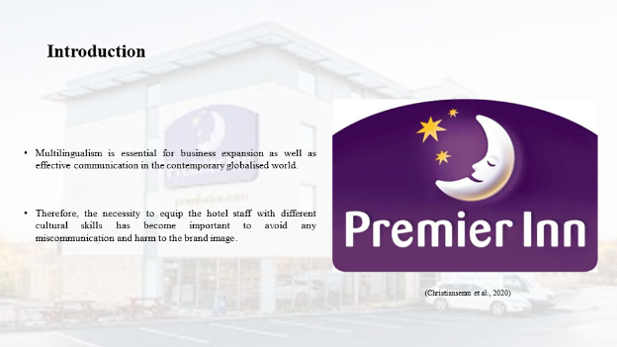
Multilingualism is essential for business expansion as well as effective communication in the contemporary globalised world. The hospitality sector has to deal with guests from varied cultural backgrounds with different languages. Therefore, the necessity to equip the hotel staff with different cultural skills has become important to avoid any miscommunication and harm to the brand image. This presentation will highlight the role of multilingualism for the hotel staff, in the context of the German language.

About the German language
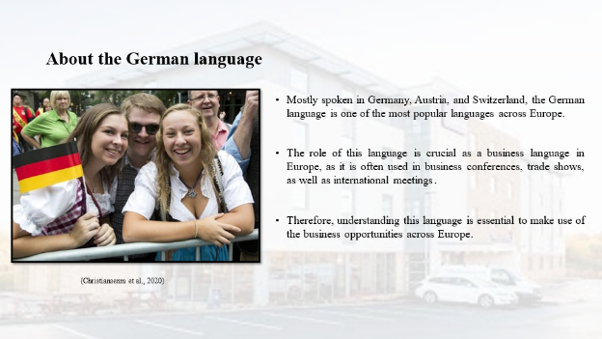
Mostly spoken in Germany, Austria, and Switzerland, the German language is one of the most popular languages across Europe. The role of this language is crucial as a business language in Europe, as it is often used in business conferences, trade shows, as well as international meetings. Therefore, understanding this language is essential to make use of the business opportunities across Europe. This will help in initiating effective communication, as well as create a strong presence in the business environment of Europe (Christiansenm et al., 2020).

Is it hard to learn German?
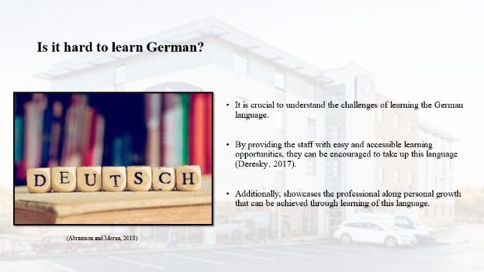
It is crucial to understand the challenges of learning the German language. Although learning German may seem formidable, the rewards of learning this language are huge. By providing the staff with easy and accessible learning opportunities, they can be encouraged to take up this language (Deresky, 2017). Additionally, showcases the professional along personal growth that can be achieved through learning of this language. It is important to reinforce the idea that learning German is a worthwhile investment in enhancing one’s cultural competency within the hospitality industry.

Politeness of the German language in the Business context
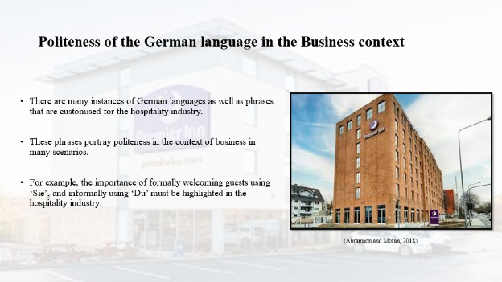
There are many instances of German languages as well as phrases that are customised for the hospitality industry. These phrases portray politeness in the context of business in many scenarios. For example, the importance of formally welcoming guests using ‘Sie’, and informally using ‘Du’ must be highlighted in the hospitality industry. Therefore, for making a positive as well as dignified environment it is crucial to know about these nuances. In this way, the hotel staff can interact with German guests and help to fulfil their cultural expectations. This, in turn, provides an enhanced guest experience and a positive brand image.

Impolite practices to avoid
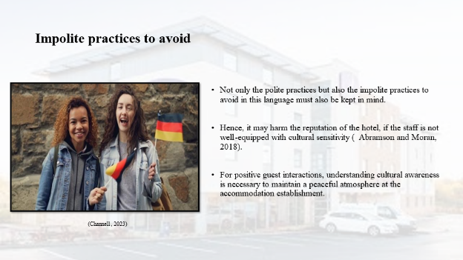
Not only the polite practices but also the impolite practices to avoid in this language must also be kept in mind. In the German business context, there are several actions that could be considered impolite. Hence, it may harm the reputation of the hotel, if the staff is not well-equipped with cultural sensitivity (Abramson and Moran, 2018). For positive guest interactions, understanding cultural awareness is necessary to maintain a peaceful atmosphere at the accommodation establishment. Examples of such practices include chewing gum while talking, putting hands in their pocket while talking, and crossing their arms over people who are shaking their arms.

Conclusion
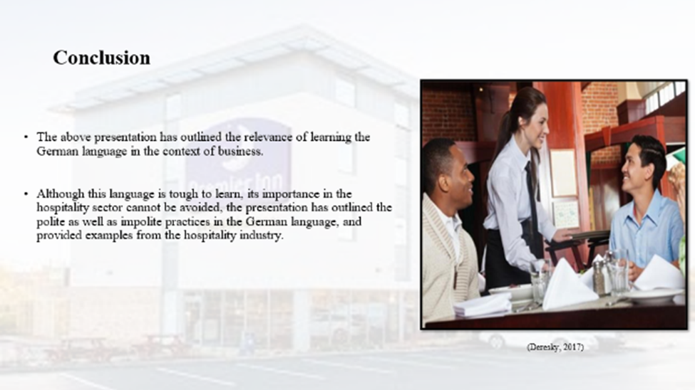
The above presentation has outlined the relevance of learning the German language in the context of business. Although this language is tough to learn, its importance in the hospitality sector cannot be avoided, the presentation has outlined the polite as well as impolite practices in the German language, and provided examples from the hospitality industry. Therefore, these are important for empowering the hotel staff for cultural development.
References (no screenshots):
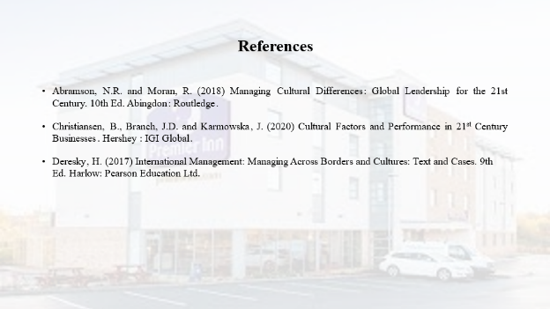
Abramson, N.R. and Moran, R. (2018) Managing Cultural Differences: Global Leadership for the 21st Century. 10th Ed. Abingdon: Routledge.
Christiansen, B., Branch, J.D. and Karmowska, J. (2020) Cultural Factors and Performance in 21st Century Businesses. Hershey : IGI Global.
Deresky, H. (2017) International Management: Managing Across Borders and Cultures: Text and Cases. 9th Ed. Harlow: Pearson Education Ltd.

