University of Wales Trinity Saint David
Wales Institute of Science and Art


Electrics
Electrical Controls System

Mohammed Nasir Mahmood
2003929
1/04/2023
Contents
1 Task 1 1
1.1 A 1
1.2 B 1
1.3 c (i) 1
1.4 c (ii) 1
1.5 c (iii) 1
1.6 c (iv) 1
1.7 d 1
1.8 e 1
1.9 f 1
1.10 g 1
2 Task 2 2
2.1 Scope Time Division Calculations 2
2.2 Function Generator output sine wave 2
2.3 Unsmoothed Rectifier Wave 2
2.4 Smoothed Rectifier Wave 2
2.5 Drop in Voltage Question 2
2.6 Rectifiers use in Automotive applications Question. 2
2.7 Probing Question 2
3 Task 3 3
3.1 Scope Time Division Calculations 3
3.2 Function Generator output sine wave 3
3.3 Capacitor charge and discharge wave marked at correct points. 3
3.4 Basic Capacitor Calculations 3
3.5 Capacitor discharge table 3
3.6 Gradient Plot and calculations 3
3.7 Inaccuracies Question 3
4 References 4

Task 1

A
12/4=3v 3/0.5=6

B
I=V/R 12÷24=0.5A
3÷0.5=6Ω
0.5-0.3=0.2
0.2-0.2=0.1
A=0.3A, B=0.1A, C=0.1A

c (i)
V=IXR
V=P/I
IXR=P/I
R=P/I² =0.3A
0.9/0.3² =10Ω

c (ii)
10/3=3.33̇˚

c (iii)
R1(1/3.33̇˚+1/3.33̇˚+1/10)-1=1.427Ω
1.427Ωx0.5=0.71367

c (iv)
5-(0.71367+3)=1.28633
1.28633/0.5=257266Ω

d
R=V/I= r=2/0.5=4Ω
Rt(1/4+1/4+1/4)=1.33Ω

e
V=IxR=0.5x6=3V

f
1.427+2.57266+6+6+6+1.33=17.32966

g
emf=17.32966x0.5=8.66483V

Task 2

Scope Time Division Calculations

Function Generator output sine wave
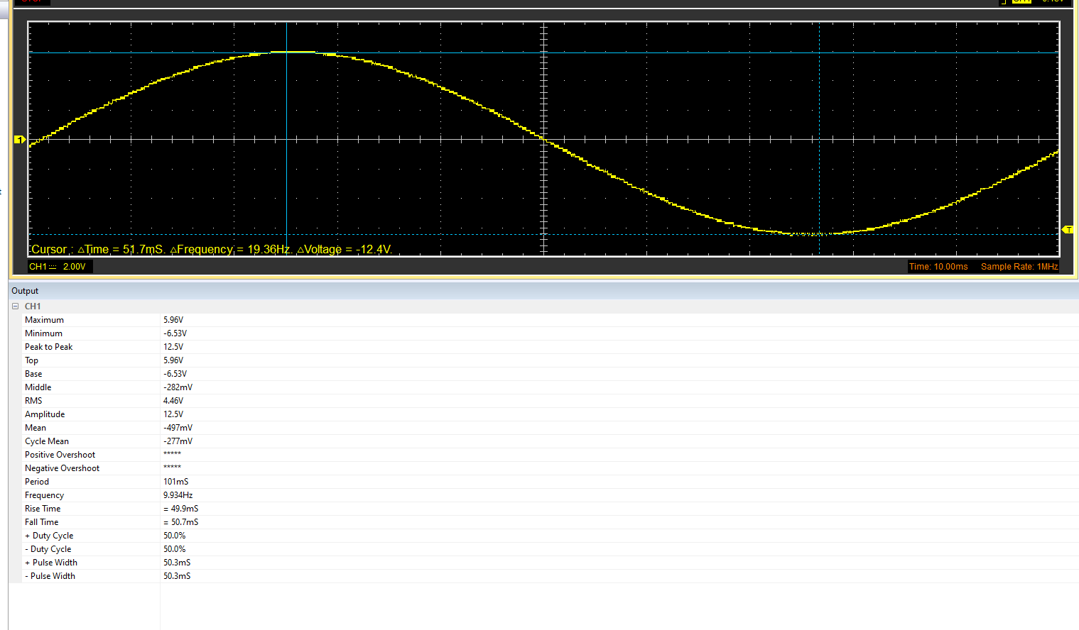

Unsmoothed Rectifier Wave
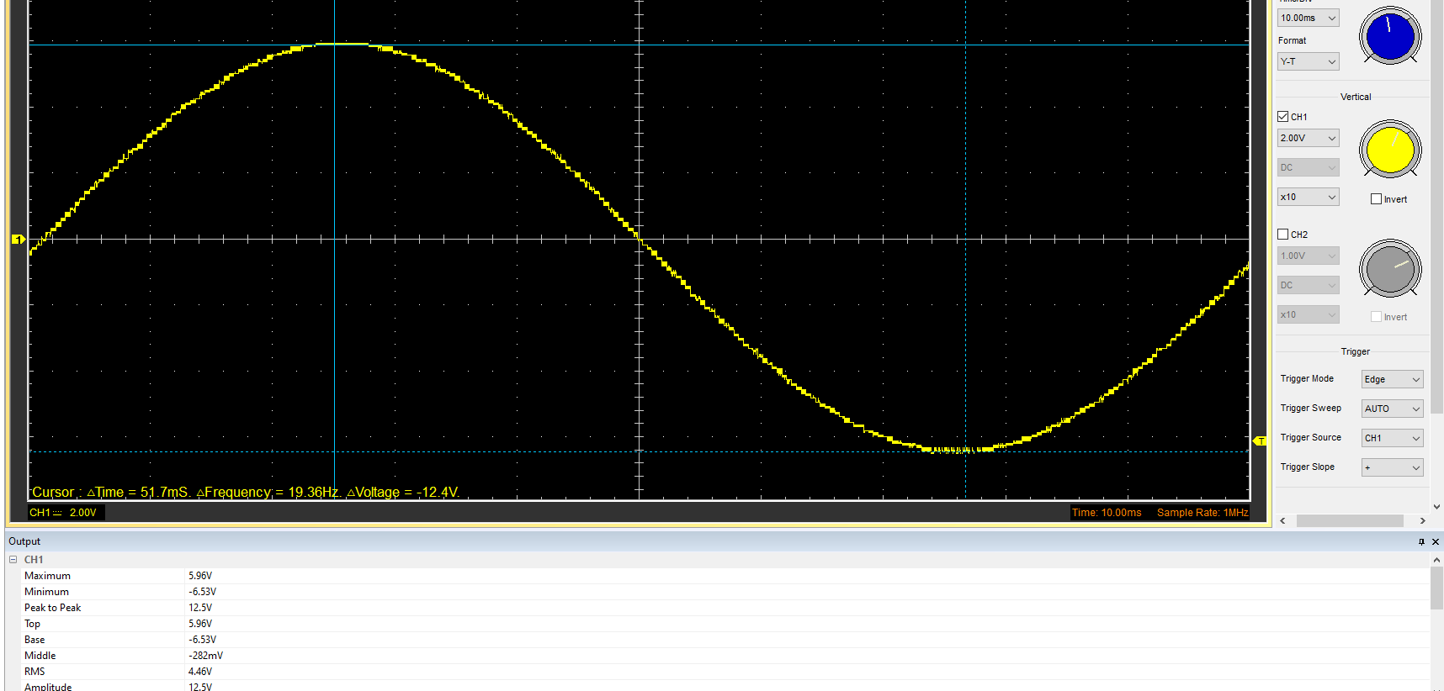

Smoothed Rectifier Wave
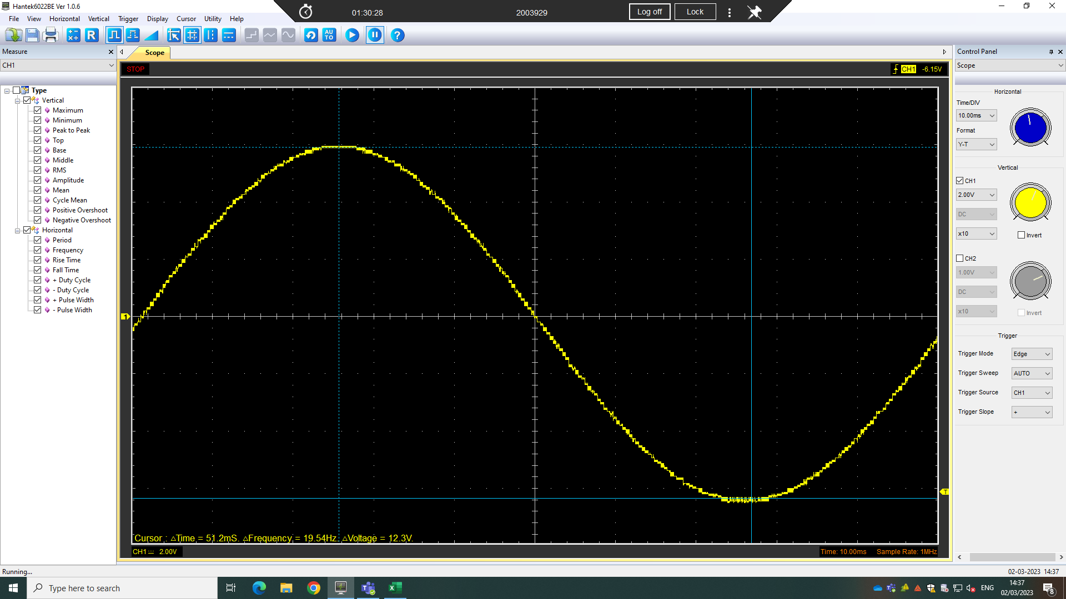

Drop in Voltage Question

Rectifiers use in Automotive applications Question.
The rectifier is a key component used in electrical applications across the automotive industry. The rectifier works by allowing current flow in one direction whilst not allowing electricity flow from the other direction through.

Probing Question

Task 3

Scope Time Division Calculations
Cpacitor-0.22
Resistor-2KΩ
T= R X C= 2000 X 0.00000022= 0.00044
Meaning 20t= 20x 0.00044= 0.0088
=f=1/0.0088=113.63Hz

Function Generator output sine wave
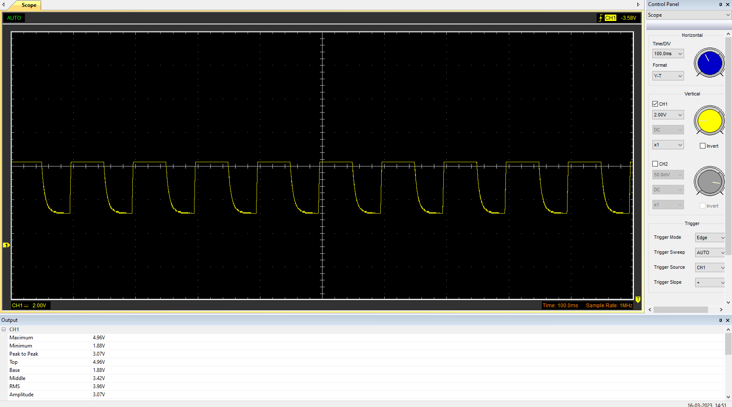

Capacitor charge and discharge wave marked at correct points.

Basic Capacitor Calculations

Capacitor discharge table

Gradient Plot and calculations

Inaccuracies Question

References

