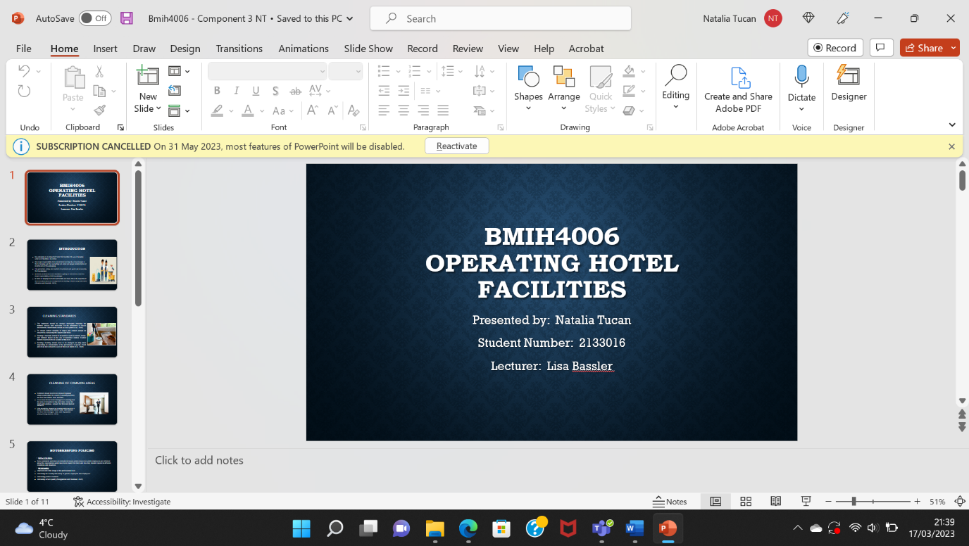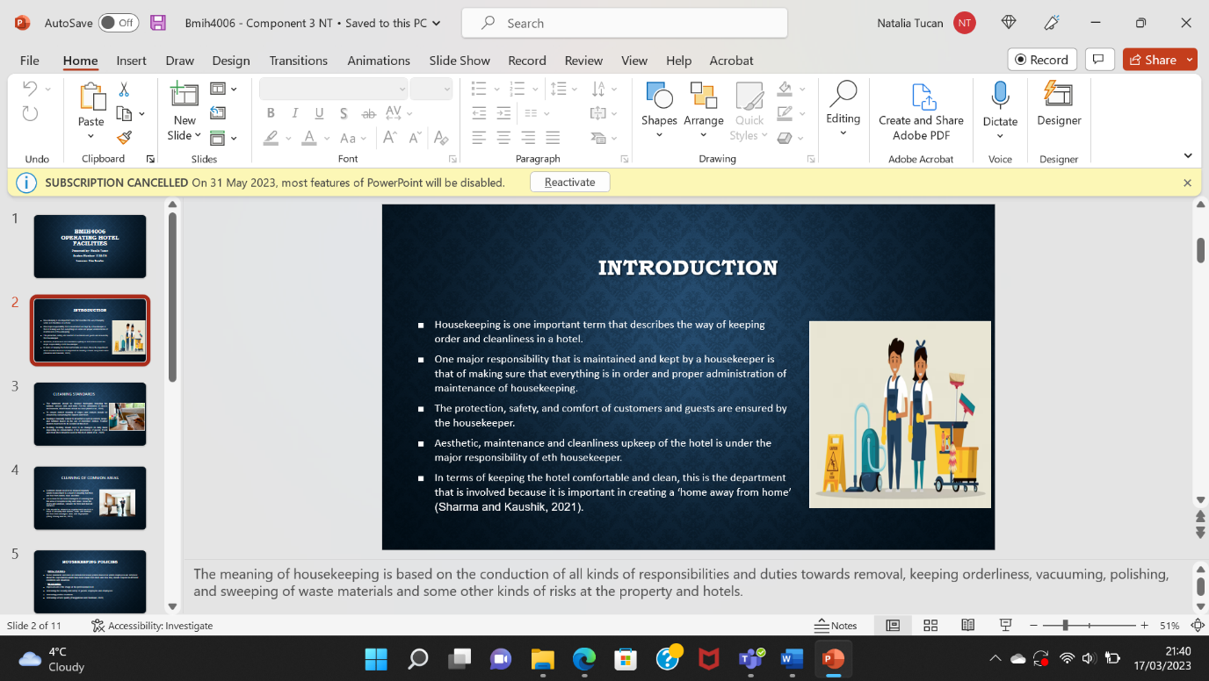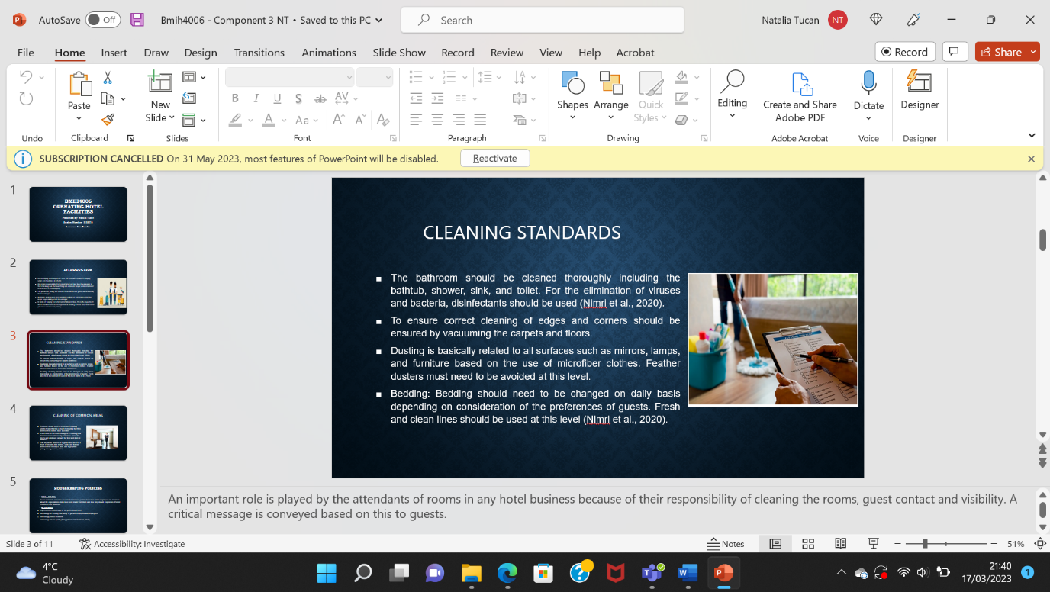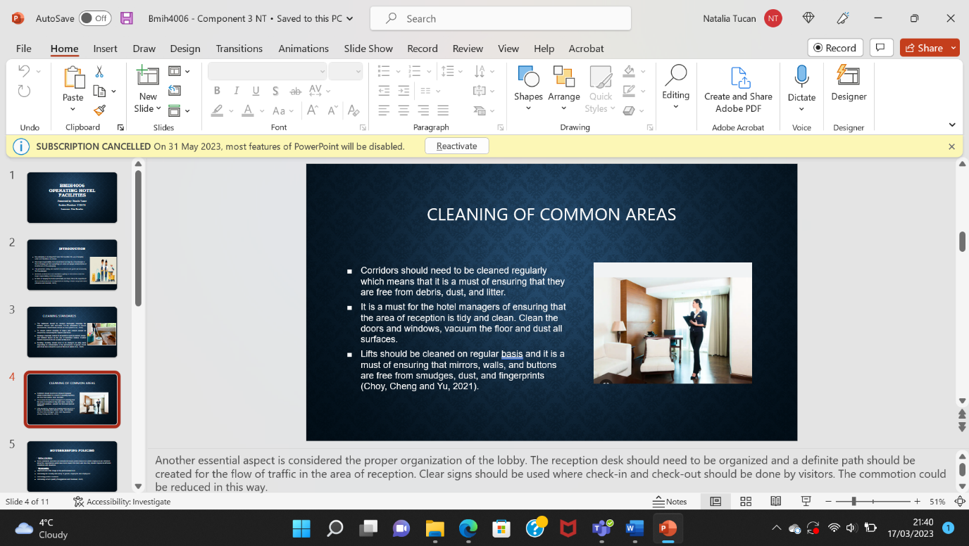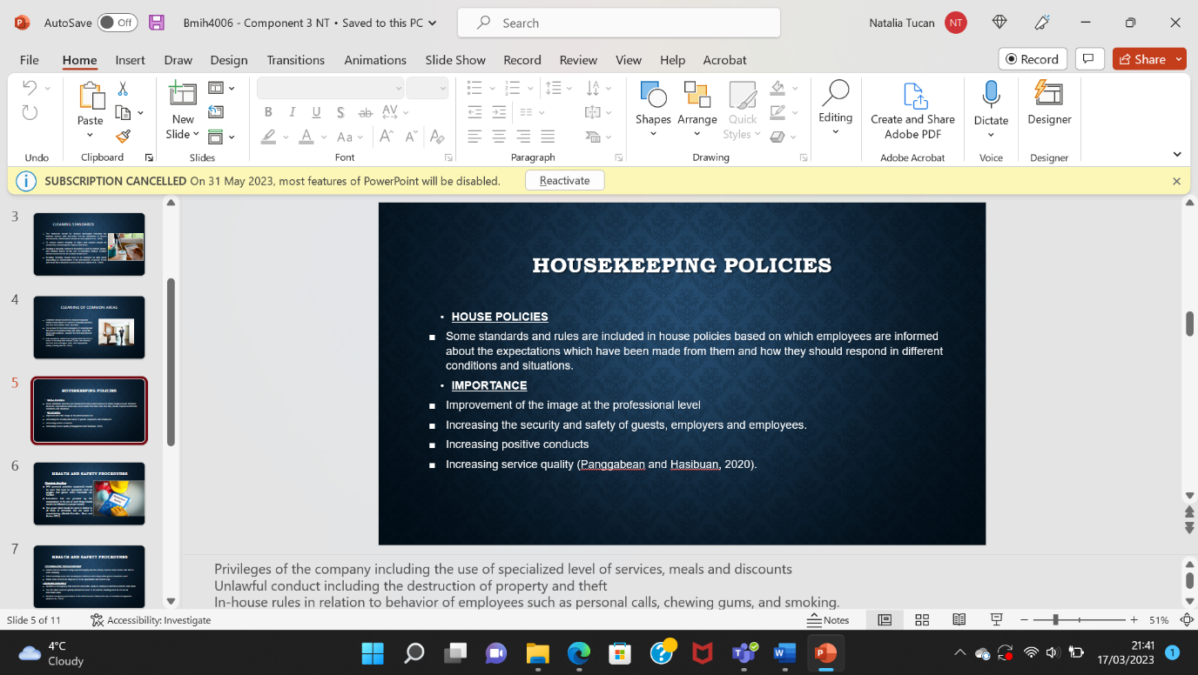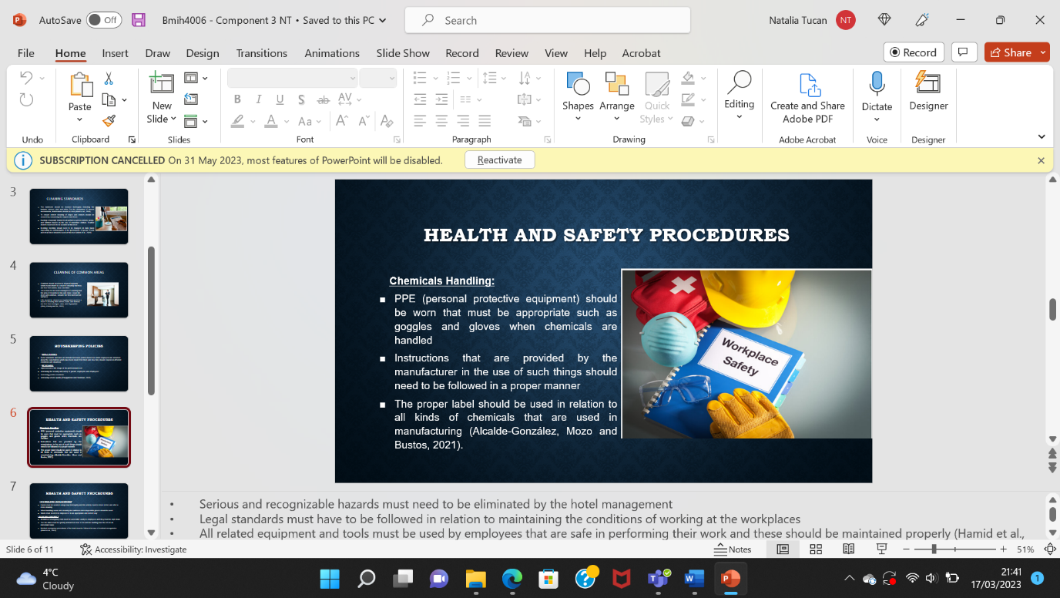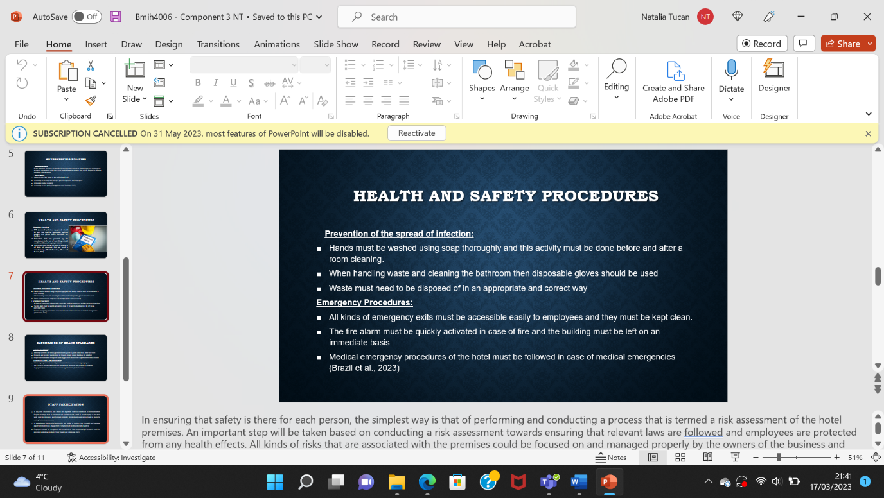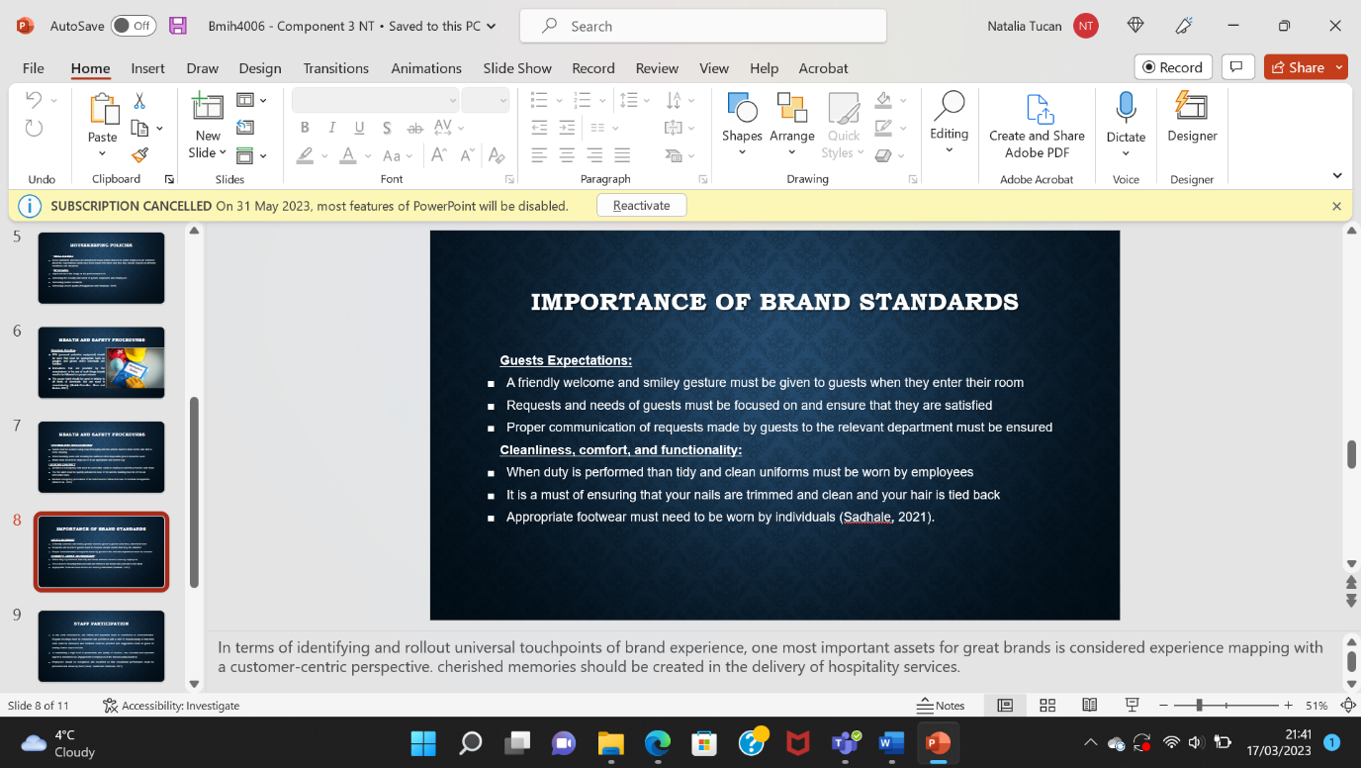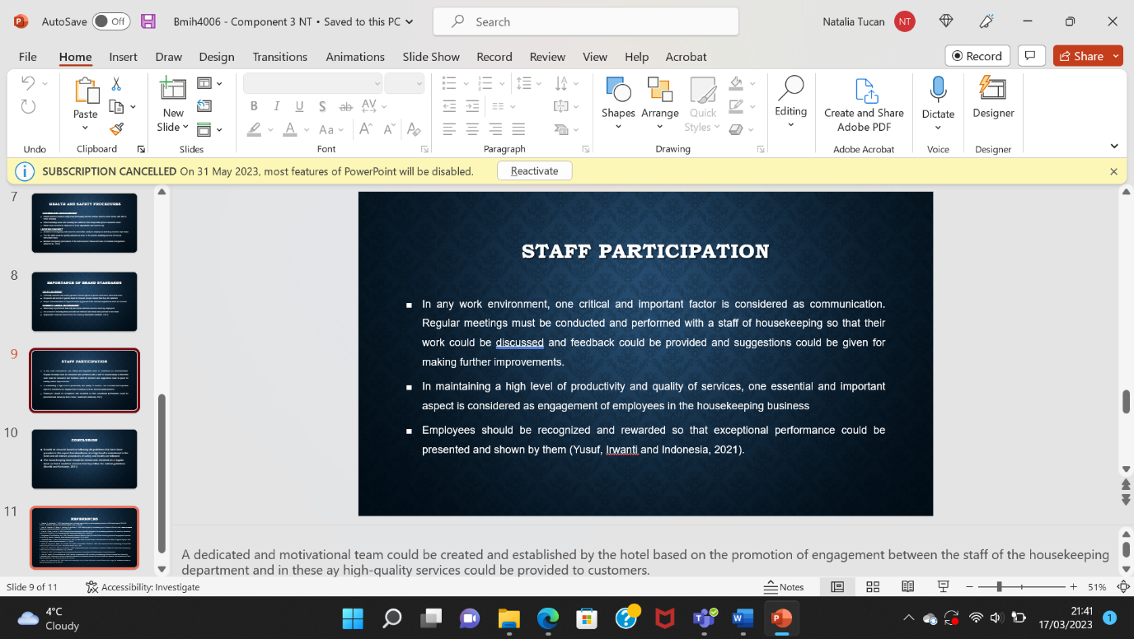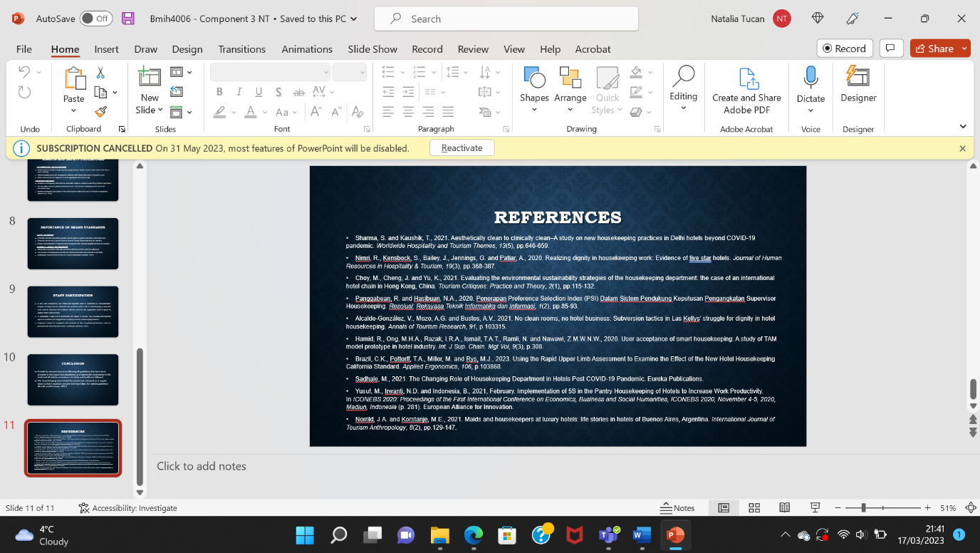

Reference –
Abo-Murad, M., Abdullah, A.K. and Jamil, R., 2019. Effect of the organisational culture on crisis management in hotel industry: A qualitative exploration. International Journal of Entrepreneurship, 23(2), pp.1-18.
Alnawas, I. and Hemsley-Brown, J., 2019. Examining the key dimensions of customer experience quality in the hotel industry. Journal of Hospitality Marketing & Management, 28(7), pp.833-861.
Chung, S.Y. and Byrom, J., 2021. Co-creating consistent brand identity with employees in the hotel industry. Journal of Product & Brand Management, 30(1), pp.74-89.
Leung, X.Y., Lyu, J. and Bai, B., 2020. A fad or the future? Examining the effectiveness of virtual reality advertising in the hotel industry. International Journal of Hospitality Management, 88, p.102391.
Mehta, M.P., Kumar, G. and Ramkumar, M., 2023. Customer expectations in the hotel industry during the COVID-19 pandemic: a global perspective using sentiment analysis. Tourism Recreation Research, 48(1), pp.110-127.
Ndiuini, A. and Baum, T., 2021. Underemployment and lived experiences of migrant workers in the hotel industry: policy and industry implications. Journal of Policy Research in Tourism, Leisure and Events, 13(1), pp.36-58.
Sonnenschein, K., Barker, M. and Hibbins, R., 2019. Benefits of work-integrated learning: Perceptions held by Chinese international students enrolled in an Australian university and managers in the Chinese hotel industry. Journal of Hospitality & Tourism Education, 31(3), pp.139-148.
Tong-On, P., Siripipatthanakul, S. and Phayaphrom, B., 2021. The implementation of business intelligence using data analytics and its effects towards on performance in the hotel industry in Thailand. International Journal of Behavioral Analytics, 1(2).
Burak, V., 2020. Training of future specialists in the hotel and restaurant industry in higher educational establishments in the conditions of distance learning. ScienceRise: Pedagogical Education, 6(39).
Dewi, P.S.R., 2022. THE LANGUAGE EXPRESSIONS USED IN HANDLING COMPLAINT DURING RESERVATION AT THE LOVINA BALI RESORT (Doctoral dissertation, Universitas Pendidikan Ganesha).
Elsaed, A.A. and Hassan, O.M., 2020. The Relationship Between Guests' Knowledge Awareness and Their Behaviors in Submitting Complaints (Applied on a Sample of Five Star Hotels in Sharm El-Sheikh). International Journal of Heritage, Tourism and Hospitality, 14(3 (Special Issue)), pp.89-100.
Mutiasari, D.E., 2020. Strategies to Promote Hotel Products and Handle Guest Complaints in Aruna Senggigi Resort and Convention (Doctoral dissertation, UNIVERSITAS AIRLANGGA).
Rossanty, Y., Nasution, M.D.T.P. and Irawan, I., 2019. Communication and Customer Relations Strategy in Improving Hotel Guests’ Satisfaction in Samosir Tourism Area, North Sumatra, Indonesia. International Journal of Management (IJM), 10(6).
Şen Küpeli, T. and Özer, L., 2020. Assessing perceived risk and perceived value in the hotel industry: an integrated approach. Anatolia, 31(1), pp.111-130.
Sihombing, D.A. and Danito, K.H., 2021, April. Operator Role In Front Office Department On Handling Guest Requests At Harris Resort Barelang. In ConCEPt-Conference on Community Engagement Project (Vol. 1, No. 1, pp. 26-30).
Wiguna Yasa, I., 2022. Procedures and Language Expressions Used in Handling Complaints at U Paasha Hotel.
Al Hayek, W.Y. and Odeh, R.A.A., 2020. Cloud ERP VS On-Premise ERP. International Journal of Applied Science and Technology, 10(4).
Alrawadieh, Z. and Dincer, M.Z., 2019. Reputation management in cyberspace: evidence from Jordan’s luxury hotel market. Journal of Hospitality and Tourism Technology, 10(1), pp.107-120.
Anagnostopoulou, S.C., Buhalis, D., Kountouri, I.L., Manousakis, E.G. and Tsekrekos, A.E., 2019. The impact of online reputation on hotel profitability. International Journal of Contemporary Hospitality Management, 32(1), pp.20-39.
Charalampous, M., Grant, C.A., Tramontano, C. and Michailidis, E., 2019. Systematically reviewing remote e-workers’ well-being at work: A multidimensional approach. European journal of work and organizational psychology, 28(1), pp.51-73.
Kodheli, O., Lagunas, E., Maturo, N., Sharma, S.K., Shankar, B., Montoya, J.F.M., Duncan, J.C.M., Spano, D., Chatzinotas, S., Kisseleff, S. and Querol, J., 2020. Satellite communications in the new space era: A survey and future challenges. IEEE Communications Surveys & Tutorials, 23(1), pp.70-109.
Lai, I.K.W., 2019. Hotel image and reputation on building customer loyalty: An empirical study in Macau. Journal of Hospitality and Tourism Management, 38, pp.111-121.
Moreira, M.W., Rodrigues, J.J., Korotaev, V., Al-Muhtadi, J. and Kumar, N., 2019. A comprehensive review on smart decision support systems for health care. IEEE Systems Journal, 13(3), pp.3536-3545.
Odin, R., 2021. Spaces of Communication. In Spaces of Communication. Amsterdam University Press.
Perez-Aranda, J., Vallespín, M. and Molinillo, S., 2019. Hotels’ online reputation management: benefits perceived by managers. International Journal of Contemporary Hospitality Management, 31(2), pp.615-632.
Sutton, R.T., Pincock, D., Baumgart, D.C., Sadowski, D.C., Fedorak, R.N. and Kroeker, K.I., 2020. An overview of clinical decision support systems: benefits, risks, and strategies for success. NPJ digital medicine, 3(1), p.17.
- Sharma, S. and Kaushik, T., 2021. Aesthetically clean to clinically clean–A study on new housekeeping practices in Delhi hotels beyond COVID-19 pandemic. Worldwide Hospitality and Tourism Themes, 13(5), pp.646-659.
- Nimri, R., Kensbock, S., Bailey, J., Jennings, G. and Patiar, A., 2020. Realizing dignity in housekeeping work: Evidence of five star hotels. Journal of Human Resources in Hospitality & Tourism, 19(3), pp.368-387.
- Choy, M., Cheng, J. and Yu, K., 2021. Evaluating the environmental sustainability strategies of the housekeeping department: the case of an international hotel chain in Hong Kong, China. Tourism Critiques: Practice and Theory, 2(1), pp.115-132.
- Panggabean, R. and Hasibuan, N.A., 2020. Penerapan Preference Selection Index (PSI) Dalam Sistem Pendukung Keputusan Pengangkatan Supervisor Housekeeping. Resolusi: Rekayasa Teknik Informatika dan Informasi, 1(2), pp.85-93.
- Alcalde-González, V., Mozo, A.G. and Bustos, A.V., 2021. No clean rooms, no hotel business: Subversion tactics in Las Kellys’ struggle for dignity in hotel housekeeping. Annals of Tourism Research, 91, p.103315.
- Hamid, R., Ong, M.H.A., Razak, I.R.A., Ismail, T.A.T., Ramli, N. and Nawawi, Z.M.W.N.W., 2020. User acceptance of smart housekeeping: A study of TAM model prototype in hotel industry. Int. J Sup. Chain. Mgt Vol, 9(3), p.308.
- Brazil, C.K., Pottorff, T.A., Miller, M. and Rys, M.J., 2023. Using the Rapid Upper Limb Assessment to Examine the Effect of the New Hotel Housekeeping California Standard. Applied Ergonomics, 106, p.103868.
- Sadhale, M., 2021. The Changing Role of Housekeeping Department in Hotels Post COVID-19 Pandemic. Eureka Publications.
- Yusuf, M., Irwanti, N.D. and Indonesia, B., 2021, February. Implementation of 5S in the Pantry Housekeeping of Hotels to Increase Work Productivity. In ICONEBS 2020: Proceedings of the First International Conference on Economics, Business and Social Humanities, ICONEBS 2020, November 4-5, 2020, Madiun, Indonesia (p. 281). European Alliance for Innovation.
- Norrild, J.A. and Korstanje, M.E., 2021. Maids and housekeepers at luxury hotels: life stories in hotels of Buenos Aires, Argentina. International Journal of Tourism Anthropology, 8(2), pp.129-147.

