The theory and application of fuel-air explosions

Jordan Hayston

ACDA6008 Scientific Principles of OME Design

Wales Institute for Science and Art
University of Wales Trinity Saint David



Abstract
This report covers the phenomena of fuel-air explosions, including the theory of the blast mechanics seen on detonation in different scenarios. A fuel-air explosion occurs when a combustible vapour cloud is ignited. This can be weaponised by filling a warhead with a liquid or dust fuel and dispersing it. The resulting cloud can then be detonated after a short delay, producing an explosion with a larger heat of detonation and blast impulse than a conventional explosive, though it will not reach high peak overpressures.
This report also covers some incidents of accidental dust explosions to provide some context to the level of destruction and fatality they can cause. Historical and current uses within the military are then explored, including some examples of Russia and the USA’s weapons. The uses and possible targets for thermobaric weapons are discussed in the conclusion.
Contents
1. Introduction and Background 4
1.1 Fuel-Air Explosions 4
1.2 Blast Mechanics 5
2. Incidents within Industry 7
2.1 Stars Engrg Pte Ltd, Singapore 7
2.2 Al Solutions, Cumberland 7
2.3 Nypro UK, Flixborough 8
3. Historical and Current Applications in the Military Environment 8
3.1 CBU-55 and CBU-72 8
3.2 BLU-118/B Thermobaric Weapon 9
3.3 9M120F 9
4. Conclusions 10
5. References 11

Table of Figures
Figure 1, how thermobaric weapons work [1] 4
Figure 2, formula for impulse of a blast [8] 5
Figure 3, typical pressure-time curve for an ideal free-air burst explosion [7] 5
Figure 4, diagrams of a free-air burst, air burst and surface burst [6] 6
Figure 5, diagram of the formation of a Mach stem [9] 6
Figure 6, post-explosion damage to recycling facility 7
Figure 7, Nypro UK plant equipment following explosion 8
Figure 8, CBU-72 cluster bomb [13] 9
Figure 9, before and after photos of the tunnel 9
Figure 10, 9M120 and 9M120F Anti-tank missile [16] 10

Introduction and Background

1.1 Fuel-Air Explosions
A fuel-air explosion occurs when a cloud of combustible material mixed with oxygen is ignited. The fuel for this type of explosion is most commonly a dust or vapour cloud and can be anything from flour to a synthesised material such as ethylene oxide. Where conventional explosives like TNT and PETN already contain oxygen, fuel-air explosives solely contain the fuel element, and rely on the air outside of the munition. As a result, a vacuum is created on detonation which rapidly sucks in any surrounding air. This can cause severe damage to structures, whilst the fire ball has the power to vaporise people. One issue, however, is that the air in our atmosphere only contains 21% oxygen; nitrogen makes up 78% of our air and absorbs a portion of the heat in a fuel-air explosion, meaning that the explosive efficiency is often below 40%. [1] [2]
When applied in a military context, a fuel-air explosive system (also known as a thermobaric weapon or vacuum bomb) is designed with two explosive charges, one which disperses the fuel and another which detonates it following a short delay. The first part of this explosive train is the bursting charge, which is designed to break the munition casing to disseminate the fuel. [3]
The delay is required in the system to allow for the fuel to adequately scatter around the target and penetrate any building openings or defences which are not completely sealed, whilst achieving a suitable mix ratio with the surrounding air. [4] On detonation, the fuel cloud has a high heat of combustion which results in a high impulse and therefore has significant destructive power. [5]

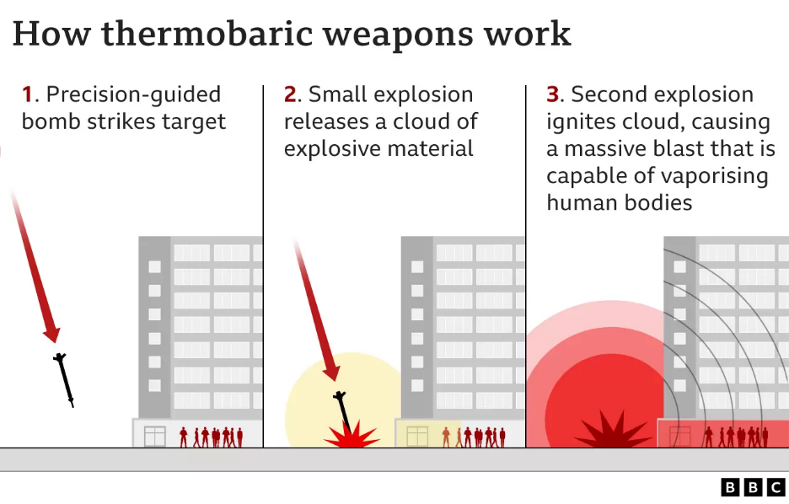
Figure 1, how thermobaric weapons work [1]

1.2 Blast Mechanics
During the detonation of an explosive, there is a quick release of energy and hot gases which occurs within milliseconds of initiation. As these gases expand, high temperatures and pressures are produced, as well as blast waves which propagate spherically from the source. [6]

Figure 3 shows a pressure-time curve for an ideal free-air burst explosion. On detonation, there is an instantaneous increase in pressure until the peak overpressure (Pso) is reached. The pressure then gradually decreases until a negative pressure is reached, and then the pressure eventually increases back to its ambient state. The positive impulse is noted as the area under the curve seen in the positive phase (to) of the graph. This is the opposite for the negative impulse, which is seen in the negative phase (to-). The impulse of a wave is a measure of the energy imparted into a building or structure, the formula for which can be seen in Figure 2. [6] [7]

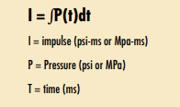
Figure 2, formula for impulse of a blast [8]
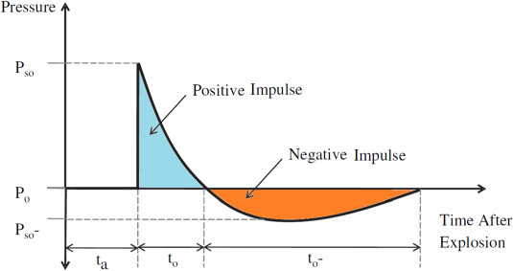
Figure 3, typical pressure-time curve for an ideal free-air burst explosion [7]

The positive phase of the blast wave has been found to be the most destructive towards structures. This is due to it having larger pressures over a shorter time, whilst the negative phase has lower pressures for an extended length of time. Fuel-air explosives usually have a lower peak overpressure than conventional explosives however, they have a greater positive impulse meaning they can be more damaging.

Figure 4 shows the three types of explosion / blast loading types: free-air bursts (a), air bursts (b) and surface bursts. A free-air burst occurs in the open air and the blast wave does not interact with the ground or any other obstacles before reaching the target structure. An air burst is similar however, the blast comes into contact with the ground and obstacles thus forming a Mach stem. A surface burst is initiated close to the ground, where the blast instantly interacts with the ground and moves outward spherically towards the target. [6]
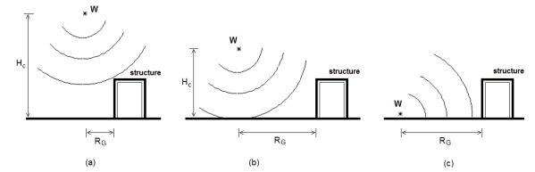
Figure 4, diagrams of a free-air burst, air burst and surface burst [6]
As mentioned earlier, an air blast has the potential to form what is called a Mach stem or Mach wave. This can occur when a reflected wave meets the initial blast wave at what is called the triple-point. Figure 5 shows the initial wave (purple) propagating outward spherically around the charge. The green waves are those which have been reflected from the ground, and eventually they catch up with the primary blast. The two waves combine to form a third, which is called the Mach stem. The point at which these three waves intersect is called the triple point. With distance, the triple point raises, and the Mach wave grows in height, though it remains constant throughout. The Mach stem pressure-time curve is similar to that seen in Figure 3 however, it has a larger overpressure than the incident wave and therefore carries more destructive power towards the target. [9]
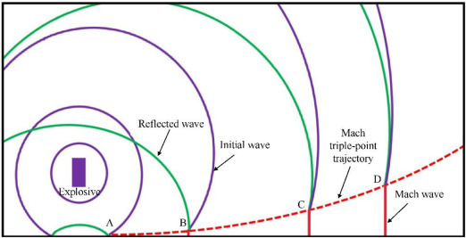
Figure 5, diagram of the formation of a Mach stem [9]
With regards to fuel-air explosives, using the technique of an air blast to produce a Mach stem may be useful. Thermobaric weapons have a high impulse, but low peak overpressure when compared to conventional explosives; by detonating the fuel cloud a defined distance above the ground, a Mach wave can be created and give the blast a better peak overpressure whilst keeping the high impulse.

Incidents within Industry
Although fuel-air explosions are mostly recognised in the military environment, there have been many incidents which have occurred unintentionally within the manufacturing and engineering industries. These events have been key in improving a wide range of production and storage processes for combustible goods across the globe, to provide better protection for workers.

2.1 Stars Engrg Pte Ltd, Singapore
One incident of an accidental dust explosion occurred in Stars Engrg’s Fire System manufacturing facility situated in Singapore, in February 2021. The event was caused by the ignition of a potato starch cloud which killed three people and injured a further seven. Reports state that there was an initial large explosion, followed by two smaller ones. Following this incident, the Minister of State for Manpower announced that the government has begun inspections on nearly 500 companies for potential dust explosion hazards. [10]

2.2 Al Solutions, Cumberland
Another accidental dust explosion occurred in the Al Solutions metal recycling facility, New Cumberland in December 2010. This event was the result of a metal dust explosion, caused by the combustion of air bourn zirconium and titanium particulate. Three people were killed in this accident, and one other person was injured. It is believed the initiation was due to metal-on-metal contact within the breakdown process. [11]
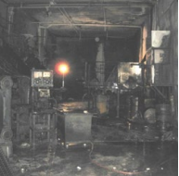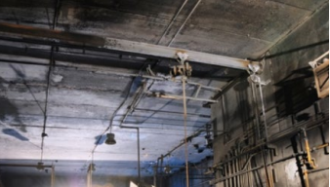
Figure 6, post-explosion damage to recycling facility [11]1

2.3 Nypro UK, Flixborough
One of the biggest incidents in the United Kingdom occurred in Flixborough, 1974. A large explosion at Nypro’s site killed 28 workers and injured a further 36. A large amount of cyclohexane leaked from a bypass pipe following its rupture and formed a large flammable vapour cloud. This cloud eventually found a source of ignition and a large vapour explosion occurred. The pipe which ruptured was a modification which was not fully assessed before continued use of the equipment. [12]
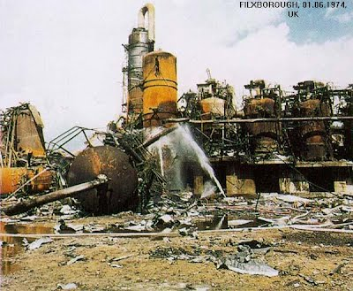
Figure 7, Nypro UK plant equipment following explosion

Historical and Current Applications in the Military Environment
Thermobaric weapons and vacuum bombs are rarely seen in the world’s military arsenals, they are only held by Russia, China, the United Kingdom, and the United States. Using a thermobaric weapon against a civilian population would break international humanitarian law however, this does not make the weapons completely unlawful. Fuel-air explosives have been used against terrorist organisations in the past and as a scare tactic to panic enemies.

3.1 CBU-55 and CBU-72
The CBU-55 and CBU-77 were cluster bombs first used by the United States Military during the Vietnam war. The CBU-55 model was 750lbs and consisted of 3 BLU-73 fuel-air explosive submunitions contained in a SUU-49 bomb system. The CBU-72 was similar in design but was 550lbs and was contained in the SUU-19 delivery system. The BLU-73 submunitions were 100lbs each and contained 75lbs of ethylene oxide, which were designed to burst at around 30ft from the ground.
The first use in Vietnam was estimated to have killed 250 soldiers by the immediate depletion of oxygen, after exploding in a fireball over 4 acres. After their initial use in the Vietnam war, the bombs were continued in use up until the Gulf war where the United States used them in Operation Desert Storm in Iraq. After this operation, the US Military removed all fuel-air explosives from service, and they had all been transferred for demilitarisation by 1996. [13] [14]
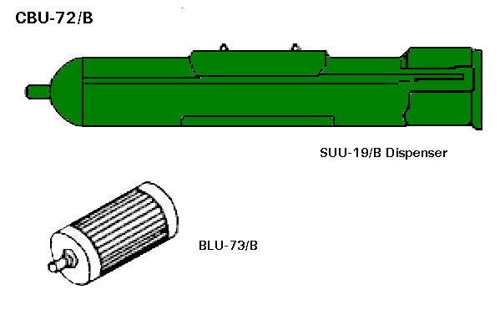
Figure 8, CBU-72 cluster bomb [13]

3.2 BLU-118/B Thermobaric Weapon
In 2001, it was first reported that US military had a new thermobaric warhead – the BLU-118B. The weapon was tested successfully in Nevada, December 2001 where it was using a guided bomb unit into a tunnel. The warhead is filled with an advanced thermobaric explosive, designed to penetrate, and produce higher sustained blast pressures (a greater positive impulse) in confined spaces. This allows the munition to perform its best in tunnels and buried structures. [15]
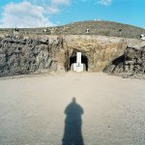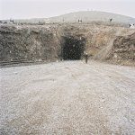
Figure 9, before and after photos of the tunnel

3.3 9M120F
First introduced in 2005, the 9M120F is a Russian anti-tank guided missile, which is a part of the Ataka family. It is an anti-personnel variant of the 9M120 tandem HEAT (High Explosive Anti-Tank) missile, the only difference being that it is fitted with a thermobaric warhead. It has an explosive power equivalent to 9.5kg TNT and was intended to be fired from the Shturm-V system from a maximum distance of 6km. The missile is designed to eliminate personnel in protected buildings, such as bunkers, as well as lightly armoured vehicles. [16]
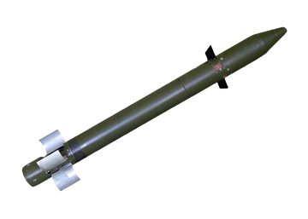
Figure 10, 9M120 and 9M120F Anti-tank missile [16]

Conclusions
Fuel-air explosives or thermobaric weapons can be a highly destructive weapon. They have devastating effects against structures and are extremely lethal in several ways. A fuel-air explosive weapon consists of a combustible liquid or dust, which is dispersed by a bursting charge and detonated by an igniter of some sort following a delay. The delay in the system allows the cloud of fuel to penetrate crack and openings, whilst achieving an adequate mixture with the surrounding oxygen. Thermobaric weapons have a much higher heat of detonation and blast impulse than conventional explosives however, it has lower peak overpressures on detonation meaning its brisance or shattering effect is also low. As this type of munition does not contain its own oxygen, it relies on the oxygen in its surroundings. As a result, the detonation depletes a large portion of air thus creating a vacuum and causing a rapid inrush of air.

Fuel-air explosives can be used in a number of different ways to defeat a range of targets. They are extremely effective against personnel; the high heats of detonation have the ability to vaporise people, whilst the impulse can cause severe internal damage to the body. Furthermore, if a person isn’t eliminated by these, they will likely be killed by the asphyxiation caused by the vacuum or possibly flying debris / fragmentation. The brutality of this weapon against a person has resulted in international laws forbidding the use of them against civilian populations.

Thermobaric weapons have been proven to be particularly effective against structures and tunnel systems; the fact that the vapour cloud can penetrate unsealed locations and produce a blast wave with a high impulse on detonation means that it great for destroying buildings. In addition, the explosion will suck the oxygen out of the target allowing for easy defeat of enemies. However, they may not be useful when pursuing sealed armoured targets. The low brisance and shattering effect of a fuel-air explosive means that it will have difficulty penetrating something with a thick, solid outer surface.
Fuel-air explosives have been known to be used clearing minefields and counter mobility obstacles; due to the large area covered by this type of explosion, it can easily unearth and possibly detonate any mines or traps on the battlefield. This can be very useful for soldiers on the ground.

Overall, fuel-air explosives are a versatile weapon that can be used to defeat a number of targets. Despite being banned by international law for use against civilian populations, they are still held by several world powers for their potential use in conflict. The blast effects on personnel and structures can be highly destructive, especially when used in the correct manner.

5. References

[1] | BBC News, “What is a thermobaric or vacuum bomb?,” BBC, 10 March 2022. [Online]. Available: https://www.bbc.co.uk/news/business-60571395. [Accessed 16 November 2022].
[2] | Ministry of Defence, “JSP 333 Service Textbook of Explosives,” Ministry of Defence, 2020.
[3] | Bureau of Alcohol, Tobacco and Firearms, “Modular Explosives Training Program - Instructor Glossary,” National Institute of Justice, Washington DC, 1976.
[4] | Action On Armed Violence, “What is a thermobaric bomb?,” Action On Armed Violence, 1 March 2022. [Online]. Available: https://aoav.org.uk/2022/what-is-a-thermobaric-or-vacuum-bomb/. [Accessed 22 November 2022].
[5] | A. A. Rao, “Fuel Air Explosives,” Explosives Research & Development Laboratory, Pune, 1987.
[6] | V. Karlos and G. Solomos, “Calculation of Blast Loads for Application to Structural Components,” Joint Research Centre, 2013.
[7] | C. Zhang, G. Gholipour and A. A. Mousavi, “Blast loads induced responses of RC structural members: State-of-the-art review,” School of Civil Engineering, Qingdao University of Technology, China, 2020.
[8] | Federal Emergency Management Agency, “Reference Manual to Mitigate Potential Terrorist Attacks Against Buildings,” FEMA, 2003.
[9] | W.-L. Xu, C. Wang, J.-m. Yuan, W.-l. Goh and T. Li, “Investigation on energy output structure of explosives near-ground explosion,” KeAi Chinese Roots Global Impact, 2020.
[10] | Dust Safety Science, “Explosion at Singapore Fire System Manufacturer Kills Three Workers,” Dust Safety Science, 10 March 2021. [Online]. Available: https://dustsafetyscience.com/potato-starch-explosion-tuas-singapore/. [Accessed 16 November 2022].
[11] | U.S. Chemical Safety and Hazard Investigation Board, “AL Solutions, Inc., New Cumberland, WV Metal Dust Explosion and Fire,” U.S. Chemical Safety and Hazard Investigation Board, 2014.
[12] | Health and Safety Executive, “Flixborough (Nypro UK) Explosion 1st June 1974,” Health and Safety Executive, [Online]. Available: https://www.hse.gov.uk/comah/sragtech/caseflixboroug74.htm.
[13] | GlobalSecurity.org, “CBU-72 / BLU-73/B Fuel/Air Explosive (FAE),” GlobalSecurity.org, 7 July 2011. [Online]. Available: https://www.globalsecurity.org/military/systems/munitions/cbu-72.htm. [Accessed 23 November 2022].
[14] | Military Wiki, “CBU-55,” Military Wiki, 19 October 2022. [Online]. Available: https://military-history.fandom.com/wiki/CBU-55. [Accessed 23 November 2022].
[15] | GlobalSecurity.org, “BLU-118/B Thermobaric Weapon,” GlobalSecurity.org, 27 August 2013. [Online]. Available: https://www.globalsecurity.org/military/systems/munitions/blu-118.htm.
[16] | Deagel, “Ataka,” Deagel, [Online]. Available: https://www.deagel.com/Defensive%20Weapons/Ataka/a001006. [Accessed 23 November 2022].

