
IWD: Database
Module Name: Computer Architecture Operating System
Module Code: (ACCA 4022)

Student Name: Mohammad Shah poor Girowal
Student ID: 2435988
Group: 3

Lecturer’s Name: Suresh Shanmugasundaram

18-11-2025
]
Date
[

Design and Development
Assignment 01
Suneth Fernando
[COMPANY NAME]

Table of content

Introduction to the case study
EcoRide – An Electric Bike Rental Scheme
The local authority has recently launched a green transport initiative called Eco_Ride - an electric bike rental service available across several public locations like parks, train stations, and university campuses. The aim is to make commuting greener and healthier. Riders can scan their ID at a rental point, take a bike, and return it to any Eco_Ride station nearby. While the service is growing in popularity, the management team is facing challenges in handling operations due to its current reliance on paper forms and basic spreadsheets. Rider details and rental transactions are recorded manually, while bike maintenance needs are tracked informally. This results in limited visibility of which bikes are available, currently in use, or undergoing repairs. Consequently, the system experiences occasional double-bookings and unreturned bikes, making it difficult to produce accurate summaries or analyse overall service usage effectively. You have been approached to design and implement a structured database solution that can streamline the operations of this scheme. The solution should enable the team to: • Register riders by storing essential details such as their name, contact information, and ID numbers. • Maintain records of all electric bikes, including their type, condition, location, maintenance history and other related details. • Record bike rental transactions, including rental and return dates, duration, cost and any other related details. • Track staff involvement, including who serviced or inspected each bike Design a database system that meets the functional requirements which includes the design and modelling of system components, implementation of core features, and demonstration of its practical use with sample data.

Entity Relationship Diagram (ERD):
Take a screenshot of your ER- Diagram and Paste it here Type of Relationship between Entities (please explain each relationship with appropriate examples from the case study.)
One – to – One
A One-to-One relationship means each record in first Table is linked to only one record in second Table , and each record in Table second is linked to only one record in first Table.

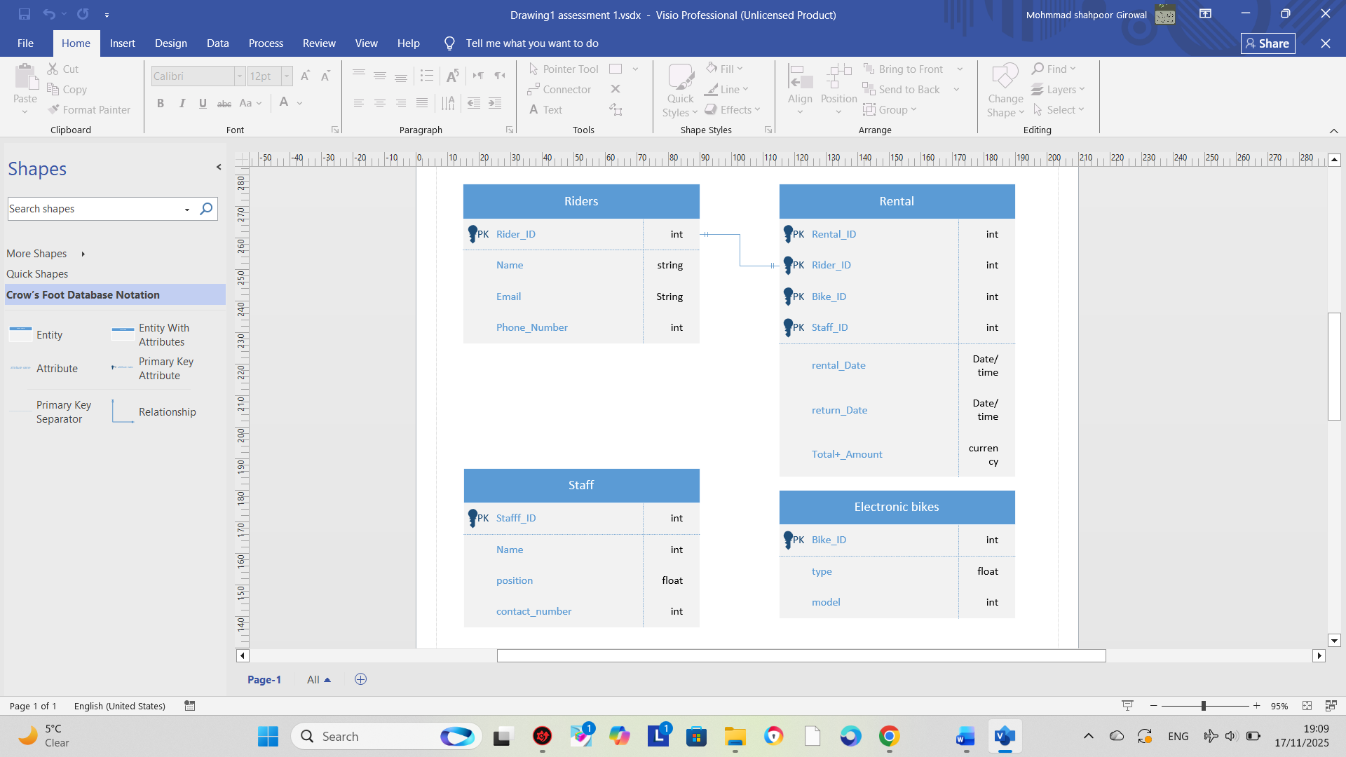

One – to – Many
One record in first Table can be linked to many records in second Table,
but each record in second Table is linked to only one record in first Table.
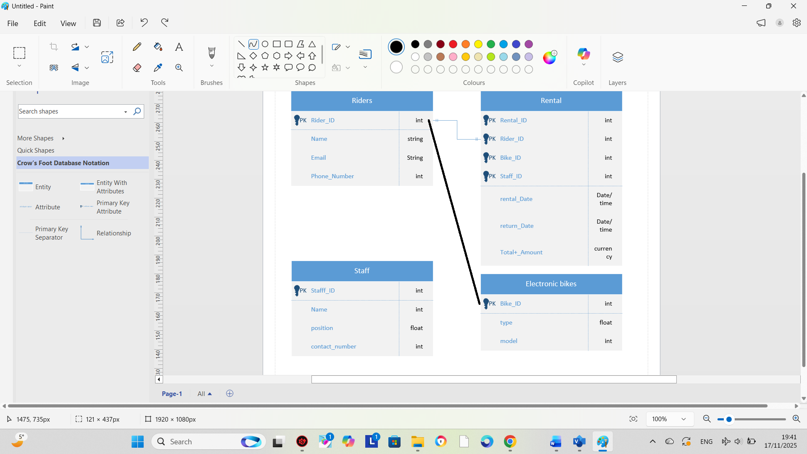

Many – to – Many
A many-to-many relationship means:
One record in first Table can link to many records in second Table,
AND
One record in second Table can link to many records in first Table.
So both sides can have multiple matches.
We can also say define it like:
A many-to-many relationship is when one record in the first table can relate to many records in the second table, and one record in the second table can relate to many records in the first table. It requires a linking table in a relational database.

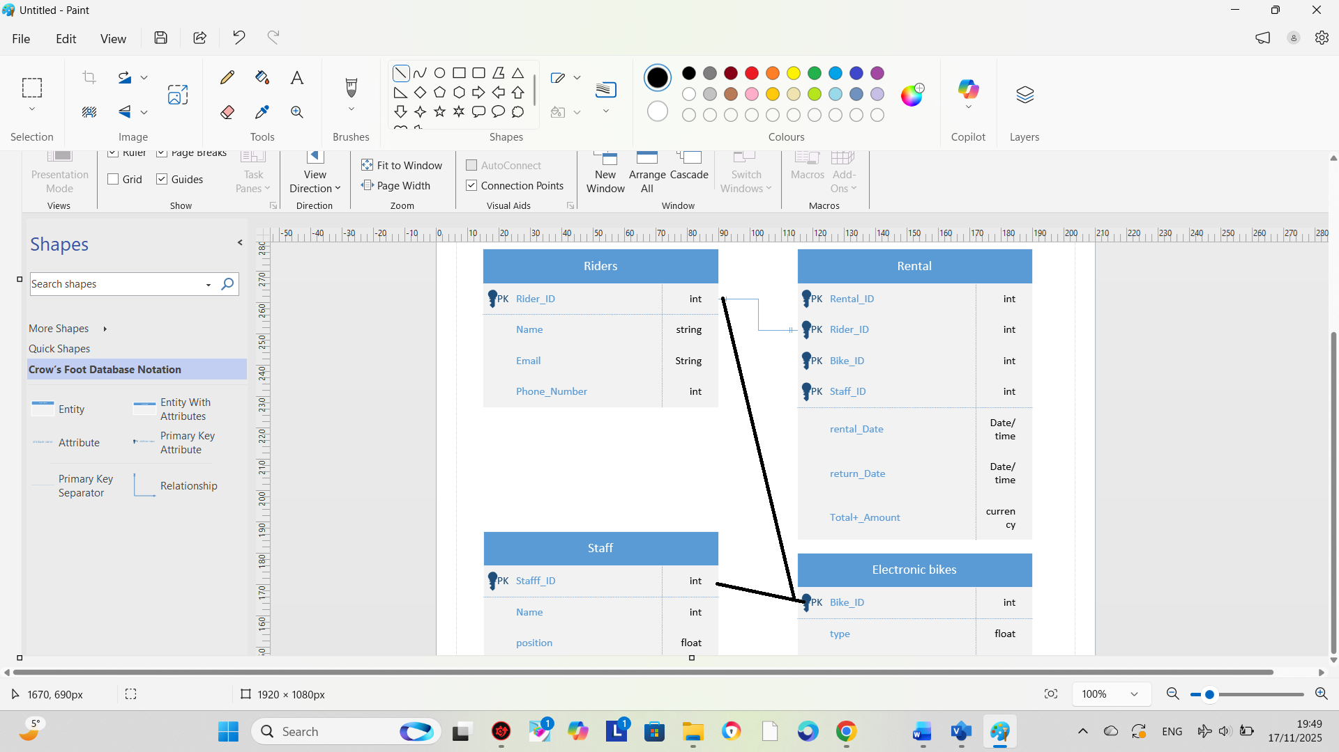

Entities interact within the database
Explain how ER modelling helps you when developing your database solution

ER modelling helps by giving a clear visual design of entities and their relationships before building the database. It improves understanding, reduces errors, organizes data properly, supports correct key relationships, makes communication easier, and leads to a more efficient and accurate database structure.

Logical Design
Table Creation in MS – Access (take screenshots of each table (Datasheet view and design view) and paste it here and annotate each screenshot. Customer Details table (Design view and datasheet view)

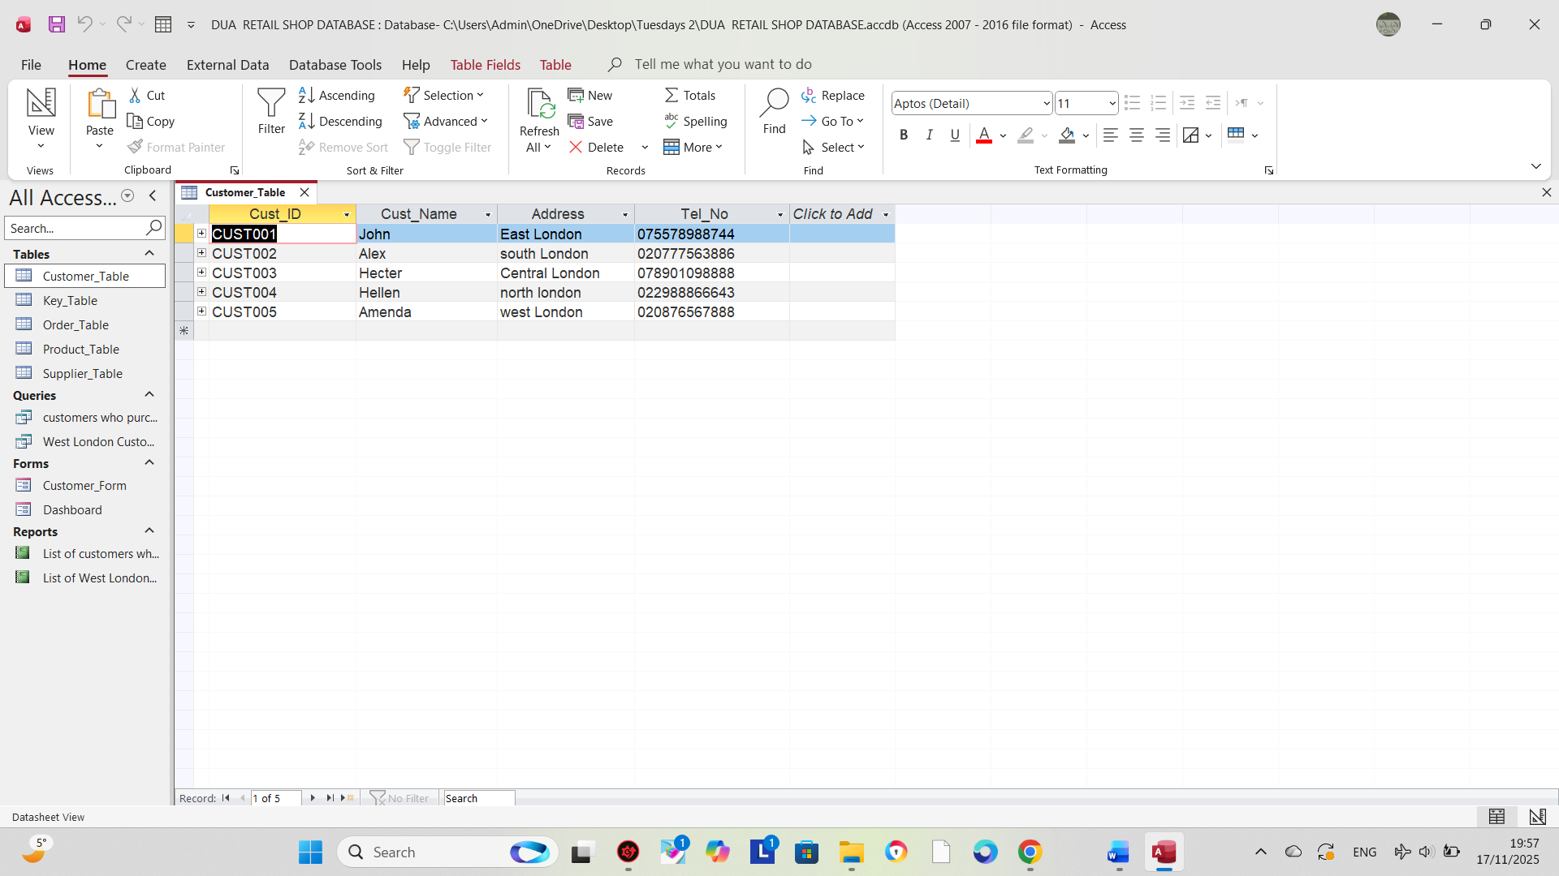

Relationships between tables
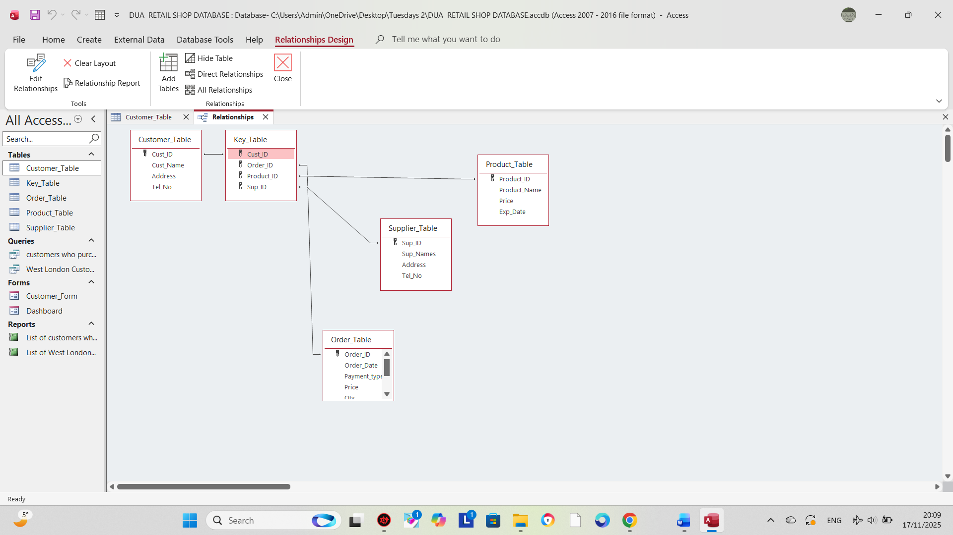
Explain what type of key attributes (each table) used to create relationships between tables.
In this database, each table uses a Primary Key (PK) to uniquely identify its records, and these keys are used as Foreign Keys (FK) in the Key_Table to create relationships.
Customer_Table uses Cust_ID (PK), which becomes a foreign key in Key_Table to link customers to their orders.
Product_Table uses Product_ID (PK), which is added as a foreign key in Key_Table to link products to orders.
Supplier_Table uses Sup_ID (PK), which appears as a foreign key in Key_Table to show which supplier is associated with each product or order.
Order_Table uses Order_ID (PK), and this key is also stored in the Key_Table as a foreign key to connect orders with customers, products, and suppliers.
Key_Table contains four foreign keys (Cust_ID, Order_ID, Product_ID, Sup_ID), and it acts as a junction table, enabling relationships between all other tables.

Testing and Validation
Requirements of the case study
- Manage an inventory : in this case a table called, “product” has been designed and developed to maintain inventory of all the products.
- Customer Information : A table called "Customer” has been designed and developed……..

Test Cases | Expected Results | Actual Results | Any Discrepancies
Manage an Inventory | It is expected to manage an  inventory for all the products of the shop | A table has been design and developed to maintain an inventory of the products. | No
Customer Information |  | A Customer_Table has been created with fields like Cust_ID, Cust_Name, Address, and Tel_No to store customer information. | No
  It is expected to store customer personal details in the system.
Supplier Information | The system should store supplier details for all products. | A Supplier_Table has been developed with Sup_ID, Sup_Names, Address, and Tel_No. | No
Order Management | The system should store order details including order date, payment type, price, and quantity. | An Order_Table has been created with all required fields to manage customer orders. | No
Data Integrity | The system should prevent duplicate or invalid data entries. | Primary Keys and relationships have been implemented correctly, ensuring data integrity. | No

Normalization Process
Take screenshots of 3rd Normal form from MS-Excel and Paste here and annotate each table.

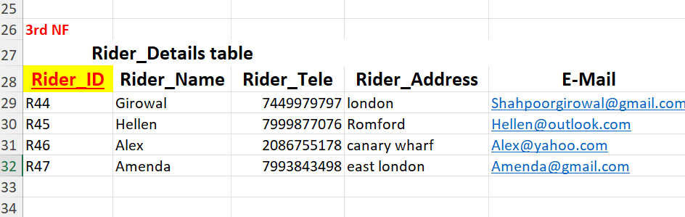

The Rider_Details table is in 3rd Normal Form because the primary key (Rider_ID) uniquely identifies each rider, all other attributes depend fully on Rider_ID, and there are no transitive dependencies between non-key attributes.

MS- Access

Forms Creation (take screenshots of all the forms and annotate them)

Microsoft Access is a database management system (DBMS) from Microsoft that combines the relational Access Database Engine (ACE) with a graphical user interface and software-development tools. It is part of the Microsoft 365 suite of applications, included in the Professional and higher editions or sold separately.
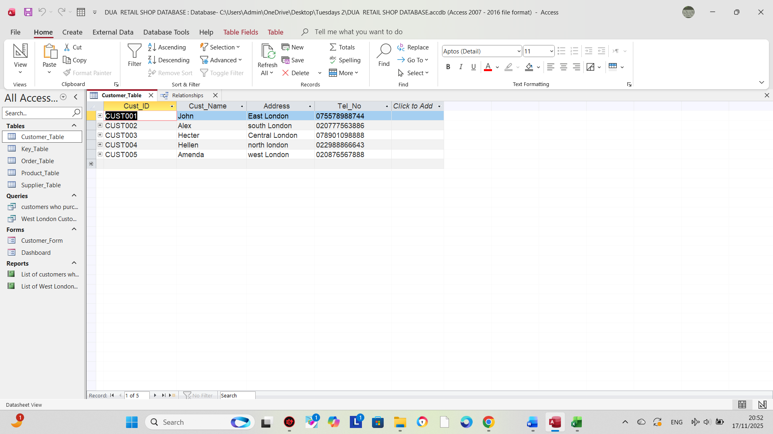
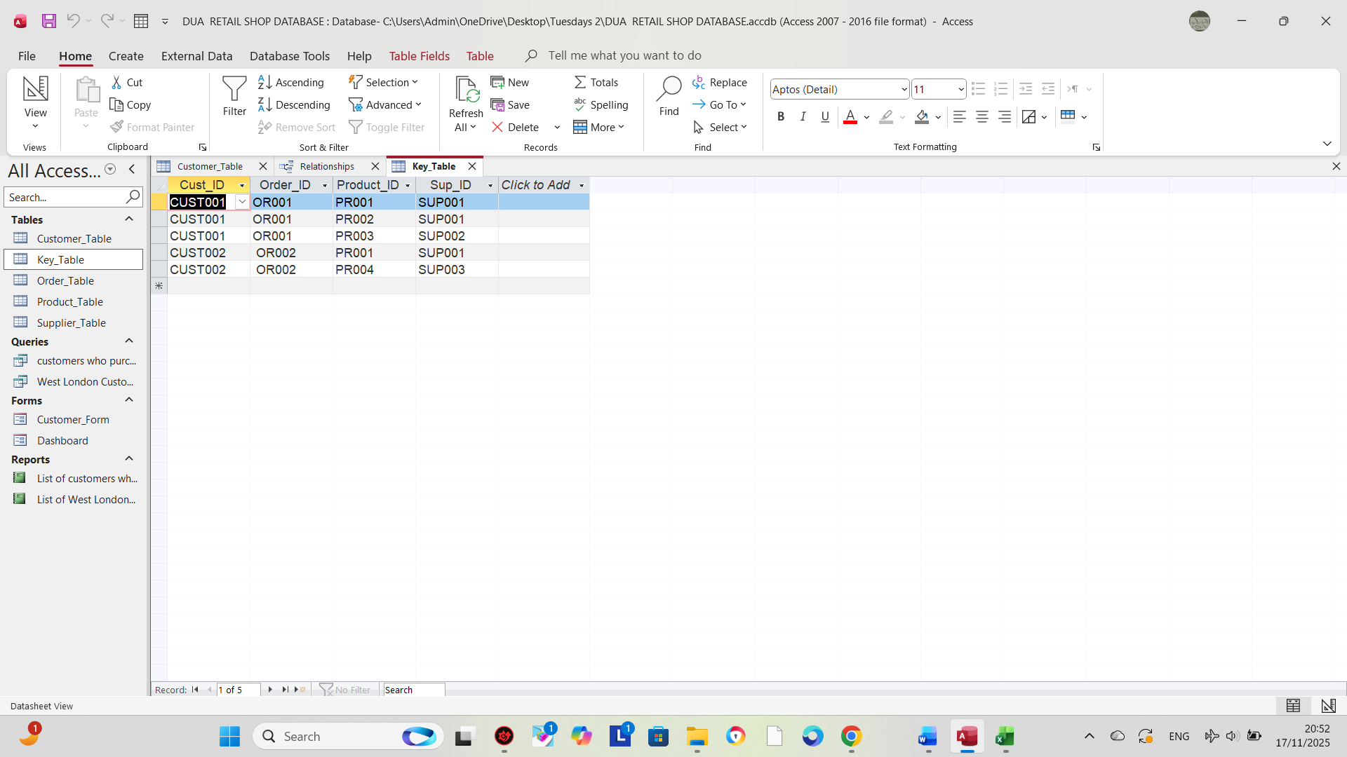
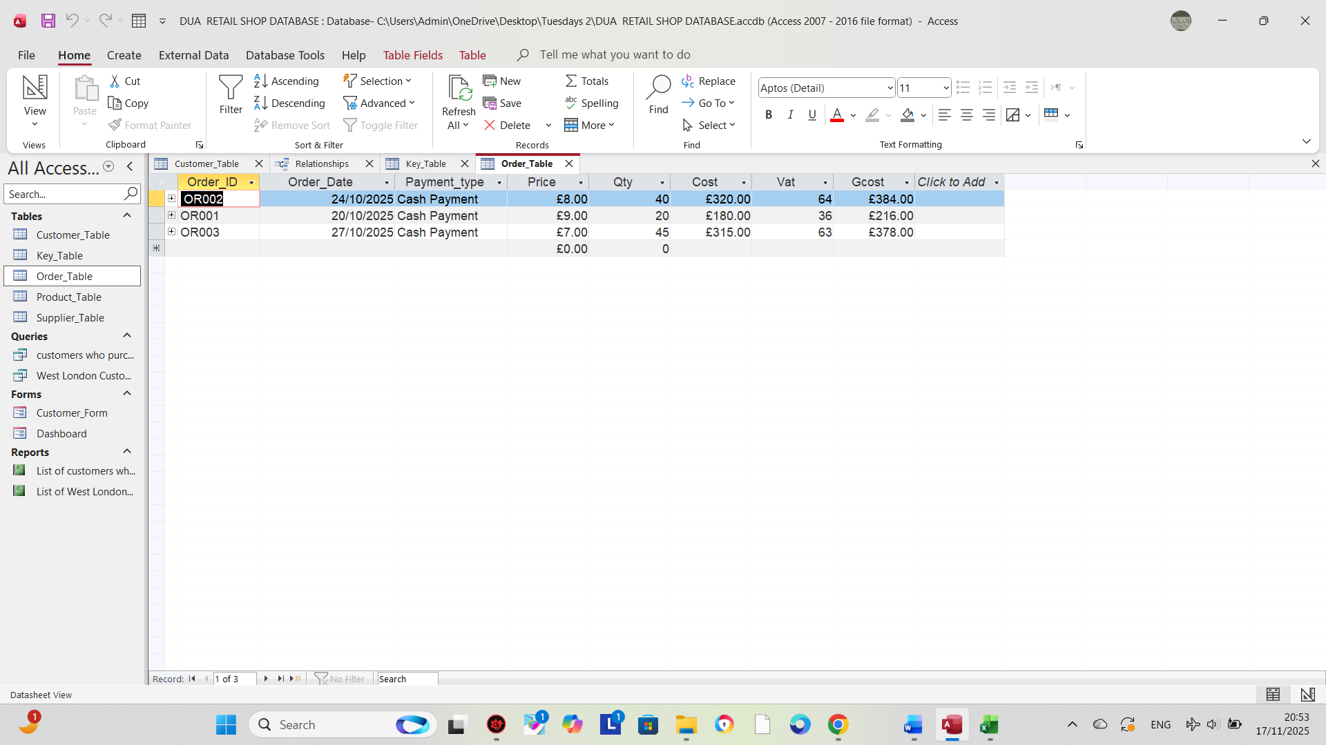
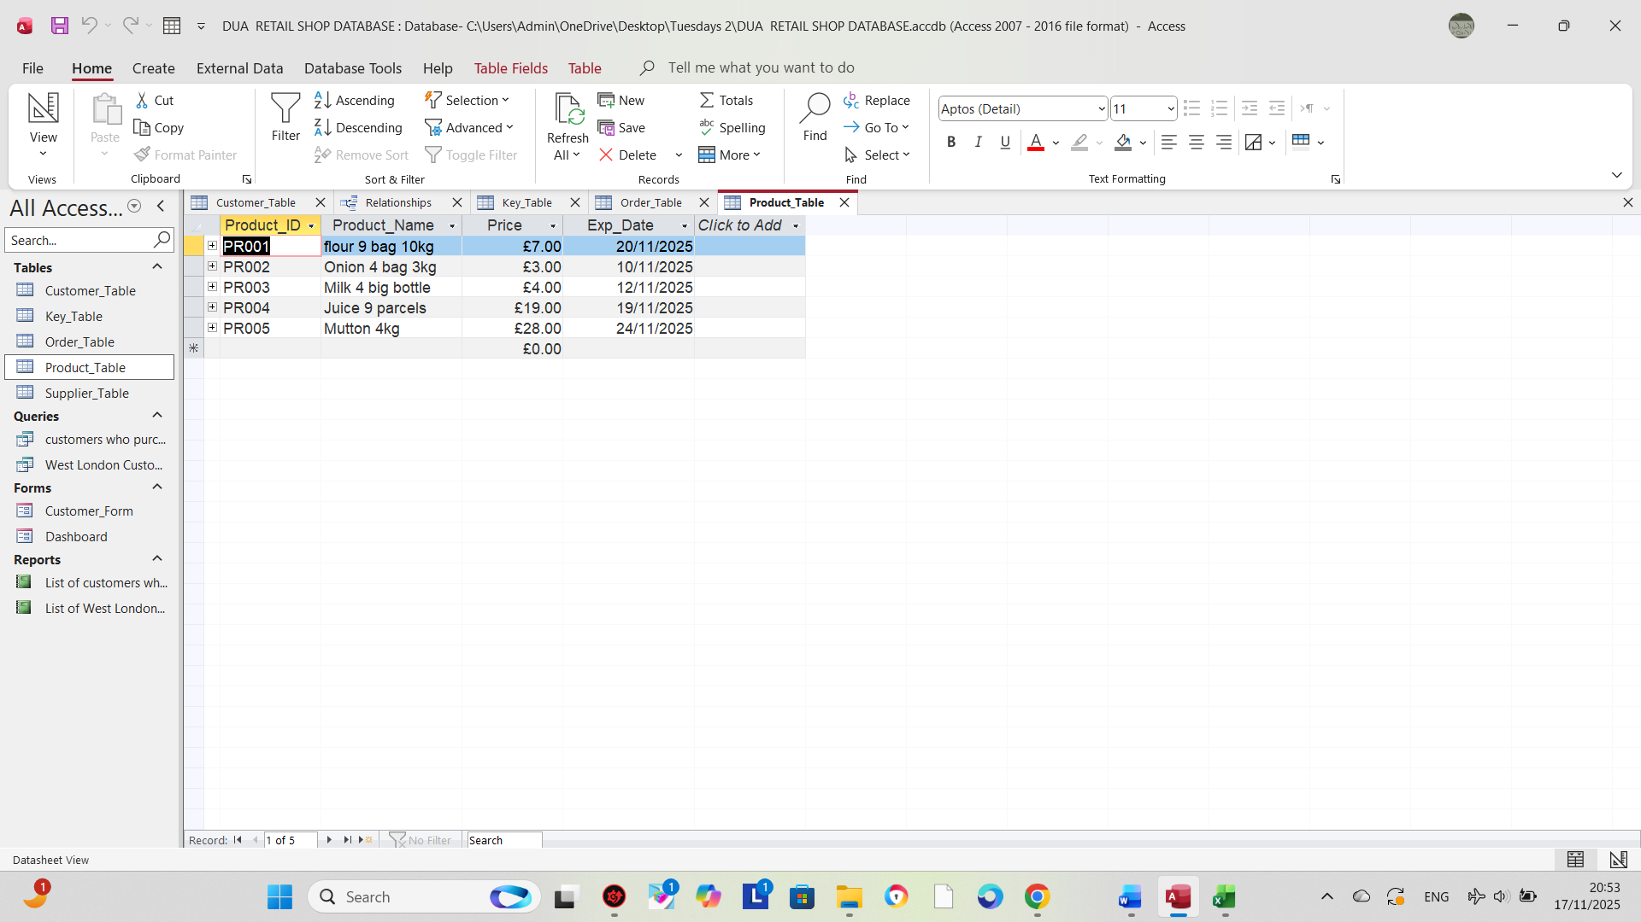

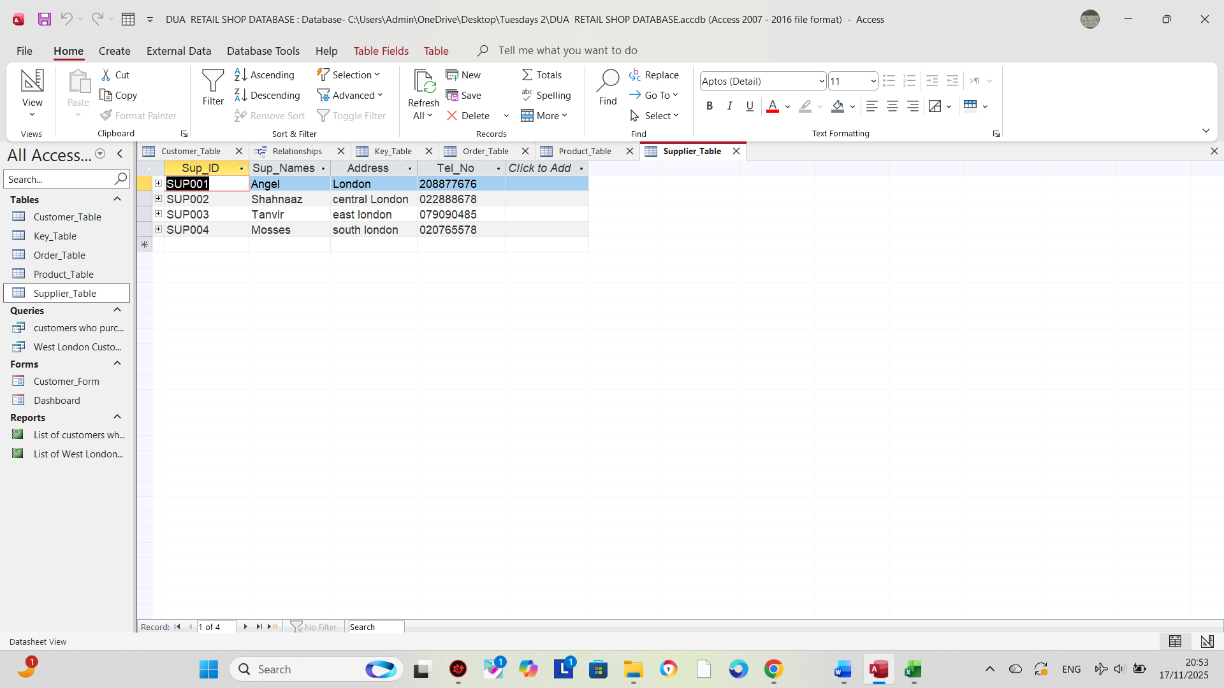

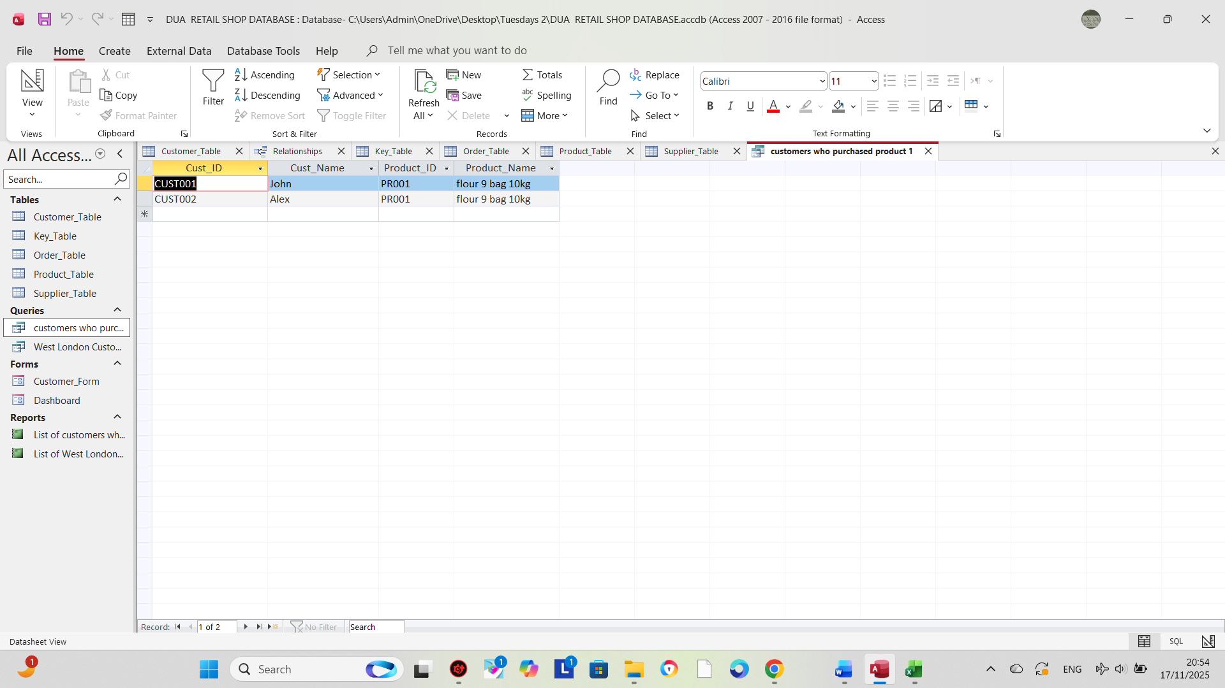

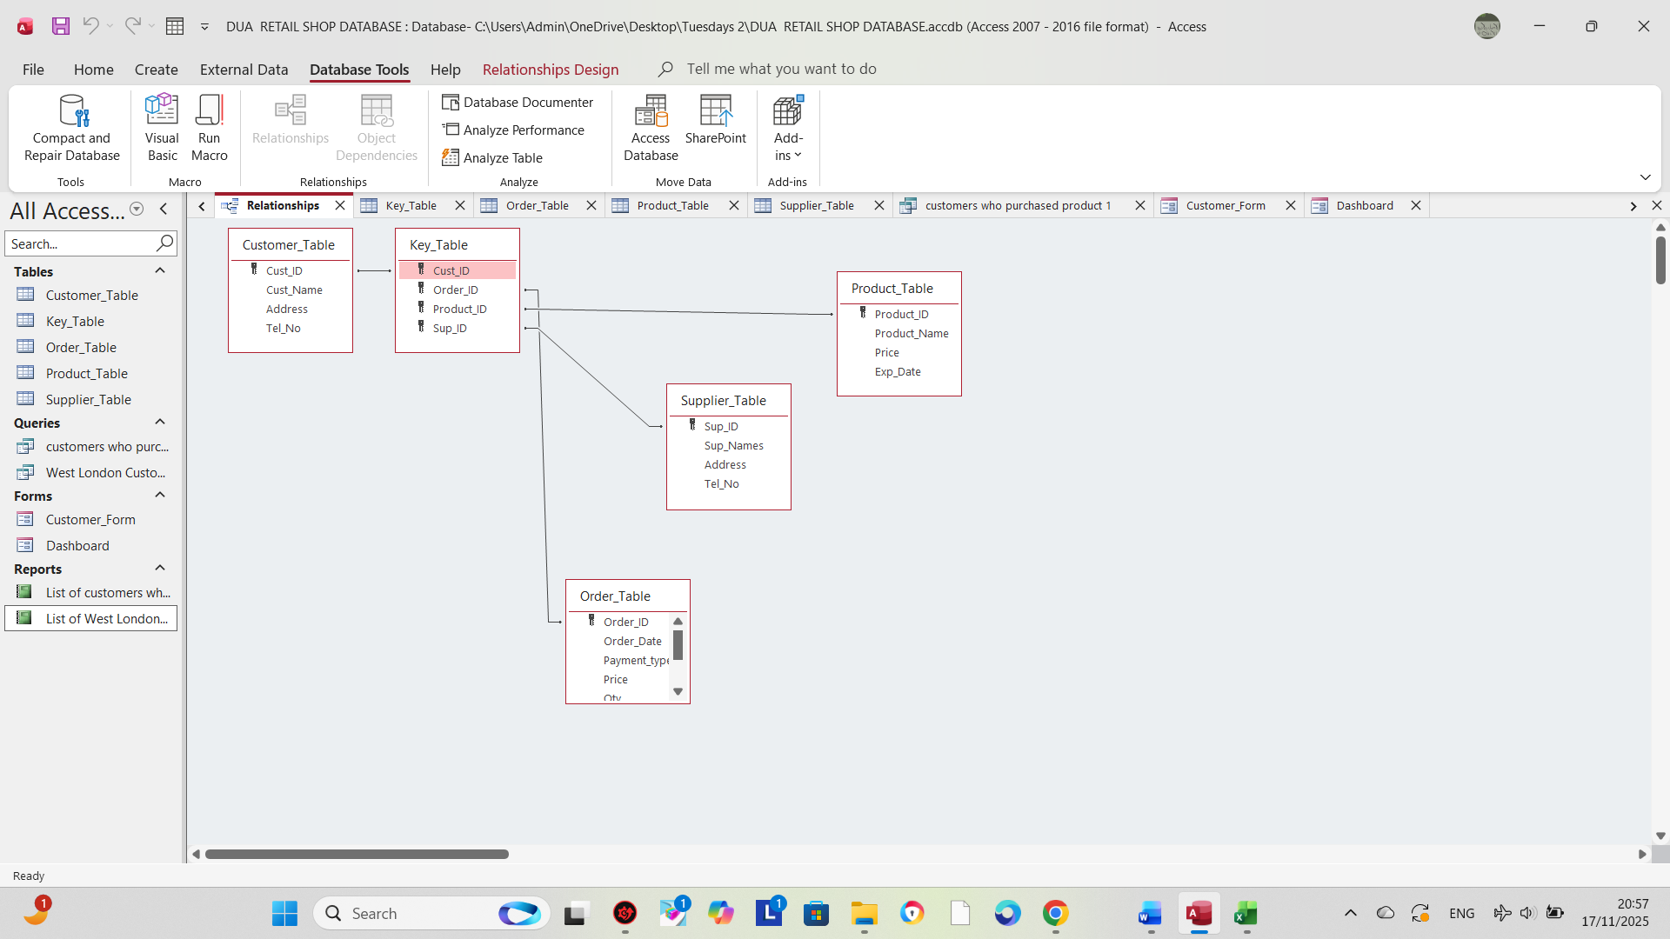

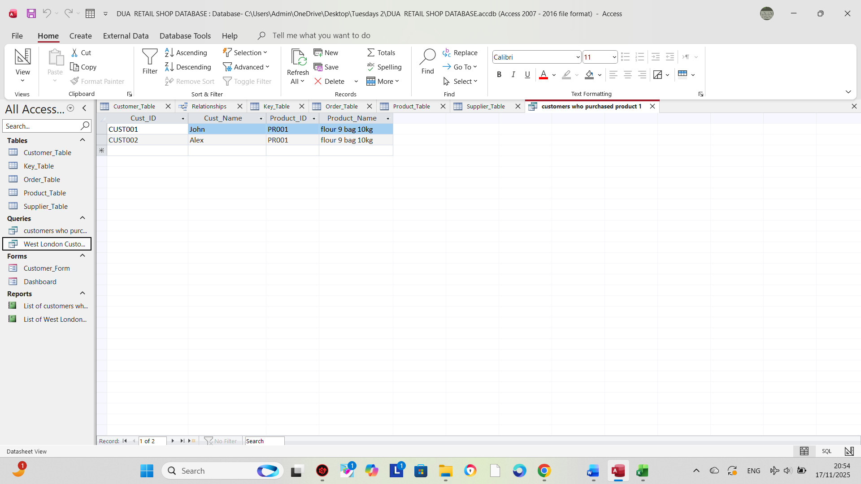

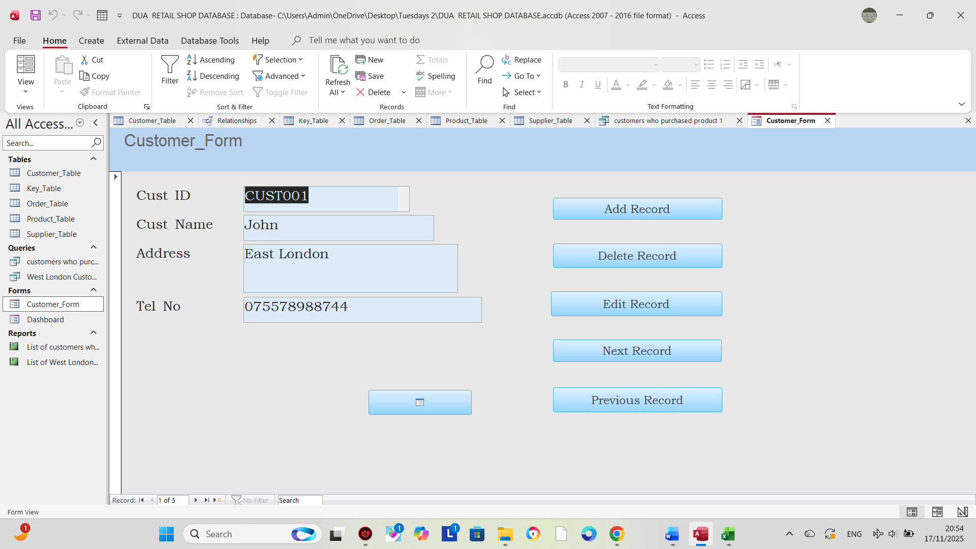
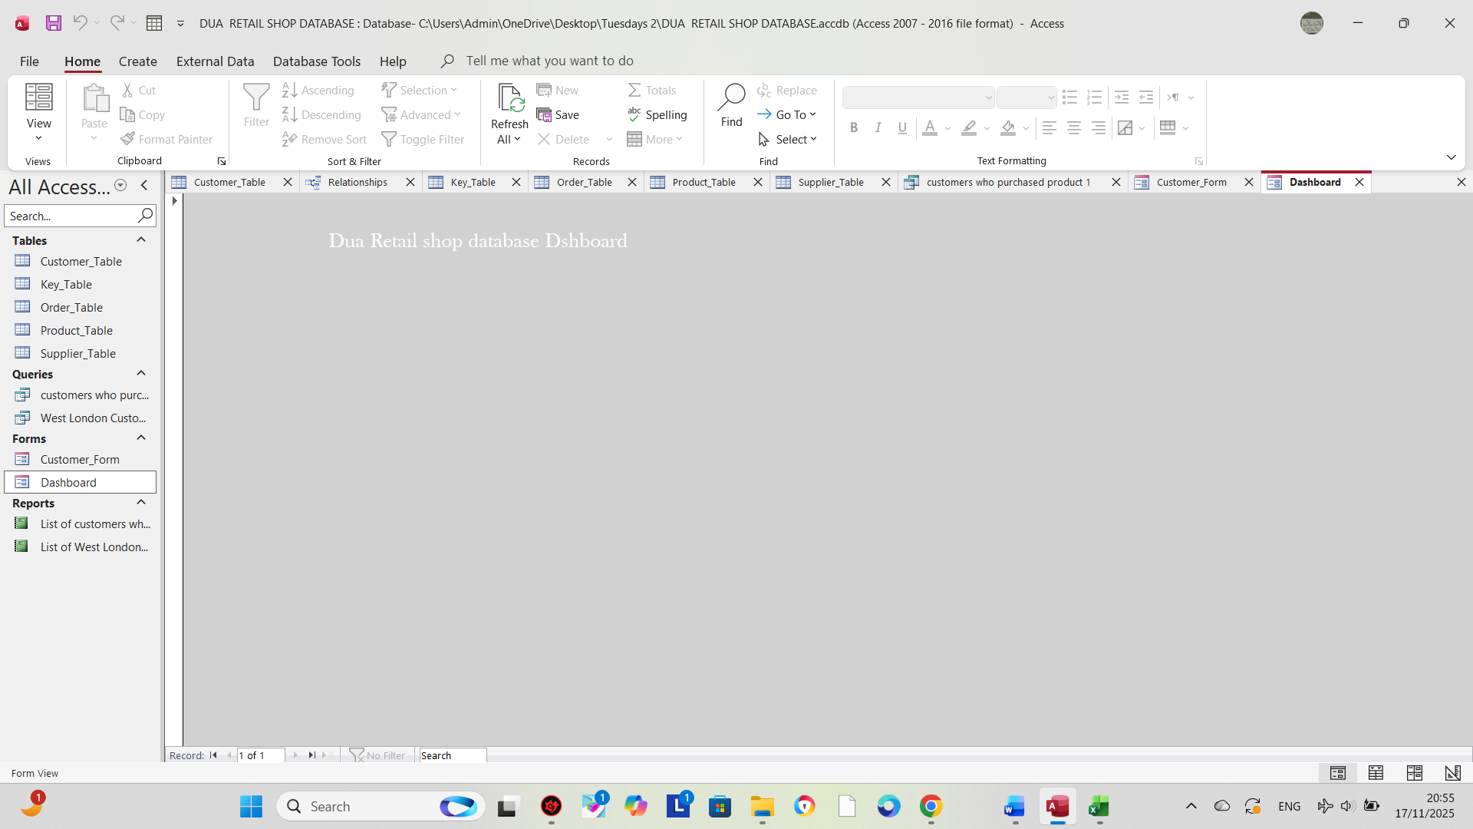

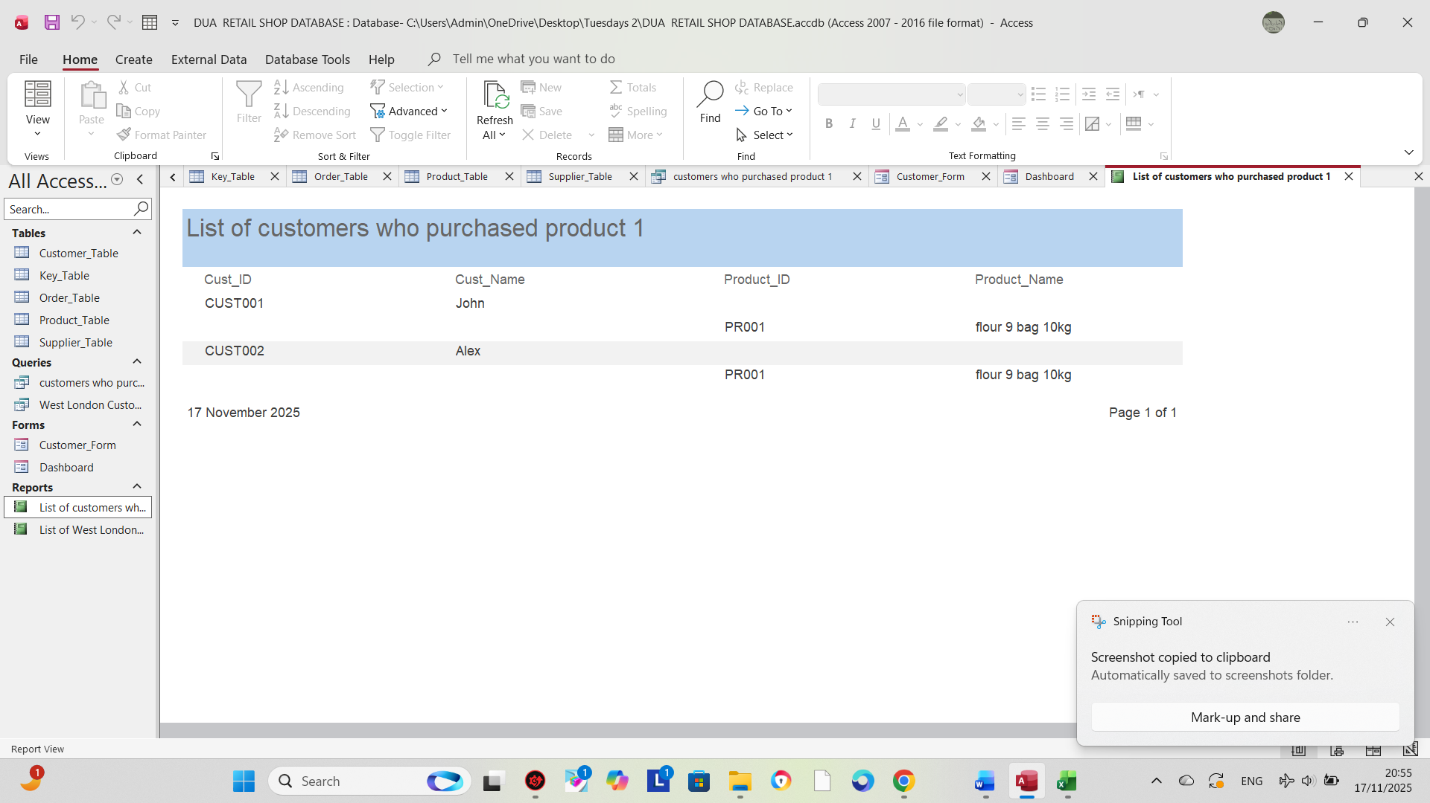

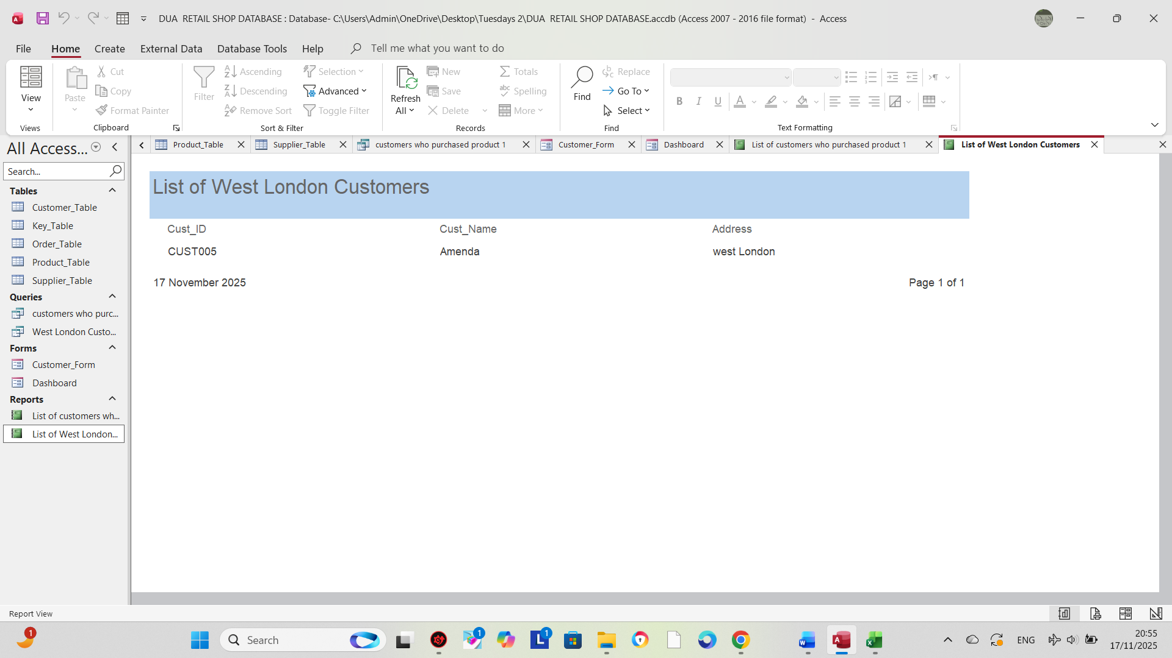

This table is designed in Microsoft Access with a primary key to uniquely identify each record. All fields are clearly defined with appropriate data types, and the table structure supports relationships with other tables in the database.

Queries Creation (take screenshots of the design view, datasheet view and SQL view of each query and annotate them)
Based on your critical thinking, create at least two – three queries
SQL view
SELECT
Customer_Details.Cust_ID,
Customer_Details.Name,
Customer_Details.Address
FROM
Customer_Details
WHERE
(((Customer_Details.Address) = "East London"));
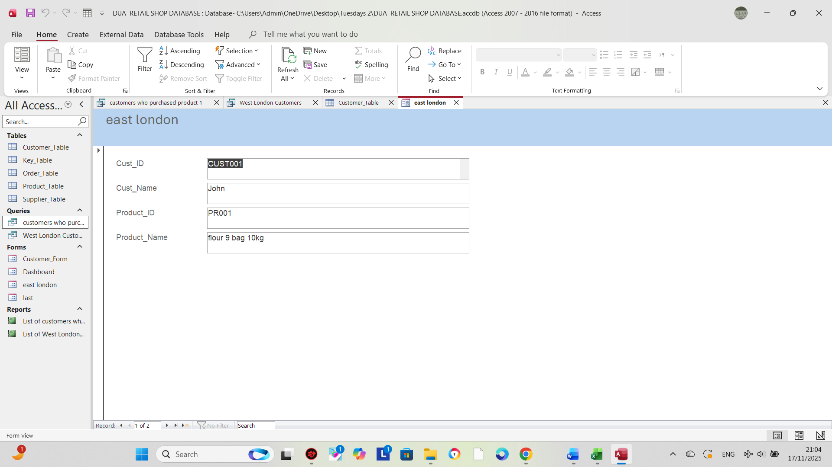

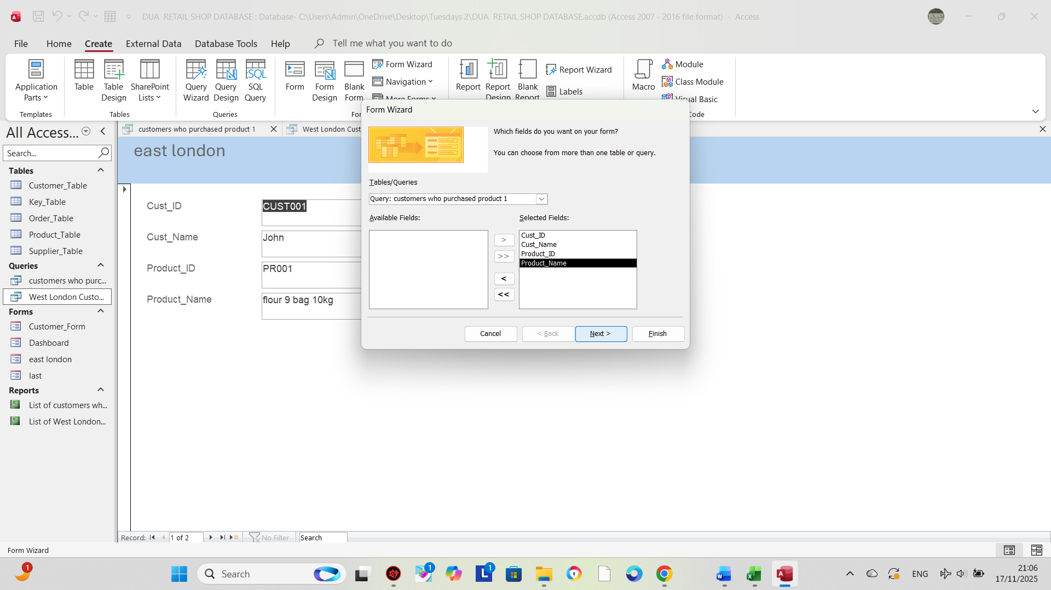

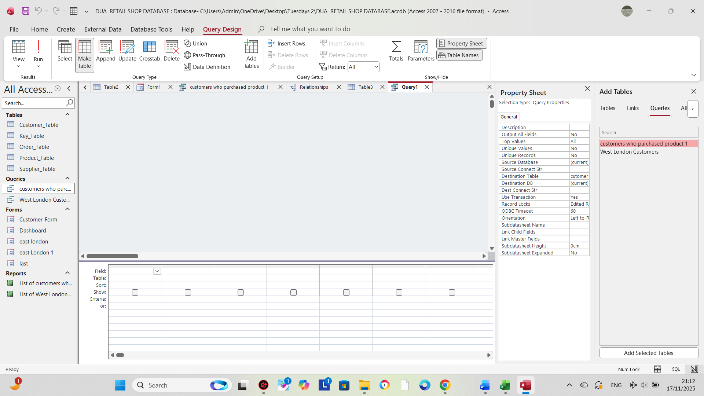

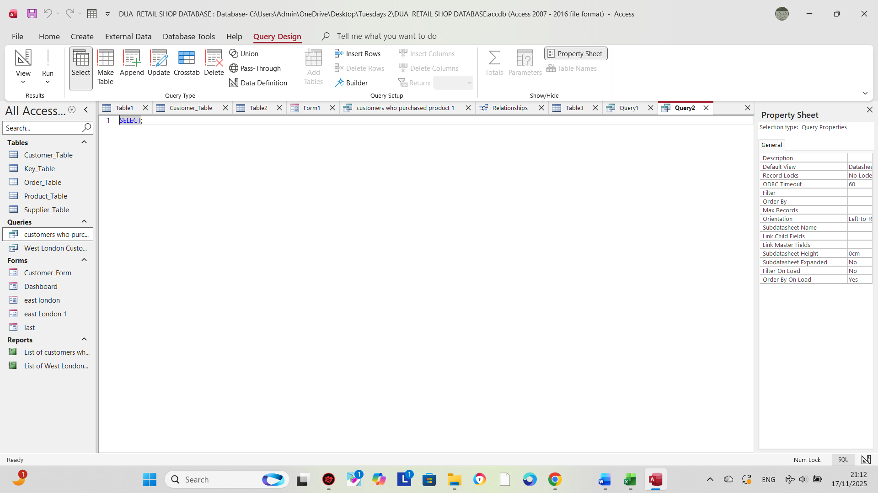

Design View Annotation
The Design View shows the fields selected from the Customer_Details table (Cust_ID, Name, Address) and the criteria set under the Address field. The criteria ‘East London’ filters the query so that only customers who live in East London are returned. This view allows easy editing of fields and conditions.
Datasheet View Annotation
The Datasheet View displays the results of the query. Only customers whose Address equals ‘East London’ appear in the output. This confirms that the query is working correctly and returns the expected filtered records.
SQL View Annotation
This SQL statement selects the customer ID, name, and address from the Customer_Details table and filters the results to only show customers who live in ‘East London’.
Report Creation (create reports from each query and annotate them)

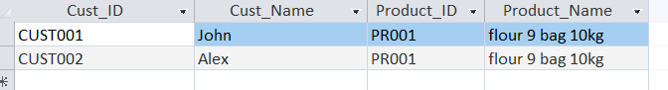
Datasheet view showing the customers matched with the product they purchased.
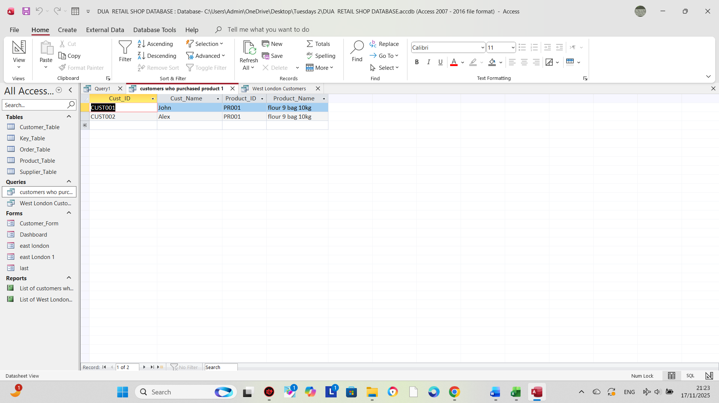

Calculations (show how you implement calculation ( if any) and take screenshots)

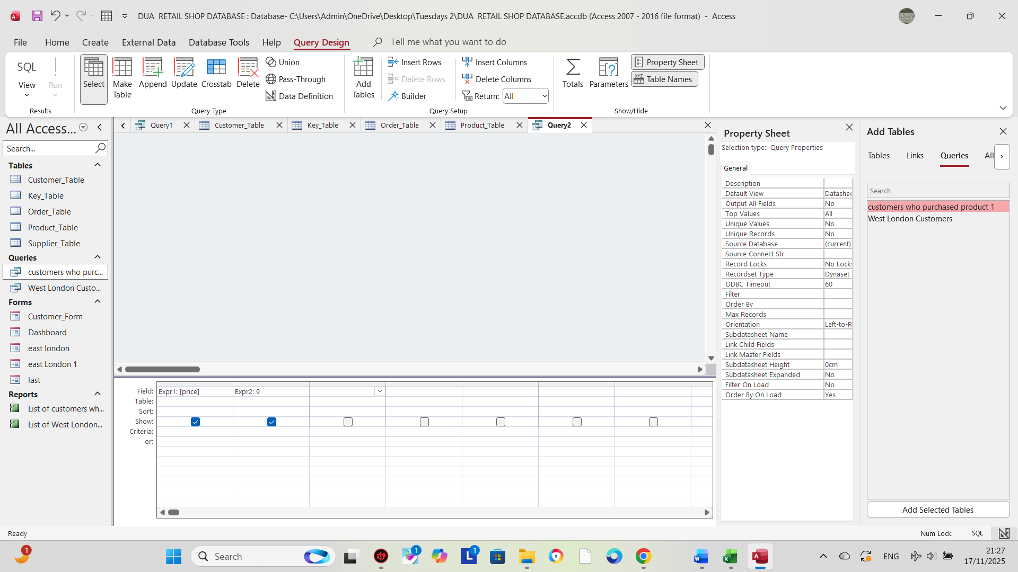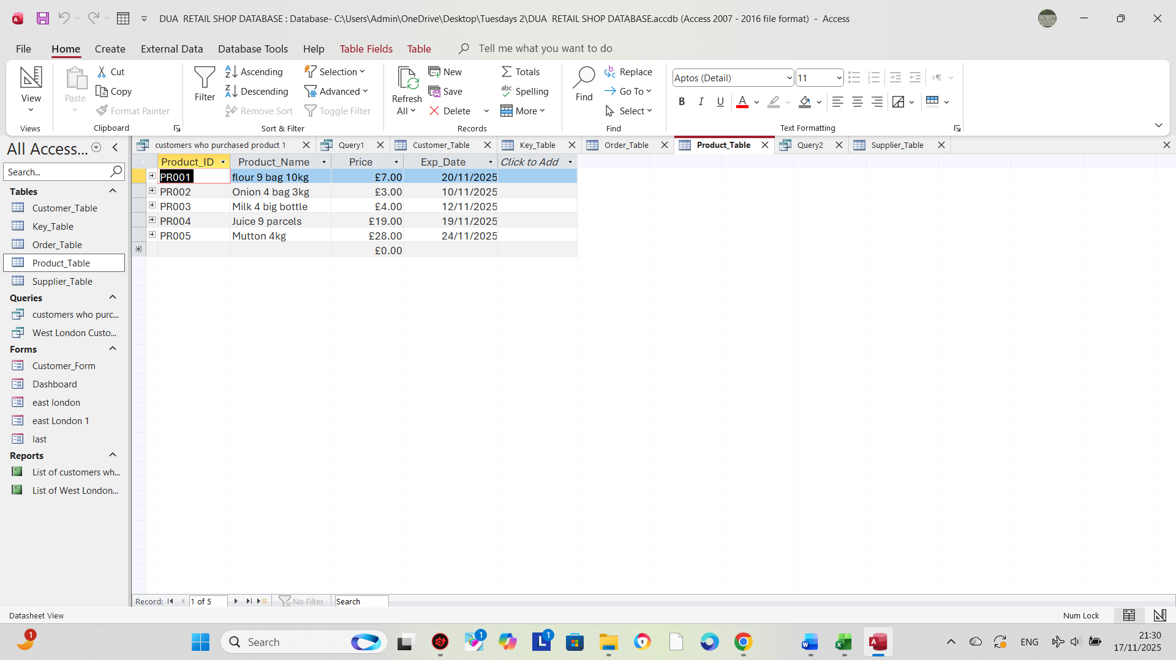

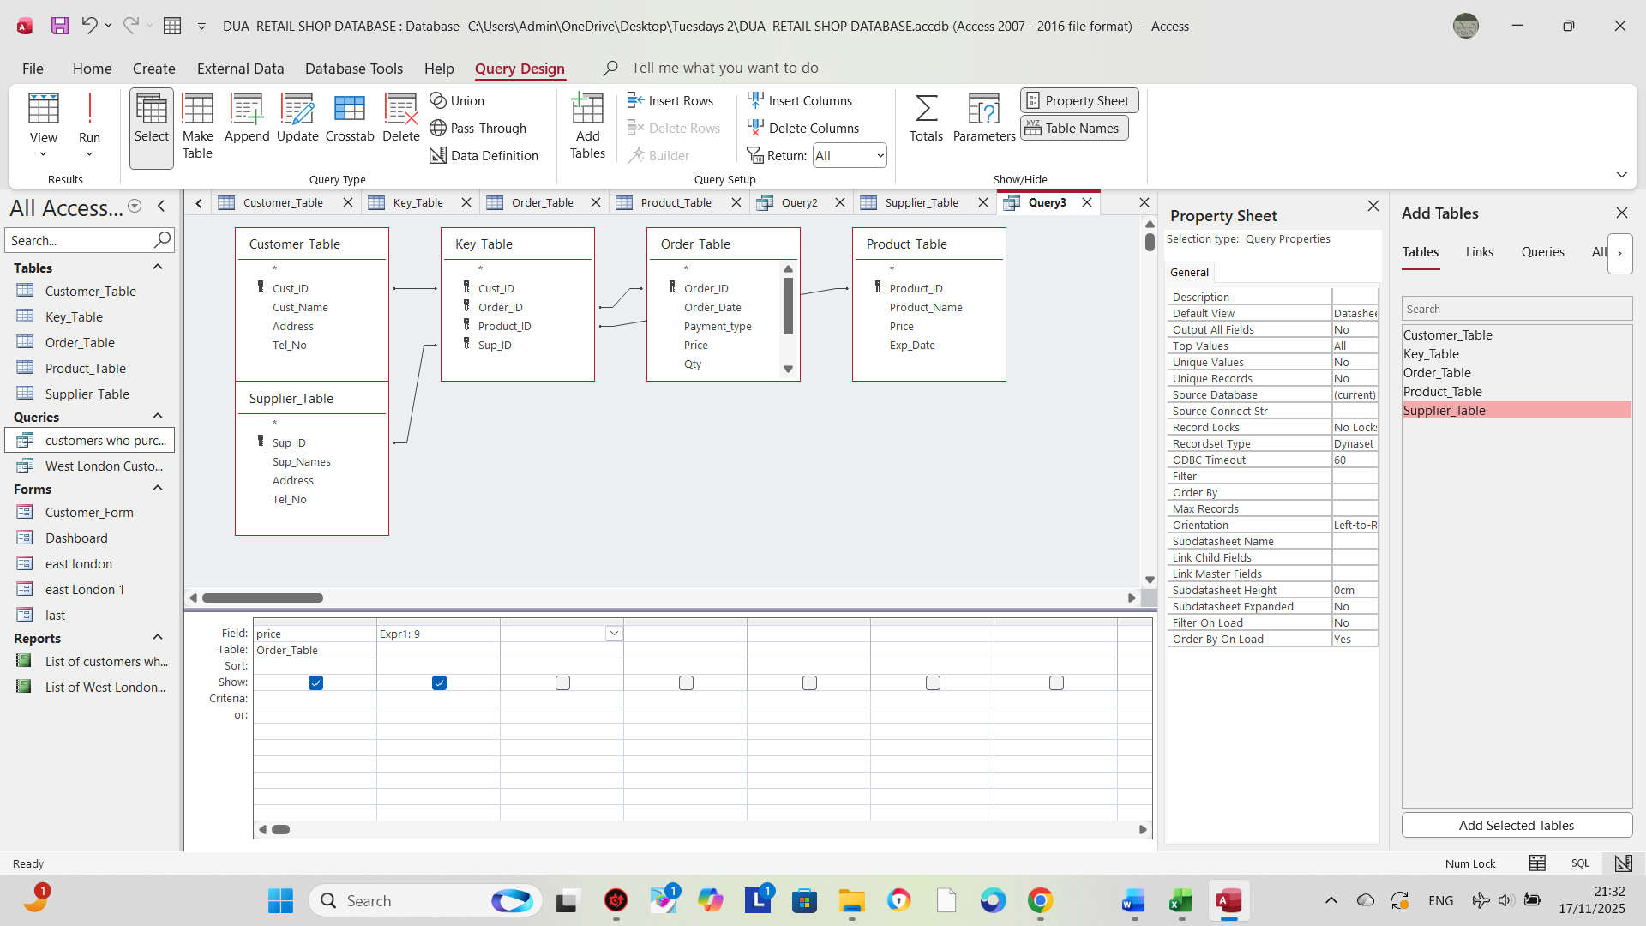

Calculation Annotation (Short Explanation)
This screenshot shows how I added a calculated field in the query. Microsoft Access automatically performs the calculation when the query runs, so the system can generate totals/values without manual entry.

Dashboard Creation (show how to navigate from dashboard to forms and forms to dashboard)

Navigation between the dashboard and the forms is created using command buttons. From the dashboard, each button opens a specific form (such as Customer Form or Product Form). Similarly, each form includes a ‘Back to Dashboard’ button that returns the user to the main menu. This allows easy movement between the dashboard and all forms in the system.
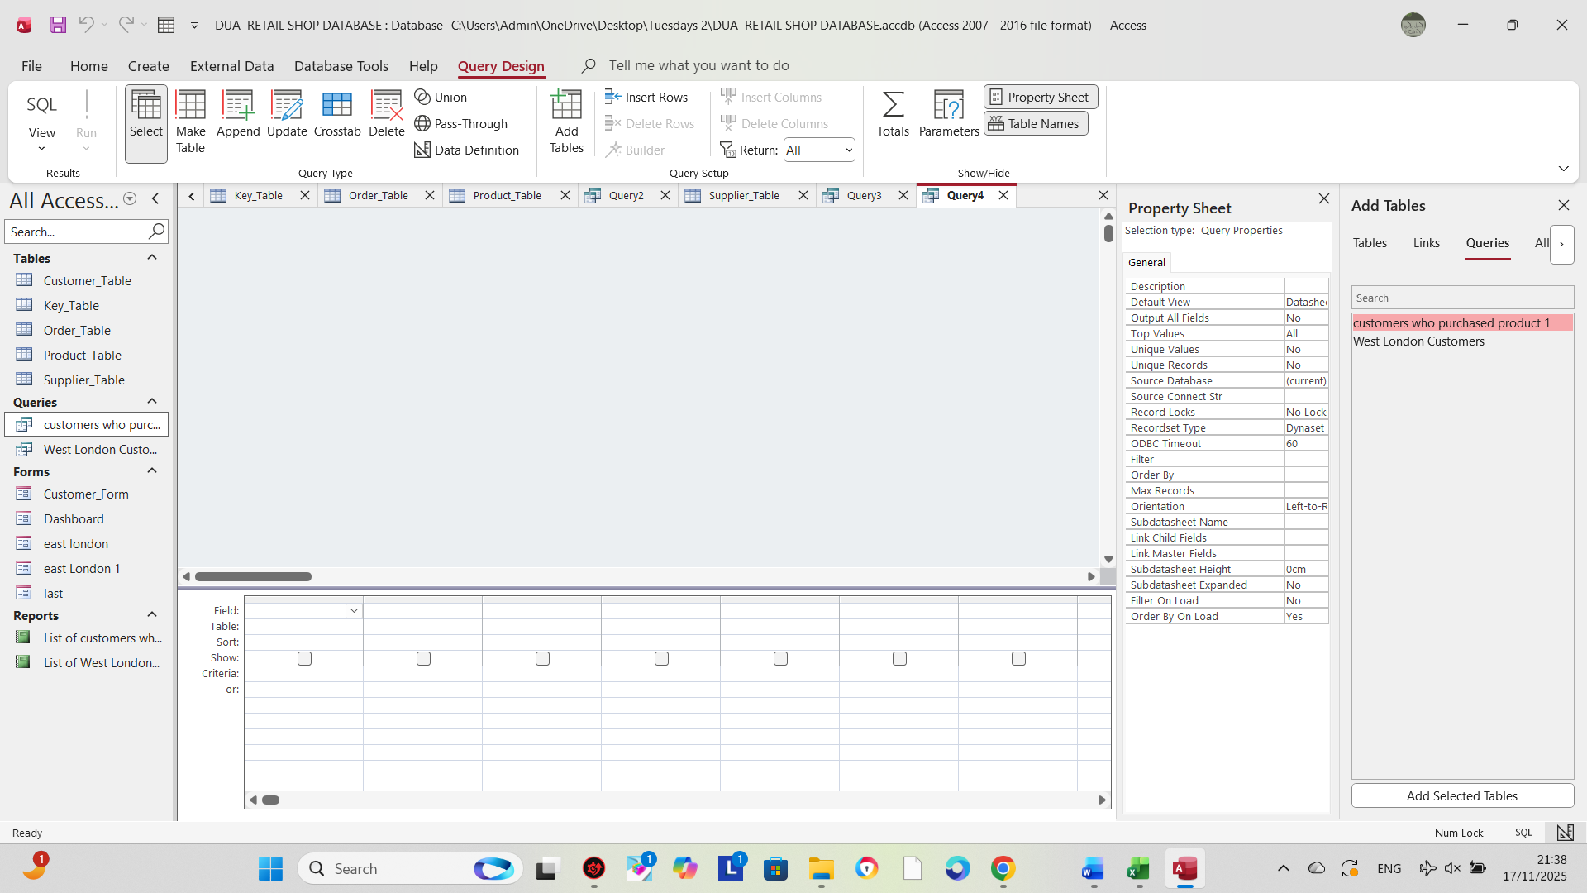
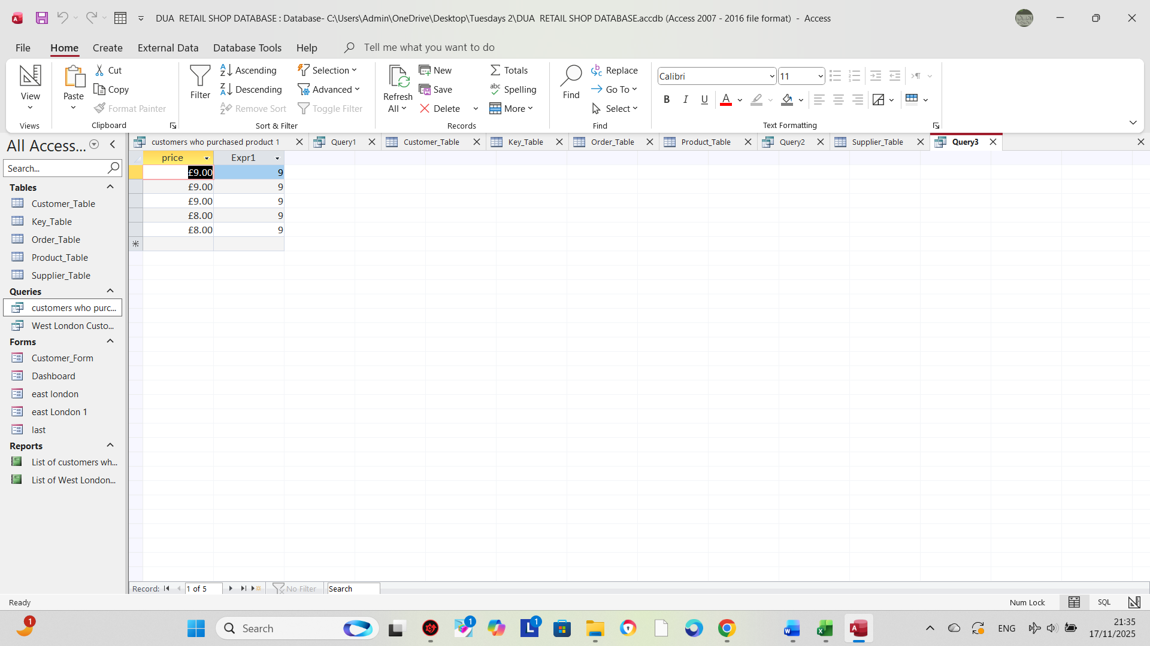

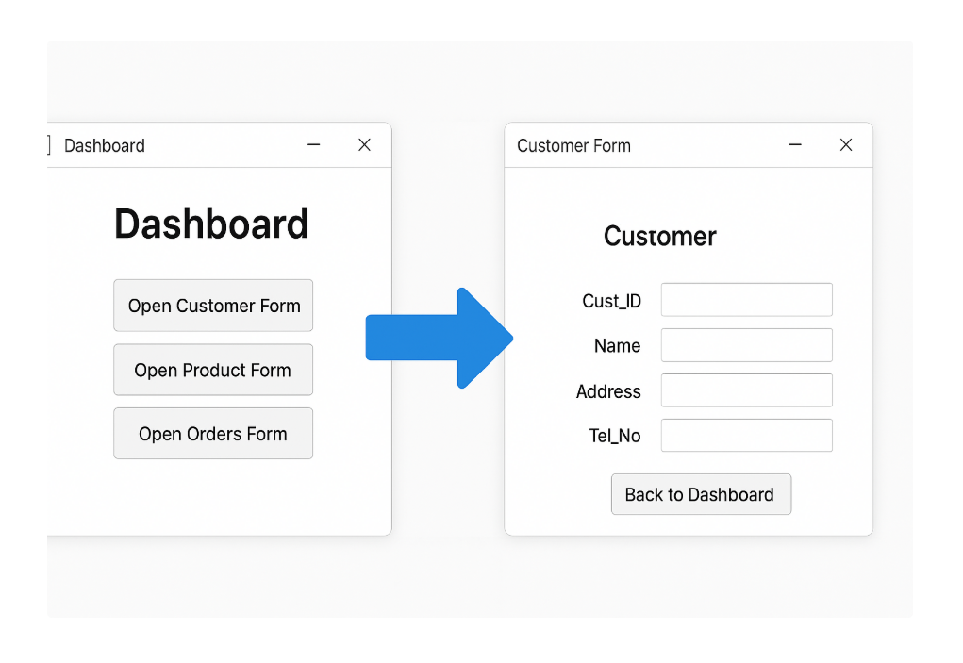
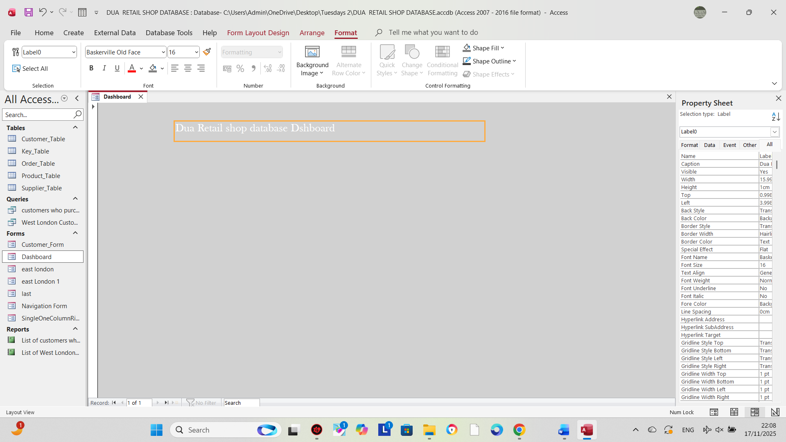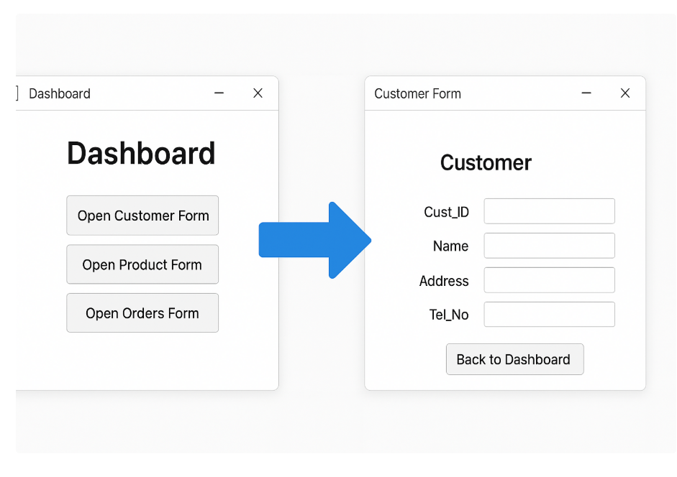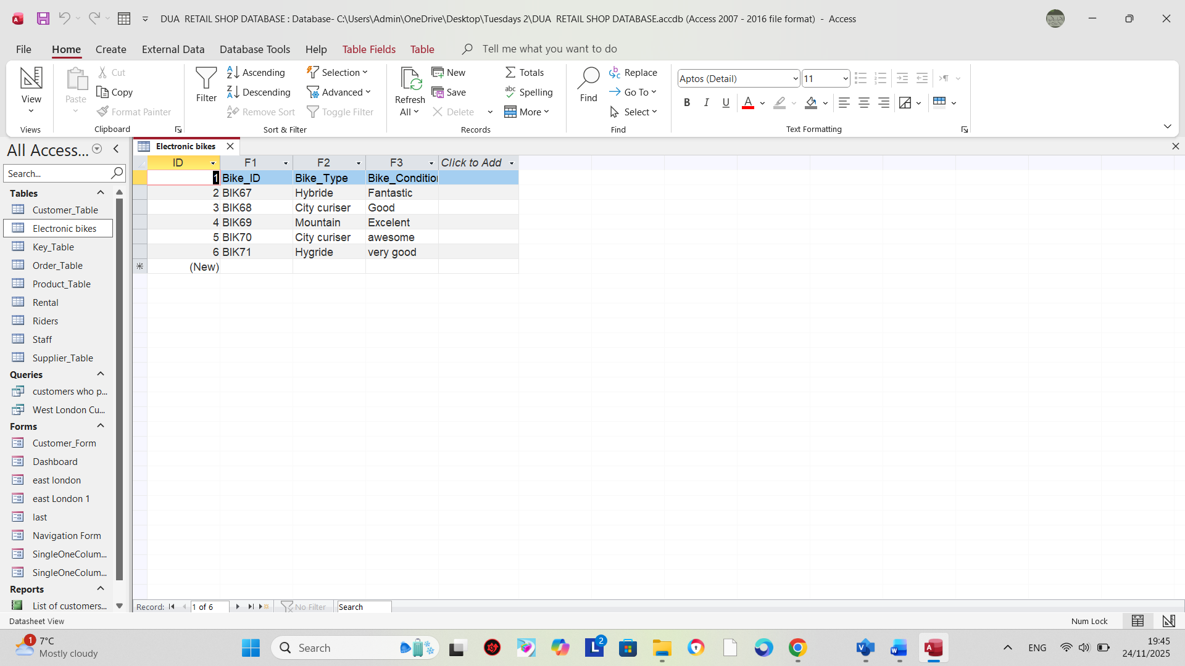

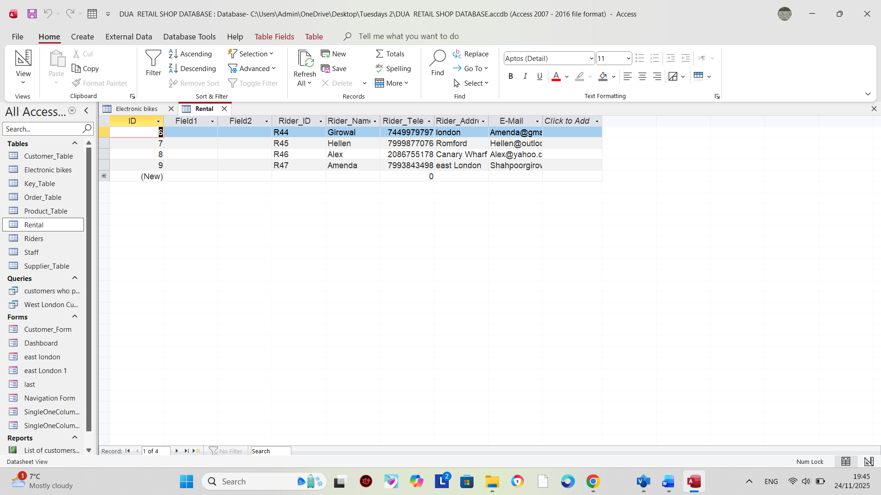

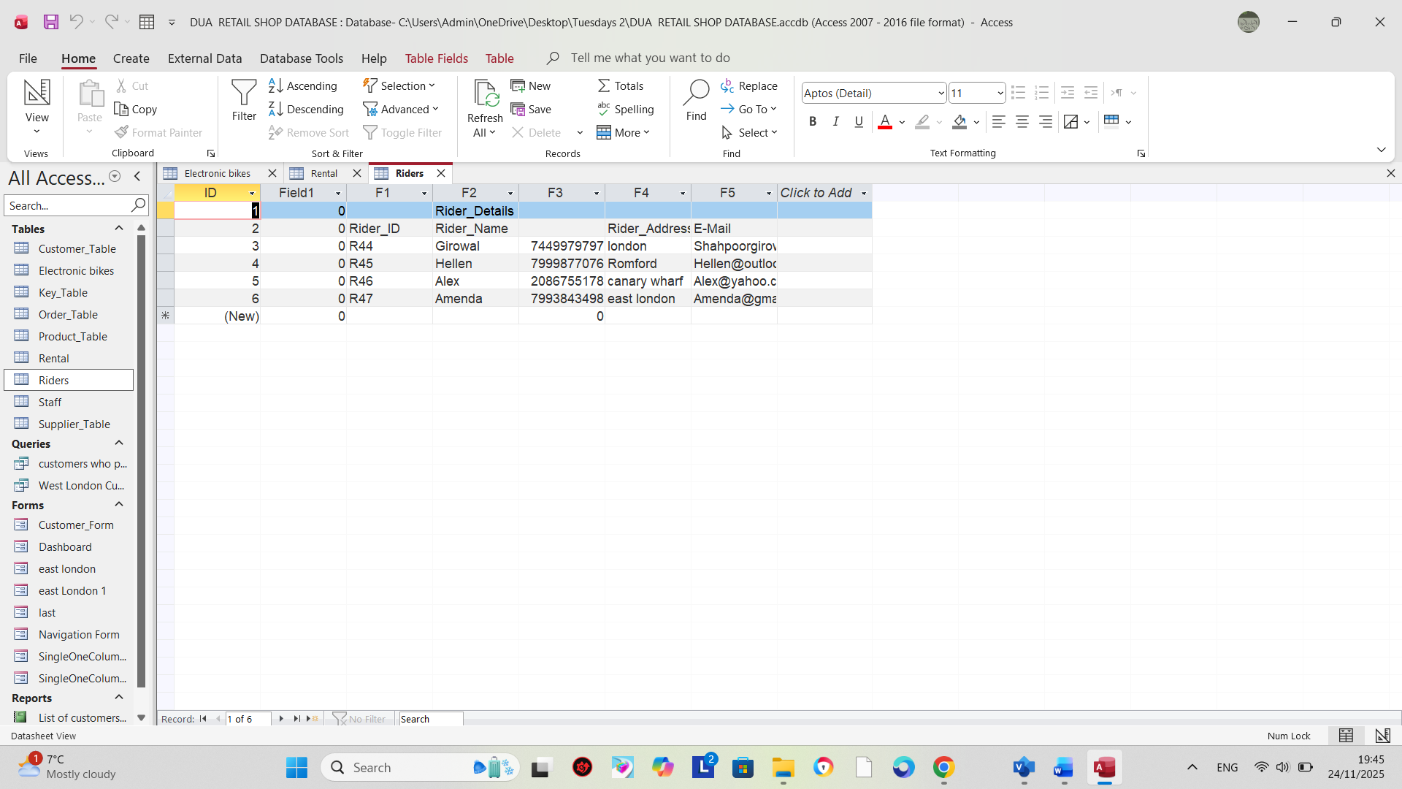

And one for MS Visio as well. And the a few above pages the relation of MS Visio is as well.



